Lab 04 - GPG Key Management, Encryption and
Signing
Student: Nenad Damjanović | Environment: Kali Linux (VirtualBox)

Objective and environment
Use GNU Privacy Guard (GPG 2.4.9) to create asymmetric keys, export/import public keys, encrypt/decrypt
messages, and create/verify digital signatures. The exercise also tests integrity after file modification and
simulates secure correspondence with Alice.

Key generation and revocation
Generated an RSA 4096-bit signing/certification key with an RSA encryption subkey for nenad@test.com. The
key was created on 19 October 2026 and expires on 20 October 2026; its expiration was intentionally left
unchanged. A previously expired Ed25519 laboratory key was separately revoked.
Figure 1. GPG version and RSA key generation
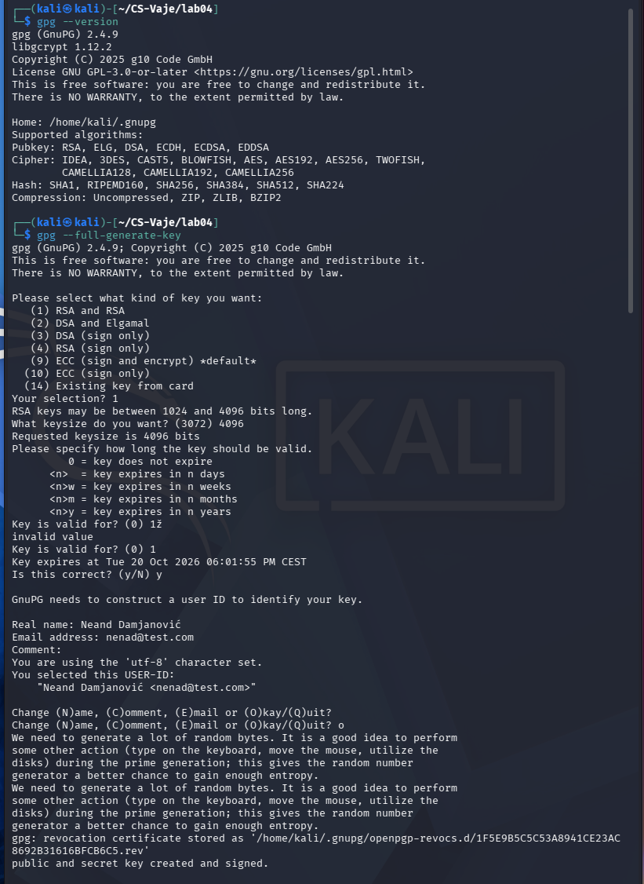

Keyring inspection and public-key export
The gpg --list-keys and gpg --list-secret-keys outputs show the new RSA key and the revoked old key. The
command gpg --armor --export nenad@test.com > public_key.asc created a distributable ASCII-armored
public key.
Figure 2. Public and private key listing; revoked former key
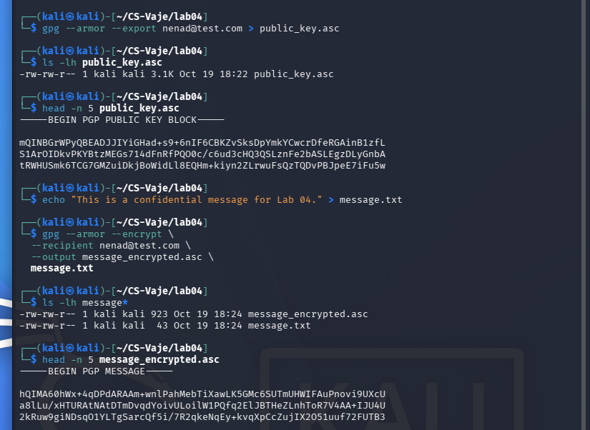
Figure 3. Public-key export and self-encryption
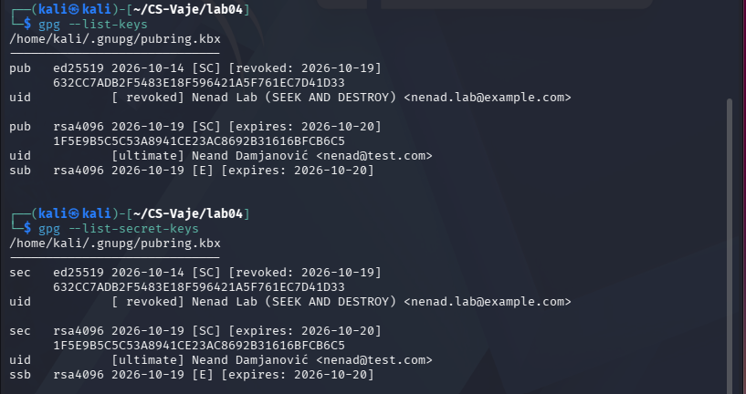

Encryption, decryption and signature verification
A test message was encrypted to the owner’s public key and decrypted using the corresponding private key.
diff produced no output, proving that the recovered plaintext matched the original.
Figure 4. Successful decryption and file comparison
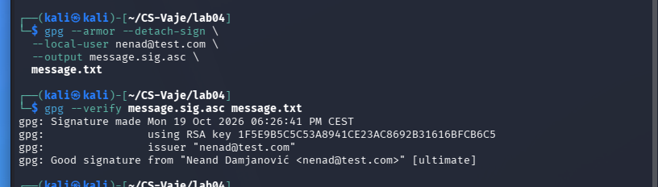
The original text was signed using a detached GPG signature. Verification reported Good signature. After
modifying a copy of the text, verifying the original signature against the changed copy reported BAD
signature. This demonstrates detection of tampering, not prevention of modification.
Figure 5. Valid signature on the original message
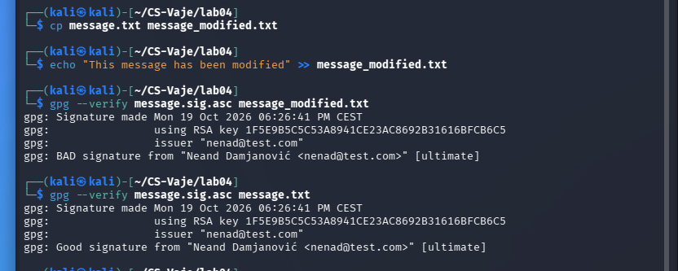
Figure 6. Invalid signature for altered data; valid for the original
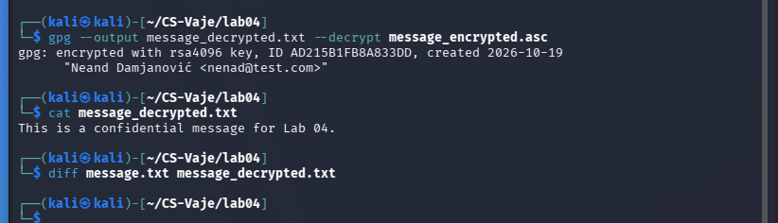

Exchange of public keys and signed encryption
To simulate a separate recipient, an isolated alice_gpg keyring was created. Alice’s public key was exported
and imported into Nenad’s keyring; the private key remained in Alice’s isolated directory.
Figure 7. Alice’s key creation and import of her public key
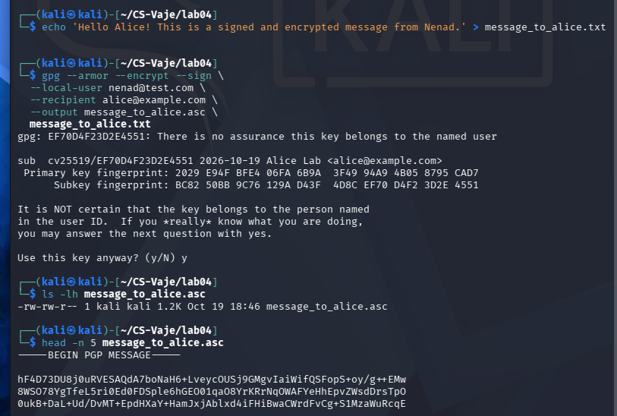
A message for Alice was encrypted using her public encryption key and simultaneously signed using Nenad’s
private signing key (gpg --armor --encrypt --sign).
Figure 8. Encryption and signing for Alice
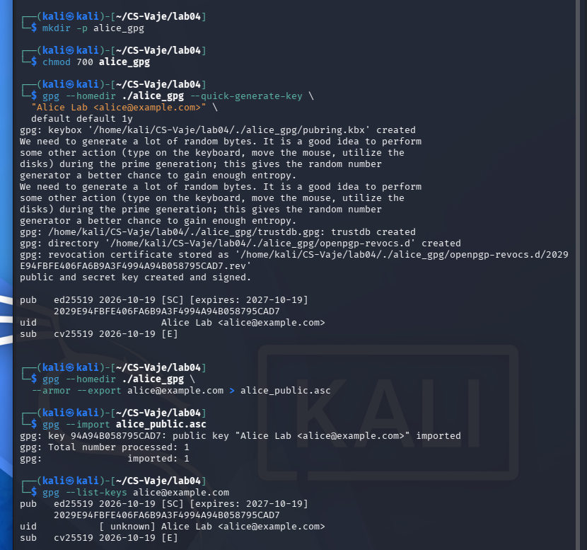

Recipient decryption and trust verification
Alice imported Nenad’s public key, decrypted the signed encrypted message in her own GPG environment,
and received Good signature [unknown]. The plaintext matched the original by diff. The [unknown] trust label
means the key-to-person identity was not independently certified; signature validity alone does not prove a
real-world identity.
Figure 9. Alice decrypts and verifies the signed message
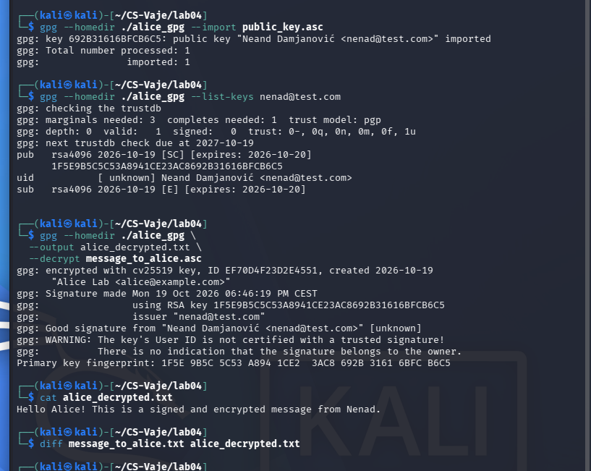

Questions and answers
Encryption vs. signing: Encryption provides confidentiality for the intended recipient. Signing supports verification of
message integrity and the signing key, but does not hide content.
Role of keys: The recipient’s public key encrypts and their private key decrypts; the sender’s private key signs and the
sender’s public key verifies. Public-key identity must be independently checked.
What if a file is modified? The demonstrated signed plaintext modification produced BAD signature. A separate direct
corruption test of encrypted ciphertext was not performed.
Security and conclusion: All operations used local test identities. Never publish private keys, passphrases, the
alice_gpg/ directory, or revocation certificates. GPG successfully demonstrated confidentiality, integrity checking, and
signed encrypted communication.
*ChatGPT is used to create a report from my own work and screenshots

