Lab 06 — Secrets Management using GPG
Student: Nenad Damjanović | Course: Cybersecurity — FIŠ
Kali Linux · GnuPG 2.4.9 · Laboratory report

Objective
Protect fictional API credentials, demonstrate two encryption methods, use environment variables safely, and simulate a repository leak. All screenshots were captured during the Kali Linux exercise.
Security scope: All displayed values are test examples. Never upload plaintext secrets, GPG private-key directories, passphrases, or revocation certificates.

1. Lab Environment and Secret Preparation
Created ~/CS-Vaje/lab06 and verified GnuPG 2.4.9. Created a local secrets.env file with two fictional values (API_KEY and DB_PASSWORD). Changed the file permissions to 600, permitting only the owner to read and write it.
cd ~/CS-Vaje/lab06
gpg --version
cat > secrets.env <<'EOF'
API_KEY=super-secret-key-123
DB_PASSWORD=VeryStrongPassword
EOF
chmod 600 secrets.env
ls -l secrets.env
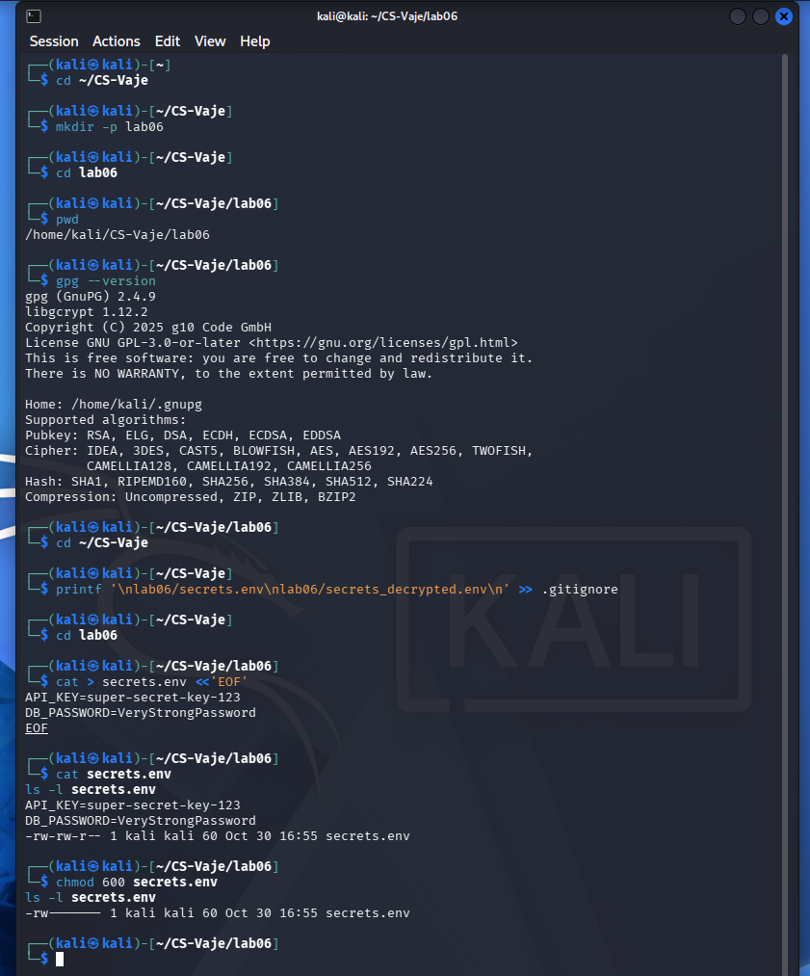
Figure 1. Environment setup and local test secrets.

2. Symmetric Encryption
GPG encrypted the test environment file using a passphrase (the -c option). The resulting secrets.env.gpg was checked before the plaintext file was removed. This protects confidentiality at rest provided the passphrase remains strong and private.
gpg -c secrets.env
ls -lh secrets.env*
test -s secrets.env.gpg && echo "Encrypted file exists"
rm secrets.env
ls -lh secrets.env*
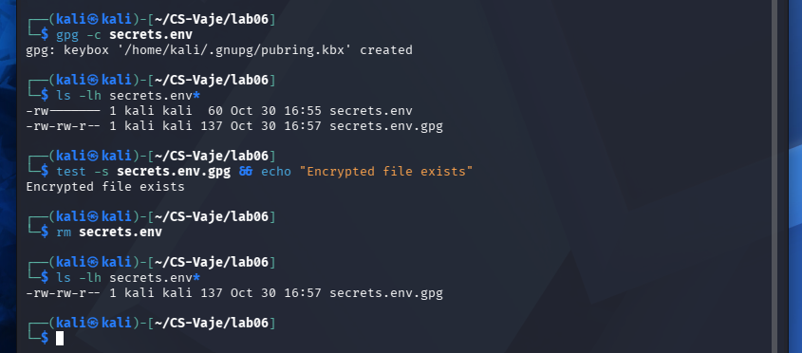
Figure 2. Symmetric GPG encryption and removal of plaintext.

3. Decryption and Verification
The encrypted file was successfully decrypted using the passphrase. Both file output and terminal-output modes were demonstrated. GPG reported AES256.CFB encrypted data, and the original fictional values were recovered. The plaintext was restricted to owner access.
gpg --output secrets.env --decrypt secrets.env.gpg
cat secrets.env
gpg -d secrets.env.gpg
chmod 600 secrets.env
ls -l secrets.env*
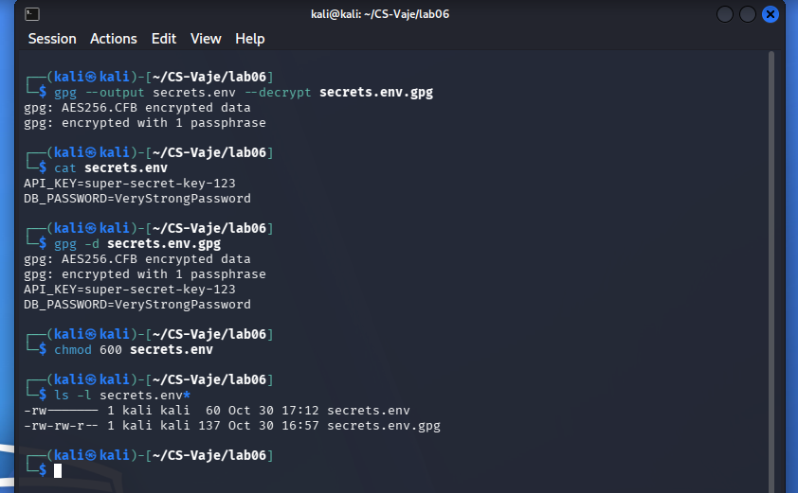
Figure 3. Successful symmetric decryption.

4. Asymmetric Encryption
Generated a separate Lab 06 GPG identity (lab06@example.com) with a one-year expiration. Encrypted secrets.env to its public key. The armored output begins with BEGIN PGP MESSAGE. Decryption used the matching secret key, and diff found no differences. The temporary duplicate plaintext copy was removed.
gpg --quick-generate-key "Lab 06 Secrets <lab06@example.com>" default default 1y
gpg --list-keys lab06@example.com
gpg --armor --encrypt --recipient lab06@example.com --output secrets_asymmetric.asc secrets.env
head -n 3 secrets_asymmetric.asc
gpg --output secrets_decrypted.env --decrypt secrets_asymmetric.asc
diff secrets.env secrets_decrypted.env
rm -i secrets_decrypted.env
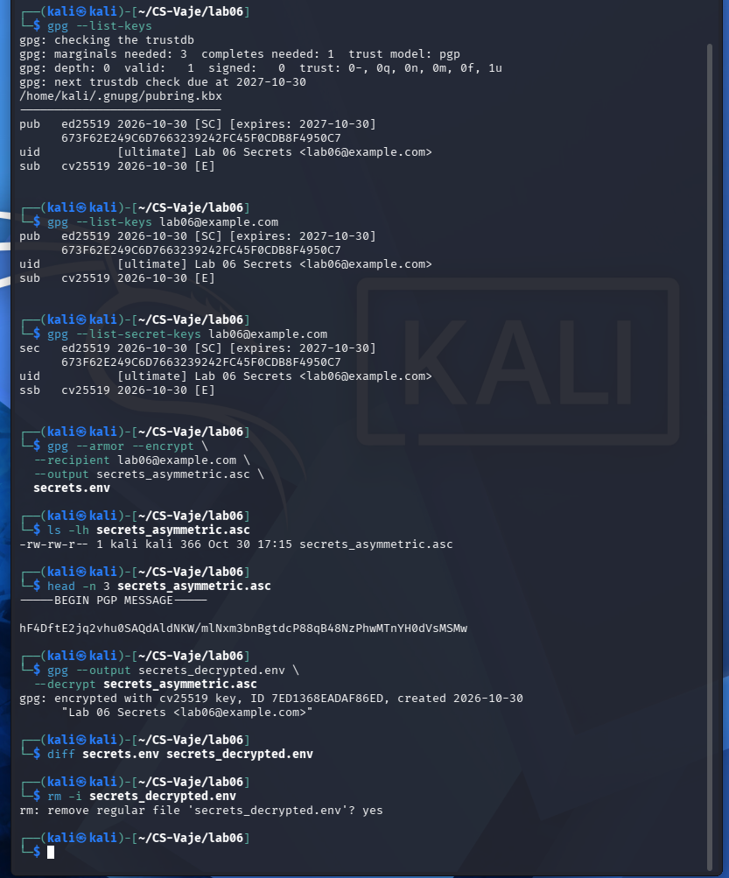
Figure 4. Asymmetric encryption and matching decrypted content.

5. Application Integration
Used shell source to load fictional variables, export to child processes, and verified that Python could read API_KEY through os.getenv(). Then unset removed the values from the active shell session. Note: source executes shell input, so the file must be trusted.
source secrets.env
export API_KEY DB_PASSWORD
python3 -c 'import os; print("API key loaded:", bool(os.getenv("API_KEY")))'
unset API_KEY DB_PASSWORD
echo "API_KEY=${API_KEY:-NOT_SET}"
echo "DB_PASSWORD=${DB_PASSWORD:-NOT_SET}"
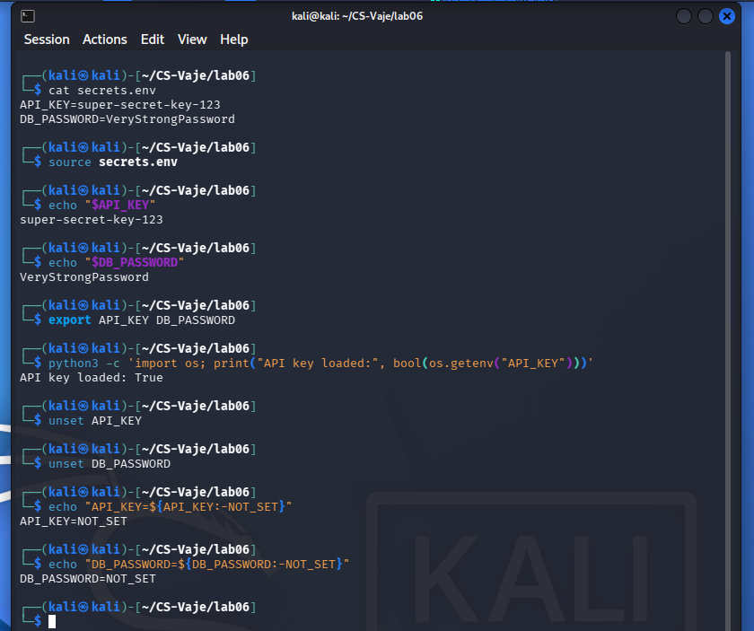
Figure 5. Using environment variables in Python and clearing them.

6. Simulated Repository Leak
Copied only the symmetrically encrypted file to a local simulated attacker directory. A separate GPG home was used. Attempts with an empty and an incorrect passphrase failed with a bad session key, whereas the authorized user could decrypt successfully. This demonstrates unsuccessful test guesses, not proof of resistance against offline password attacks.
mkdir -p attacker_simulation attacker_gpg
chmod 700 attacker_gpg
cp secrets.env.gpg attacker_simulation/
gpg --homedir ./attacker_gpg --batch --pinentry-mode loopback --passphrase '' --decrypt attacker_simulation/secrets.env.gpg
# Attempt with a wrong test passphrase also failed.
gpg -d secrets.env.gpg
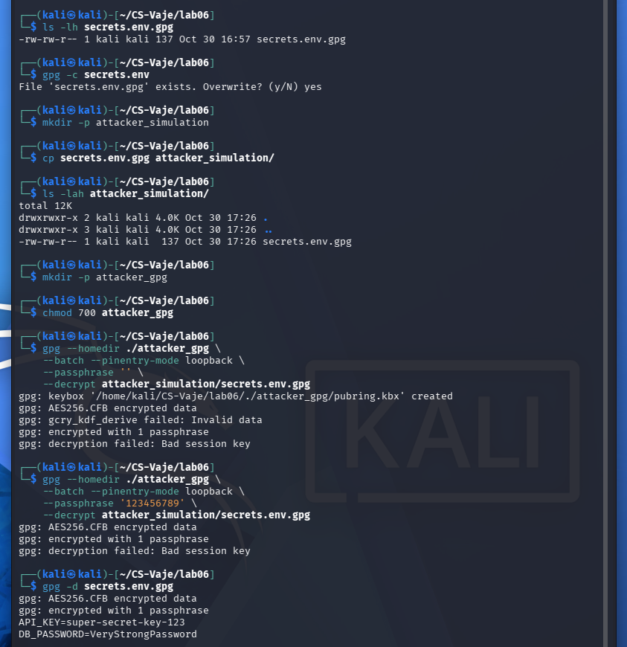
Figure 6. Repository leak simulation: failed guesses and authorized decryption.

Questions and answers
What is a secret, and why should it not be committed to Git?
Secrets include passwords, API keys, tokens, and private certificates. Unencrypted secrets exposed in source history may remain accessible even after later deletion, requiring revocation and rotation.
How does symmetric encryption differ from asymmetric encryption?
Symmetric encryption uses one shared secret/passphrase to encrypt and decrypt. Asymmetric encryption uses the recipient public key to encrypt and a matching private key to decrypt.
Why does chmod 600 matter if the file is encrypted later?
File permissions restrict local access to plaintext and reduce exposure. They do not replace cryptographic protection or remove copies from backups and history.
Why might an attacker fail to decrypt an encrypted file?
Without the correct passphrase or private key, normal GPG decryption cannot recover the plaintext. However, a weak passphrase could be guessed offline, so encryption strength depends on secret quality and management.
What are the advantages and limitations of environment variables?
They decouple configuration from source code and work well with application processes, but can leak via logging, debugging, process access, or careless shell history. In production, dedicated secret managers and least privilege are preferable.

Results and conclusions
Symmetric and asymmetric GPG encryption both succeeded, with successful authorized decryption. The Python test confirmed that exported shell variables were available to the child process, and they were removed afterward. The leak simulation showed failed empty/wrong passphrase attempts and successful authorized recovery. These tests do not establish resistance to all password attacks.
The key lesson is to avoid plaintext secrets in Git, minimize copies of sensitive material, and manage encryption keys and passphrases separately. More comprehensive production options include HashiCorp Vault, Mozilla SOPS, and AWS Secrets Manager.
Source: Robi Pritržnik, Secrets Management using GPG, FIŠ lecture/exercise slides (2025/26).
*ChatGPT is used to create a report from my own work and screenshots

