Lab 00 — Linux Command-Line Basics
Student: Nenad Damjanović | Environment: Kali Linux | Date: 19 October 2026

Objective
Practise Linux navigation, file management, text and log inspection, Unix permissions, and file discovery. The course handout also mentions SSH; an SSH session was not demonstrated in this exercise.

1. Directory navigation
cd ~/CS-Vaje
mkdir -p lab00
cd lab00
pwd
ls -lah
pwd confirmed /home/kali/CS-Vaje/lab00; ls showed the directory contents and permissions.
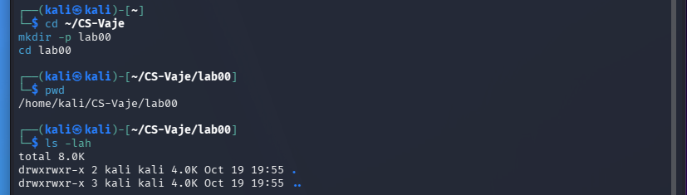
Figure 1. Navigation and listing files.

2. Creating files and directories
mkdir test_folder
touch test.txt
echo "This is my first Linux lab." > test.txt
echo "I am learning cybersecurity." >> test.txt
cat test.txt
The > operator overwrites, while >> appends. The result contained both lines.
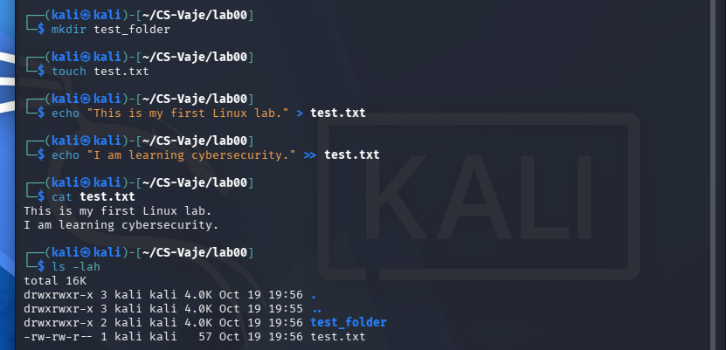
Figure 2. Directory and text file creation.

3. Copy, move, rename, delete
cp test.txt test_copy.txt
mv test_copy.txt test_folder/
mv test_folder/test_copy.txt test_folder/renamed.txt
rm -i test_folder/renamed.txt
cp duplicates files; mv moves or renames them; rm -i asks before deleting.
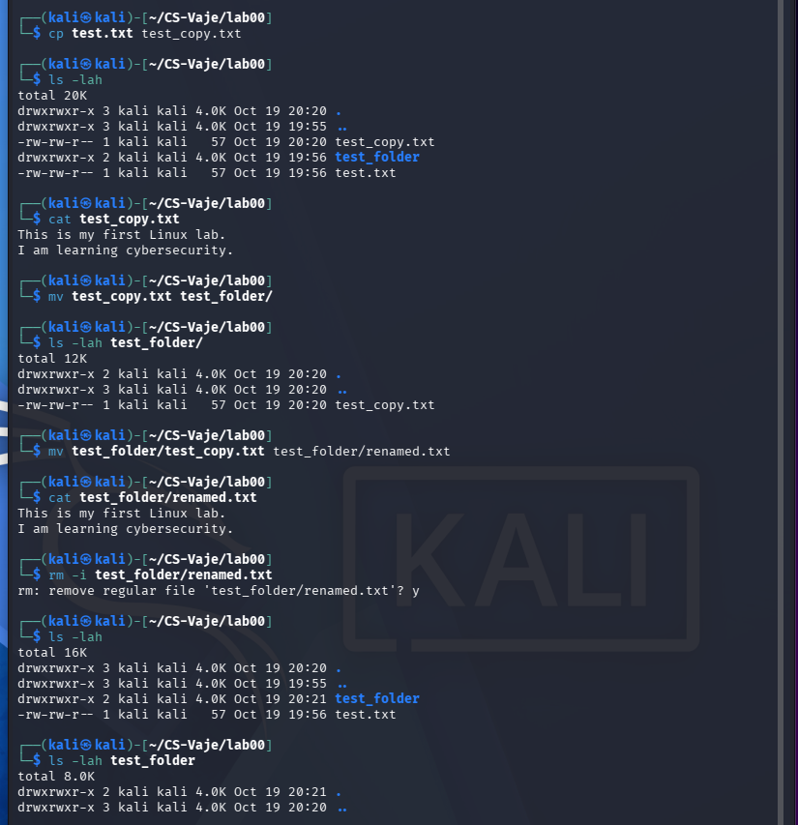
Figure 3. File management operations.

4. Log inspection and filtering
head -n 3 security_log.txt
tail -n 3 security_log.txt
grep "Failed login" security_log.txt
grep -n "ERROR" security_log.txt
grep -c "WARNING" security_log.txt
The simulated security log contained two WARNING lines and two ERROR lines. grep -c returned 2; grep -n showed matching line numbers.
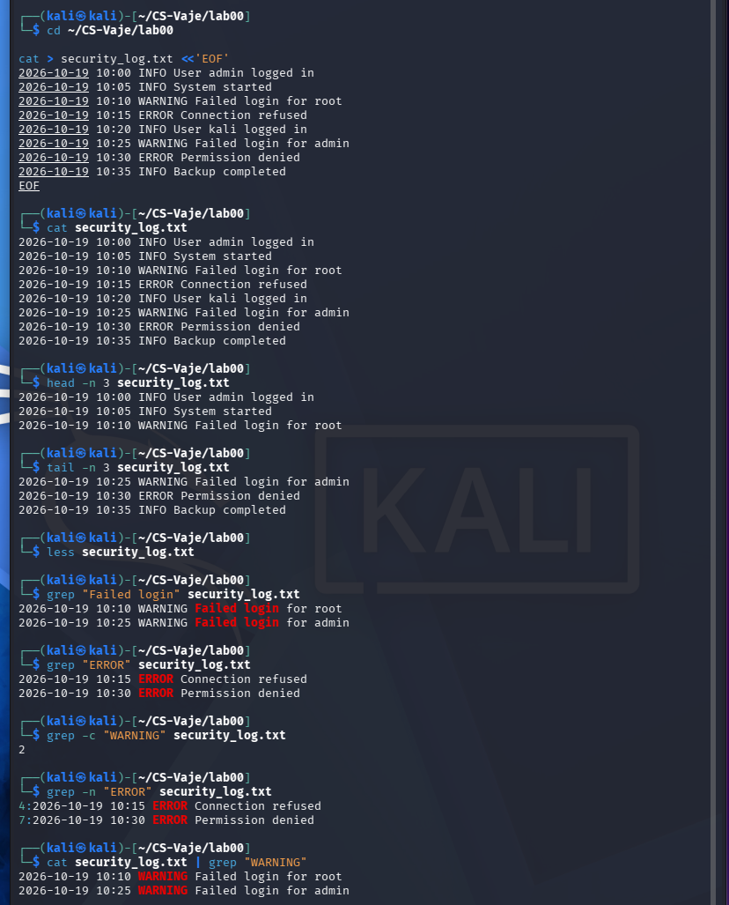
Figure 4. Searching a simulated security log.

5. Unix permissions and ownership
chmod 600 test.txt; ls -l test.txt
chmod 644 test.txt; ls -l test.txt
chmod 700 test_folder; ls -ld test_folder
chmod 755 test_folder; ls -ld test_folder
sudo chown kali:kali test.txt
Read = 4, write = 2, execute = 1. 600 restricts file reading and writing to its owner; 644 allows others to read; 700 restricts a directory to its owner; 755 gives directory traversal and read access to others.
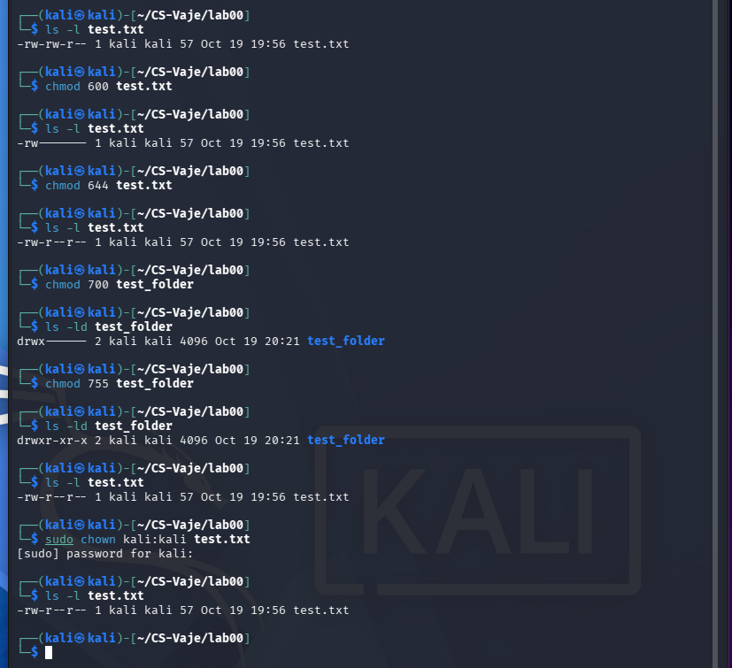
Figure 5. Changing modes and checking ownership.

6. Finding files
find . -name "test.txt"
find . -type f -name "*.txt"
find . -type d
find . -type f -size +1k
find . -type f -name "*.txt" -exec grep -l "WARNING" {} +
find located the file names, directories and matching text files. The last command returned ./security_log.txt.
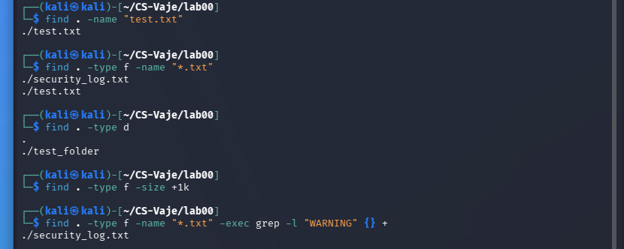
Figure 6. Finding files and text matches.

Questions and answers
CLI vs GUI A CLI accepts text commands, which suit repeatable operations and automation; a GUI uses visual controls.
What do > and >> do? > overwrites or creates a file; >> appends to it.
How do cp, mv and rm differ? cp copies, mv moves/renames, and rm deletes. rm -i prompts before deletion.
What do 600, 644, 700 and 755 represent? Octal permissions for owner, group and others; their read/write/execute bits have values 4/2/1.
Why are grep and find useful in cybersecurity? They locate relevant logs and files and filter events for further investigation.

Conclusion
The six practical tasks were completed on Kali Linux: navigation, file creation, manipulation, mock-log analysis, permissions and file search. The screenshots document actual command output. SSH connectivity was not tested.

Source
FIŠ, Introduction to Linux: Basics of Working in the Command Line (cs_lab00.pdf), academic year 2025/26.
*ChatGPT is used to create a report from my own work and screenshots

