Library application

The app is developed using:

* .NET Core 6 for BE
  + Dapper for retrieving data
  + Entity framework is used for migrations
* Angular 16 for FE

The application is split in 4 projects:

* Library – contains API logic (controllers)
* Library.Business
  + Repositories
  + Services
  + Models (DTOs)
  + Enums
* Library.Database
  + Database context
  + EF migrations
  + Seed database logic
  + Fluent configuration used to configure column types
  + Models (database tables)
* Library.SPA – Angular project
  + Split in modules
    - Books module
      * Components
        + Add new book dialog
        + View books component
        + Book card component(each entry from the grid)
        + Add new author dialog component (to be moved in authors module)
      * Services
    - Authors module (to be implemented)
    - Core module
      * Components
        + Confirmation dialog – reusable component to confirm actions (for example deleting a book)
        + Spinner overlay – component shown when HTTP request is made
      * Interceptors
        + Interceptor used to show loading overlay when HTTP requests are made
      * Services
        + Alert service (Toastr) – show alert based on alert type
        + Confirmation dialog comp
      * Layouts
        + Application layout component
        + Login layout component (to be implemented)

Functionalities:

Menu:

* In the right corner there are details about current user and his role. Also language can be changed (at the moment the value of the language isn’t stored in database or in local storage, so if a refresh happens the default language will be loaded)
* The title of the current page (in this case “Books”) can be changed using a method from CommonService, so if we are on authors page the title will be “Authors”



Books page:

* Contains two action buttons:
  + One for adding a new author which opens the add new author dialog
  + One for adding a new book which opens the add new book dialog
* A grid with books details:
  + Search textbox is used to search in books details : title, description, authors first name and last name
  + Pagination

Add new author dialog

* Mandatory fields : FirstName, LastName

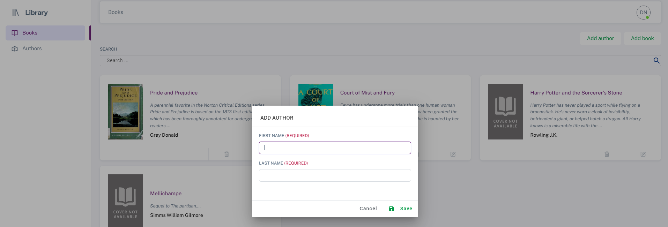

(add new author dialog)

Add new book dialog

* Mandatory fields : title, description, authors
* Optional fields : book cover

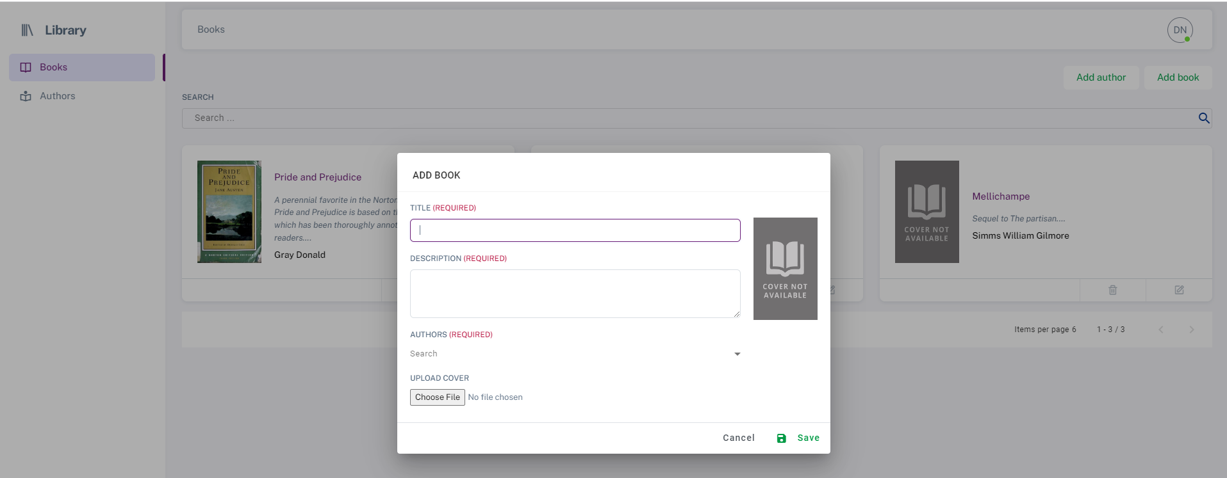

(add new booking dialog)

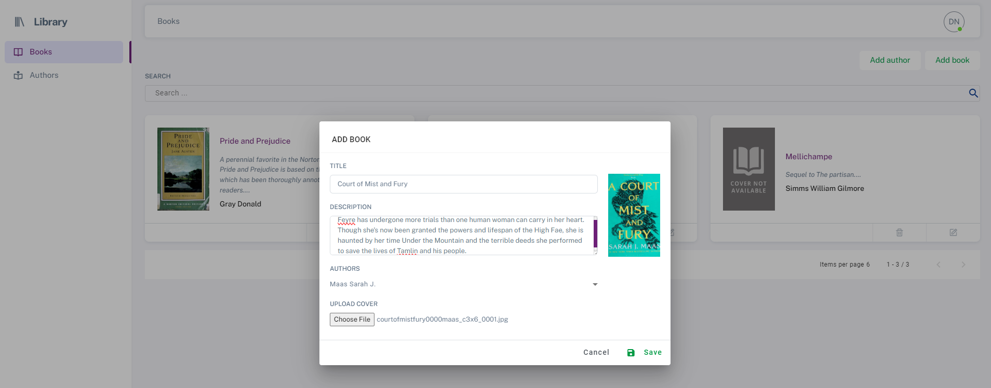

(New dialog with all fields completed)

* If save is successful a confirmation message is shown and books list from behind the dialog will be refreshed (as you can see the new book was added – now we have 4 books)

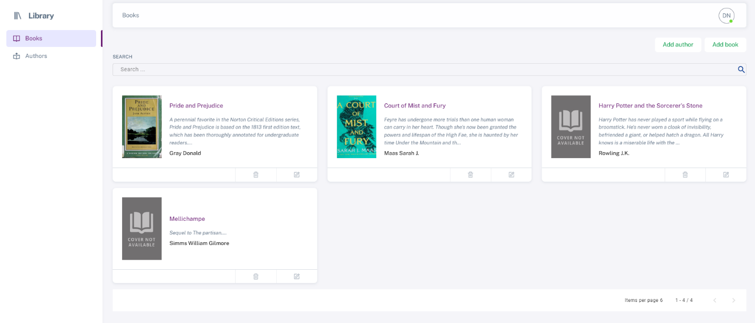

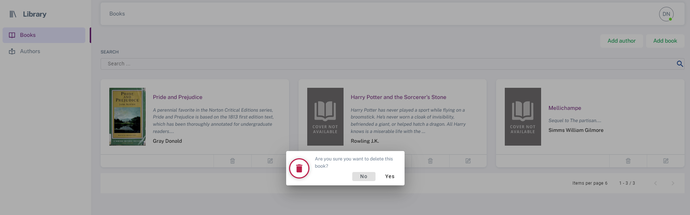

(confirmation dialog when deleting a book)