Step 1

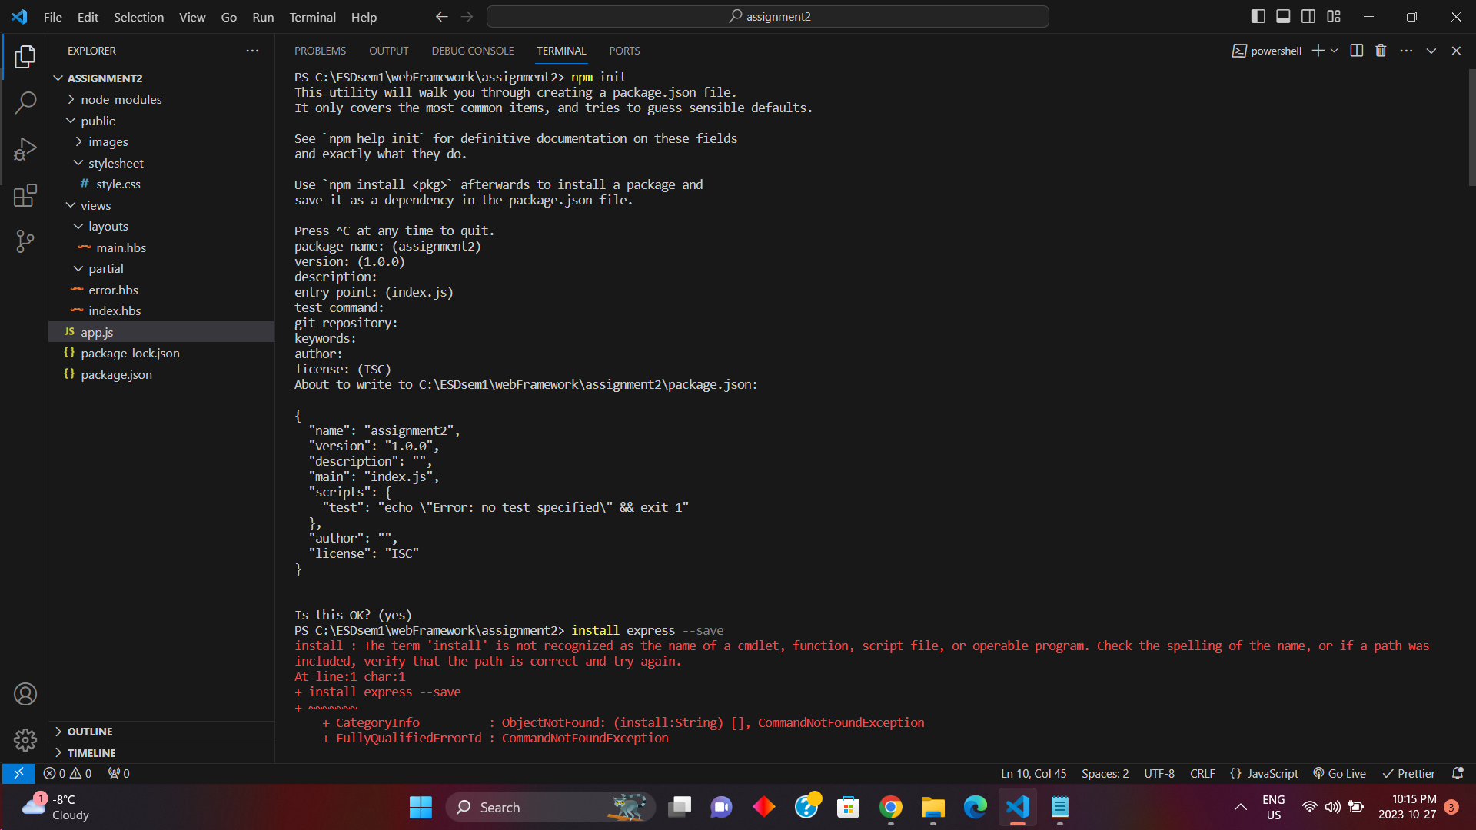

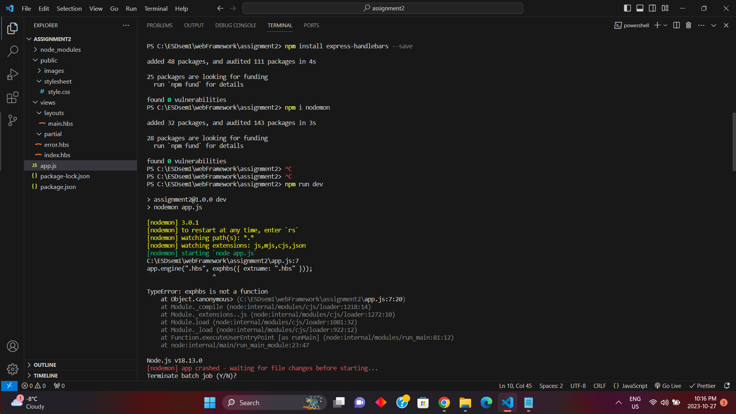

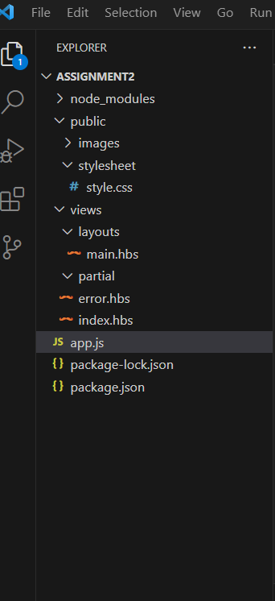

Step 3:

<http://localhost:3000/>

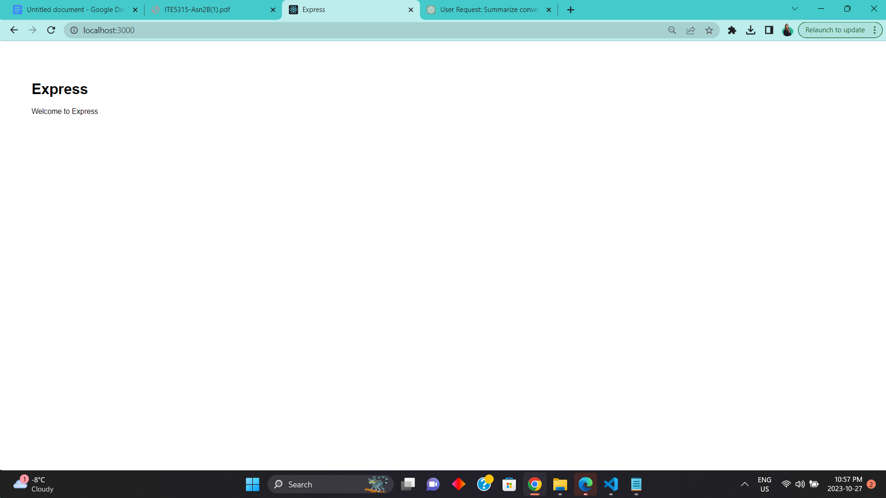

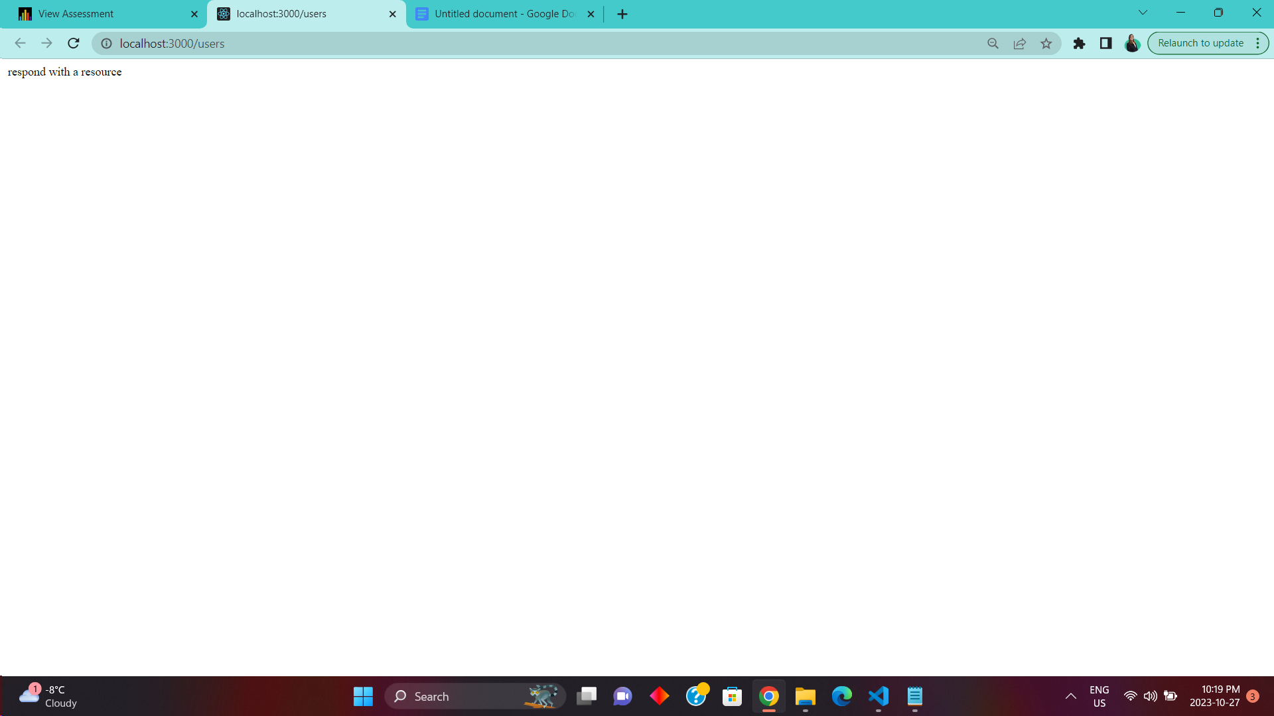

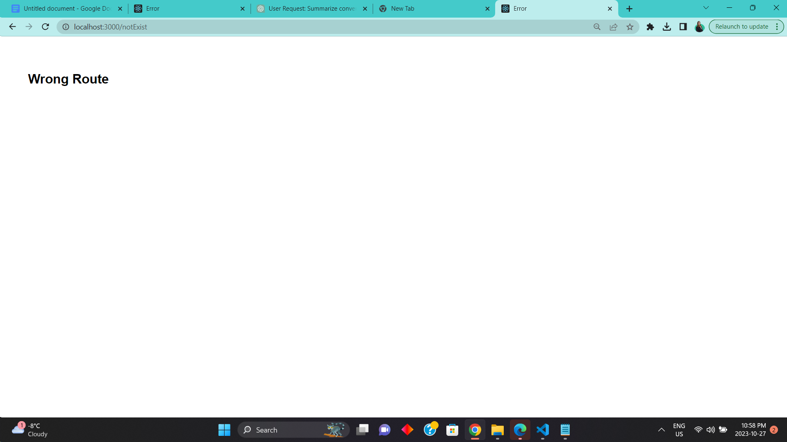

Step 4:

a) What is the role of “main. hbs”? How is it being used/called in the app?

Ans:-main.hbs is working like a layout or a particular format that is being displayed in each page while displaying the content changes but only the content of the body is changes but style and everything remain.the main.html is called app.engine(".hbs", exphbs.engine({ extname: ".hbs" }));

Because of this line node will search for the layout folder and inside of that folder it will search specifically for main.hbs file by default that is why main.hbs is being called.

b) What is the role of “index.hbs” and “error.hbs”? How do these files being used/called in the app?

Ans:-the file are being called while we render the path . we have to use the file name app.get("/", function (req, res) {

res.render("index", { title: "Express" });

});

While rendering so the node will go to main.hbs and and when the body part come it will search for the file that is specified in the res.render and it will display its content.

c) In “app.js”, what is the role of the following line? What happens if you commend it out?

app.use(express.static(path.join(__dirname, 'public')));

Ans:- if we remove this code the stylesheet won’t be able to display because we are giving it the static path and if we take it out it won’t be able to merge the CSS file in the public directory.

d) Try to add proper comments to each line/block in app.js

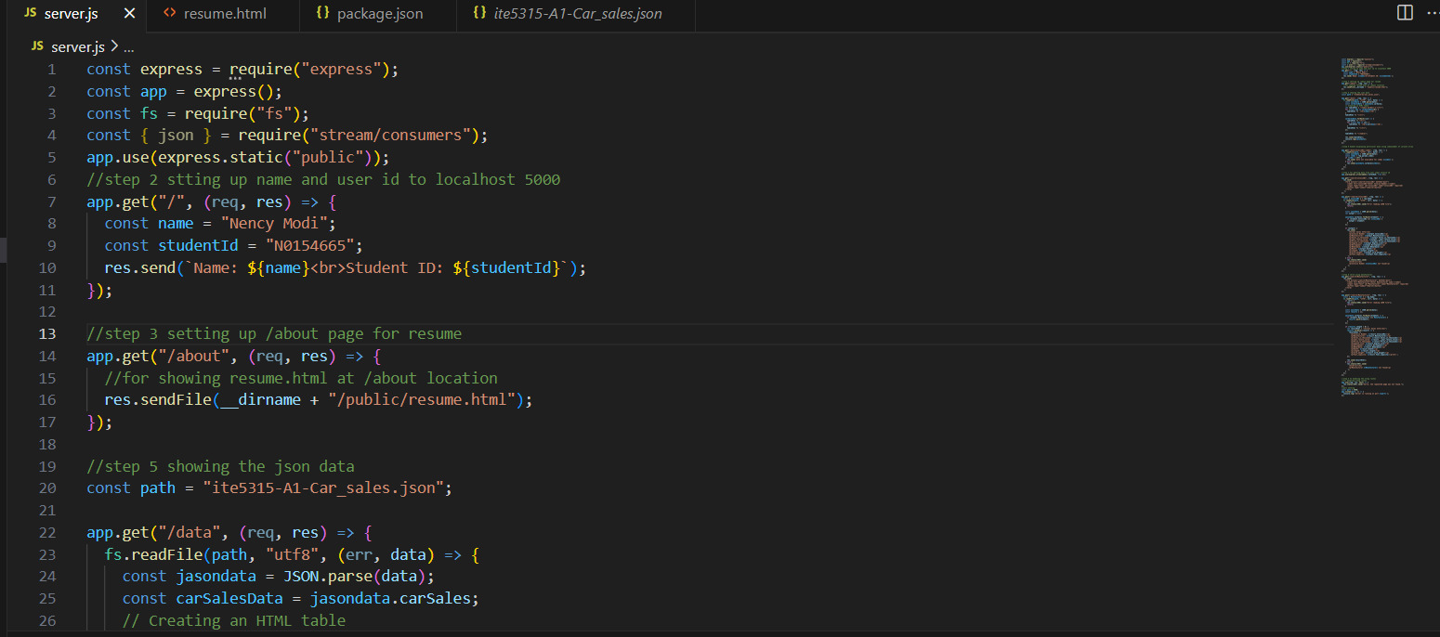

Step 5:

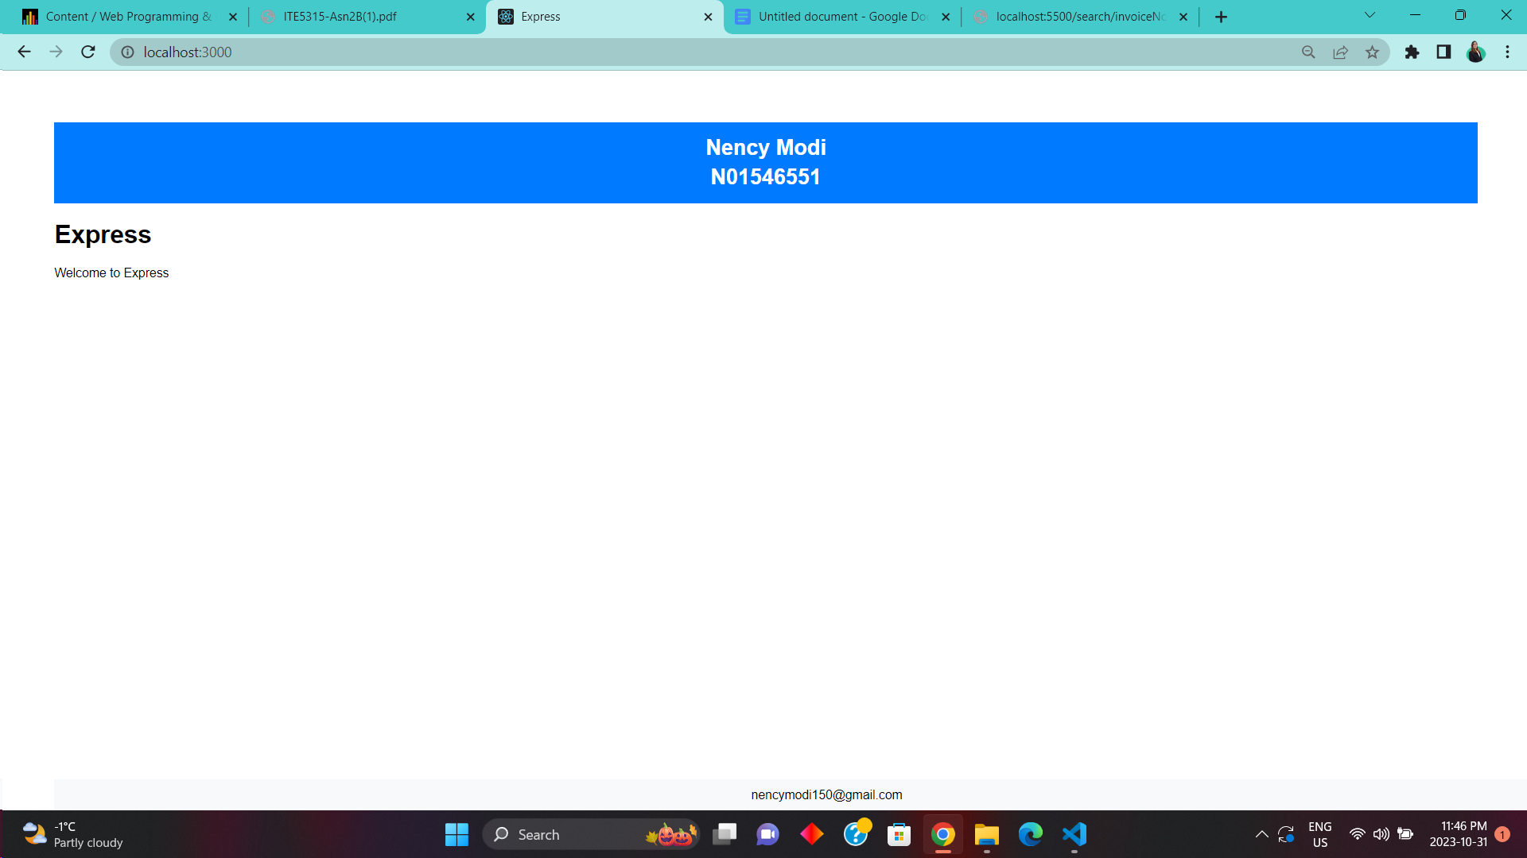

Step 6:

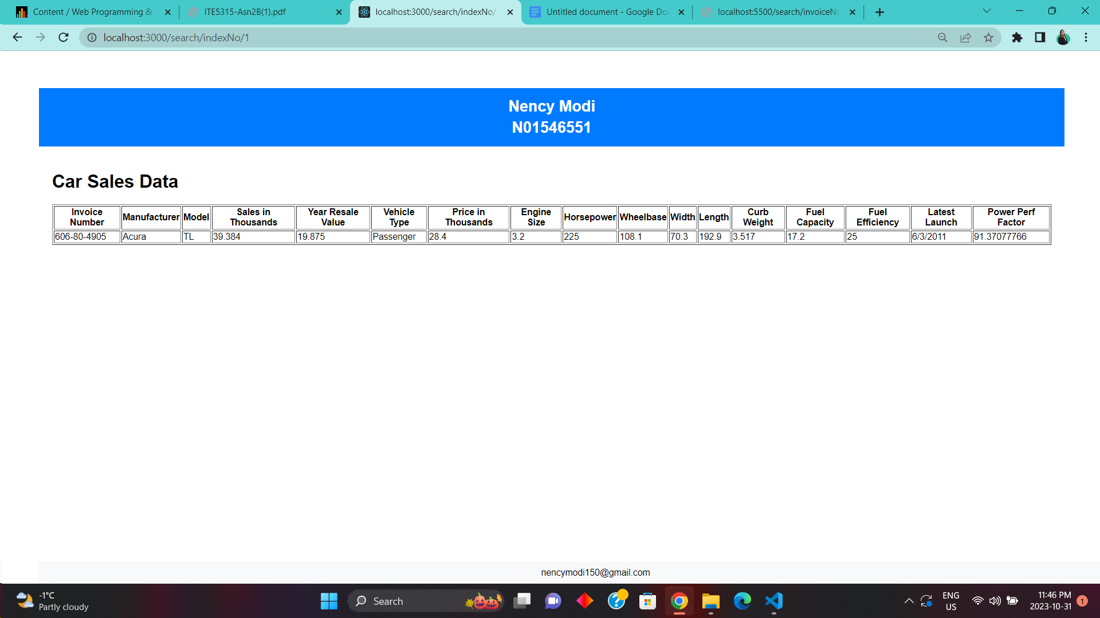

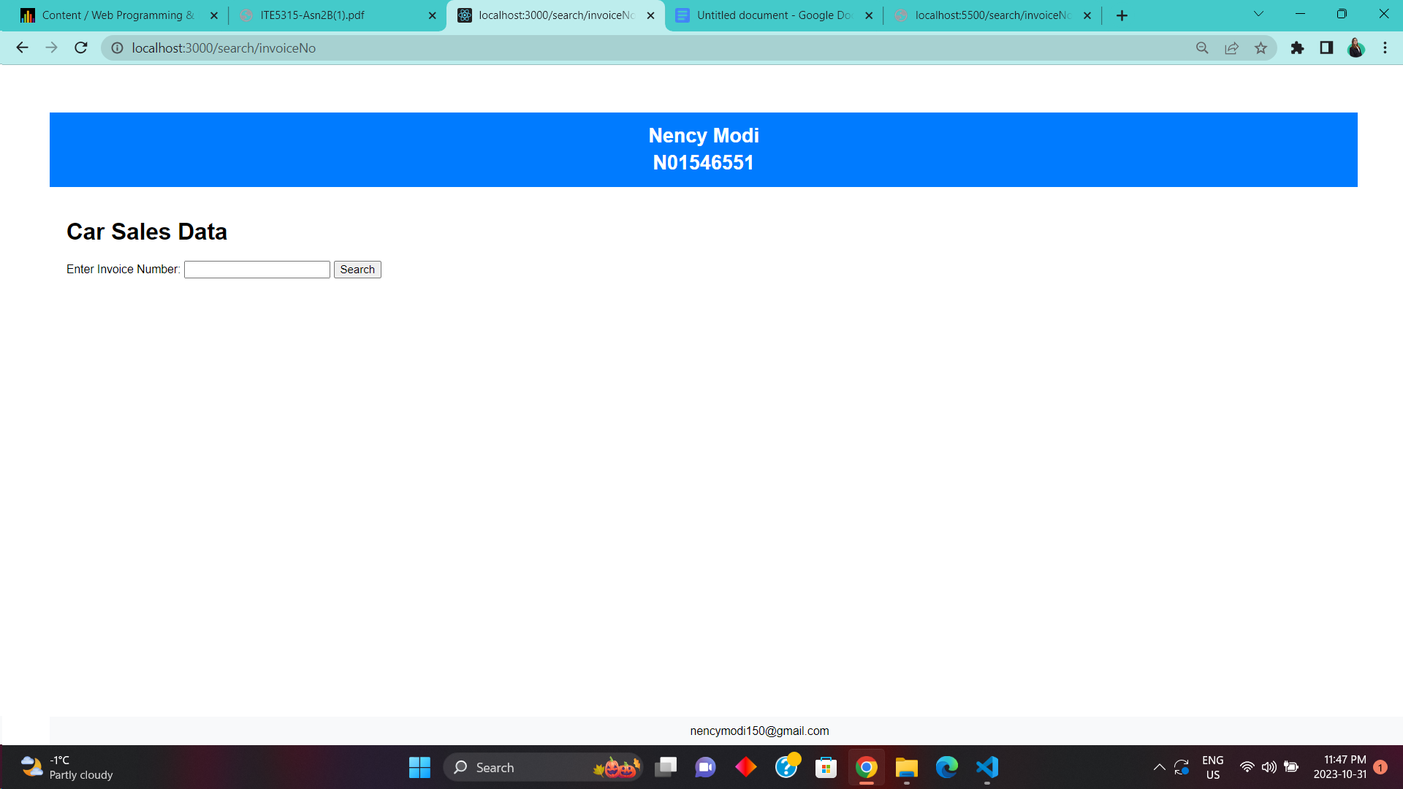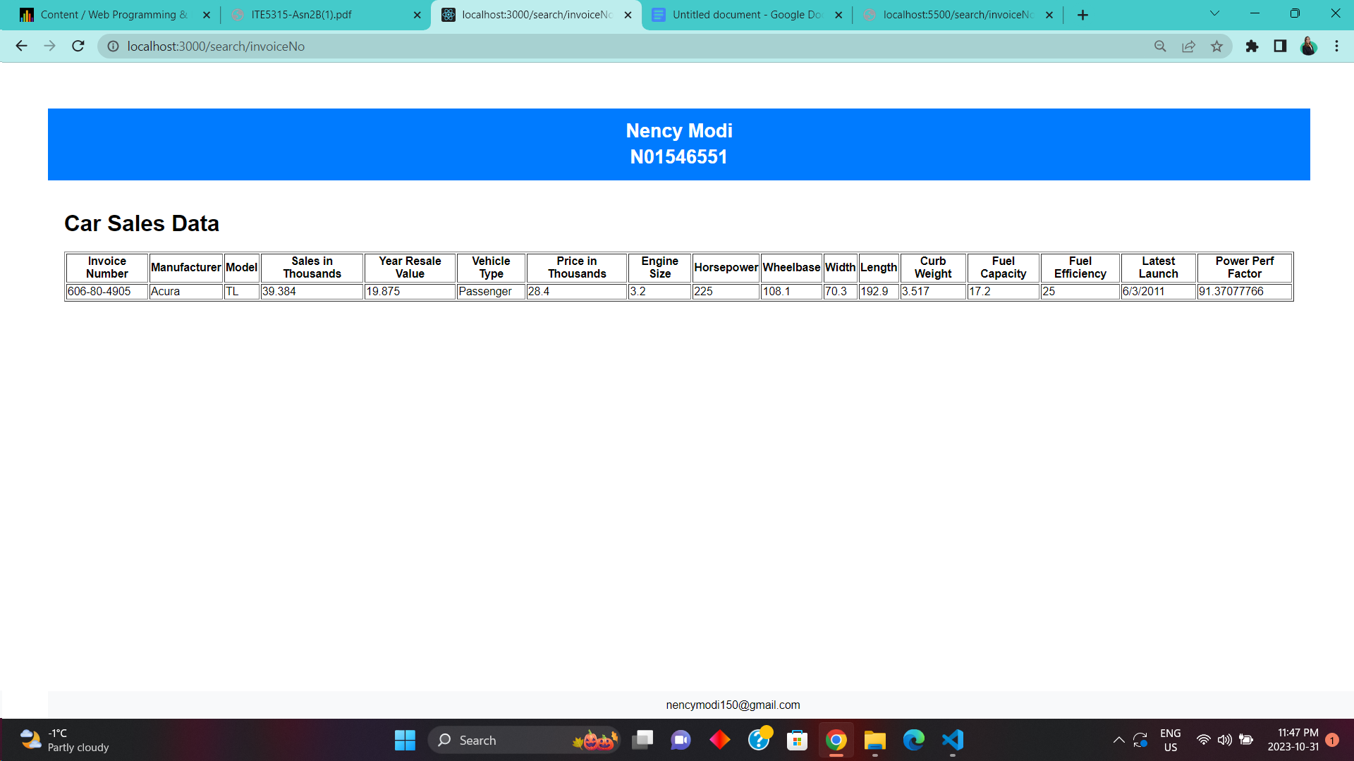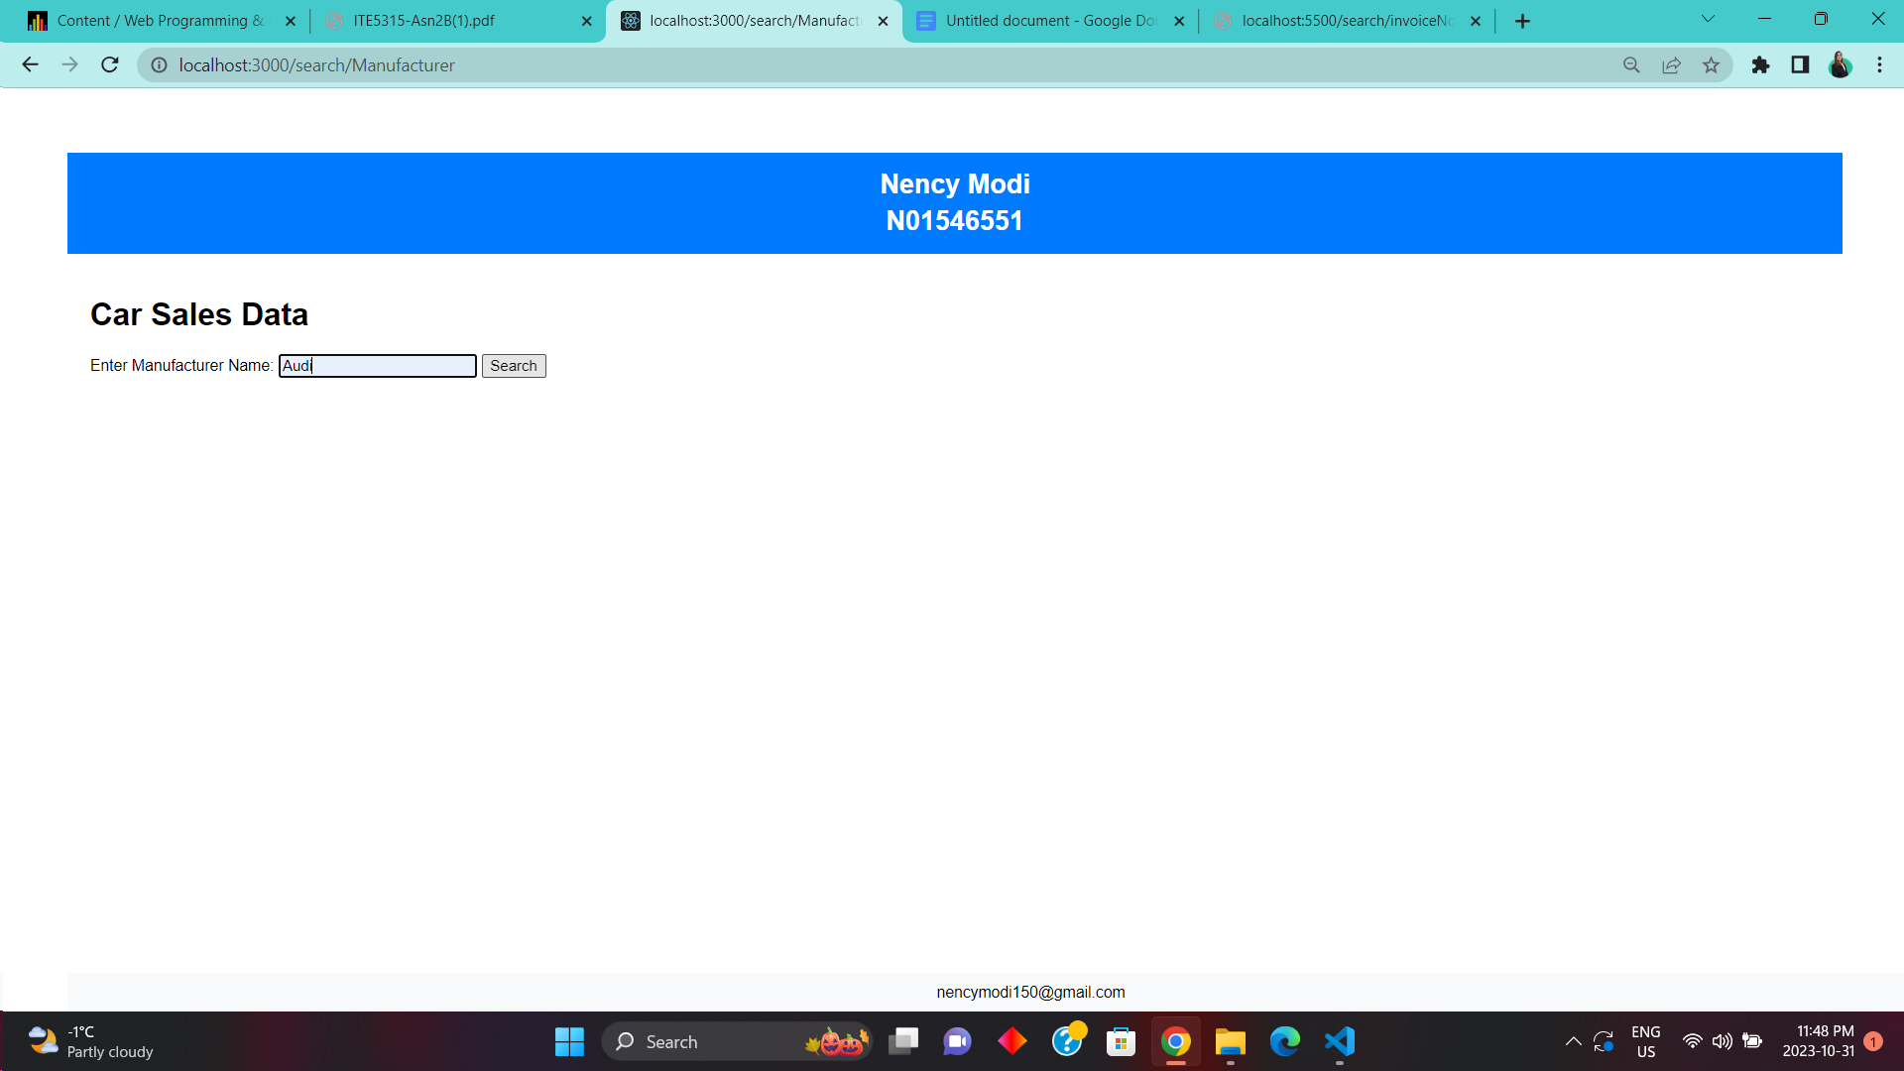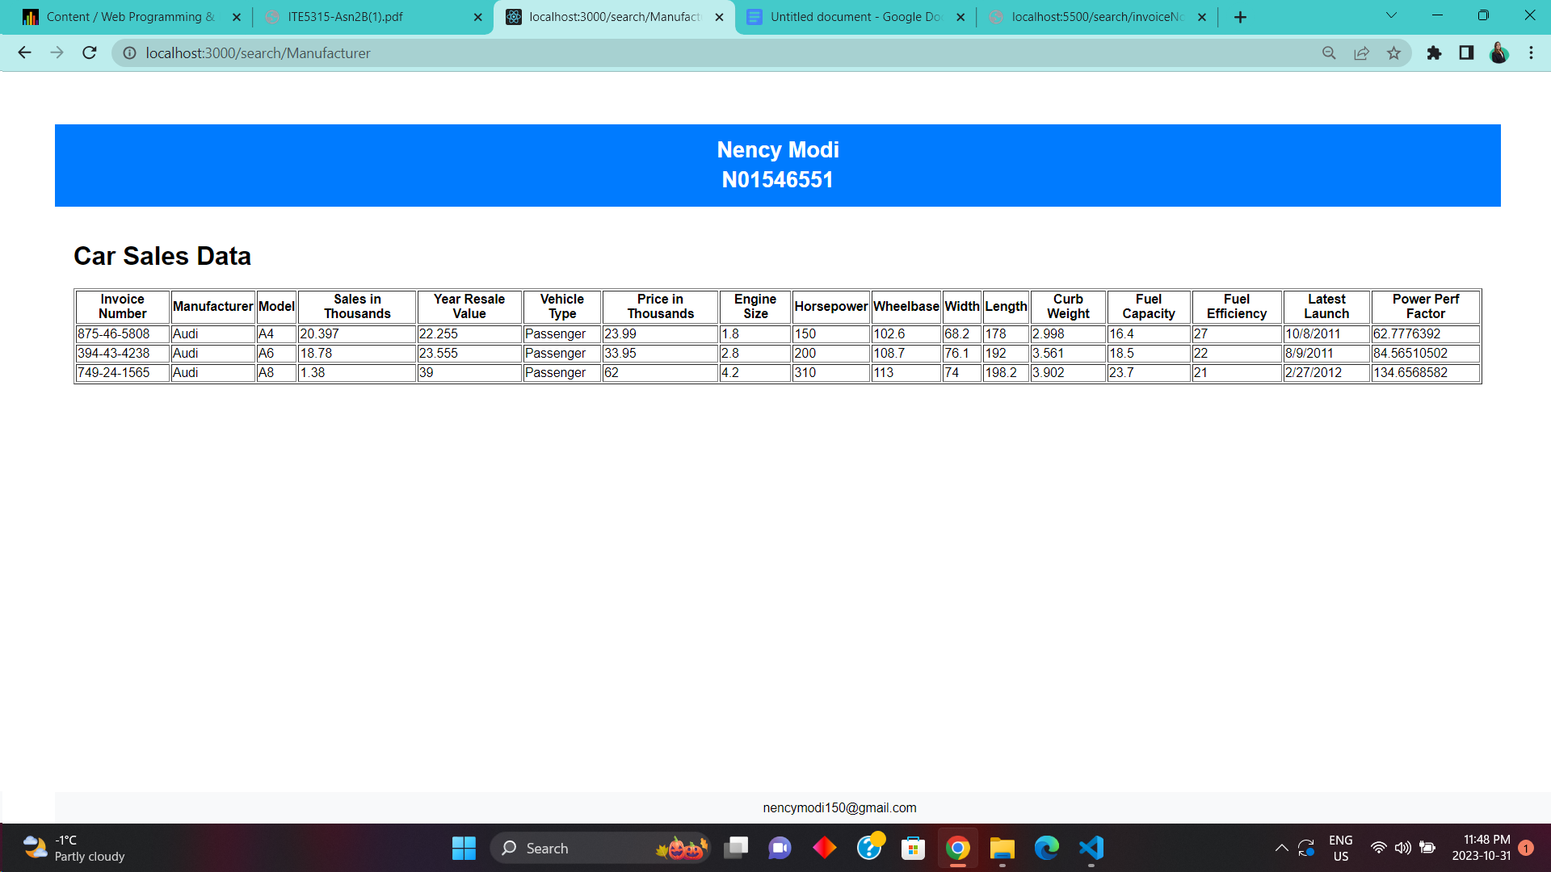

Step 7:

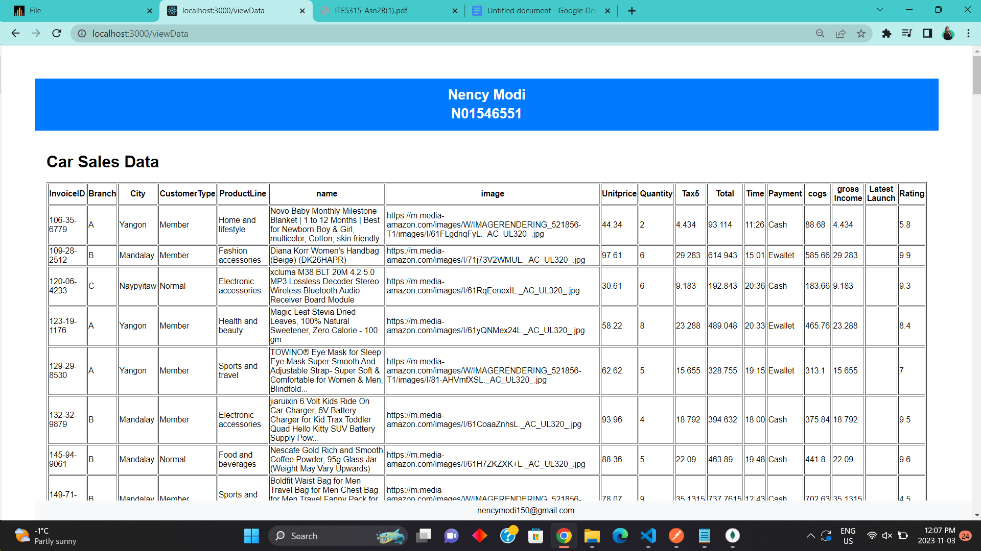

Step 8:

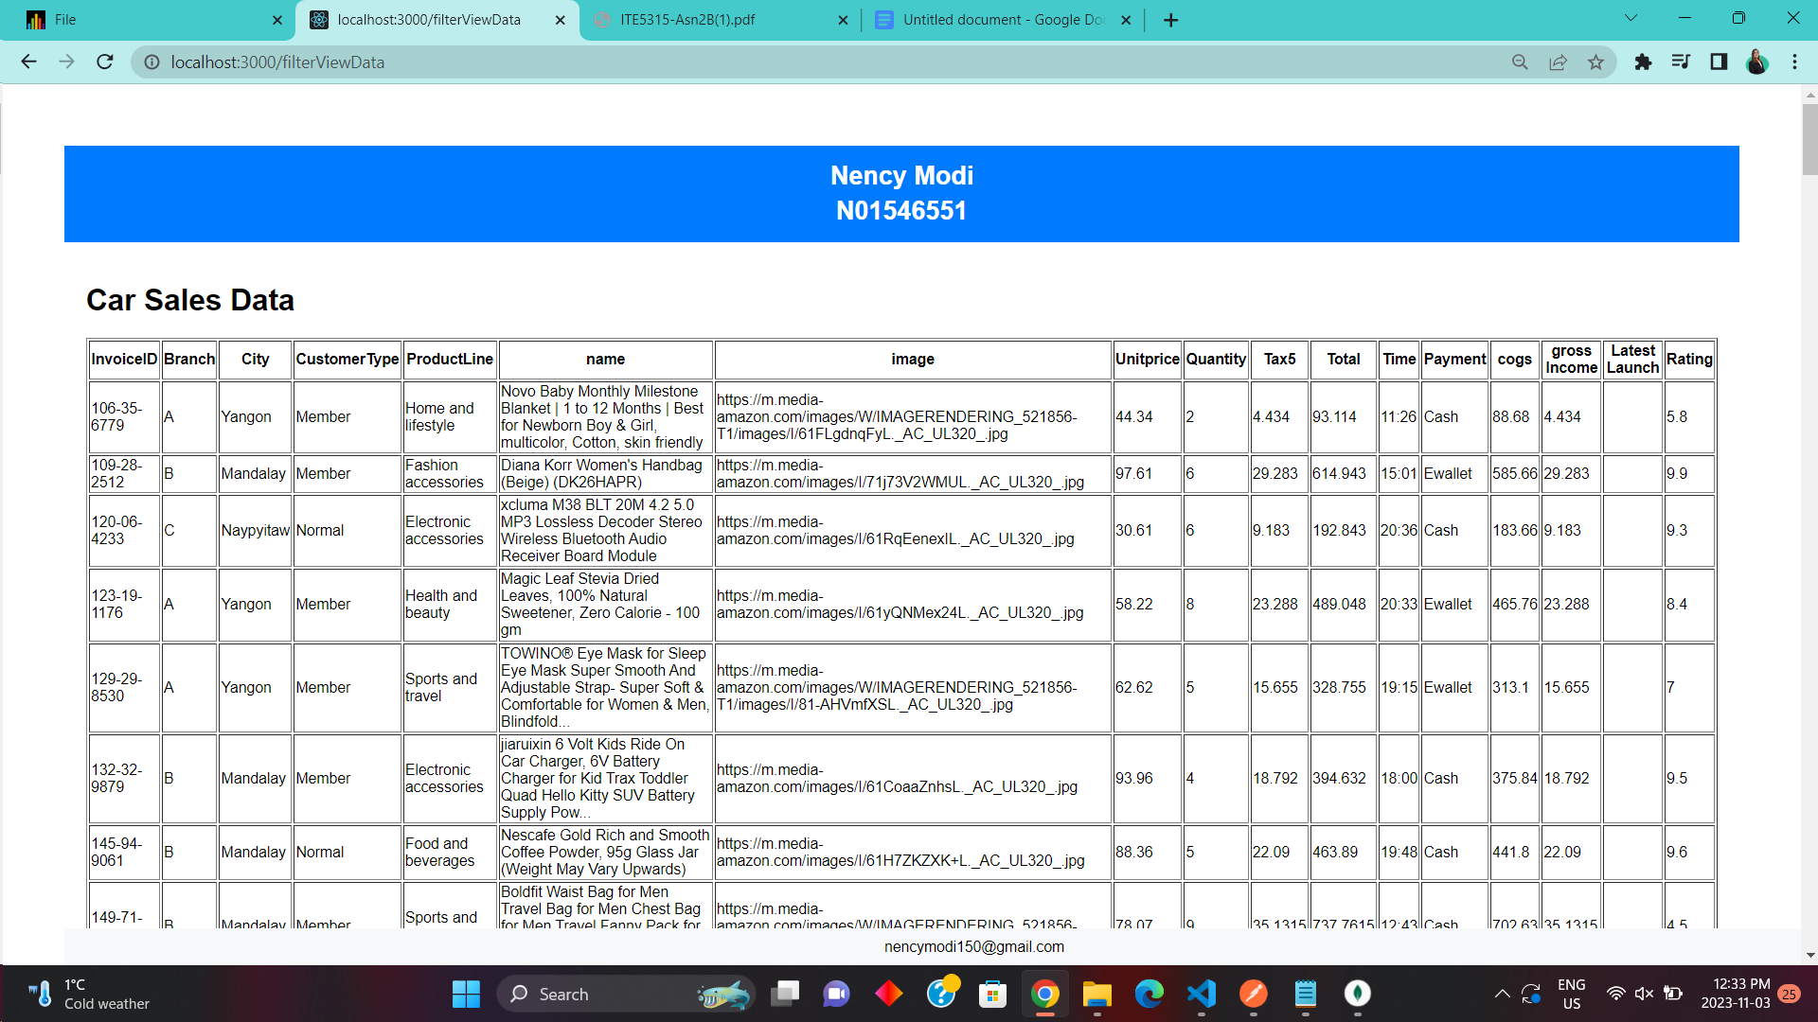

Step 9: