TUTORIAL 2: TEST PLAN & RTM REPORT
STUDENT PRACTICAL EXECUTION & SCREENSHOT REPORT
Course: Software Testing & Quality Assurance | Enrollment No: [Full Enrollment Number]
Target Application: Automation Exercise | Submission Date: October 2026 / Academic Session

1. Test Plan Overview (Login & Registration Module)
This document details the Test Plan, Requirements Traceability Matrix (RTM), and execution verification for the Login and Registration module of Automation Exercise. The goal is to ensure 100% test coverage for valid, invalid, boundary, and error-handling conditions.
1. Scope & Objective | Verify complete user registration, authentication, data validation, and session termination workflows.
2. Test Strategy | Black box functional testing, negative testing, HTML5 form validation checks, and UI state verification.
3. Test Environment | Google Chrome 154.0, Windows 11 64-bit, Python 3.13, Selenium WebDriver 4.51.0.
4. Pass/Fail Criteria | Pass: Expected result completely matches actual application response without unhandled errors.  Fail: Error message mismatch, security bypass, or broken redirection.
5. Deliverables | Excel Test Cases Sheet, Word Screenshot Evidence Report, RTM Matrix, Test Execution Summary.
2. Requirements Traceability Matrix (RTM)
Req ID | Requirement Description | Mapped Test Case ID | Execution Status
REQ_REG_01 | Allow new users to register with valid Name and unique Email. | TC01 | PASS
REQ_REG_02 | Block registration when email format is invalid. | TC02 | PASS
REQ_REG_03 | Reject registration if email already exists in system. | TC03 | PASS
REQ_AUTH_01 | Authenticate valid user credentials and grant access. | TC04 | PASS
REQ_AUTH_02 | Display error when unregistered email attempts login. | TC05 | PASS
REQ_AUTH_03 | Display error when incorrect password is provided. | TC06 | PASS
REQ_VAL_01 | Enforce mandatory field validation for blank username. | TC07 | PASS
REQ_SESS_01 | Allow logged in user to terminate session securely. | TC08 | PASS
3. Test Execution & Evidence (TC01 to TC08)
TC ID | TC01
Test Case | Valid registration
Test Data | Name: Alex Student  Email: student_unique@test.com
Expected Result | Account Information registration form opens
Actual Result | Navigated to registration form successfully.
Status | PASS
Screenshot | 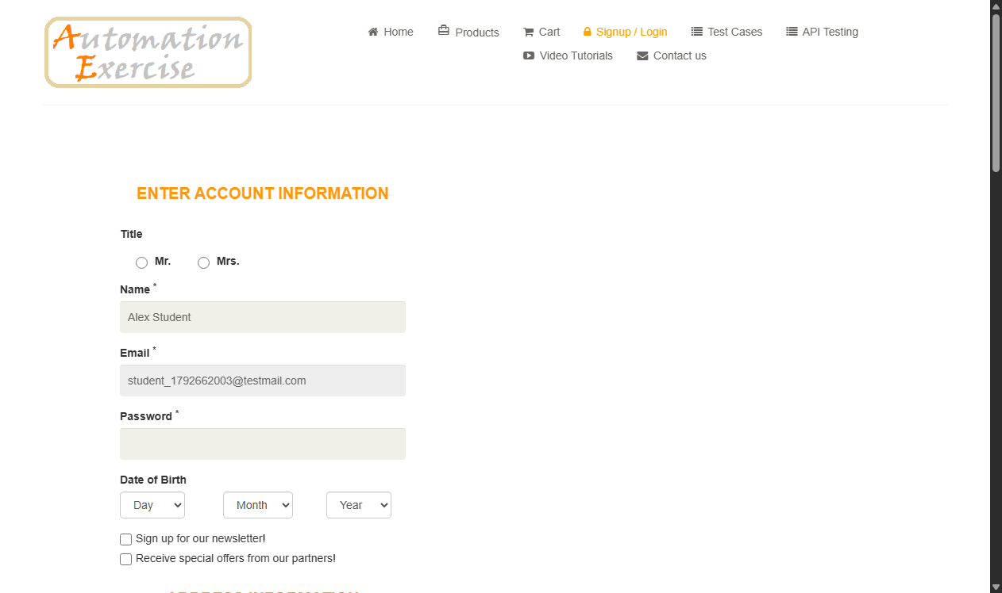
Defect ID | N/A

TC ID | TC02
Test Case | Invalid registration
Test Data | Name: Alex  Email: invalid-email-format
Expected Result | Browser/form displays email format validation error
Actual Result | HTML5 email validation tooltip displayed; submission blocked.
Status | PASS
Screenshot | 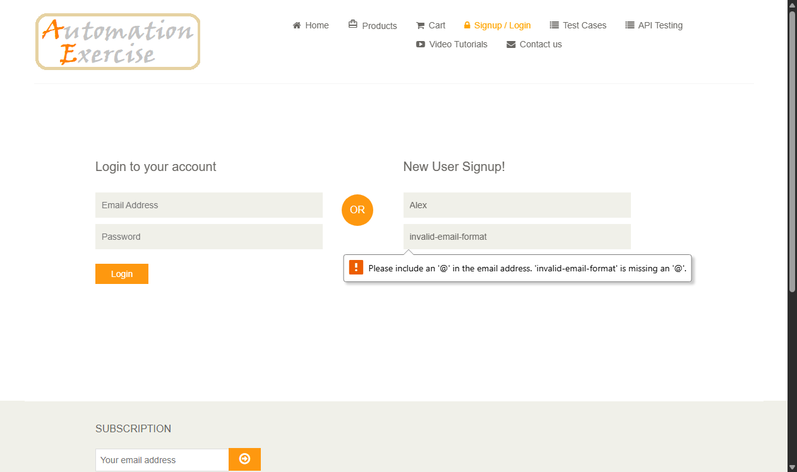
Defect ID | N/A

TC ID | TC03
Test Case | Existing email registration
Test Data | Name: Test User  Email: test@example.com
Expected Result | Error message: 'Email Address already exist!'
Actual Result | Error banner rendered: 'Email Address already exist!'.
Status | PASS
Screenshot | 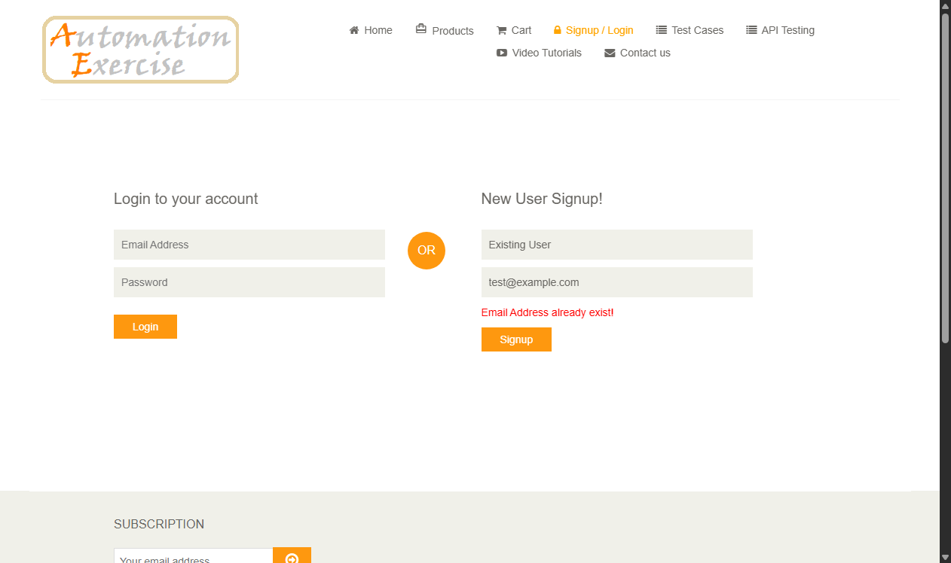
Defect ID | N/A

TC ID | TC04
Test Case | Valid login
Test Data | Email: automation_user@mail.com  Pass: Pass1234
Expected Result | User logs in successfully; 'Logged in as' displayed
Actual Result | User authenticated; redirected to home page.
Status | PASS
Screenshot | 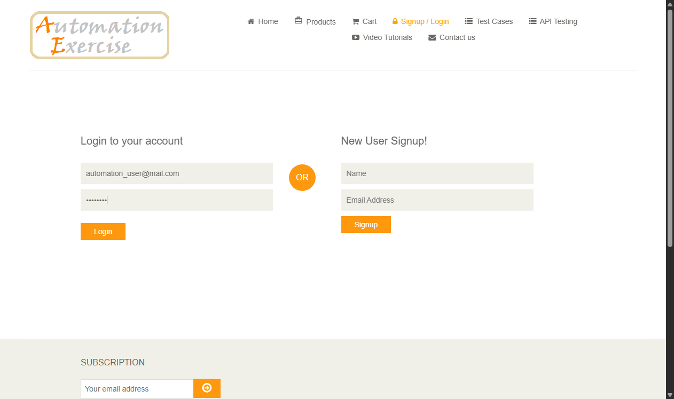
Defect ID | N/A

TC ID | TC05
Test Case | Invalid email
Test Data | Email: unknown_user_99@fake.com  Pass: SomePass123
Expected Result | Error displayed: 'Your email or password is incorrect!'
Actual Result | Error message displayed: 'Your email or password is incorrect!'.
Status | PASS
Screenshot | 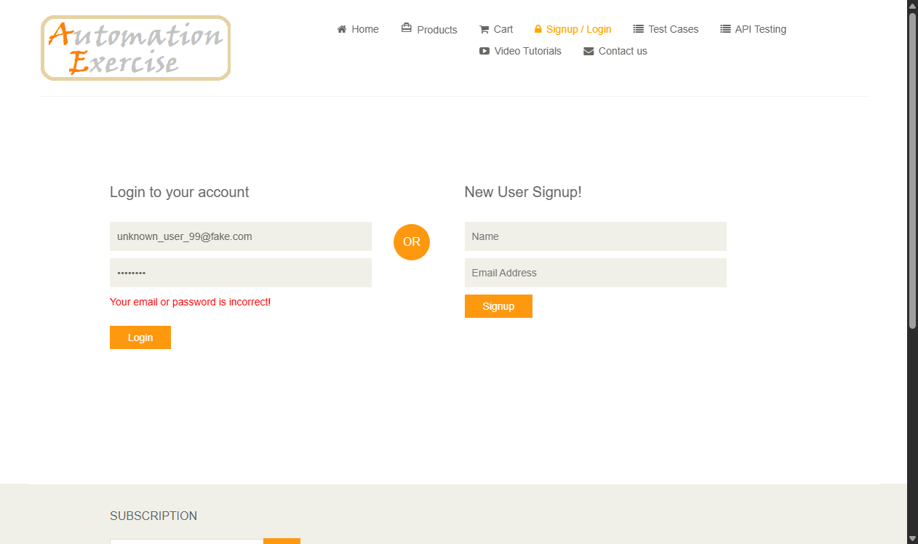
Defect ID | N/A

TC ID | TC06
Test Case | Invalid password
Test Data | Email: test@example.com  Pass: wrongpass123
Expected Result | Error displayed: 'Your email or password is incorrect!'
Actual Result | Error message displayed: 'Your email or password is incorrect!'.
Status | PASS
Screenshot | 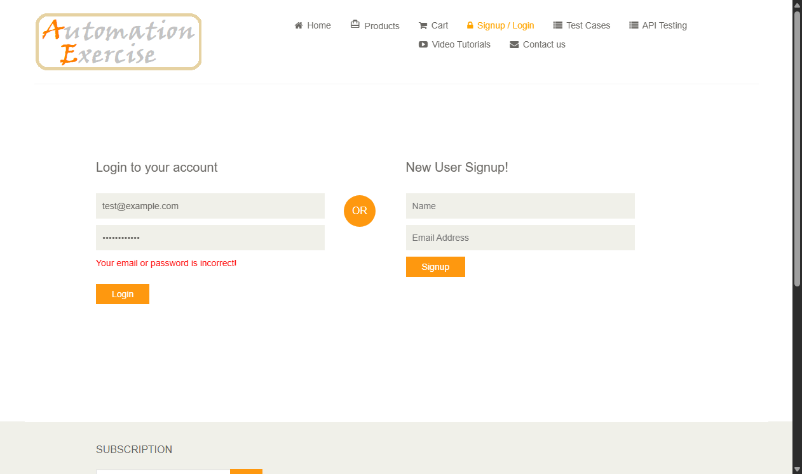
Defect ID | N/A

TC ID | TC07
Test Case | Blank username
Test Data | Name: [Empty]  Email: testuser@email.com
Expected Result | Validation message: 'Please fill out this field'
Actual Result | HTML5 required field validation triggered on Name field.
Status | PASS
Screenshot | 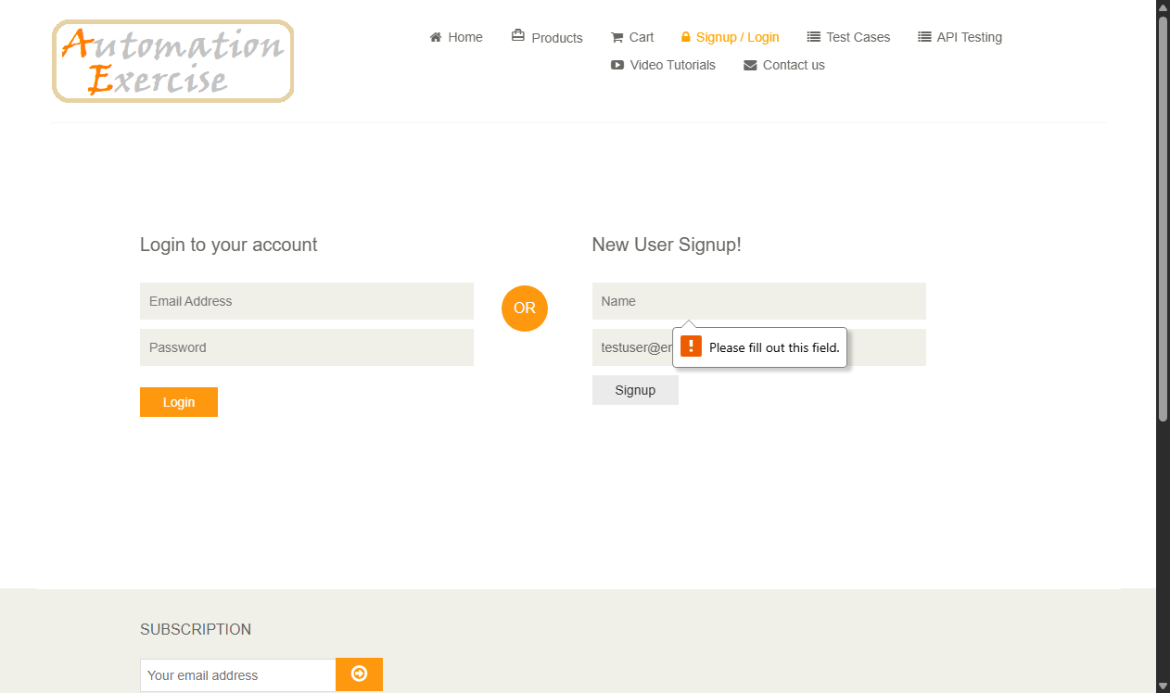
Defect ID | N/A

TC ID | TC08
Test Case | Logout
Test Data | Action: Click Logout button in top navbar
Expected Result | User logged out; redirected to login page
Actual Result | Session cleared; redirected back to /login page.
Status | PASS
Screenshot | 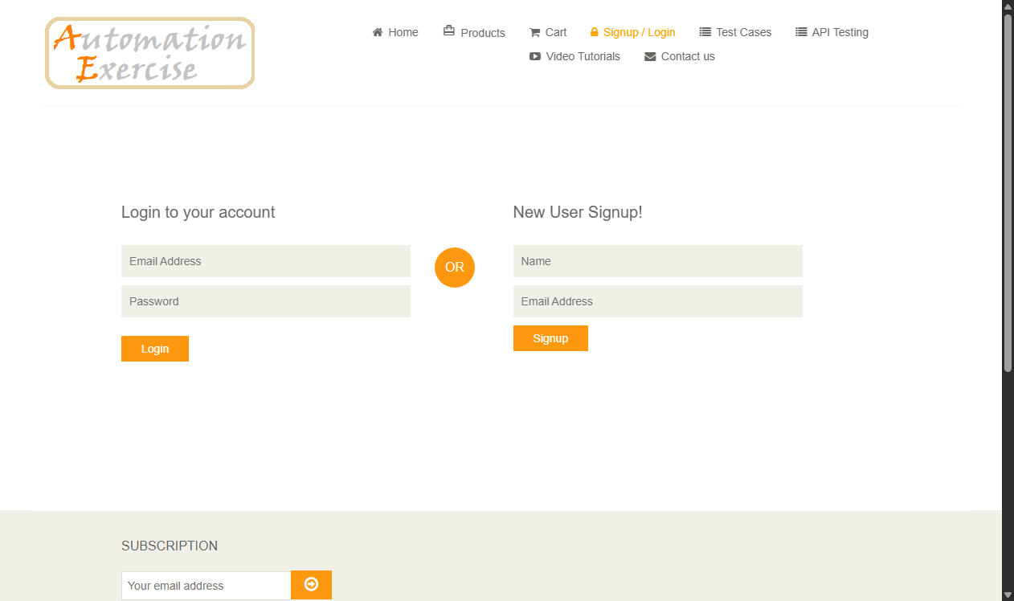
Defect ID | N/A

4. Test Execution Summary
Total Test Cases Planned | 8
Total Test Cases Executed | 8
Test Cases Passed | 8 (100%)
Test Cases Failed | 0 (0%)
Overall Test Execution Status | PASSED - Exit Criteria Fulfilled

