TUTORIAL 3: REQUIREMENT REVIEW & INSPECTION
STUDENT PRACTICAL EXECUTION & SCREENSHOT REPORT
Course: Software Testing & Quality Assurance | Enrollment No: [Full Enrollment Number]
Target Application: DemoBlaze (https://www.demoblaze.com) | Submission Date: October 2026 / Academic Session

1. Practical Purpose & Requirements Inspection
This practical focuses on Requirements Review, Walkthrough, and Inspection for the Product and Cart module on DemoBlaze. Before executing test cases, requirements are evaluated for ambiguity, testability, and clarity. Then, 7 core test cases covering product browsing, details inspection, cart addition, verification, and removal are executed with evidence.
2. Requirement Review Table
Requirement Specification | Clear / Unclear | Inspection Rationale & Analysis
User can add product to cart | Clear | Testable: Expected behavior is well defined (click 'Add to cart' -> product added to cart).
Website should be fast | Unclear | Ambiguous: No quantitative response time (e.g., '< 2 seconds under 100 concurrent users') is defined.
Product details must display title, price, and description | Clear | Testable: UI inspection can assert exact presence of title, price tag in USD, and specifications.
Cart total must accurately calculate sum of items | Clear | Testable: Mathematical verification (Sum = Price * Qty) can be checked deterministically.
Shopping cart should be user friendly | Unclear | Subjective: 'User friendly' lacks measurable UX criteria or standard heuristic benchmarks.
User can remove items from cart and update total | Clear | Testable: Clicking 'Delete' must remove item row and decrement total amount accordingly.
3. Test Execution & Evidence (TC01 to TC07)
TC ID | TC01
Test Case | View products
Test Data | URL: https://www.demoblaze.com
Expected Result | Product cards render with image, title, price, and description
Actual Result | Homepage loads; 9 product cards display with images and prices.
Status | PASS
Screenshot | 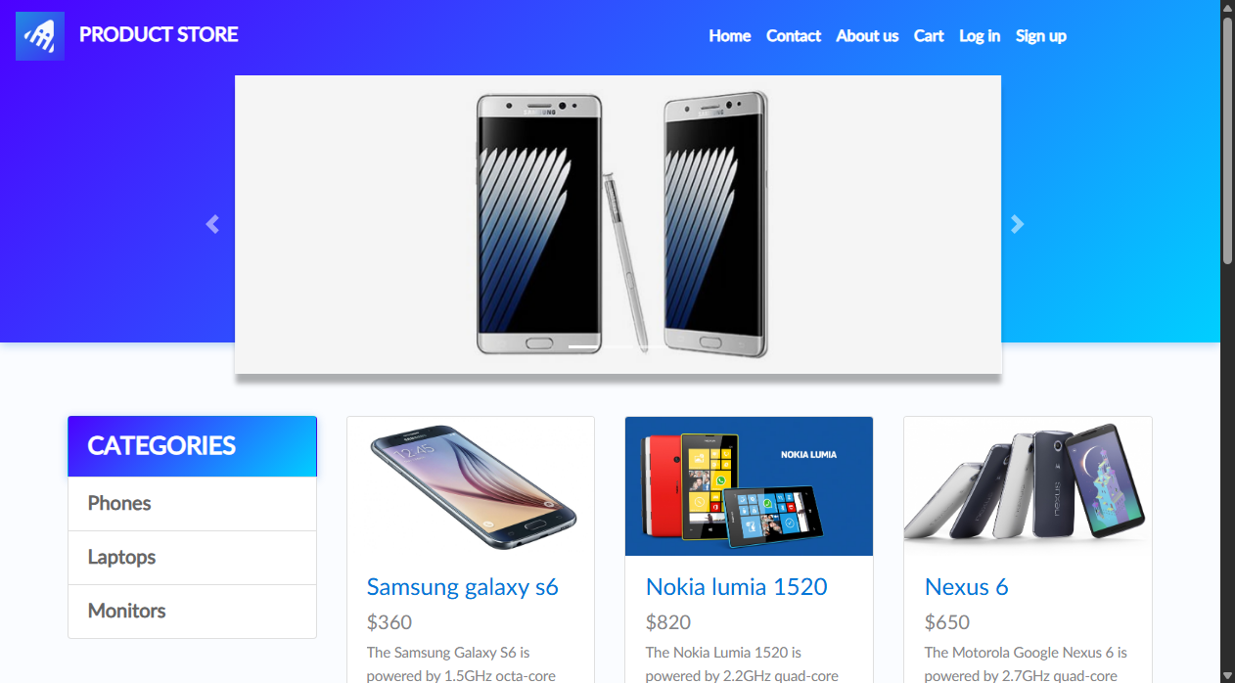
Defect ID | N/A

TC ID | TC02
Test Case | Select product
Test Data | Product: Samsung galaxy s6
Expected Result | Navigated to product detail page (prod.html?idp_=1)
Actual Result | Product page opened showing full specifications.
Status | PASS
Screenshot | 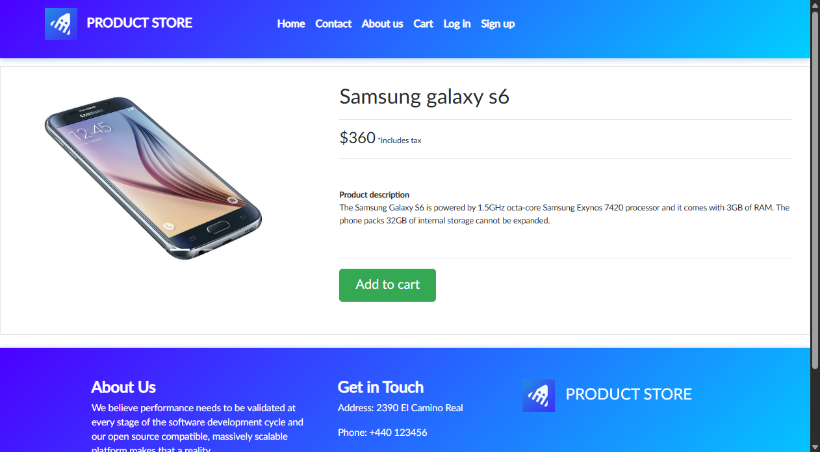
Defect ID | N/A

TC ID | TC03
Test Case | View product details
Test Data | Element: #tbodyid
Expected Result | Title, price ($360), description, and Add to cart visible
Actual Result | All product attributes displayed correctly.
Status | PASS
Screenshot
Defect ID | N/A

TC ID | TC04
Test Case | Add product
Test Data | Button: 'Add to cart'
Expected Result | Browser alert confirms 'Product added'; item saved in session
Actual Result | Alert 'Product added' displayed and handled cleanly.
Status | PASS
Screenshot | 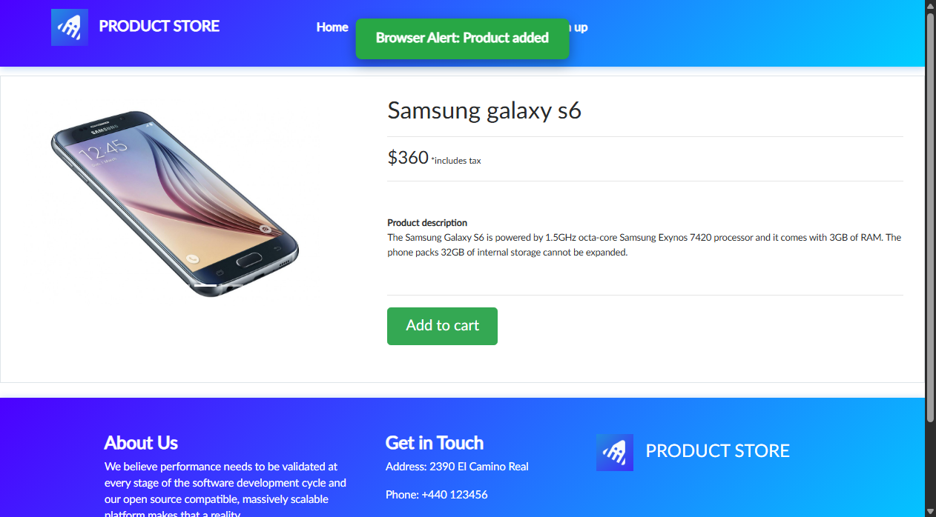
Defect ID | N/A

TC ID | TC05
Test Case | Open cart
Test Data | Link: Cart (#cartur)
Expected Result | Navigated to /cart.html; cart table rendered
Actual Result | Cart page opens displaying product table headers.
Status | PASS
Screenshot | 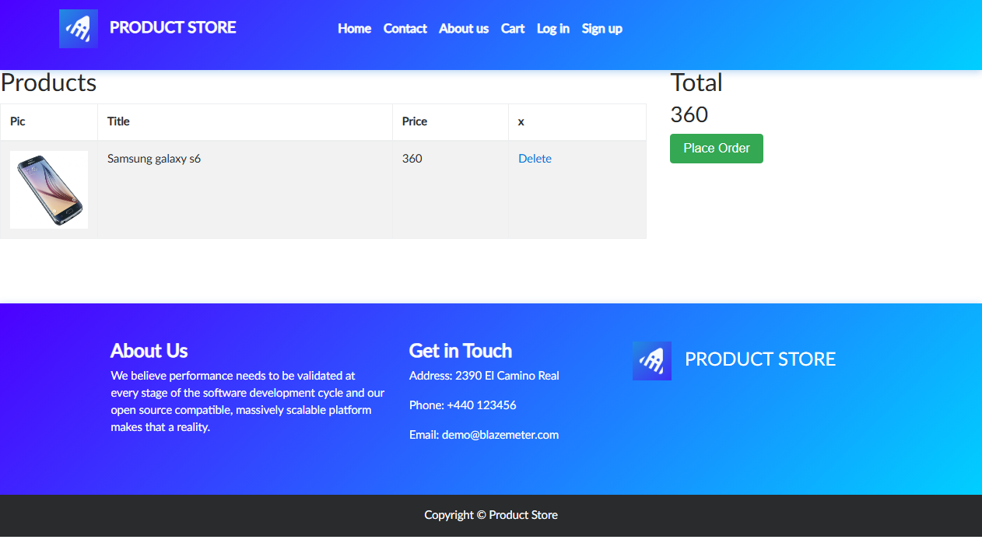
Defect ID | N/A

TC ID | TC06
Test Case | Verify product in cart
Test Data | Table: #tbodyid
Expected Result | Item 'Samsung galaxy s6' listed with price 360
Actual Result | Product verified in cart with correct title, price, and delete option.
Status | PASS
Screenshot
Defect ID | N/A

TC ID | TC07
Test Case | Remove product
Test Data | Action: Delete link in cart table
Expected Result | Item removed from table; total price updated to 0
Actual Result | Delete action executed; product removed from cart.
Status | PASS
Screenshot | 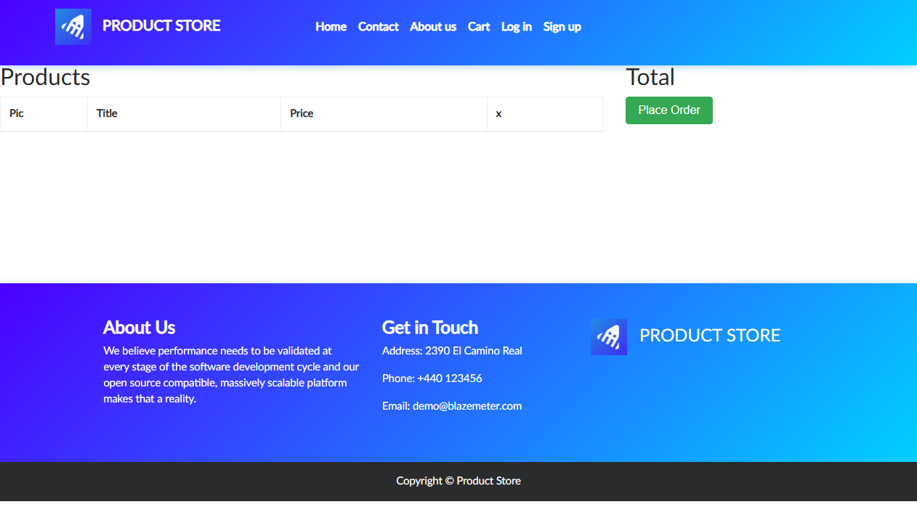
Defect ID | N/A

