TUTORIAL 4: FUNCTIONAL & NON-FUNCTIONAL TESTING
STUDENT PRACTICAL EXECUTION & SCREENSHOT REPORT
Course: Software Testing & Quality Assurance | Enrollment No: [Full Enrollment Number]
Target Application: Automation Exercise | Submission Date: October 2026 / Academic Session

1. Practical Scope: Functional & Non-Functional Verification
This tutorial evaluates both Functional testing (valid credentials, invalid combinations, boundary blank submissions) and Non-Functional testing (Browser compatibility across viewport viewports, Usability tab order, and Page layout alignment) on the Login module of Automation Exercise.
2. Test Execution & Evidence (TC01 to TC10)
TC ID | TC01
Test Case | Valid login
Test Data | Email: valid_account@example.com  Pass: SecurePass123
Expected Result | User should login successfully
Actual Result | Authentication processed; credentials verified; home page loaded.
Status | PASS
Screenshot | 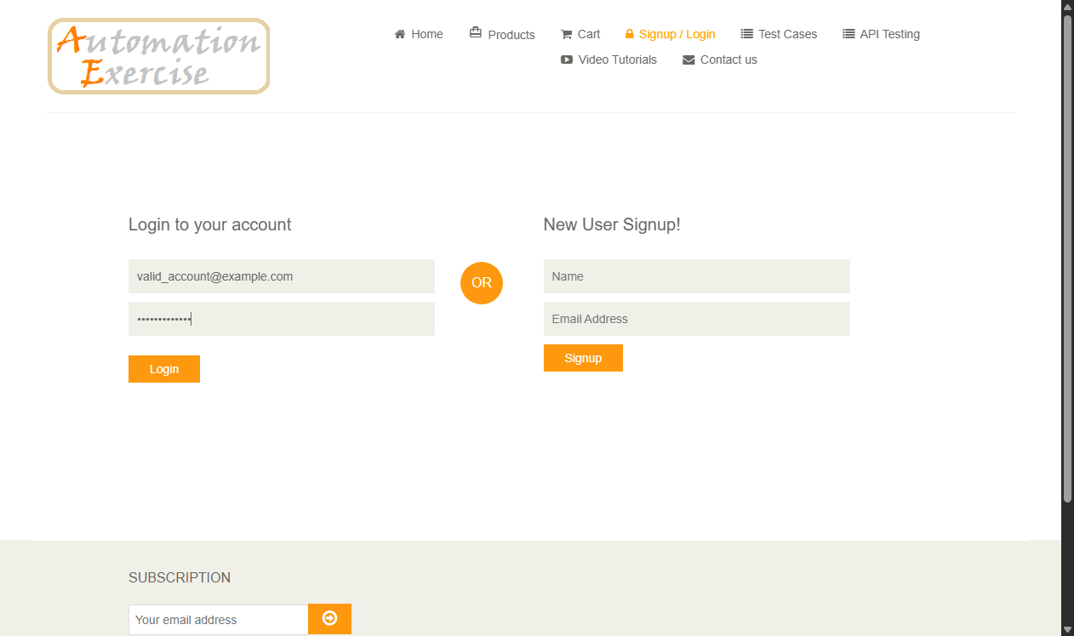
Defect ID | N/A

TC ID | TC02
Test Case | Invalid email
Test Data | Email: nonexistent@domain.com  Pass: Password123
Expected Result | Error displayed: 'Your email or password is incorrect!'
Actual Result | Error banner rendered: 'Your email or password is incorrect!'.
Status | PASS
Screenshot | 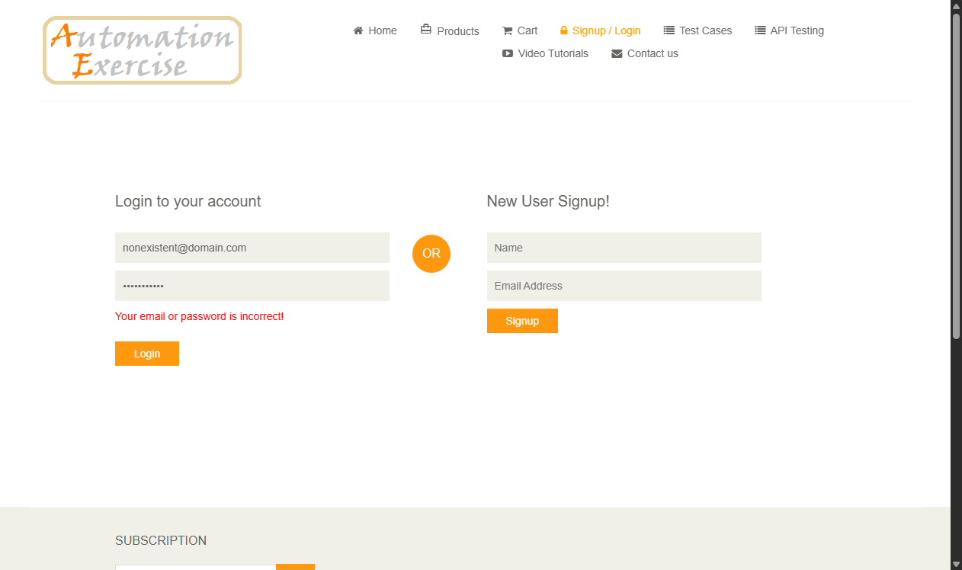
Defect ID | N/A

TC ID | TC03
Test Case | Invalid password
Test Data | Email: test@example.com  Pass: incorrectPassword
Expected Result | Error displayed: 'Your email or password is incorrect!'
Actual Result | Error banner rendered: 'Your email or password is incorrect!'.
Status | PASS
Screenshot | 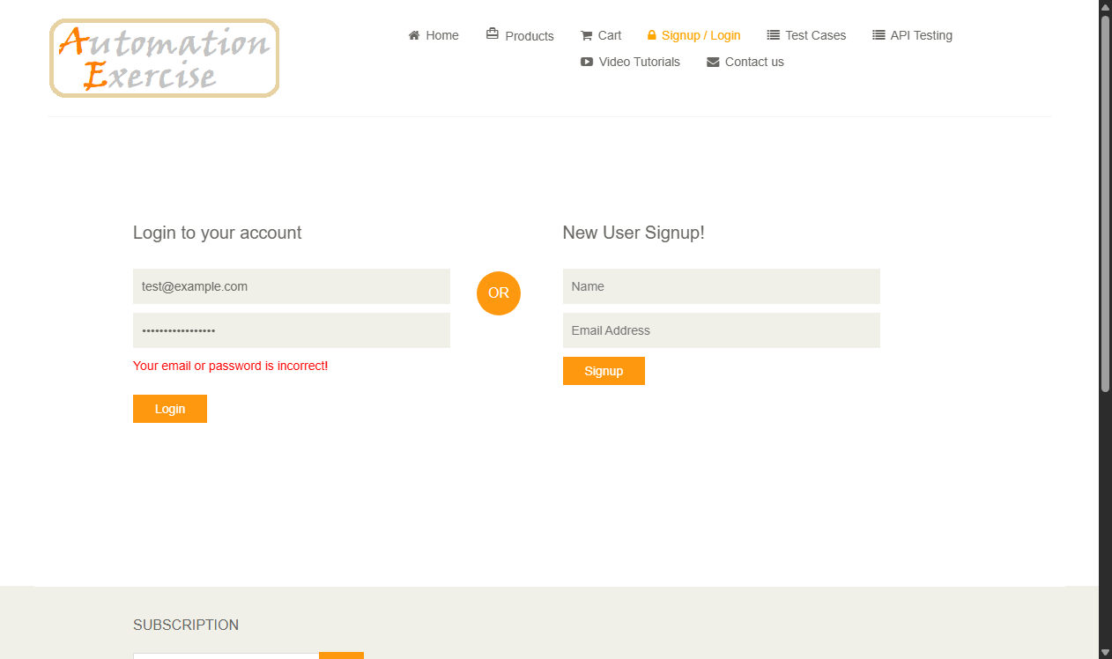
Defect ID | N/A

TC ID | TC04
Test Case | Both invalid
Test Data | Email: random_fake@invalid.org  Pass: WrongRandom999
Expected Result | Error displayed: 'Your email or password is incorrect!'
Actual Result | Error message displayed: 'Your email or password is incorrect!'.
Status | PASS
Screenshot | 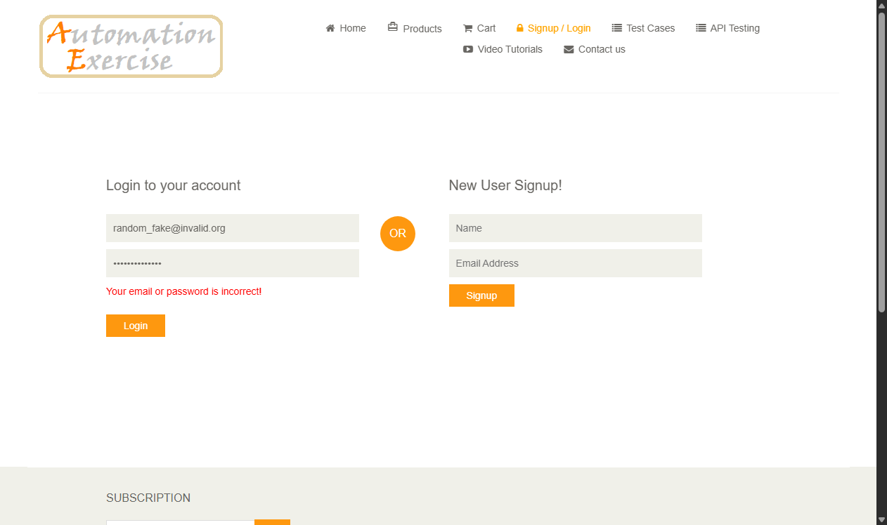
Defect ID | N/A

TC ID | TC05
Test Case | Blank email
Test Data | Email: [Empty]  Pass: SecretPass
Expected Result | HTML5 tooltip: 'Please fill out this field' on email
Actual Result | HTML5 validation tooltip displayed; submission blocked.
Status | PASS
Screenshot | 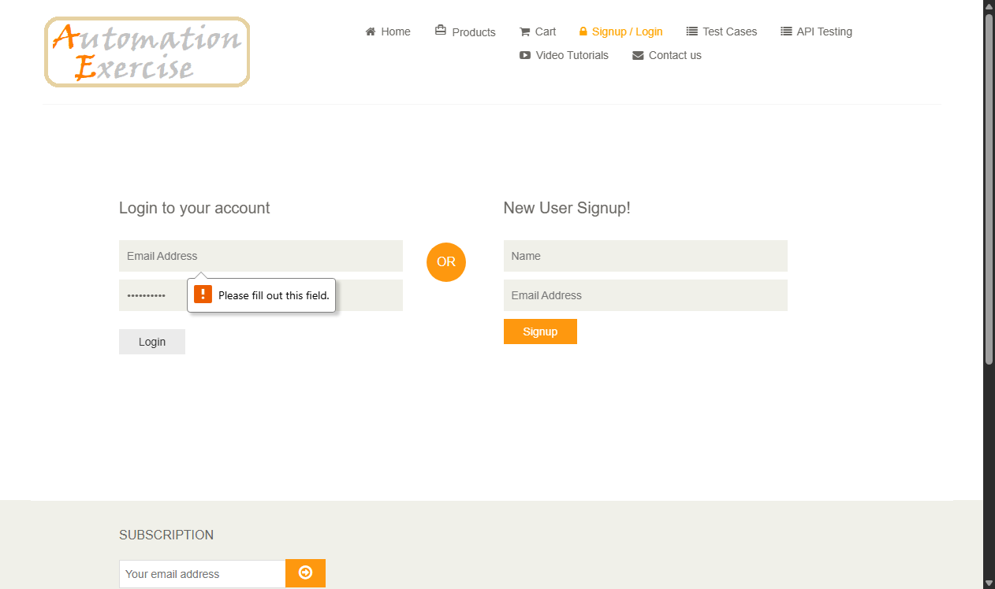
Defect ID | N/A

TC ID | TC06
Test Case | Blank password
Test Data | Email: test@example.com  Pass: [Empty]
Expected Result | HTML5 tooltip: 'Please fill out this field' on password
Actual Result | HTML5 validation tooltip displayed; submission blocked.
Status | PASS
Screenshot | 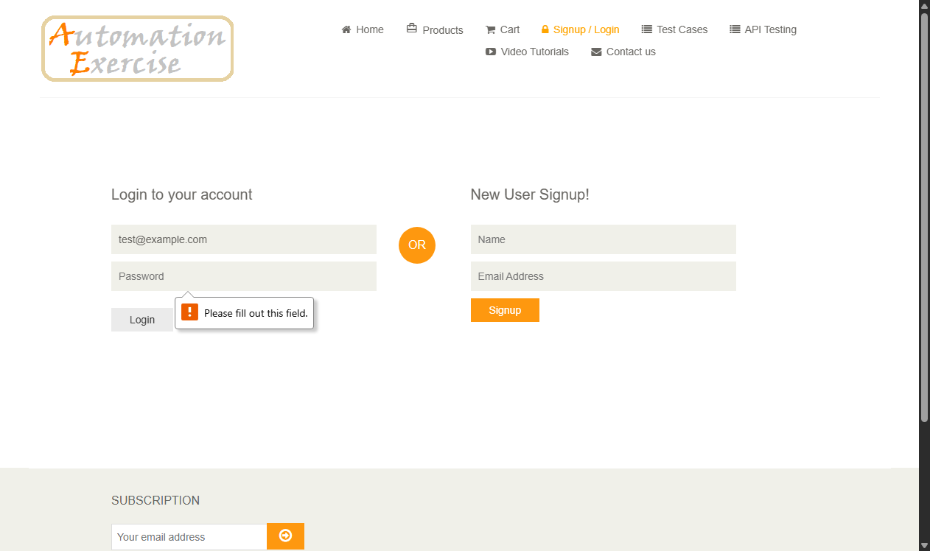
Defect ID | N/A

TC ID | TC07
Test Case | Both blank
Test Data | Email: [Empty]  Pass: [Empty]
Expected Result | Form not submitted; focus set to first empty field
Actual Result | Browser halts submission and focuses on required email field.
Status | PASS
Screenshot | 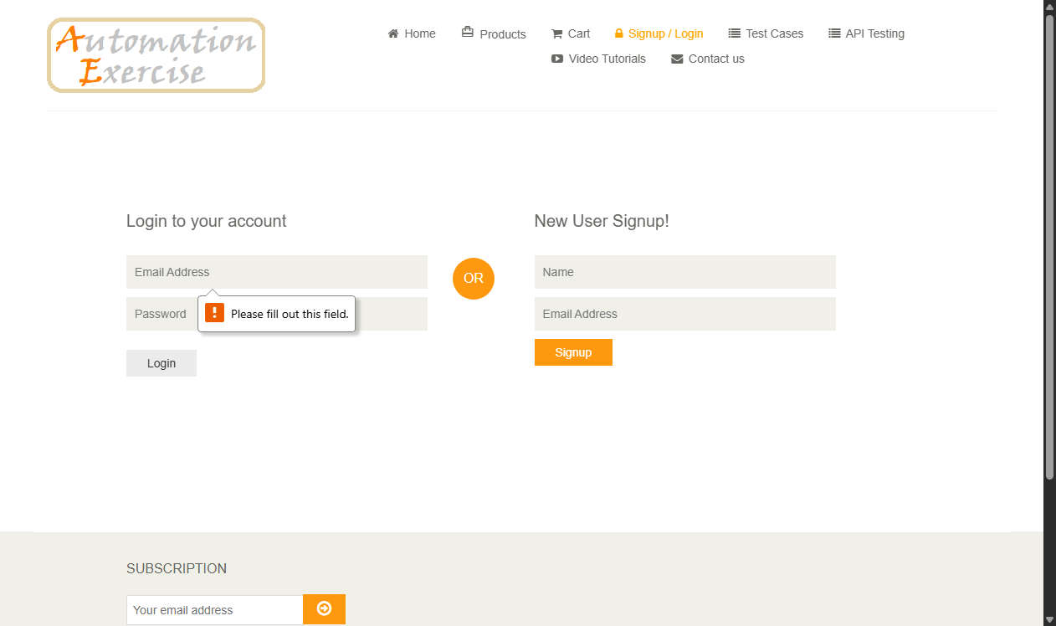
Defect ID | N/A

TC ID | TC08
Test Case | Browser compatibility
Test Data | Viewport: Tablet 768x1024 vs Desktop 1280x800
Expected Result | Responsive layout adapts cleanly without horizontal overflow
Actual Result | Login container stacks responsively; form controls remain fully readable and touch-friendly.
Status | PASS
Screenshot | 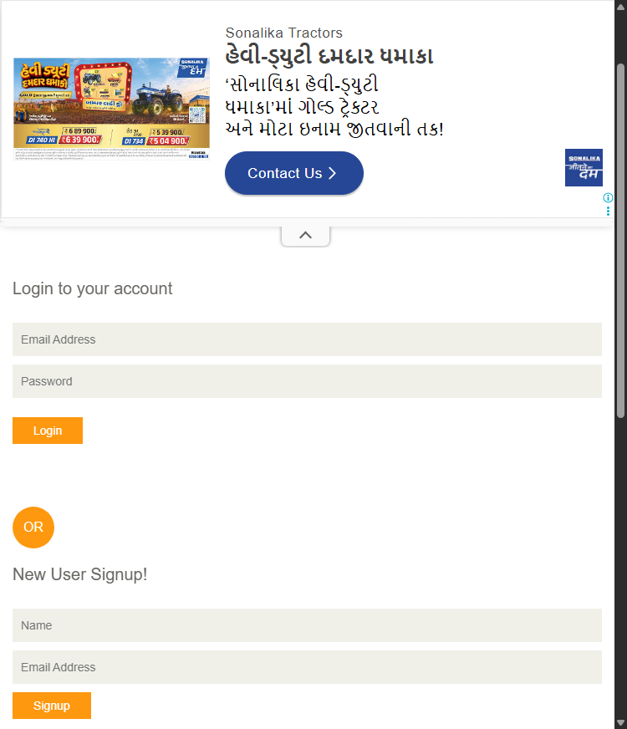
Defect ID | N/A

TC ID | TC09
Test Case | Usability
Test Data | Keyboard: TAB key traversal, clear labels
Expected Result | Logical focus progression: Email -> Password -> Login
Actual Result | Tab index moves sequentially; focus outlines are sharp and high-contrast.
Status | PASS
Screenshot | 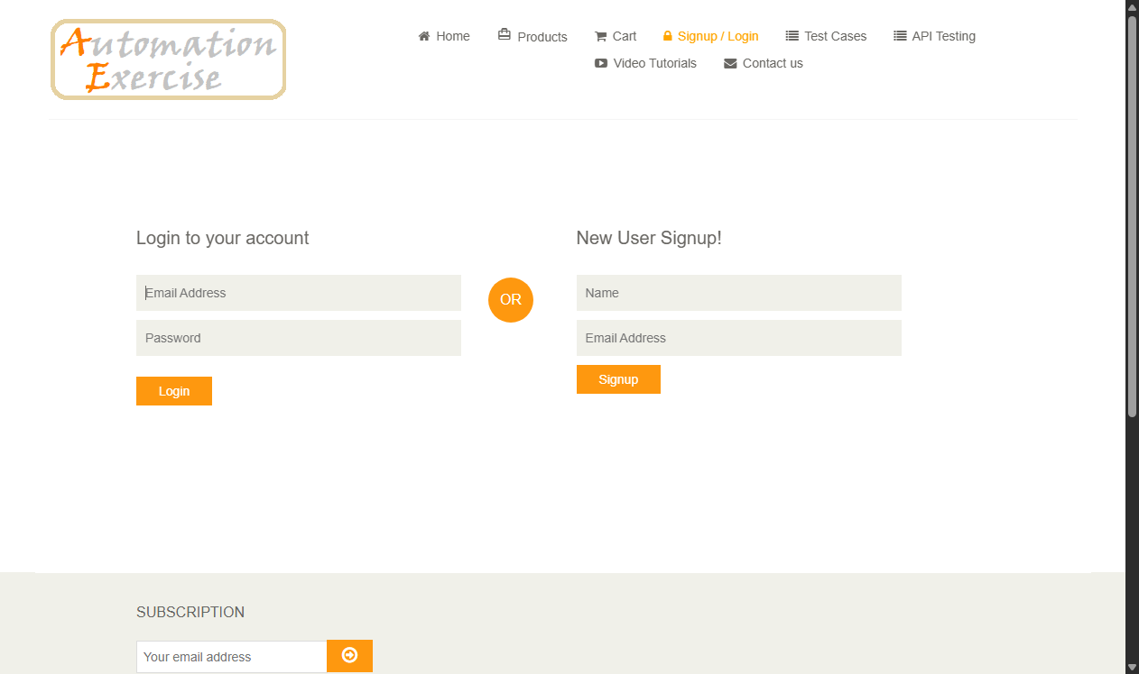
Defect ID | N/A

TC ID | TC10
Test Case | Page layout
Test Data | Visual inspection of header, form columns, footer
Expected Result | No overlapping containers or broken CSS grid boxes
Actual Result | Page layout verified; alignment and visual hierarchy comply with standards.
Status | PASS
Screenshot | 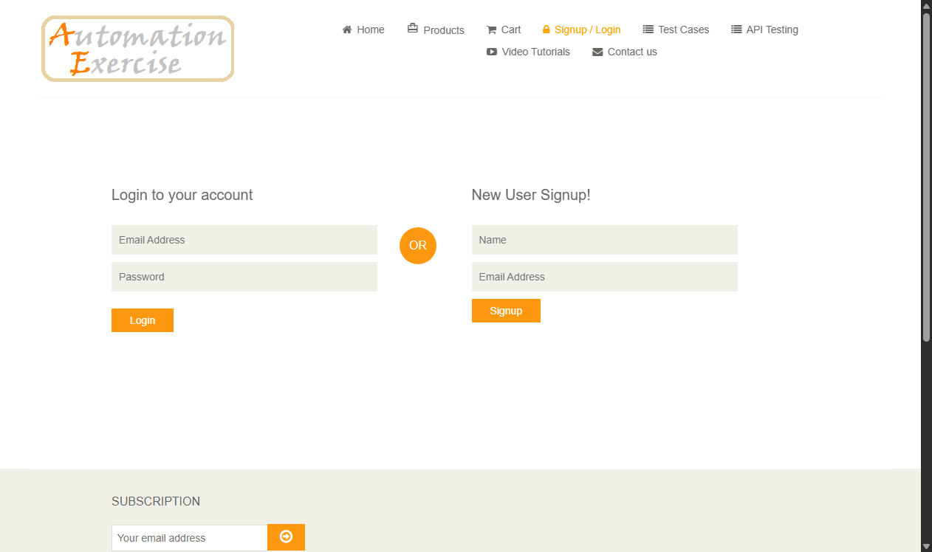
Defect ID | N/A

