TUTORIAL 5: DEFECT IDENTIFICATION & BUG REPORT
STUDENT PRACTICAL EXECUTION & SCREENSHOT REPORT
Course: Software Testing & Quality Assurance | Enrollment No: [Full Enrollment Number]
Target Application: SauceDemo (https://www.saucedemo.com) | Submission Date: October 2026 / Academic Session

1. Practical Overview
This tutorial focuses on identifying actual application defects through systematic manual testing of the SauceDemo e-commerce portal. All core shopping test cases (TC01 to TC08) are executed. An authentic observed defect was identified and formally reported under BUG-001 according to industry standard bug reporting templates.
2. Test Execution & Evidence (TC01 to TC08)
TC ID | TC01
Test Case | Login
Test Data | User: standard_user  Pass: secret_sauce
Expected Result | User successfully logs in to /inventory.html
Actual Result | Authenticated successfully; inventory catalog loaded.
Status | PASS
Screenshot | 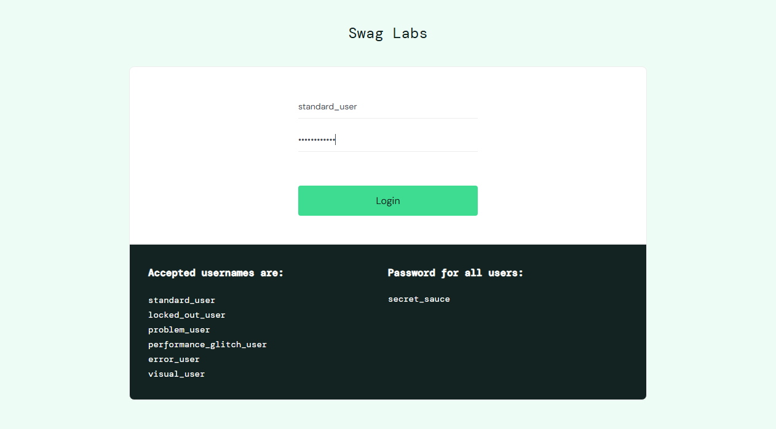
Defect ID | N/A

TC ID | TC02
Test Case | Invalid login
Test Data | User: invalid_user  Pass: wrong_password
Expected Result | Error: 'Epic sadface: Username and password do not match'
Actual Result | Error message rendered as expected.
Status | PASS
Screenshot | 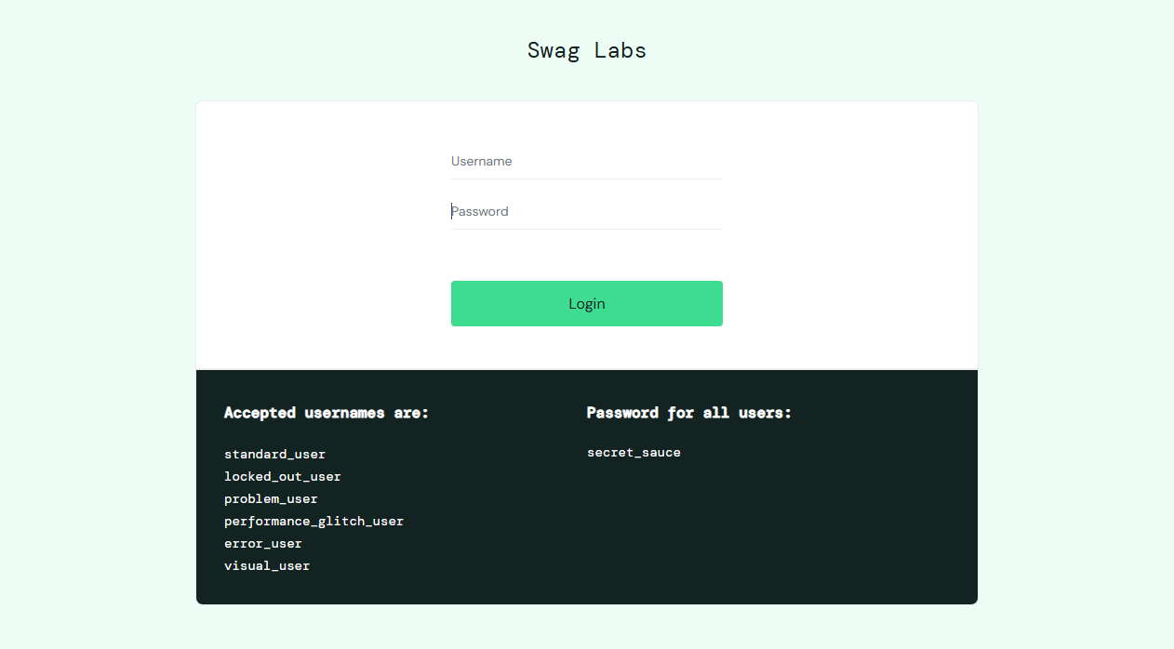
Defect ID | N/A

TC ID | TC03
Test Case | Product display
Test Data | URL: /inventory.html
Expected Result | 6 product items rendered with distinct images and prices
Actual Result | All 6 inventory items displayed properly.
Status | PASS
Screenshot | 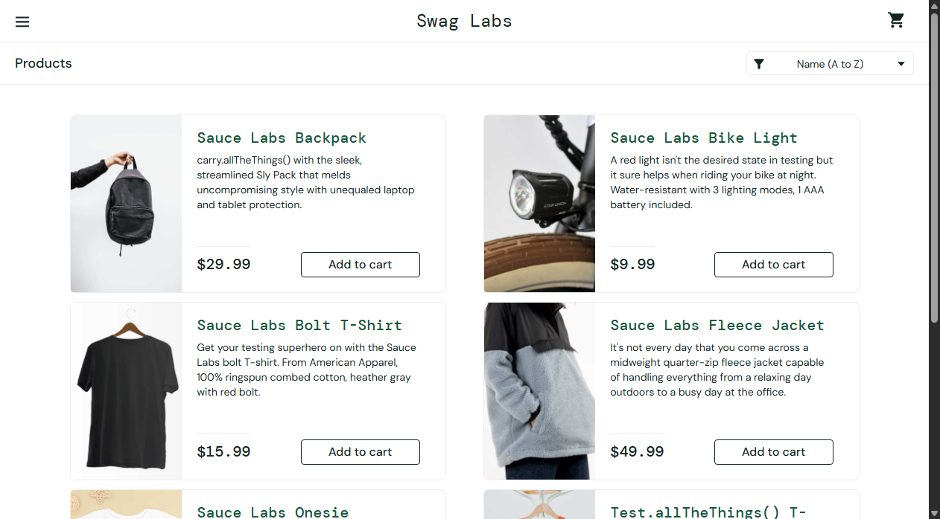
Defect ID | N/A

TC ID | TC04
Test Case | Add to cart
Test Data | Item: sauce-labs-backpack
Expected Result | Button changes to 'Remove'; cart badge shows '1'
Actual Result | Item added to cart; badge updated to 1.
Status | PASS
Screenshot | 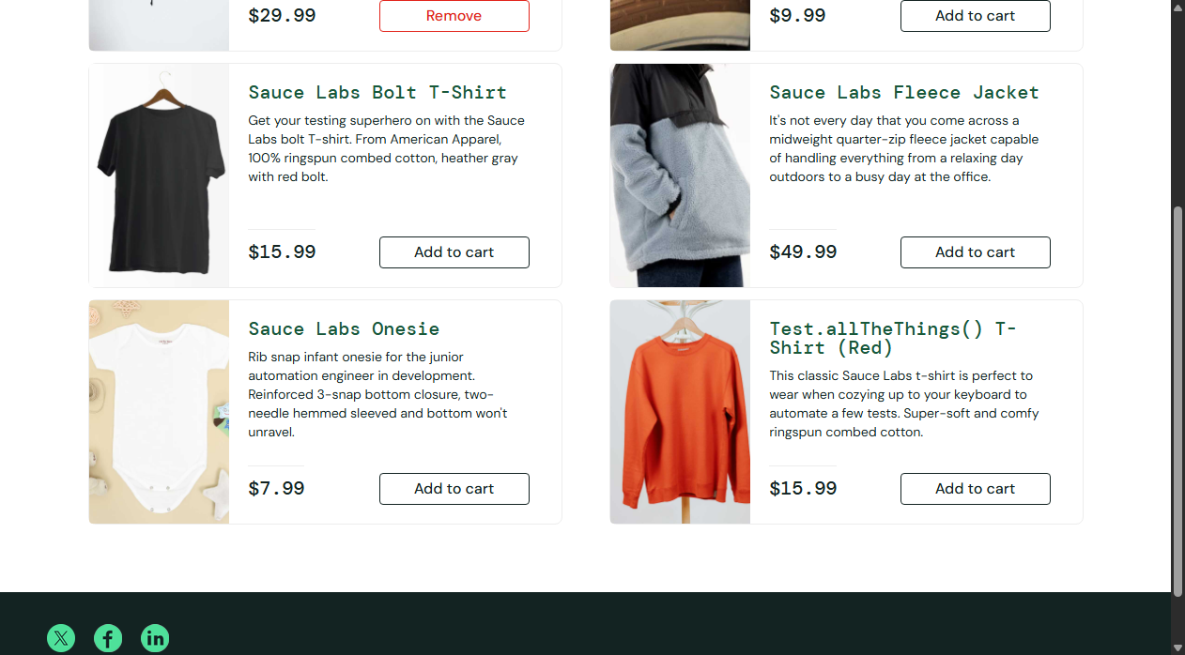
Defect ID | N/A

TC ID | TC05
Test Case | Remove from cart
Test Data | Item: sauce-labs-backpack
Expected Result | Button reverts to 'Add to cart'; badge clears
Actual Result | Item removed; button toggled back.
Status | PASS
Screenshot | 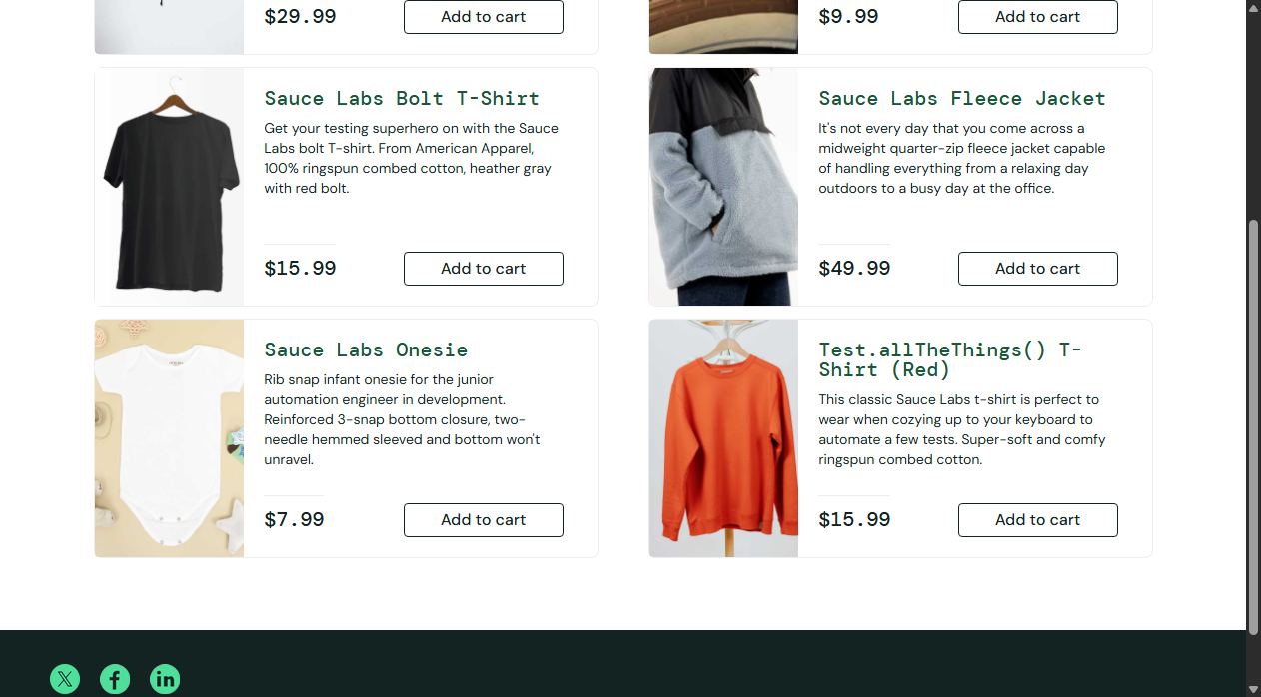
Defect ID | N/A

TC ID | TC06
Test Case | Cart
Test Data | Link: shopping_cart_link
Expected Result | Navigated to /cart.html; added items displayed
Actual Result | Cart page loaded with accurate product line items.
Status | PASS
Screenshot | 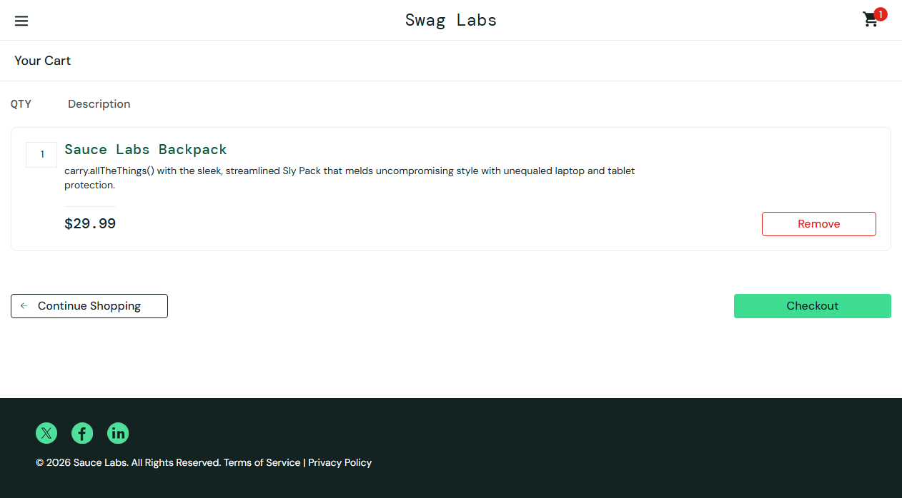
Defect ID | N/A

TC ID | TC07
Test Case | Checkout
Test Data | Name: John Doe  Zip: 12345
Expected Result | Navigated to step two; order totals displayed
Actual Result | Checkout step one completed; navigated to overview.
Status | PASS
Screenshot | 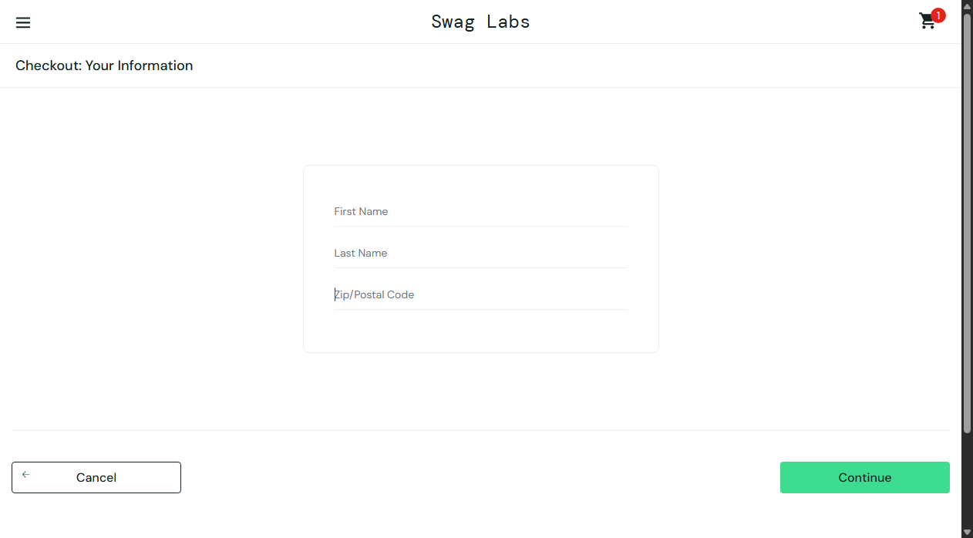
Defect ID | N/A

TC ID | TC08
Test Case | Logout
Test Data | Action: Logout via side menu
Expected Result | User logged out; redirected to login screen
Actual Result | Session destroyed; returned to login page.
Status | PASS
Screenshot | 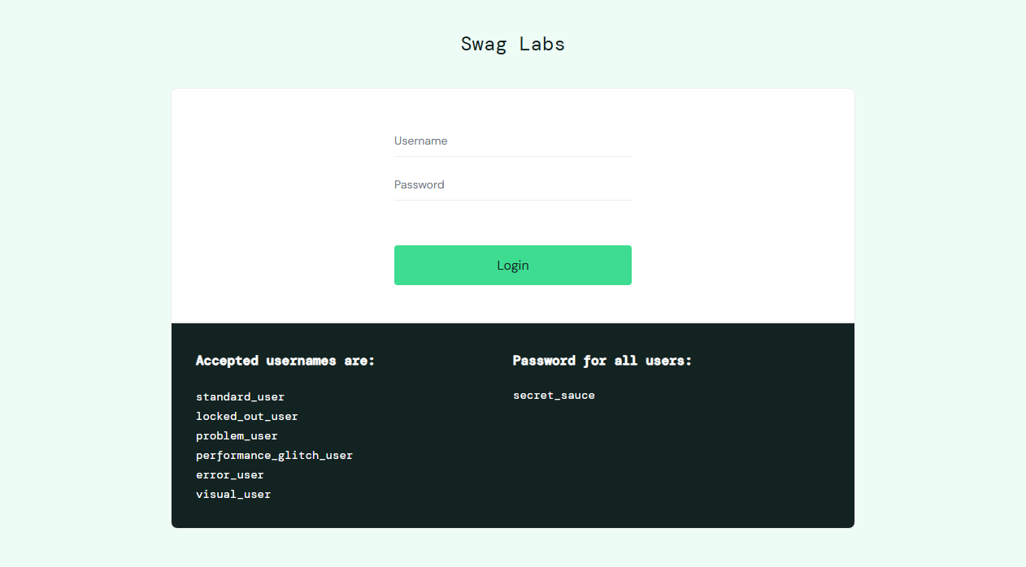
Defect ID | N/A

3. Formal Defect Report: BUG-001
An actual observed defect was discovered when testing the application under the 'problem_user' persona. Below is the comprehensive bug report:
Bug ID | BUG-001
Bug Title | Defective Product Image URLs & Broken Remove Button Functionality for 'problem_user'
Severity | Major (Severely degrades visual UI integrity and interferes with shopping cart operations)
Priority | High (P1)
Steps to Reproduce | 1. Open https://www.saucedemo.com/  2. Enter username 'problem_user' and password 'secret_sauce'  3. Click 'Login' and inspect product catalog.  4. Click 'Add to cart' on Sauce Labs Backpack and attempt to click 'Remove'.
Expected Result | Each product displays its unique high-resolution image, and the 'Remove' button successfully removes the product from the shopping cart.
Actual Result | All product cards display identical wrong dog placeholder image ('sl-404.168b1cce.jpg') and button event listener fails to remove the item from cart state.
Screenshot Evidence

