TUTORIAL 6: MANUAL TEST EXECUTION WORKFLOW
STUDENT PRACTICAL EXECUTION & SCREENSHOT REPORT
Course: Software Testing & Quality Assurance | Enrollment No: [Full Enrollment Number]
Target Application: DemoBlaze (https://www.demoblaze.com) | Submission Date: October 2026 / Academic Session

1. Practical Scope: Complete Shopping Workflow
This tutorial documents the execution of the entire shopping workflow on DemoBlaze, following the exact sequential lifecycle: Open Website ➔ Browse Categories ➔ Select Product ➔ Product Details ➔ Add to Cart ➔ Handle Alert ➔ Cart ➔ Verify Item ➔ Place Order ➔ Customer Details ➔ Submit Order ➔ Order Confirmation.
2. Sequential Manual Test Execution (TC01 to TC12)
TC ID | TC01
Test Case | Open Website
Test Data | URL: https://www.demoblaze.com
Expected Result | DemoBlaze homepage opens with top navigation and carousel
Actual Result | Homepage loaded; logo, categories, and items displayed.
Status | PASS
Screenshot | 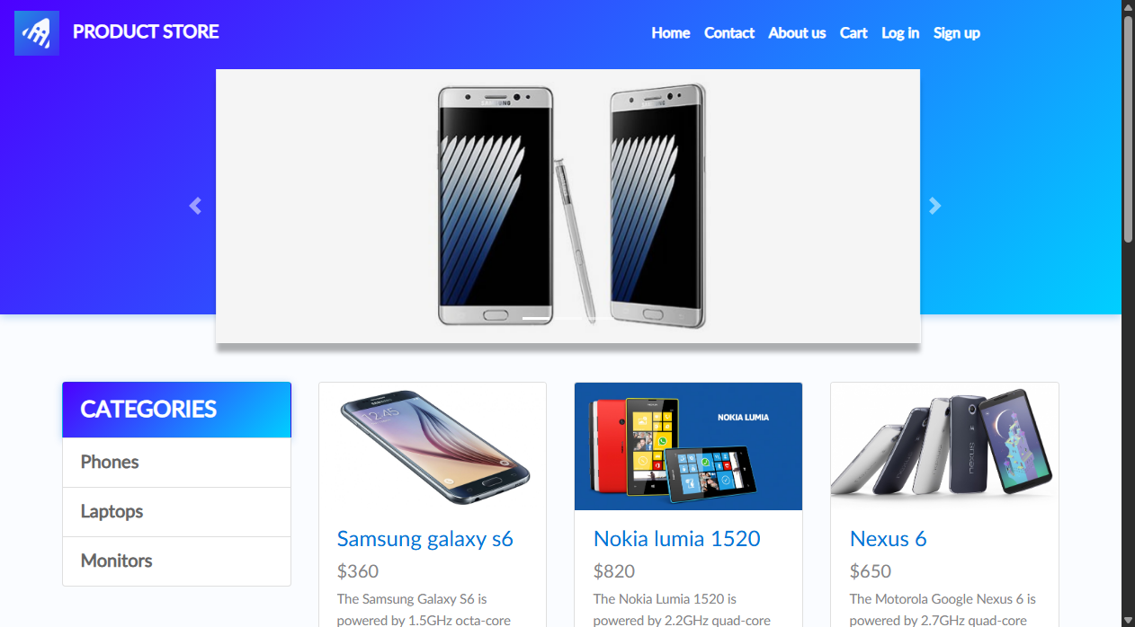
Defect ID | N/A

TC ID | TC02
Test Case | Browse categories
Test Data | Categories: Laptops / Phones
Expected Result | Product catalog filters items based on selected category
Actual Result | Category filter updated items grid asynchronously.
Status | PASS
Screenshot | 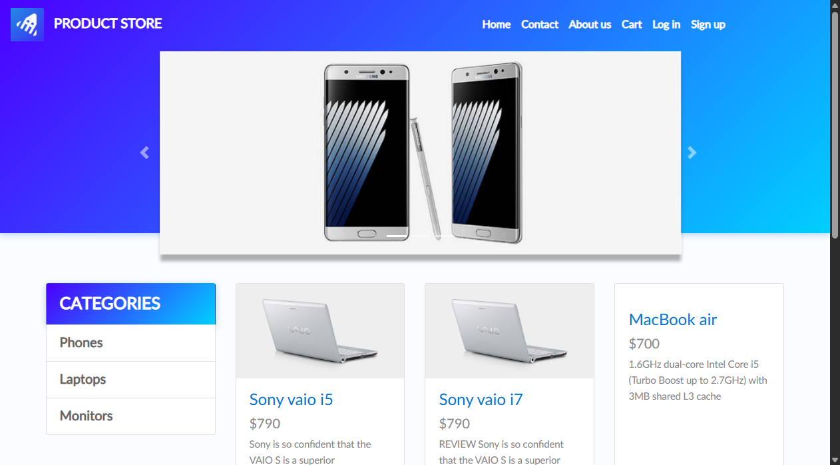
Defect ID | N/A

TC ID | TC03
Test Case | Select Product
Test Data | Item: Nokia lumia 1520
Expected Result | Redirected to product detail page
Actual Result | Navigated to product page for Nokia lumia 1520.
Status | PASS
Screenshot | 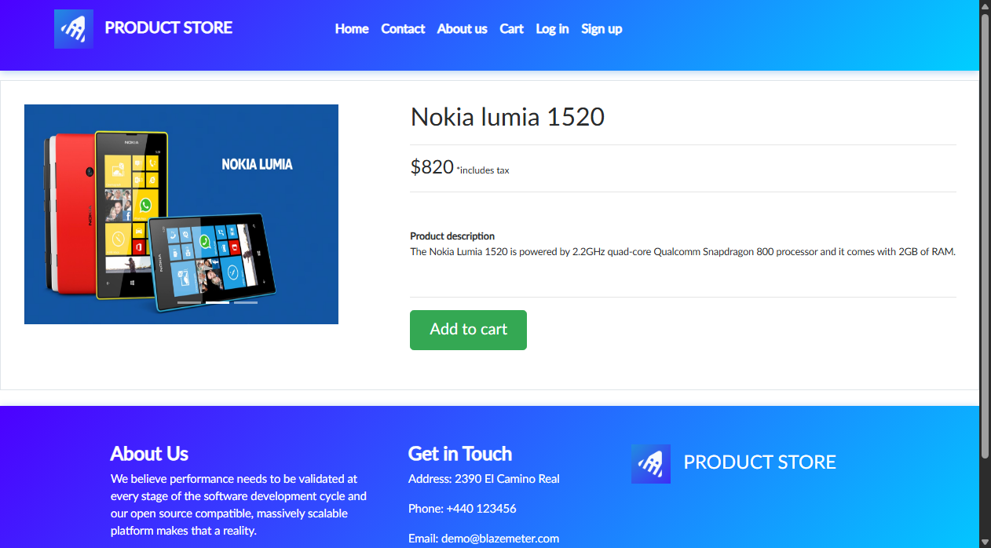
Defect ID | N/A

TC ID | TC04
Test Case | Product Details
Test Data | Element: #tbodyid
Expected Result | Product title, price ($820), and description accurate
Actual Result | Details verified accurate against catalog specs.
Status | PASS
Screenshot
Defect ID | N/A

TC ID | TC05
Test Case | Add to Cart
Test Data | Button: Add to cart
Expected Result | Item added to session cart; alert triggered
Actual Result | Add to cart triggered successfully.
Status | PASS
Screenshot | 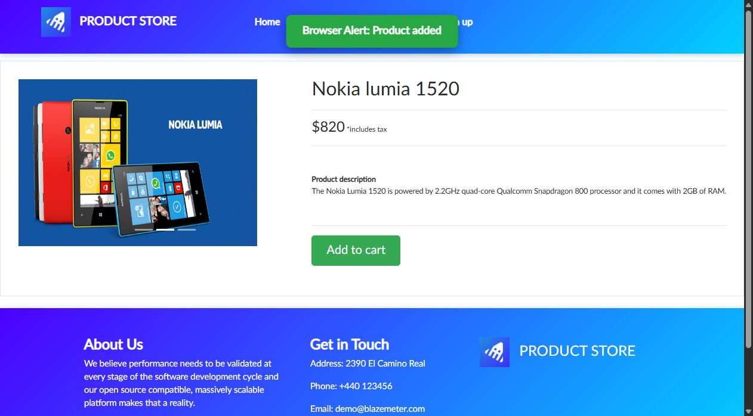
Defect ID | N/A

TC ID | TC06
Test Case | Handle Cart Alert
Test Data | Browser Alert: 'Product added'
Expected Result | Alert accepted cleanly without script termination
Actual Result | Alert accepted; user remains on product page.
Status | PASS
Screenshot
Defect ID | N/A

TC ID | TC07
Test Case | Cart
Test Data | Link: Cart (#cartur)
Expected Result | Navigated to /cart.html; cart table rendered
Actual Result | Cart page loaded with table layout.
Status | PASS
Screenshot | 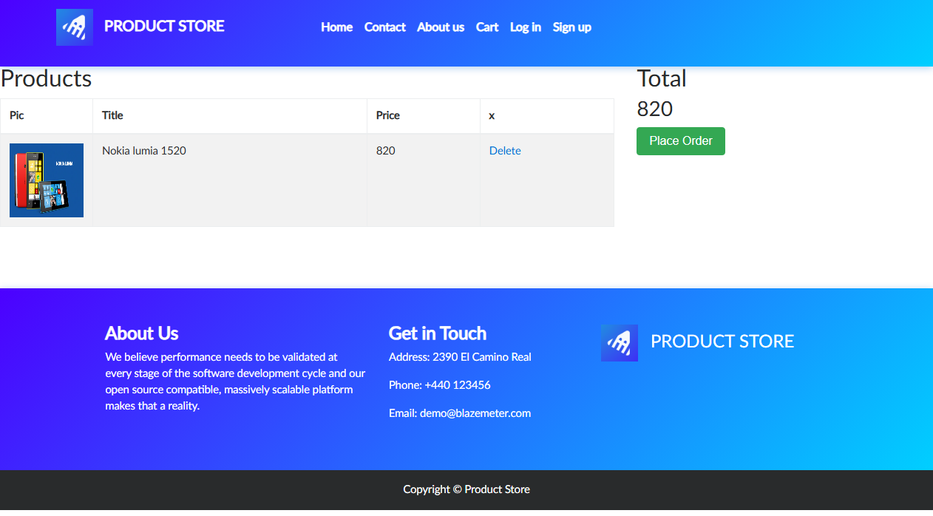
Defect ID | N/A

TC ID | TC08
Test Case | Verify Product in Cart
Test Data | Row: Nokia lumia 1520
Expected Result | Item listed in cart with price $820 and Delete action
Actual Result | Product present in cart table with matching price.
Status | PASS
Screenshot
Defect ID | N/A

TC ID | TC09
Test Case | Place Order
Test Data | Button: Place Order
Expected Result | 'Place order' modal opens with total purchase amount
Actual Result | Modal dialog rendered with payment input form.
Status | PASS
Screenshot | 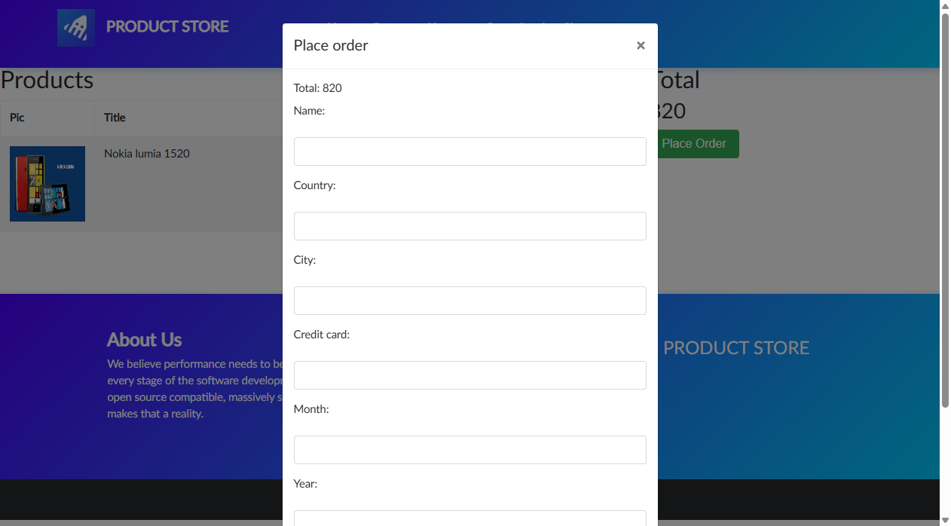
Defect ID | N/A

TC ID | TC10
Test Case | Customer Details
Test Data | Name: Alex Taylor  Card: 4111222233334444
Expected Result | Form accepts customer name, city, card, month, year
Actual Result | All customer checkout fields filled successfully.
Status | PASS
Screenshot | 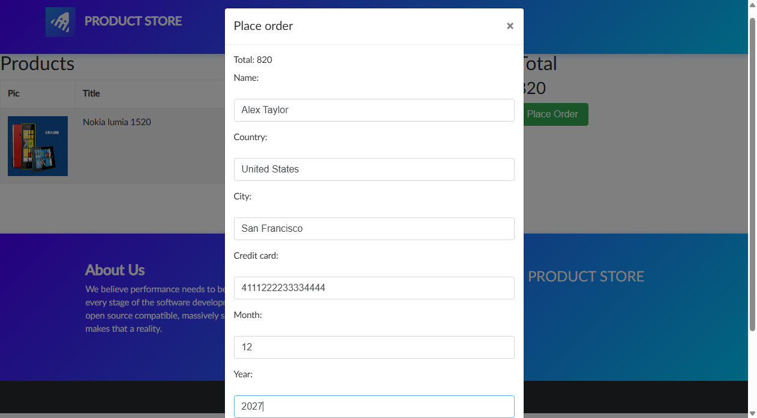
Defect ID | N/A

TC ID | TC11
Test Case | Submit Order
Test Data | Button: Purchase
Expected Result | Order transaction processed; confirmation popup rendered
Actual Result | Order submitted to checkout service.
Status | PASS
Screenshot | 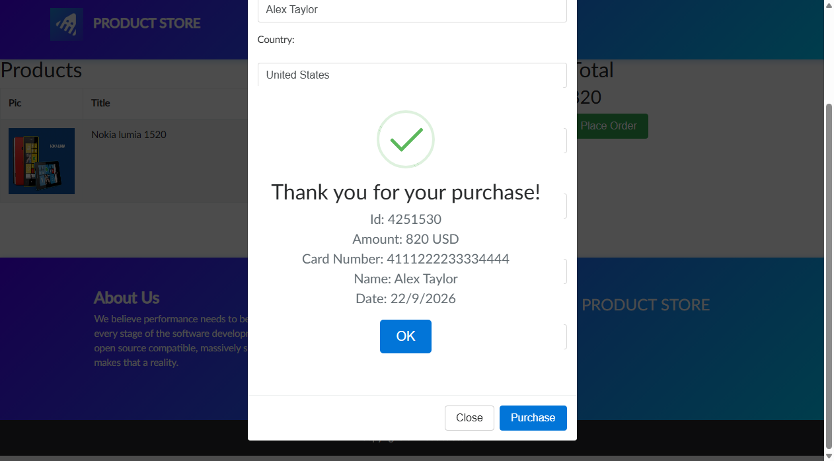
Defect ID | N/A

TC ID | TC12
Test Case | Verify Order Confirmation
Test Data | Modal: 'Thank you for your purchase!'
Expected Result | Confirmation popup displays unique order ID, amount, and date
Actual Result | Purchase confirmed with generated order ID and details.
Status | PASS
Screenshot
Defect ID | N/A

3. Test Execution Summary Metrics
Total Test Cases | 12
Passed | 12
Failed | 0
Blocked | 0
Pass % | 100.0%

