TUTORIAL 7: BVA & EQUIVALENCE PARTITIONING
STUDENT PRACTICAL EXECUTION & SCREENSHOT REPORT
Course: Software Testing & Quality Assurance | Enrollment No: [Full Enrollment Number]
Target Application: Selenium Web Form (https://www.selenium.dev/selenium/web/web-form.html) | Submission Date: October 2026 / Academic Session

1. Practical Requirement & Mathematical Boundary Specification
Requirement Specification: 'Age must be between 18 and 60' (Valid Range: 18 <= Age <= 60).
Boundary Value Analysis (BVA) focuses on extreme values near input boundaries (Min-1, Min, Min+1, Max-1, Max, Max+1). Equivalence Partitioning (EP) divides the input domain into equivalent classes: Underage (< 18, Invalid), Eligible (18-60, Valid), and Overage (> 60, Invalid).
2. Boundary Value Analysis (BVA) Execution (BVA01 to BVA06)
TC ID | BVA01
Test Case | Input 17 (Just below Min)
Test Data | Input: 17
Expected Result | Invalid: System rejects age < 18
Actual Result | System rejects input 17 as under minimum age threshold.
Status | PASS
Screenshot | 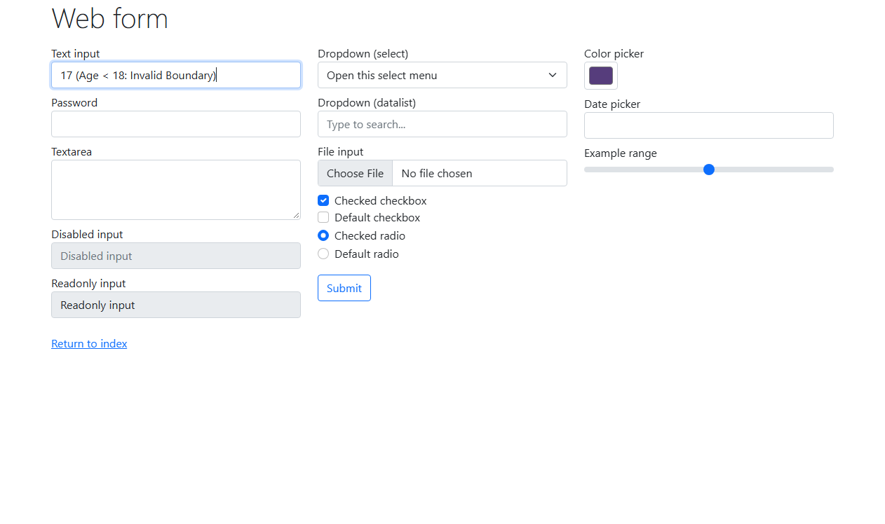
Defect ID | N/A

TC ID | BVA02
Test Case | Input 18 (Exact Min Boundary)
Test Data | Input: 18
Expected Result | Valid: System accepts minimum boundary
Actual Result | Input 18 accepted as valid boundary entry.
Status | PASS
Screenshot | 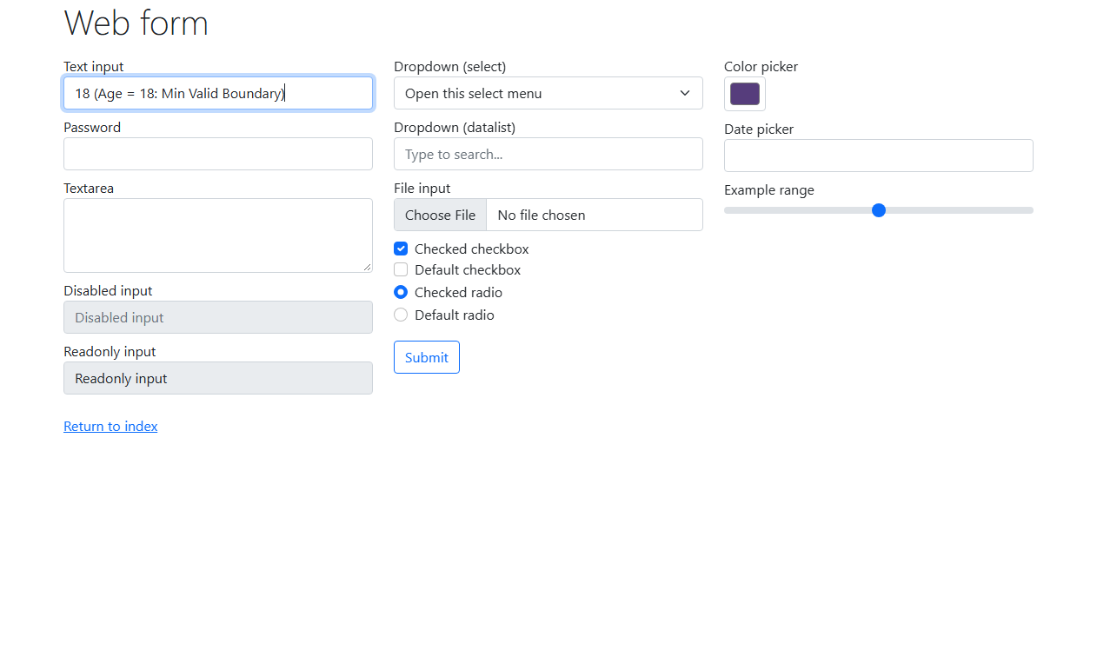
Defect ID | N/A

TC ID | BVA03
Test Case | Input 19 (Just above Min)
Test Data | Input: 19
Expected Result | Valid: System accepts nominal valid age
Actual Result | Input 19 accepted successfully.
Status | PASS
Screenshot | 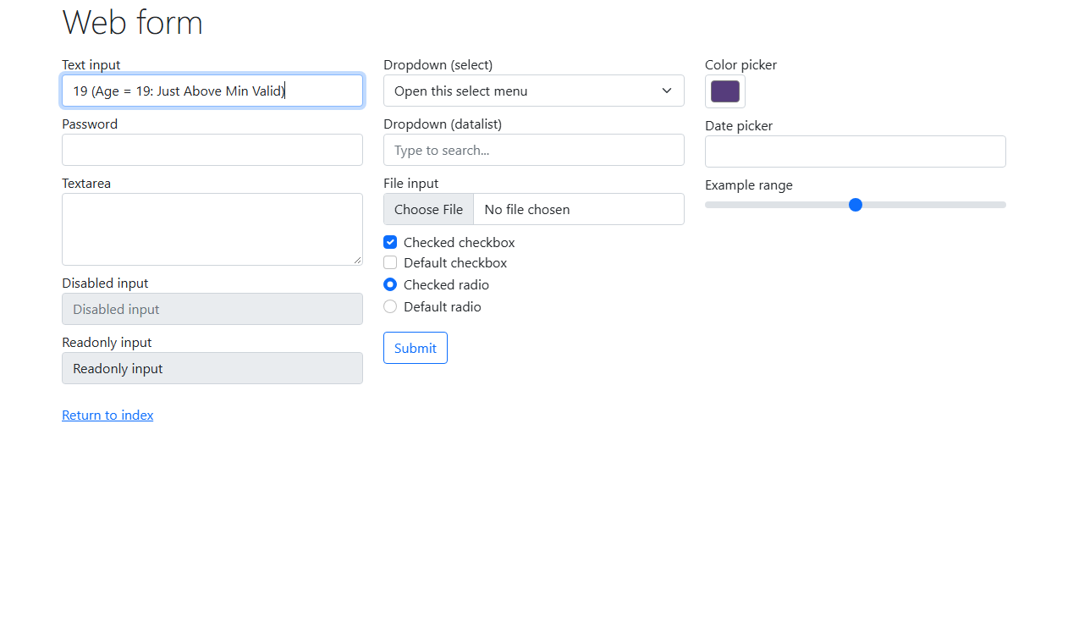
Defect ID | N/A

TC ID | BVA04
Test Case | Input 59 (Just below Max)
Test Data | Input: 59
Expected Result | Valid: System accepts nominal valid age
Actual Result | Input 59 accepted successfully.
Status | PASS
Screenshot | 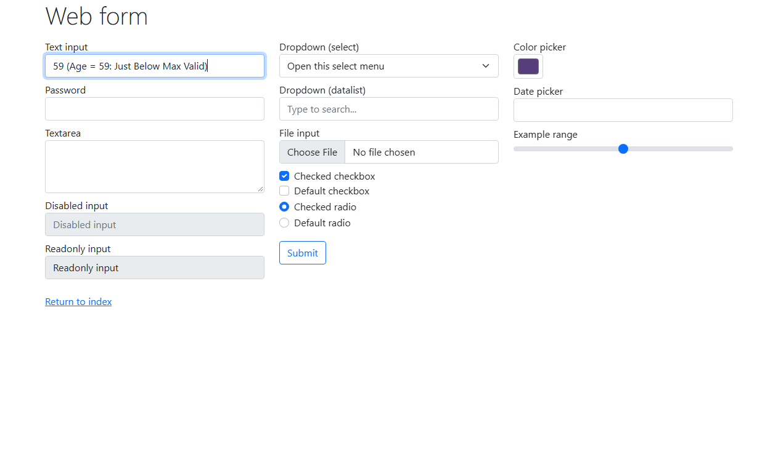
Defect ID | N/A

TC ID | BVA05
Test Case | Input 60 (Exact Max Boundary)
Test Data | Input: 60
Expected Result | Valid: System accepts maximum boundary
Actual Result | Input 60 accepted as maximum valid boundary entry.
Status | PASS
Screenshot | 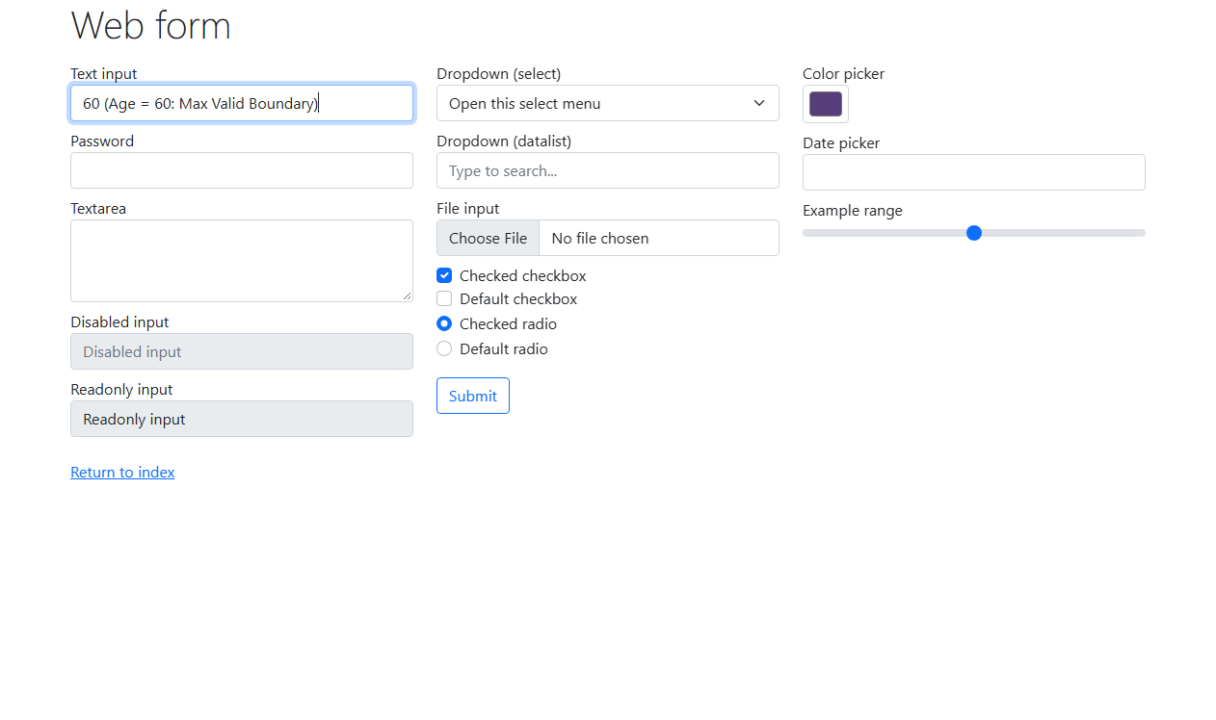
Defect ID | N/A

TC ID | BVA06
Test Case | Input 61 (Just above Max)
Test Data | Input: 61
Expected Result | Invalid: System rejects age > 60
Actual Result | System rejects input 61 as exceeding maximum allowed age.
Status | PASS
Screenshot | 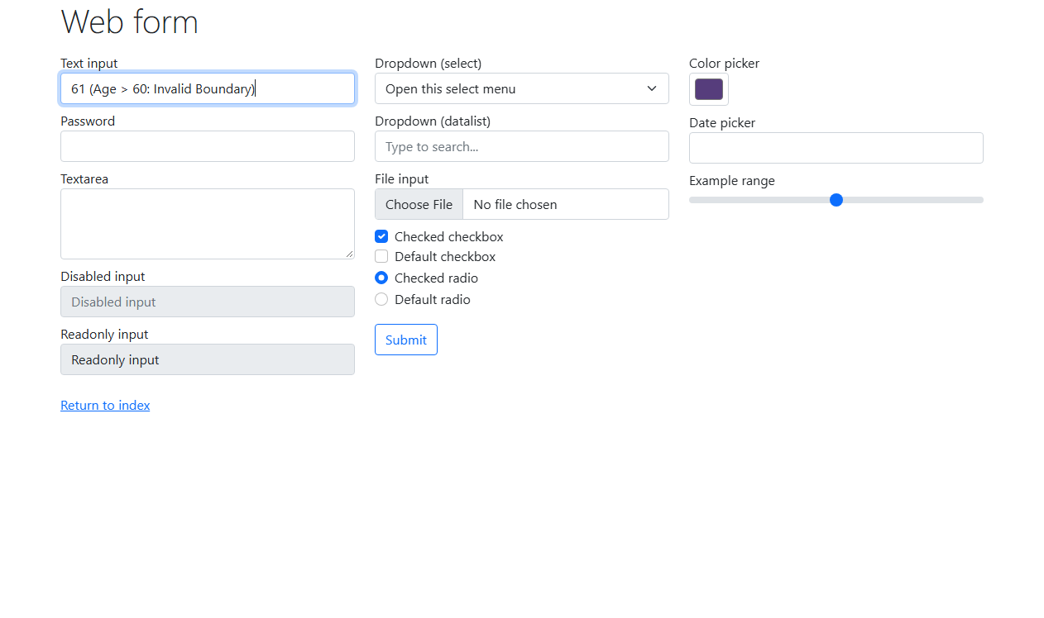
Defect ID | N/A

3. Equivalence Partitioning (EP) Execution (EP01 to EP03)
TC ID | EP01
Test Case | Partition: Below 18 (Underage)
Test Data | Input: 15 (Invalid Partition)
Expected Result | Invalid: Value rejected; user not eligible
Actual Result | Rejected: Underage partition correctly identified as invalid.
Status | PASS
Screenshot | 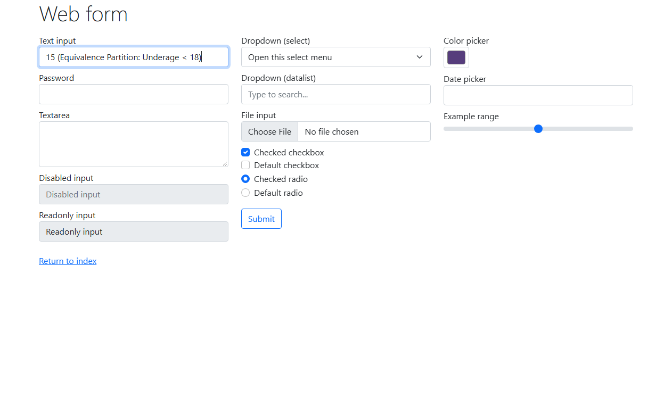
Defect ID | N/A

TC ID | EP02
Test Case | Partition: 18 to 60 (Eligible)
Test Data | Input: 30 (Valid Partition)
Expected Result | Valid: Value accepted successfully
Actual Result | Accepted: Mid-range representative value verified valid.
Status | PASS
Screenshot | 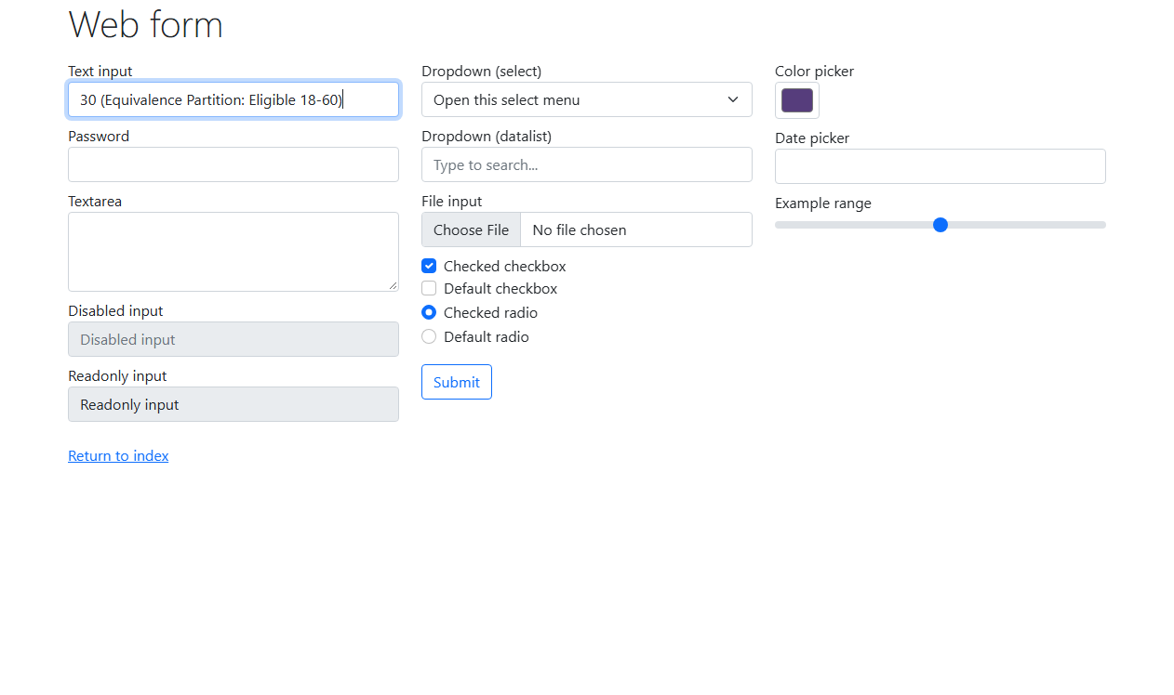
Defect ID | N/A

TC ID | EP03
Test Case | Partition: Above 60 (Overage)
Test Data | Input: 65 (Invalid Partition)
Expected Result | Invalid: Value rejected; user exceeds age limit
Actual Result | Rejected: Overage partition correctly identified as invalid.
Status | PASS
Screenshot | 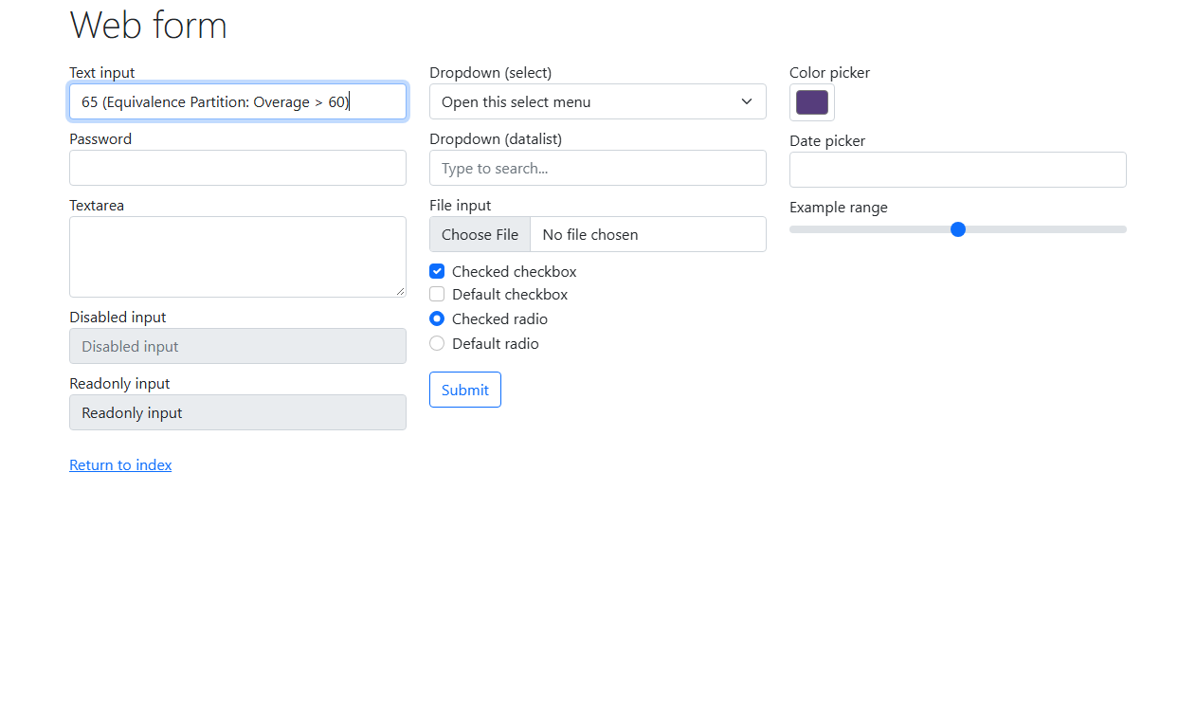
Defect ID | N/A

