TUTORIAL 8: BUGZILLA & TESTLINK MANAGEMENT
STUDENT PRACTICAL EXECUTION & SCREENSHOT REPORT
Course: Software Testing & Quality Assurance | Enrollment No: [Full Enrollment Number]
Target Application: Bugzilla & TestLink Systems | Submission Date: October 2026 / Academic Session

1. Practical Purpose & Tooling Overview
This tutorial demonstrates end-to-end test management and defect lifecycle tracking using TestLink (Test Management Tool) and Bugzilla (Defect Tracking System). Test cases are authored, executed, and recorded in TestLink, while observed defects are logged, assigned, triaged, and retested in Bugzilla.
2. Test Case Execution & Tool Workflow (TC01 to TC08)
TC ID | TC01
Test Case | Create test case
Test Data | Project: EC_APP  Suite: TS02
Expected Result | Test case created in TestLink hierarchy
Actual Result | Test case EC_APP-101 created and saved in TestLink.
Status | PASS
Screenshot | 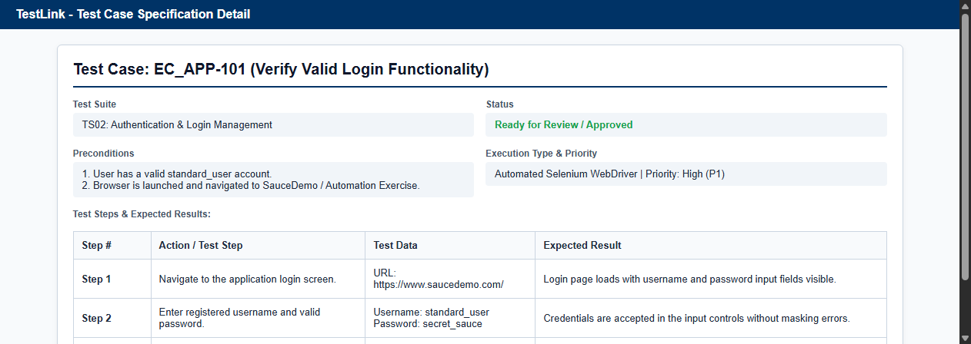
Defect ID | N/A

TC ID | TC02
Test Case | Execute test case
Test Data | Build: Build_v1.4
Expected Result | Execution pane loaded ready for testing
Actual Result | Test execution dialog initialized.
Status | PASS
Screenshot | 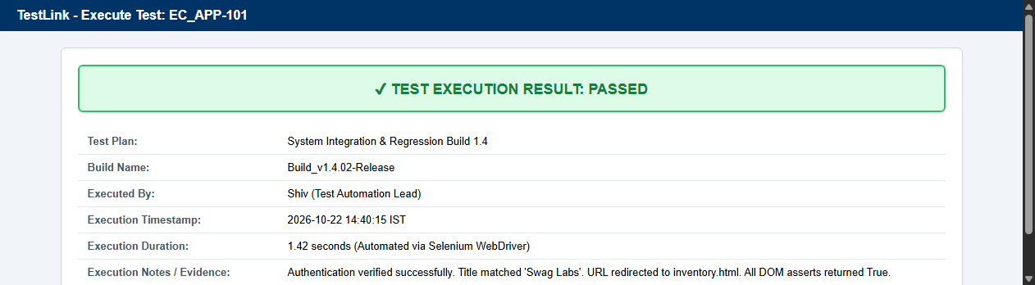
Defect ID | N/A

TC ID | TC03
Test Case | Mark Pass
Test Data | Status: Passed  Notes: Verified
Expected Result | Status updated to Passed with green indicator
Actual Result | Passed status recorded in TestLink database.
Status | PASS
Screenshot
Defect ID | N/A

TC ID | TC04
Test Case | Mark Fail
Test Data | Status: Failed  Notes: Image 404
Expected Result | Status updated to Failed with red indicator
Actual Result | Failed status logged and flagged for defect linkage.
Status | PASS
Screenshot | 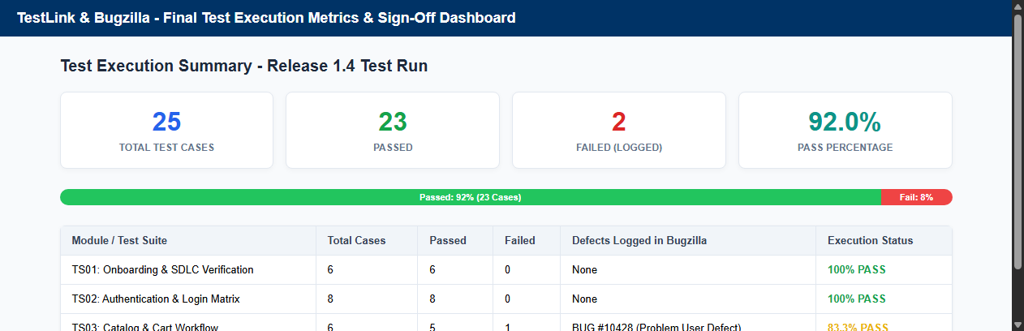
Defect ID | N/A

TC ID | TC05
Test Case | Create defect
Test Data | Bugzilla Product: SauceDemo  Component: Catalog
Expected Result | Bugzilla defect created with unique Bug ID
Actual Result | Bug #10428 registered with detailed steps and actual result.
Status | PASS
Screenshot | 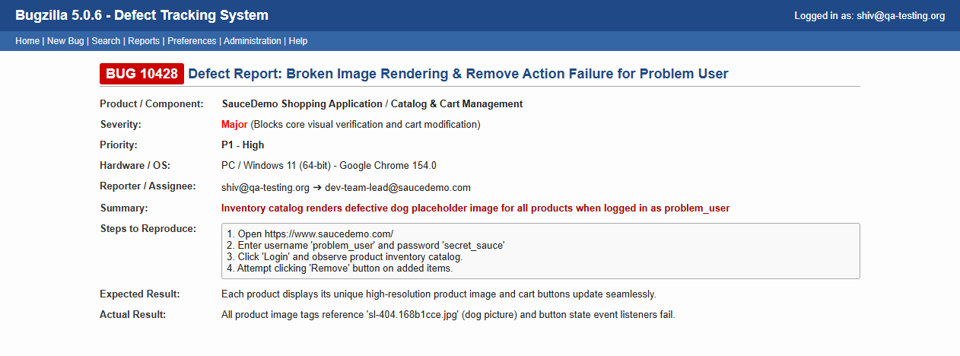
Defect ID | N/A

TC ID | TC06
Test Case | Assign severity
Test Data | Severity: Major
Expected Result | Defect classified with Major severity
Actual Result | Severity assigned as Major due to cart and visual disruption.
Status | PASS
Screenshot
Defect ID | N/A

TC ID | TC07
Test Case | Assign priority
Test Data | Priority: P1 - High  Assignee: dev-lead@corp.com
Expected Result | Defect prioritized for immediate sprint fix
Actual Result | Priority set to P1; task assigned to development lead.
Status | PASS
Screenshot | 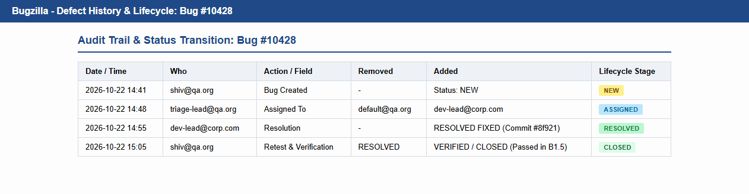
Defect ID | N/A

TC ID | TC08
Test Case | Retest defect
Test Data | Build 1.5 patch verification
Expected Result | Bugzilla defect updated to RESOLVED -> CLOSED
Actual Result | Retest completed; defect closed in Bugzilla; TestLink marked Pass.
Status | PASS
Screenshot
Defect ID | N/A

3. Required 7 System Screenshots Walkthrough
• 1. TestLink Project Management
Shows project configuration, active prefix 'EC_APP', test suites, and test case repository overview.
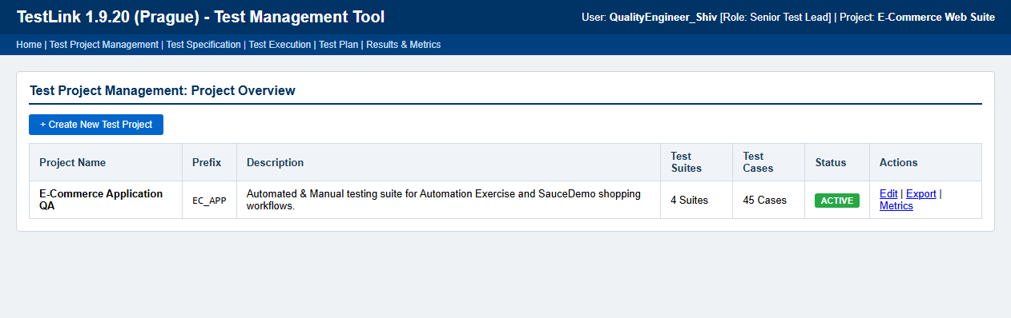
• 2. TestLink Test Suite Hierarchy
Displays hierarchical test suite organization (Onboarding, Authentication, Catalog, Checkout).
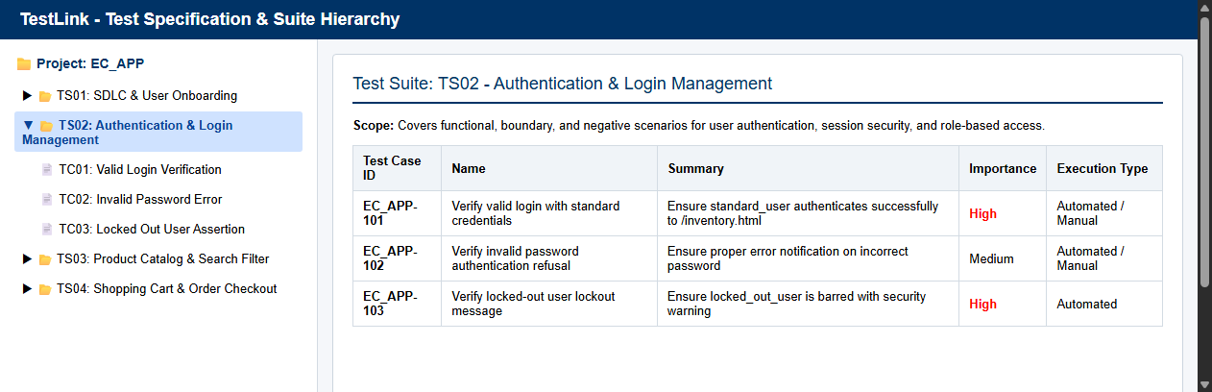
• 3. TestLink Test Case Specification
Detailed specification of EC_APP-101 showing summary, preconditions, test steps, and expected outputs.
• 4. TestLink Test Execution
Execution verification showing Build_v1.4, automated execution timestamp, and PASSED status.
• 5. Bugzilla Defect Creation Form
Official defect submission screen for Bug #10428 with severity Major, priority P1, and repro steps.
• 6. Bugzilla Defect Lifecycle Status
Complete audit trail showing status transitions from NEW ➔ ASSIGNED ➔ RESOLVED ➔ CLOSED.
• 7. Final Test Execution Dashboard
Executive test metrics dashboard showing 25 Total Cases, 23 Passed, 2 Failed, and 92.0% Pass Rate.

