TUTORIAL 11: PYTHON + SELENIUM MULTI-PAGE WORKFLOW
STUDENT PRACTICAL EXECUTION & SCREENSHOT REPORT
Course: Software Testing & Quality Assurance | Enrollment No: [Full Enrollment Number]
Target Application: Automation Exercise (https://automationexercise.com) | Submission Date: October 2026 / Academic Session

1. Practical Purpose & Automation Framework
This tutorial demonstrates end-to-end multi-page navigation and dynamic web element interaction using Python and Selenium WebDriver. The automated script navigates from Homepage ➔ Products ➔ Search ➔ Product Selection ➔ Cart Addition ➔ View Cart, validating DOM state at each phase.
2. Python Selenium Test Script Code Screenshot
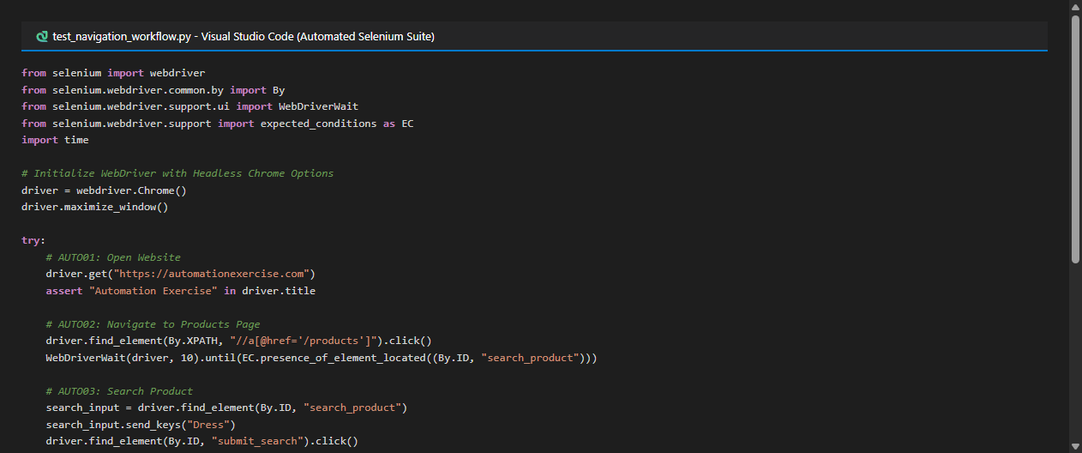
3. Test Execution & Evidence (AUTO01 to AUTO06)
TC ID | AUTO01
Test Case | Open website
Test Data | driver.get('https://automationexercise.com')
Expected Result | Title contains 'Automation Exercise'
Actual Result | Homepage opens; title verified via assertion.
Status | PASS
Screenshot | 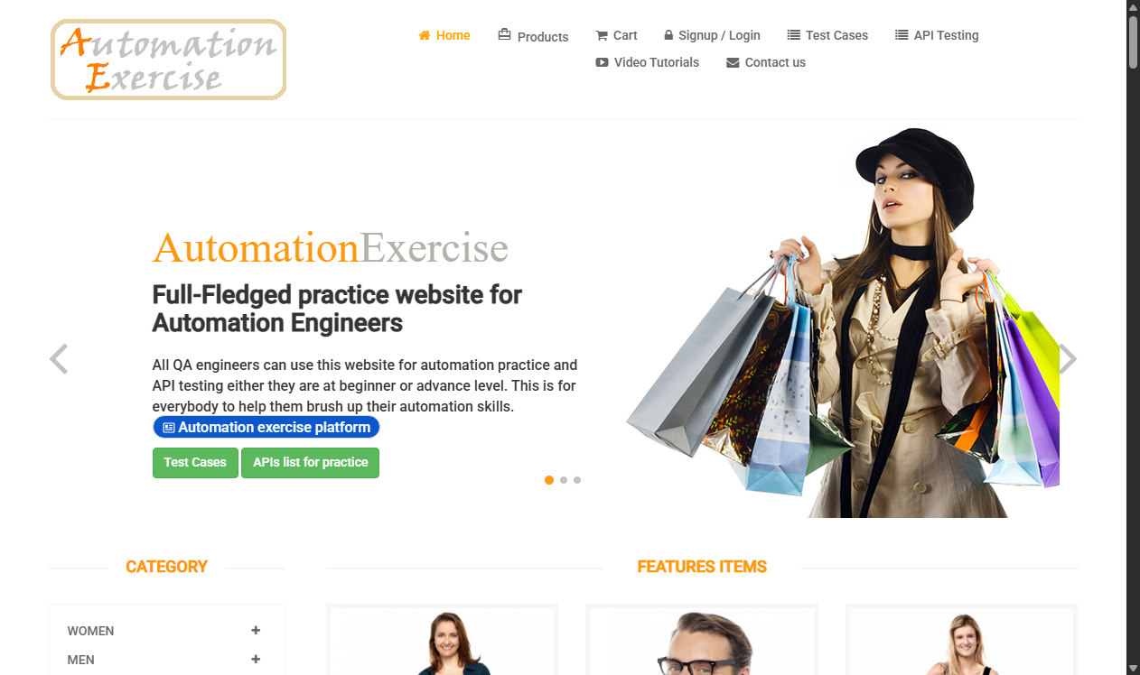
Defect ID | N/A

TC ID | AUTO02
Test Case | Products
Test Data | driver.find_element(By.XPATH, "//a[@href='/products']").click()
Expected Result | Navigated to /products page; products catalog displayed
Actual Result | Products page loaded; 'ALL PRODUCTS' header rendered.
Status | PASS
Screenshot | 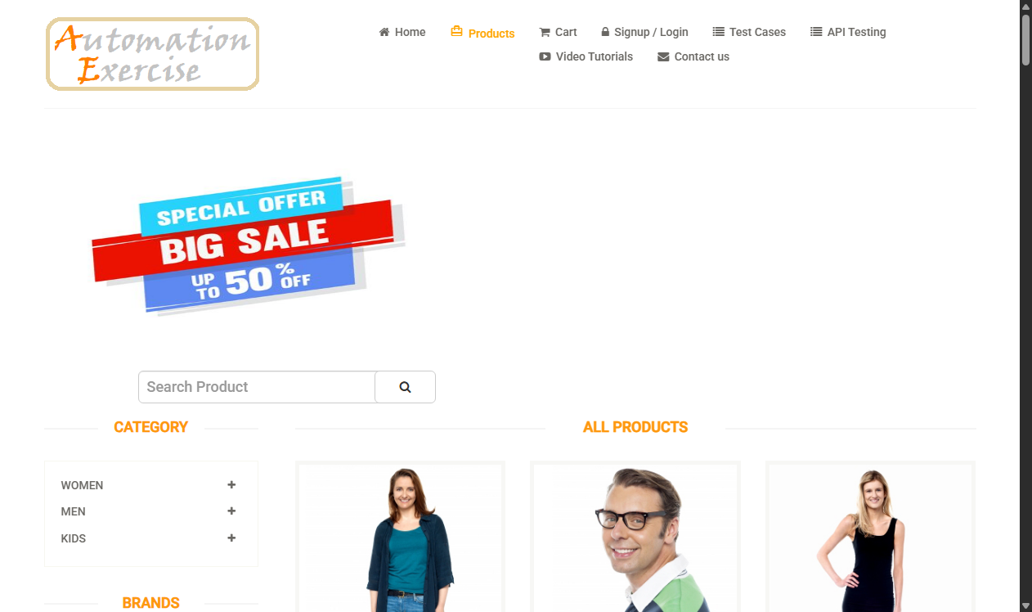
Defect ID | N/A

TC ID | AUTO03
Test Case | Search product
Test Data | Query: 'Dress'
Expected Result | Search results display matching items
Actual Result | Search returned dress items under 'SEARCHED PRODUCTS'.
Status | PASS
Screenshot | 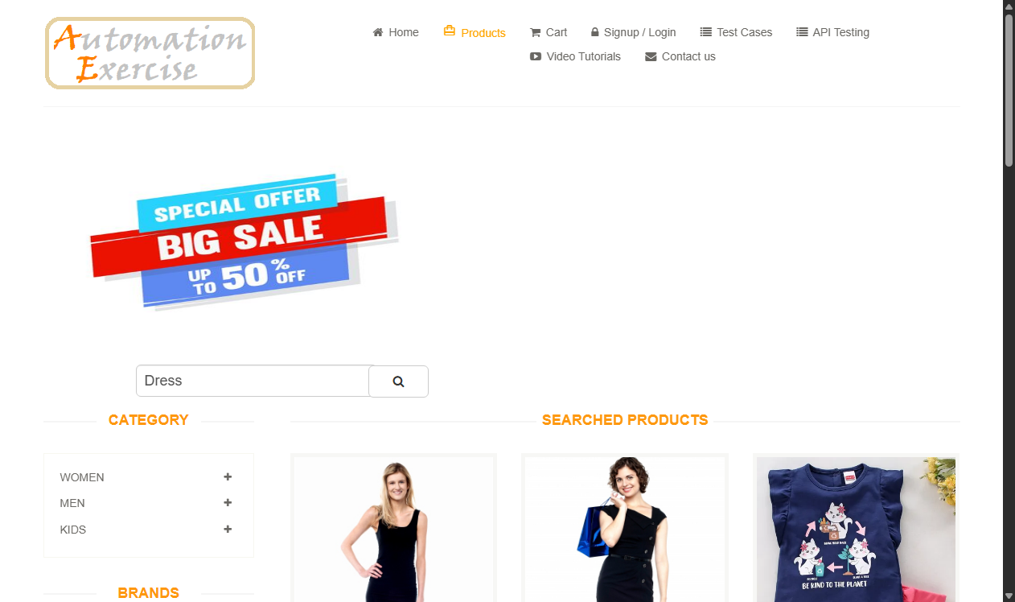
Defect ID | N/A

TC ID | AUTO04
Test Case | Select product
Test Data | Click: 'View Product'
Expected Result | Product detail page opens with specs and price
Actual Result | Product details loaded; quantity and price verified.
Status | PASS
Screenshot | 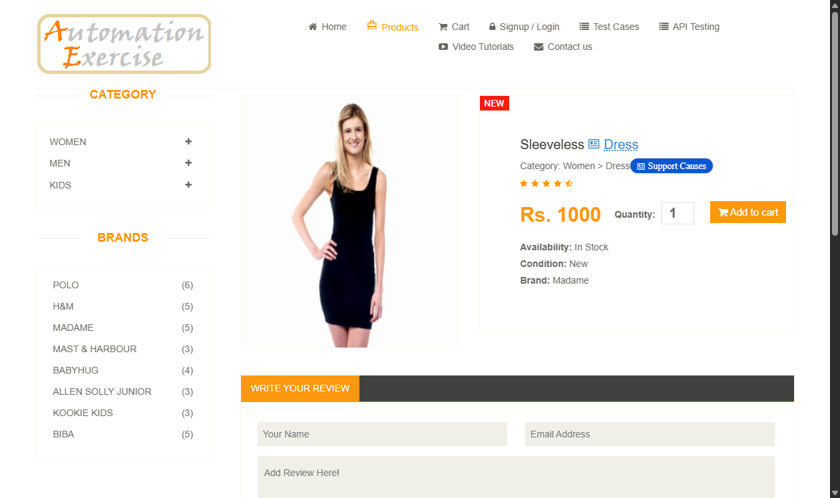
Defect ID | N/A

TC ID | AUTO05
Test Case | Add to cart
Test Data | Click: button.cart
Expected Result | 'Added!' confirmation modal appears
Actual Result | Modal dialog appears confirming cart addition.
Status | PASS
Screenshot | 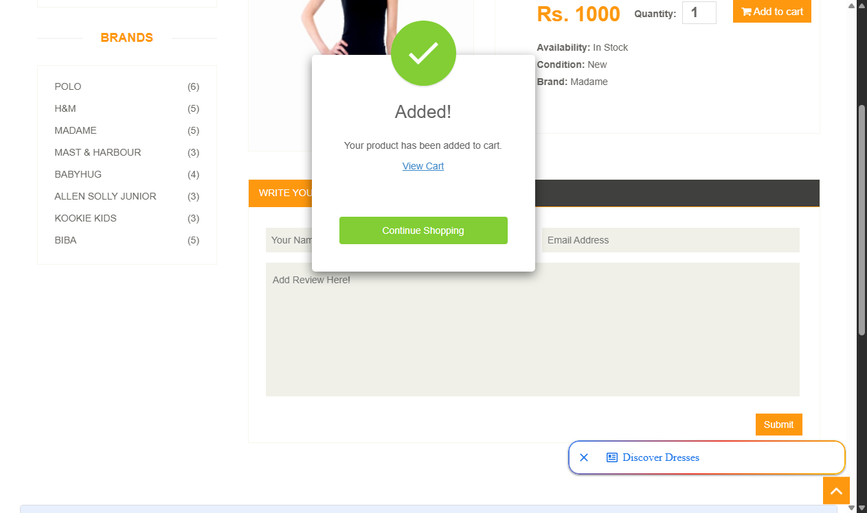
Defect ID | N/A

TC ID | AUTO06
Test Case | Open cart
Test Data | driver.get('https://automationexercise.com/view_cart')
Expected Result | Cart displays added product row with details
Actual Result | Cart page shows product with matching description and quantity.
Status | PASS
Screenshot | 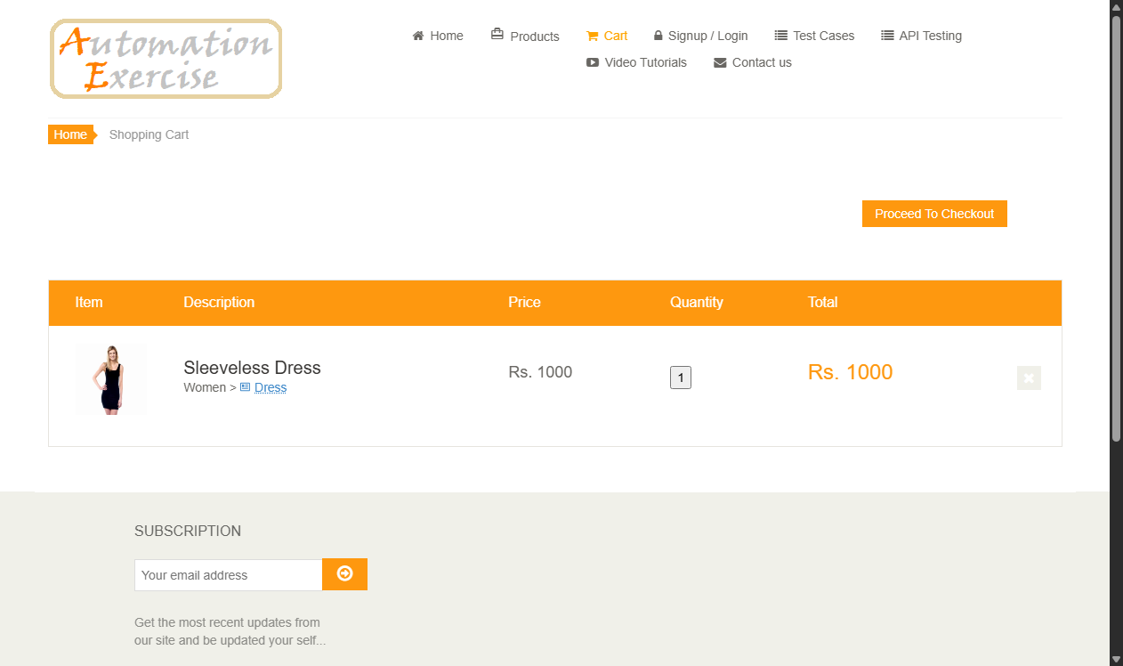
Defect ID | N/A

