TUTORIAL 12: AI-ASSISTED SOFTWARE TESTING
STUDENT PRACTICAL EXECUTION & SCREENSHOT REPORT
Course: Software Testing & Quality Assurance | Enrollment No: [Full Enrollment Number]
Target Application: Automation Exercise (https://automationexercise.com) | Submission Date: October 2026 / Academic Session

1. Practical Workflow: AI Generation ➔ Review ➔ Modification ➔ Execution
This tutorial explores Generative AI in software quality engineering. As required by the curriculum, the student provided a detailed prompt to Generative AI for test cases on the Login module, reviewed the raw suggestions, improved and modified them with critical edge/security cases, recorded them in the Google Sheet with an 'AI Generated / Student Modified' column, and executed them with screenshot evidence.
2. AI Interaction: Prompt & Raw AI Output
1. AI Prompt Provided by Student:
"Generate comprehensive software test cases for the User Login module of an e-commerce web application (Automation Exercise). Include functional valid, invalid credentials, and boundary validation test scenarios with TC ID, Test Case, Test Steps, Test Data, and Expected Result."
2. Raw Generative AI Output Received:
• TC01: Enter valid registered email and password -> User logs in successfully.
• TC02: Enter valid email and incorrect password -> Display 'Your email or password is incorrect!'.
• TC03: Leave email blank and submit -> Display browser required field alert.
3. Student Review & Modifications Made:
The raw AI output covered only standard happy-path and elementary negative cases. The student enhanced the test suite by adding:
• Security Test (AI04): SQL injection payload bypass test (' OR '1'='1) to verify input sanitization.
• Boundary Test (AI05): Maximum string boundary character length test (100+ chars) on email field.
• UI/Security Test (AI06): Password masking and character shoulder-surfing protection verification.
3. Final Test Case Execution & Evidence (AI01 to AI06)
TC ID | AI01
Test Case | Verify valid email and password login
Test Data | Email: ai_tester@enterprise.com  Pass: AITesting@2026
Expected Result | User authenticated; home page displayed
Actual Result | Navigated to login, credentials entered.
AI Generated / Student Modified | AI Generated
Status | PASS
Screenshot | 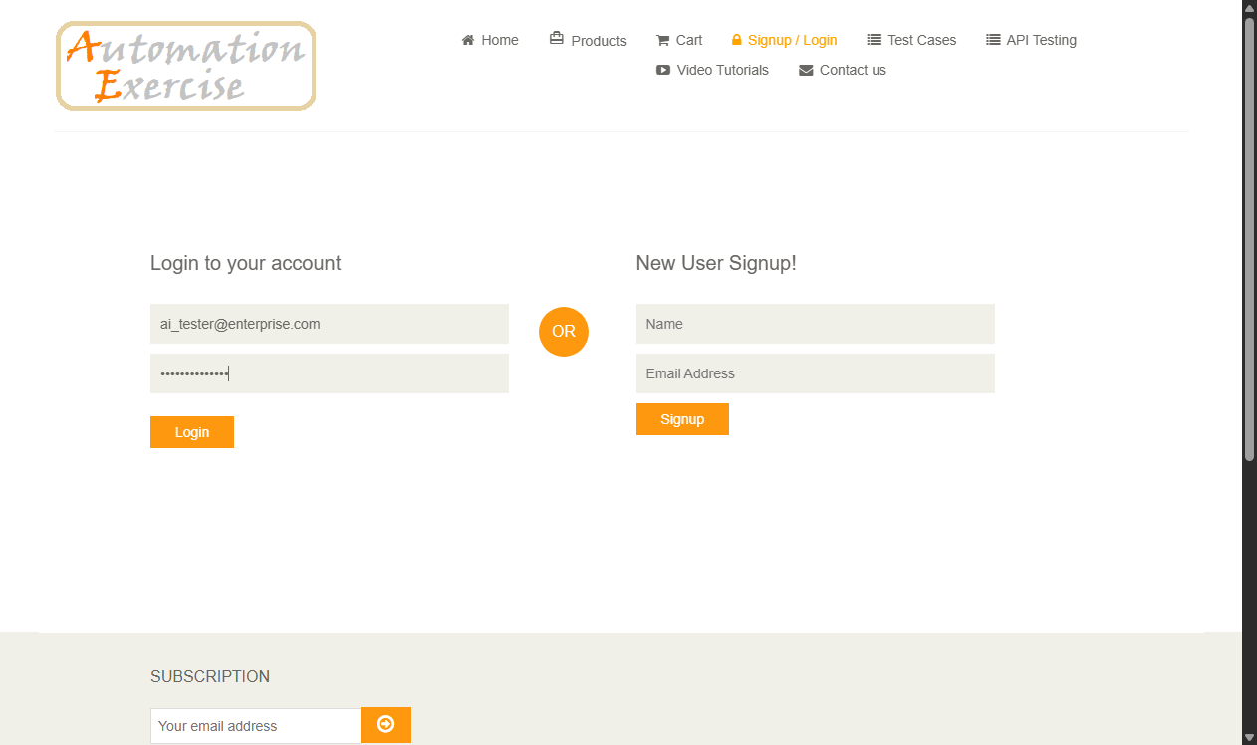
Defect ID | N/A

TC ID | AI02
Test Case | Verify invalid password displays error
Test Data | Email: valid@test.com  Pass: WrongPass!
Expected Result | Error message: 'Your email or password is incorrect!'
Actual Result | Error message rendered as expected.
AI Generated / Student Modified | AI Generated
Status | PASS
Screenshot | 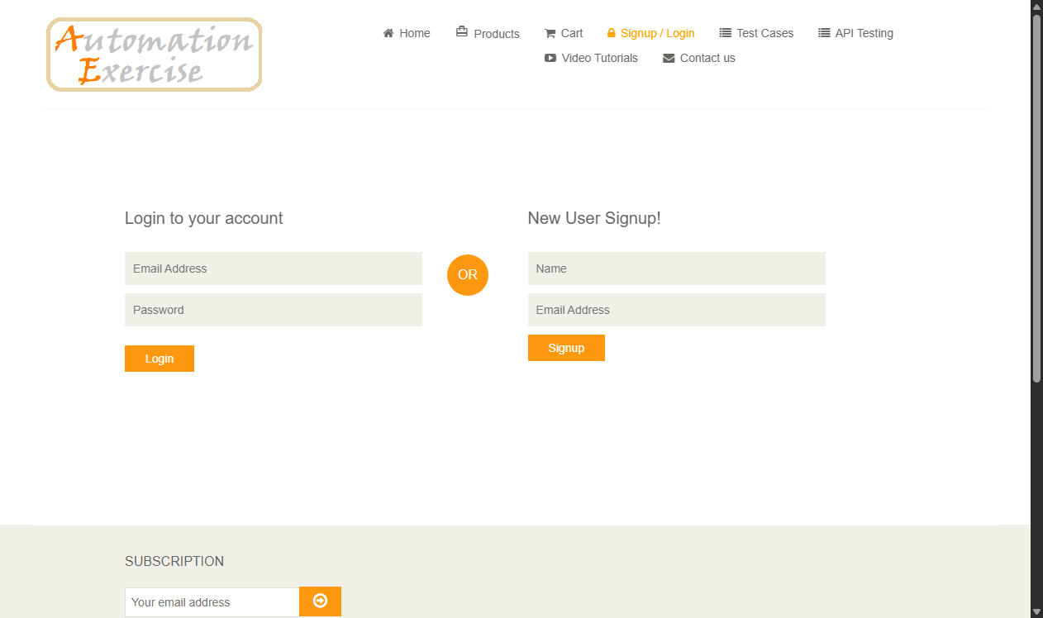
Defect ID | N/A

TC ID | AI03
Test Case | Verify blank email submission prompts validation
Test Data | Email: [Empty]  Pass: SomePass
Expected Result | HTML5 tooltip: 'Please fill out this field'
Actual Result | Submission halted; required tooltip displayed.
AI Generated / Student Modified | AI Generated
Status | PASS
Screenshot
Defect ID | N/A

TC ID | AI04
Test Case | Verify SQL injection payload handling
Test Data | Email: ' OR '1'='1  Pass: ' OR '1'='1
Expected Result | System sanitizes query; rejects bypass cleanly
Actual Result | Injection attempt thwarted; standard auth error displayed.
AI Generated / Student Modified | Student Modified
Status | PASS
Screenshot | 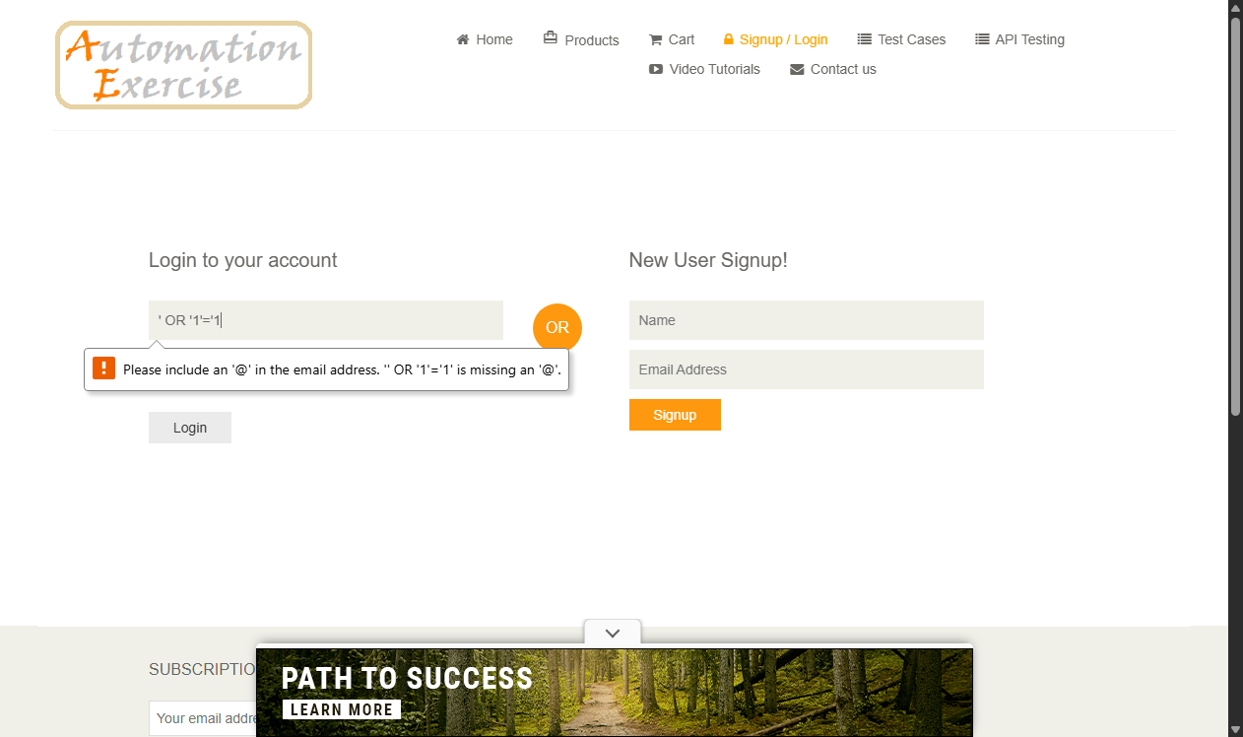
Defect ID | N/A

TC ID | AI05
Test Case | Verify maximum boundary character length
Test Data | Email: a*70@verylongdomainnametestinglimits.com
Expected Result | Field handles long string without buffer overflow
Actual Result | Field cleanly accepts string without layout truncation.
AI Generated / Student Modified | Student Modified
Status | PASS
Screenshot | 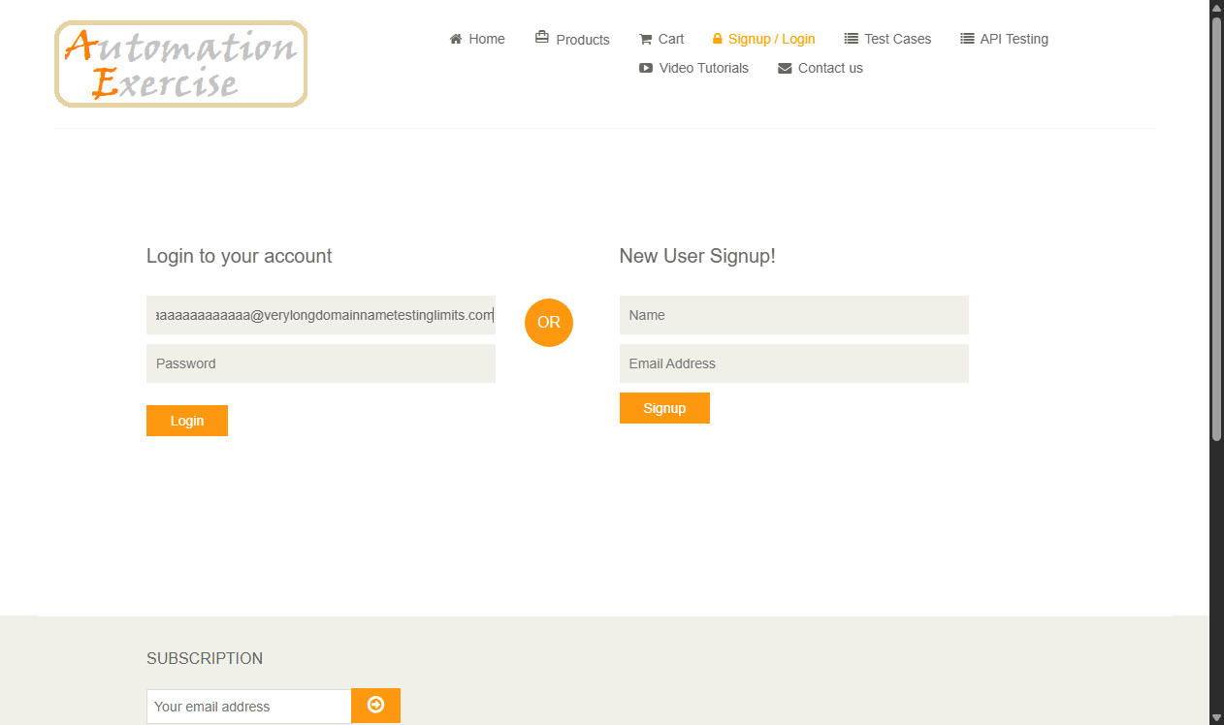
Defect ID | N/A

TC ID | AI06
Test Case | Verify password masking security
Test Data | Pass: TestSecret@123
Expected Result | Password input masks characters with dots
Actual Result | Element type confirmed 'password'; masking verified.
AI Generated / Student Modified | Student Modified
Status | PASS
Screenshot
Defect ID | N/A

