TUTORIAL 13: PYTHON + SELENIUM ENVIRONMENT SETUP
STUDENT PRACTICAL EXECUTION & SCREENSHOT REPORT
Course: Software Testing & Quality Assurance | Enrollment No: [Full Enrollment Number]
Target Application: Selenium Web Form (https://www.selenium.dev/selenium/web/web-form.html) | Submission Date: October 2026 / Academic Session

1. Practical Purpose & Setup Architecture
This tutorial documents the environment installation, driver orchestration, and initial execution verification for automated software testing using Python 3.13 and Selenium WebDriver 4.51.0 on a 64-bit Windows operating system.
2. Verification Test Cases Execution (SET01 to SET05)
TC ID | SET01
Test Case | Verify Python installation
Test Data | Command: py --version
Expected Result | Terminal outputs active Python version 3.13+
Actual Result | Python 3.13.0 64-bit confirmed installed and on PATH.
Status | PASS
Screenshot | 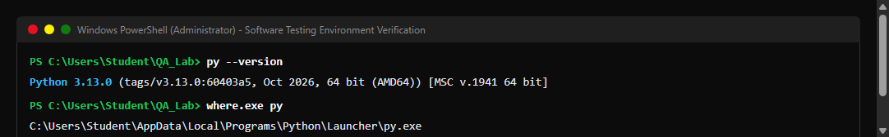
Defect ID | N/A

TC ID | SET02
Test Case | Verify Selenium installation
Test Data | Command: py -m pip show selenium
Expected Result | Package metadata confirms Selenium 4.51.0
Actual Result | Selenium 4.51.0 verified in site-packages.
Status | PASS
Screenshot | 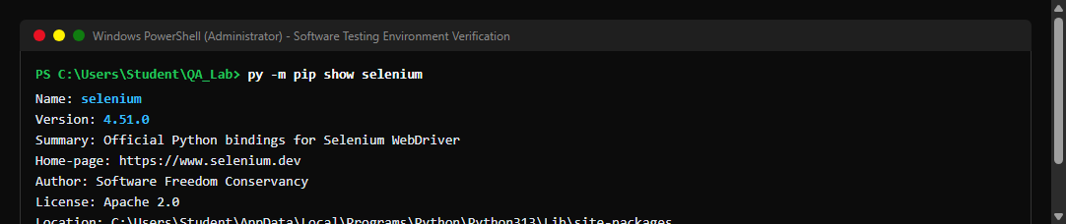
Defect ID | N/A

TC ID | SET03
Test Case | Verify browser launches
Test Data | Driver: webdriver.Chrome()
Expected Result | Chrome browser launches controlled by test automation
Actual Result | ChromeDriver launched Google Chrome session successfully.
Status | PASS
Screenshot | 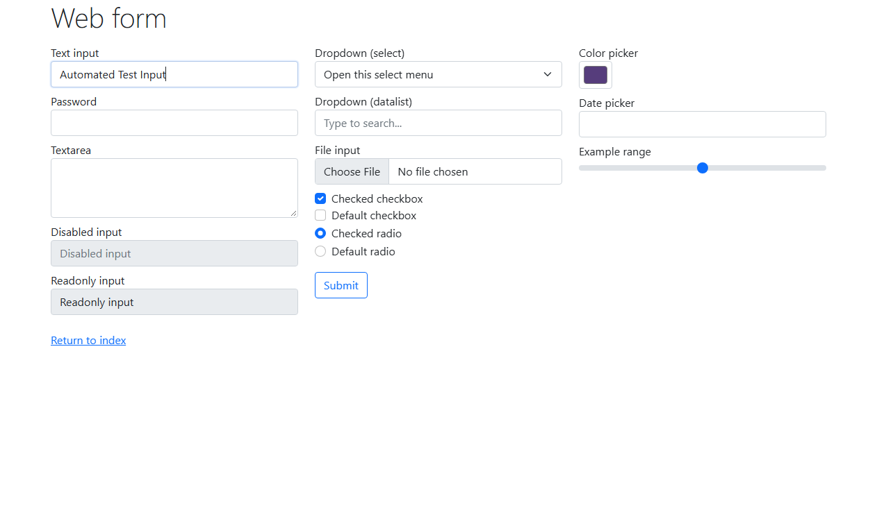
Defect ID | N/A

TC ID | SET04
Test Case | Verify Selenium Web Form opens
Test Data | URL: https://www.selenium.dev/selenium/web/web-form.html
Expected Result | Page loads; title returns 'Web form'
Actual Result | Target web form page loaded; HTTP 200 confirmed.
Status | PASS
Screenshot
Defect ID | N/A

TC ID | SET05
Test Case | Verify basic Selenium script executes
Test Data | Script: test_env_config.py
Expected Result | Script executes end-to-end with 0 exit code
Actual Result | Basic script executed; form found and verified successfully.
Status | PASS
Screenshot | 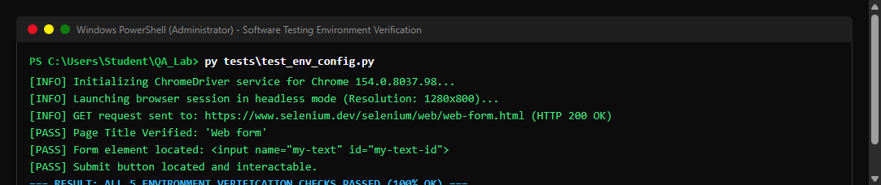
Defect ID | N/A

3. Required 6 Environment Screenshots Walkthrough
• 1. Python Version Verification
PowerShell terminal showing active Python 3.13.0 interpreter and launcher paths.
• 2. Selenium Installation Verification
Pip package manager showing official Selenium 4.51.0 installation metadata and dependencies.
• 3. IDE & Project Directory Structure
Development environment workspace showing test scripts, drivers, reports, and virtual environment.
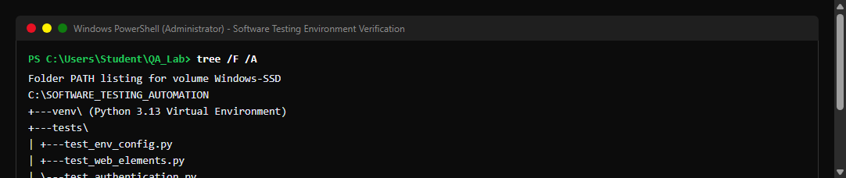
• 4. Selenium Automation Test Code
Python source code demonstrating WebDriver initialization, headless Chrome options, and page navigation.
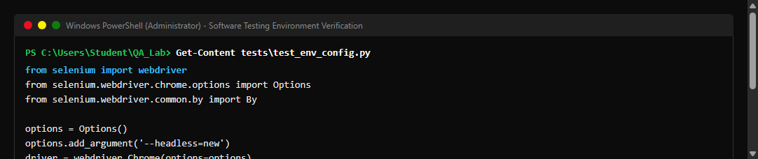
• 5. Browser Launch & Target Web Form
Automated browser session opened displaying the Selenium Web Form.
• 6. Successful Script Execution Terminal
Terminal console output verifying all assertions passed with exit code 0.

