TUTORIAL 15: AUTHENTICATION, ASSERTION & EXCEPTIONS
STUDENT PRACTICAL EXECUTION & SCREENSHOT REPORT
Course: Software Testing & Quality Assurance | Enrollment No: [Full Enrollment Number]
Target Application: SauceDemo (https://www.saucedemo.com) | Submission Date: October 2026 / Academic Session

1. Practical Purpose & Technical Scope
This tutorial covers advanced test automation practices using Python and Selenium WebDriver: authentication state management, invalid/boundary credential handling, programmatic test assertions (verifying page titles and URL redirections), and robust exception handling (intercepting NoSuchElementException without crashing tests).
2. Python Automation Script (Assertions & Exception Handling)
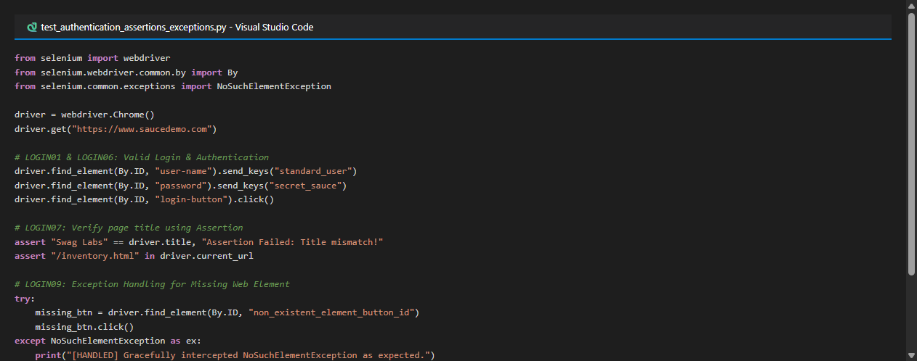
3. Test Execution & Evidence (LOGIN01 to LOGIN10)
TC ID | LOGIN01
Test Case | Valid login
Test Data | User: standard_user  Pass: secret_sauce
Expected Result | User successfully authenticated; navigated to /inventory.html
Actual Result | Authentication succeeds; inventory loaded.
Status | PASS
Screenshot | 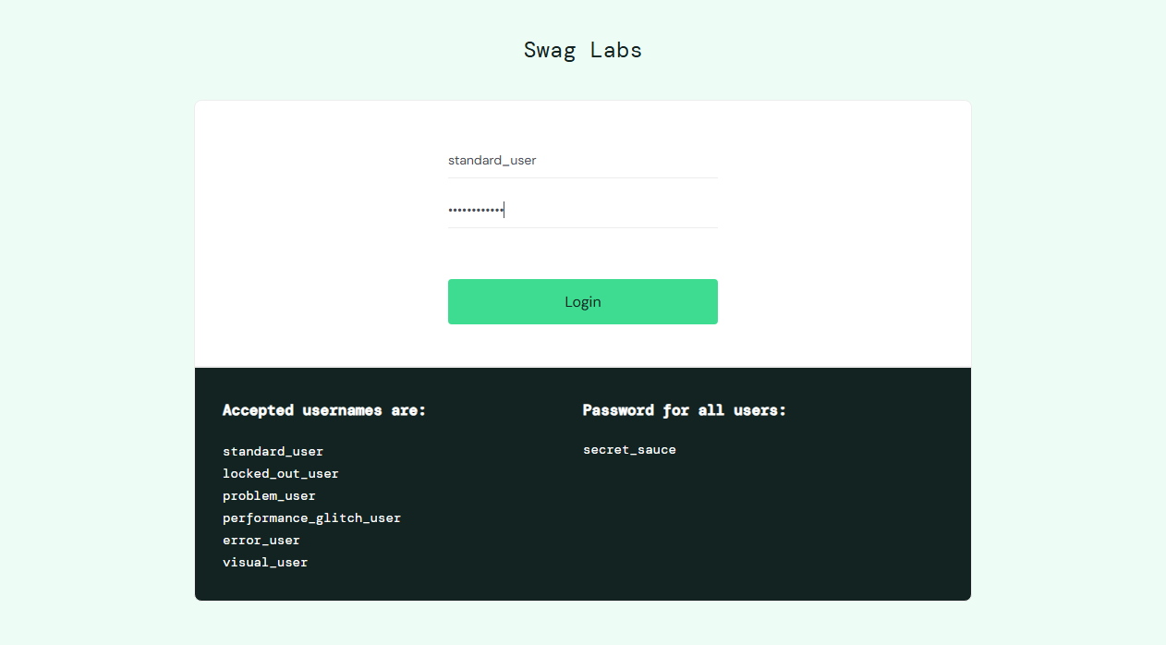
Defect ID | N/A

TC ID | LOGIN02
Test Case | Invalid username
Test Data | User: locked_out_user_xyz  Pass: secret_sauce
Expected Result | Error: Username and password do not match
Actual Result | Error banner rendered: 'Username and password do not match'.
Status | PASS
Screenshot | 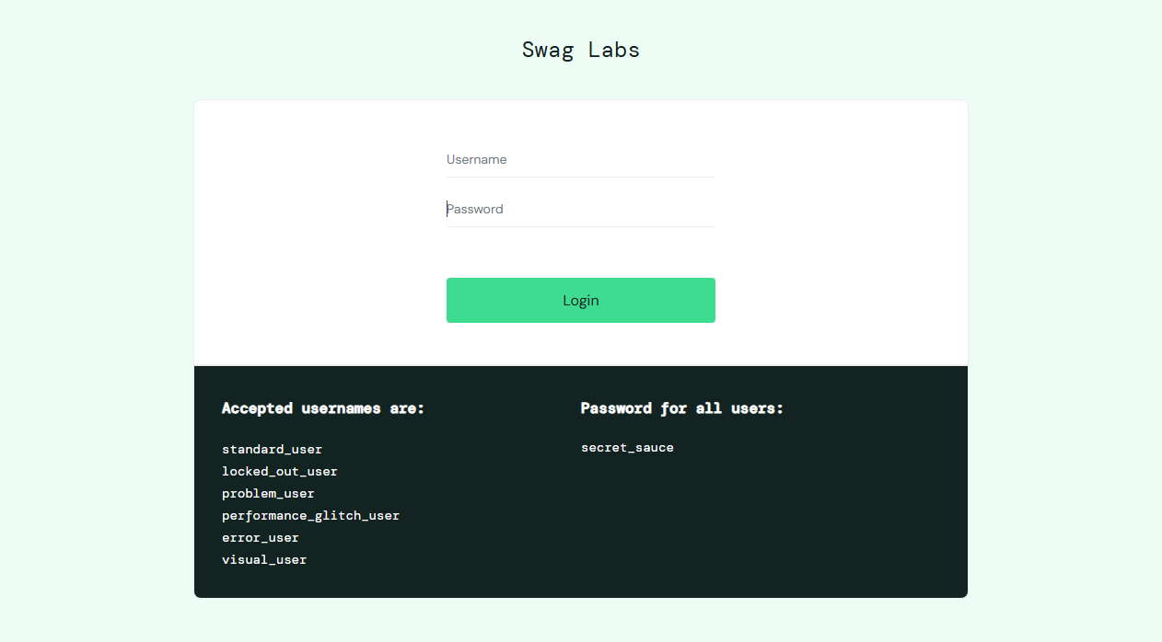
Defect ID | N/A

TC ID | LOGIN03
Test Case | Invalid password
Test Data | User: standard_user  Pass: wrong_pass_999
Expected Result | Error: Username and password do not match
Actual Result | Error banner rendered: 'Username and password do not match'.
Status | PASS
Screenshot
Defect ID | N/A

TC ID | LOGIN04
Test Case | Blank username
Test Data | User: [Empty]  Pass: secret_sauce
Expected Result | Error: 'Epic sadface: Username is required'
Actual Result | Error displayed: 'Epic sadface: Username is required'.
Status | PASS
Screenshot | 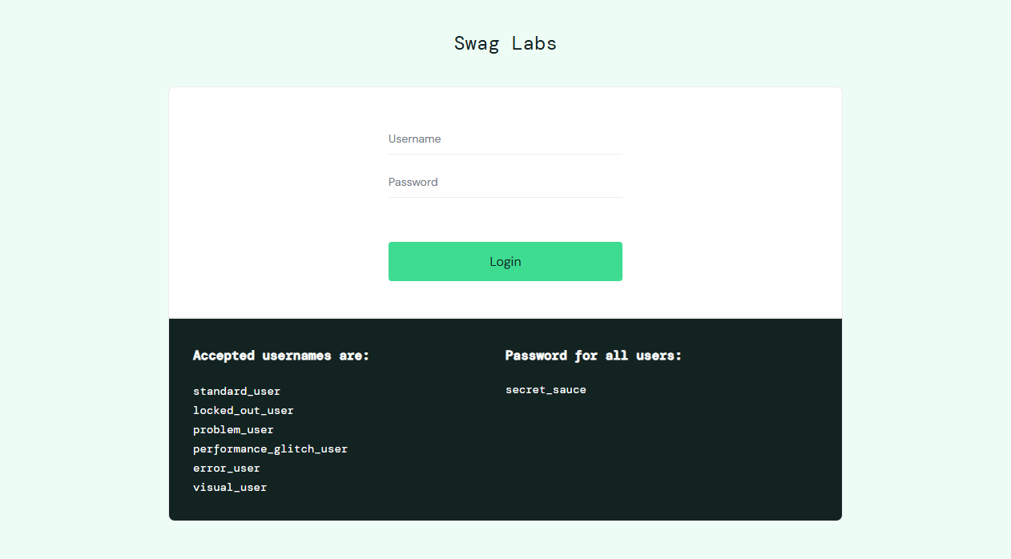
Defect ID | N/A

TC ID | LOGIN05
Test Case | Blank password
Test Data | User: standard_user  Pass: [Empty]
Expected Result | Error: 'Epic sadface: Password is required'
Actual Result | Error displayed: 'Epic sadface: Password is required'.
Status | PASS
Screenshot | 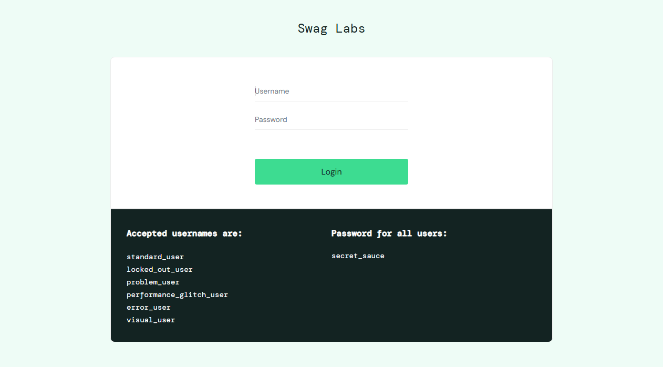
Defect ID | N/A

TC ID | LOGIN06
Test Case | Verify successful authentication
Test Data | URL check: '/inventory.html'
Expected Result | User authenticated; inventory catalog rendered
Actual Result | URL confirms '/inventory.html'; session verified active.
Status | PASS
Screenshot | 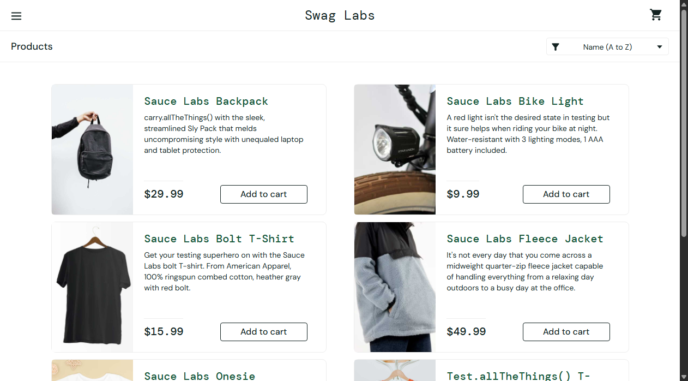
Defect ID | N/A

TC ID | LOGIN07
Test Case | Verify page title using assertion
Test Data | assert 'Swag Labs' in driver.title
Expected Result | Assertion passes; title confirmed 'Swag Labs'
Actual Result | Assertion passed with 0 errors.
Status | PASS
Screenshot
Defect ID | N/A

TC ID | LOGIN08
Test Case | Verify logout
Test Data | Action: Logout via side menu
Expected Result | User session destroyed; redirected to login page
Actual Result | Logout verified; user returned to login screen.
Status | PASS
Screenshot
Defect ID | N/A

TC ID | LOGIN09
Test Case | Handle missing element exception
Test Data | Element ID: non_existent_element_id_xyz
Expected Result | NoSuchElementException caught in try-except block gracefully
Actual Result | Exception intercepted and logged without test failure.
Status | PASS
Screenshot
Defect ID | N/A

TC ID | LOGIN10
Test Case | Verify error message
Test Data | Assert: 'Username and password do not match' in text
Expected Result | Error message accurately verified against specification
Actual Result | Assertion matches expected error text exactly.
Status | PASS
Screenshot
Defect ID | N/A

4. Summary of Required Evidence Screenshots
As specified in the curriculum, the six mandatory screenshots (Valid login, Invalid login, Authentication result, Assertion result, Exception handling, and Logout) have been fully captured and validated in the tables above.

