* *What causes substantial upload on my computer?*

As a general rule, the only way to get yourself over the upload limit is the use of p2p-based programs or websites. This includes:

* + Torrent clients (utorrent, bittorrent, etc) – **note that illegal activity is strictly forbidden and can result in a one month ban if we get reports!**
  + P2P-based streaming programs and embedded flash players (Sopcast, Streamtorrent, Veetle, GOMplayer, Ycast etc) – **YouTube is okay!**
  + P2P-based movie sites (every site which can be googled with "full movies online")
  + Obscure Chinese and Russian stuff which we don't even know at all
  + Also: many hours of videochatting in Skype

Of course, you can also get over the limit if you're intentionally uploading huge image galleries, movies, or ISO-files, but if you're geek enough to do that, we assume you know what you're doing anyways.

* *What can I do to avoid huge uploads?*

Restrict upload speed if you're using any of the above stuff. You can usually do it in the settings of the respective program. However, we recommend to restrict your upload on the system level. Unsurprisingly, there's no option in Windows to do that, but there are apps for it. We recommend and use NetBalancer. Here is the installation guide:

1. Go to <http://seriousbit.com/netbalancer/> and download the free version

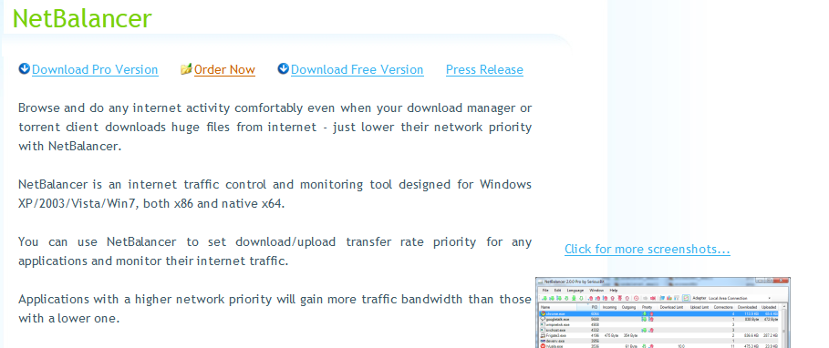

1. Install (Next->next->finish method). Restart the computer when prompted! Restart.

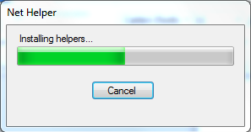

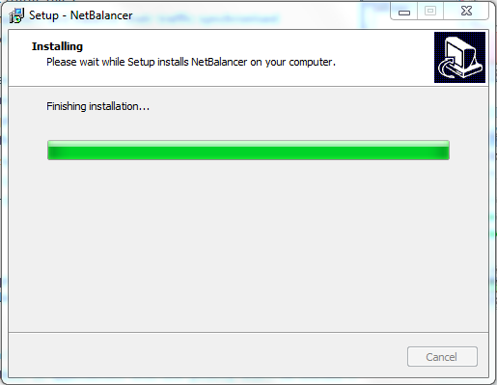

1. Open up netbalancer from the tray or the start menu, and go to settings:

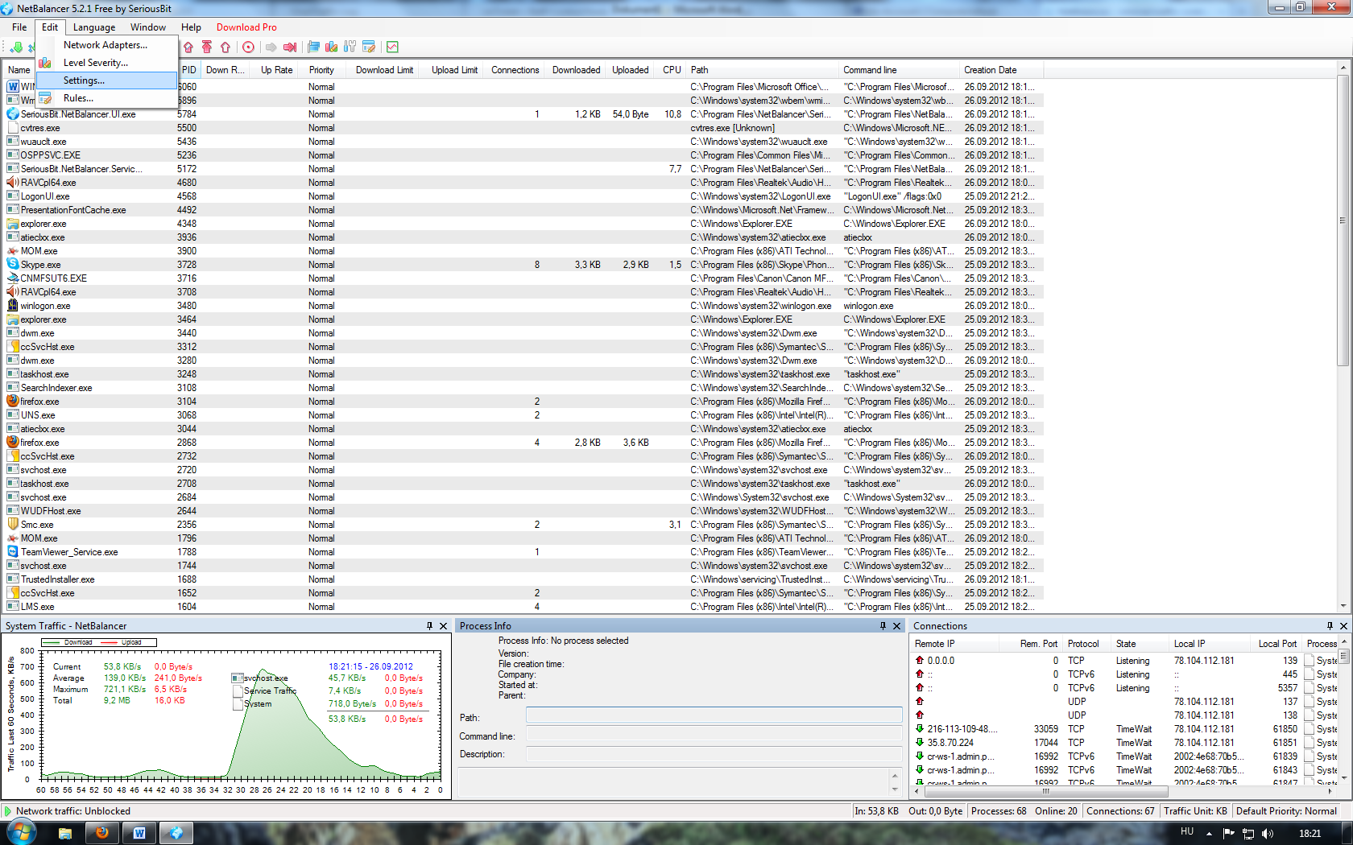

1. Set up automatic start and limit upload to not more than 50 KB. Apply.

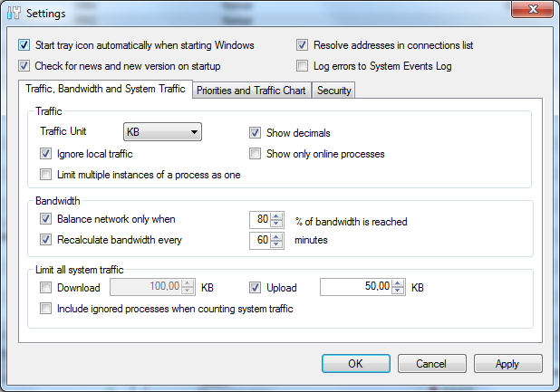

1. Enjoy the benefit of not being banned due to overtraffic.
2. Profit!

For MacOS, you have a number of software which have more or less the same functionality as NetBalancer, e.g. Entonnoir, DummyMac, or you can even do it manually:

http://pcsplace.com/apple/how-to-limit-download-and-upload-speed-on-mac/