[linux]
sockets and d-bus
Sockets use a socket number and d-bus use IPC (These are used by system.d to start all of the systems in linux).

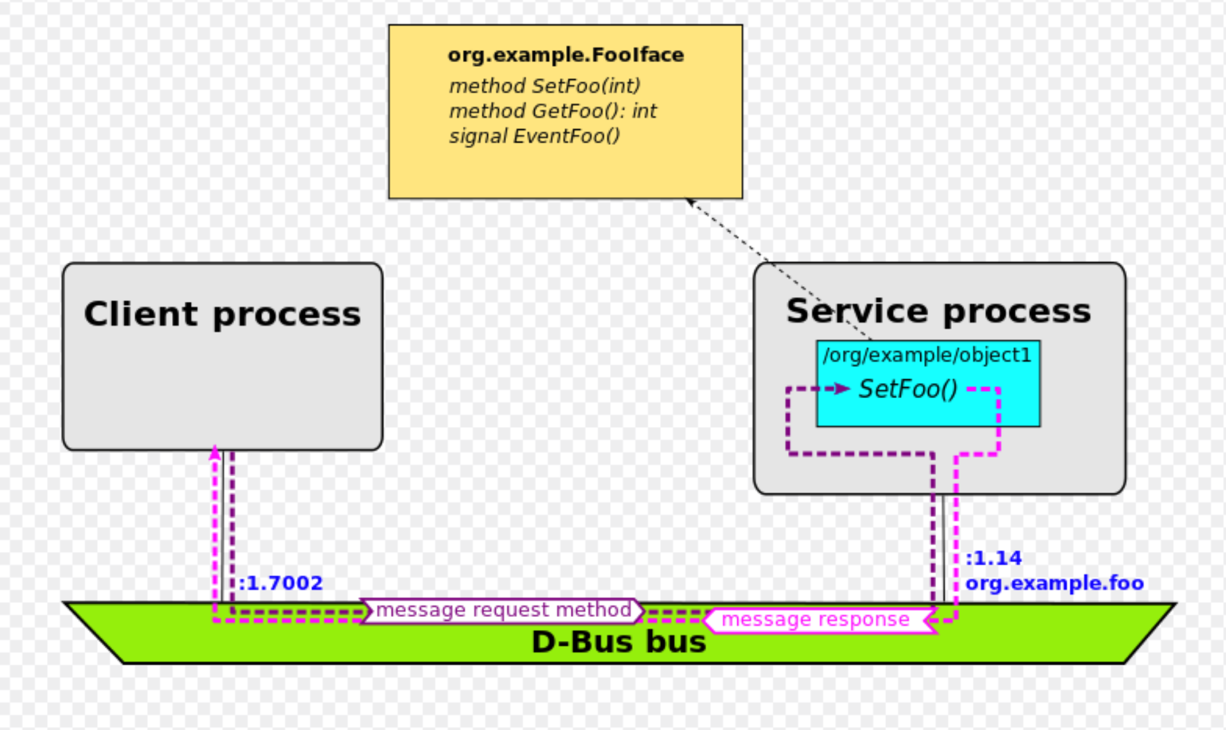
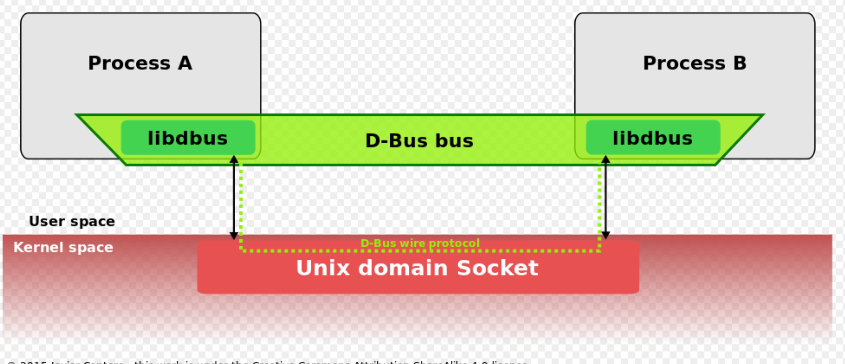

It looks like D-Bus uses linux sockets at its lover level (libdbus sockets, but dbus can also use TCP sockets).

Libdbus has a Java API implementation.

[linux]
/etc/sudoers and etc/sudoers.d (do not change these unless you really know what you are doing!!!! To erase etcsudoer.d because of a file mistake requires to reboot in single user rescue mode.

1) reboot and hold down shift key which gives you options, just press “e” for edit and add the systemd.unit-rescue.target after linux…., press F10 to execute. This will ask to confirm to go to commandline mode, change to directory with bad file (e.g., /etc/sudoers.d/) and remove the offending file. Whew! It worked. Reboot a couple of times to put back to normal. MORAL: changing sudoers is dangerous because it prevents you from changing or erasing sudoer files and BACKUP you system regularly.
