[front-end, back-end, full-stack]
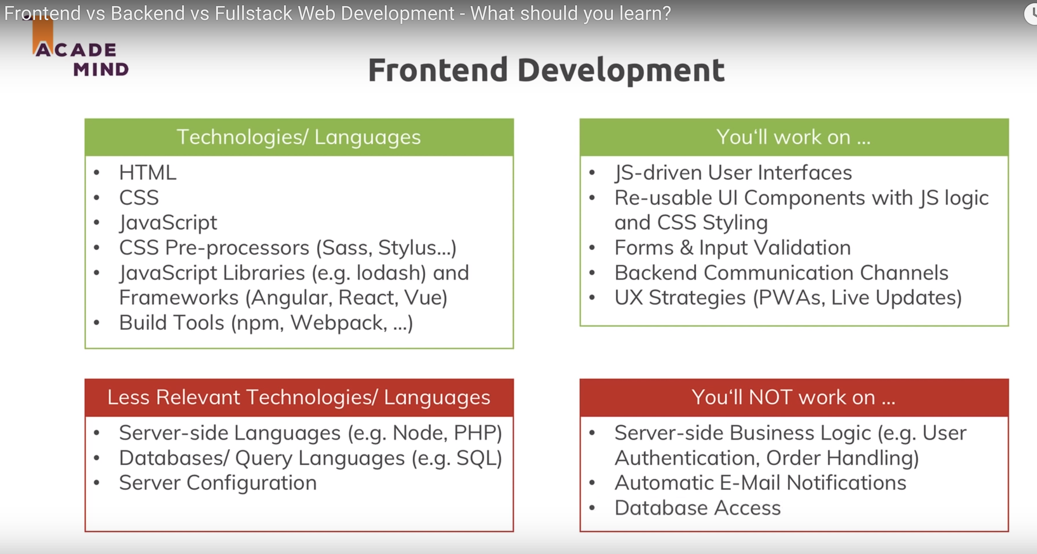

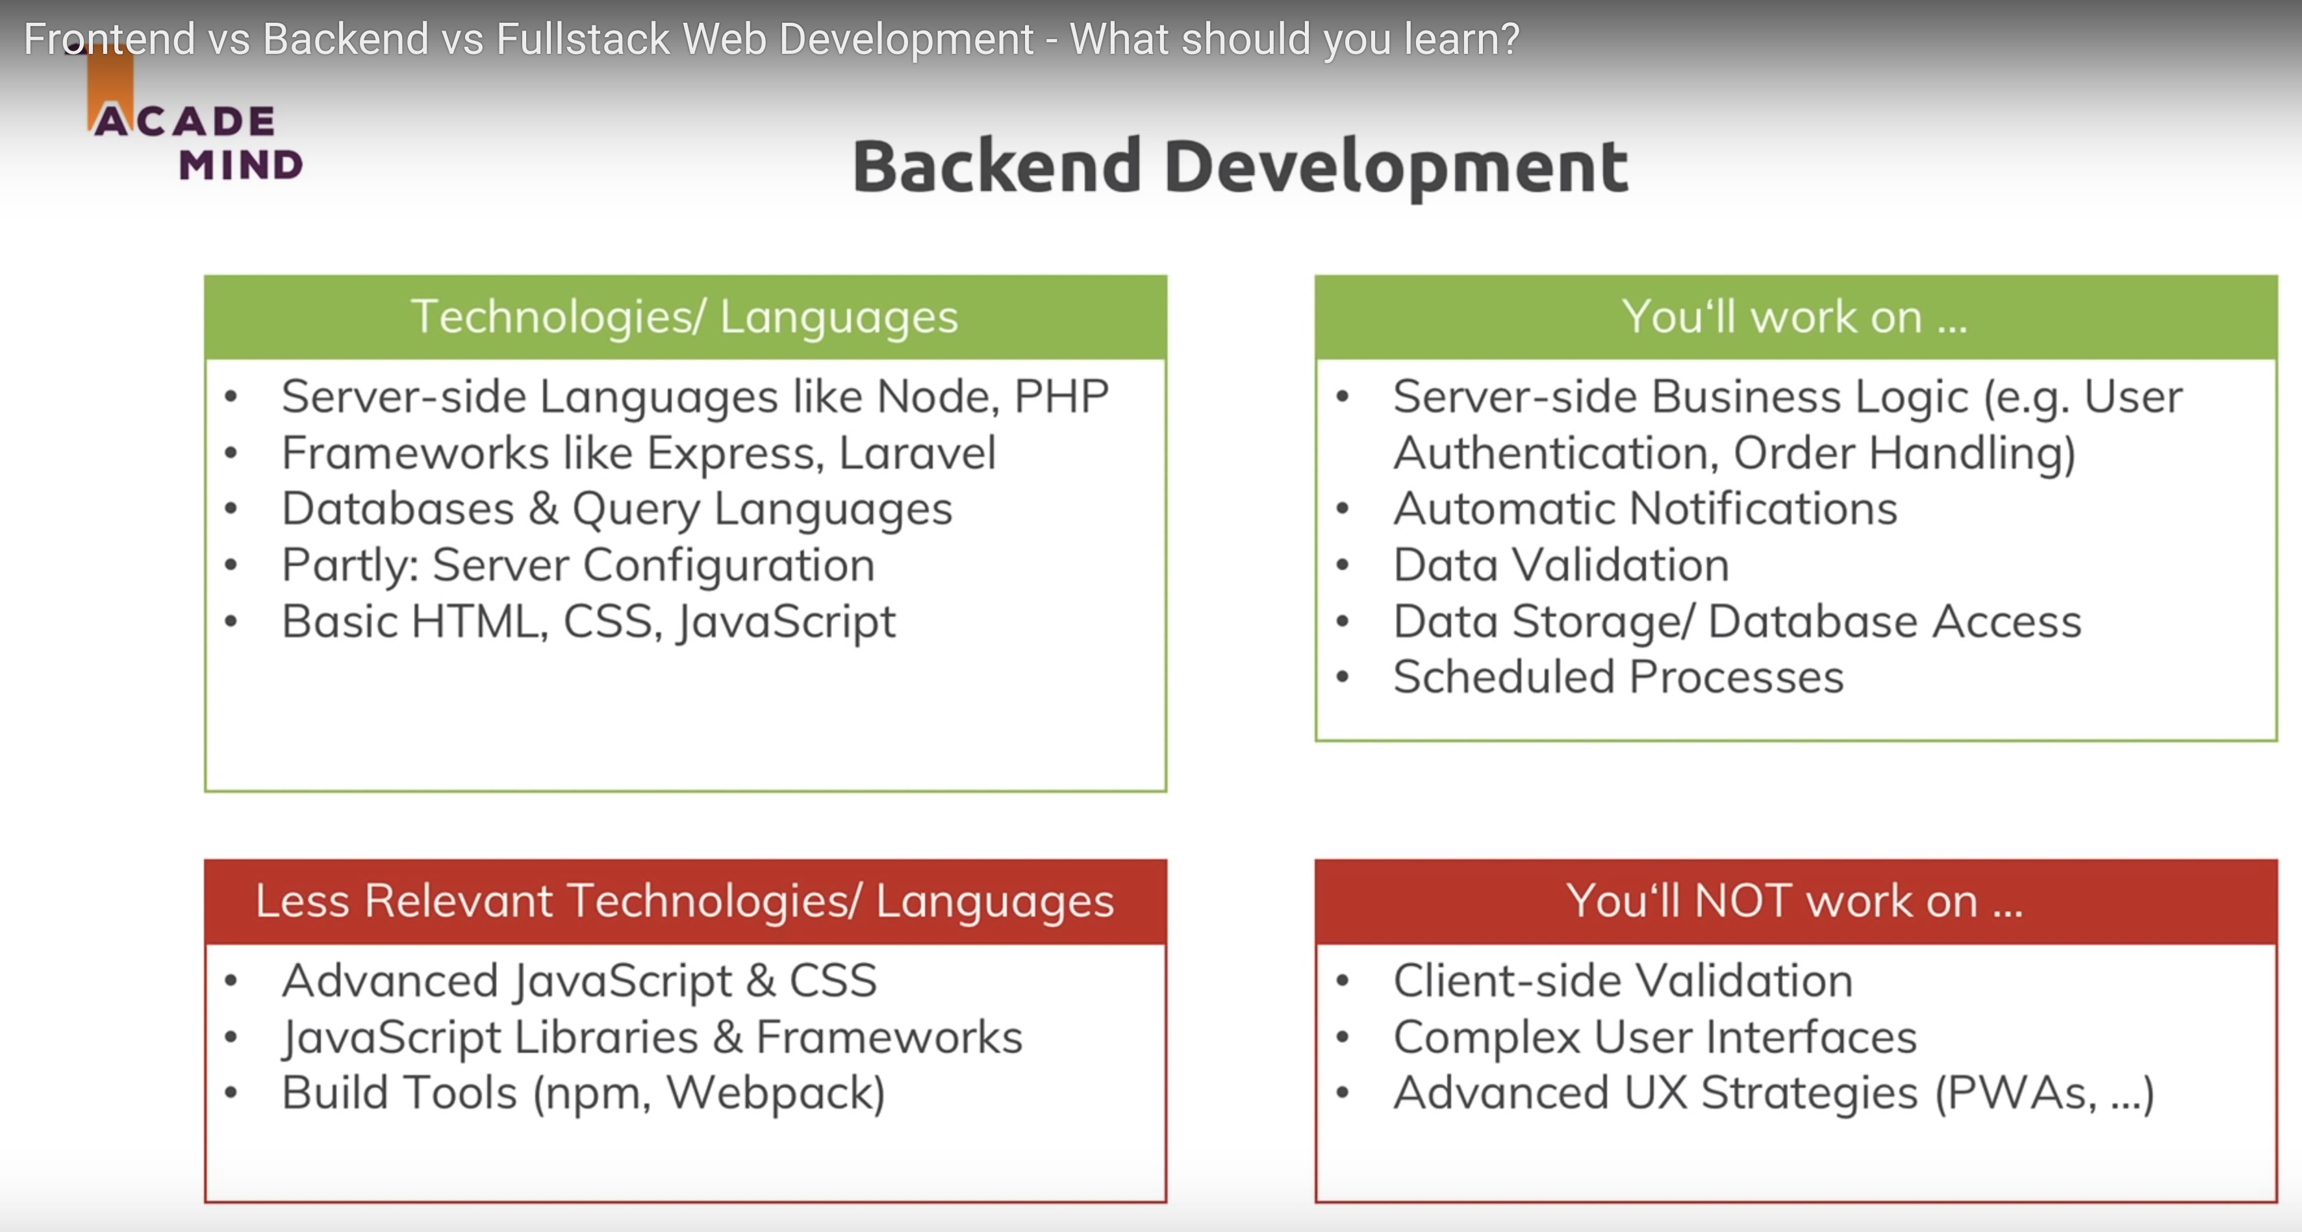

[node.js]
Use node version manager to install the latest release of node.js and npm -
1) curl -o- https://raw.githubusercontent.com/creationix/nvm/v0.33.11/install.sh | bash
2) If using zsh add .nvm to PATH
3) execute the following shell script commands -
export NVM_DIR="$HOME/.nvm"
[ -s "$NVM_DIR/nvm.sh" ] && \. "$NVM_DIR/nvm.sh" # This loads nvm
[ -s "$NVM_DIR/bash_completion" ] && \. "$NVM_DIR/bash_completion" # This loads nvm bash_completion

use npm to install angular -
npm install -g @angular/cli

[angular] – To configure Angular with Chromium, install chromium-browser from apt-get and add the following line to launch.json.
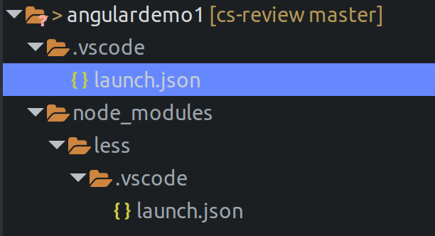
"runtimeExecutable": "/usr/bin/chromium-browser"

Screenshot from 2019-02-08 08-24-31[angular]
How an Angular module is started.
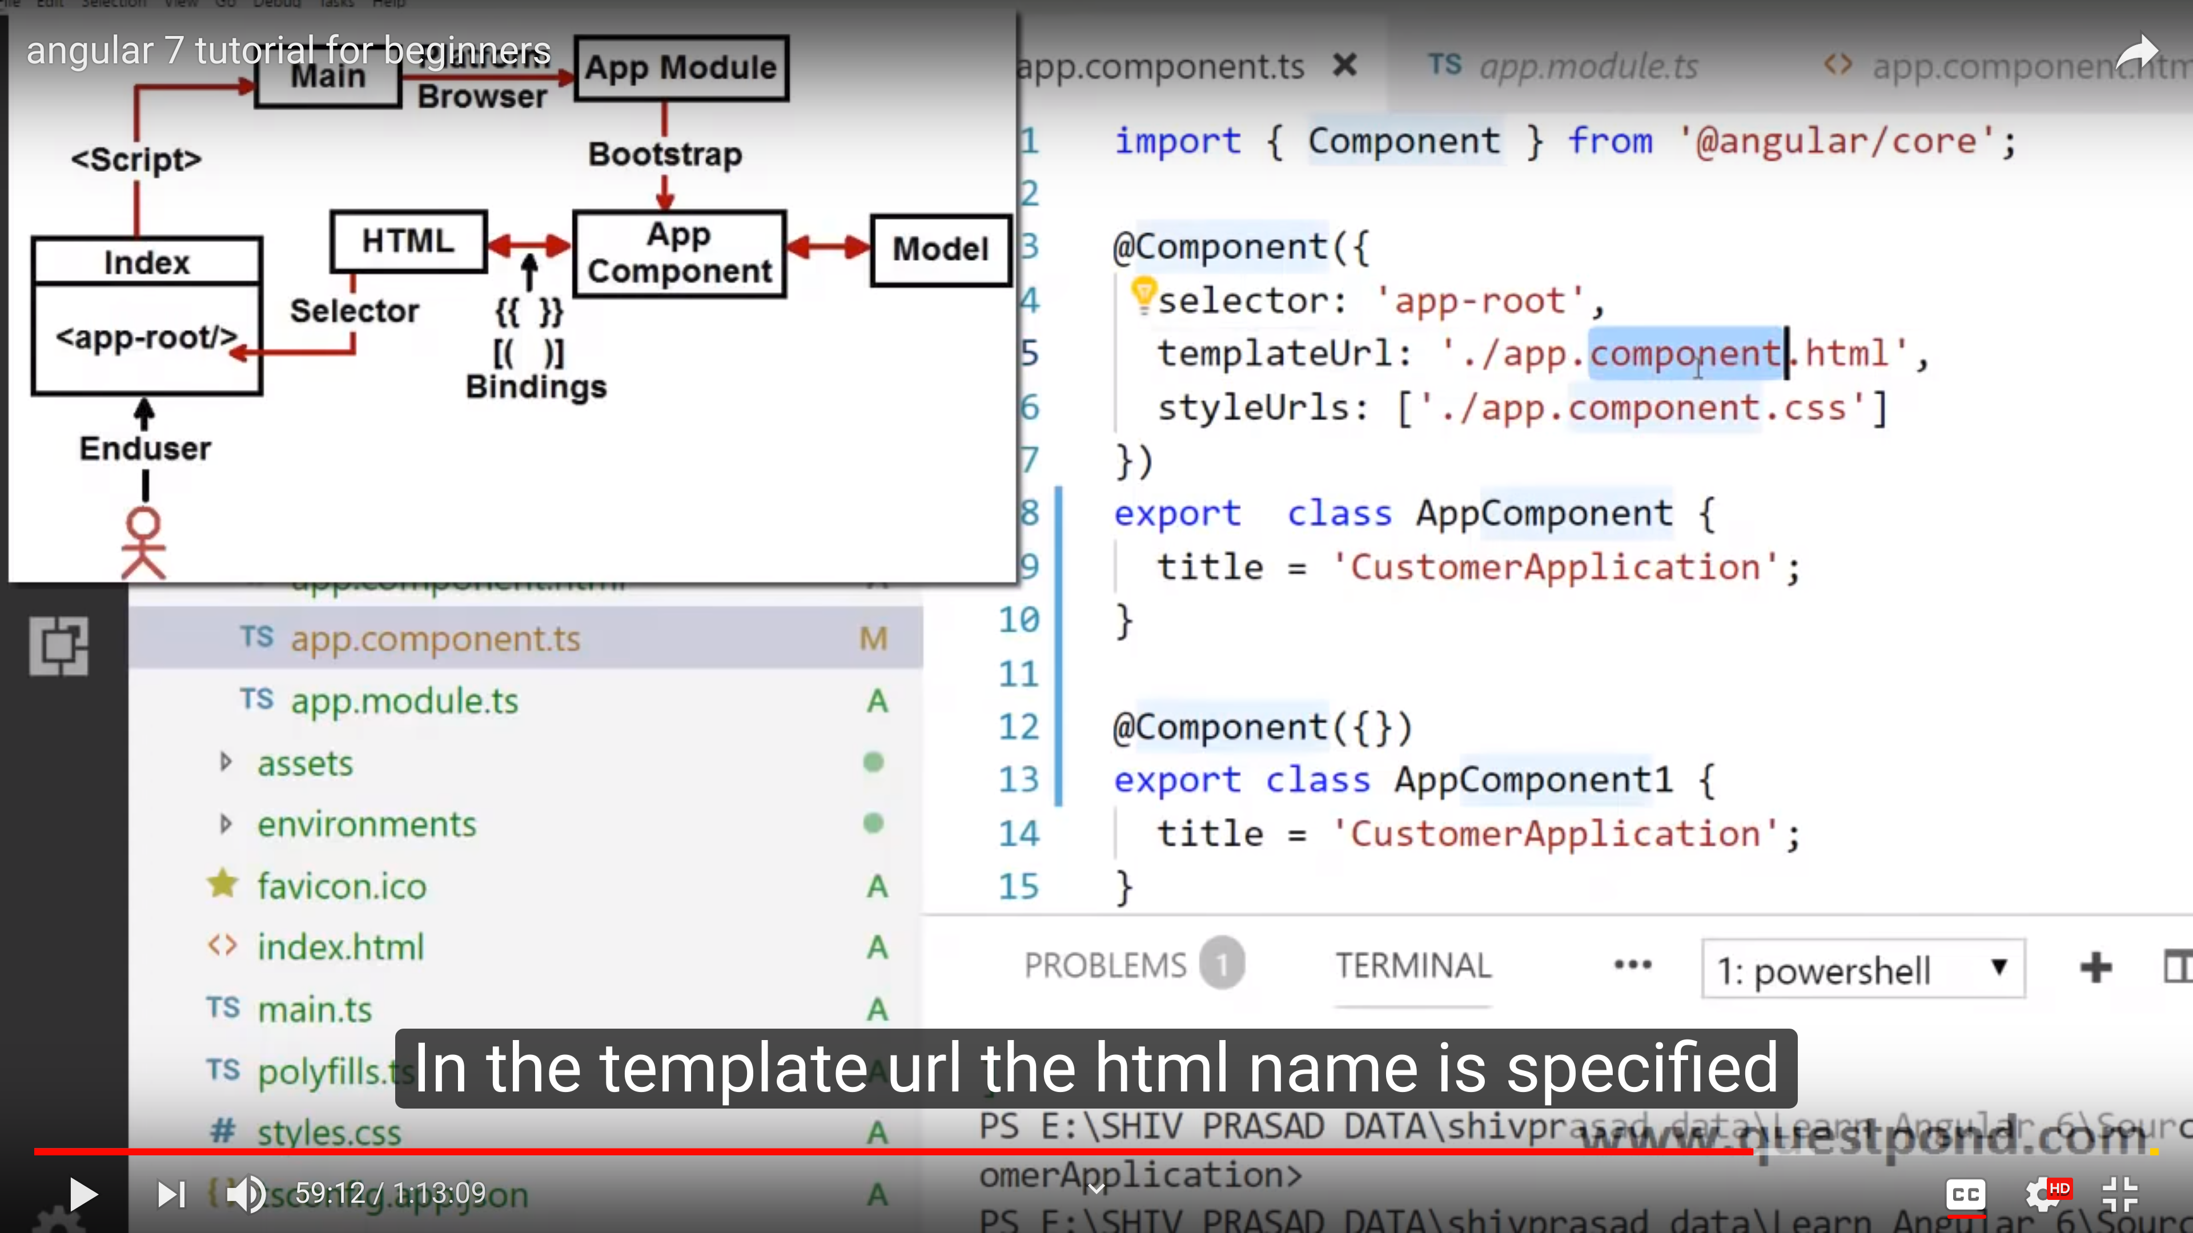
//
How an Angular typescript/html/css files are compiled to js and bundled in Webpack Package Manager
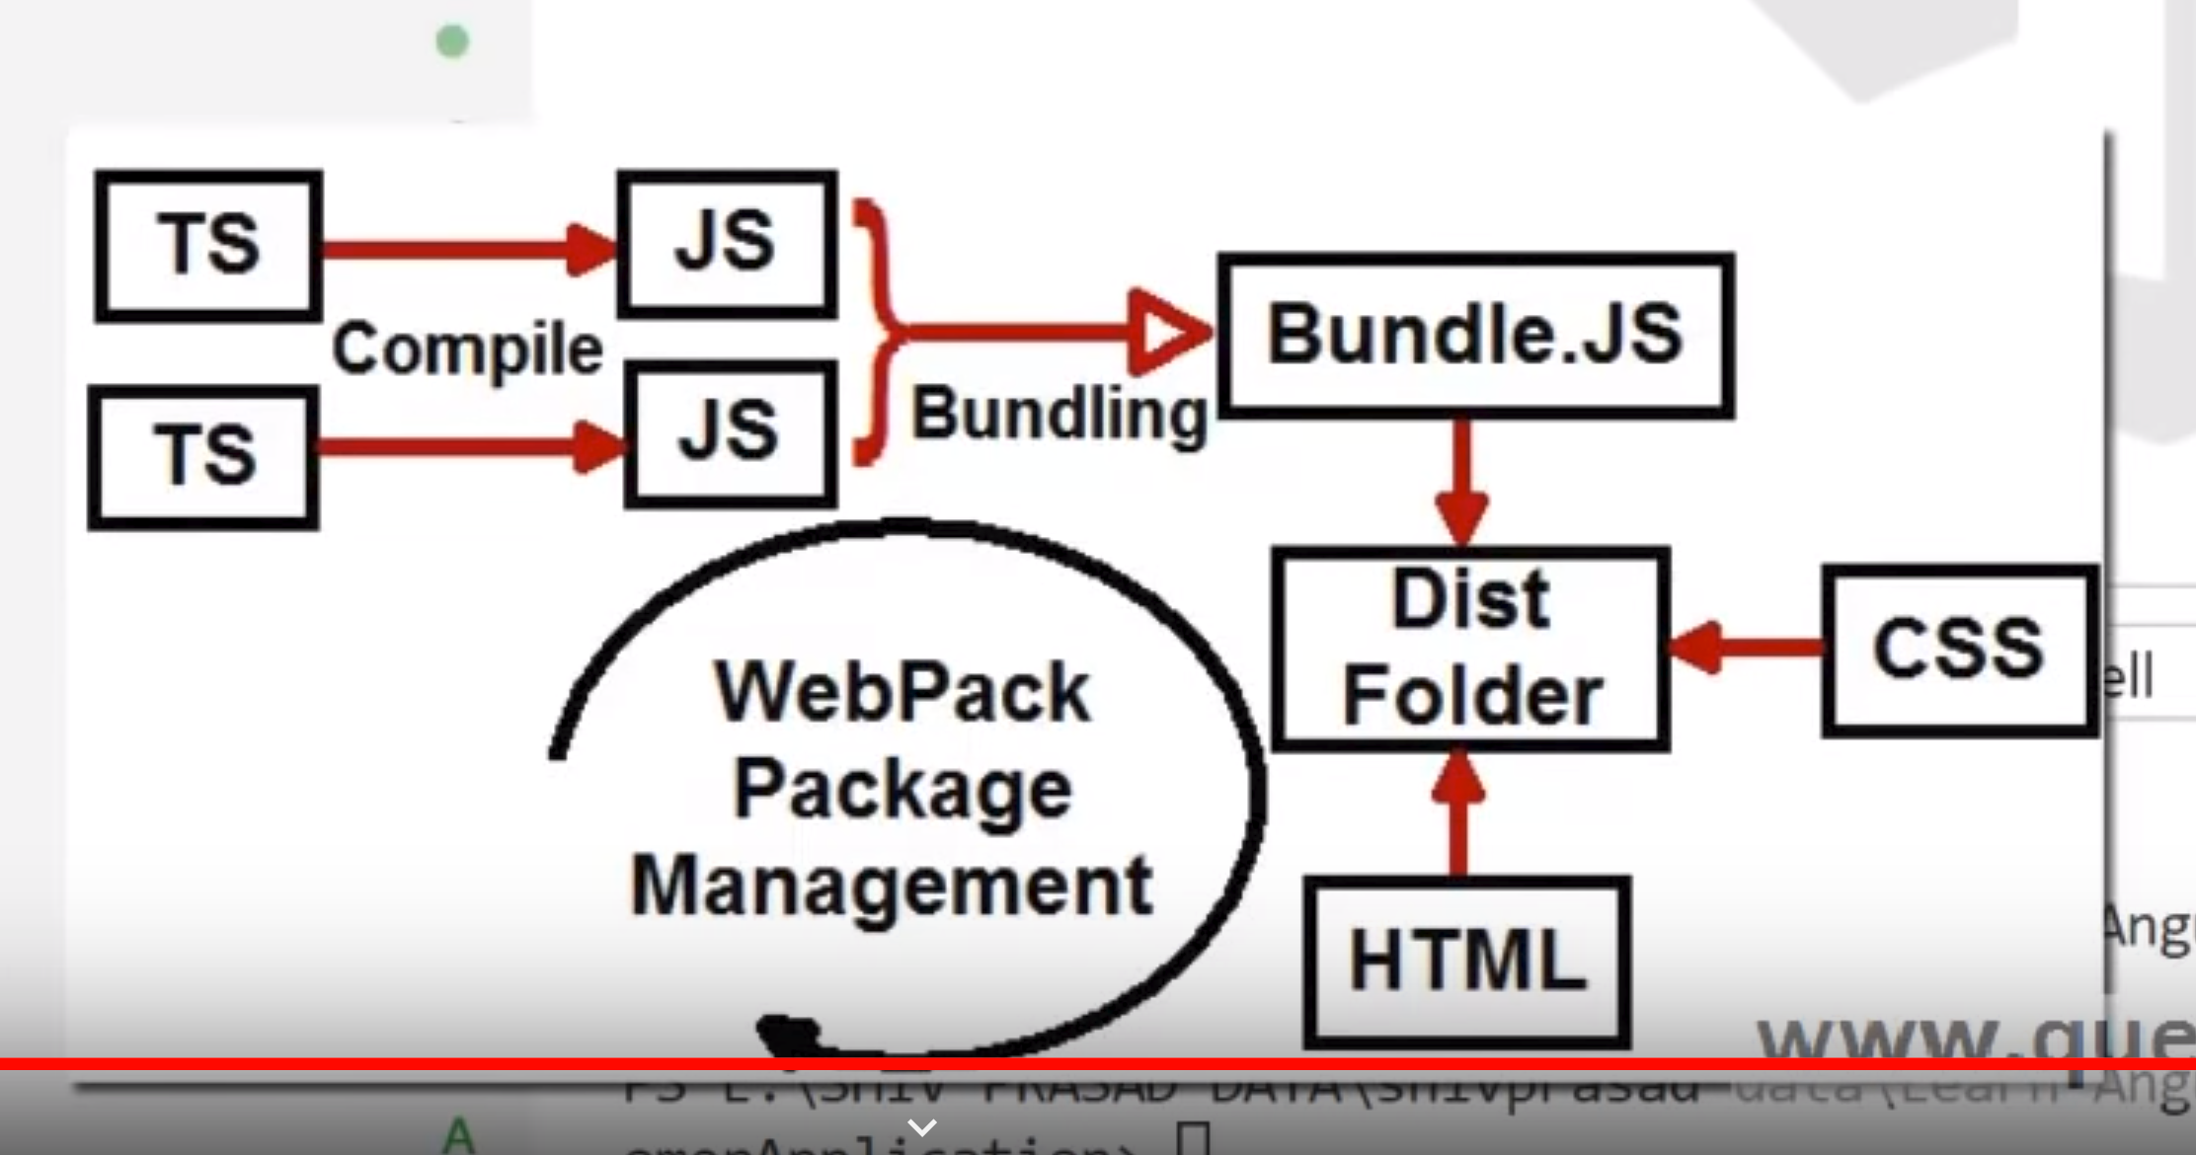

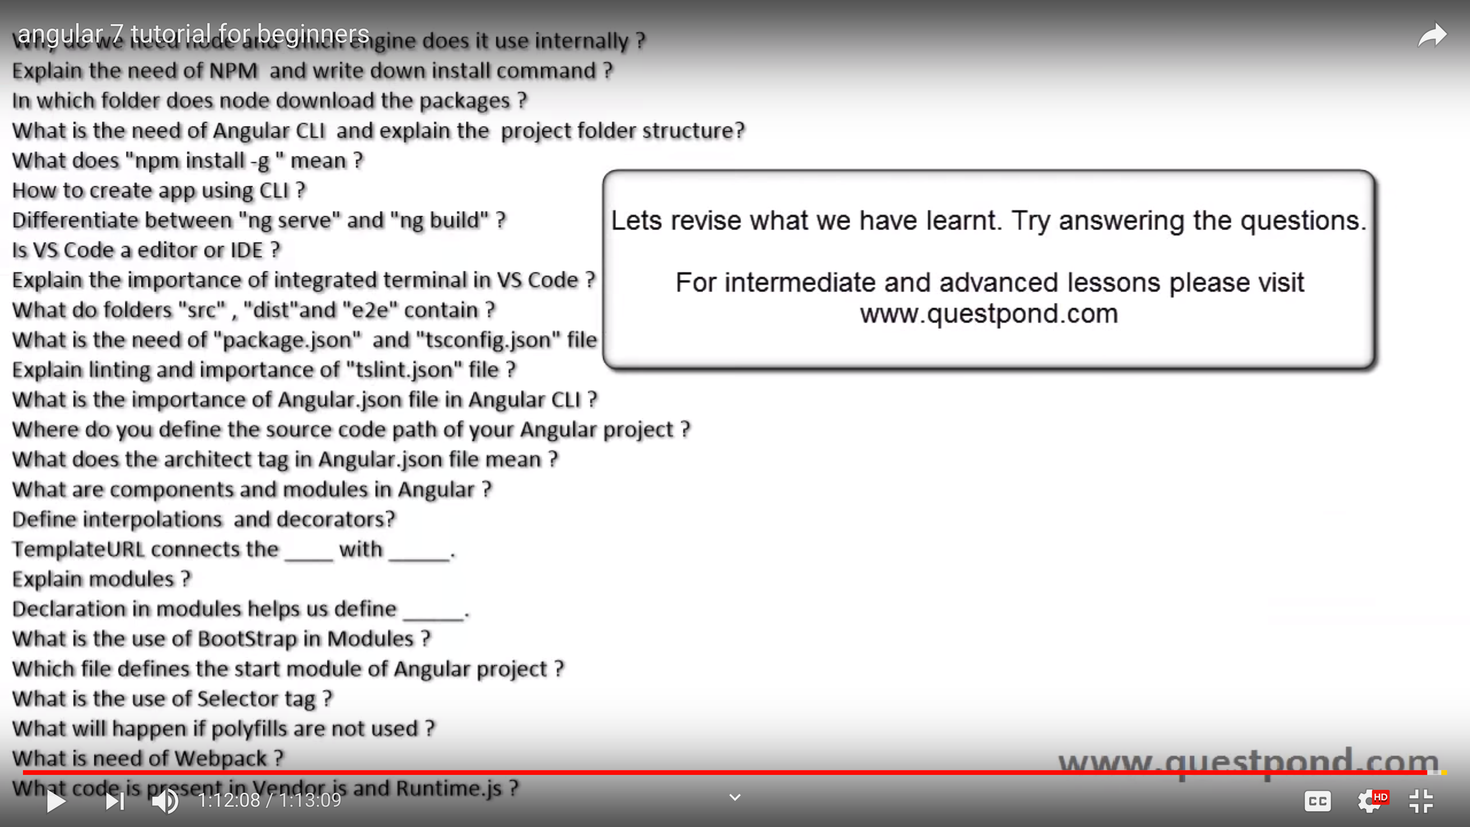
￼

[angular]
Angular components can be tags or attributes depending on how the selector is defined. Below the selector: app-service defines a custom tag.
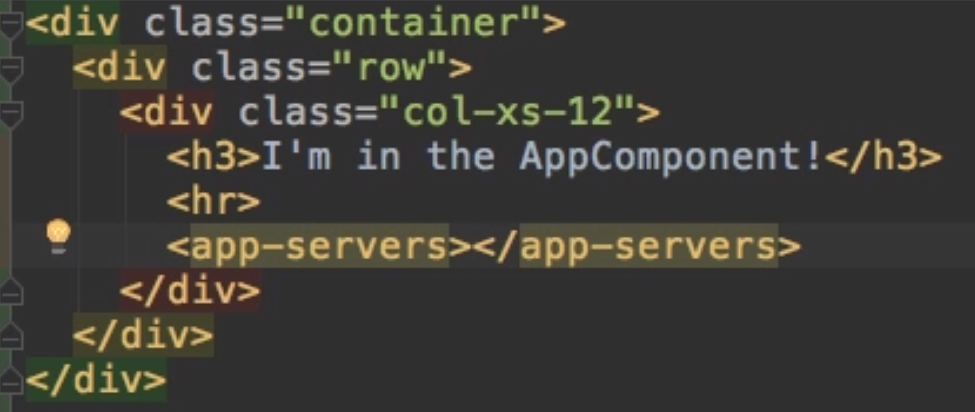

Selector: [app-service] defines app-service as an attribute which can be used in a div tag
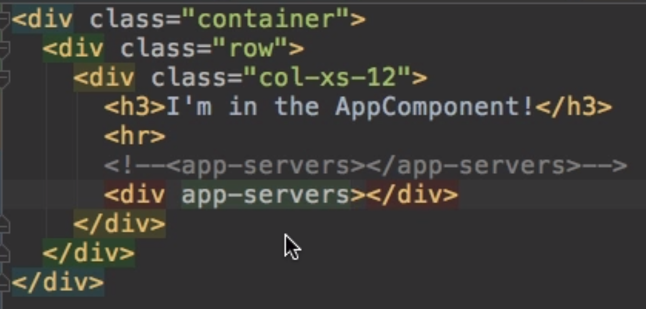

[java]
Arrays – Java arrays are fixed and cannot be added to or substracted from. Important - When initializing a java array of Objects, you must explicitly initialize elements (e.g., using new Person(“ed”,1). If not, the array will contain null values which will cause an exception if accessed. Arrays of primitive types are initialized to 0 (e.g., 0 for int and 0.0 for float).

Use the utility function java.util.Arrays to manipulate and print out arrays. When printing use something like – System.out.println(Arrays.toString(primitive or Object)); This will also print out null values instead of giving an exception when printing out Object arrays!

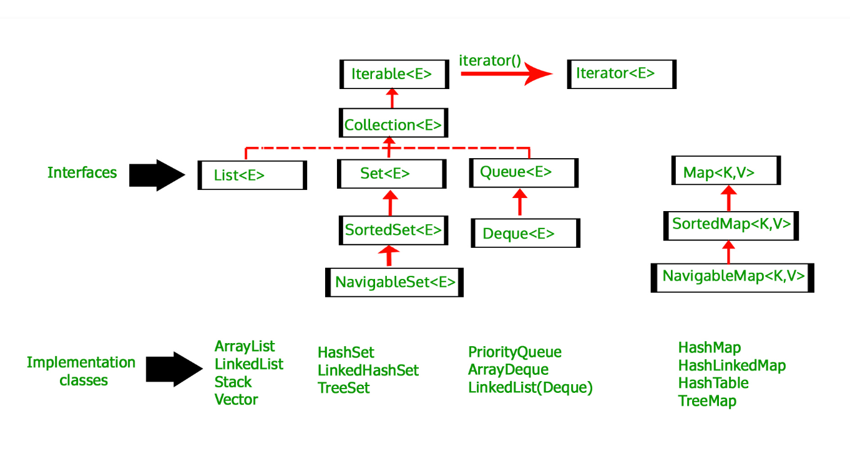

www.google.com/patents
[f ull-stack developer]
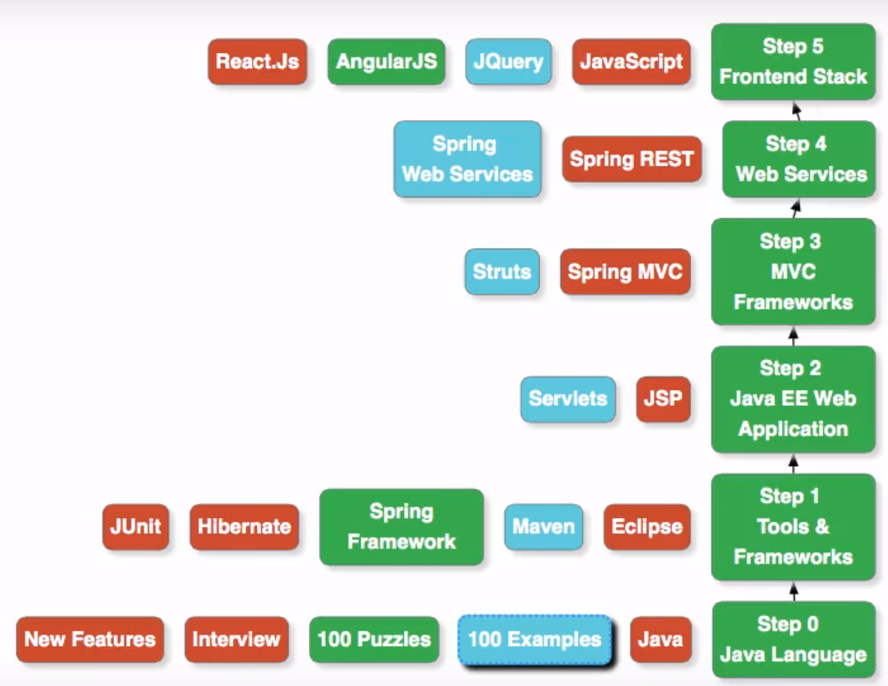

[SQ]
Primary datatypes - int, dec(m,n), varchar(), blob, date, timestamp

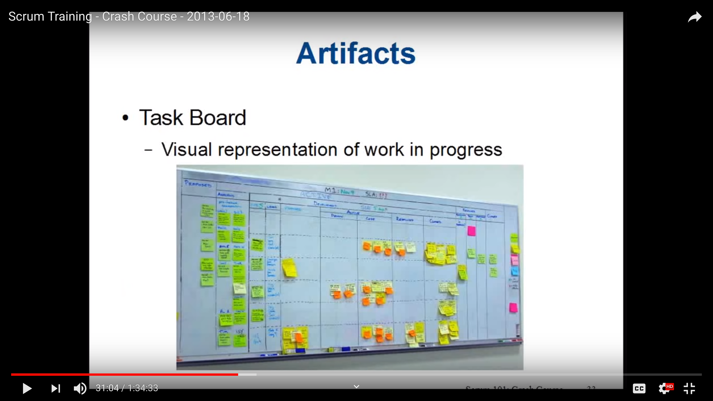
[Jira] Jira software is Jira core + agile functions
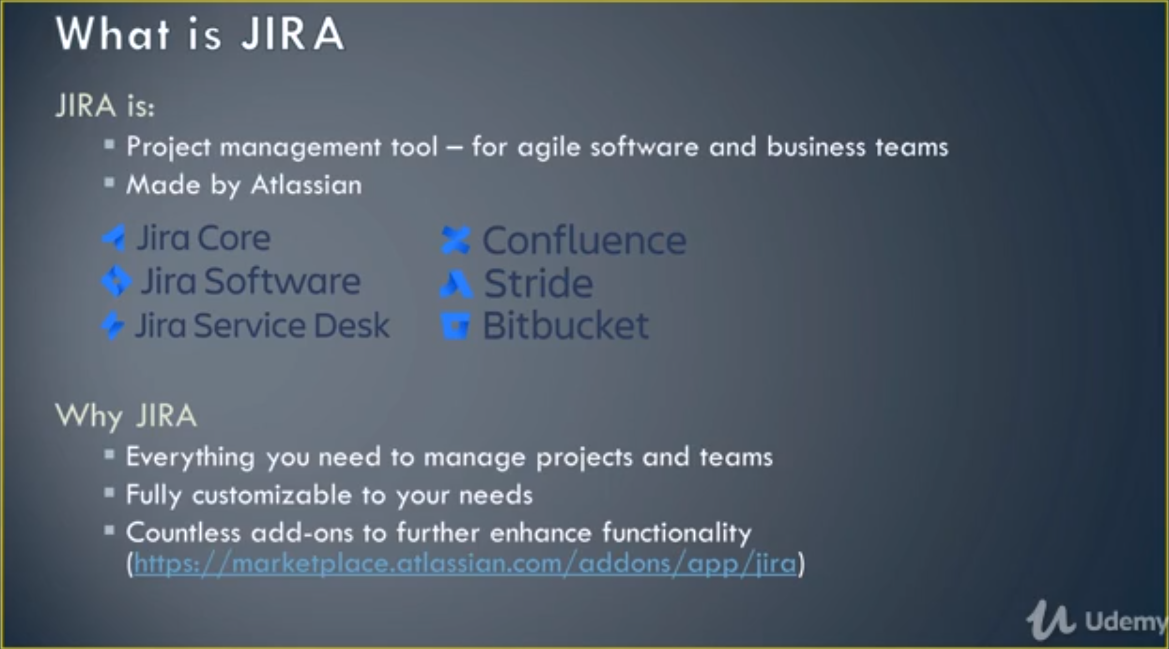

Jira Agile Functionality – Create User Stories, plan and track sprints, organize reports and releases, create custom workflows.

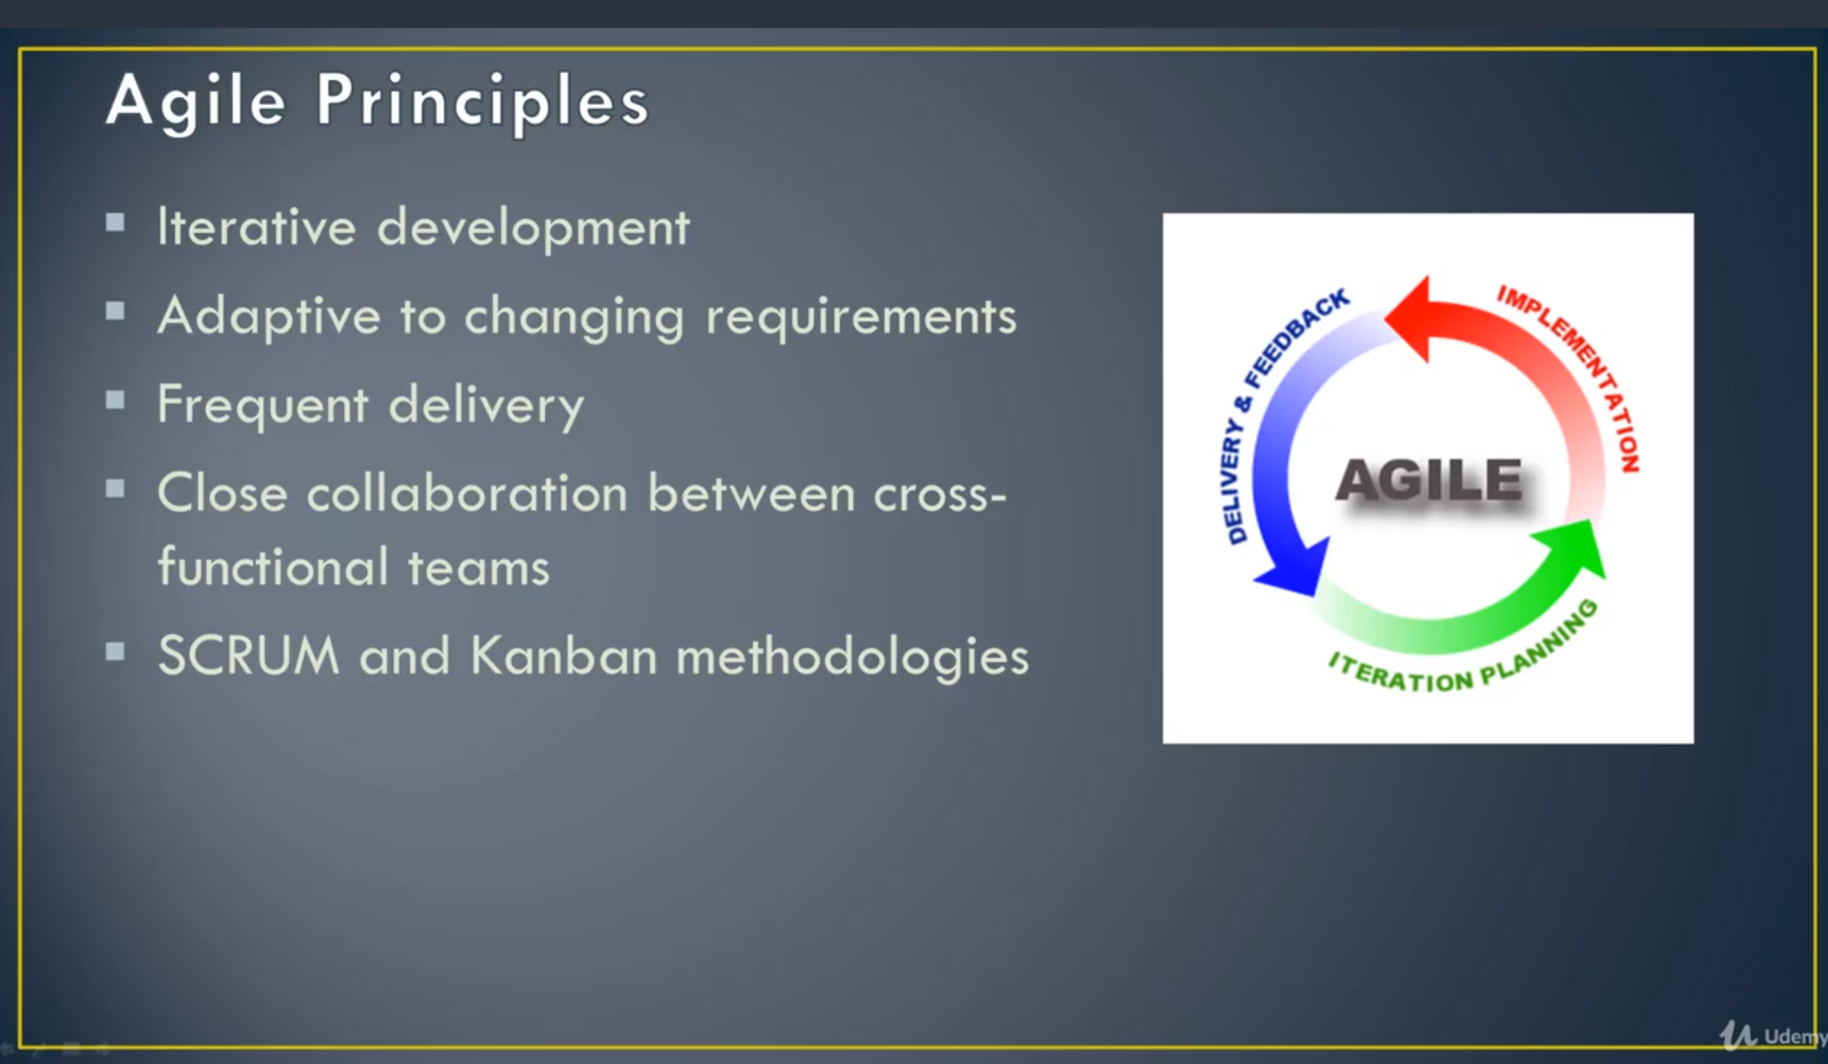

Stories are who, what and why for a new software feature (represented bystickies).
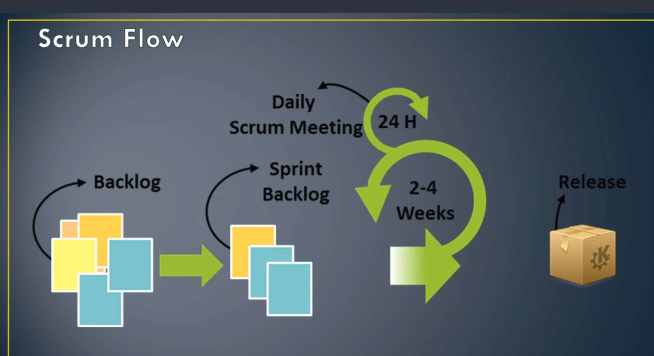

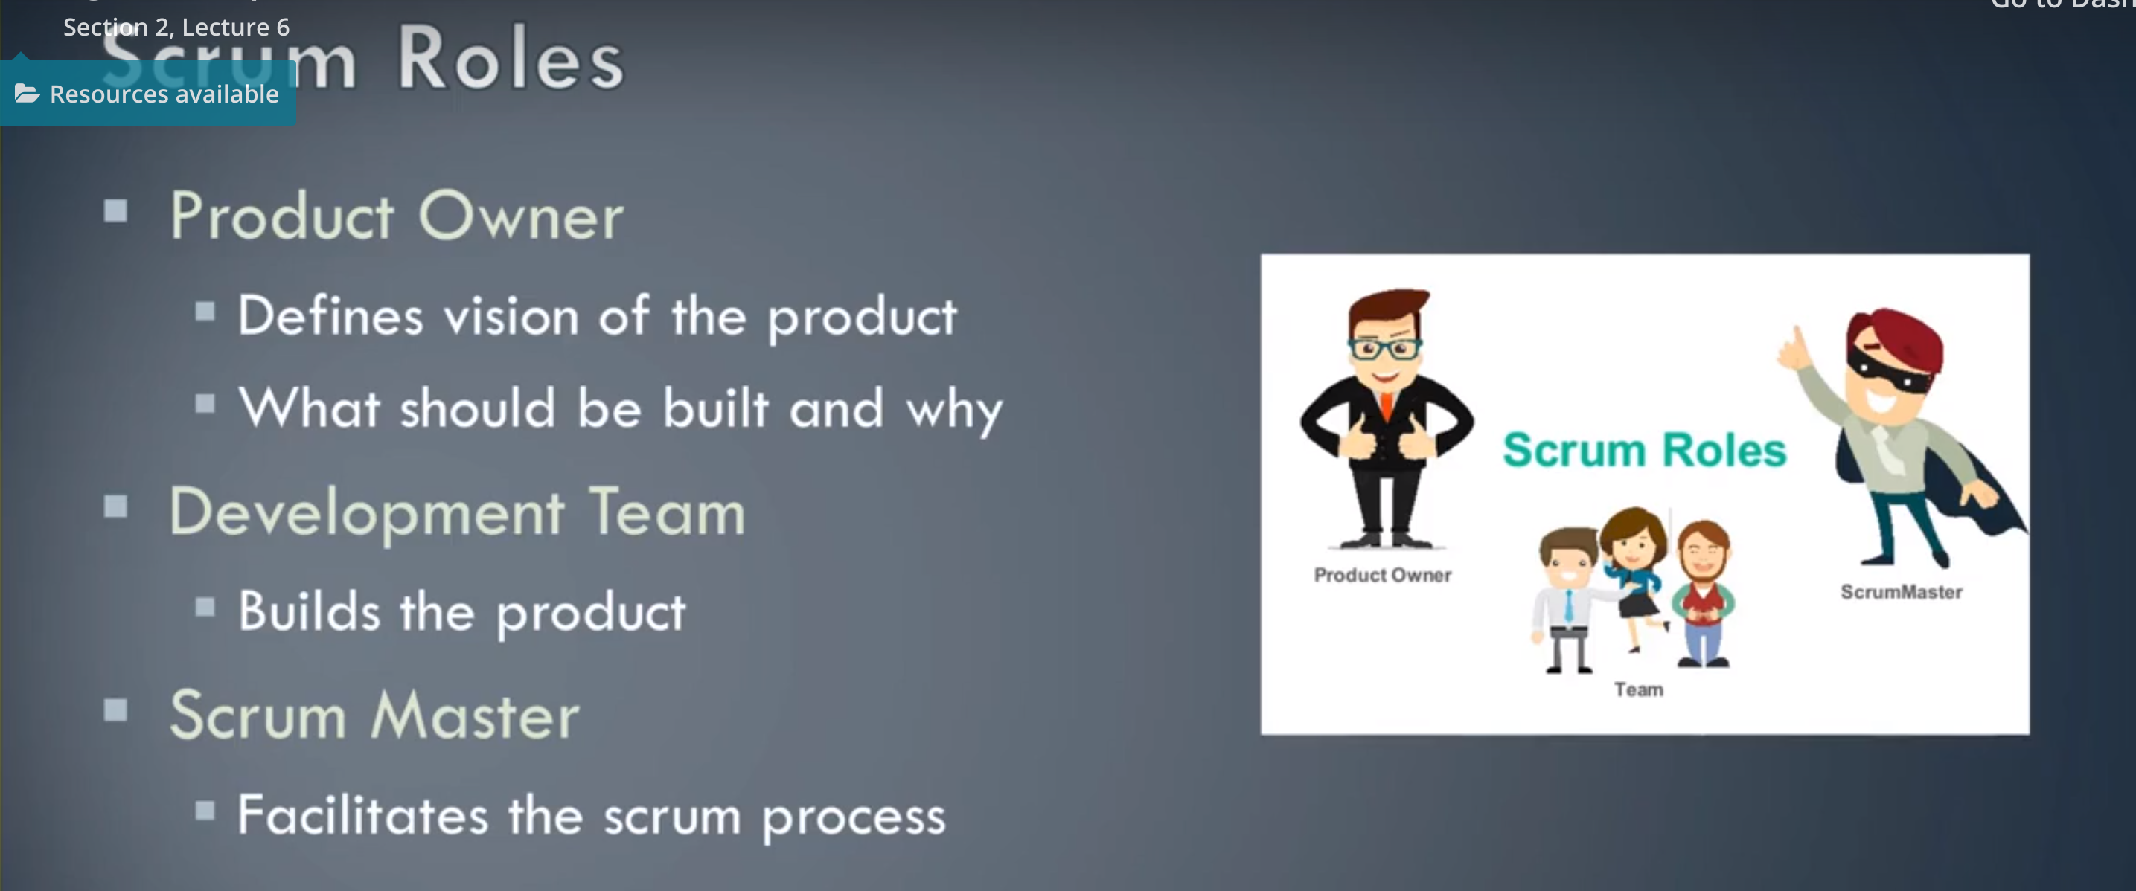

Scrum meetings and reviews -
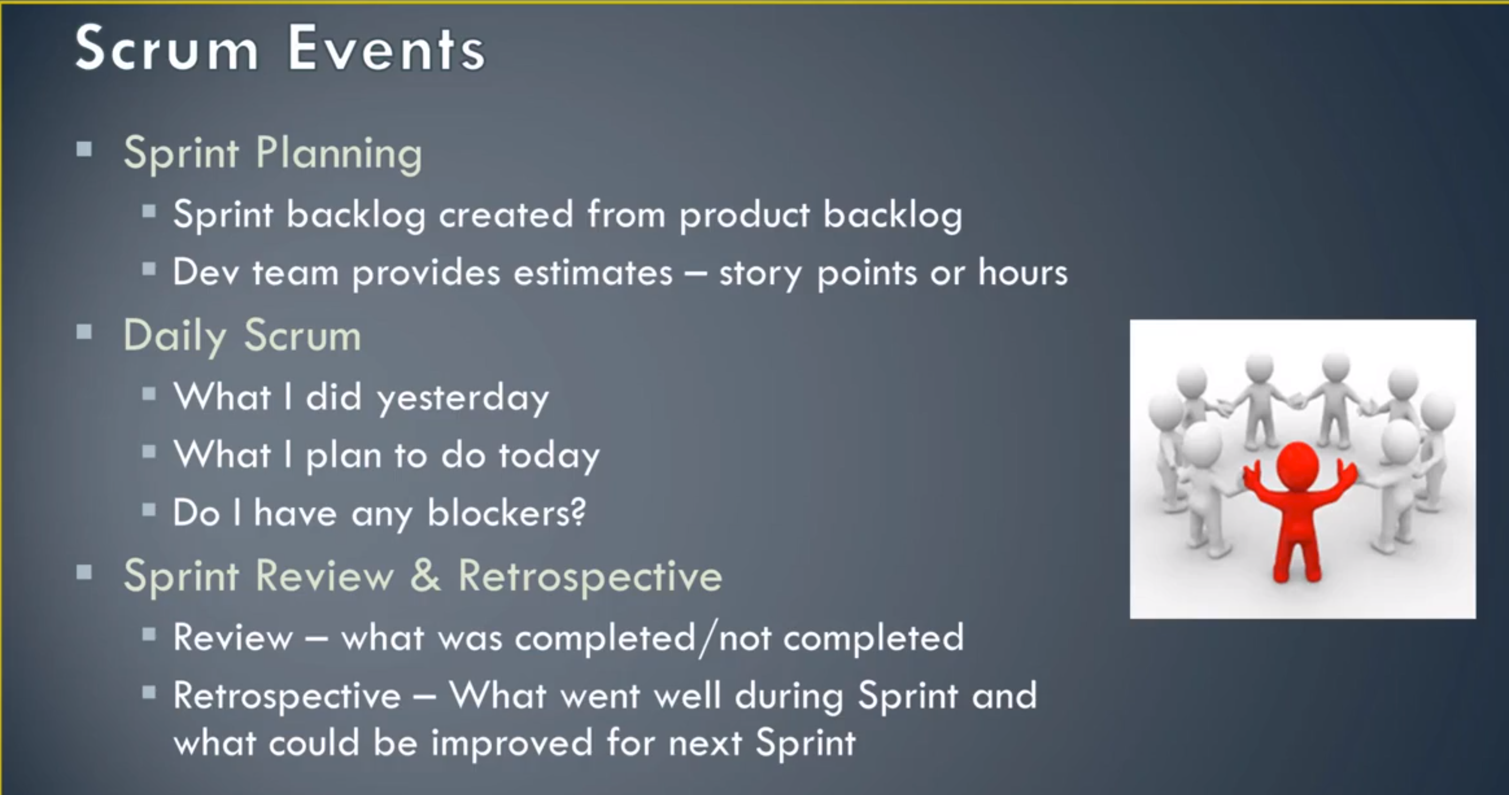

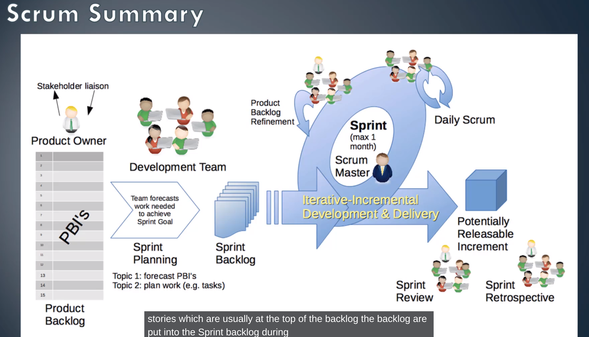
Kanban versus Scrum -

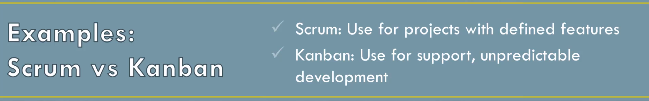

Jira Terms -
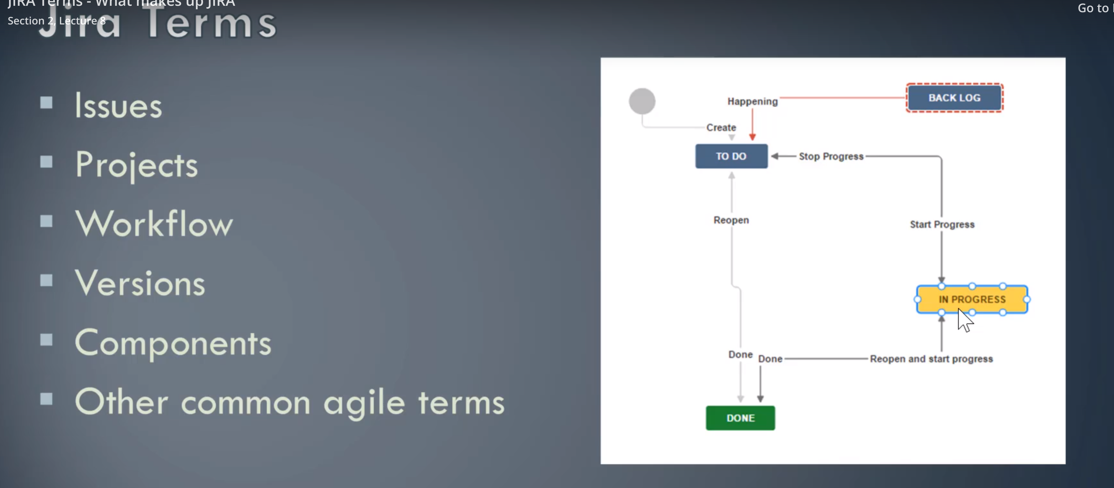

[Web Design]




[Junit]
Junit 5 separates test creation API (Jupiter API) with running tests (JUnit Platform).

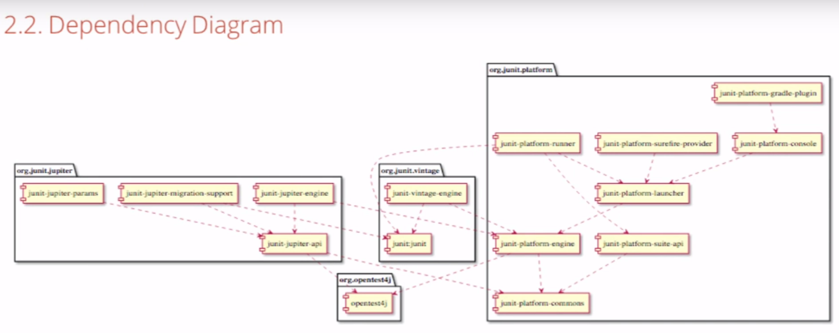
JUnit5 test cases allow for @Nested keyword to insert a new nested test class. This allows grouping of tests (e.g., input all positive numbers in a sum tests or input mixed positive/negative numbers in a sum test). In JUnit4, all tests had to have different names which were direct member functions of the top-level test class.

Junit 5 AssertAll() function runs all test even if there is a failure in the initial test and reports. Junit 4 would abort where a failure is found.

[Junit] – Using stubs and mocks

SUT – System under test
Dependency – a service that is called by the SUT

Stubs are just Java classes, so when trying to return different stub results, conditions (if cond1, return “a, b, c” list, if cond2, return “a, b” list only) become complex. Also, modifying the service interface, all of the implementing classes of the service interface (app and test classes) must be modified. This also creates complexity.

When creating tests that use a stub good to specify “-usingStub” appended to the test method name. Us “-usingMock” when using a mock.

[maven]
Maven uses JAVA_HOME environment variable to configure the target version (e.g., java 11). Have to manually set JAVA_HOME to the right implementation.

[apache]

Import org.apache.commons.io.FileUtils.readString(String filename) will read an entire file and return a String of the contents.

