[shell scripting]
There is a difference in setting a variable in interactive shell versus script which launches a new shell process.

In interactive shell and shell scripts use <prompt>set key=”value”
can check correct value with echo $key

[regex]
back referencing - <([A-Z][A-Z0-9]*)\b[^>]*>.*?</\1>. This regex contains only one pair of parentheses, which capture the string matched by [A-Z][A-Z0-9]*. This is the opening HTML tag. (Since HTML tags are case insensitive, this regex requires case insensitive matching.) The backreference \1 (backslash one) references the first capturing group. \1 matches the exact same text that was matched by the first capturing group. The / before it is a literal character. It is simply the forward slash in the closing HTML tag that we are trying to match.

[eclipse]
Tomcat 9/012 is installed in opt directory. To start and stop the server from Eclipse Photon, you must make a Server project (in others...) and open the Servers window (others...) as below. You will not get the top level servlet pages.

Also this does not configure any TSL/SSL (public or private keys) which should be done on a front-end server, e.g., a reverse proxy configuration of Apache (DB ↔ Tomcat ↔ Apache).

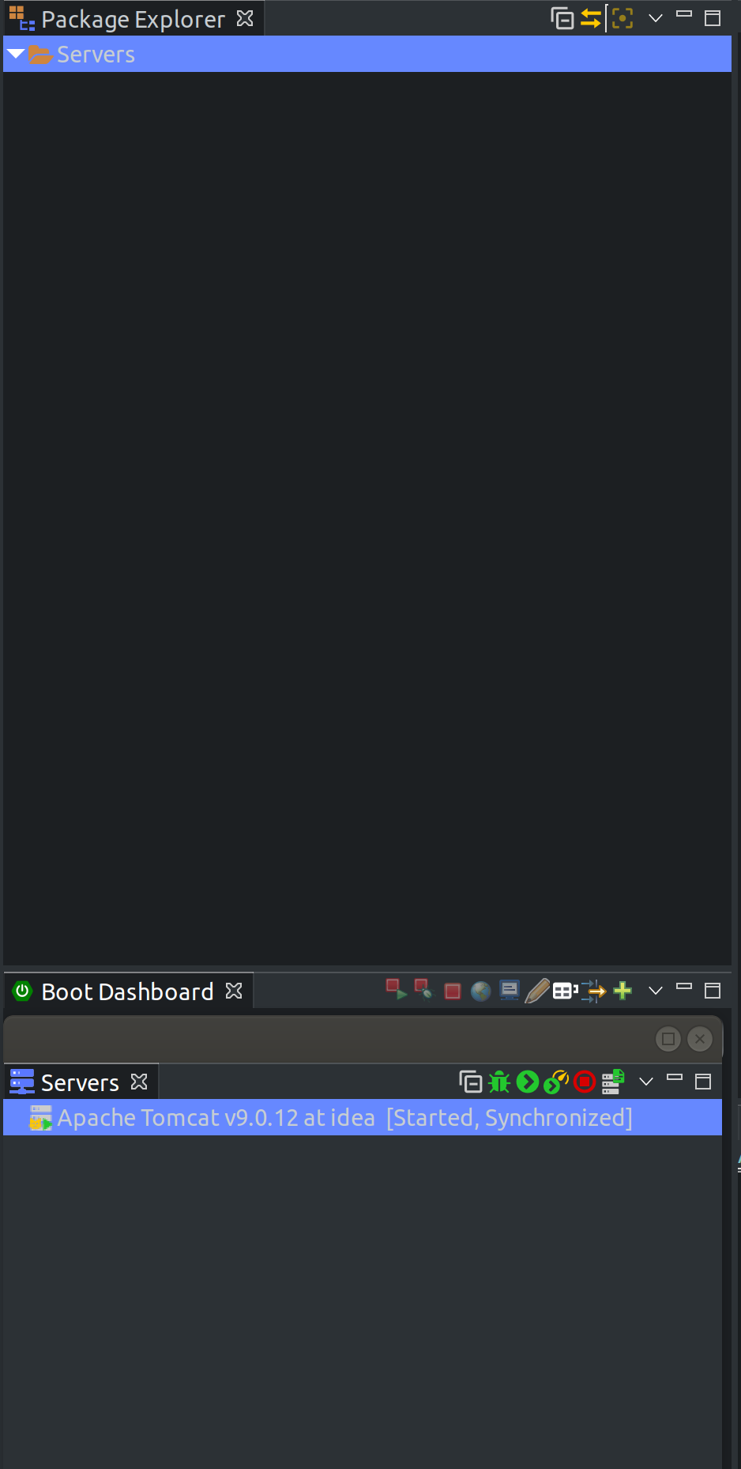
Eclipse has its own tomcat configuration directory that it uses.guitar kahului

For example Tomcat 9.0.X has /opt/conf directory with all of the configuration files.

Eclipse still uses the /opt/conf Tomcat executable but uses a conf file in the Eclipse Server project.

[spring]
Used for developing applications based on micro-services. Micro-services need a lot of configuration rather than developer code and Spring uses boilerplate configurations.

[spring boot]
Adds more intelligence to Spring by features such as auto-configuration of beans,… It does things such as look at the CLASSPATH and if it sees hibernate will auto-configure and try to resolve dependencies. Will use startup templates to make initial configurations (sounds logical).

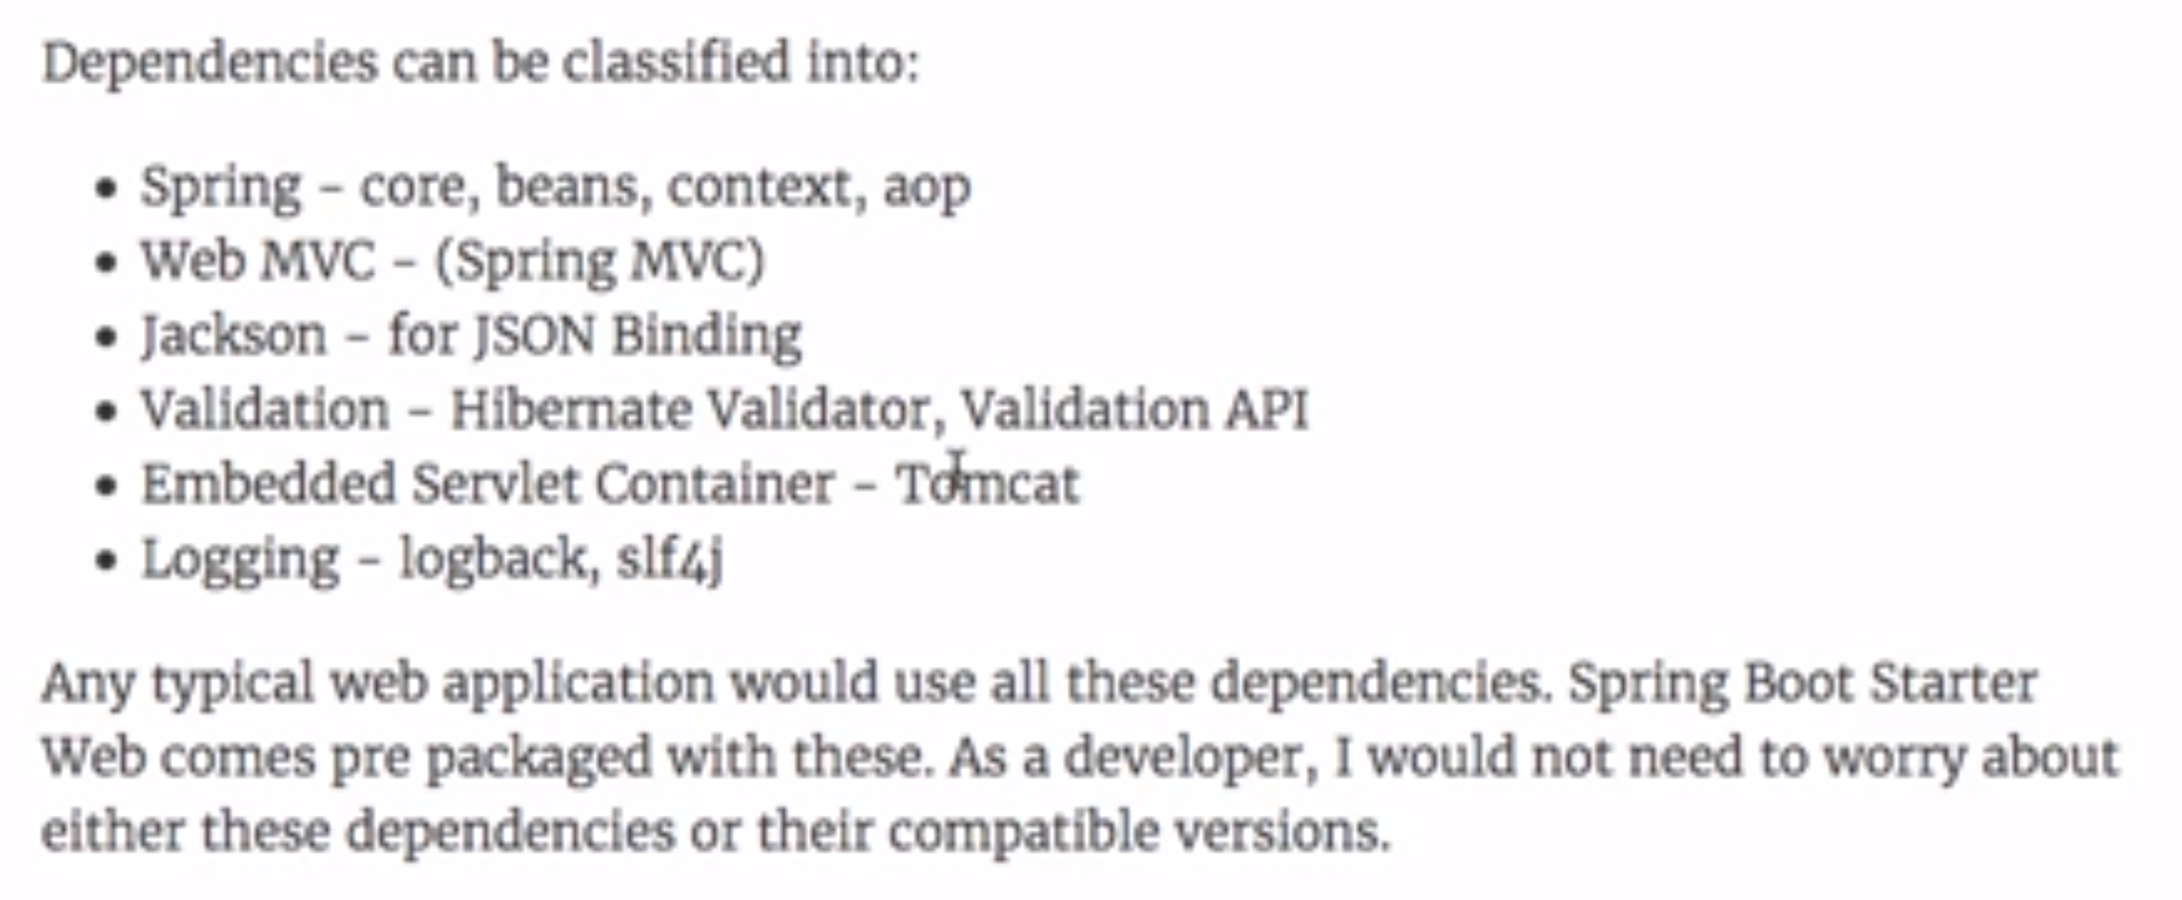

[spring mvc framework]
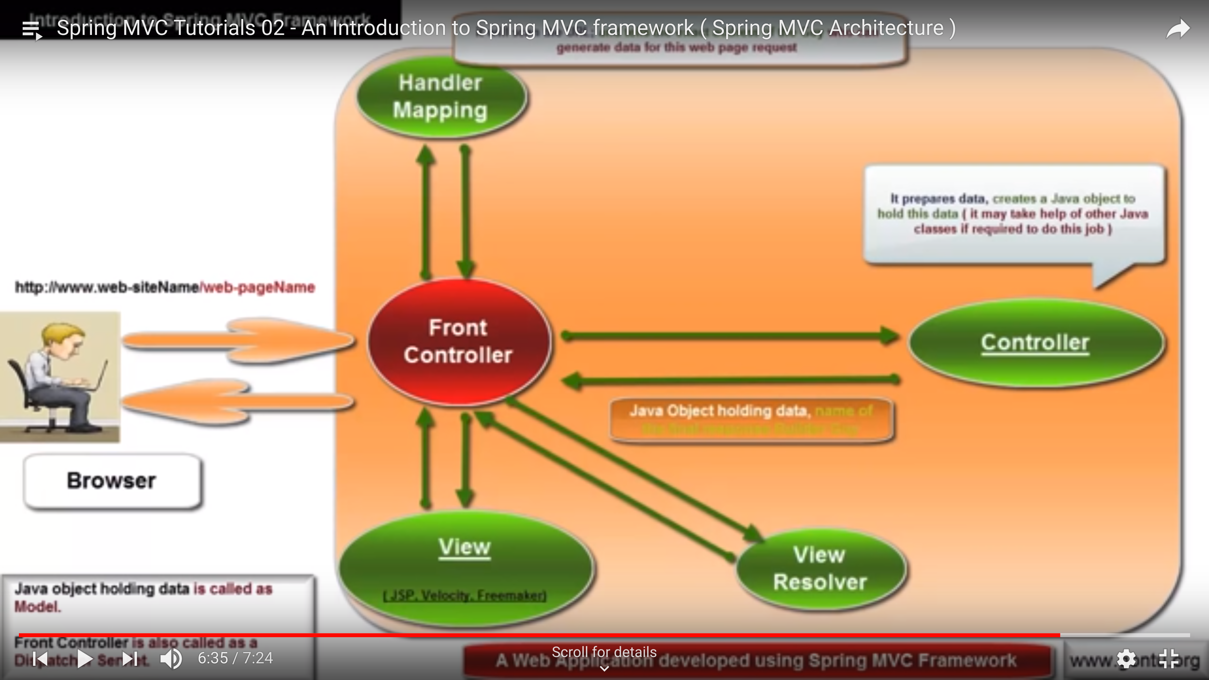
Spring MVC Framework has a front controller which talks with handler mapping (controller directory) and view resolver (view directory). The Front Controller is a servlet. Many times a reverse proxy is used with an Apache service on the front of the Front Controller.

[tomcat]
Tomcat is not a full-fledged application server (e.g., websphere from IBM, weblogic from Oracle or Jboss). Tomcat is part application server and web server.

[reverse proxy]
Apache can be used as a reverse proxy, that distributes and provides some front-end process to web applications.

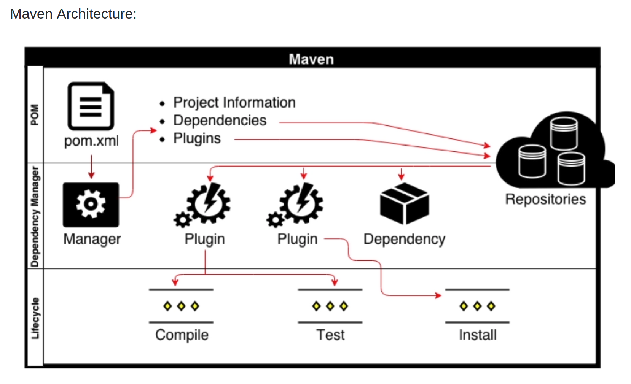

[maven]
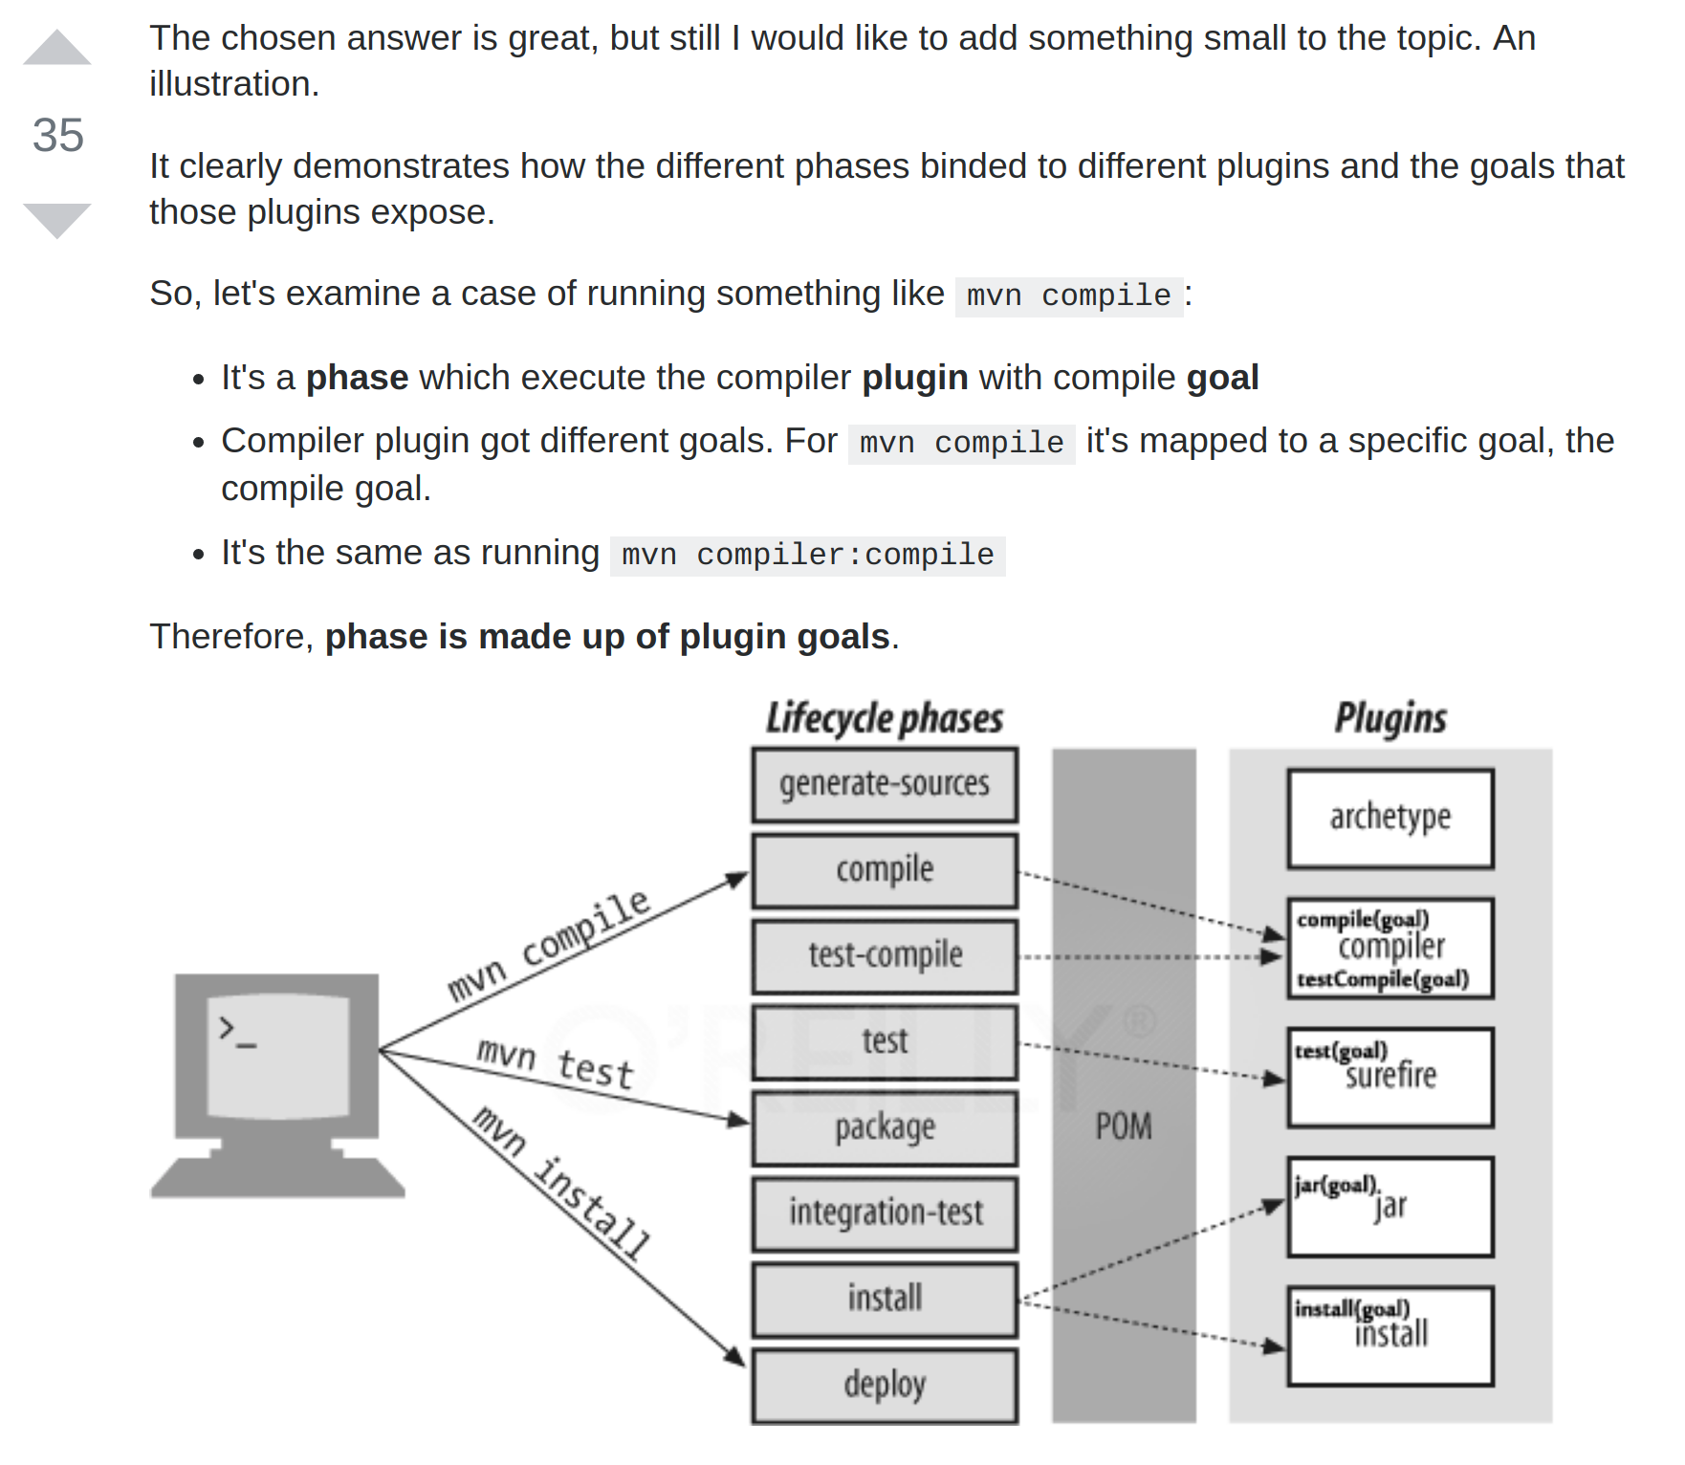

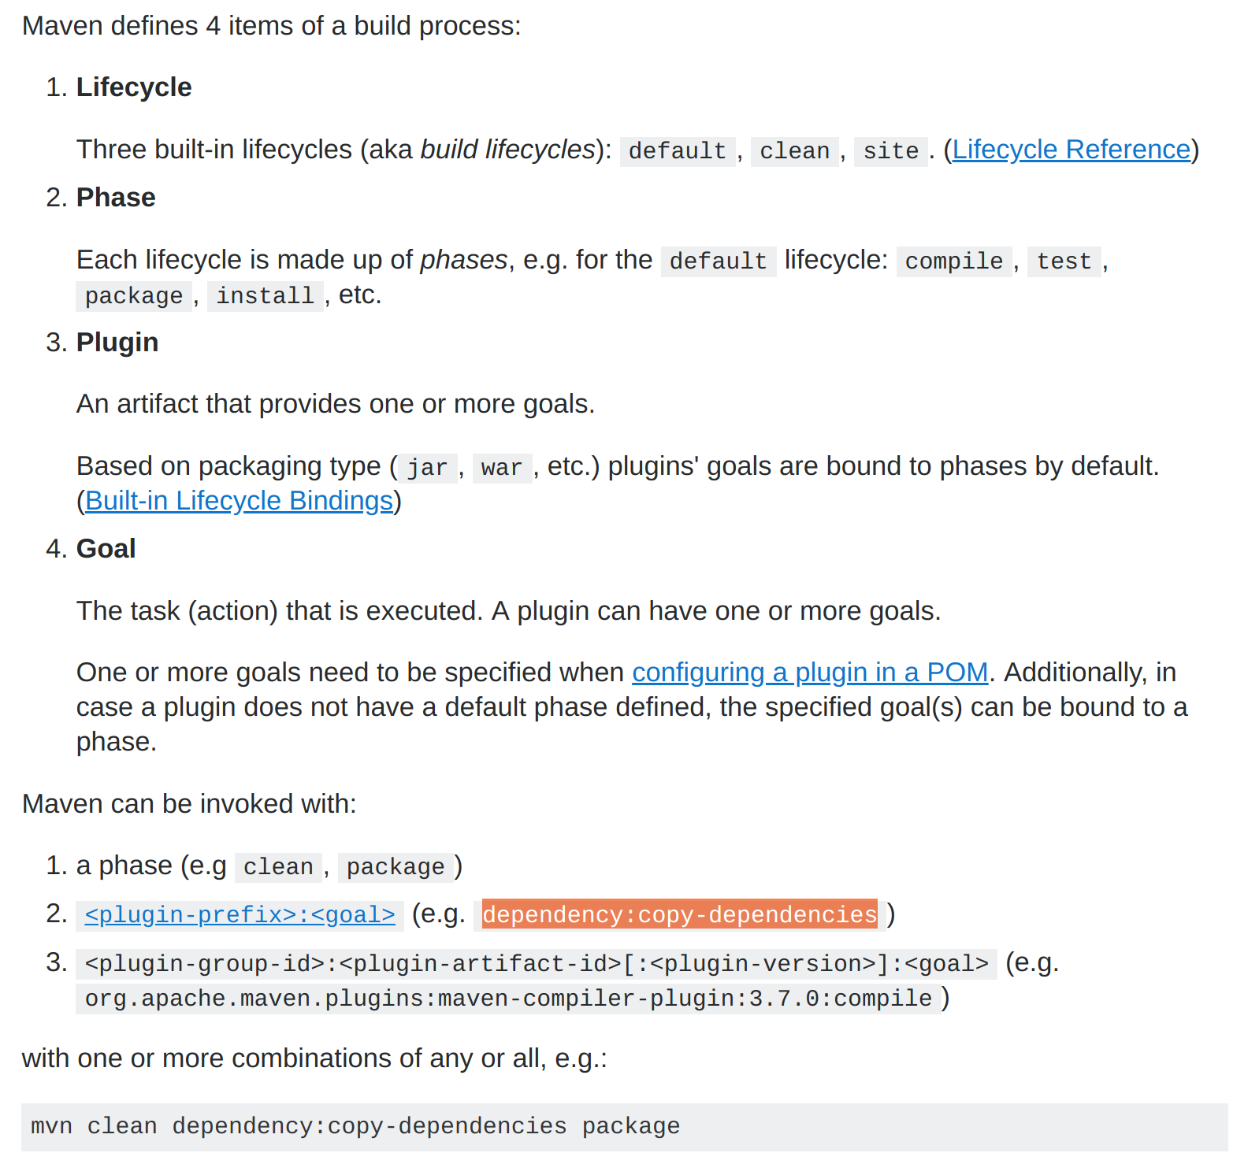

[ssh remote login]

Used for setting up your own encryping and decrypting connection, does not authenticate if private key is compromised!]
IMPORTANT – Setup keys to remote login to multiple servers rather than use the default ssh-keygen files!)

Good video: https://www.youtube.com/watch?v=t1R2BlVEwkQ

GENERAL IDEA – private key is held secret on client (use chmod 400 <private key>, so only owner can only see it). Send <public key>, does not have to be chmod 400 to server.

Use asymmetric keys to send secret messages (encrypt/decrypt in both directions)
Use certificate authority that holds all of the private keys

Process -

1) Create <private, public> key directory and chmod private key to 400.
ssh-keygen t <rsa>, when prompted pick a base key directory and private key name (e.g., home/mm/.rsa/ubuntu-server)org.springframework.boot.SpringApplicationScreenshot from 2018-11-26 12-49-01

2) Generate <private, public key> on client. Do not use the default rsa_id. This is used for automatic configuration if you only use 1 server. Change private key to chmod 400.

3)
For one-to-many ssh secure login, put <private, public> key pair in separate folders under ~/.ssh (like ~/.ssh/ubuntu-server, ….).

[digital signatures , does not in include certificate authority]
This process is how to make sure data is created by the originator, but does not verify the originator is the person they say they are! Verification of originator’s identity is based on Certificate Authorities.
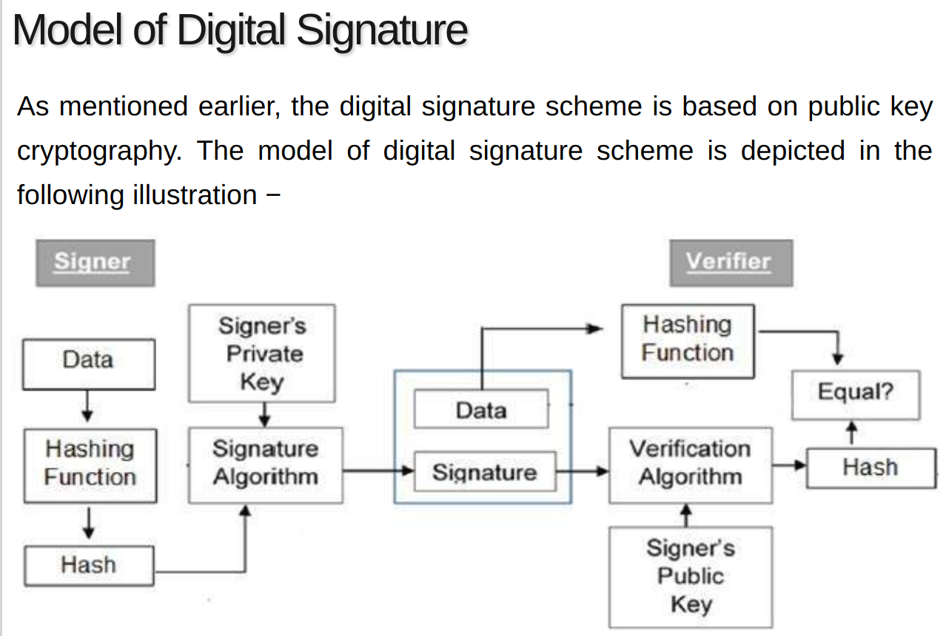
This is without Certificate Authority

Screenshot from 2018-11-26 12-49-01

[Digital certificates]
The client will get the public key from the Certificate Authority, rather than from the sender! The Certificate Authority will go through a verification process of the sender. When a message from the sender is sent, the receiver will directly contact the certificate authority to get the public key of the sender. So it knows the identity of the sender is real!

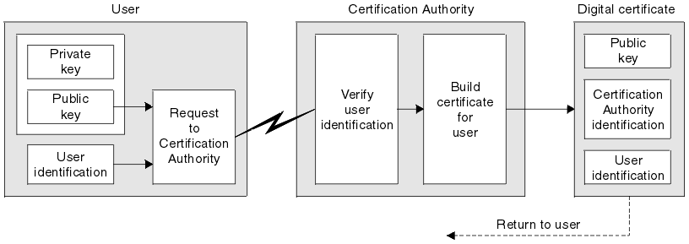

You can test a <private,public> key pair by using ssh-keygen -y -f <private key file>
to output the public key for the given private key, so then just compare the output to each *.pub file.
[linux server 18.04] – setting up static ip with netplan
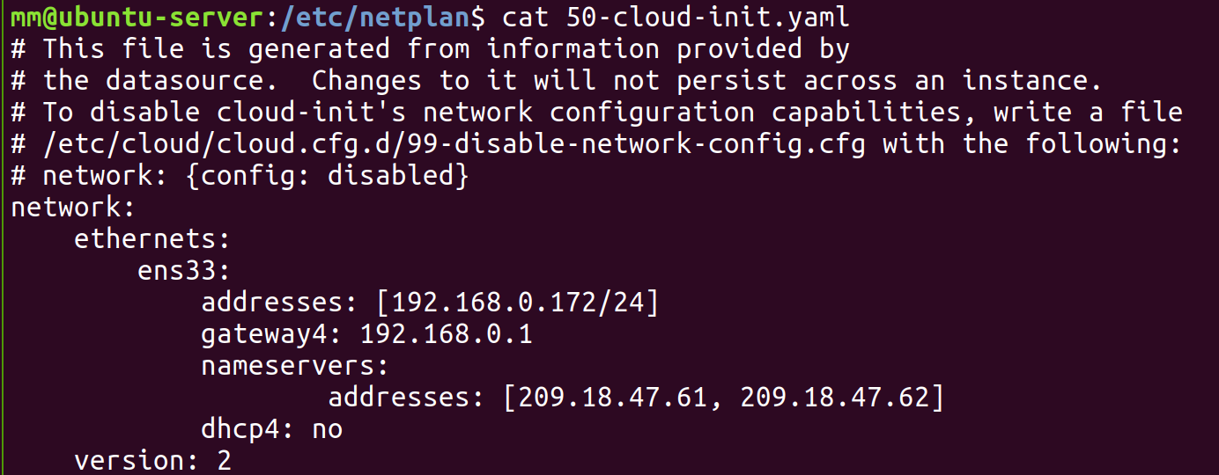
1) create /etc/netplan/*.yaml
2) sudo netplan try (to test before applying)
3) sudo netplan apply (to apply the yaml file changes)

Setting up ubuntu-server address outside the 192.168.0/24 (home) network.

1. Must change ubuntu-server /etc/netplan/*yaml back to dhcp. This is because the vmware network is bridged and makes ubuntu-server act like it is directly connected to the physical network.

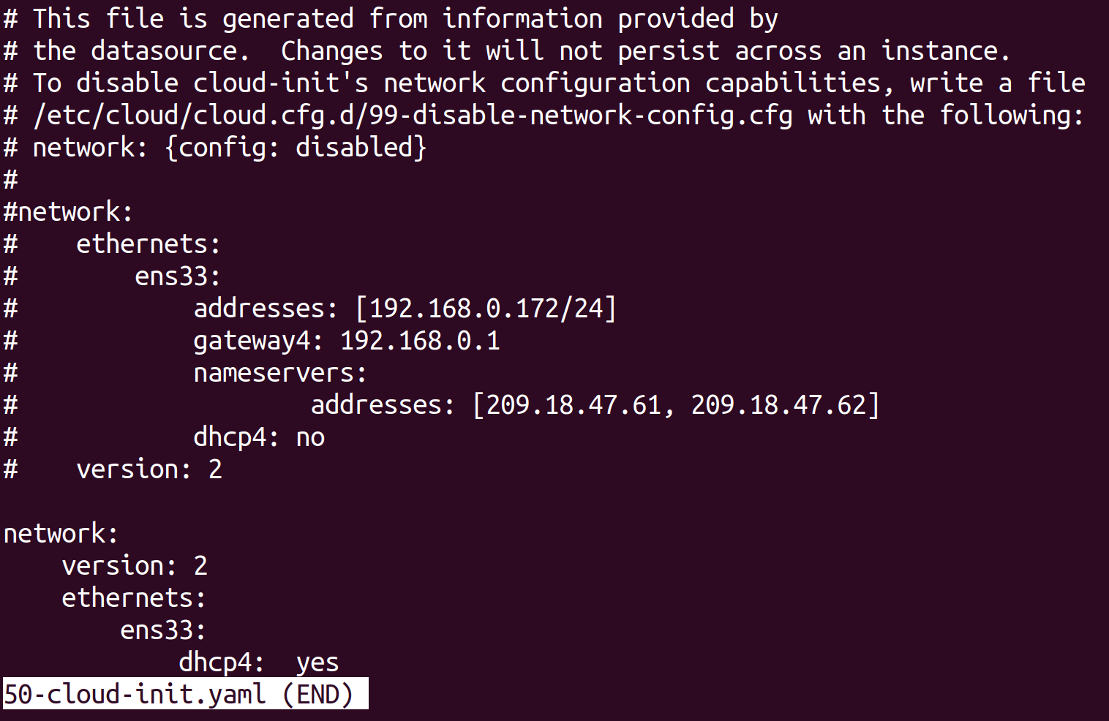
this is for home
this is for dhcp

Screenshot from 2018-11-26 12-49-01
IMPORTANT – since dhcp changes the ip address, this will affect connections to other machines. For example -

1. ssh (~/.ssh/config file)

[java]
Need to setup JAVA_HOME on ubuntu-server correctly.

[linux] getting the md5 hash of a file (used to check sameness of 2 files)
echo -n SpringBootTutorial-0.0.1-SNAPSHOT.war | md5sum

[tomcat]
Can set chmod 700 to //opt/tomcat/conf to hide configuration and passwords.

IMPORTANT: You can manually copy a web archive file into tomcat’s webapp directory and it will deploy the war file. If it does not work, there could be some configuration problem in the .war file.

IMPORTANT: WAR file owners must be added to the the tomcat group. There are work, temp and log files that need to be created on the fly after a WAR file is deployed. The easiest way is to add webapp owner to tomcat group. ANOTHER way is to make sure the WAR file is chowned by tomcat:tomcat and then deployed.

When there is a problem accessing tomcat pages, use the tomcat log files.

[ajax]
Ajax allows the server to interact with the browser asynchronously. This is a comparison of conventional versus ajax webpages. Instead of using just HTML elements to invoke HTTP requests, Ajax uses Javascript inbetween HTML elements and the server.
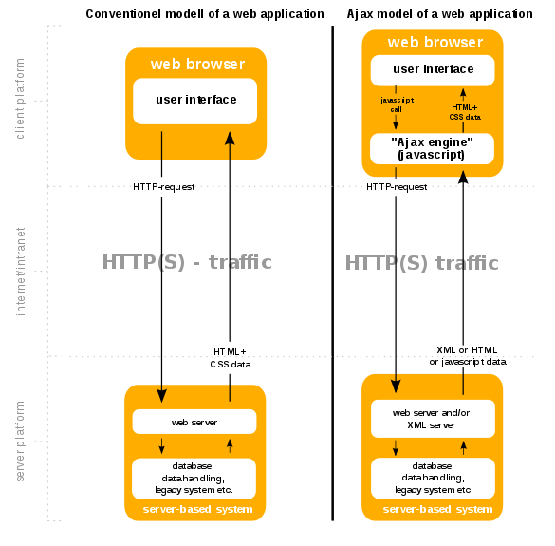

[jdbc transaction flow]
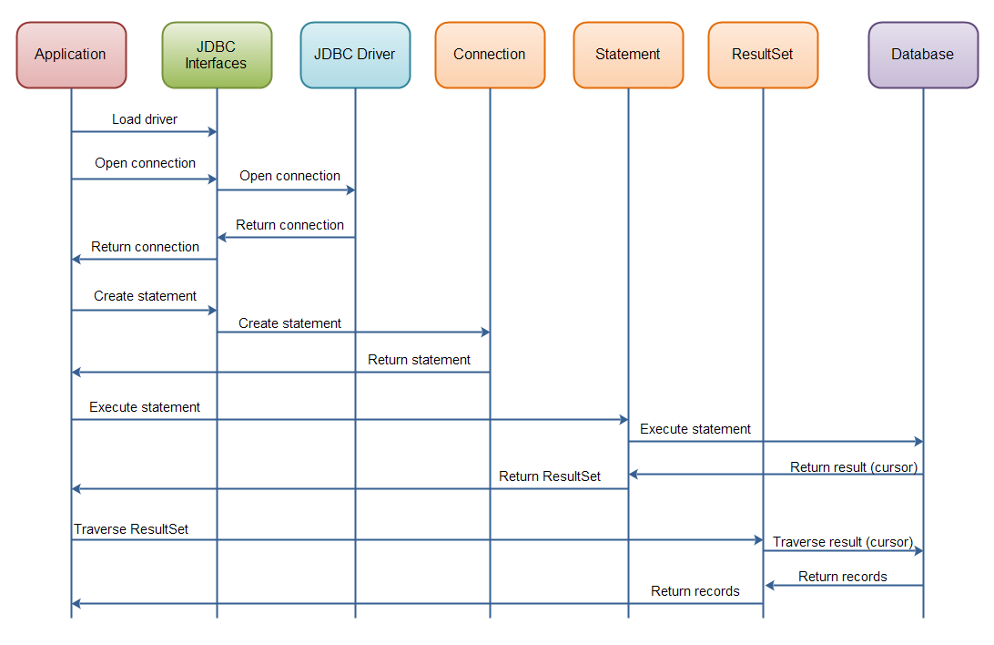
There are 4 different types of JDBC drivers that implement the JDBC interface -

- Type 1: JDBC-ODBC bridge driver
- Type 2: Java + Native code driver
- Type 3: All Java + Middleware translation driver
- Type 4: All Java driver.

[maven]
This is to show the maven SCM POM file construction. When you add a depencency to mysql:mysql-connector-java:8:0:13, the mvn commmand goes to this file on the scm and adds the dependencies of this file. This happens recursively for every pom.xml file until there are no more depencencies.
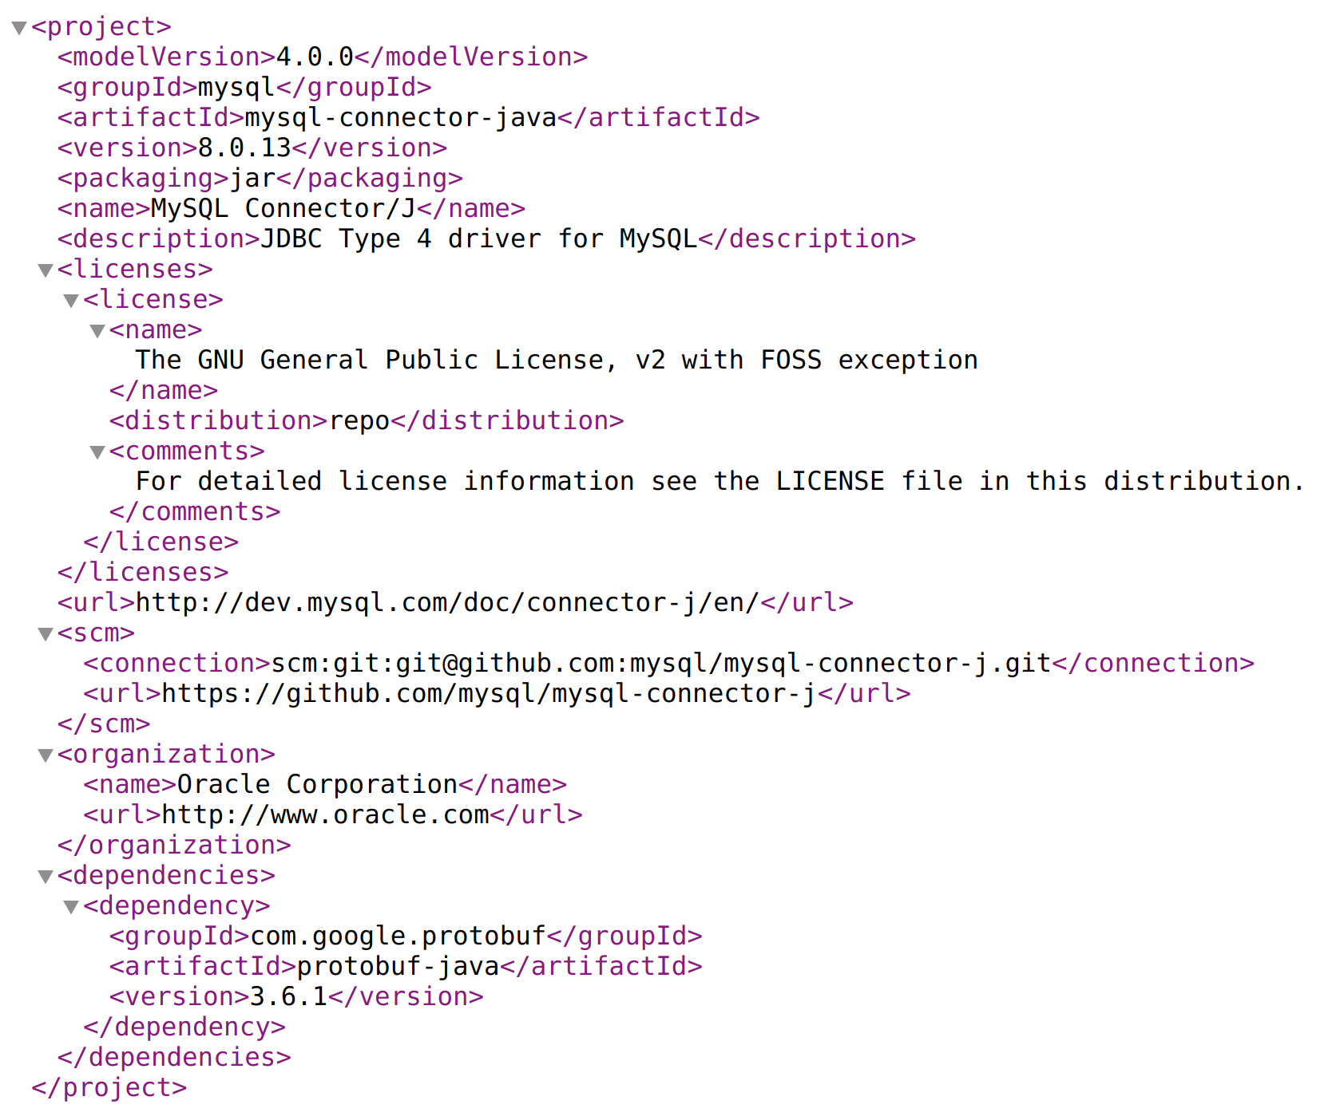

[maven]
IMPORTANT: When creating a project in Eclipse using the maven archetype, all depenencies can be downloaded AND the .m2 dependency jar locations are added to the build path.
If you have a resource (.jar, .war, .pom, …) that is not in the maven central repository. You can install the file using the following -
mvn install:install-file -Dfile=non-maven-proj.jar -DgroupId=some.group -DartifactId=non-maven-proj -Dversion=1 -Dpackaging=jar

[numpy]
A scientific computing library written in python that can integrate c/c++ and fortran.

[neural networks]
The loss of images versus representative class images across 3 images and 3 classes.
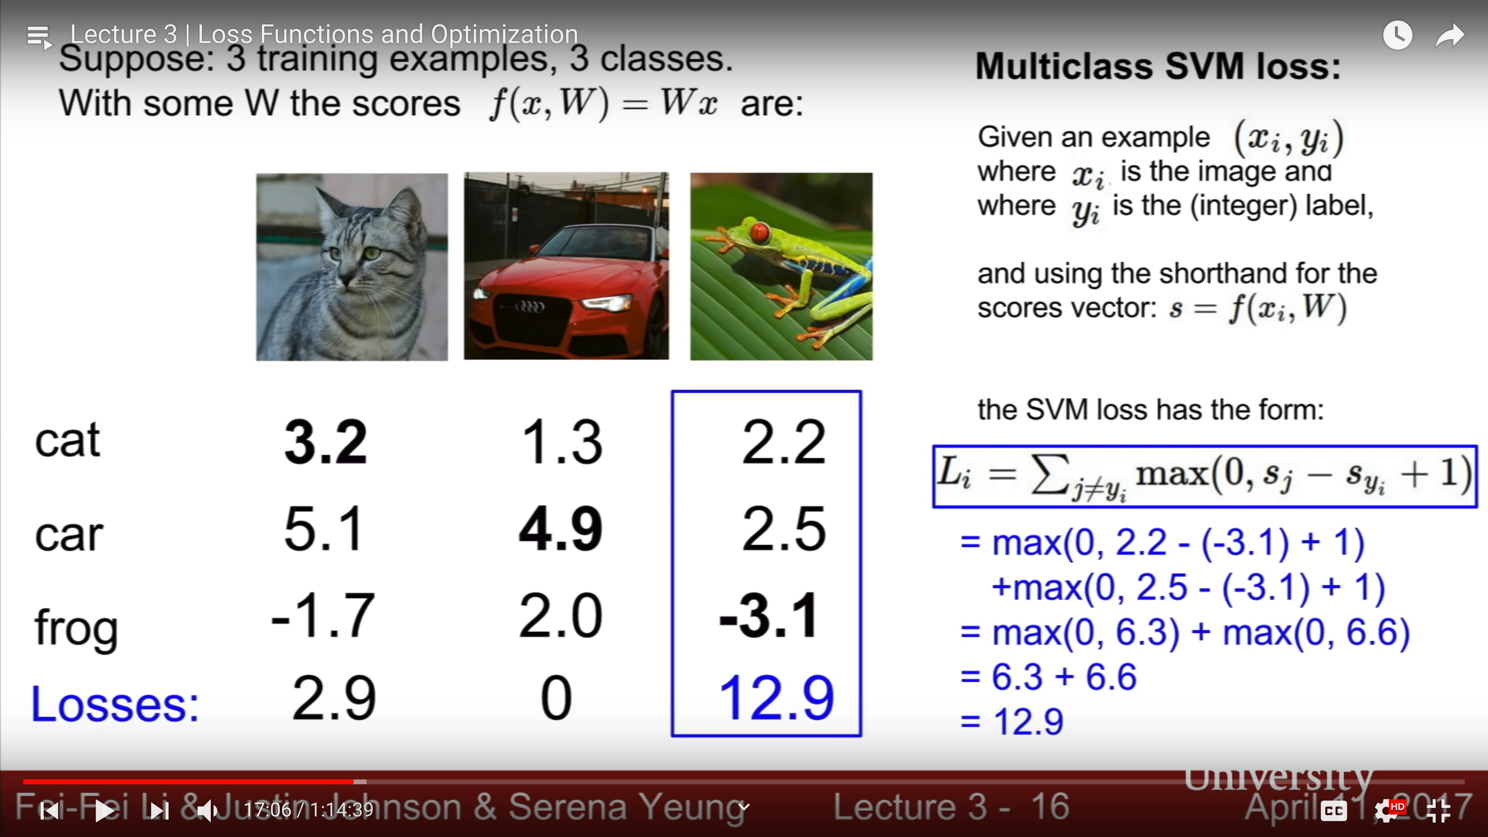

Regularization(R(W) supplies a way to trade off betweeen diimensinoally complex boundaries and simplre buondaries that may be closer to naturla recoginiiton occurances.


