[neural network]
Likelihood is a measure of the extent to which a sample provides support for particular values of a parameter in a parametric model. This means that probability and statistics are inverses. One (statistics) fits data to a model parameters assuming a fixed model (gaussian,...), and the other (probability) predicts the possibility of it being a model based on continually adding data.

The likelihood of a coin toss after making 2 heads.

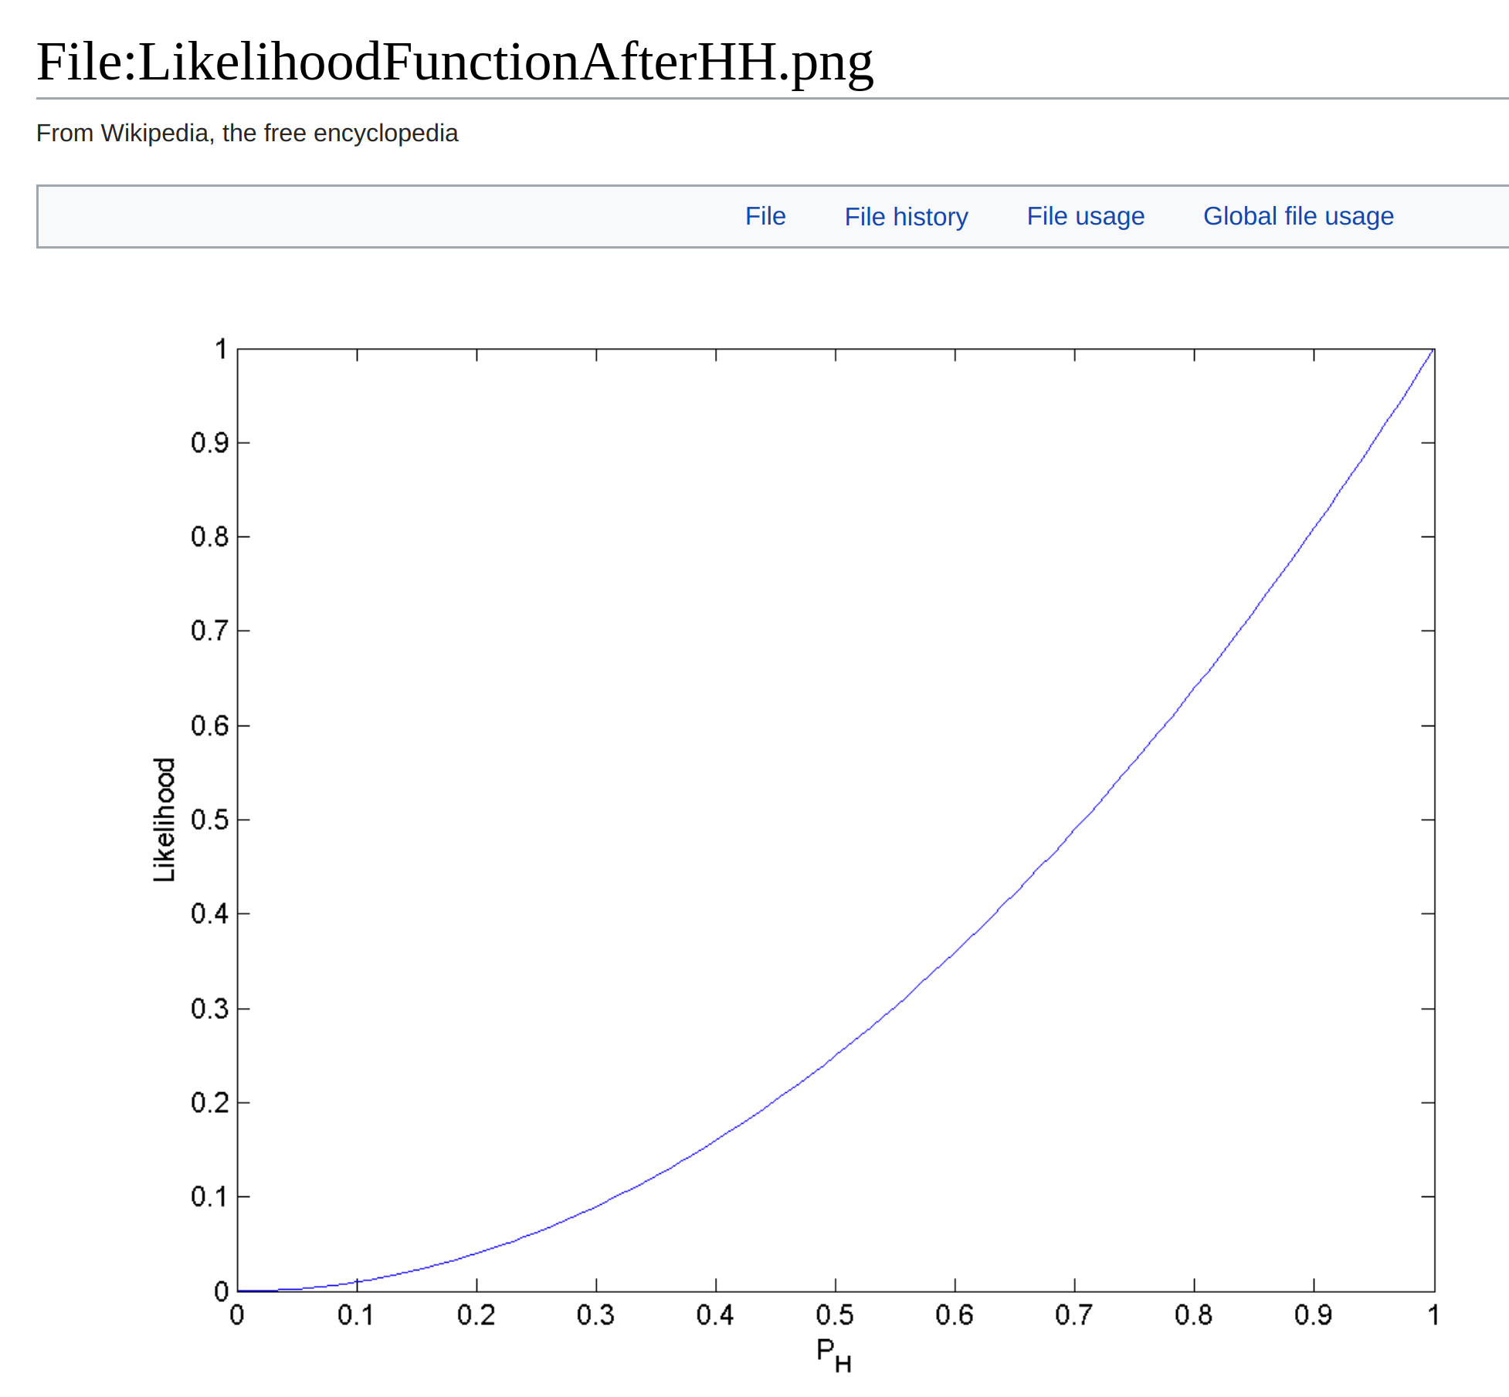

[logback]
The possible levels are, in order of precedence: TRACE, DEBUG, INFO, WARN and ERROR. Each level has a corresponding method that we use to log a message at that level.
[mysql]
Installation and configuration on ubuntu 18.04 using apt-get.
Sudo apt update
Sudo apt-get install mysql-server, theen run mysql_secure_connection
Sudo mysql, then in mysql cli –
use mysql;
UPDATE mysql.user set authentication_string=PASSWORD('q') where user='root';
UPDATE mysql.user set authentication_string=PASSWORD('new password') where user='root';
Now test with -
mysql -p -u root (should not have to use sudo)

