[Java design patterns]

State Strategy -
Similar to Strategy pattern, except calling general methods on the Context object to do some strategy, the methods set a state, represented by an object, like RoomOpen and RoomClosed. Then you can call methods of state object to see if the room is open or closed (e.g., context.currentState.isRoomAvailable() which can return “yes” or “no”).

Proxy pattern -
Proxy object implements same interface as real service and wraps methods to add access (e.g., add password access to get tweets from twitter).

ChainOfResponsibility pattern

Each object in a chain, holds reference to the next object all setup in a driver class. A common interface for the objects (add, subtract, divide,…) method, execute will either execute or call the next chain object. Need to make sure that the calculation does not have a null pointer exception at the last step if the desired excution is not found (e.g., exponent). It is also used in try/catch with multiple catch statements.

Bridge patterns

When designing a system of related objects, try to decouple (use less inheritance!!) object by using encapulation (e.g., do not have Employees inherit from Company or Department, add references to employees inside Company or Department objects). Has-a relationship should use encapsulation. Is-a relationship should use inheritance or interface.

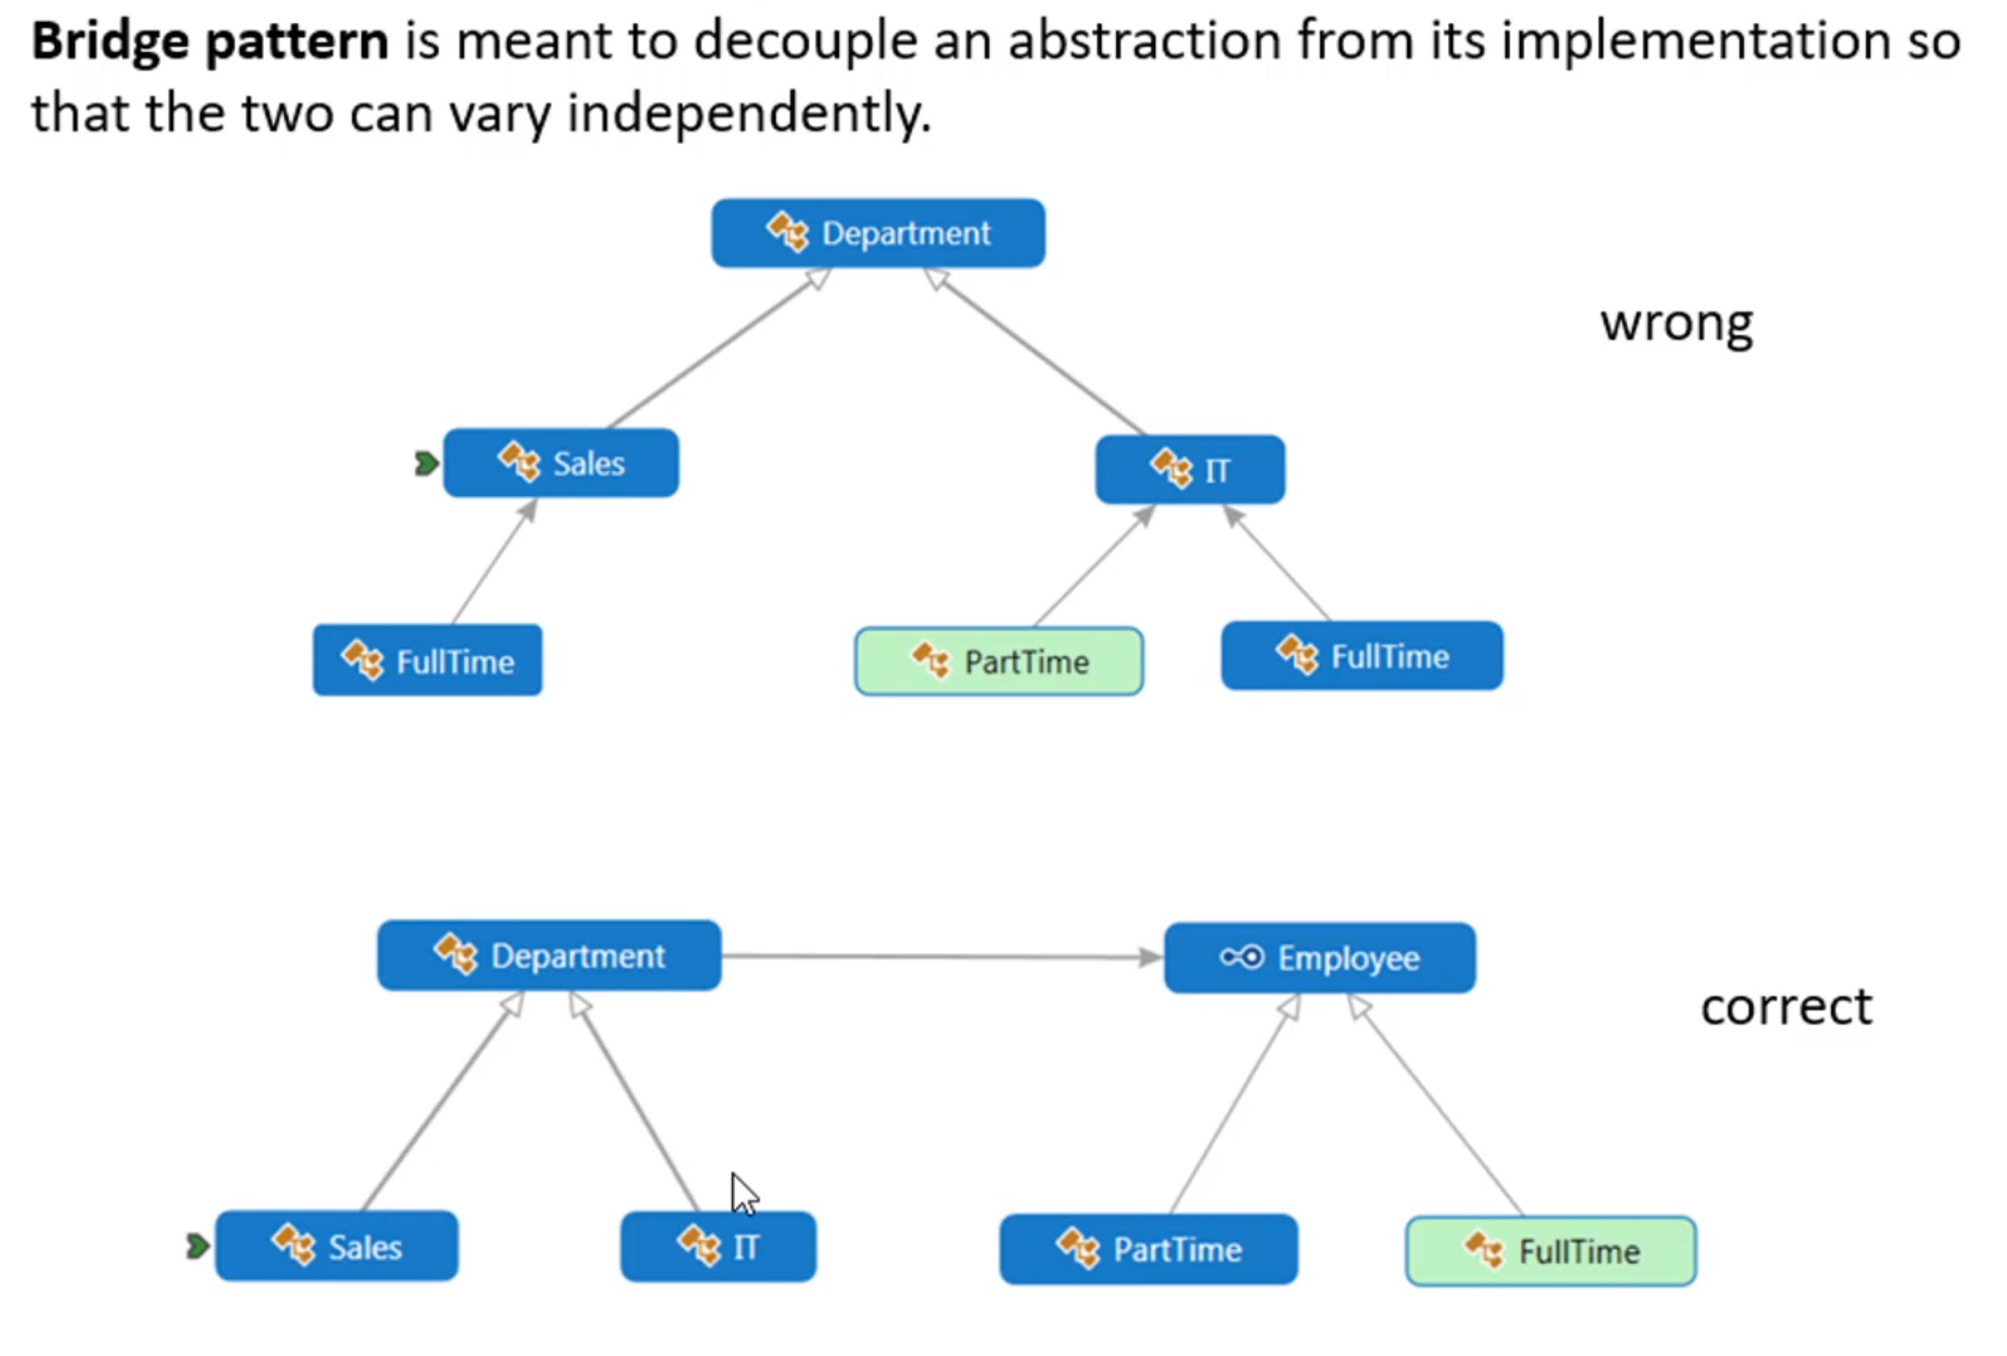

Composite pattern -
A tree structure of encapuslated objects that you can define parent/child pattern.
Use abstract employee class and extend to director, manager, developer, where developer does not have any encapsulated direct reports, manager and director has reports.

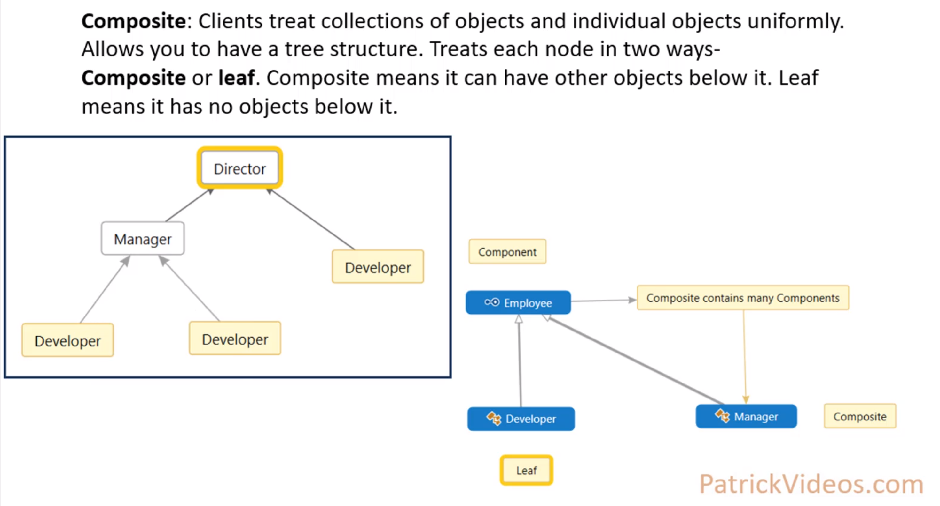

Decorator pattern -
A way to add accumulation to objects. The Decorator class extends a base class and encapsulates a super object which is the parent object in the chain. It also implements the accumulation methods, like icecream.description() and icecream.cost(). The concrete class like chocolate has the accumulation methods, but only returns a string without calling super methods (super.description and super.cost).

Observer pattern -
In blogging, a blog would to register and notify users. A blog implements a subject (publisher or subject) interface and users implement a observer interface.

Builder pattern -
Used when building a complex object, like an insurance quote which will touch different systems (location, age, record, car make). An insurance quote system will generate an insurance object with name, location, age and make. The different concrete classes (e.g., Auto) will implement an InsuranceBuilder interface and encapsulate the insurance object. Then an EngineerDirector object (engineer) will be constructed with the InsuranceBuilder reference. Call the engineer.calculateInsurance() method to compute insurance.price. Then call engineer.returnInsurance() which returns insurance.price.

The EngineerDirector is the class that implements a complex series of steps with the Auto object methods. Insurance is the object that holds all the data that is presented to a client. Auto can be replaced by other insured vehicles, like Truck, Boat, or Plane.

Flyweight pattern -
Used to minimize storage of same objects (e.g., font glyphs in a Word document). Need to hold a Hashmap of <characters, Glyph> to search when building the document, character by character. The document holds a List of <Glyph>. The Glyph objects have the character, font and size information.

[Java]
A new class variable can be instantiated with new keyword at the beginning of the class.
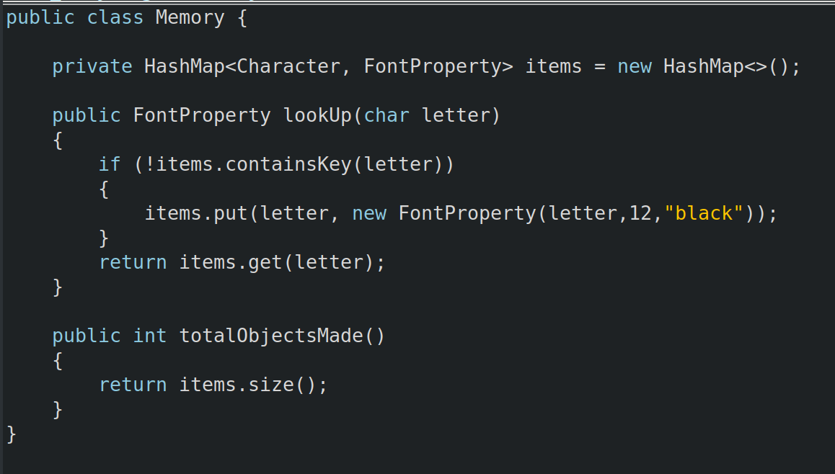

Repository pattern -
Used to change the way large lists, maps, tables are stored (e.g., in-memory with Hashmap, in text file, in database).

1. Make a Repository<T> interface (T is generic) with all of the required methods (add, remove, getAll,… →basic commands for Lists and Hashmaps)
2. Instantiate Repository<Contact> where Contact is a class that includes the name. The Work and Friend classes extend the Contact class to include the contactMethod (e.g., phone number and/or email,…)
3.

[java]
To scan in an int use
int numSlots = Integer.decode(numSlotsString);
To generate a random int between 0 and 100
(int) Math.floor(Math.random() * 101)

[java]

Web frameworks popularity index -
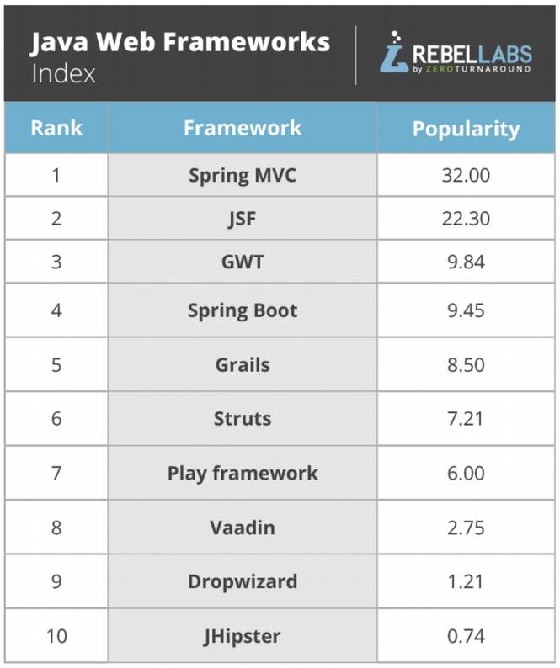

[linux]
z-shell setting path variable
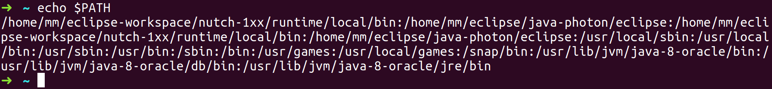

/etc/environment path variable

[linux]
To list machine’s PCI bus connected hardware us lspci command. Result on Lenovo idea machine.
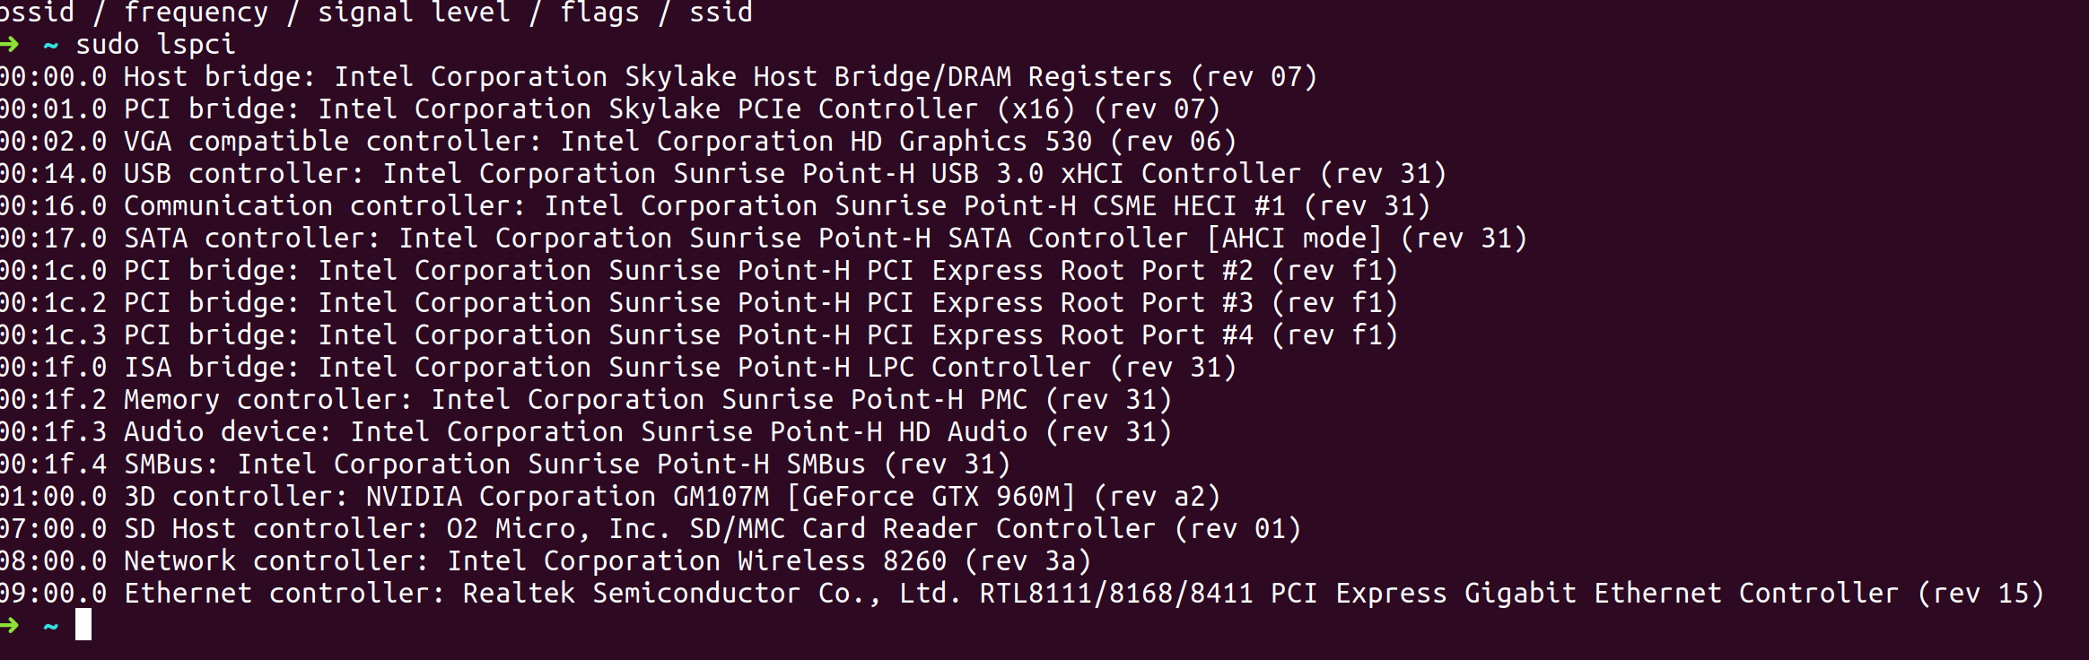

Sudo lshw -c network
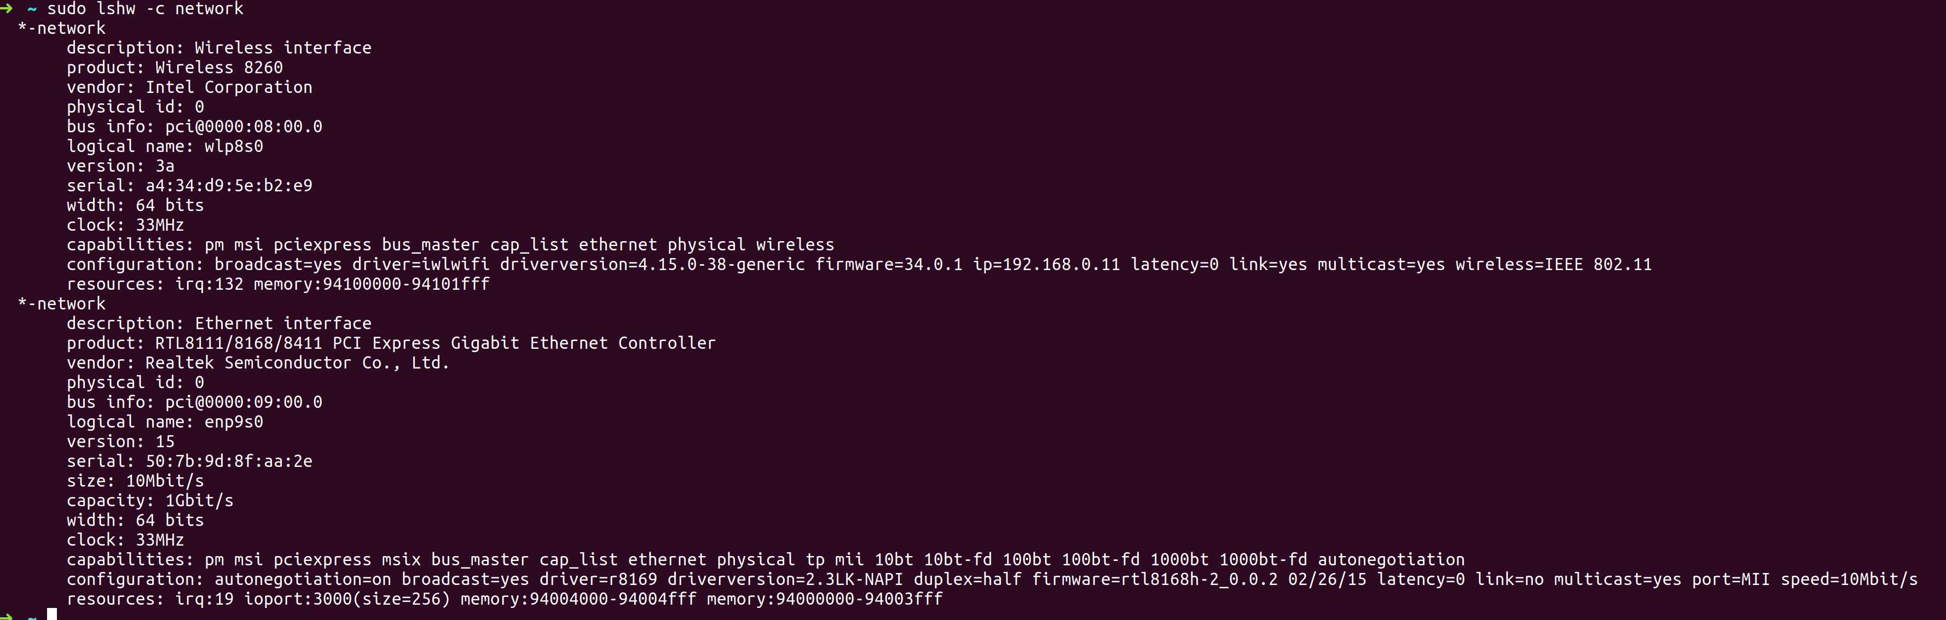

[linux]
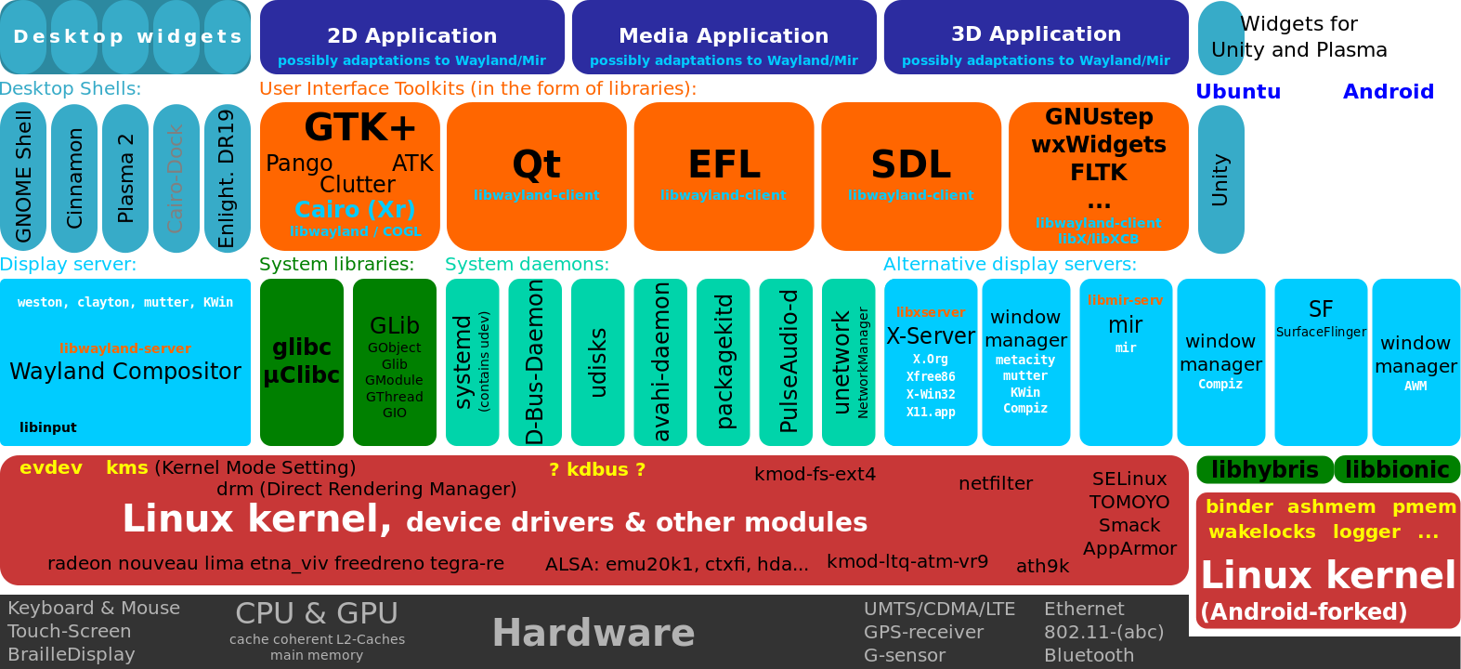
[linux]
to mount a drive, usb, … plug in device, create a mount point (e.g., mkdir /mnt/hd1) and mount the device using mount <device> <directory>. There are block devices (storage) and char devices (mouse or keyboard). Network drivers do not have device files. After mounting new device files are created in /dev as below...

[linux]
create a bootable USB in ubuntu by downloading a iso image (mounting the usb drive ( >2GB) and run startup-disk-creator from gnome applications.
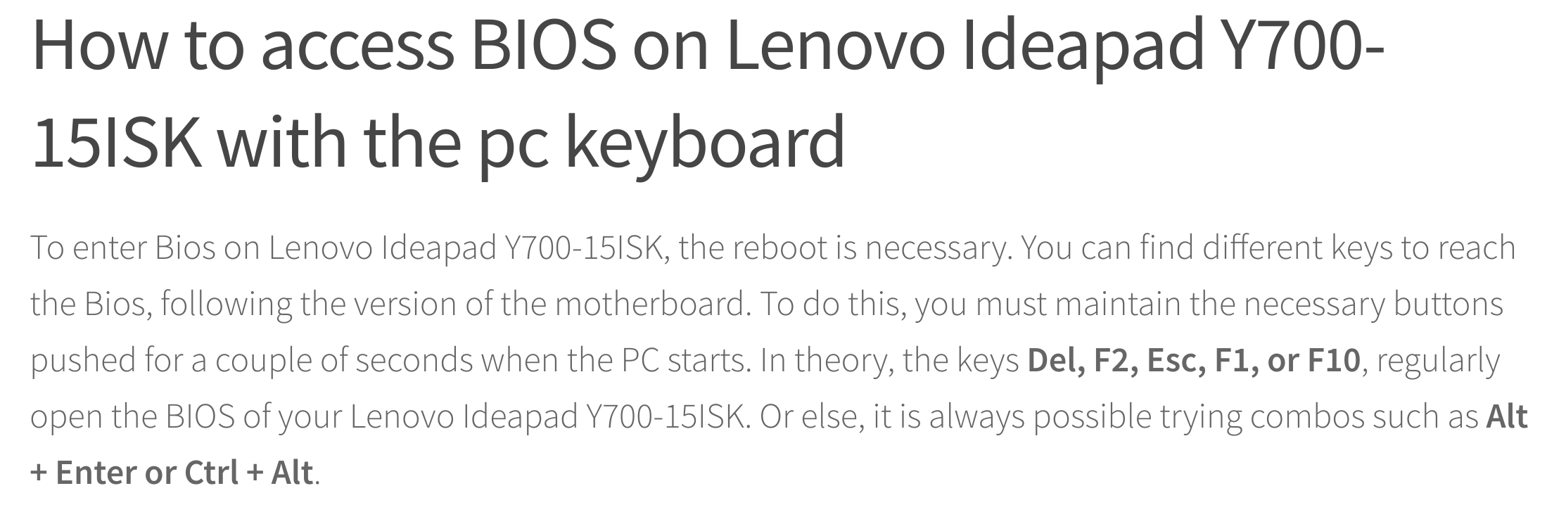

[linux] current ideapad mounts with external seagate and fsw USB
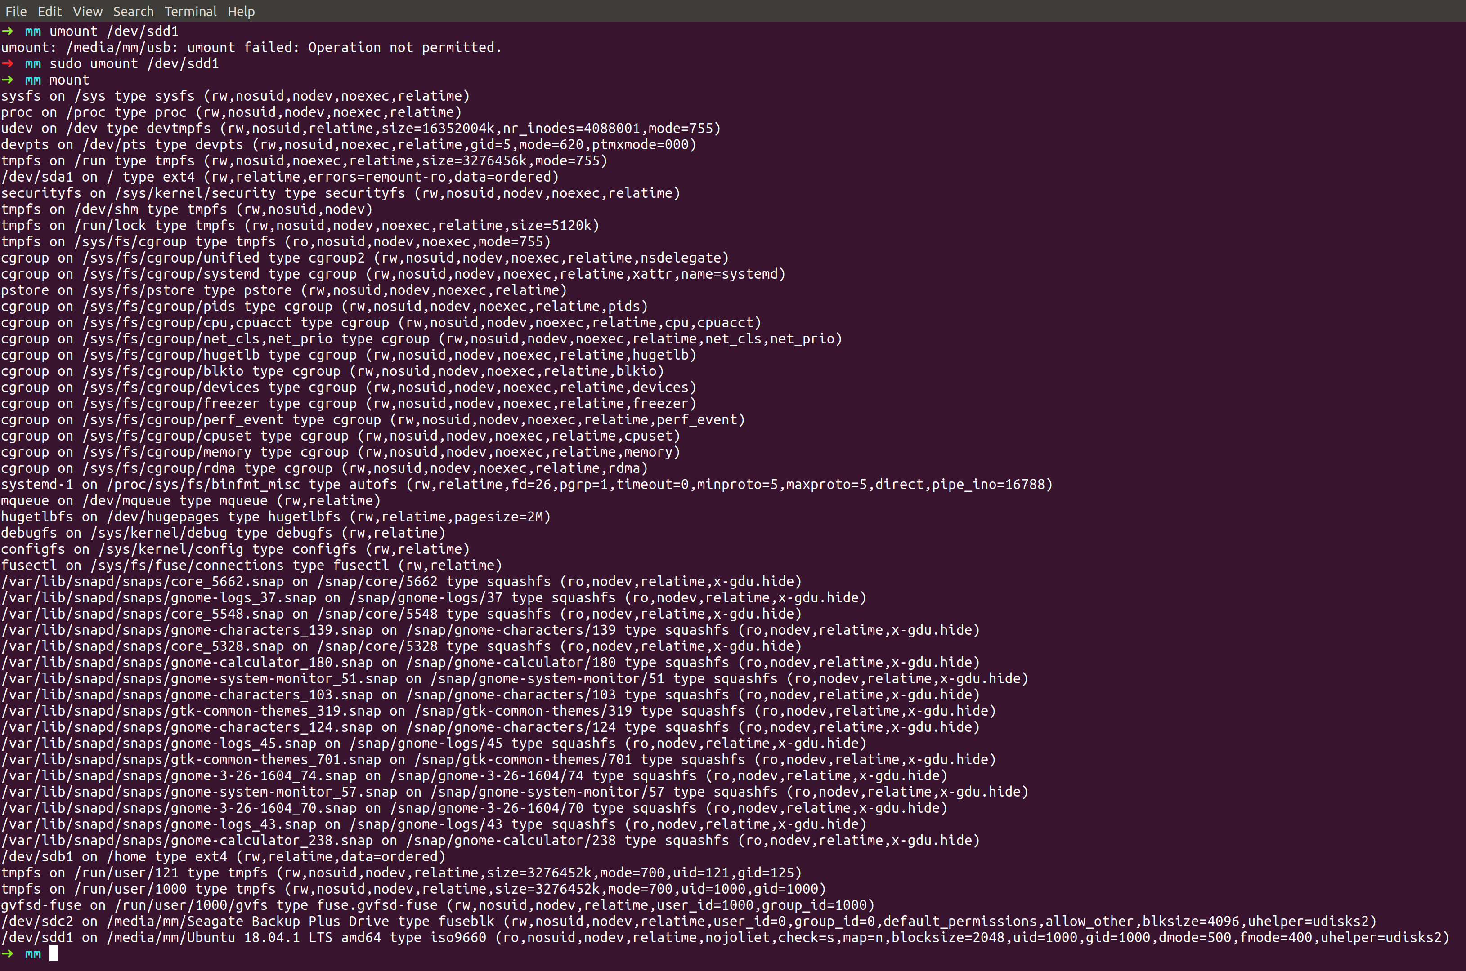

[vivaldi] – do not search in the address bar or you will search unintended local domains {like idea:8080 ot idea:80}

ps -e | grep tomcat (this does not work!)
ps -e | grep apache
Do not check addresss search field
[linux] change from systemV to init
