[java enterprise edition]

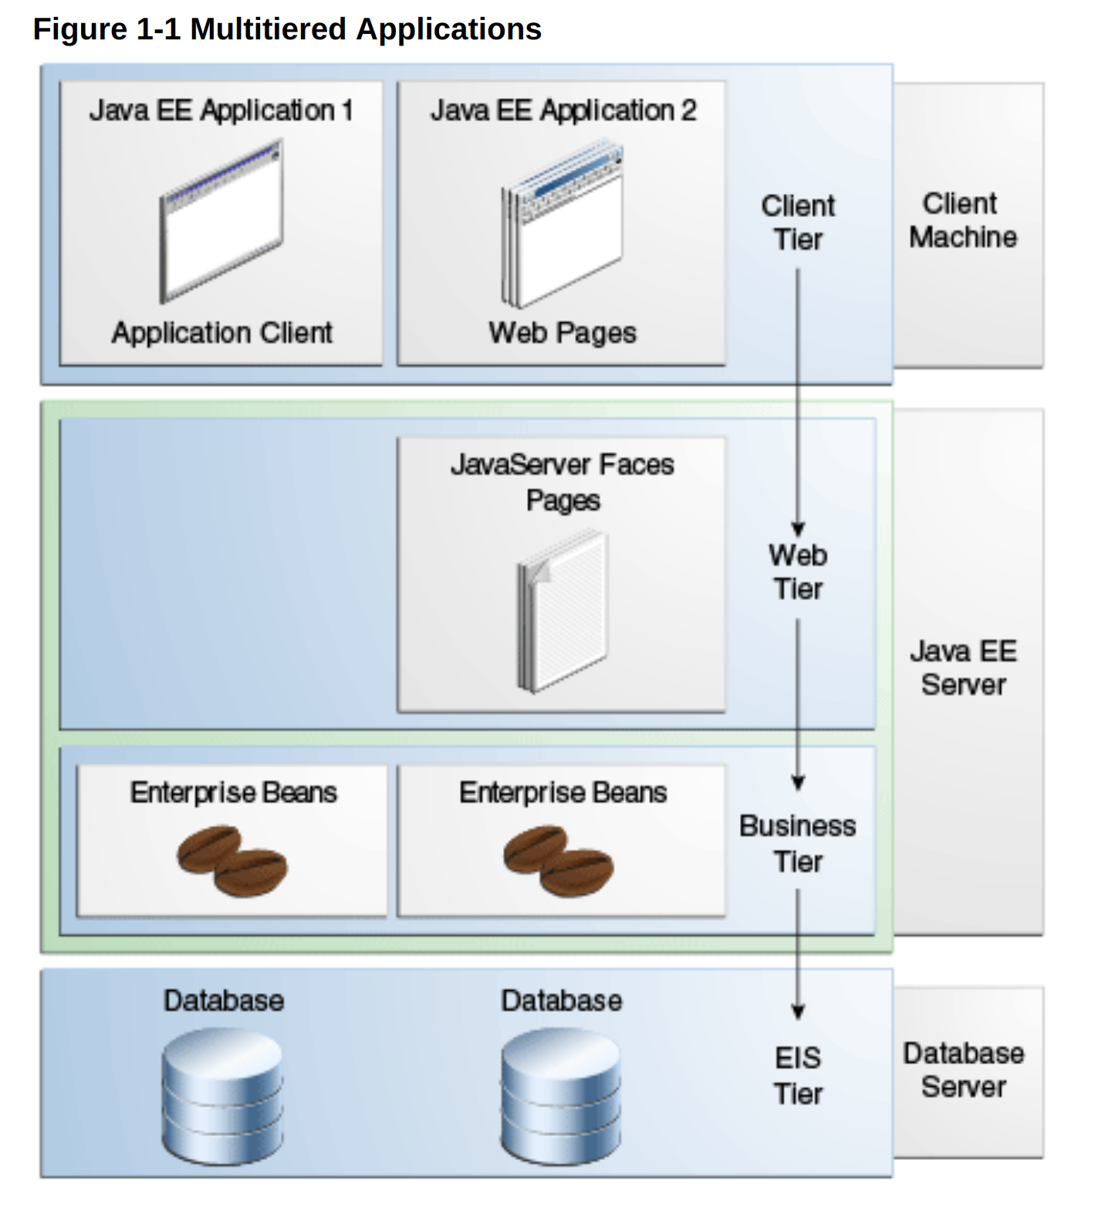

Java EE are just Java components that are well formed to JEE specifications - Java EE components are written in the Java programming language and are compiled in the same way as any program in the language. The differences between Java EE components and "standard" Java classes are that Java EE components are assembled into a Java EE application, they are verified to be well formed and in compliance with the Java EE specification, and they are deployed to production, where they are run and managed by the Java EE server.
Java Server Beans - A web client is sometimes called a thin client. Thin clients usually do not query databases, execute complex business rules, or connect to legacy applications. When you use a thin client, such heavyweight operations are off-loaded to enterprise beans executing on the Java EE server, where they can leverage the security, speed, services, and reliability of Java EE server-side technologies.
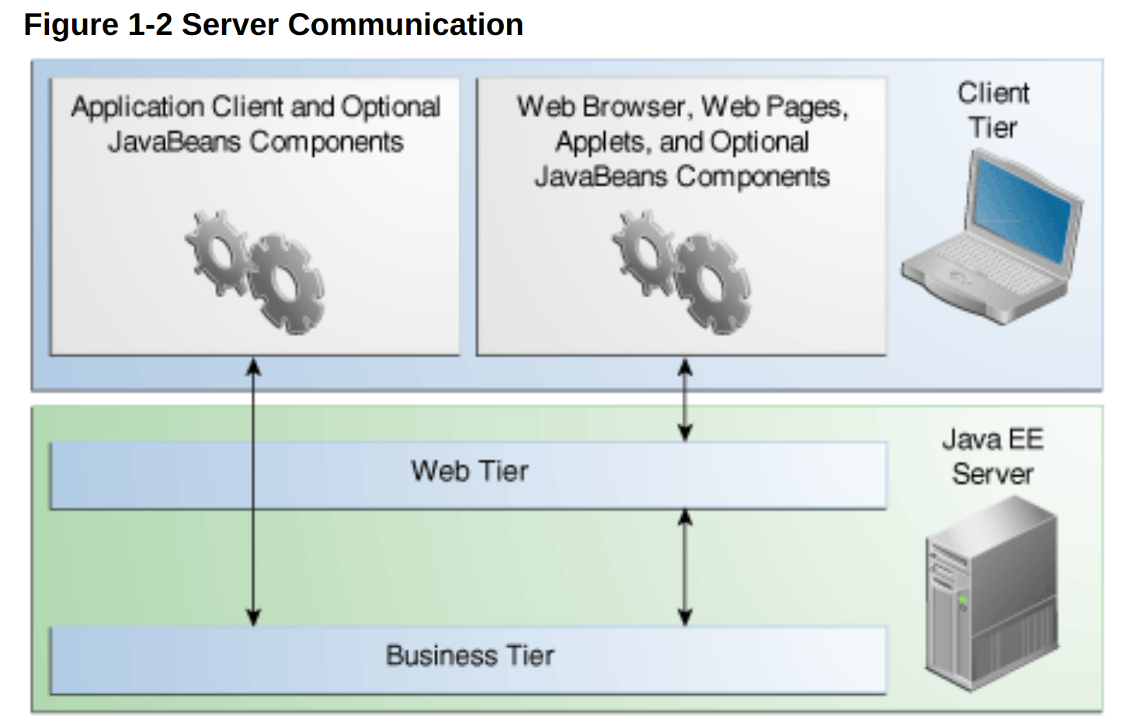
Tiered view of a java client versus a web browser to access the business components of an JEE server.

[Java enterprise edition]
This conceptual architecture drives the structure of a war or ear file. Remember that an enterprise server includes both a web container (like tomcat, apache but also includes an EJB container for java beans).
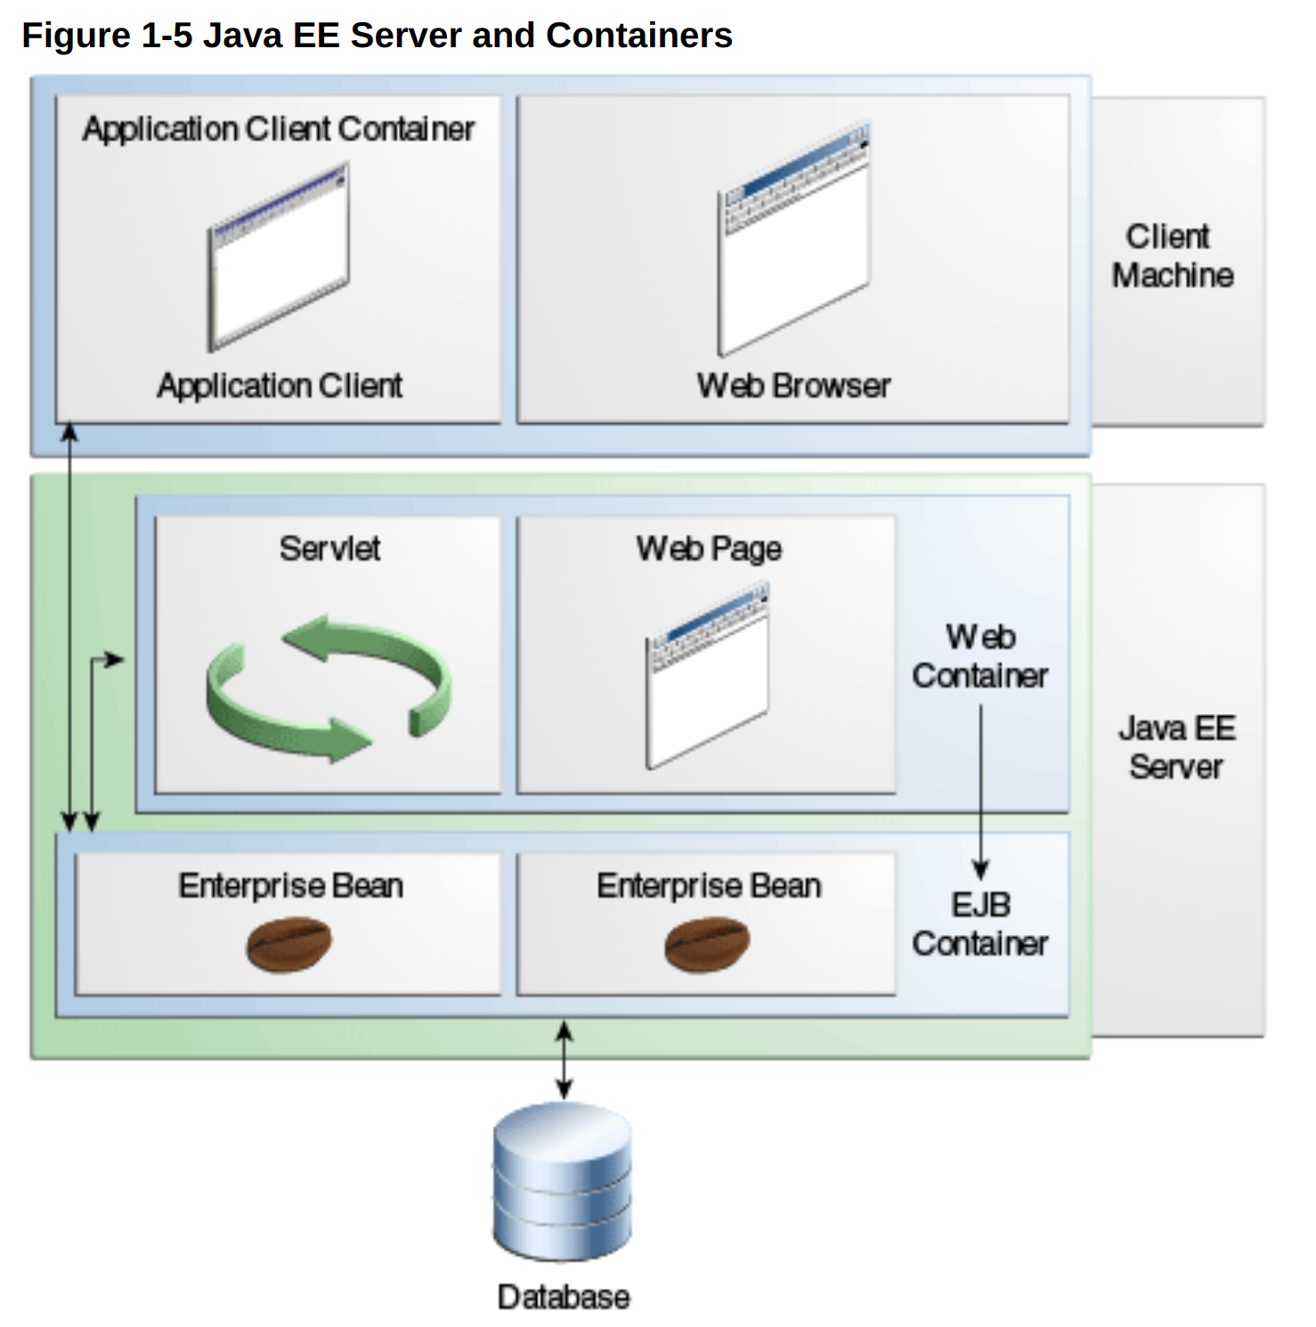

The server and containers are as follows:
- Java EE server: The runtime portion of a Java EE product. A Java EE server provides EJB and web containers.
- EJB container: Manages the execution of enterprise beans for Java EE applications. Enterprise beans and their container run on the Java EE server.
- Web container: Manages the execution of web pages, servlets, and some EJB components for Java EE applications. Web components and their container run on the Java EE server.
- Application client container: Manages the execution of application client components. Application clients and their container run on the client.
- Applet container: Manages the execution of applets. Consists of a web browser and a Java Plug-in running on the client together. (this is no longer used)
Java EE Application Assembly and Deployment:
A Java EE application is packaged into one or more standard units for deployment to any Java EE platform-compliant system. Each unit contains
- A functional component or components, such as an enterprise bean, web page, servlet, or applet
- An optional deployment descriptor that describes its content
Once a Java EE unit has been produced, it is ready to be deployed. Deployment typically involves using a platform’s deployment tool to specify location-specific information, such as a list of local users who can access it and the name of the local database. Once deployed on a local platform, the application is ready to run.

Enterprise JavaBeans Technology
An Enterprise JavaBeans (EJB) component, or enterprise bean, is a body of code that has fields and methods to implement modules of business logic. You can think of an enterprise bean as a building block that can be used alone or with other enterprise beans to execute business logic on the Java EE server.
Enterprise beans are either session beans or message-driven beans.
- A session bean represents a transient conversation with a client. When the client finishes executing, the session bean and its data are gone.
- A message-driven bean combines features of a session bean and a message listener, allowing a business component to receive messages asynchronously. Commonly, these are Java Message Service (JMS) messages.
The Java EE 8 platform requires Enterprise JavaBeans 3.2 and Interceptors 1.2. The Interceptors specification is part of the EJB specification.
Java Servlet Technology
Java Servlet technology lets you define HTTP-specific servlet classes. A servlet class extends the capabilities of servers that host applications accessed by way of a request-response programming model. Although servlets can respond to any type of request, they are commonly used to extend the applications hosted by web servers.
In the Java EE 8 platform, new Java Servlet technology features include the following:
- Server Push
- HTTP Trailer
The Java EE 8 platform requires Servlet 4.0
JavaServer Faces Technology
JavaServer Faces technology is a user interface framework for building web applications. The main components of JavaServer Faces technology are as follows:
- A GUI component framework.
- A flexible model for rendering components in different kinds of HTML or different markup languages and technologies. A Renderer object generates the markup to render the component and converts the data stored in a model object to types that can be represented in a view.
- A standard RenderKit for generating HTML 4.01 markup.
The following features support the GUI components:
- Input validation
- Event handling
- Data conversion between model objects and components
- Managed model object creation
- Page navigation configuration
- Expression Language (EL)
All this functionality is available using standard Java APIs and XML-based configuration files.
In the Java EE 8 platform, new features of JavaServer Faces technology include the following:
- Direct support for WebSockets via the new <f:websocket> tag
- Class-level bean validation via the new <f:validateWholeBean> tag
- A CDI-compatible @ManagedProperty annotation
- Enhanced component search expression framework
The Java EE 8 platform requires JavaServer Faces 2.3 and Expression Language 3.0.
For an excellent summary of what’s new in JSF 2.3, see https://javaserverfaces.github.io/users.html.

