Project ID
46


Project Report On
GYM PRO – GYM MANAGEMENT SYSTEM
Submitted in the Partial fulfillment of the requirement for awarding the degree of Bachelor of Computer Application (BCA)
SEM V, Year 2025

By
Rathod Nenshi
Nandaniya Pal

Under the Guidance of
Prof. Ishita Madhwani

DEPARTMENT OF COMPUTER SCIENCE
LATE P.S. HIRAPARA MAHILA BCA COLLEGE JETPUR
Affiliated to
SAURASHTRA UNIVERSITY - RAJKOT

Preface

This report contains all the outputs of a project undertaken to develop a working model of GYM PRO – Gym Management System and to study the existing working system. As part of this study, we analyzed the requirements of the working model and tried to improve it using the technological functionality that the current computer science provides.
This volume contains the documentation summary of the working system, the background study and analysis, the technical requirements and the working specification of the developed system.
We recommend the user to take the advantage of the study presented here and implement the system with their required improvisation. We hope this study will reduce the burden of the reanalysis of the development phase.

Acknowledgment

“It is not possible to prepare a project report without the assistance & encouragement of other people. This one is certainly no exception.”

On the very outset of this report, we would like to extend our sincere & heartfelt obligation towards all the personages who have helped us in this endeavor. Without their active guidance, help, cooperation & encouragement, we would not have made headway in the project. We are ineffably indebted to our HOD / Prof. Jitendra Kabariya for conscientious guidance and encouragement to accomplish this assignment.

We are extremely thankful and pay our gratitude to our project guide Prof. Ishita Madhvani. her valuable guidance and support on completion of this project in it’s presently.

We extend our gratitude to Department Of Computer Science, Late P.S. HiraparaMahila BCA College-Jetpur for giving us this opportunity.

Thanking You
Rathod Nenshi (24CS002UG05309)
Nandaniya Pal (24CS002UG05285)

INDEX

- Front Page
- Certificate
- Preface
- Acknowledgement
Sr. No. | Title |  | Page No.
1 | Project Profile
 | 1.1 | Project Definition
 | 1.2 | Scope
 | 1.3 | Objective
 | 1.4 | Technical Description
2 | System Analysis and Specification
 | 2.1 | Study of Current System
 | 2.2 | Weakness of Current System
 | 2.3 | Introduction of New System
 | 2.4 | Hardware and Software Requirement
3 | System Requirement Specification
 | 3.1 | Proposed System and Advantages
4 | System Design
 | 4.1 | Use – case Diagram
 | 4.2 | Data Flow Diagram
 | 4.3 | E-R Diagram
 | 4.4 | Data Dictionary
5 | Screen Design
6 | Testing (Manual, Test Cases and Test Data)
 | 6.1 | Manual Testing
 | 6.2 | Test Cases
7 | Enhancements
 | 7.1 | Advantages
 | 7.2 | Limitation
 | 7.3 | Future Scope
8 | Bibliography

- Project Profile
1.1 Definition
- GYM PRO – Gym Management System is a web-based software application developed to manage and maintain the daily activities of a gym. It helps the gym administrator manage member information, membership details, batches, trainers, attendance, payments and other gym-related records in a systematic and efficient way.
- The system reduces manual paperwork, saves time, improves data management, and makes it easier to store, update, and retrieve gym information whenever required. It provides three separate, password-protected panels for the Admin, the Trainers and the Members, in addition to a public informational website for visitors.

1.2 Scope
- The GYM PRO – Gym Management System is designed to manage gym members, memberships, batches, trainers, attendance and payments in an organized way. It reduces manual paperwork and makes daily gym management easier for the owner and staff.
- The system helps the administrator to add, update, delete and view records easily. It saves time, reduces errors, and provides quick access to important gym information such as who is due for renewal, which batch is running short of trainers, and how much revenue has been collected.

1.3 Objective
- The main objective of the GYM PRO – Gym Management System is to develop a simple and efficient system for managing gym activities and records. It aims to reduce manual work and make gym management faster, easier, and more organized.
- The major objectives are to:
- Maintain accurate member and membership records.
- Manage batches, trainers, attendance and payment information.
- Allow a member to join more than one batch while automatically preventing any clash between the timings of the selected batches.
- Ensure no membership becomes Active without a logged or verified payment, by gating every new registration and renewal behind a payment step.
- Provide easy adding, updating, approving, deleting and viewing of records.
- Reduce paperwork and manual errors.
- Save time and improve the overall efficiency of gym management.

1.4Technical Description

Technical Aspect | Description
Frontend | PHP
Backend | MySQL

2. System Analysis and Specification
2.1 Study of Current System
- Most small and medium gyms still manage their day-to-day operations manually. During the study of the existing system, the following observations were made:
- New member details, batch timings and fee amounts are written down in a membership register or note-book.
- Attendance of members is taken on a paper sign-in sheet kept at the reception desk.
- Trainers keep track of which members belong to which batch from memory or hand-written batch sheets pinned on a notice board.
- Renewal of a membership is tracked by checking a physical register or a diary maintained by the gym owner.
- Fee receipts are hand-written and a carbon copy or a simple cash-book is kept for accounts.
2.2 Weakness of Current System
- The manual system currently followed by most gyms suffers from the following drawbacks:
- Registers can be lost, damaged, misplaced or duplicated, and there is no backup of the data.
- Checking whether a new admission's chosen time slot clashes with an existing batch is done manually and is error-prone; double-booking of a batch beyond its capacity is common.
- Retrieving a particular member's payment history or attendance record takes considerable time when done manually.
- There is no way for a member to check their own membership status, batch timing, attendance or dues without visiting or calling the gym.
- Sending renewal reminders or announcements to all members has to be done individually by phone or word of mouth, which is slow and unreliable.
- Trainers have no organized way to record attendance or maintain a workout plan for their batch.

2.3 Introduction of New System
- GYM PRO – Gym Management System replaces the manual register with a centralized, web-based application. The new system introduces the following improvements:
- A public website lets any visitor view the gym's batches, trainers and gallery, and submit an online registration request; the Admin reviews and approves it, after which the member is created automatically.
- A member can join more than one batch at the same time, and the system automatically prevents the member from picking two batches whose timings overlap.
- Every new registration or renewal is payment-gated: the member is created with a 'Pending Payment' status and cannot reach their dashboard until a payment covering the amount due is logged by the Admin or verified online — this applies even when the Admin adds or renews a member directly.
- A member can pay online by scanning the gym's own UPI/QR code and submitting the transaction ID, which queues the claim for the Admin to verify before it is treated as a real payment; alternatively, the Admin logs the payment directly when it is collected in person.
- Registration now enforces a minimum age of 18 years, checked both on the date-picker and again on the server.
- Trainers mark attendance for their own assigned batches from their own login, and can maintain a simple workout plan for the batch.
- A dashboard gives the Admin an at-a-glance view of active members, pending requests and revenue collected.

2.4 Hardware and Software Requirement (Feasibility Study)
FEASIBILTY STUDY

- Feasibility study is the likelihood that whether the system will be useful to the organization or not. After studying the requirements, whether the proposed project is feasible or not is determined by checking the various feasibilities.

- The main aim of the feasibility study is to determine whether developing system is financially and technically feasible. The feasibility study involves analysis of the problem and collection of data which would be input to the system, the processing required to be carried out on these data, the output data required to be produced by the system, as well as study of various constraints on the behavior of the system.

- The three aspects in the feasibility study portion are:

- Technical Feasibility
- Economical Feasibility
- Operational Feasibility

- Brief introduction of above 3 feasibilities is as under:

Technical Feasibility

- Technical feasibility is considered in terms of technical requirements and their availability in the market. It determines whether the current level of technology supports the proposed system or not. The technical possibility of proposed system is as follow:
- Since the main aim of technical feasibility study is to determine whether unit possess the hardware as well as related software for the project.
- Proposed system does not require much technical detail.
- The current manual system is not so much sufficient for processing of all kinds of tasks.
- It needs low configuration computer system or high configuration computer system and the required operation system.
- It just required windows operating system.
- The organization is ready to purchase the entire required device, required by the proposed system.
- This technical specification is easily available in the market. Therefore the proposed system is technical feasible.

- Technical feasibility is considered in terms of technical requirements and their availability in the market. It determines whether the current level of technology supports the proposed system or not. The technical possibility of proposed system is as follow.

- In order to develop the web-application except some basic requirement there is no need of extra technology. Also no other workforce is required to develop the application. Yes, Internet is required but you can also run it off-line by sharing

Technical Feasibility

Hardware | Specification
Processor | 1 GHz or Higher Intel
Motherboard | Compatible with the processor
Hard Disk | 250 GB or More
RAM | 1 or 2 GB
Monitor | Any CRT/LCD/LED
SMPS | 450 Watt
Keyboard | Any Multimedia
Mouse | Optical
.

Software | Specification
Front End | HTML,PHP, CSS, JS
Back End | MySql Server
Browser | Any web browser (Preferable Mozilla Firefox, Chrome)
Operating System | Cross Platform(Windows, Linux, etc…)

ECONOMICAL FEASIBILITY

- The economical feasibility is considered in terms of money or rupees value. The organization measures the cost effectiveness of the project. The economical feasibility of the proposed system is as under.

- The organization is ready to invest in the proposed system for latest technology and better result.
- As the personnel and the manager know the computer operating, the unit need not have to appoint any computer operator.
- If any of the staff in the firm knows how to operate the computer, than the firm needs number to recruit a new person.
- The unit has to spend not much amount for the computer hardware and software.
- The organization is capable for paying the money for proposed system.
- Therefore the project possesses the economical feasibility.

- The economical feasibility is considered in terms of money or rupees value. It measures the cost effectiveness of the project. The economical feasibility of the proposed system is as under.

- As it is an on-line application a minimal cost of web-hosting will be charged. But it will be affordable. There would not be any charge to have look to site off-line while under construction.

Economical Feasibility

Hardware | Specification | Price
Processor | Intel core i3 10th Gen | ₹ 8200
Motherboard | GA H110 | ₹ 6800
Hard Disk | SeagateBarraCuda1 TB | ₹3400
RAM | DDR44GB | ₹ 850
Monitor | Dell 18.5” LED | ₹5800
SMPS | Circle 450 Watt | ₹1200
Keyboard | Logitech Wired keyboard | ₹750
Mouse | Logitech Optical USB | ₹350

Software | Specification | Price
Front End | HTMl, PHP, CSS, JS | Free
Back End | MySql Server | Free
Browser | Any web browser (Preferable Mozilla Firefox) | Free
Operating System | Microsoft Windows 10  Linux (Ubuntu) | ₹3500  Free

- Prices are approximately as per current year (2025)

Operational feasibility

- Operational feasibility determines whether the proposed Gym Management System can fulfill the requirements of the gym and its users.

- The system manages members, trainers, batches, attendance, payments, and memberships.

- It reduces manual paperwork and makes data management easier.

- Admins, trainers, and members can easily use the system with basic computer knowledge.

- It provides quick and efficient access to gym information.

- Therefore, the proposed Gym Management System is operationally feasible and beneficial for daily gym operations.

3. System Requirement Specification
3.1 Proposed System and Advantages
Public User
- Home
  - Displays gym information, active members, trainers and basic gym features.
- About
  - Provides information about the gym and its services.
- Gallery
  - Shows images of the gym and its facilities.
- Batches
  - Displays available gym batches and their schedules.
- Contact
  - Provides gym contact details and enquiry information.
- Registration
  - Allows new users to submit a membership registration request.

Member
- Dashboard
  - Displays membership summary, batch information and announcements.
- My Profile
  - Shows the personal information of the member.
- Membership
  - Displays membership details and current membership status.
- Payment History
  - Shows the member's previous payment records.
- My Attendance
  - Displays the member's attendance records.
- My Batch
  - Shows the batch assigned to the member and related details.
- Announcements
  - Displays important gym announcements.
- Renew Membership
  - Allows the member to submit a membership renewal request.
- Change Password
  - Allows the member to change their account password.
- Log out
  - Ends the member session securely

Trainer
- Dashboard
  - Displays trainer summary and assigned activities.
- My Batches
  - Shows the batches assigned to the trainer.
- My Members
  - Displays members assigned to the trainer.
- Today's Schedule
  - Shows the trainer's current batch schedule.
- Workout Plans
  - Allows the trainer to manage workout plans for members.
- Mark Attendance
  - Allows the trainer to mark member attendance.
- Announcements
  - Displays gym announcements.
- My Profile
  - Shows trainer personal and professional information.
- Change Password
  - Allows the trainer to change their account password.
- Log out
  - Ends the member session securely

Admin
- Dashboard
  - Displays an overall summary of gym activities.
- Members
  - Allows the admin to add, view, edit, delete and renew members.
- Trainers
  - Allows the admin to add, view, edit and delete trainers.
- Batches
  - Allows the admin to create, edit, view and delete gym batches.
- Payments
  - Manages member payment records and payment receipts.
- Online Payment Requests
  - Allows the admin to verify submitted online payments.
- Reports
  - Provides membership, revenue, batch and expired membership reports.
- Announcements
  - Allows the admin to add and manage gym announcements.
- Registration Requests
  - Allows the admin to approve or reject new member registration requests.
- Renewal Requests
  - Allows the admin to manage membership renewal requests.
- Settings
  - Allows the administrator to manage system settings.
- Logout – Ends the administrator's session securely.

Advantages of the Proposed System
- Replaces scattered paper registers with a single, centralized, always-available database.
- Automatically prevents a member from being enrolled in two batches whose timings clash, which is not practically possible to check by hand.
- No membership can ever become Active without a logged or Admin-verified payment — the payment gate applies identically whether the member registered themselves or the Admin added them directly, closing a gap that manual systems cannot enforce.
- Lets a member pay online at their own convenience via UPI/QR, while still giving the Admin final control through a Verify/Reject step before any online claim is treated as real money received.
- Cuts down the time needed to search for a member's record, payment history or attendance from minutes to seconds.
- Gives every member and trainer self-service, read-only access to their own information, reducing the number of enquiries handled at the reception desk.
- Scales easily as the number of members, batches or trainers grows, unlike a paper register.

4. System Design
4.1 Use – Case Diagram
1.Visitor
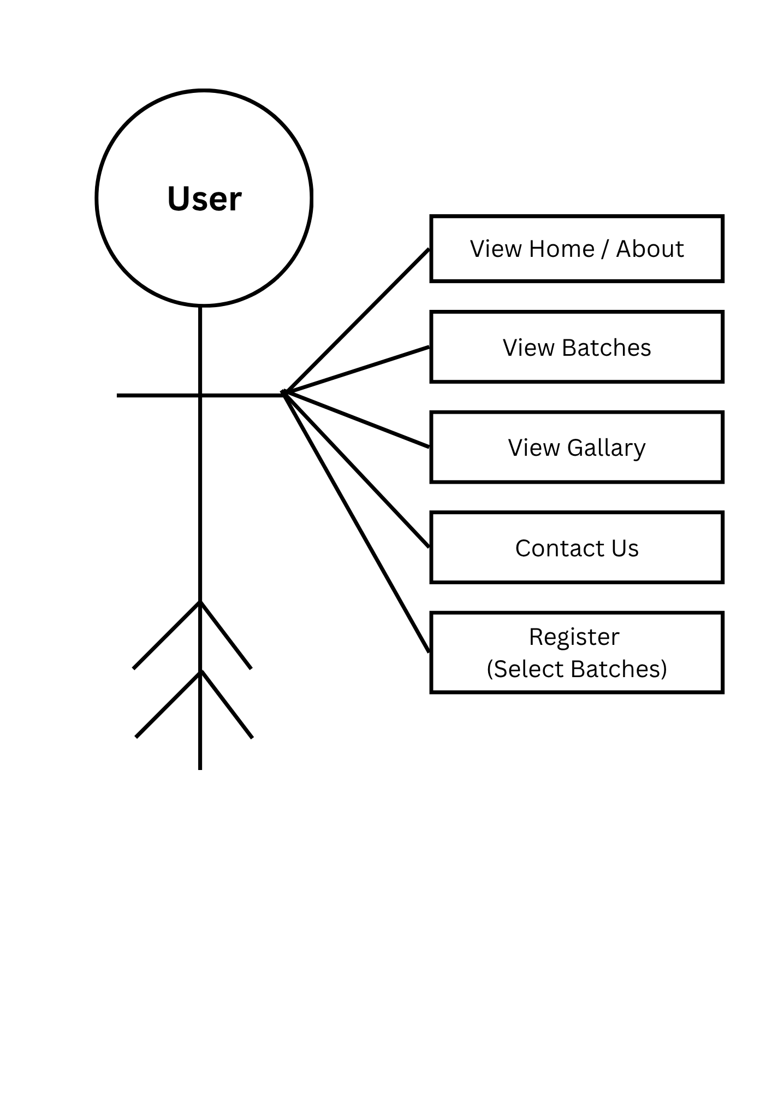
Visitor

2. Member
View/Edit profile
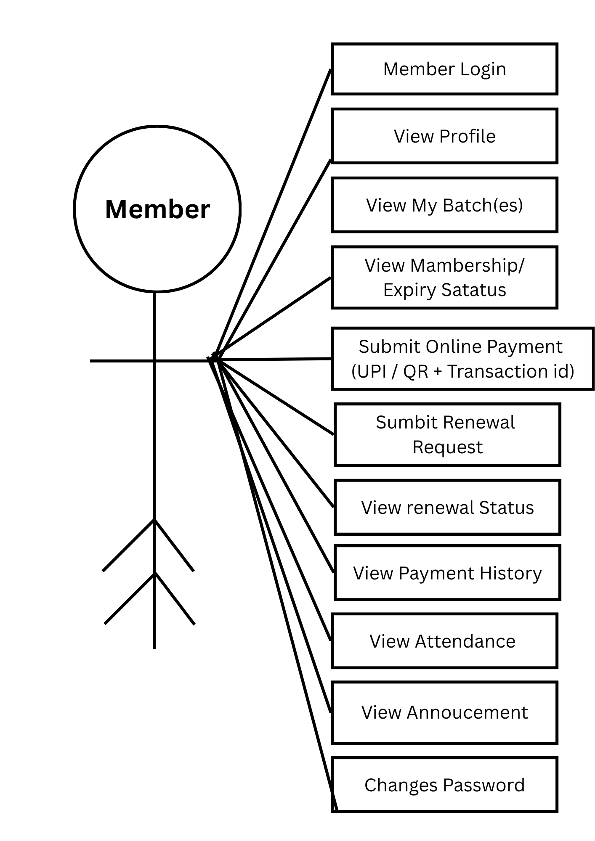
Logout
3. Trainer
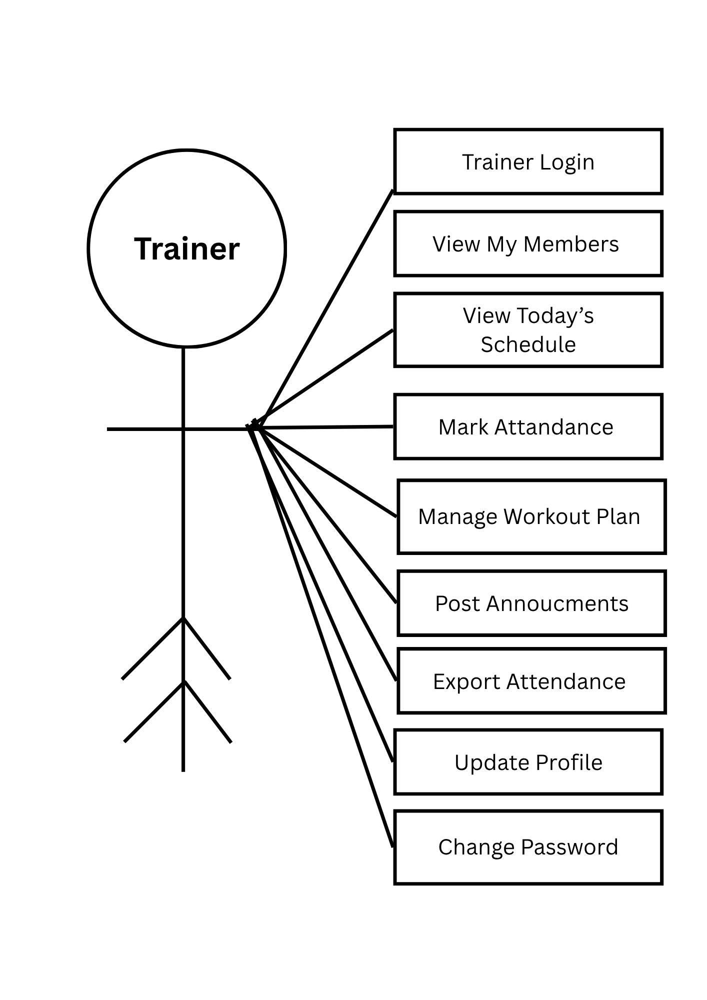
Logout

4. Admin
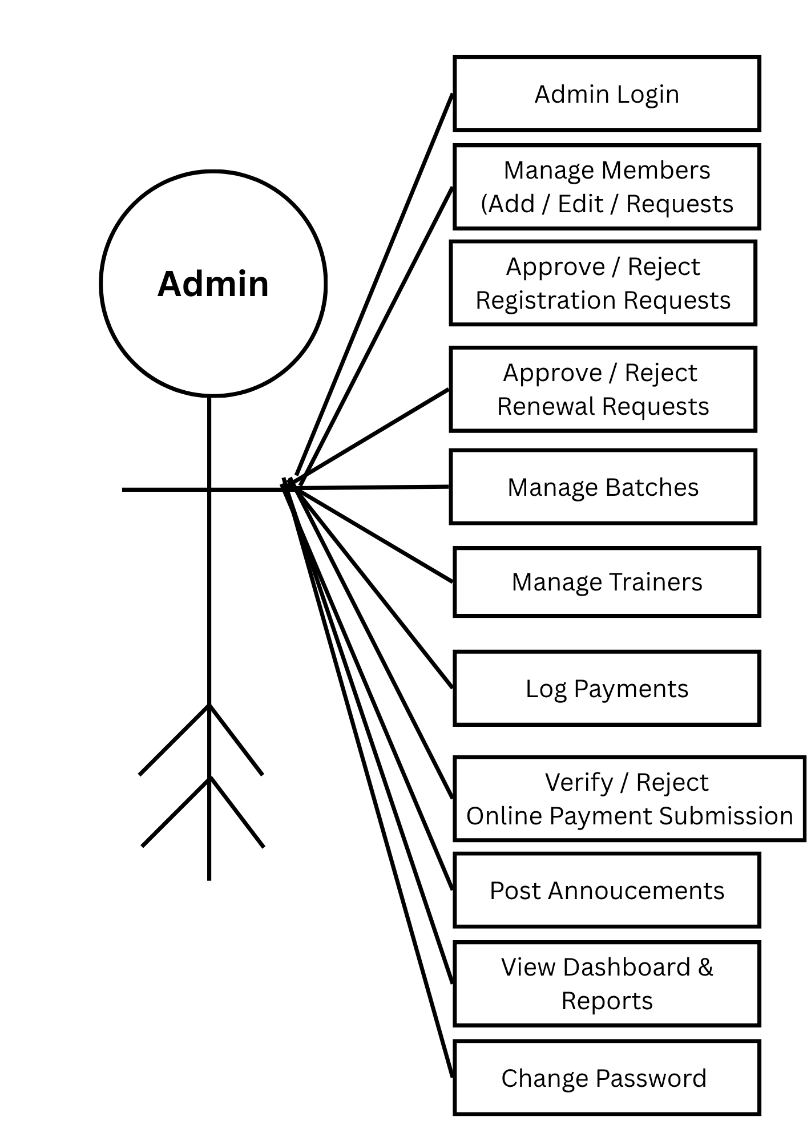
Logout
4.2 Data Flow Diagram

Symbol | Name | Use
 |  | Represents an external entity or source.
  Rectangle
 | Circle | Represents a process that transforms data.
 | Non-directed Line | Represents a connection without a specific direction.
 | Directed Line | Represents the direction of data flow.
 | Rounded Rectangle
  Represents a process or activity in the system

1. Level 0
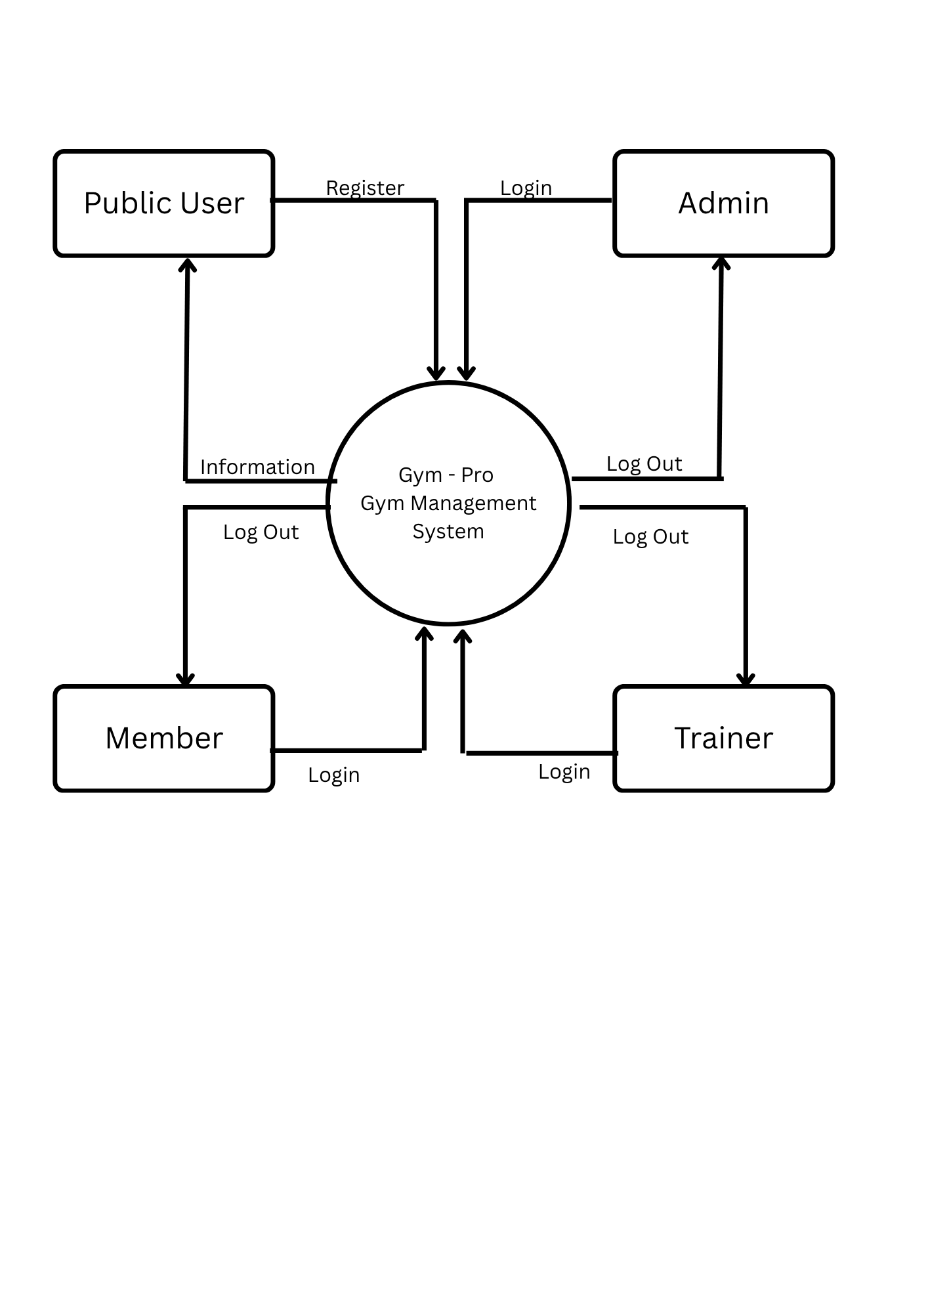

2. Level 1
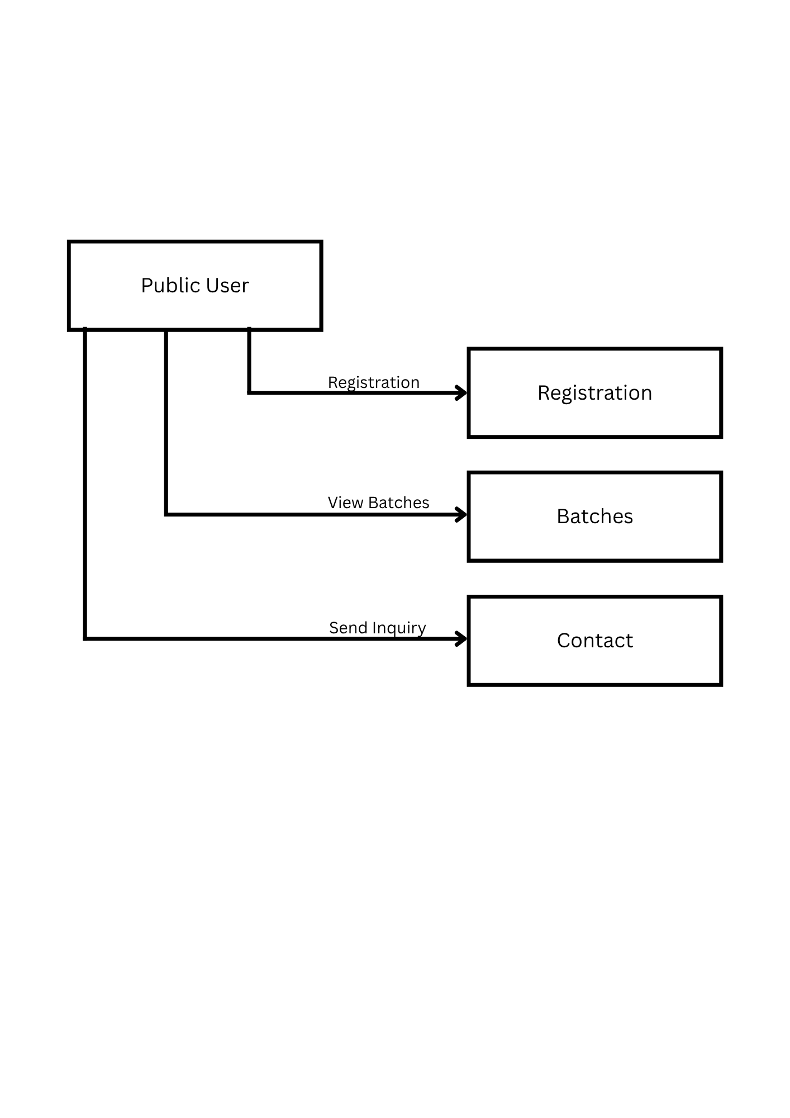
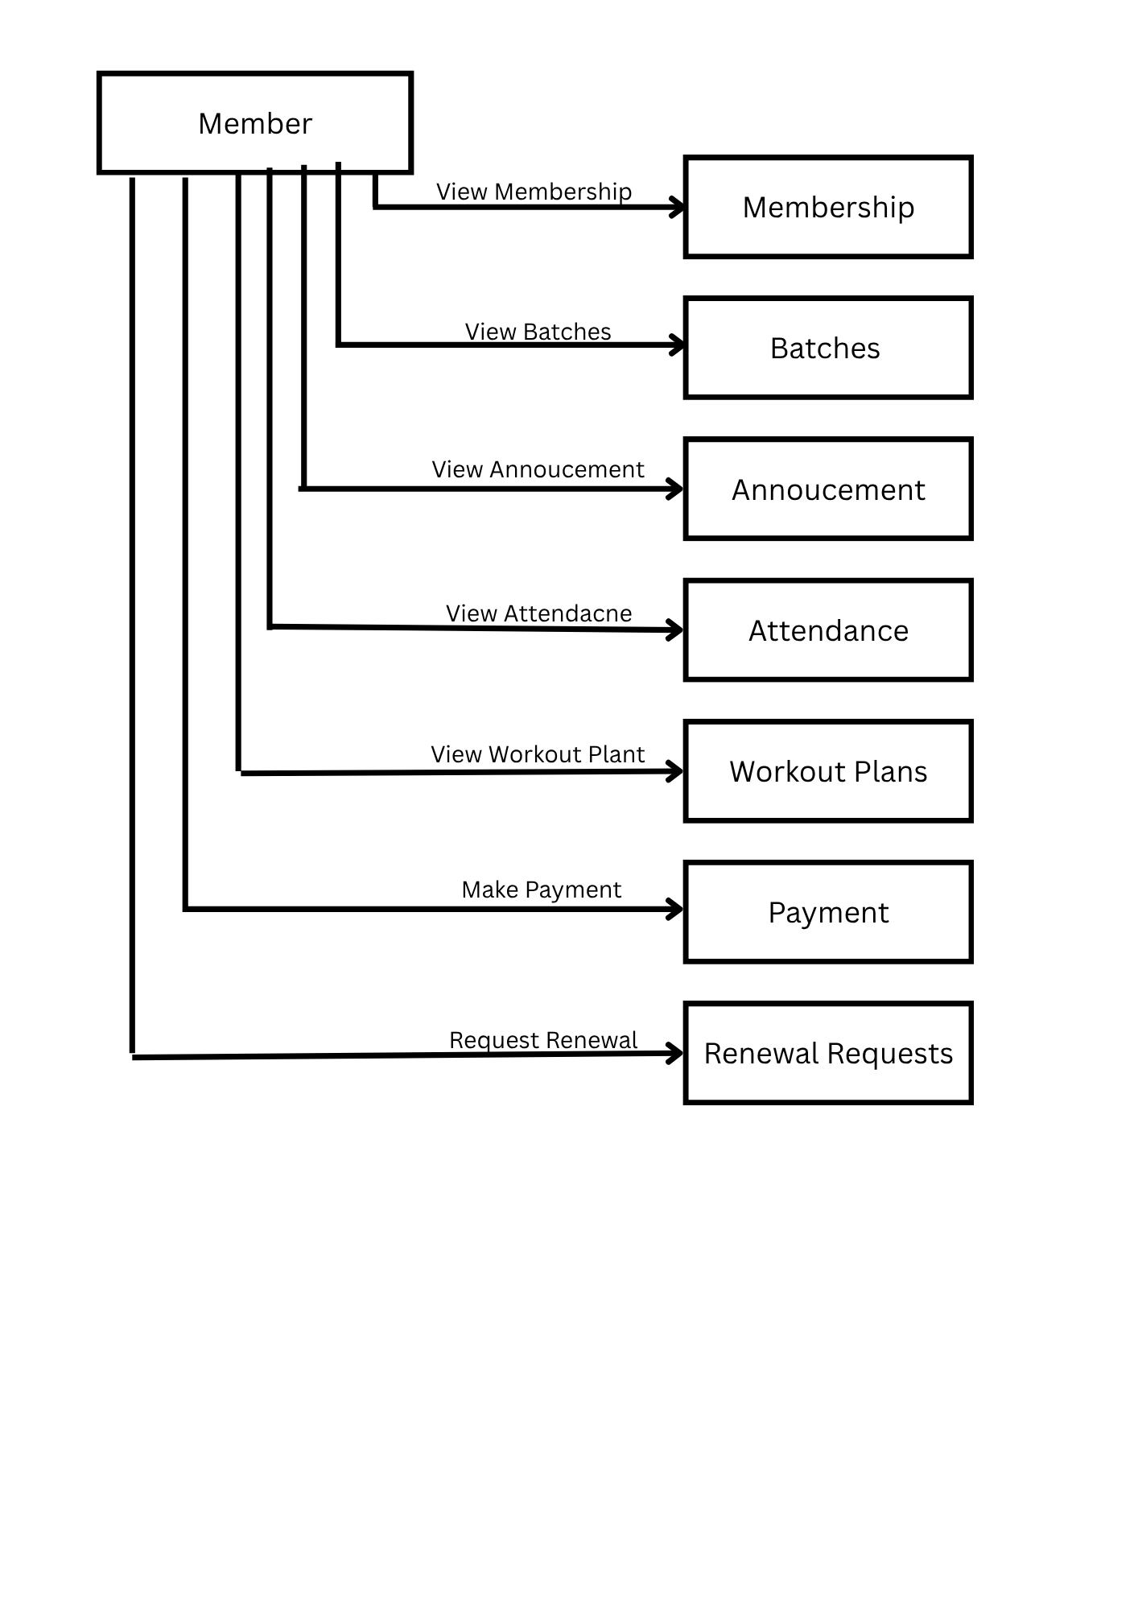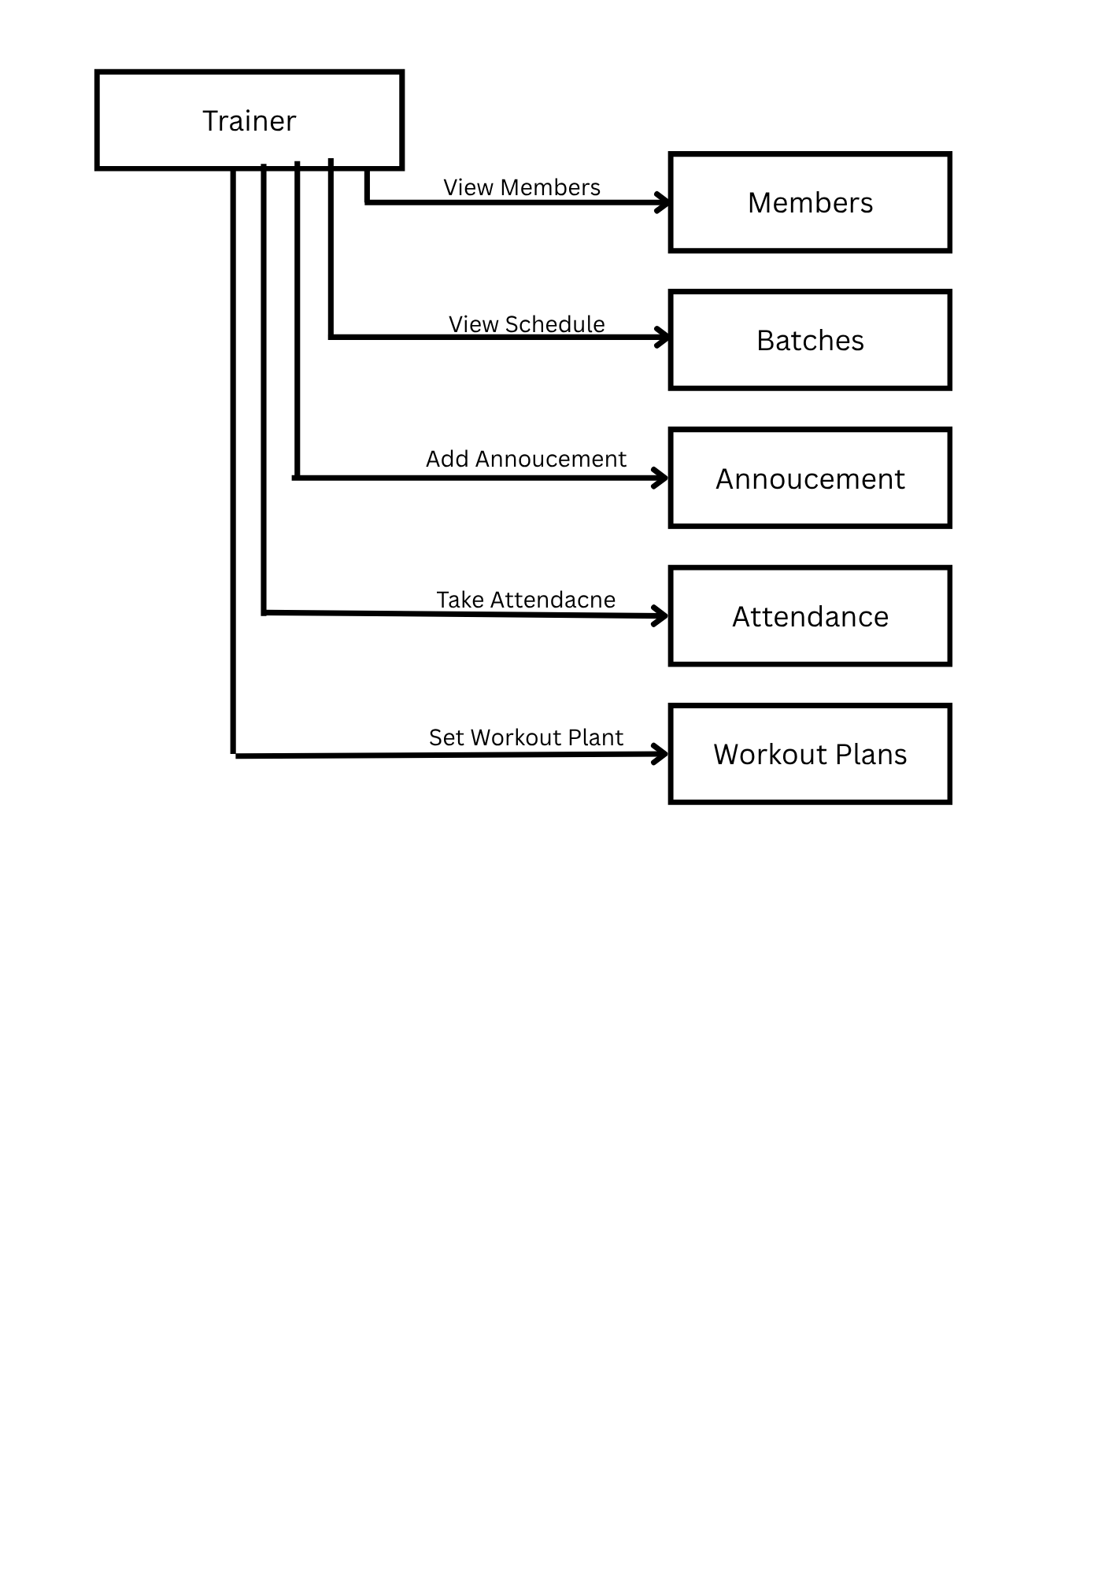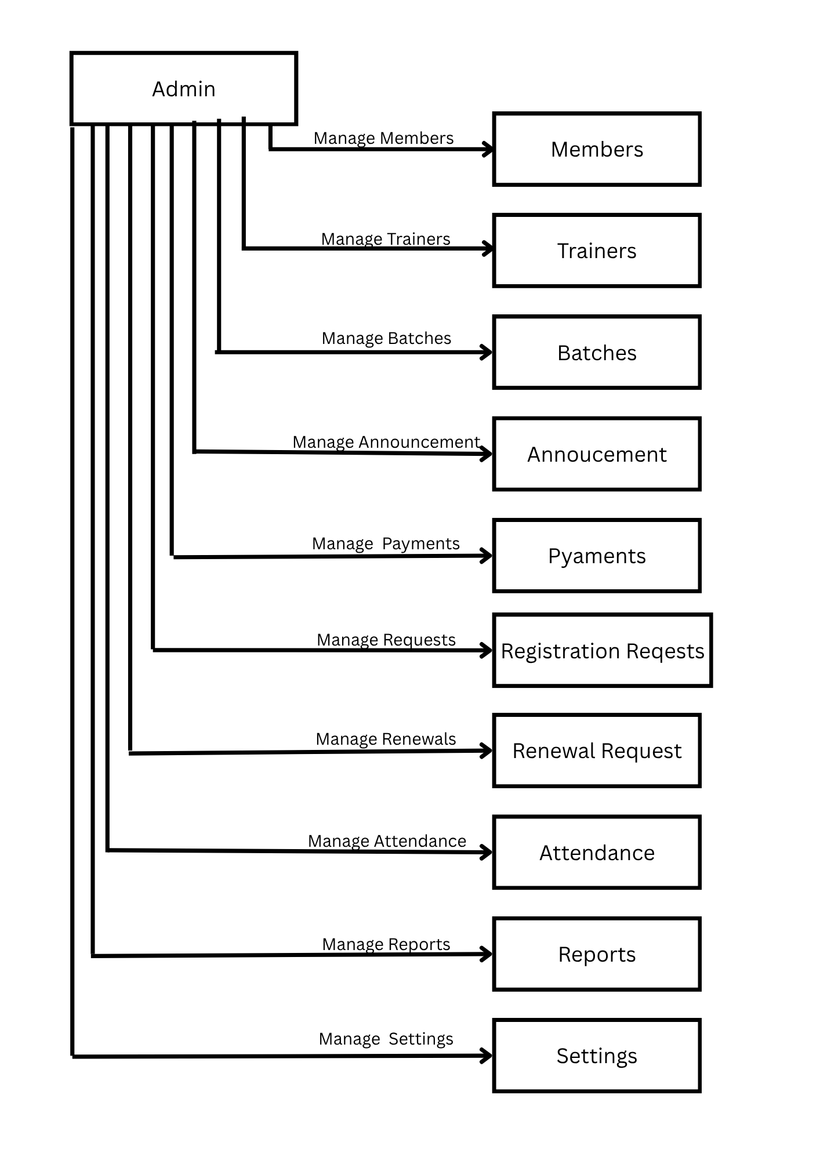
4.3 E-R Diagram
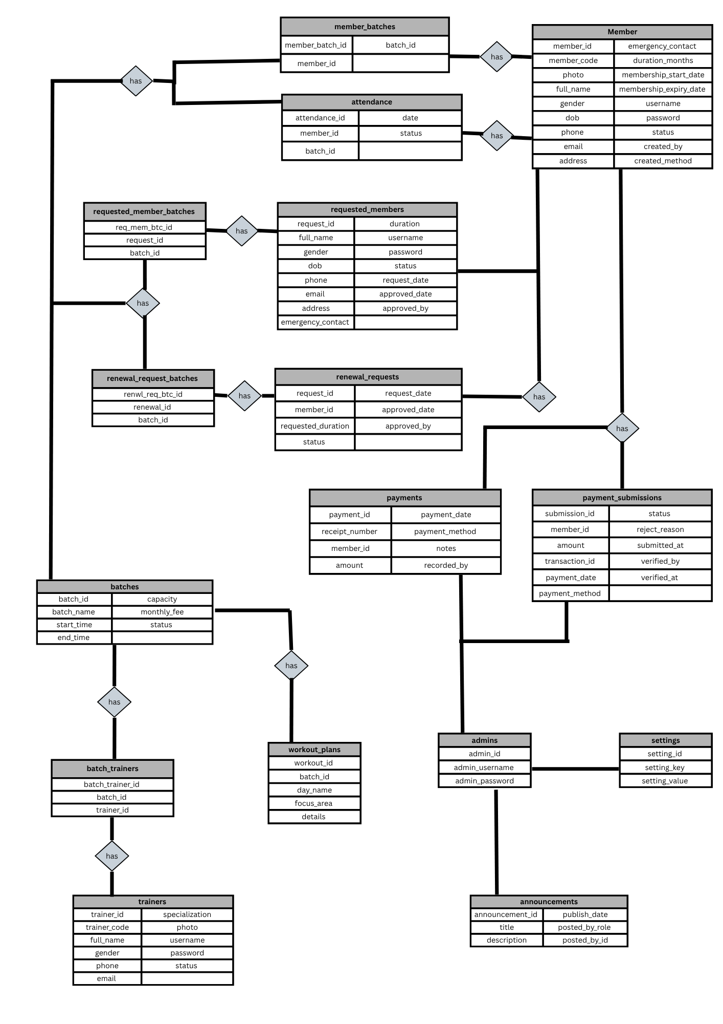

4.4 Data Dictionary
admins
Column Name | Data Type | Key / Constraint
admin_id | INT (Auto Increment) | Primary Key
admin_username | VARCHAR(50) | Not Null
admin_password | VARCHAR(255) | Not Null

trainers
Column Name | Data Type | Key / Constraint
trainer_id | INT (Auto Increment) | Primary Key
trainer_code | VARCHAR(20) | Not Null
full_name | VARCHAR(100) | Not Null
gender | ENUM('Male','Female','Other') | -
phone | VARCHAR(20) | Not Null
email | VARCHAR(100) | Not Null
specialization | VARCHAR(100) | -
photo | VARCHAR(255) | -
username / password | VARCHAR(50) / VARCHAR(255) | Not Null
status | ENUM('Active','Inactive') | -

batches
Column Name | Data Type | Key / Constraint
batch_id | INT (Auto Increment) | Primary Key
batch_name | VARCHAR(100) | Not Null
start_time / end_time | TIME | Not Null
capacity | INT | -
monthly_fee | DECIMAL(10,2) | -
status | ENUM('Active','Inactive') | -

batch_trainers
Column Name | Data Type | Key / Constraint
batch_trainer_id | INT (Auto Increment) | Primary Key
batch_id | INT | Foreign Key
trainer_id | INT | Foreign Key

members
Column Name | Data Type | Key / Constraint
member_id | INT (Auto Increment) | Primary Key
member_code | VARCHAR(20) | Not Null
photo | VARCHAR(255) | -
full_name | VARCHAR(100) | Not Null
gender | ENUM('Male','Female','Other') | -
dob | DATE | Not Null
phone / email | VARCHAR(20) / VARCHAR(100) | Not Null
address | VARCHAR(255) | -
emergency_contact | VARCHAR(20) | -
duration_months | INT | -
membership_start_date | DATE | Not Null
membership_expiry_date | DATE | Not Null
username / password | VARCHAR(50) / VARCHAR(255) | Not Null
status | ENUM('Active','Expired','Inactive','Pending Payment') | -
created_by | VARCHAR(50) | -
created_method | ENUM('Request','Admin') | -

member_batches
Column Name | Data Type | Key / Constraint
member_batch_id | INT (Auto Increment) | Primary Key
member_id | INT | Foreign Key
batch_id | INT | Foreign Key

payments
Column Name | Data Type | Key / Constraint
payment_id | INT (Auto Increment) | Primary Key
receipt_number | VARCHAR(20) | Not Null
member_id | INT | Foreign Key
amount | DECIMAL(10,2) | Not Null
payment_date | DATE | Not Null
payment_method | ENUM('Cash','UPI','Card','BankTransfer','Other') | -
notes | VARCHAR(255) | -
recorded_by | INT | Foreign Key

payment_submissions
Column Name | Data Type | Key / Constraint
submission_id | INT (Auto Increment) | Primary Key
member_id | INT | Foreign Key
amount | DECIMAL(10,2) | Not Null
transaction_id | VARCHAR(100) | Not Null
payment_date | DATE | Not Null
payment_method | VARCHAR(20) | -
status | ENUM('Pending Verification','Verified','Rejected') | -
reject_reason | VARCHAR(255) | -
submitted_at | DATETIME | -
verified_by | INT | Foreign Key
verified_at | DATETIME | -

requested_members
Column Name | Data Type | Key / Constraint
request_id | INT (Auto Increment) | Primary Key
full_name, gender, dob | VARCHAR/ENUM/DATE | Not Null
phone, email | VARCHAR(20) / VARCHAR(100) | Not Null
address, emergency_contact | VARCHAR | -
duration | INT | -
username / password | VARCHAR(50) / VARCHAR(255) | Not Null
status | ENUM('Pending','Approved','Rejected') | -
request_date / approved_date | DATETIME | -
approved_by | INT | Foreign Key

requested_member_batches
Column Name | Data Type | Key / Constraint
req_mem_btc_id | INT (Auto Increment) | Primary Key
request_id | INT | Foreign Key
batch_id | INT | Foreign Key

renewal_requests
Column Name | Data Type | Key / Constraint
renewal_id | INT (Auto Increment) | Primary Key
member_id | INT | Foreign Key
requested_duration | INT | -
status | ENUM('Pending','Approved','Rejected') | -
request_date / approved_date | DATETIME | -
approved_by | INT | Foreign Key

renewal_request_batches
Column Name | Data Type | Key / Constraint
renwl_req_btc_id | INT (Auto Increment) | Primary Key
renewal_id | INT | Foreign Key
batch_id | INT | Foreign Key

announcements
Column Name | Data Type | Key / Constraint
announcement_id | INT (Auto Increment) | Primary Key
title | VARCHAR(150) | Not Null
description | TEXT | Not Null
publish_date | DATETIME | -
posted_by_role | ENUM('Admin','Trainer') | -
posted_by_id | INT | Not Null

workout_plans
Column Name | Data Type | Key / Constraint
workout_id | INT (Auto Increment) | Primary Key
batch_id | INT | Foreign Key
day_name | ENUM('Monday'…'Sunday') | Not Null
focus_area | VARCHAR(100) | -
details | TEXT | -

attendance
Column Name | Data Type | Key / Constraint
attendance_id | INT (Auto Increment) | Primary Key
member_id | INT | Foreign Key
batch_id | INT | Foreign Key
date | DATE | Not Null
status | ENUM('Present','Absent') | -
(member_id, batch_id, date) | - | -

settings
Column Name | Data Type | Key / Constraint
setting_id | INT (Auto Increment) | Primary Key
setting_key | VARCHAR(50) | Not Null
setting_value | VARCHAR(255) | Not Null

5. Screen Design
1. Public User Side
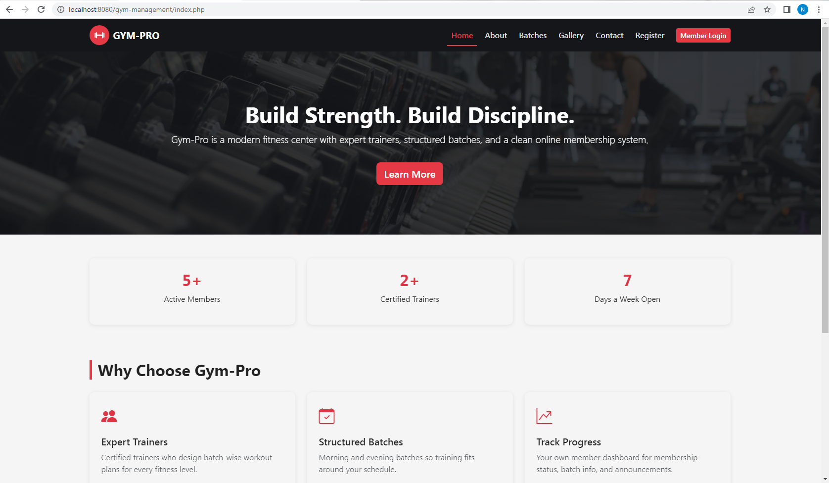
- Home

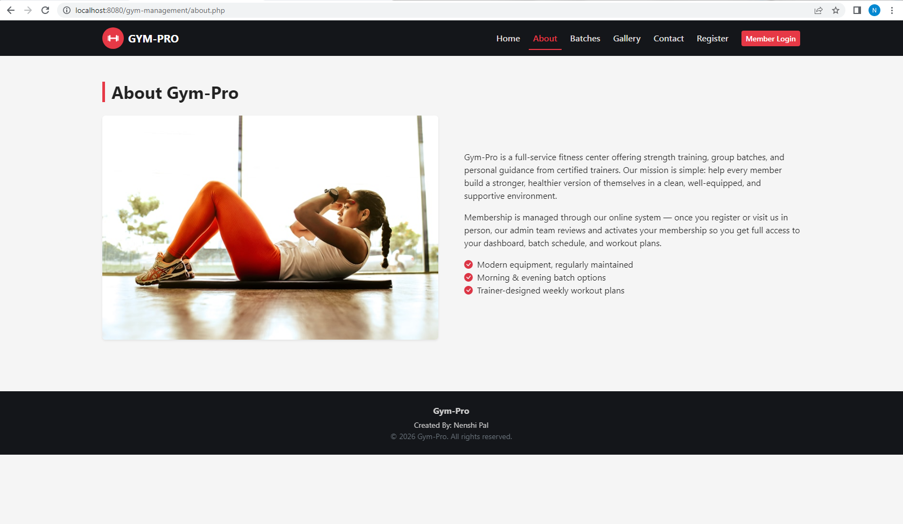
- About
About: Provides information about the gym and its services.

- Batches
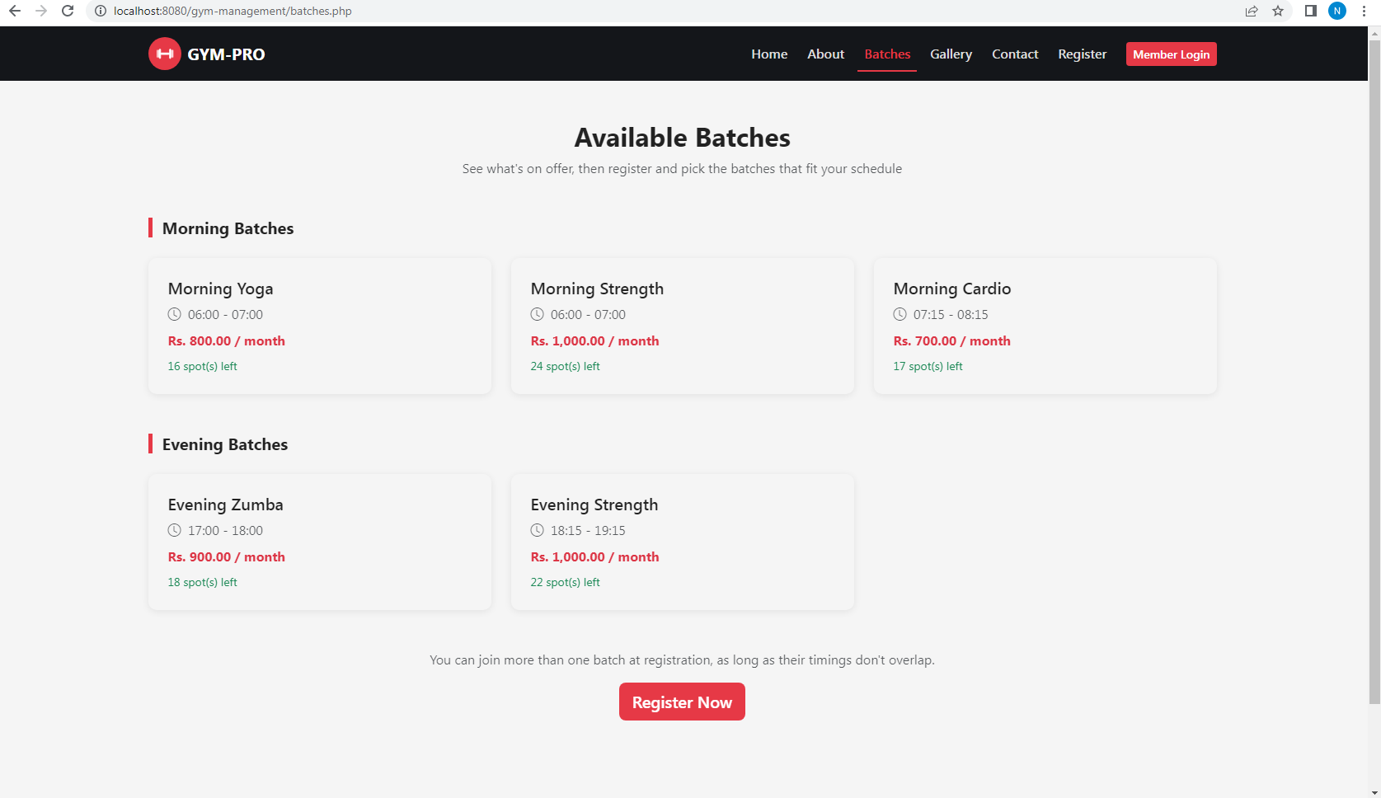
Batches: Displays available gym batches with their schedules and details.
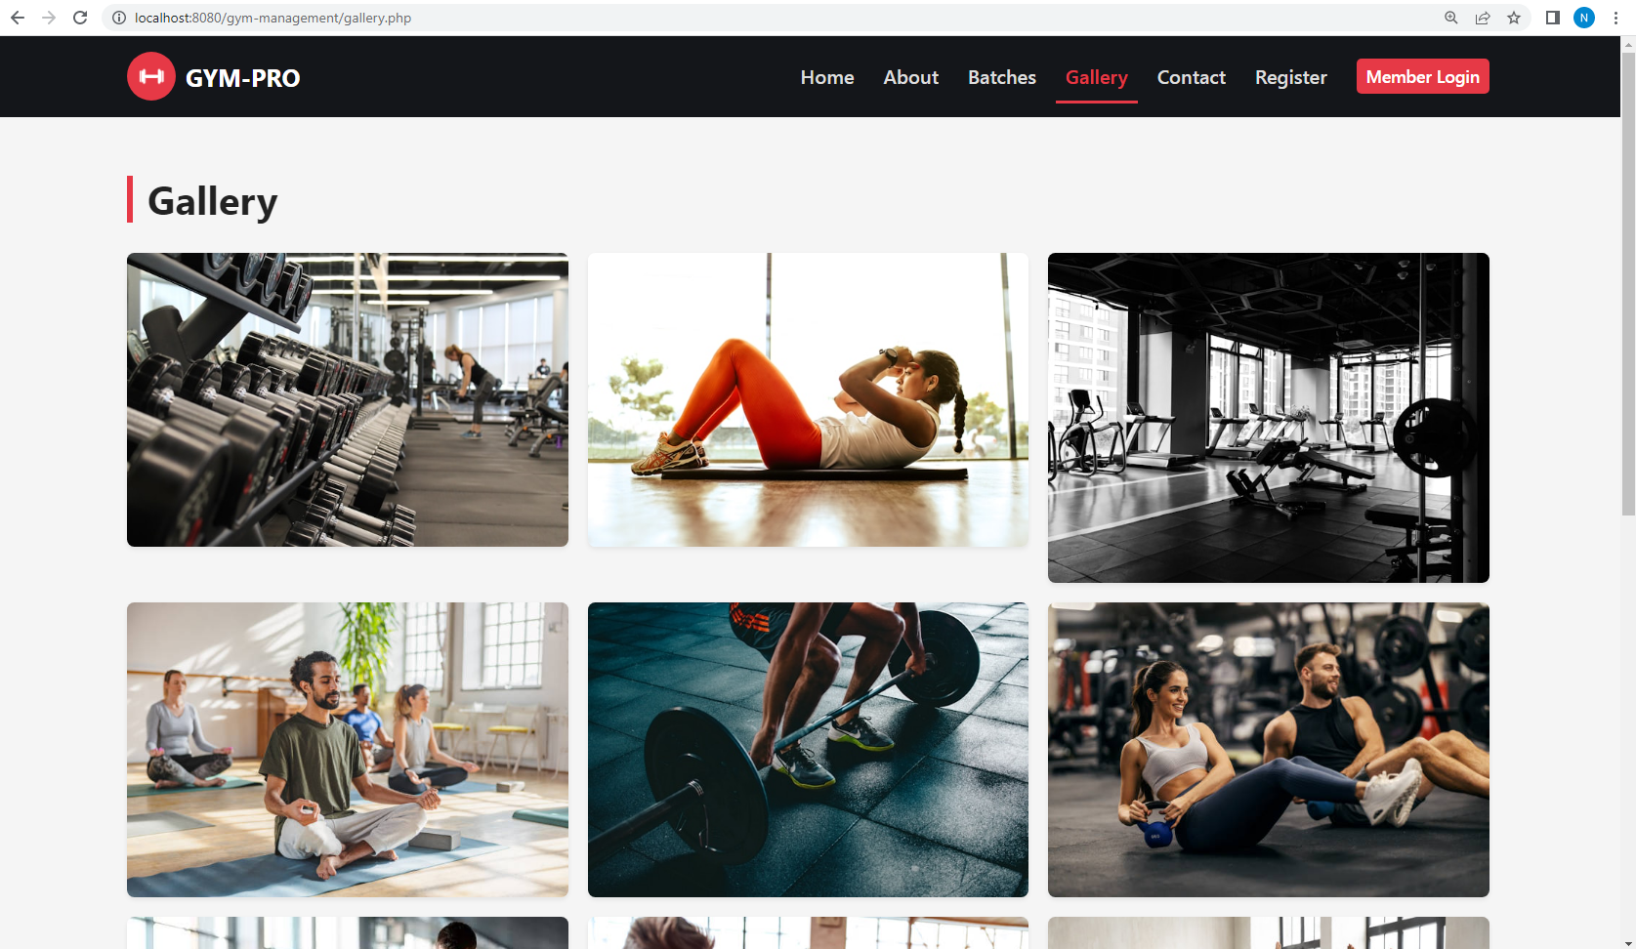
- Gallery

Gallery: Shows images of the gym and its facilities.

- Contact

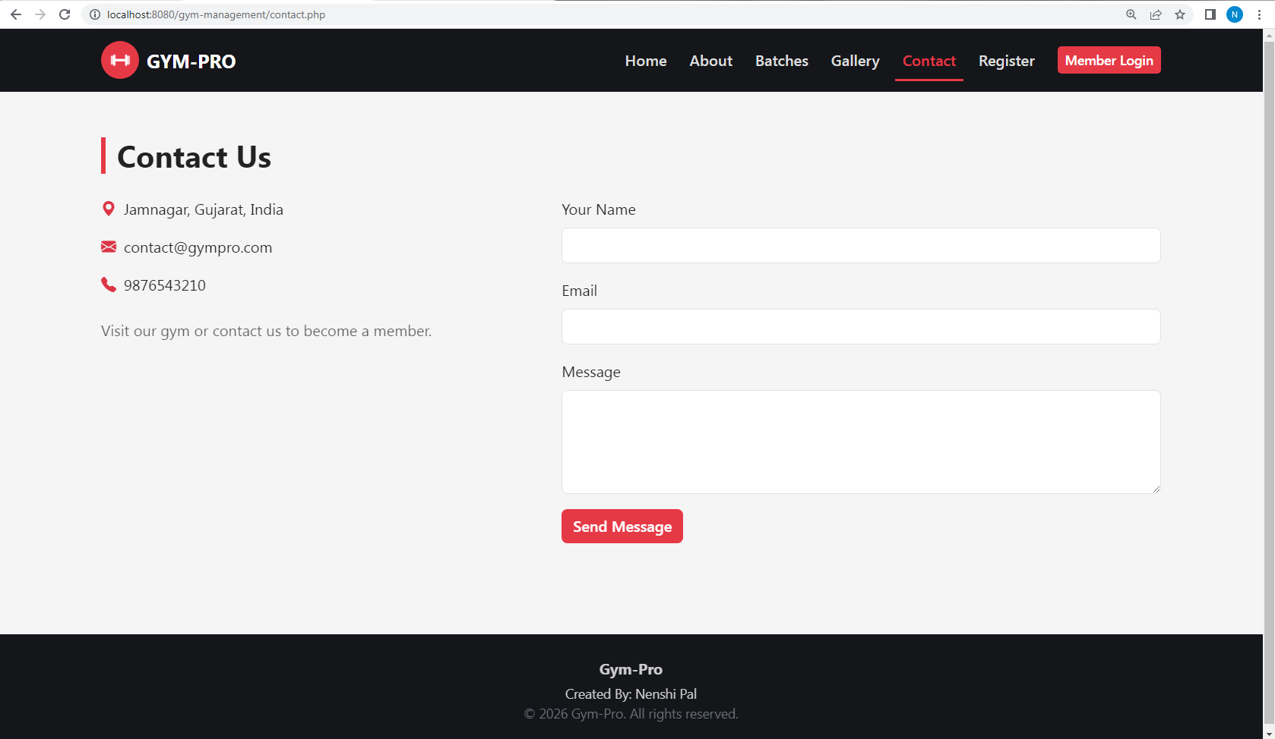
Contact: Displays gym contact details for user enquiries.

- Register

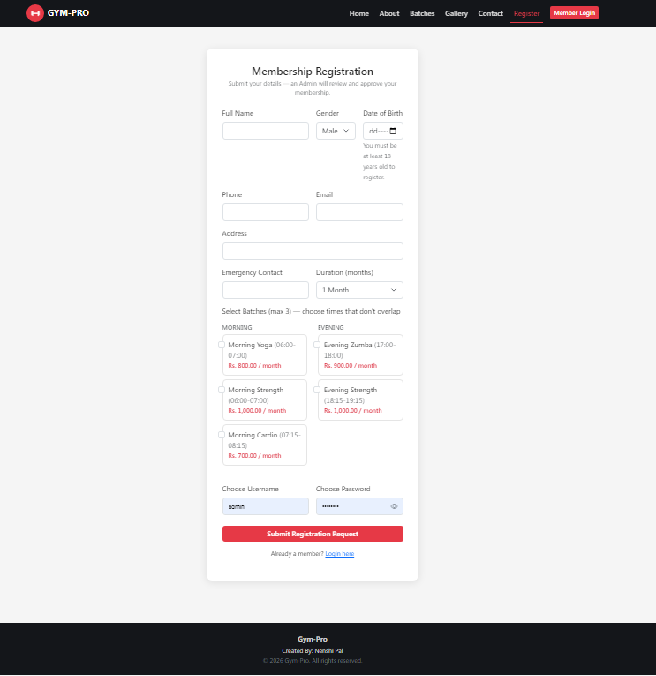
Register: Allows new users to submit their gym membership registration details.

- Member Login
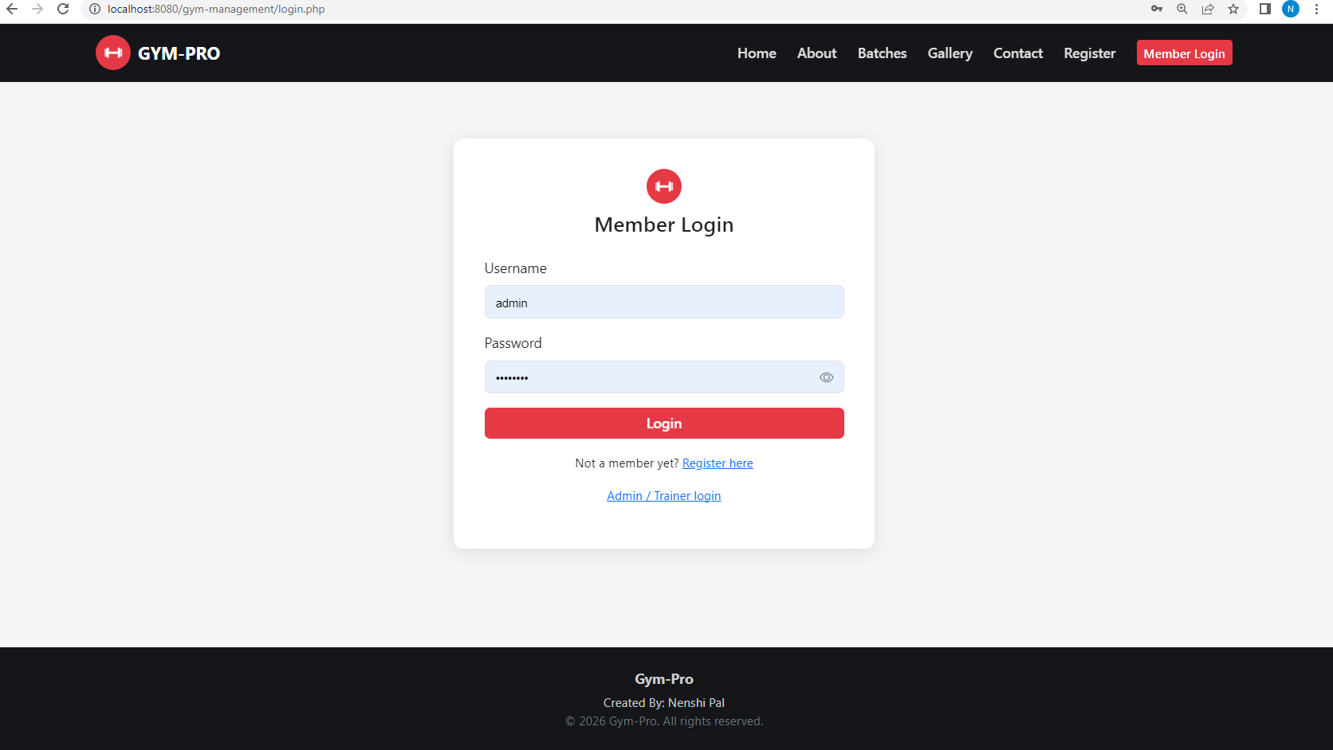
Member Login: Allows registered members to securely access their account.

2. Admin side
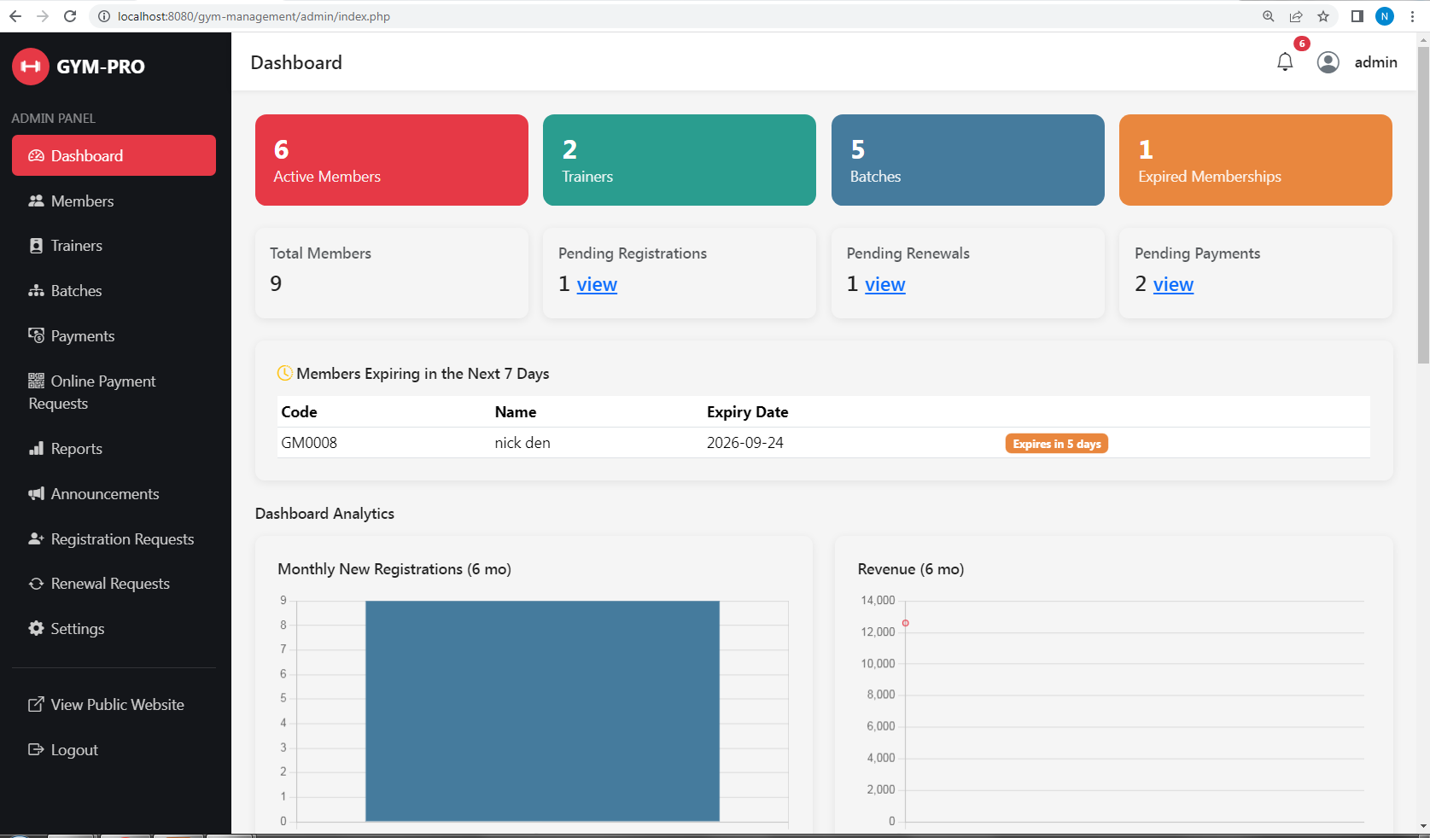
- Dashboard
Dashboard: Displays an overview of members, requests, payments and gym activities.
- Members
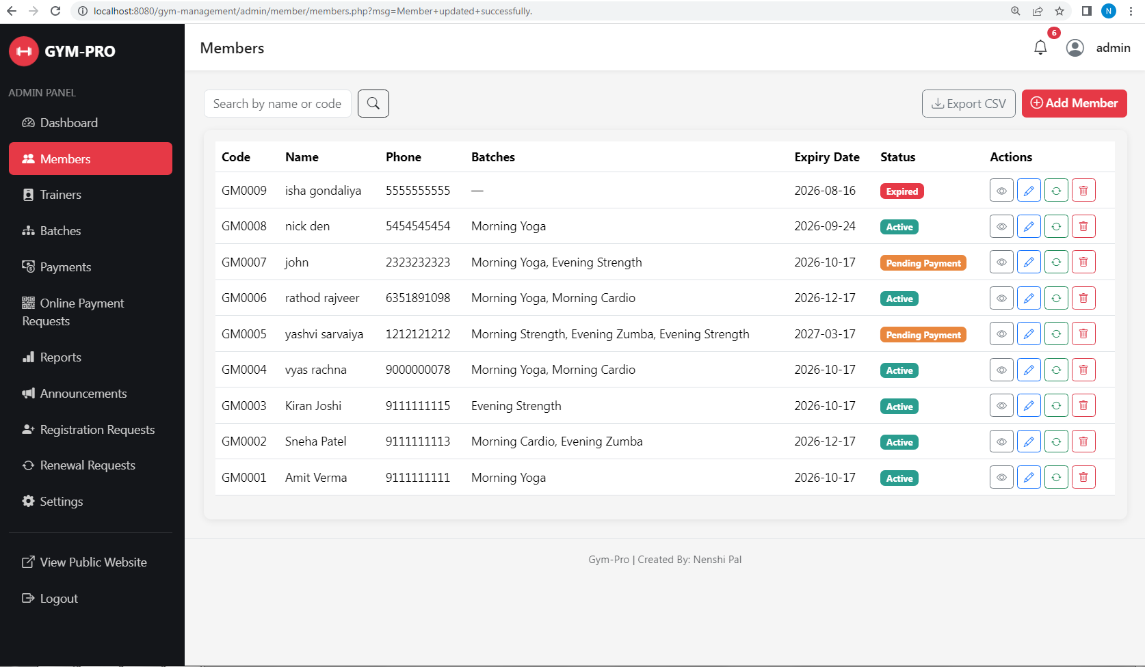
Members: Allows the admin to manage gym member records.
- Trainer
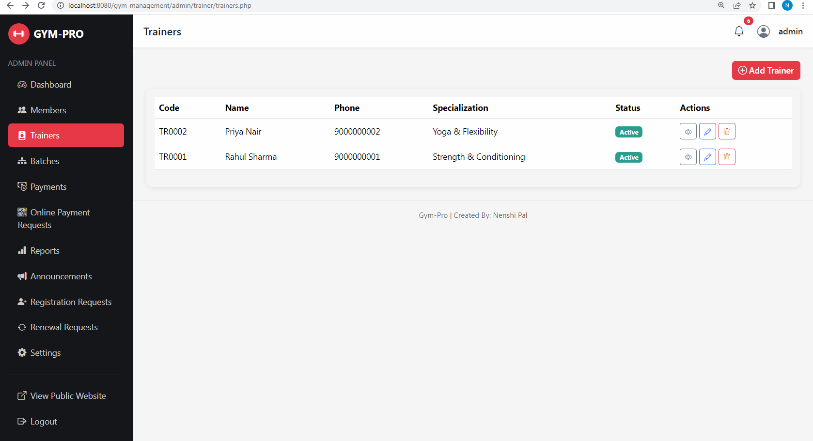
Trainer: Allows the admin to add and manage trainer information.

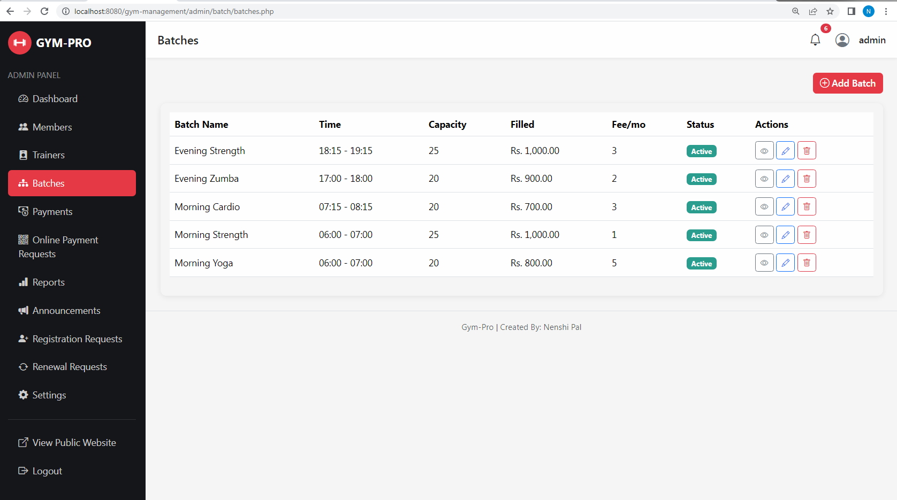
- Batches
Batches: Allows the admin to manage gym batches and their details.

- Payment
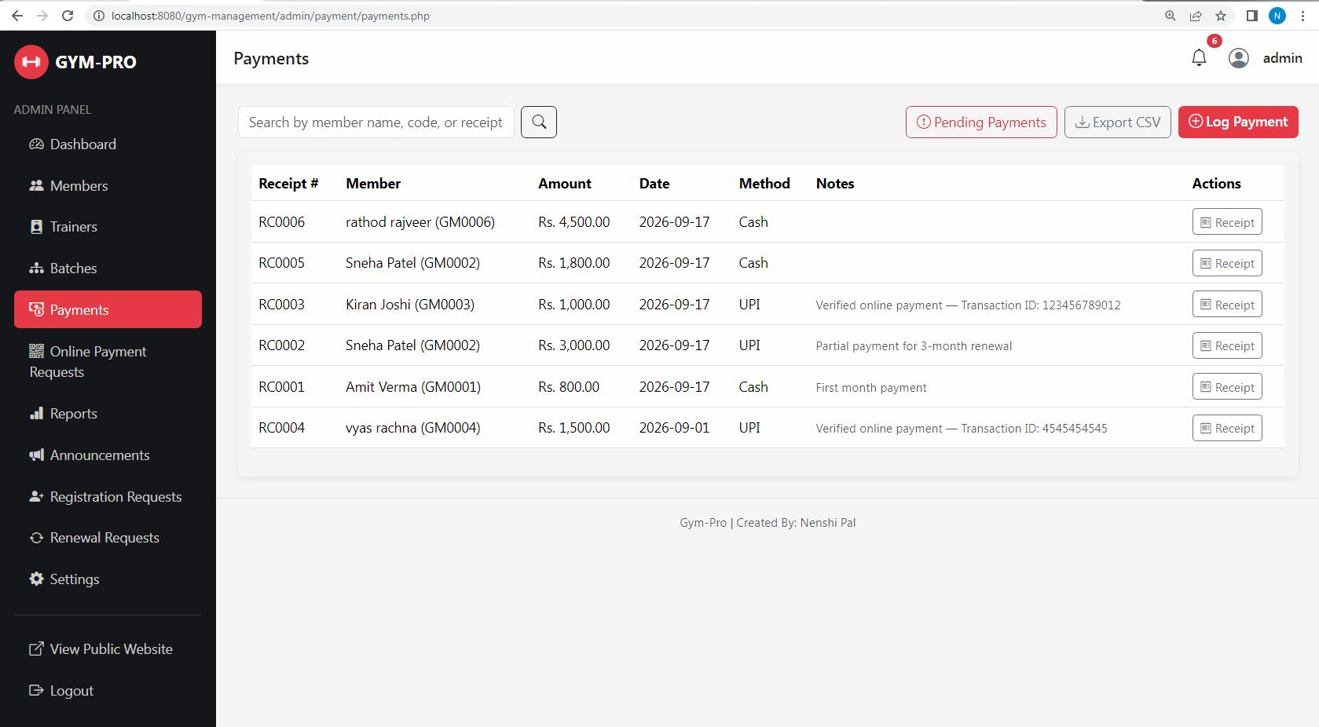
Payment: Allows the admin to record and manage member payments.

- Online Payment Request
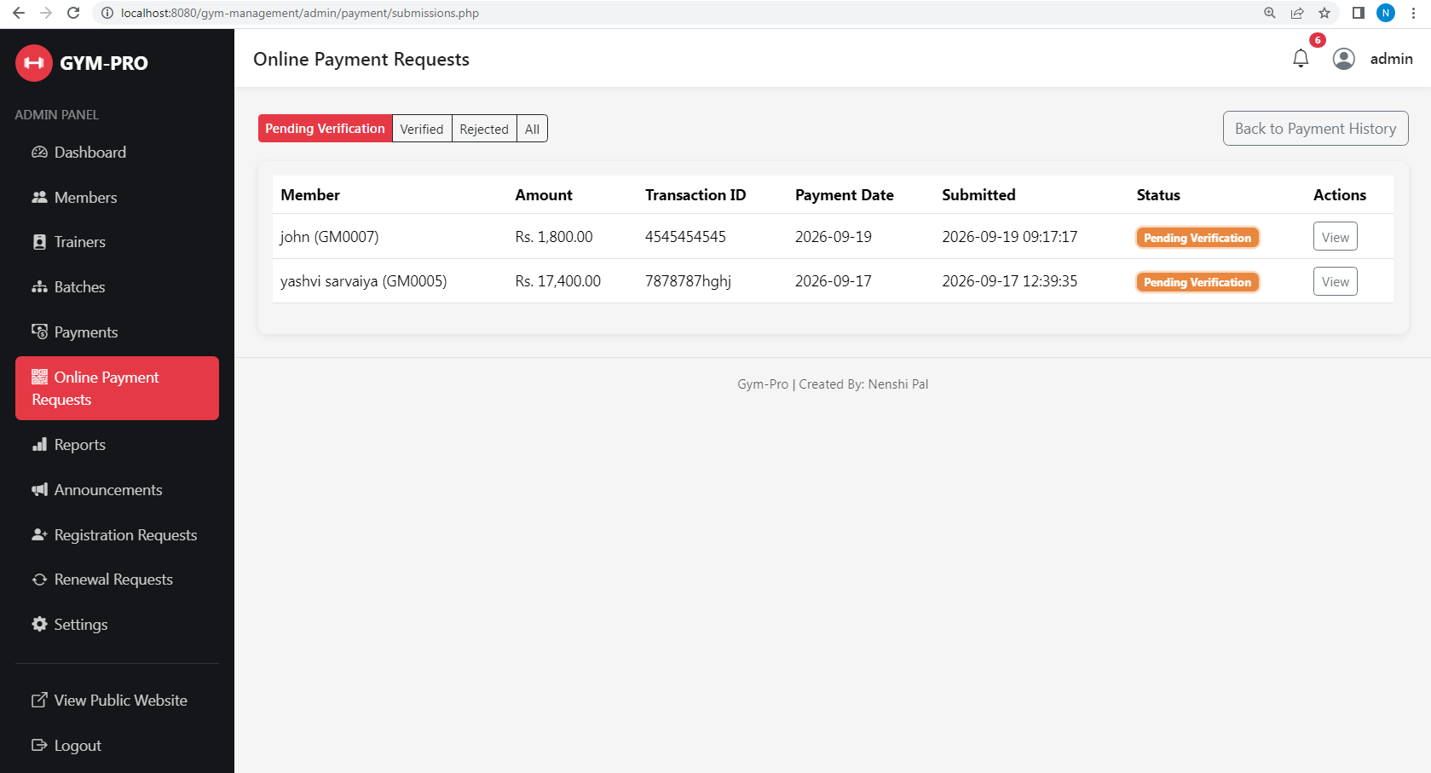
Online Payment Request: Allows the admin to verify or reject online payment submissions.

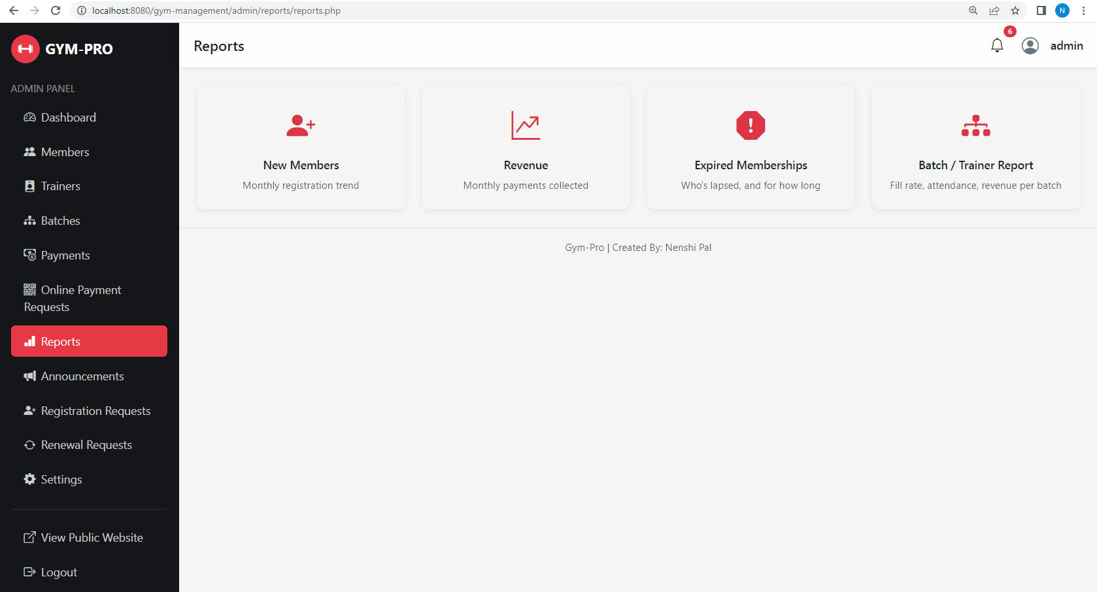
- Reports
Reports: Displays important gym management reports and records.

- Announcement

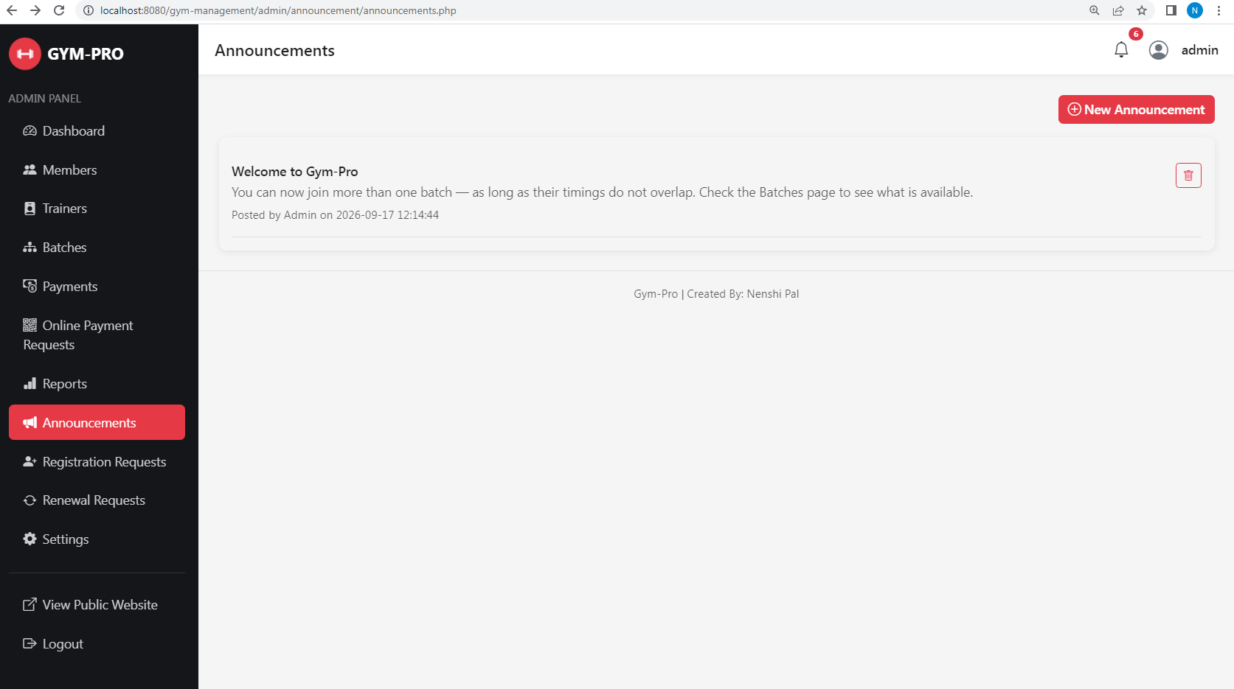
Announcement: Allows the admin to create and manage gym announcements.

- Registration requests
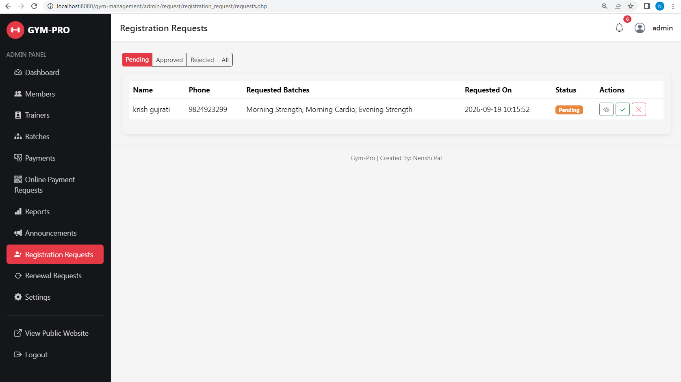
Registration Requests: Allows the admin to approve or reject new member registration requests.

- Renewal requests
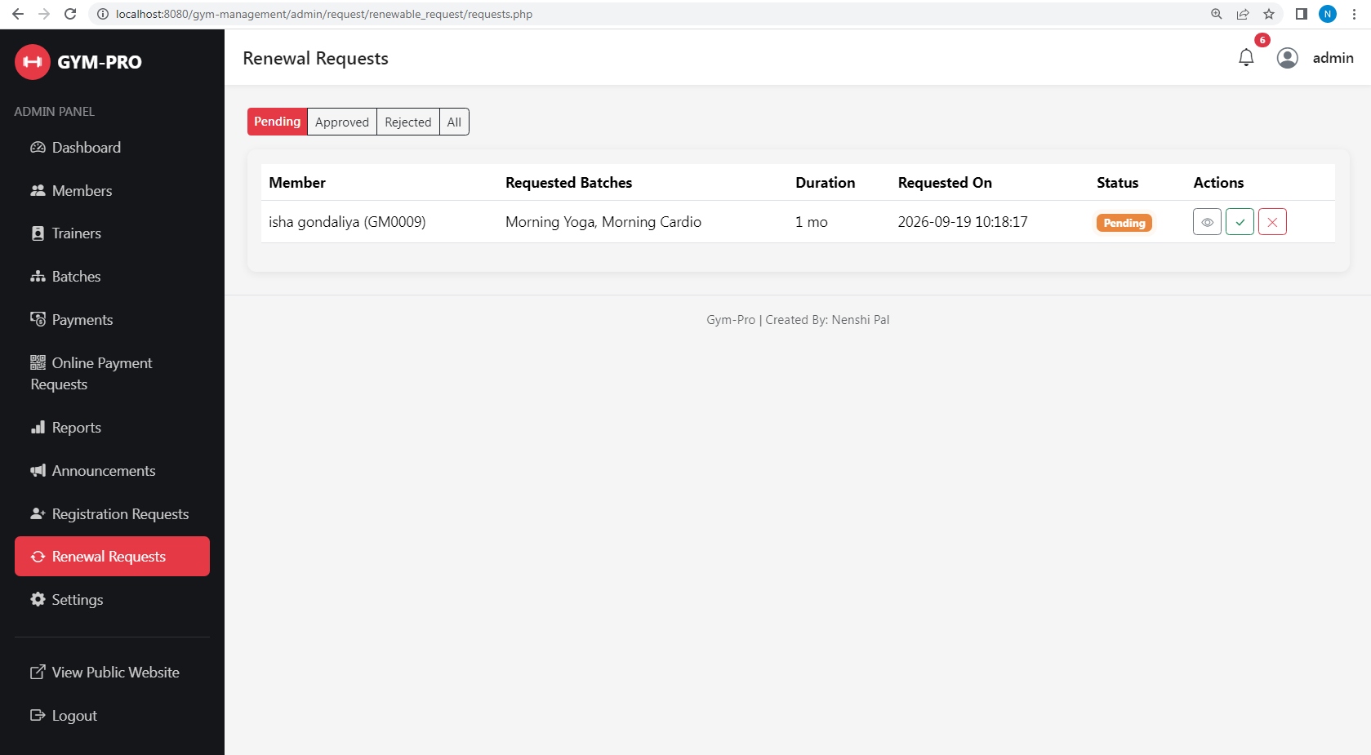
Renewal Requests: Allows the admin to manage member membership renewal requests.

- Settings
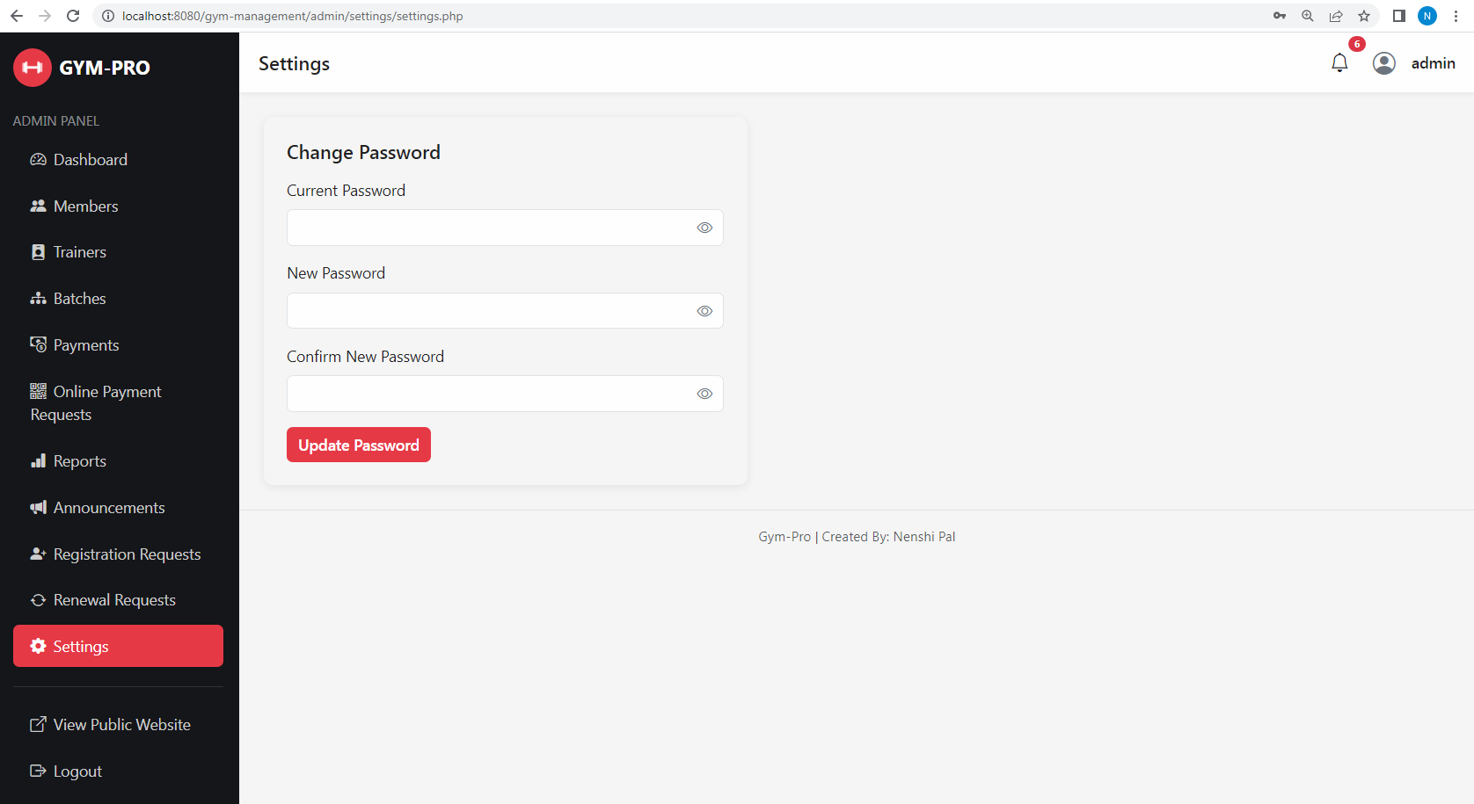
Setting: Allows the admin to manage system settings.

3. Trainer side
- Dashboard
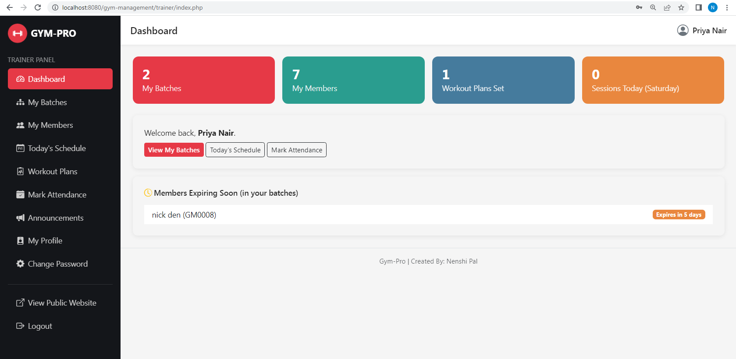

Dashboard: Displays an overview of the trainer's assigned gym activities.

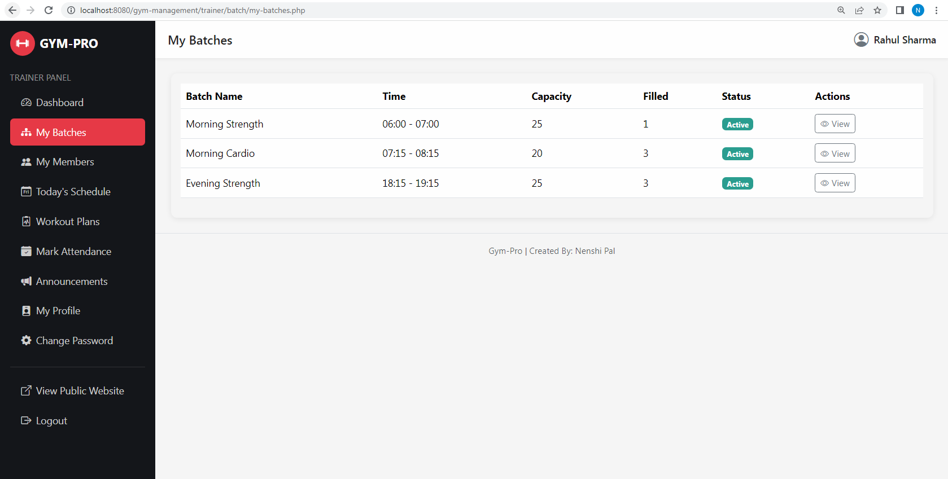
- My Batches

My Batches: Displays the batches assigned to the trainer.

- My Members
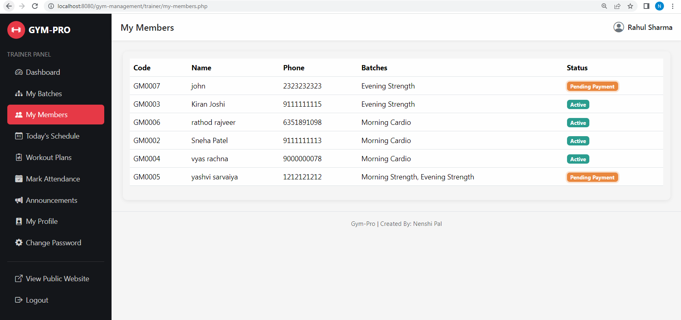
My Members: Displays members belonging to the trainer's assigned batches.

- Today’s Schedule

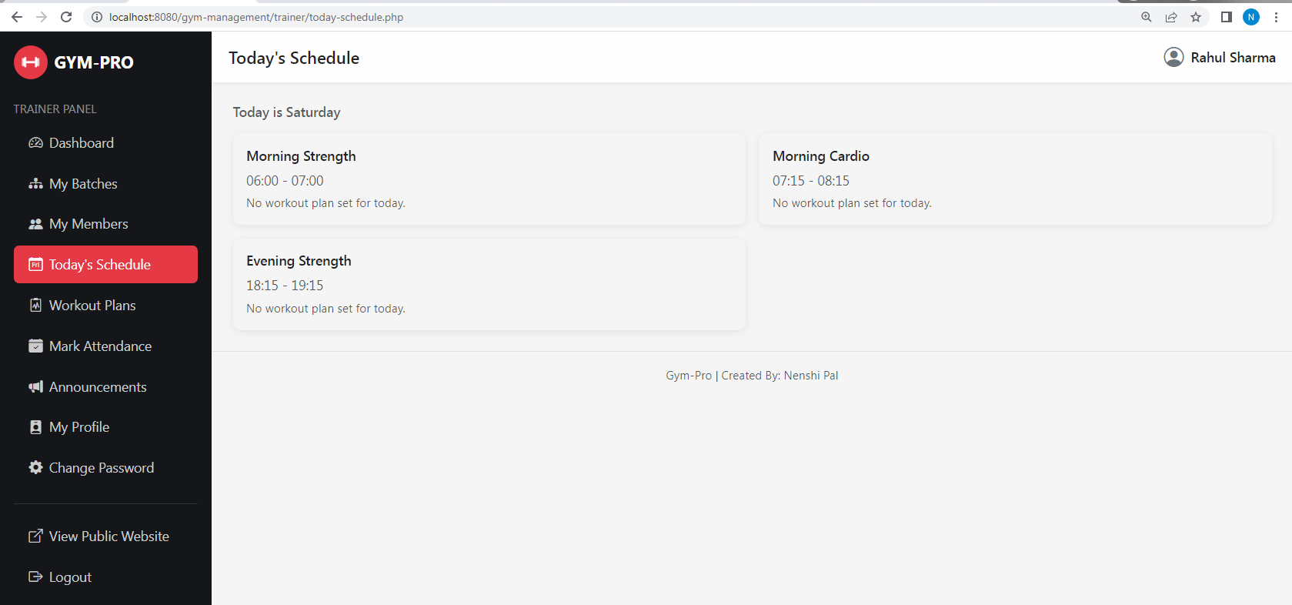
Today's Schedule: Displays the trainer's schedule for the current day.

- Workout Plans
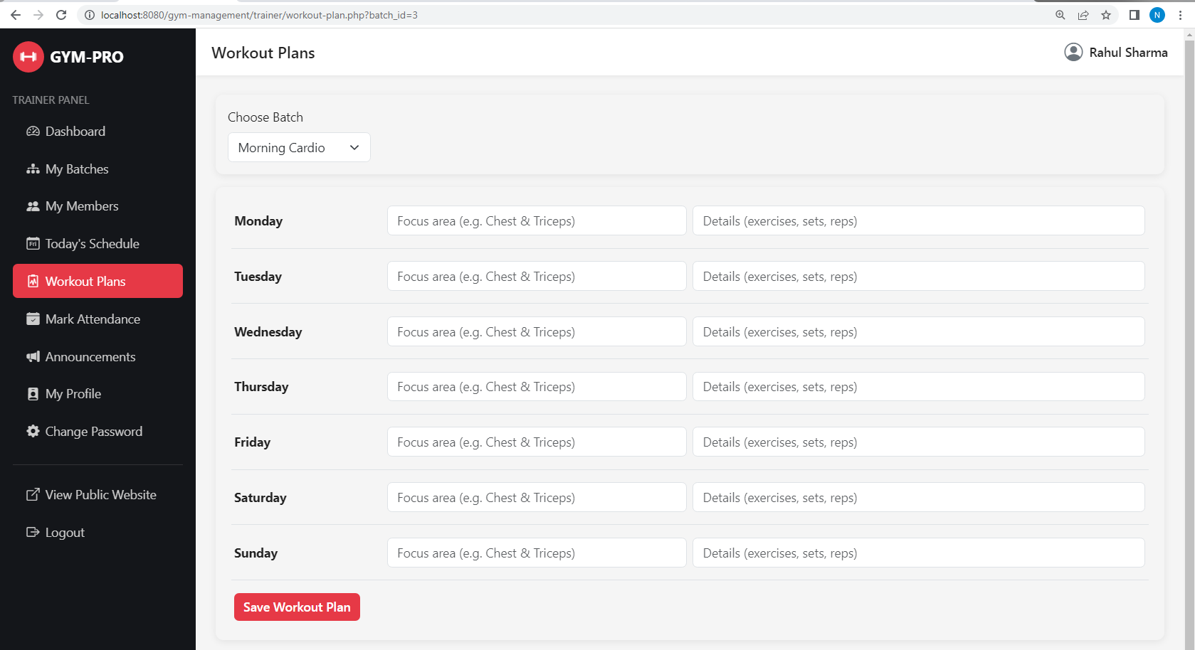
Workout Plans: Allows the trainer to manage workout plans for assigned batches.

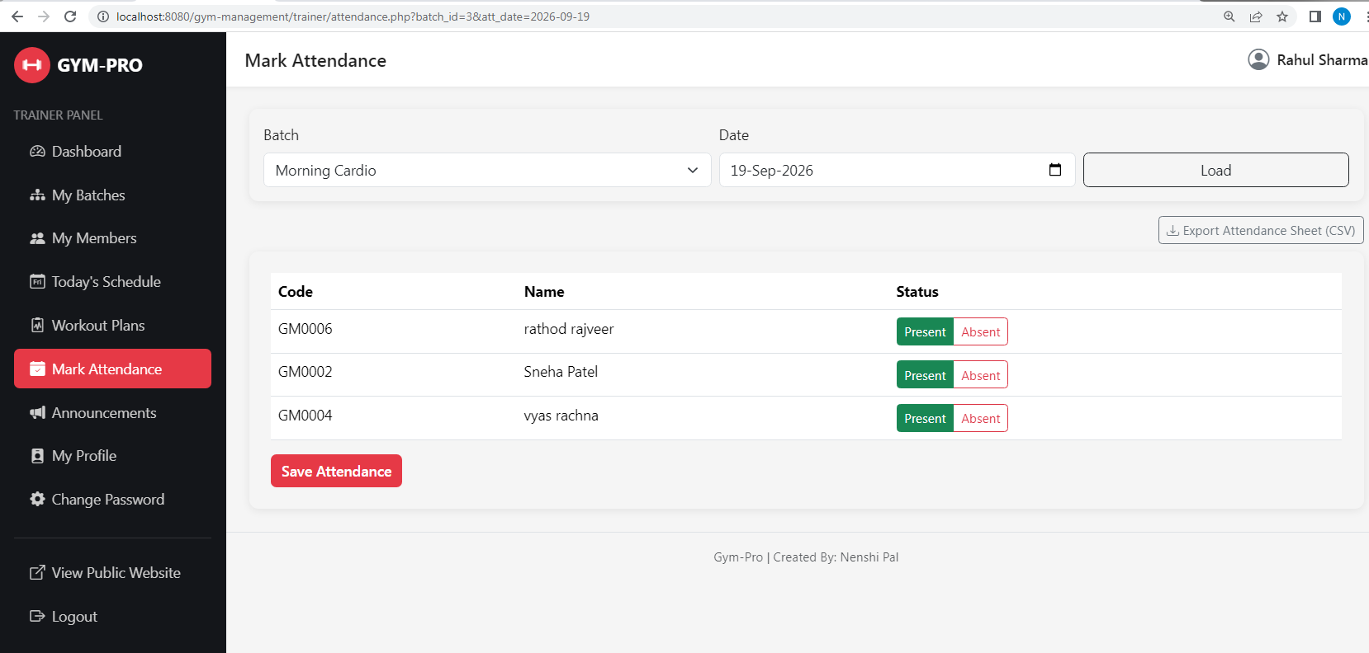
- Mark Attendance
Mark Attendance: Allows the trainer to record member attendance.

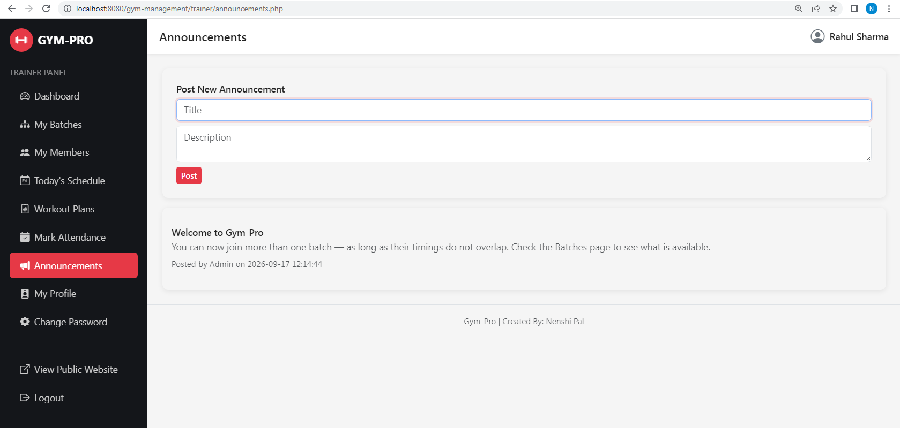
- Announcement

Announcement: Allows the trainer to view and post gym announcements.

- My Profile

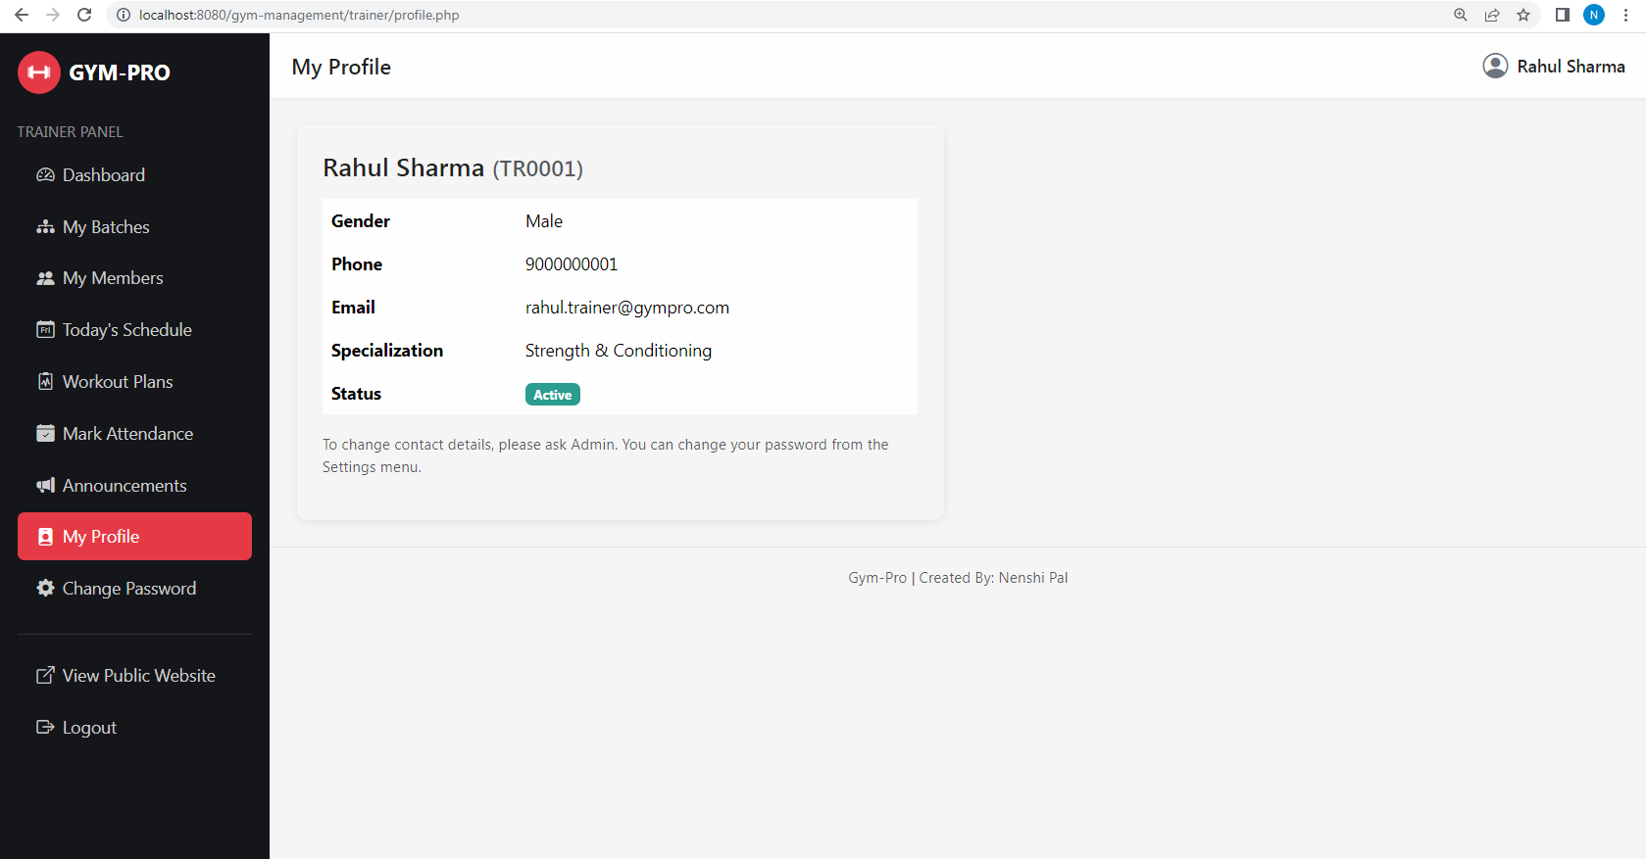
My Profile: Displays the trainer's personal and professional information.

- Change Password

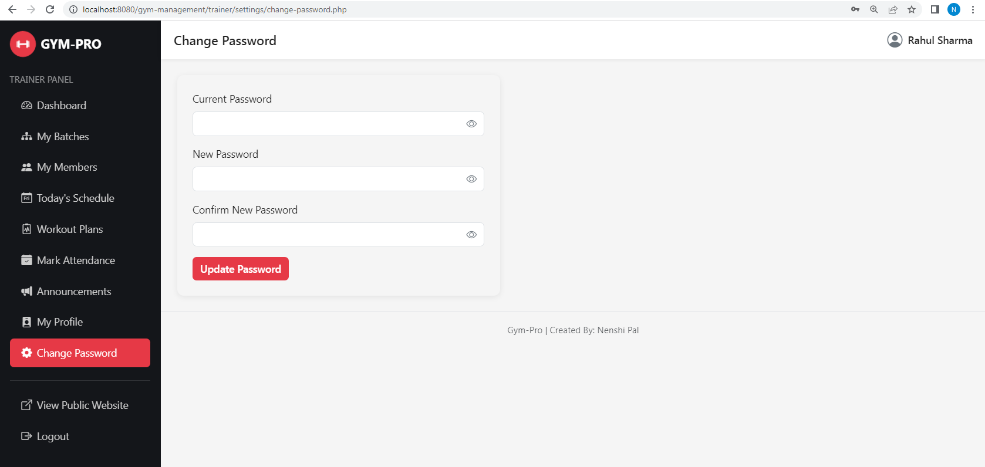
Change Password: Allows the trainer to change their account password.

4. Member

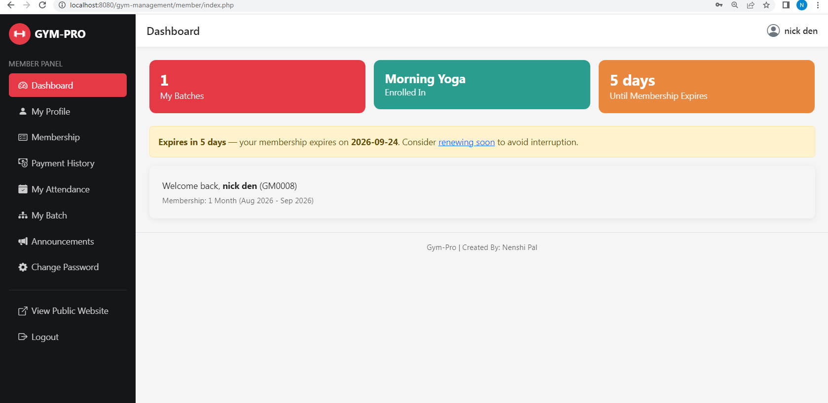
- Dashboard
Dashboard: Displays the member's membership and gym activity summary.

- My Profile
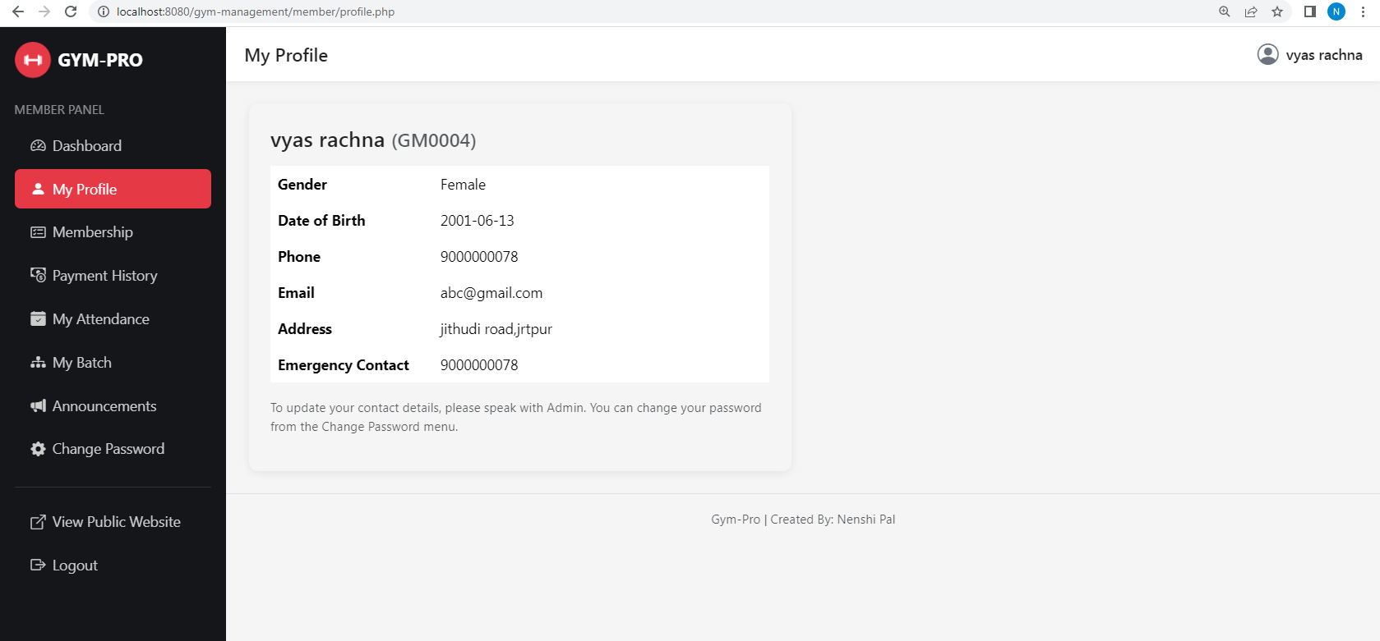
My Profile: Displays the member's personal information.

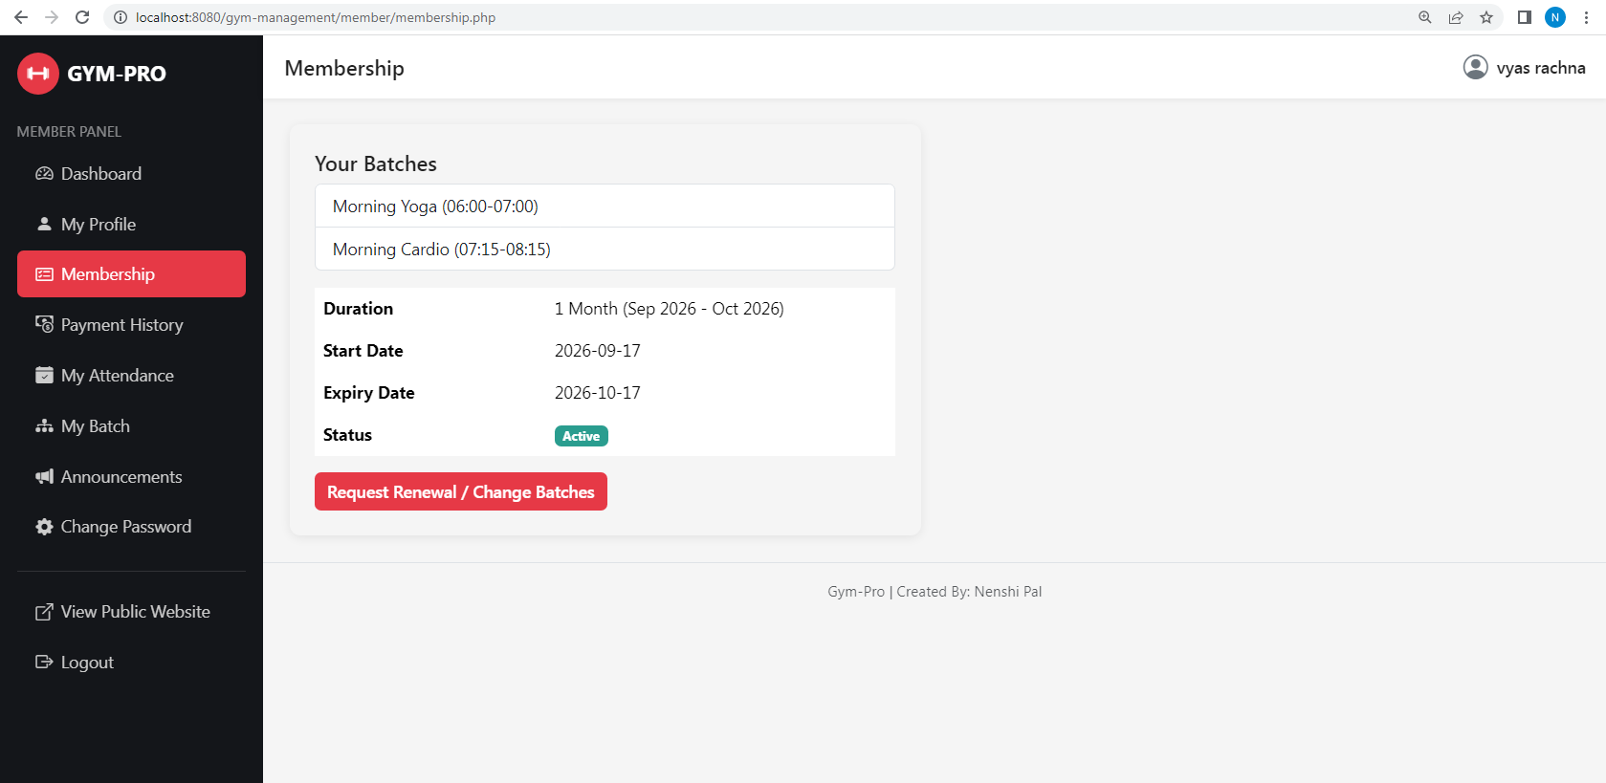
- My Membership
My Membership: Displays the member's current membership details.

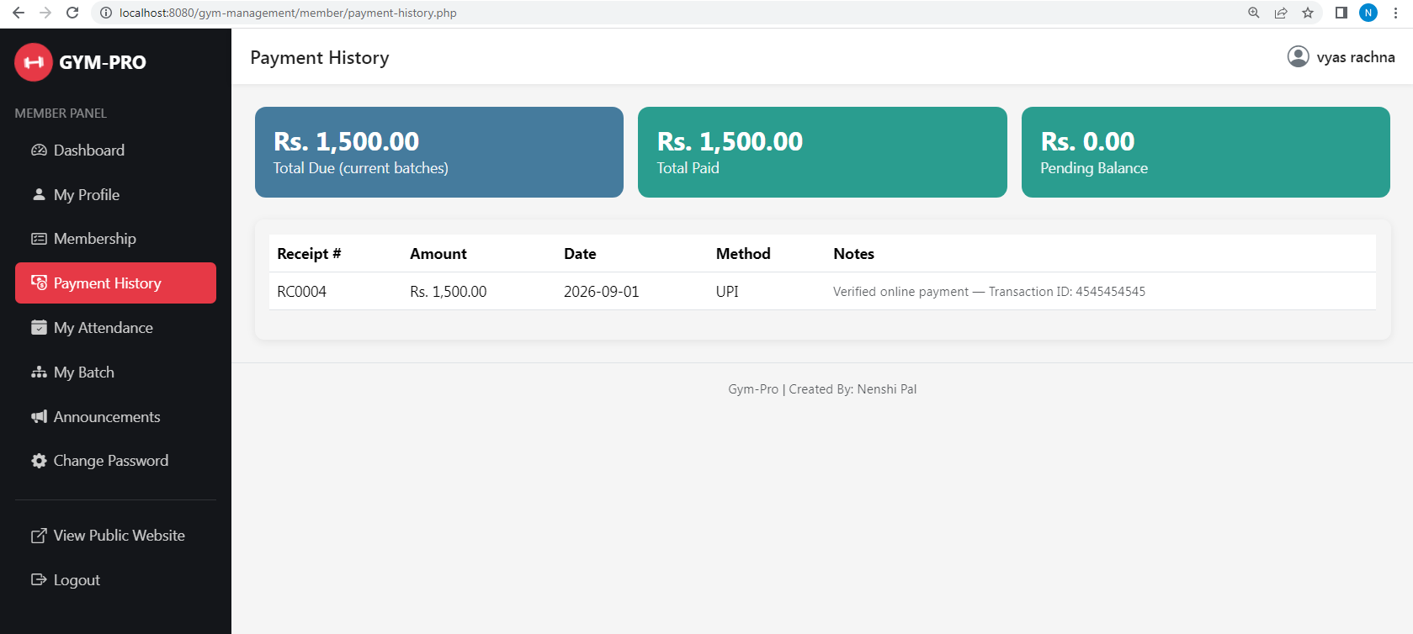
- Payment History
Payment History: Displays the member's previous payment records.

- My Attendance
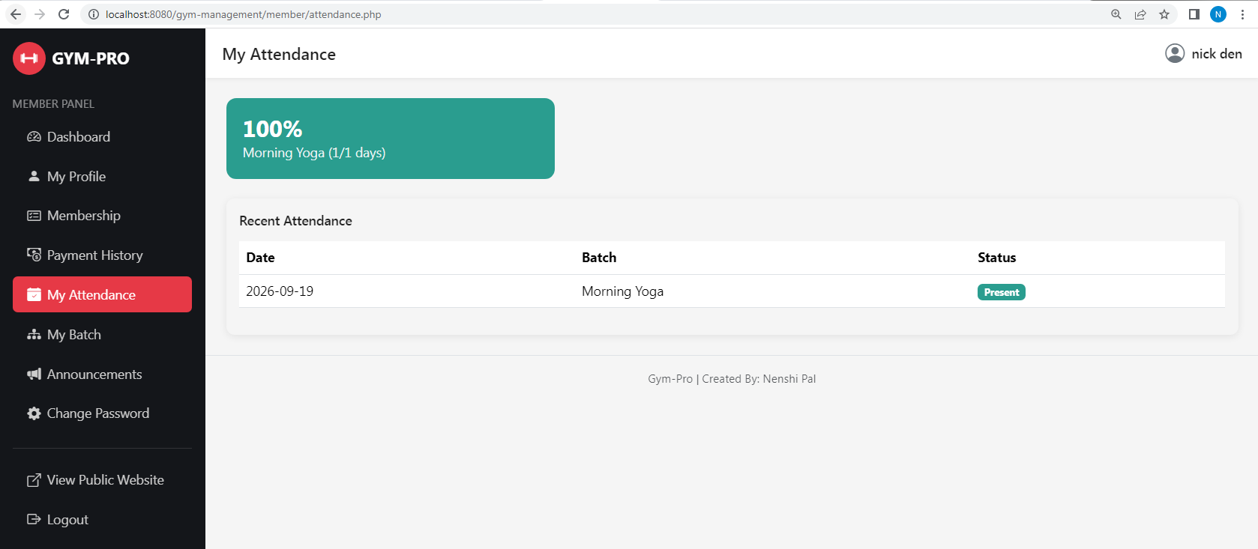
My Attendance: Displays the member's attendance records.

- My Batch

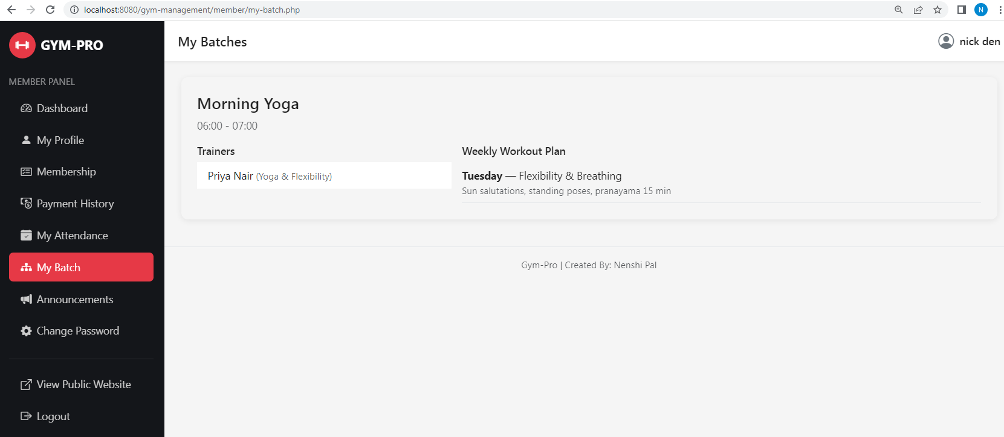

My Batch: Displays the batch assigned to the member.

- Pending Payment

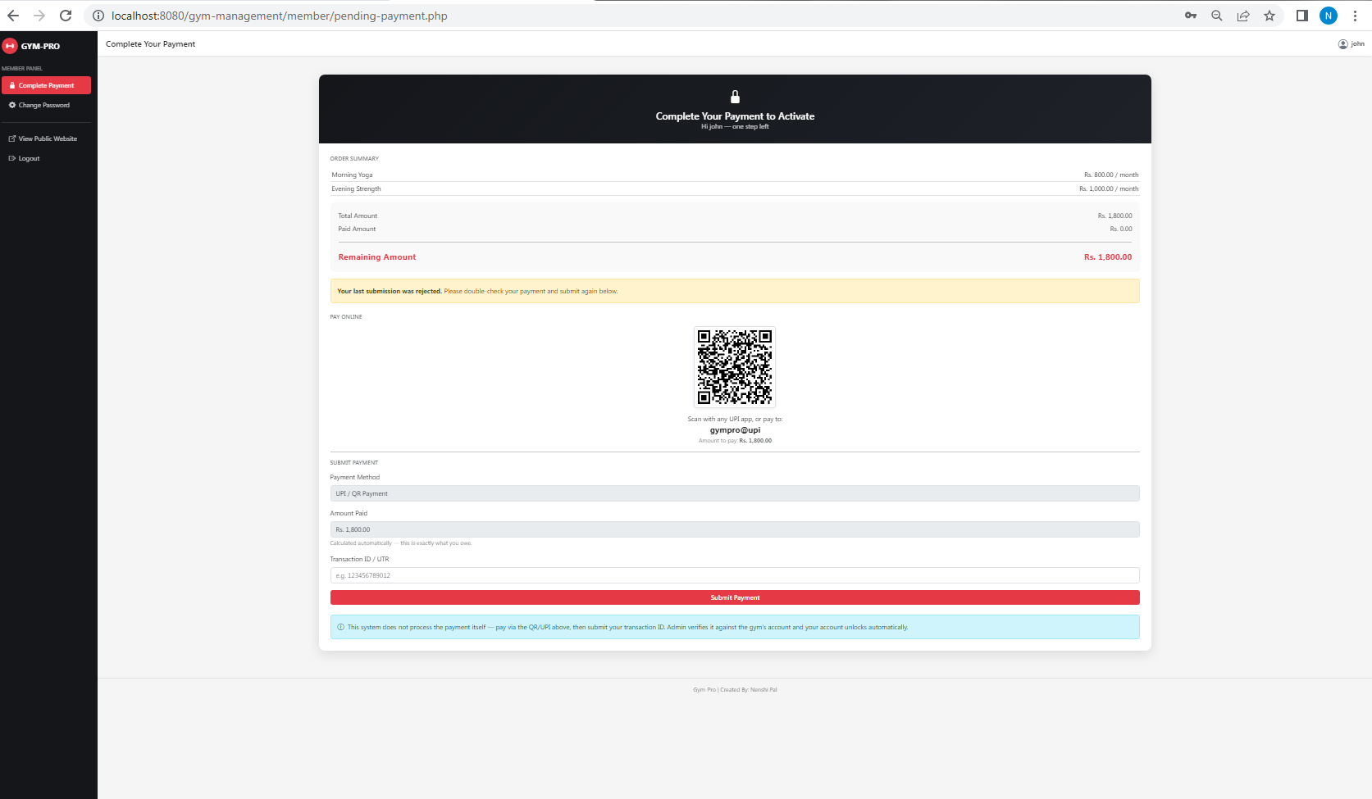

Pending Payment: Displays the member's pending payment details and payment option.

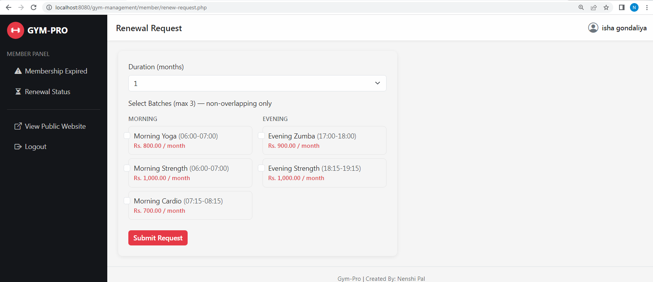
- Renewal – Request

Renewal Request: Allows the member to submit a membership renewal request.

- Testing (Manual Test Cases and Test Data)

6.1 Manual Testing
- Software testing can be stated as the process of verifying and validating whether a software or application is bug-free, meets the technical requirements as guided by its design and development, and meets the user requirements effectively and efficiently by handling all the exceptions and boundary cases.
- The process of software testing aims not only at finding faults in the existing software, but also at finding suitable measures to improve the software in terms of efficiency, accuracy, and usability. It mainly aims at measuring the specification, functionality, and performance of software program or application.
Software testing can be divided into two steps:
- Verification :- It refers to the set of tasks that ensures the software currently implements a specific function.
- Validation :- It refers to a different set of tasks that ensure the software that has been built is traceable to customer requirements.
→ What are the different types of software testing techniques?
→ Software testing techniques can be mainly classified into two categories:
- Black Box Testing
- The technique of testing in which the tester doesn't have access to the source code of the software and is conducted at the software interface without any concern for the internal logical structure of the software is known as black box testing.
- White Box Testing
- The technique of testing in which the tester is aware of the internal working of the product, has access to its source code and is conducted by making sure that internal operations are performed according to the specification.

What are the different levels of software testing? Software level testing can be mainly classified into four levels:
- Unit Testing
- A level of software testing process where individual units or components of a software system are tested.
- Integration Testing
- A level of software testing process where individual units are combined and tested as a group.
- System Testing
- A level of software testing process where a complete integrated system/software is tested.
- Acceptance Testing
- A level of software testing process where acceptability of a software system is tested.
6.2 Test Cases
Registration
Field | Input 1 | Input 2 | Input 3 | Input 4
Full Name | Yes | No | Yes | No
Phone | Yes | Yes | No | No
Email | Yes | Yes | No | Yes
Date of Birth | Yes | No | Yes | No
Username | Yes | No | Yes | No
Password | Yes | No | Yes | No
Batch Selection | Yes | Yes | No | No
Result | Pass | Error | Error | Error

Login
Field | Input 1 | Input 2 | Input 3 | Input 4
Username | Yes | Yes | No | No
Password | Yes | No | Yes | No
Result | Pass | Error | Error | Error

Add Batch
Field | Input 1 | Input 2 | Input 3 | Input 4
Batch Name | Yes | No | Yes | No
Start Time | Yes | Yes | No | No
End Time | Yes | Yes | No | No
Capacity | Yes | Yes | No | Yes
Monthly Fee | Yes | Yes | No | Yes
Result | Pass | Error | Error | Error

Add Member
Field | Input 1 | Input 2 | Input 3 | Input 4
Full Name | Yes | No | Yes | Yes
Phone | Yes | Yes | No | No
Email | Yes | Yes | No | Yes
Duration | Yes | Yes | No | Yes
Batch Selection | Yes | Yes | Yes | No
Result | Pass | Error | Error | Error

Assign Trainer to Batch
Field | Input 1 | Input 2 | Input 3 | Input 4
Batch | Yes | No | Yes | Yes
Trainer | Yes | Yes | No | Yes
Result | Pass | Error | Error | Error

Renewal Request
Field | Input 1 | Input 2 | Input 3 | Input 4
Renewal Request | Yes | No | Yes | Yes
Decision | Yes | Yes | No | Yes
Requested Duration | Yes | Yes | No | Yes
Result | Pass | Error | Error | Error

Log Payment
Field | Input 1 | Input 2 | Input 3 | Input 4
Member | Yes | No | Yes | Yes
Amount | Yes | Yes | No | No
Payment Date | Yes | Yes | No | No
Payment Method | Yes | Yes | No | Yes
Result | Pass | Error | Error | Error

Online Payment Submission
Field | Input 1 | Input 2 | Input 3 | Input 4
Transaction ID | Yes | Yes | No | No
Payment Date | Yes | Yes | No | No
Result | Pass | Error | Error | Error

System Settings
Field | Input 1 | Input 2 | Input 3 | Input 4
Setting Key | Yes | No | Yes | Yes
Setting Value | Yes | Yes | No | Yes
Result | Pass | Error | Error | Error

7. Enhancements
7.1 Advantages
- All database queries use prepared statements (mysqli), which protects the system against SQL-injection attacks.
- Passwords are stored using PHP's password_hash()/password_verify() functions and are never kept in plain text.
- Each panel — Admin, Trainer and Member — has its own independent session-based login; an unauthorized visitor is redirected back to that panel's login page.
- The core business rule — that a member cannot join two batches whose timings overlap — is enforced on the server side, so it cannot be bypassed even if JavaScript is disabled in the browser.
- The payment gate applies with no exceptions: every path that creates or renews a member, including the Admin's own Add Member and Renew Member actions, lands in Pending Payment first, so no membership can become Active without a logged or verified payment.
- An online payment is never trusted on its own — the member only submits a transaction ID, and nothing is treated as a real payment until the Admin verifies it, which keeps a human check in the loop.
- A trainer can view and manage only the batches actually assigned to them, not the entire gym's data.
- The system is built to run on both modern PHP (7.x / 8.x) and older PHP 5.4 installations, which is useful in college lab environments.
7.2 Limitation
- There is still no real payment gateway integration; online payment is a submit-and-verify claim against the gym's own UPI ID, not an automated checkout.
- Photo upload for members and trainers is not yet implemented, although the database already has a column reserved for it.
- No automatic email or SMS notification is sent when a registration or renewal request is approved or rejected, or when a payment is verified — the member has to log in to check the status.
- Long lists (members, trainers, requests) do not yet have pagination, which may slow down as the number of records grows very large.
- The Contact Us form on the public site only shows a confirmation message; enquiries are not yet stored in the database for the Admin to review later.

7.3 Future Scope
- Add real photo upload for members and trainers using PHP's move_uploaded_file() function.
- Integrate an actual payment gateway (for example Razorpay) so an online payment is confirmed automatically instead of waiting for Admin verification.
- Send an automatic email or SMS notification when a registration/renewal request is approved or rejected, or when a payment submission is verified or rejected.
- Add a contact_messages table and an Admin inbox so enquiries from the Contact Us page can be tracked and answered.
- Add pagination and search/filter options to all the long list pages.
- Package the member-facing pages as a Progressive Web App (PWA) so members can check their schedule, attendance and payment status conveniently on mobile.

8. Bibliography
Websites:
https://www.php.net
https://www.w3schools.com
https://getbootstrap.com
https://dev.mysql.com/doc/
https://www.chartjs.org
https://davidshimjs.github.io/qrcodejs/
Books:
- PHP and MySQL Web Development – Luke Welling & Laura Thomson
- Learning PHP, MySQL & JavaScript – Robin Nixon

Support:

- ChatGPT
- Opencode

