

A
Project Report On
GYM PRO – GYM MANAGEMENT SYSTEM
Submitted in the Partial fulfillment of the requirement for awarding the degree of Bachelor of Computer Application (BCA)
SEM V, Year 2026
By
Rathod Nenshi
Nandaniya Pal
Under the Guidance of
Prof. Ishita Mem

DEPARTMENT OF COMPUTER SCIENCE
LATE P.S. HIRAPARA MAHILA BCA COLLEGE JETPUR
Affiliated to
SAURASHTRA UNIVERSITY - RAJKOT

CERTIFICATE
(To be provided by the Project Guide on completion of the project)

Preface
This report contains all the outputs of a project undertaken to develop a working model of GYM PRO – Gym Management System and to study the existing working system. As part of this study, we analyzed the requirements of the working model and tried to improve it using the technological functionality that the current computer science provides.
This volume contains the documentation summary of the working system, the background study and analysis, the technical requirements and the working specification of the developed system.
We recommend the user to take the advantage of the study presented here and implement the system with their required improvisation. We hope this study will reduce the burden of the reanalysis of the development phase.

Acknowledgment
“It is not possible to prepare a project report without the assistance & encouragement of other people. This one is certainly no exception.”
On the very outset of this report, we would like to extend our sincere & heartfelt obligation towards all the personages who have helped us in this endeavor. Without their active guidance, help, cooperation & encouragement, we would not have made headway in the project. We are ineffably indebted to our HOD / Prof. Jitendra Kabariya for conscientious guidance and encouragement to accomplish this assignment.
We are extremely thankful and pay our gratitude to our project guide Prof. Ishita mem for her valuable guidance and support on completion of this project in its entirety.
We extend our gratitude to the Department Of Computer Science, Late P.S. Hirapara Mahila BCA College-Jetpur for giving us this opportunity.
Thanking You
Student -1 Rathod Nenshi (24CS002UG05309)
Student -2 Nandaniya Pal (Enrollment No.)

INDEX
• Front Page
• Certificate
• Preface
• Acknowledgement
Sr. No. | Title |  | Page No.
1 | Project Profile |  | 6
 | 1.1 | Definition | 6
 | 1.2 | Scope | 6
 | 1.3 | Objective | 6
 | 1.4 | Technical Description | 6
2 | System Analysis and Specification |  | 8
 | 2.1 | Study of Current System | 8
 | 2.2 | Weakness of Current System | 8
 | 2.3 | Introduction of New System | 8
 | 2.4 | Hardware and Software Requirement | 8
3 | System Requirement Specification |  | 10
 | 3.1 | Proposed System and Advantages | 10
4 | System Design |  | 11
 | 4.1 | Use – case Diagram | 11
 | 4.2 | Data Flow Diagram | 15
 | 4.3 | E-R Diagram | 15
 | 4.4 | Data Dictionary | 16
 | 4.5 | Flowchart (Optional) | 21
5 | Screen Design |  | 23
6 | Testing (Manual, Test Cases and Test Data) |  | 24
 | 6.1 | Manual Testing | 24
 | 6.2 | Test Cases | 24
7 | Enhancements |  | 26
 | 7.1 | Advantages | 26
 | 7.2 | Limitation | 26
 | 7.3 | Future Scope | 26
8 | Bibliography |  | 28

1. Project Profile
1.1 Definition
GYM PRO – Gym Management System is a web-based software application developed to manage and maintain the daily activities of a gym. It helps the gym administrator manage member information, membership details, batches, trainers, attendance, payments and other gym-related records in a systematic and efficient way.
The system reduces manual paperwork, saves time, improves data management, and makes it easier to store, update, and retrieve gym information whenever required. It provides three separate, password-protected panels for the Admin, the Trainers and the Members, in addition to a public informational website for visitors.
1.2 Scope
The GYM PRO – Gym Management System is designed to manage gym members, memberships, batches, trainers, attendance and payments in an organized way. It reduces manual paperwork and makes daily gym management easier for the owner and staff.
The system helps the administrator to add, update, delete and view records easily. It saves time, reduces errors, and provides quick access to important gym information such as who is due for renewal, which batch is running short of trainers, and how much revenue has been collected.
1.3 Objective
The main objective of the GYM PRO – Gym Management System is to develop a simple and efficient system for managing gym activities and records. It aims to reduce manual work and make gym management faster, easier, and more organized.
The major objectives are to:
- Maintain accurate member and membership records.
- Manage batches, trainers, attendance and payment information.
- Allow a member to join more than one batch while automatically preventing any clash between the timings of the selected batches.
- Ensure no membership becomes Active without a logged or verified payment, by gating every new registration and renewal behind a payment step.
- Provide easy adding, updating, approving, deleting and viewing of records.
- Reduce paperwork and manual errors.
- Save time and improve the overall efficiency of gym management.
1.4 Technical Description
Technical Aspect | Description
Front End | HTML5, CSS3, Bootstrap 5, Bootstrap Icons, JavaScript, Chart.js, qrcodejs (for the UPI QR code)
Back End | PHP (procedural style, mysqli extension, prepared statements)
Database | MySQL

2. System Analysis and Specification
2.1 Study of Current System
Most small and medium gyms still manage their day-to-day operations manually. During the study of the existing system, the following observations were made:
- New member details, batch timings and fee amounts are written down in a membership register or note-book.
- Attendance of members is taken on a paper sign-in sheet kept at the reception desk.
- Trainers keep track of which members belong to which batch from memory or hand-written batch sheets pinned on a notice board.
- Renewal of a membership is tracked by checking a physical register or a diary maintained by the gym owner.
- Fee receipts are hand-written and a carbon copy or a simple cash-book is kept for accounts.
2.2 Weakness of Current System
The manual system currently followed by most gyms suffers from the following drawbacks:
- Registers can be lost, damaged, misplaced or duplicated, and there is no backup of the data.
- Checking whether a new admission's chosen time slot clashes with an existing batch is done manually and is error-prone; double-booking of a batch beyond its capacity is common.
- Retrieving a particular member's payment history or attendance record takes considerable time when done manually.
- There is no way for a member to check their own membership status, batch timing, attendance or dues without visiting or calling the gym.
- Sending renewal reminders or announcements to all members has to be done individually by phone or word of mouth, which is slow and unreliable.
- Trainers have no organized way to record attendance or maintain a workout plan for their batch.
2.3 Introduction of New System
GYM PRO – Gym Management System replaces the manual register with a centralized, web-based application. The new system introduces the following improvements:
- A public website lets any visitor view the gym's batches, trainers and gallery, and submit an online registration request; the Admin reviews and approves it, after which the member is created automatically.
- A member can join more than one batch at the same time, and the system automatically prevents the member from picking two batches whose timings overlap.
- Every new registration or renewal is payment-gated: the member is created with a 'Pending Payment' status and cannot reach their dashboard until a payment covering the amount due is logged by the Admin or verified online — this applies even when the Admin adds or renews a member directly.
- A member can pay online by scanning the gym's own UPI/QR code and submitting the transaction ID, which queues the claim for the Admin to verify before it is treated as a real payment; alternatively, the Admin logs the payment directly when it is collected in person.
- Registration now enforces a minimum age of 18 years, checked both on the date-picker and again on the server.
- Trainers mark attendance for their own assigned batches from their own login, and can maintain a simple workout plan for the batch.
- A dashboard gives the Admin an at-a-glance view of active members, pending requests and revenue collected.
2.4 Hardware and Software Requirement (Feasibility Study)
Software Requirement
Software | Specification
Front End | HTML5, CSS3, Bootstrap 5, JavaScript, Chart.js, qrcodejs
Back End | PHP (compatible with PHP 5.4 as well as PHP 7/8)
Database | MySQL
Web Server | Apache (via XAMPP / WAMP / UwAmp)
Operating System | Windows 10 / 11 (or any OS that can run XAMPP/WAMP)
Browser | Google Chrome / Mozilla Firefox / Microsoft Edge (any modern browser)
Hardware Requirement
Hardware | Specification
Processor | Intel Pentium / Core i3 or above
RAM | 4 GB minimum (8 GB recommended)
Hard Disk | 100 MB free space for the project and the XAMPP/WAMP installation
Monitor | Standard colour monitor, 1024 x 768 resolution or higher
Input Devices | Keyboard, Mouse

3. System Requirement Specification
3.1 Proposed System and Advantages
Based on the study of the current manual system and its weaknesses, the following project model (modules) is proposed for GYM PRO – Gym Management System:
1) Public Website
Provides Home, About, Batches, Gallery and Contact pages so that any visitor can learn about the gym before joining.
2) Visitor Registration
A visitor can register online by filling in personal details and choosing one or more batches. The system groups batches by time-of-day and blocks any selection whose timings overlap, before the request is sent for approval.
3) Admin Module
The Admin can manage members, trainers and batches; approve or reject registration and renewal requests; log in-person payments and verify or reject online payment submissions; post announcements; and view a dashboard of key statistics.
4) Trainer Module
A trainer can view the batches and members assigned to them, mark daily attendance, maintain a simple workout plan for the batch, and post announcements.
5) Member Module
A member can view their profile, batch(es), attendance and payment history; pay online via UPI/QR and submit the transaction ID when their status is Pending Payment; request renewal of an expiring membership; and view announcements posted by the Admin or trainer.
Advantages of the Proposed System
- Replaces scattered paper registers with a single, centralized, always-available database.
- Automatically prevents a member from being enrolled in two batches whose timings clash, which is not practically possible to check by hand.
- No membership can ever become Active without a logged or Admin-verified payment — the payment gate applies identically whether the member registered themselves or the Admin added them directly, closing a gap that manual systems cannot enforce.
- Lets a member pay online at their own convenience via UPI/QR, while still giving the Admin final control through a Verify/Reject step before any online claim is treated as real money received.
- Cuts down the time needed to search for a member's record, payment history or attendance from minutes to seconds.
- Gives every member and trainer self-service, read-only access to their own information, reducing the number of enquiries handled at the reception desk.
- Scales easily as the number of members, batches or trainers grows, unlike a paper register.

4. System Design
4.1 Use – Case Diagram
The system has four types of actors — Visitor, Member, Trainer and Admin. The use-case diagrams below show the functions available to each actor.
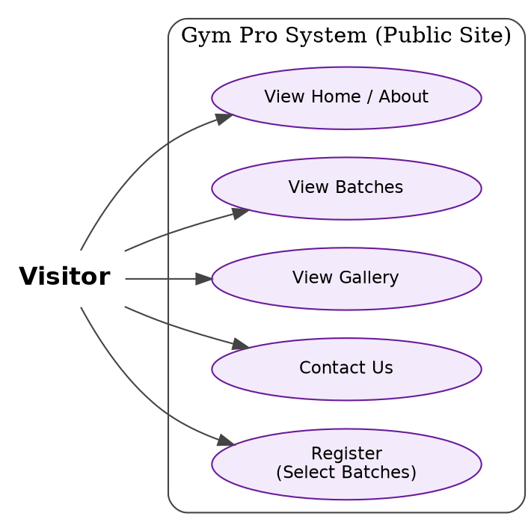
Fig 4.1(a): Use-case diagram – Visitor
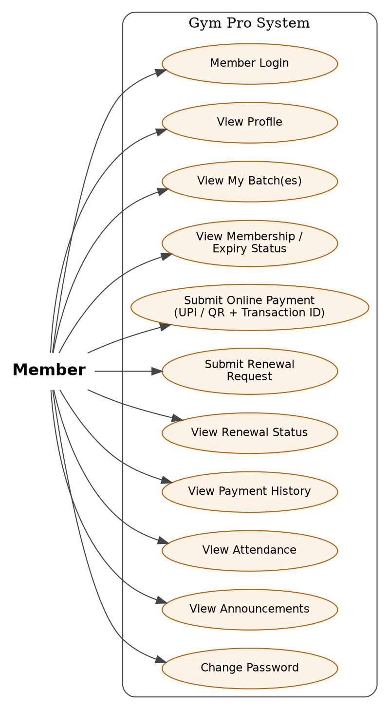
Fig 4.1(b): Use-case diagram – Member

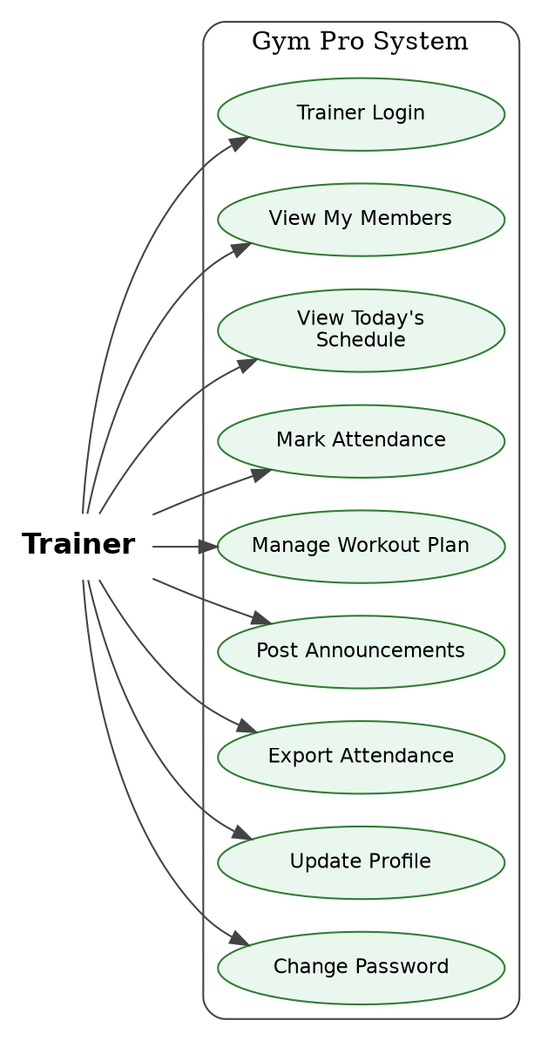
Fig 4.1(c): Use-case diagram – Trainer
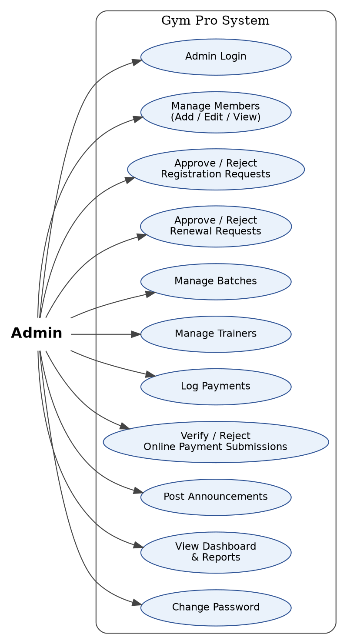
Fig 4.1(d): Use-case diagram – Admin

4.2 Data Flow Diagram
4.3 E-R Diagram

4.4 Data Dictionary
The data dictionary below lists every table of the gym_pro database exactly as created in the system (16 tables in total), showing each column, its data type and its key/constraint.
admins
Column Name | Data Type | Key / Constraint
admin_id | INT (Auto Increment) | Primary Key
admin_username | VARCHAR(50) | Not Null, Unique
admin_password | VARCHAR(255) | Not Null (hashed)

trainers
Column Name | Data Type | Key / Constraint
trainer_id | INT (Auto Increment) | Primary Key
trainer_code | VARCHAR(20) | Not Null, Unique
full_name | VARCHAR(100) | Not Null
gender | ENUM('Male','Female','Other') | Default 'Male'
phone | VARCHAR(20) | Not Null, Unique
email | VARCHAR(100) | Not Null, Unique
specialization | VARCHAR(100) | -
photo | VARCHAR(255) | Default 'default-trainer.png'
username / password | VARCHAR(50) / VARCHAR(255) | Not Null, Unique / Not Null
status | ENUM('Active','Inactive') | Default 'Active'

batches
Column Name | Data Type | Key / Constraint
batch_id | INT (Auto Increment) | Primary Key
batch_name | VARCHAR(100) | Not Null
start_time / end_time | TIME | Not Null
capacity | INT | Default 20
monthly_fee | DECIMAL(10,2) | Default 0
status | ENUM('Active','Inactive') | Default 'Active'

batch_trainers
Column Name | Data Type | Key / Constraint
batch_trainer_id | INT (Auto Increment) | Primary Key
batch_id | INT | Foreign Key -> batches
trainer_id | INT | Foreign Key -> trainers
(batch_id, trainer_id) | - | Unique Key

members
Column Name | Data Type | Key / Constraint
member_id | INT (Auto Increment) | Primary Key
member_code | VARCHAR(20) | Not Null, Unique
photo | VARCHAR(255) | Default 'default-member.png'
full_name | VARCHAR(100) | Not Null
gender | ENUM('Male','Female','Other') | Default 'Male'
dob | DATE | Not Null (18+ enforced)
phone / email | VARCHAR(20) / VARCHAR(100) | Not Null, Unique (both)
address | VARCHAR(255) | -
emergency_contact | VARCHAR(20) | -
duration_months | INT | Default 1
membership_start_date | DATE | Not Null
membership_expiry_date | DATE | Not Null
username / password | VARCHAR(50) / VARCHAR(255) | Not Null, Unique / Not Null
status | ENUM('Active','Expired','Inactive','Pending Payment') | Default 'Active'
created_by | VARCHAR(50) | -
created_method | ENUM('Request','Admin') | Default 'Admin'

member_batches
Column Name | Data Type | Key / Constraint
member_batch_id | INT (Auto Increment) | Primary Key
member_id | INT | Foreign Key -> members
batch_id | INT | Foreign Key -> batches
(member_id, batch_id) | - | Unique Key

payments
Column Name | Data Type | Key / Constraint
payment_id | INT (Auto Increment) | Primary Key
receipt_number | VARCHAR(20) | Not Null, Unique
member_id | INT | Foreign Key -> members
amount | DECIMAL(10,2) | Not Null
payment_date | DATE | Not Null
payment_method | ENUM('Cash','UPI','Card','Bank Transfer','Other') | Default 'Cash'
notes | VARCHAR(255) | -
recorded_by | INT | Foreign Key -> admins

payment_submissions
Column Name | Data Type | Key / Constraint
submission_id | INT (Auto Increment) | Primary Key
member_id | INT | Foreign Key -> members
amount | DECIMAL(10,2) | Not Null (system-calculated)
transaction_id | VARCHAR(100) | Not Null
payment_date | DATE | Not Null
payment_method | VARCHAR(20) | Default 'UPI'
status | ENUM('Pending Verification','Verified','Rejected') | Default 'Pending Verification'
reject_reason | VARCHAR(255) | -
submitted_at | DATETIME | Default Current Timestamp
verified_by | INT | Foreign Key -> admins (nullable)
verified_at | DATETIME | -

requested_members
Column Name | Data Type | Key / Constraint
request_id | INT (Auto Increment) | Primary Key
full_name, gender, dob | VARCHAR/ENUM/DATE | full_name Not Null
phone, email | VARCHAR(20) / VARCHAR(100) | Not Null
address, emergency_contact | VARCHAR | -
duration | INT | Default 1
username / password | VARCHAR(50) / VARCHAR(255) | Not Null
status | ENUM('Pending','Approved','Rejected') | Default 'Pending'
request_date / approved_date | DATETIME | Default Current / Null
approved_by | INT | Foreign Key -> admins (nullable)

requested_member_batches
Column Name | Data Type | Key / Constraint
req_mem_btc_id | INT (Auto Increment) | Primary Key
request_id | INT | Foreign Key -> requested_members
batch_id | INT | Foreign Key -> batches

renewal_requests
Column Name | Data Type | Key / Constraint
renewal_id | INT (Auto Increment) | Primary Key
member_id | INT | Foreign Key -> members
requested_duration | INT | Default 1
status | ENUM('Pending','Approved','Rejected') | Default 'Pending'
request_date / approved_date | DATETIME | Default Current / Null
approved_by | INT | Foreign Key -> admins (nullable)

renewal_request_batches
Column Name | Data Type | Key / Constraint
renwl_req_btc_id | INT (Auto Increment) | Primary Key
renewal_id | INT | Foreign Key -> renewal_requests
batch_id | INT | Foreign Key -> batches

announcements
Column Name | Data Type | Key / Constraint
announcement_id | INT (Auto Increment) | Primary Key
title | VARCHAR(150) | Not Null
description | TEXT | Not Null
publish_date | DATETIME | Default Current Timestamp
posted_by_role | ENUM('Admin','Trainer') | Default 'Admin'
posted_by_id | INT | Not Null

workout_plans
Column Name | Data Type | Key / Constraint
workout_id | INT (Auto Increment) | Primary Key
batch_id | INT | Foreign Key -> batches
day_name | ENUM('Monday'…'Sunday') | Not Null
focus_area | VARCHAR(100) | -
details | TEXT | -
(batch_id, day_name) | - | Unique Key

attendance
Column Name | Data Type | Key / Constraint
attendance_id | INT (Auto Increment) | Primary Key
member_id | INT | Foreign Key -> members
batch_id | INT | Foreign Key -> batches
date | DATE | Not Null
status | ENUM('Present','Absent') | Default 'Present'
(member_id, batch_id, date) | - | Unique Key

settings
Column Name | Data Type | Key / Constraint
setting_id | INT (Auto Increment) | Primary Key
setting_key | VARCHAR(50) | Not Null, Unique
setting_value | VARCHAR(255) | Not Null (e.g. gym_upi_id)

4.5 Flowchart (Optional)
The flowchart below traces registration, approval and the payment gate end to end — a new member always starts as Pending Payment and only becomes Active once a payment is logged by the Admin or verified from an online submission.
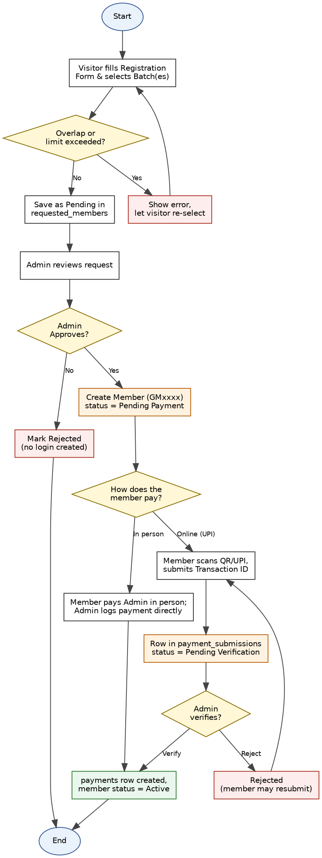
Fig 4.5: Flowchart of Registration, Approval & Payment Gate

5. Screen Design

6. Testing (Manual, Test Cases and Test Data)
6.1 Manual Testing
Every input form of the system was tested manually using the Black Box Testing technique, in which each field is tested without looking at the underlying code — only the input given and the result produced are checked. Four types of input were used for every field:
- Input Type 1 — Valid Input: correct, properly formatted data in every field.
- Input Type 2 — Mandatory Field left blank: a required field is submitted empty.
- Input Type 3 — Invalid Input: data of the wrong format or an out-of-range value.
- Input Type 4 — Optional Field / Default Value / Boundary Condition: an optional field is left at its default, or a value is tested exactly at its allowed limit.
For every module, the mandatory fields are marked "Yes" under Input Type 1, and the overall Pass/Fail result of submitting the form under each of the four input types is recorded in the Result row.
6.2 Test Cases
1. Registration
Field Name | Input Type 1 | Input Type 2 | Input Type 3 | Input Type 4
Full Name | Yes | - | - | -
Phone | Yes | - | - | -
Email | Yes | - | - | -
Date of Birth | Yes | - | - | -
Username | Yes | - | - | -
Password | Yes | - | - | -
Batch Selection | Yes | - | - | -
Result | Pass | Fail | Fail | Pass
Criteria: Full Name, Phone, Email, Date of Birth, Username, Password and at least one Batch are mandatory. Date of Birth must show the visitor is 18 years or older (boundary condition), and the chosen batch(es) must not overlap in timing.
2. Login (Admin / Trainer / Member)
Field Name | Input Type 1 | Input Type 2 | Input Type 3 | Input Type 4
Username | Yes | - | - | -
Password | Yes | - | - | -
Result | Pass | Fail | Fail | Pass
Criteria: Username and Password are mandatory.

3. Renewal Request
Field Name | Input Type 1 | Input Type 2 | Input Type 3 | Input Type 4
Requested Duration | Yes | - | - | -
Batch Selection | Yes | - | - | -
Result | Pass | Fail | Fail | Pass
Criteria: Requested Duration and Batch Selection are mandatory; Duration has a boundary condition of 1 to 12 months.
4. Online Payment Submission
Field Name | Input Type 1 | Input Type 2 | Input Type 3 | Input Type 4
Transaction ID | Yes | - | - | -
Payment Date | Yes | - | - | -
Result | Pass | Fail | Fail | Pass
Criteria: Transaction ID and Payment Date are mandatory. Amount is system-calculated from the member's due fee and cannot be edited (default value).

7. Enhancements
7.1 Advantages
- All database queries use prepared statements (mysqli), which protects the system against SQL-injection attacks.
- Passwords are stored using PHP's password_hash()/password_verify() functions and are never kept in plain text.
- Each panel — Admin, Trainer and Member — has its own independent session-based login; an unauthorized visitor is redirected back to that panel's login page.
- The core business rule — that a member cannot join two batches whose timings overlap — is enforced on the server side, so it cannot be bypassed even if JavaScript is disabled in the browser.
- The payment gate applies with no exceptions: every path that creates or renews a member, including the Admin's own Add Member and Renew Member actions, lands in Pending Payment first, so no membership can become Active without a logged or verified payment.
- An online payment is never trusted on its own — the member only submits a transaction ID, and nothing is treated as a real payment until the Admin verifies it, which keeps a human check in the loop.
- A trainer can view and manage only the batches actually assigned to them, not the entire gym's data.
- The system is built to run on both modern PHP (7.x / 8.x) and older PHP 5.4 installations, which is useful in college lab environments.
7.2 Limitation
- There is still no real payment gateway integration; online payment is a submit-and-verify claim against the gym's own UPI ID, not an automated checkout.
- Photo upload for members and trainers is not yet implemented, although the database already has a column reserved for it.
- No automatic email or SMS notification is sent when a registration or renewal request is approved or rejected, or when a payment is verified — the member has to log in to check the status.
- Long lists (members, trainers, requests) do not yet have pagination, which may slow down as the number of records grows very large.
- The Contact Us form on the public site only shows a confirmation message; enquiries are not yet stored in the database for the Admin to review later.
7.3 Future Scope
- Add real photo upload for members and trainers using PHP's move_uploaded_file() function.
- Integrate an actual payment gateway (for example Razorpay) so an online payment is confirmed automatically instead of waiting for Admin verification.
- Send an automatic email or SMS notification when a registration/renewal request is approved or rejected, or when a payment submission is verified or rejected.
- Add a contact_messages table and an Admin inbox so enquiries from the Contact Us page can be tracked and answered.
- Add pagination and search/filter options to all the long list pages.
- Package the member-facing pages as a Progressive Web App (PWA) so members can check their schedule, attendance and payment status conveniently on mobile.

8. Bibliography
Websites:
https://www.php.net
https://www.w3schools.com
https://getbootstrap.com
https://dev.mysql.com/doc/
https://www.chartjs.org
https://davidshimjs.github.io/qrcodejs/
Books:
- PHP and MySQL Web Development – Luke Welling & Laura Thomson
- Learning PHP, MySQL & JavaScript – Robin Nixon

