INTER INTEGRATED CIRCUIT
(I2C PROTOCOL)
DESIGN, SIMULATION & FPGA IMPLEMENTATION
USING VERILOG

HARDWARE PLATFORM:
Digilent Arty A7-100T FPGA Board
PERIPHERAL DEVICE:
24512A I2C EEPROM

Prepared by:
Nensi Thummar

Table of Contents
1. ABSTRACT 4
2. PROJECT OBJECTIVES 4
3. INTRODUCTION 5
4. I2C PROTOCOL OVERVIEW 5
4.1 I2C bus architecture 5
4.2 I2C communication process 6
4.3 I2C operation modes 8
5. DEVELOPMENT METHODOLOGY 9
5.1 development flow 9
5.2 Phase I: design and simulation 9
5.3 Phase II: FPGA Implementation 10
6. SYSTEM ARCHITECTURE 10
6.1 Block Diagram 10
6.2 Signal Interface Table 11
7. CLOCK ARCHITECTURE AND SCL GENERATION 12
7.1 Clock Architecture 12
7.2 SCL Generation 12
8. I2C MASTER DESIGN 13
8.1 I2C master features 13
8.2 I2C master working 13
9. FINAL STATE DIAGRAM(FSM) OF I2C 14
9.1 FSM state diagram 14
9.2 FSM state description 15
1. IDLE State 15
2. START State 15
3. ADDR State 15
4. ACK State 15
5. DATA State 16
6. ACK2 State 16
7. STOP State 16
9.3 FSM state transition table 17
10. EEPROM INTERFACING 18
10.1 EEPROM write operation 18
10.2 EEPROM read operation 19
10.3 Repeated START Condition 20
10.4 ACK Error Accumulation 20
10.5 FPGA implementation enhancements 20
11. TESTBENCH DESIGN 20
12. SIMULATION RESULT 21
13. HARDWARE IMPLEMENTATION RESULTS 22
13.1 FPGA Implementation 22
13.2 Vivado implementation summary 22
13.3 Hardware Setup 23
13.4 Hardware Implementation Results 24
14. CHALLENGES FACED DURING PROJECT DEVELOPMENT 24
15. ADVANTAGES 24
16. DISADVANTAGES 25
17. APPLICATIONS 25
18. LEARNING OUTCOMES 25
19. CONCLUSION 25
20. REFERENCES 26

ABSTRACT
The Inter-Integrated Circuit (I2C) protocol is a widely used synchronous serial communication protocol that enables data transfer between devices using two communication lines: Serial Data (SDA) and Serial Clock (SCL). This project presents the design, simulation, and hardware implementation of an I2C Master Controller using Verilog HDL on a Digilent Arty A7-100T FPGA board, with a 24512A EEPROM serving as the slave device.
The initial phase of the project involved the design and simulation of an FSM-based I2C master controller in Verilog HDL. The FSM manages key I2C operations, including START/STOP generation, slave addressing, acknowledgement detection, and read/write data transfers. A clock divider was used to generate the SCL signal, while tri-state logic enabled bidirectional open-drain SDA communication. The design was functionally verified using a dedicated Verilog testbench and waveform analysis.
After a successful simulation, the controller was implemented on the Arty A7-100T FPGA and interfaced with a 24512A EEPROM. The system performs complete EEPROM write and read transactions by storing an 8-bit data value at a specified memory location and subsequently retrieving it using a repeated START condition. Operating from a 100 MHz system clock, the design generates a standard 100 kHz I2C clock and incorporates acknowledgement monitoring, button debouncing, and LED-based status indication for hardware verification.
The design was synthesized and implemented using Xilinx Vivado Design Suite. Hardware testing confirmed successful communication between the FPGA and EEPROM, demonstrating reliable data transfer and correct implementation of the I²C protocol. A 24 MHz 8-channel Logic Analyzer and Saleae Logic 2 software were used to capture and verify the SDA and SCL waveforms, further validating protocol timing and EEPROM read/write operations. The project highlights the effectiveness of FSM-based digital design methodologies for implementing serial communication interfaces on FPGA platforms.

PROJECT OBJECTIVES
- To design and develop an FSM-based I2C Master Controller in Verilog HDL for reliable serial communication.
- To implement and verify core I2C protocol operations.
- To simulate and validate the proposed design using a Verilog testbench and waveform analysis before hardware implementation.
- To implement the I2C master controller on the Digilent Arty A7-100T FPGA board using Xilinx Vivado Design Suite.
- To interface the FPGA with a 24512A EEPROM and perform successful memory write and read operations through the I2C bus.
- To generate a standard 100 kHz I2C clock from the FPGA's 100 MHz system clock using an efficient clock divider.

INTRODUCTION
Serial communication protocols play a crucial role in modern embedded systems by enabling efficient data exchange between digital devices. Among these protocols, the Inter-Integrated Circuit (I2C) protocol is widely used due to its simple two-wire architecture, low hardware complexity, and support for multiple devices on a shared communication bus.
The I2C protocol uses the Serial Data (SDA) and Serial Clock (SCL) lines to facilitate communication between master and slave devices. Its reliability, flexibility, and ease of implementation make it suitable for interfacing memory devices, sensors, and various peripheral components.
This project focuses on the design, simulation, and FPGA implementation of an FSM-based I2C Master Controller using Verilog HDL. The controller is implemented on a Digilent Arty A7-100T FPGA board and interfaced with a 24512A EEPROM to perform data write and read operations through the I2C bus.

I2C PROTOCOL OVERVIEW
The Inter-Integrated Circuit (I2C) protocol is a synchronous serial communication protocol developed by Philips Semiconductors (now NXP Semiconductors) as a low-speed communication protocol for connecting controller devices, such as microcontrollers and processors with target devices such as data converters and other peripheral devices. It enables data transfer using only two communication lines: Serial Data (SDA) and Serial Clock (SCL). The protocol supports multiple slave devices on a common bus while requiring minimal hardware resources, making it one of the most widely used communication standards in embedded systems.
In an I2C network, the master device controls communication by generating the clock signal and initiating data transfers, while slave devices respond to commands addressed to them. Each slave device is assigned a unique address, allowing multiple devices to share the same communication bus.

I2C bus architecture
The I2C (Inter-Integrated Circuit) bus architecture is a two-wire serial communication system that enables data exchange between a master device and one or more slave devices. The communication is carried out using two bidirectional lines: Serial Data (SDA) and Serial Clock (SCL).
Serial Data (SDA)
The SDA line is responsible for transferring data between the master and slave devices. It is a bidirectional line, allowing both transmission and reception of data depending on the communication operation being performed.
Serial Clock (SCL)
The SCL line carries the clock signal generated by the master device. It synchronizes data transfer on the SDA line and ensures that both the master and slave operate at the same timing rate during communication.

Open-Drain Architecture
I2C employs an open-drain configuration in which devices can only pull the SDA and SCL lines low. The lines are returned to a logic high state through pull-up resistors. This arrangement prevents bus contention and allows multiple devices to share the same communication bus safely.
Master and Slave Devices
The master device initiates communication, generates the clock signal, and controls the data transfer process. Slave devices respond only when their unique address is detected on the bus. Multiple slave devices can be connected to the same SDA and SCL lines.

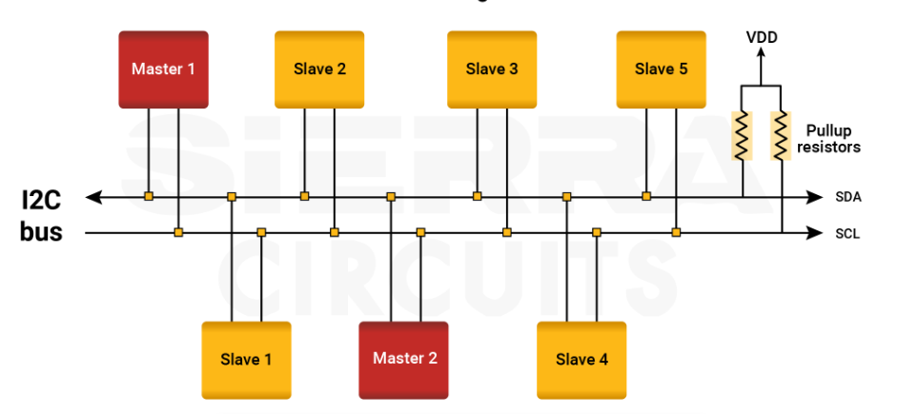
Figure 1 I2C BUS ARCHITECTURE

I2C communication process
Communication in the I2C protocol follows a predefined sequence of operations controlled by the master device. Each transaction begins with a START condition and ends with a STOP condition. During communication, the master transmits the slave address, exchanges data, and monitors acknowledgement signals to ensure reliable data transfer.

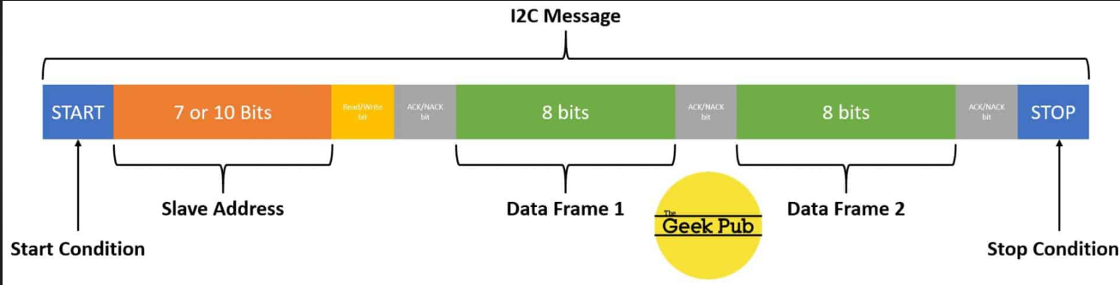
Figure 2 I2C DATA FRAME

START Condition
An I2C transaction begins with a START condition. It is generated when the master pulls the SDA line from high to low while the SCL line remains high. This condition alerts all slave devices that a communication session is about to begin.
Slave Address Transmission
After generating the START condition, the master transmits the 7-bit slave address followed by a Read/Write (R/W) control bit. The R/W bit determines whether the operation is a read or write transaction. Only the slave whose address matches the transmitted address responds to the communication request.
- R/W = 0 → Write Operation
- R/W = 1 → Read Operation

ACK/NACK Mechanism
After each byte transfer, the receiving device sends an acknowledgement signal. The ACK/NACK mechanism ensures reliable data transfer between the master and slave devices.
- ACK (Acknowledgement): SDA is pulled low during the acknowledgement clock pulse.
- NACK (Not Acknowledgement): SDA remains high, indicating unsuccessful reception or termination of communication.

Data Transfer
Data is transferred in 8-bit bytes. During a write operation, data is transmitted from the master to the slave. During a read operation, data is transmitted from the slave to the master. Multiple bytes can be transferred sequentially if required.
Repeated START Condition
A repeated START condition allows the master to begin a new transaction without issuing a STOP condition. It is commonly used in EEPROM read operations to switch from writing the memory address to reading data while retaining control of the bus.
STOP Condition
Communication ends with a STOP condition. It is generated when the SDA line transitions from low to high while the SCL line remains high. After the STOP condition, the bus becomes idle and is available for the next communication transaction.

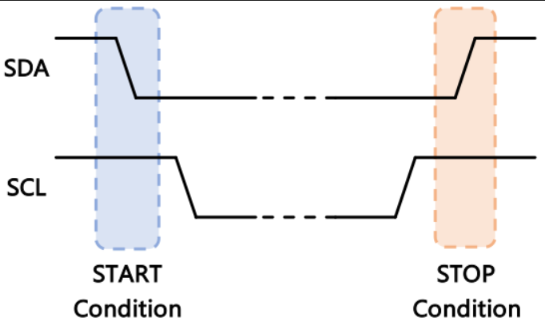
Figure 3start and stop conditions

I2C operation modes
The I2C protocol supports multiple operating modes that differ in their maximum clock frequencies. These modes allow designers to select an appropriate communication speed based on application requirements.

OPERATING MODE | MAXIMUM CLOCK FREQUENCY
Standard Mode (Sm) | 100 kHz
Fast Mode (Fm) | 400 kHz
Fast Mode Plus (Fm+) | 1 MHz
High-Speed Mode (Hs) | 3.4 MHz

Operating Mode Used in This Project:
The proposed I2C master controller operates in Standard Mode (100 kHz). A clock divider is implemented to generate the required SCL signal from the FPGA's 100 MHz system clock. Standard Mode was selected to ensure reliable communication with the 24512A EEPROM while satisfying the timing specifications of both the I2C protocol and the EEPROM device.

DEVELOPMENT METHODOLOGY
The development of the proposed I2C Master Controller was carried out in two phases. First, an FSM-based I2C master was designed and verified through simulation. After successful verification, the design was implemented on the Digilent Arty A7-100T FPGA board and interfaced with a 24512A EEPROM for hardware validation.

Development flow
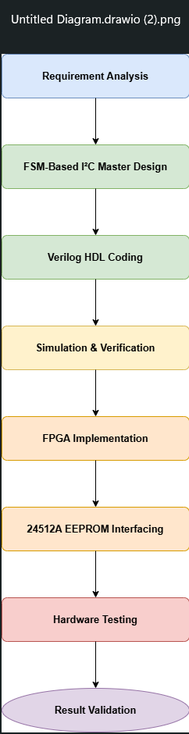
Figure 4 Development flow of the proposed I2C Master Controller

Phase I: design and simulation
The first phase focused on the design and functional verification of an FSM-based I2C Master Controller using Verilog HDL. The controller was developed to perform essential I2C operations such as START and STOP condition generation, slave address transmission, acknowledgement detection, and serial data transfer.
A simulation environment was created to verify the functionality of the controller and analyse protocol timing, state transitions, and communication sequences. Waveform analysis was performed to ensure compliance with the I2C protocol and validate the correctness of the design before hardware implementation.

Phase II: FPGA Implementation
Following a successful simulation, the validated design was implemented on the Digilent Arty A7-100T FPGA board. The FPGA was interfaced with a 24512A EEPROM through the SDA and SCL communication lines to establish I2C communication. Additional hardware support functions, including clock generation, button debouncing, acknowledgement monitoring, and status indication, were incorporated to facilitate reliable operation.
The implemented system was tested by performing EEPROM write and read operations, and the results were verified through hardware indicators to confirm successful communication between the FPGA and EEPROM.

SYSTEM ARCHITECTURE
The proposed system consists of an FPGA-based I2C Master Controller and a 24512A EEPROM acting as the slave device. The master controls the complete communication process, including clock generation, address transmission, data transfer, and acknowledgement detection through the SDA and SCL lines.
The system performs EEPROM write and read operations and verifies successful communication by comparing the transmitted and received data. Hardware validation is facilitated through button-controlled operation and LED-based status indication.

Block Diagram

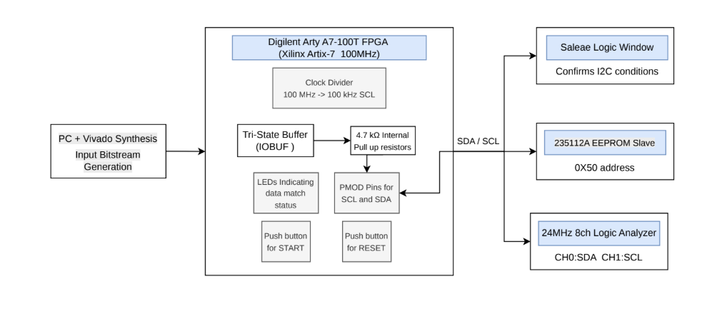
Figure 5 BLOCK ARCHITECTURE OF PROPOSED SYSTEM

Signal Interface Table
SIGNAL | FPGA PIN | DIRECTION | CONNECTED TO | DESCRIPTION
clk | E3 | Input | Arty A7-100T FPGA | 100 MHz system clock used for controller operation
reset | BTN0 | Input | Push Button (BTN0) | Resets the I²C controller and initializes all states
start | BTN1 | Input | Push Button (BTN1) | Initiates EEPROM write and read transactions
scl | G13 | Output | 24512A EEPROM SCL Pin | Serial clock generated by the I²C master
sda | B11 | Bidirectional | 24512A EEPROM SDA Pin | Serial data line used for I²C communication
led[3:0] | LED0-LED3 | Output | On-board LEDs | Displays communication and verification status
error_led | RGB0 | Output | RGB LED | Indicates communication or verification failure
write_data |  | Internal | EEPROM Interface Logic | Data transmitted to EEPROM
read_data |  | Internal | EEPROM Interface Logic | Data received from EEPROM

CLOCK ARCHITECTURE AND SCL GENERATION

Clock Architecture
The Digilent Arty A7-100T FPGA board provides a 100 MHz system clock, which is significantly higher than the clock frequency required by the I2C protocol. Therefore, a clock divider is implemented to generate a lower-frequency clock suitable for I2C communication.

SCL Generation
The Serial Clock (SCL) signal is generated by dividing the 100 MHz system clock to produce a standard I2C clock frequency of 100 kHz. The generated SCL signal is used to synchronize all data transfers between the FPGA-based I2C master and the 24512A EEPROM slave device. Proper clock generation ensures compliance with I2C timing requirements and reliable communication between the devices.

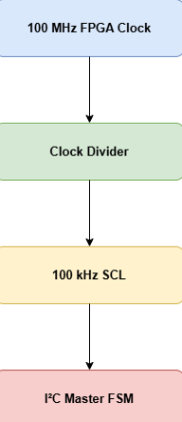
Figure 6 I2C CLOCK DIVIDER

I2C MASTER DESIGN

I2C master features
The proposed I2C Master Controller incorporates the following features:
- FSM-based architecture for protocol control.
- Support for both read and write operations.
- ACK/NACK detection mechanism.
- Bidirectional SDA communication using tri-state logic.
- SCL generation through an internal clock divider.
- Support for 7-bit slave addressing.
- Protocol-compliant serial data transfer.

I2C master working
The I2C Master Controller initiates communication by generating a START condition on the bus. It then transmits the slave address along with the Read/Write (R/W) control bit and waits for an acknowledgement from the slave device. Upon receiving a valid acknowledgement, the controller performs either a write or read operation depending on the selected mode.
During a write operation, data is transmitted from the master to the slave. During a read operation, data is received from the slave and stored internally. After each data transfer, the controller checks for an acknowledgement to ensure successful communication. Once the transaction is completed, a STOP condition is generated and the controller returns to the idle state.
The entire communication process is managed by a Finite State Machine (FSM), which ensures orderly execution of all I2C protocol operations.

FINAL STATE DIAGRAM(FSM) OF I2C
The I2C Master Controller is implemented using a Finite State Machine (FSM) to control and manage I2C communication. The FSM executes protocol operations such as START generation, address transmission, acknowledgement detection, data transfer, and STOP generation in a sequential manner. The design consists of 7 states:
- IDLE
- START
- ADDR
- ACK
- DATA
- ACK2
- STOP

FSM state diagram
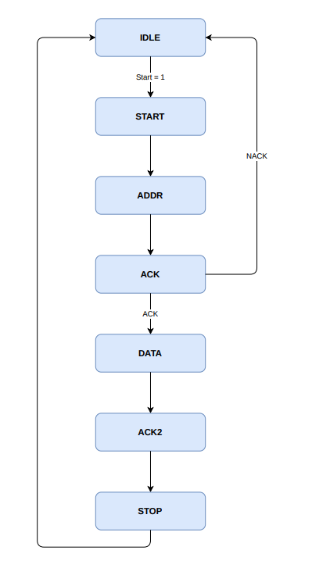
Figure 7 STATE DIAGRAM OF I2C

FSM state description

1. IDLE State
This is the waiting state of the I2C master controller.
In this state:
- SDA and SCL remain in the idle condition.
- No communication is active.
- Internal counters are reset.
- The controller waits for the start signal.

2. START State
This state generates the I2C START condition.

In this state:
- SDA output is enabled.
- SCL is maintained high.
- The START condition is generated by pulling SDA low while SCL remains high.
- A start counter is used to control the timing of the START sequence.
- Communication with the slave device begins.
When start_cnt = 2:
- The start counter is reset to zero.
- The slave address and R/W bit are loaded into the shift register.
- Bit counter=8.
- SCL is driven low.
- FSM moves to the ADDR state.

3. ADDR State
This state transmits the slave address and the Read/Write (R/W) bit.
In this state:
- Address bits are shifted serially on the SDA line.
- Transmission is synchronized with the SCL signal.
- Bit counter keeps track of transmitted bits.
- The R/W control bit is transmitted.
After all address bits are transmitted:
- SDA is released for acknowledgement.
- FSM moves to the ACK state.

4. ACK State
This state checks the acknowledgement from the slave device.
In this state:
- SDA is released by the master.
- Slave drives the ACK/NACK bit.
- Acknowledgement status is monitored.
If ACK is received:
- Communication proceeds normally.
- FSM moves to the DATA state.
If NACK is received:
- Communication is terminated.
- FSM moves to the STOP state.

5. DATA State
This state performs the actual data transfer.
In this state:
- Data is transmitted or received through the SDA line.
- Data transfer is synchronized with the SCL signal.
- One bit is transferred during each clock cycle.
- Bit counter decreases after each transfer.
- During a read operation received bits are shifted into the shift register.
- During a write operation, data from the input register (din) is transmitted to the slave.

6. ACK2 State
This state verifies acknowledgement after data transfer.
In this state:
- Receiver generates an ACK or NACK response.
- Communication status is checked.
- Successful acknowledgement confirms correct data transfer.

7. STOP State
This state terminates the I2C communication.
In this state:
- SDA transitions from low to high while SCL remains high.
- The STOP condition is generated.
- Communication is completed successfully.
After STOP generation:
- Internal control signals are cleared.
- FSM returns to the IDLE state.

FSM state transition table

PRESENT STATE | CONDITION | NEXT STATE | OPERATION
IDLE | start = 1 | START | Waits for a communication request and initialises the transaction
START | START condition generated | ADDR | Generates I2C START condition
ADDR | Address transmission complete | ACK | Transmits slave address and R/W bit
ACK | ACK received | DATA | Verifies slave acknowledgement and continues communication
ACK | NACK received | STOP | Terminates communication due to acknowledgement failure
DATA | Data transfer complete | ACK2 | Performs data transmission or reception
ACK2 | ACK/NACK detected | STOP | Verifies acknowledgement after data transfer
STOP | STOP condition generated | IDLE | Generates STOP condition and returns to idle state

EEPROM INTERFACING
The FPGA-based I2C master communicates with the 24512A EEPROM to perform memory write and read operations. The EEPROM uses a 16-bit memory addressing scheme, requiring transmission of both the high-byte and low-byte memory addresses before accessing a memory location.

EEPROM write operation
In the implemented system, the FPGA acts as the I2C master and writes an 8-bit data value to a specified memory location of the 24512A EEPROM. Since the EEPROM uses a 16-bit addressing scheme, both the high-byte and low-byte memory addresses must be transmitted before the data byte.
The write operation begins with the generation of a START condition, followed by transmission of the EEPROM device address with the write bit. The master then transmits the high-byte memory address, low-byte memory address, and the data byte to be stored. After each byte transmission, the EEPROM generates an acknowledgement (ACK) signal to confirm successful reception.
Once all bytes have been transmitted successfully, the master generates a STOP condition. The EEPROM then enters its internal write cycle, during which the received data is permanently stored at the specified memory location.
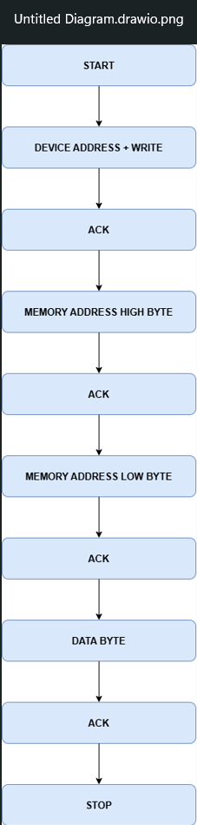
Figure 8 EEPROM write operation implemented in the proposed system.

EEPROM read operation
After completion of the EEPROM write cycle, the FPGA performs a read operation to verify that the data has been stored correctly. The read operation follows the standard random-read procedure recommended for the 24512A EEPROM.
The master first generates a START condition and transmits the EEPROM device address with the write bit. The high-byte and low-byte memory addresses are then transmitted to specify the target memory location. After receiving acknowledgement for the address bytes, the master generates a Repeated START condition instead of a STOP condition.
The EEPROM device address is transmitted again, this time with the read bit enabled. The EEPROM responds by transmitting the data stored at the specified memory location. After receiving the data byte, the master generates a NACK signal followed by a STOP condition to terminate communication.
The received data is then compared with the originally transmitted data to verify successful EEPROM write and read operations.
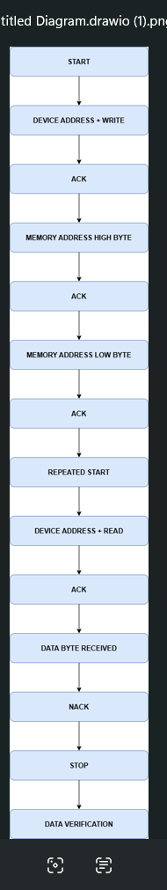
Figure 9 EEPROM read operation and read-back verification sequence.

Repeated START Condition
- Prevents release of the I2C bus.
- Ensures that the EEPROM retains the previously transmitted memory address, which is required for random-read operations.
- Allows switching from write mode to read mode.
- Required for EEPROM random-read operations.
- Complies with the 24512A EEPROM communication procedure.

ACK Error Accumulation
To ensure reliable communication, the I2C master continuously monitors acknowledgement (ACK) responses from the EEPROM after every address and data transmission. An acknowledgement indicates that the transmitted byte has been successfully received by the slave device.
Features of ACK Error Accumulation:
- Detects communication failures at any stage of the transaction.
- Monitors acknowledgements throughout both write and read operations.
- Combines multiple acknowledgement results into a single error status flag.
- Prevents false indication of successful communication.
- Simplifies error detection during hardware testing and debugging.

FPGA implementation enhancements
The FPGA implementation extends the basic I2C master controller to support practical communication with the 24512A EEPROM. Several additional features were incorporated to ensure reliable operation and successful hardware validation.
Key Enhancements:
- Support for 16-bit EEPROM memory addressing.
- Generation of a 100 kHz I2C clock from the FPGA's 100 MHz system clock.
- Implementation of EEPROM write-cycle delay to allow completion of internal memory programming.
- Support for Repeated START generation during EEPROM read operations.
- ACK monitoring and error accumulation for communication reliability.
- Read-back verification to confirm successful data storage in EEPROM.
- Button-controlled initiation of EEPROM transactions.
- LED-based indication of communication and verification status.

TESTBENCH DESIGN
Testbench features:
- Generates the system clock signal.
- Applies reset initialization.
- Provides start stimulus for communication.
- Supports both read and write operation verification.
- Monitors SDA and SCL activity.

SIMULATION RESULT
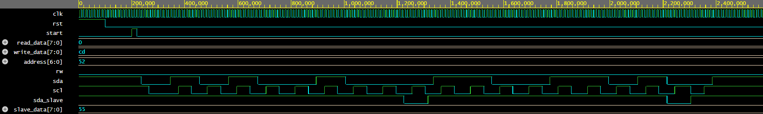
Figure 10 SIMULATION RESULT OF WRITE OPERATION

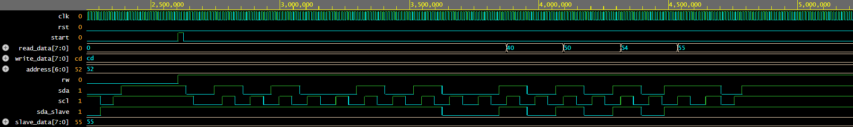
Figure 11 SIMULATION RESULT OF READ OPERATION

HARDWARE IMPLEMENTATION RESULTS

FPGA Implementation
The designed I2C Master Controller was implemented on the Digilent Arty A7-100T FPGA board and tested with a 24512A EEPROM device. Hardware testing was performed to verify EEPROM write and read operations through the I2C interface. To validate the hardware implementation, a 24 MHz 8-channel Logic Analyzer was connected to the SDA and SCL lines of the I2C bus. The captured signals were analyzed using Saleae Logic 2 software.
The logic analyzer enabled real-time observation of I2C communication, including START and STOP conditions, slave addressing, acknowledgements, repeated START generation, and EEPROM data transfer operations. This provided additional verification of protocol compliance beyond LED-based status indication.

Vivado implementation summary
The design was synthezised and implemented using Xilinx Vivado, targeting the Artix-7 FPGA present on the Arty A7-100T development board.
Resource utilization summary:
Resource | Utilization | Available | Utilization %
LUT | 175 | 63400 | 0.28
Flip flops | 98 | 126800 | 0.08
IO | 13 | 210 | 6.19

Timing Summary:
Parameter | Value
Timing Status | MET
Worst Negative Slack (WNS) | 5.031 ns
Total Negative Slack (TNS) | 0.000 ns
Worst Hold Slack (WHS) | 0.112 ns
Total Hold Slack (THS) | 0.000 ns

Power utilization summary :
Parameter | Value
Total On-Chip Power | 0.099 W
Dynamic Power | 0.002 W (2% )
Static Power | 0.097 W (98%)

Hardware Setup
Hardware Components Used:
- Digilent Arty A7-100T FPGA Board
- 24512A EEPROM
- 24 MHz 8-Channel USB Logic Analyzer
- USB Programming Cable
- Breadboard and Connecting Wires

Interfacing Connections:
EEPROM PIN | FPGA CONNECTION
VCC | 3.3 V
GND | GND
SDA | FPGA SDA Pin
SCL | FPGA SCL Pin
A0 | GND
A1 | GND
A2 | GND

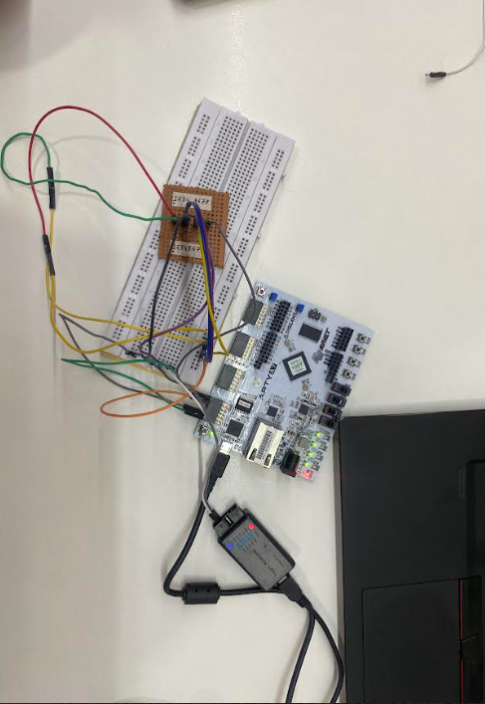
Figure 12 HARDWARE CONNECTIONS

Hardware Implementation Results

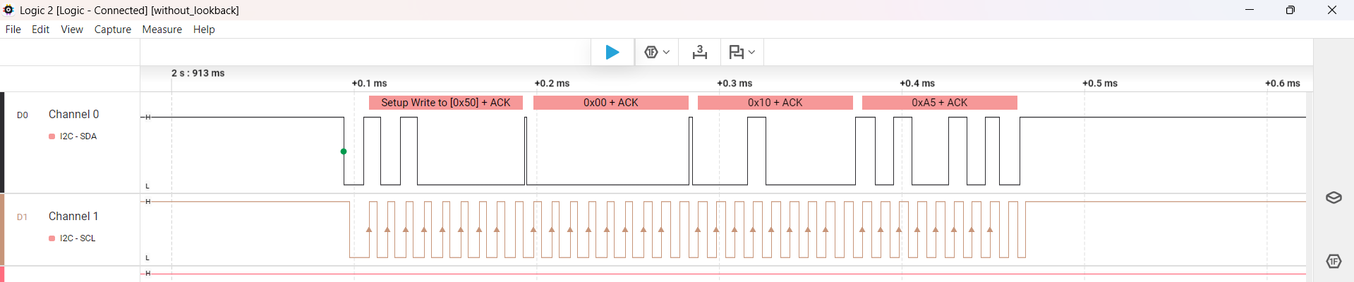
Figure 13 LOGIC ANALYZER OUTPUT OF WRITE OPERATION

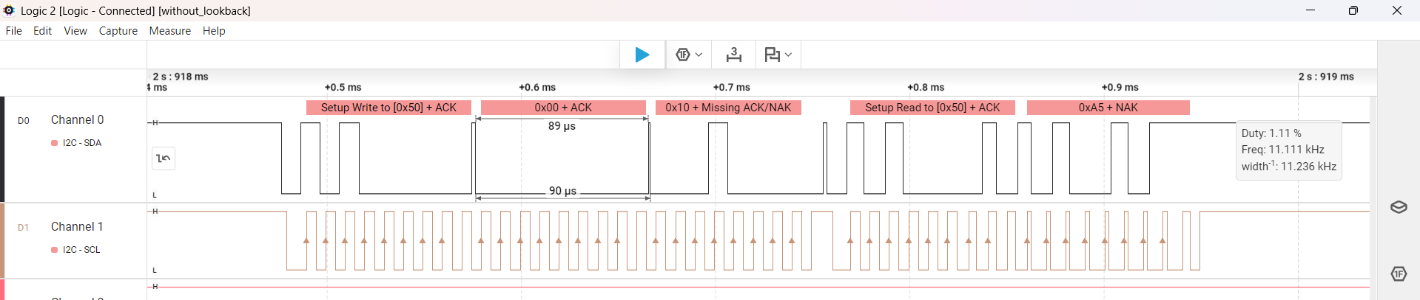
Figure 14 LOGIC ANALYZER OUTPUT OF READ OPERATION

CHALLENGES FACED DURING PROJECT DEVELOPMENT
- Generating an accurate 100 kHz I2C clock from the FPGA's 100 MHz system clock.
- Managing bidirectional SDA communication using tri-state logic.
- Implementing protocol-compliant START, STOP, and Repeated START conditions.
- Handling ACK/NACK detection and ensuring reliable communication with the EEPROM.
- Debugging FSM state transitions and protocol timing during simulation.
- Capturing and decoding real-time I²C signals using a logic analyzer for hardware verification.

ADVANTAGES
- Requires only two communication lines (SDA and SCL).
- Supports multiple devices on a single bus.
- Reduces wiring complexity and PCB routing requirements.
- Provides reliable communication through ACK/NACK acknowledgment.
- Supports both read and write operations.
- Widely used for interfacing memories, sensors, RTCs, and other peripherals.

DISADVANTAGES
- Lower communication speed compared To other protocol.
- Limited communication distance due to bus capacitance.
- Requires pull-up resistors on SDA and SCL lines.
- Protocol overhead caused by START, STOP, and ACK/NACK signals.
- Slower when multiple devices share the same bus.
- More complex timing and arbitration in multi-master systems.

APPLICATIONS
- EEPROM and Flash memory interfacing for data storage applications.
- Communication with sensors such as temperature, humidity, and pressure sensors.
- Real-Time Clock (RTC) interfacing for time and date management.
- Display interfacing in LCD and OLED-based embedded systems.
- Configuration and control of peripheral devices in microcontroller and FPGA systems.
- Consumer electronics, industrial automation, and IoT applications requiring low-speed serial communication.

LEARNING OUTCOMES
- Developed a strong understanding of the I2C communication protocol and its operation.
- Gained hands-on experience in Verilog HDL-based digital design and FSM implementation.
- Learned FPGA design flow using Xilinx Vivado, including synthesis and implementation.
- Acquired practical experience in interfacing external EEPROM devices with FPGA systems.
- Enhanced debugging and verification skills using simulation tools and Logic Analyzer-based waveform analysis.

CONCLUSION
An FSM-based I2C Master Controller was successfully designed and implemented using Verilog HDL. The design was verified through simulation and validated on the Digilent Arty A7-100T FPGA board by interfacing with a 24512A EEPROM. Successful EEPROM write and read operations, along with read-back verification, confirmed reliable I2C communication. The project demonstrated effective implementation of the I2C protocol and provided valuable experience in FPGA design, FSM development, and hardware verification.

REFERENCES
[1] NXP Semiconductors, I2C-bus Specification and User Manual, Rev. 7.0, October 2021.
[2] Microchip Technology Inc., 24AA512/24LC512/24FC512 (24512A) EEPROM Datasheet, Microchip Technology.
[3] Xilinx Inc., Vivado Design Suite User Guide, Xilinx Documentation.
[4] Digilent Inc., Arty A7 FPGA Development Board Reference Manual, Digilent.
[5] Samir Palnitkar, Verilog HDL: A Guide to Digital Design and Synthesis, 2nd Edition, Pearson Education.
[6] M. Morris Mano and Michael D. Ciletti, Digital Design, 6th Edition, Pearson Education.

