Craft Me Up

Subject
Conversion of the existing Craft Me Up game, a top-down shooter game where the player must survive monster waves in a pseudo-random world, to the Godot game engine.

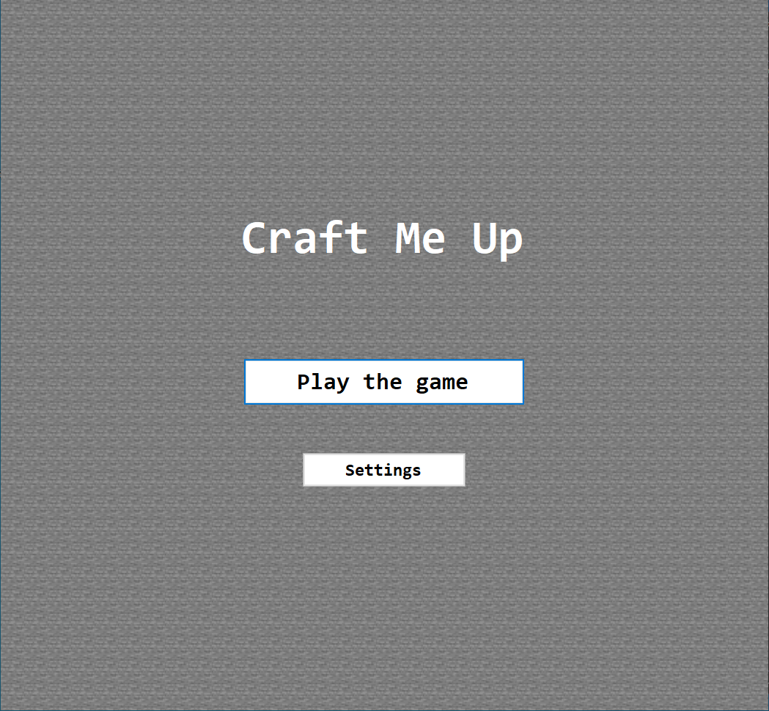

The conversion of this application requires knowledge of several concepts related to game development, software architecture and Module 320.
The objective is to adapt the existing C# application to Godot while preserving its original gameplay, mechanics and functionality.

Topics covered
 | - Variables and constants |  | - Variables and constants
 | - Classes and methods |  | - Classes and methods
 | - Iterations, conditions and operators |  | - Iterations, conditions and operators
 | - Lists and collections |  | - Lists and collections
Requirements |  | Project duration: 32p
You are asked to convert the existing Craft Me Up game to the Godot game engine, with particular attention to the programming method, which must be rigorous and consider the fundamental concepts of software quality.
The existing game is written in C# and must be adapted to work within Godot. The conversion should focus on reusing existing code and functionality wherever possible, while adapting components that depend on the original development environment.
The project must preserve (and if time allows it, upgrade) the original gameplay and ensure that the different game mechanics function correctly after the conversion.

Returns
- The complete Godot project and source code with comments
- A work log

The program’s objective
The program aims to simulate a top-down video game, where the player must kill enemies in a pseudo-infinite world using different weapons.
The objective of the conversion is to reproduce the existing game's functionality in Godot without changing its fundamental gameplay, unless for the better.
First, the user has the option of changing the game's speed.
Once the game has started, the user can move in every direction within the world, while being blocked by random obstacles that they can either break or walk around.
After five seconds, the enemies start spawning, giving the player time to get used to the controls.
The game itself doesn't have an ending; it just keeps going until the player dies, with tougher enemies being sent in after every wave.

Additional features
If there is enough time, here is a list of features to add to the game:
- A game over screen
- Make maps be one biome set only (not all of them at once)
  - After every boss encounter, update that biome set (and map)
- An indicator of where you will shoot
- A toggle in the settings that can be used for auto aim
- Change the density of obstacles so that they are denser near the border and sparser near the center.
- A break level after a boss wave
  - A currency system (for every monster killed / for how fast you completed the wave)
  - A shop where you can buy upgrades (movement speed, faster shooting, slower shooting but stronger ammo, extra life, temporary invincibility, critical damage, …)

