Craft Me Up

Subject
A top-down shooter game where the player has to survive monster waves in a pseudo-random world.

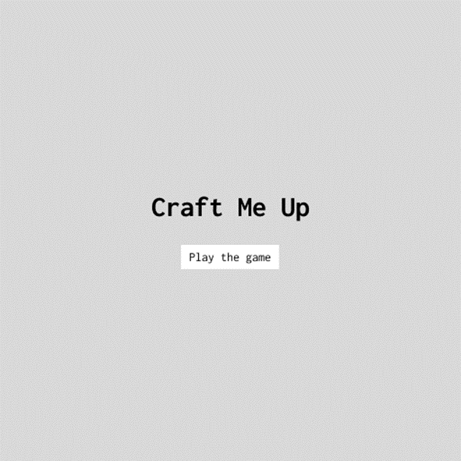

Designing and implementing this program requires knowledge of several concepts related to Module 320.
These include correct data typing and class creation, among others.

Topics covered
- Iterations, conditions, operators | - Variables and constants  - Lists
- Classes | - WinForms
- Methods | - Sprites
- Loops | - Rectangle objects

Project duration: 24p/56p

Requirements
You are asked to develop the project with particular attention to the programming method, which must be rigorous and consider the fundamental concepts of software quality.
You must use Visual Studio and the C# language. Programming will be done in WinForms with the .Net Framework.

Returns
- The complete source code with comments
- A work log
- The project plan (GitHub projects, Trello, etc.)

The program’s objective
The program aims to simulate a top-down video game, where the player must kill enemies in a pseudo-infinite world using different weapons.
First, the user has the option of changing the game's difficulty. This affects the speed of every character (including the player), their spawn rate, and the number of lives.
Once the game has started, the user can move in every direction within the top-down, pseudo-random world, while being blocked by random obstacles that they must either break down or walk around.
After five seconds, the enemies start spawning, giving the player time to get used to the controls.
The game itself doesn't have an ending; it just keeps going until the player dies, with tougher enemies being sent in after every wave.

