Project Report

Summary
Cancer dataset for United States obtained for the year 1999-2013 is used for Hadoop Analysis. The overall size of the dataset is above 100MB. It consists of files for Cancers By Area having fields like Area(State), Count, Year, Race, Gender, Cancer Site etc. The dataset is taken from CDC website : https://wonder.cdc.gov/cancer.html and

Summary of the Patterns and Analysis Performed
Analysis on Cancer by State:
- Job Chaining:
All the below patterns were applied on a single file in a chained manner where the next job would be executed only on the execution of the previous job.

- Data Preprocessing and cleansing :
Used Grep Filtering technique to discard data that were irrelevant and to clean it.

- Cancer Incidents & Mortality :
The preprocessed dataset contained two specific event types of cancer called ‘Mortality’ and ‘Incidence’. Partitioned the dataset based on these two categories. The cancer incidents were
taken into consideration for further analysis.

- Data Summarization to combine the different types of cancer by state:
From the incidence data, a summary by state was carried out over the years 1999-2013 to see the occurrence of cancer incidents. Used a combiner for performance optimization. Thus, the output fetched are the states with their respective cancer incidents count.

- Join Pattern:
Joined the list of states to fetch state names with the state code in the dataset.

- Top Ten States affected by Cancer:
Used top ten filtering to get the top 10 cancer affected states and used a Comparator to sort
the output in descending order.

- Summary of all the sub-sites of Cancer and the topmost occurring
Joined the parent sites with sub-sites to see the count of occurrences of those type.

Results/Conclusions:
- Thus, by the analysis performed over the years, it was found that the two main conclusions were state of California had the maximum number of cancer incidents.

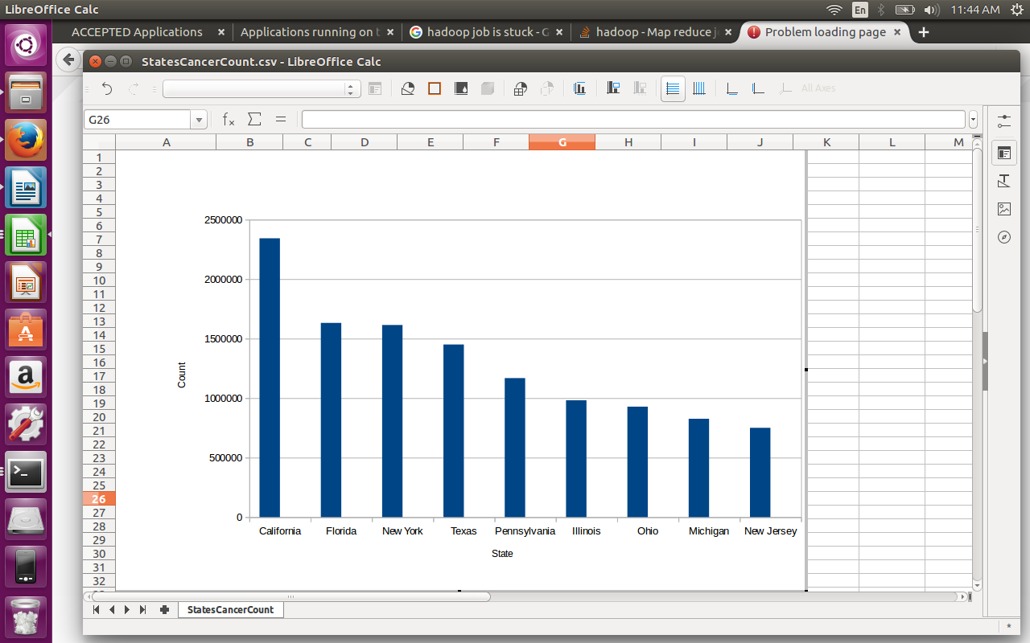

Digestive System being the most frequently occurring over the country.

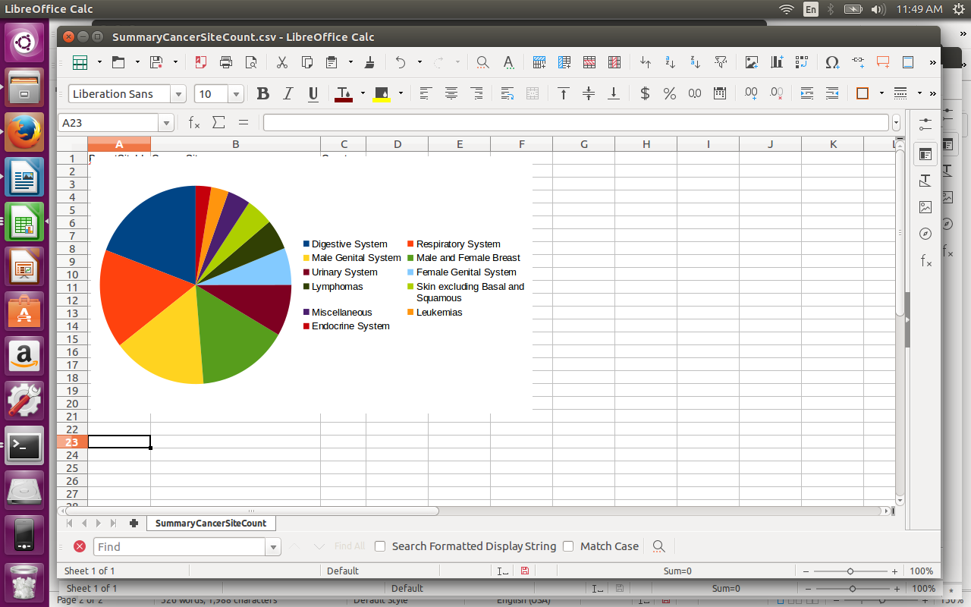

Source Code:

//Driver

/*
* To change this license header, choose License Headers in Project Properties.
* To change this template file, choose Tools | Templates
* and open the template in the editor.
*/
package cancerbyareaanalysis;

import java.io.IOException;
import org.apache.hadoop.conf.Configuration;
import org.apache.hadoop.fs.Path;
import org.apache.hadoop.io.IntWritable;
import org.apache.hadoop.io.LongWritable;
import org.apache.hadoop.io.NullWritable;
import org.apache.hadoop.io.Text;
import org.apache.hadoop.mapreduce.Job;
import org.apache.hadoop.mapreduce.lib.input.FileInputFormat;
import org.apache.hadoop.mapreduce.lib.input.MultipleInputs;
import org.apache.hadoop.mapreduce.lib.input.TextInputFormat;
import org.apache.hadoop.mapreduce.lib.output.FileOutputFormat;

/**
*
* @author neola
*/
public class CancerByAreaAnalysis {

/**
* @param args the command line arguments
*/
public static void main(String[] args) throws IOException, InterruptedException, ClassNotFoundException {
// TODO code application logic here
Configuration conf = new Configuration();

//Grep Filtering to clean data
Job job = Job.getInstance(conf, "GrepFilter");
job.setJarByClass(CancerByAreaAnalysis.class);
job.setMapperClass(GrepMapper.class);
job.getConfiguration().set("mapregex", "(.*)All Races(.*)Male and Female(.*)All Cancer Sites Combined(.*)2009-2013(.*)");

job.setMapOutputKeyClass(NullWritable.class);
job.setMapOutputValueClass(Text.class);
FileInputFormat.addInputPath(job, new Path(args[1]));
FileOutputFormat.setOutputPath(job, new Path(args[2]));
int filter = (job.waitForCompletion(true) ? 0 : 1);
int partition = 1;
int topTenFlag = 1;

//Partitioning to consider Incidence data
if(filter == 0)
{
Job job1 = Job.getInstance(conf,"Partition");
job1.setJarByClass(CancerByAreaAnalysis.class);
job1.setMapperClass(EventTypeMapper.class);
job1.setMapOutputKeyClass(IntWritable.class);
job1.setMapOutputValueClass(Text.class);
job1.setPartitionerClass(EventTypePartition.class);
EventTypePartition.setMinId(job1, 0);
job1.setNumReduceTasks(2);
job1.setReducerClass(EventTypeReducer.class);
job1.setOutputKeyClass(NullWritable.class);
job1.setOutputValueClass(Text.class);
FileInputFormat.addInputPath(job1, new Path(args[2]));
FileOutputFormat.setOutputPath(job1, new Path(args[3]));
partition = (job1.waitForCompletion(true) ? 0 : 1);
}
int join = 1;
//State Summary of Incidence
if(partition == 0)
{
Job job2 = Job.getInstance(conf,"StateSummary");
job2.setJarByClass(CancerByAreaAnalysis.class);
job2.setMapperClass(StateSummaryMapper.class);
job2.setMapOutputKeyClass(Text.class);
job2.setMapOutputValueClass(LongWritable.class);
job2.setReducerClass(StateSummaryReducer.class);
job2.setOutputKeyClass(Text.class);
job2.setOutputValueClass(LongWritable.class);
FileInputFormat.addInputPath(job2, new Path(args[4]));
FileOutputFormat.setOutputPath(job2, new Path(args[5]));
topTenFlag = (job2.waitForCompletion(true) ? 0 : 1);
}

if(join == 0)
{
Job job2 = Job.getInstance(conf, "Join");
job2.setJarByClass(CancerByAreaAnalysis.class);

MultipleInputs.addInputPath(job2, new Path(args[6]),TextInputFormat.class,StateJoinMapper.class);
MultipleInputs.addInputPath(job2, new Path(args[5]), TextInputFormat.class,StateCancerMapper.class);
job2.getConfiguration().set("join.type", "inner");
job2.setMapOutputKeyClass(IntWritable.class);
job2.setMapOutputValueClass(Text.class);
job2.setReducerClass(StateCancerReducer.class);
job2.setOutputKeyClass(Text.class);
job2.setOutputValueClass(Text.class);
FileOutputFormat.setOutputPath(job2, new Path(args[7]));
join = (job2.waitForCompletion(true) ? 0 : 1);
}

//Top 10 Filtering sorted in descending order
if(topTenFlag == 0)
{
Job job3 = Job.getInstance(conf, "Top10");
job3.setJarByClass(CancerByAreaAnalysis.class);
job3.setMapperClass(TopTenStatesMapper.class);
//job.setCombinerClass(CancerSiteReducer.class);
job3.setMapOutputKeyClass(LongWritable.class);
job3.setMapOutputValueClass(Text.class);
job3.setSortComparatorClass(SortKeyComparator.class);
job3.setReducerClass(TopTenStatesReducer.class);
job3.setOutputKeyClass(Text.class);
job3.setOutputValueClass(LongWritable.class);
FileInputFormat.addInputPath(job3, new Path(args[7]));
FileOutputFormat.setOutputPath(job3, new Path(args[8]));
System.exit(job3.waitForCompletion(true) ? 0 : 1);
}

}

}

/*
* To change this license header, choose License Headers in Project Properties.
* To change this template file, choose Tools | Templates
* and open the template in the editor.
*/
package cancerbyareaanalysis;

import java.io.IOException;
import org.apache.hadoop.io.IntWritable;
import org.apache.hadoop.io.Text;
import org.apache.hadoop.mapreduce.Mapper;

/**
*
* @author neola
*/
public class EventTypeMapper extends Mapper<Object,Text,IntWritable,Text>{

private IntWritable outkey = new IntWritable();
private int parentId;
protected void map(Object key,Text value,Context context) throws IOException, InterruptedException
{
String str[] = value.toString().split("\\|");
if(str[0].equalsIgnoreCase("AREA"))
return;
else
{
if(str[5].equalsIgnoreCase("Incidence"))
{
System.out.println("INC: "+str[5]);
parentId = 0;
outkey.set(parentId);
}

if(str[5].equalsIgnoreCase("Mortality"))
{
System.out.println("Mort: "+str[5]);
parentId = 1;
outkey.set(parentId);
}

context.write(outkey, value);
}
}
}

/*
* To change this license header, choose License Headers in Project Properties.
* To change this template file, choose Tools | Templates
* and open the template in the editor.
*/
package cancerbyareaanalysis;

import org.apache.hadoop.conf.Configurable;
import org.apache.hadoop.conf.Configuration;
import org.apache.hadoop.io.IntWritable;
import org.apache.hadoop.io.NullWritable;
import org.apache.hadoop.io.Text;
import org.apache.hadoop.mapreduce.Job;
import org.apache.hadoop.mapreduce.Partitioner;

/**
*
* @author neola
*/
public class EventTypePartition extends Partitioner<IntWritable,Text> implements Configurable
{

private static final String MIN_ID = "min.id";
private Configuration conf = null;
private int minId = 0;

@Override
public int getPartition(IntWritable key, Text value, int i) {
return key.get() - minId;
}

@Override
public void setConf(Configuration c) {
this.conf = c;
minId = conf.getInt(MIN_ID, 0);
}

@Override
public Configuration getConf() {
return conf;
}

public static void setMinId(Job job,int minId){
job.getConfiguration().setInt(MIN_ID, minId);
}

}

package cancerbyareaanalysis;

import java.io.IOException;
import org.apache.hadoop.io.IntWritable;
import org.apache.hadoop.io.NullWritable;
import org.apache.hadoop.io.Text;
import org.apache.hadoop.mapreduce.Reducer;

/*
* To change this license header, choose License Headers in Project Properties.
* To change this template file, choose Tools | Templates
* and open the template in the editor.
*/

/**
*
* @author neola
*/
public class EventTypeReducer extends Reducer<IntWritable,Text,Text,NullWritable>{
protected void reduce(IntWritable key,Iterable<Text> values,Context context) throws IOException, InterruptedException
{
for(Text t:values){
System.out.println(t);
context.write(t, NullWritable.get());
}
}
}

/*
* To change this license header, choose License Headers in Project Properties.
* To change this template file, choose Tools | Templates
* and open the template in the editor.
*/
package cancerbyareaanalysis;

import java.io.IOException;
import org.apache.hadoop.io.NullWritable;
import org.apache.hadoop.io.Text;
import org.apache.hadoop.mapreduce.Mapper;

/**
*
* @author neola
*/
public class GrepMapper extends Mapper<Object, Text, NullWritable, Text> {
private String mapRegex = null;

public void setup(Context context) throws IOException, InterruptedException
{
mapRegex = context.getConfiguration().get("mapregex");

}
public void map(Object key, Text value, Context context) throws IOException, InterruptedException
{
if(!value.toString().matches(mapRegex)) {
context.write(NullWritable.get(), value);
}
}
}

/*
* To change this license header, choose License Headers in Project Properties.
* To change this template file, choose Tools | Templates
* and open the template in the editor.
*/
package cancerbyareaanalysis;

import org.apache.hadoop.io.LongWritable;
import org.apache.hadoop.io.WritableComparable;
import org.apache.hadoop.io.WritableComparator;

/**
*
* @author neola
*/
public class SortKeyComparator extends WritableComparator{

protected SortKeyComparator()
{
super(LongWritable.class,true);
}

@Override
public int compare(WritableComparable a, WritableComparable b) {
LongWritable key1 = (LongWritable) a;
LongWritable key2 = (LongWritable) b;

// Implemet sorting in descending order
int result = key1.get() < key2.get() ? 1 : key1.get() == key2.get() ? 0 : -1;
return result;
}

}

/*
* To change this license header, choose License Headers in Project Properties.
* To change this template file, choose Tools | Templates
* and open the template in the editor.
*/
package cancerbyareaanalysis;

import java.io.IOException;
import org.apache.hadoop.io.IntWritable;
import org.apache.hadoop.io.Text;
import org.apache.hadoop.mapreduce.Mapper;

/**
*
* @author neola
*/
public class StateCancerMapper extends Mapper<Object, Text, IntWritable, Text> {
private IntWritable outkey = new IntWritable();
private Text outvalue = new Text();

public void map(Object key, Text value, Context context) throws IOException, InterruptedException
{
String str[] = value.toString().split("\\t");
// The foreign join key is the user ID
outkey.set(Integer.parseInt(str[0]));
// Flag this record for the reducer and then output
outvalue.set("B" + value.toString());
context.write(outkey, outvalue);
}
}

/*
* To change this license header, choose License Headers in Project Properties.
* To change this template file, choose Tools | Templates
* and open the template in the editor.
*/
package cancerbyareaanalysis;

import java.io.IOException;
import java.util.ArrayList;
import org.apache.hadoop.io.IntWritable;
import org.apache.hadoop.io.Text;
import org.apache.hadoop.mapreduce.Reducer;

/**
*
* @author neola
*/
public class StateCancerReducer extends Reducer<IntWritable, Text, Text, Text> {
private static final Text EMPTY_TEXT = new Text("");
private Text tmp = new Text();
private ArrayList<Text> listA = new ArrayList<Text>();
private ArrayList<Text> listB = new ArrayList<Text>();
private String joinType = null;
public void setup(Context context) {
// Get the type of join from our configuration
joinType = context.getConfiguration().get("join.type");
}
public void reduce(IntWritable key, Iterable<Text> values, Context context)throws
IOException, InterruptedException
{
// Clear our lists
listA.clear();
listB.clear();
// iterate through all our values, binning each record based on what
// it was tagged with. Make sure to remove the tag!
for(Text val : values) {
tmp = val;
if(tmp.charAt(0) == 'A') {
String t[] = tmp.toString().split(",");
listA.add(new Text(t[1]));
}
else if(tmp.charAt(0) == 'B') {
listB.add(new Text(tmp.toString().substring(1)));
}
}
// Execute our join logic now that the lists are filled
executeJoinLogic(context);
}

private void executeJoinLogic(Context context) throws IOException, InterruptedException
{
if(joinType.equalsIgnoreCase("inner")) {
// If both lists are not empty, join A with B
if(!listA.isEmpty() && !listB.isEmpty()) {
for(Text A : listA) {
for(Text B : listB) {
context.write(A, B);
}
}
}
}
}
}

/*
* To change this license header, choose License Headers in Project Properties.
* To change this template file, choose Tools | Templates
* and open the template in the editor.
*/
package cancerbyareaanalysis;

import java.io.IOException;
import org.apache.hadoop.io.IntWritable;
import org.apache.hadoop.io.Text;
import org.apache.hadoop.mapreduce.Mapper;

/**
*
* @author neola
*/
public class StateJoinMapper extends Mapper<Object, Text, IntWritable, Text> {
private IntWritable outkey = new IntWritable();
private Text outvalue = new Text();
public void map(Object key, Text value, Context context)
throws IOException, InterruptedException {
// Parse the input string into a nice map
String str[] = value.toString().split(",");
if(str[1].equalsIgnoreCase("States"))
return;
else
{
// The foreign join key is the user ID
outkey.set(Integer.parseInt(str[0]));
// Flag this record for the reducer and then output
outvalue.set("A" + value.toString());
context.write(outkey, outvalue);
}
}
}

/*
* To change this license header, choose License Headers in Project Properties.
* To change this template file, choose Tools | Templates
* and open the template in the editor.
*/
package cancerbyareaanalysis;

import java.io.IOException;
import org.apache.hadoop.io.IntWritable;
import org.apache.hadoop.io.LongWritable;
import org.apache.hadoop.io.Text;
import org.apache.hadoop.mapreduce.Mapper;

/**
*
* @author neola
*/
public class StateSummaryMapper extends Mapper<Object,Text,Text,LongWritable>{
private Text outkey = new Text();
private LongWritable outvalue = new LongWritable();

@Override
protected void map(Object key, Text value, Mapper.Context context) throws IOException, InterruptedException {
String str[] = value.toString().split("\\|");
outkey.set(str[0]);
outvalue.set(Long.parseLong(str[6]));
context.write(outkey, outvalue);
}
}

/*
* To change this license header, choose License Headers in Project Properties.
* To change this template file, choose Tools | Templates
* and open the template in the editor.
*/
package cancerbyareaanalysis;

import java.io.IOException;
import org.apache.hadoop.io.IntWritable;
import org.apache.hadoop.io.LongWritable;
import org.apache.hadoop.io.Text;
import org.apache.hadoop.mapreduce.Reducer;

/**
*
* @author neola
*/
public class StateSummaryReducer extends Reducer<Text,LongWritable,Text,LongWritable>{

private LongWritable result = new LongWritable();

@Override
protected void reduce(Text key, Iterable<LongWritable> values, Context context) throws IOException, InterruptedException {
long sum = 0;
for(LongWritable val:values)
{
sum += val.get();
}
result.set(sum);
context.write(key,result);
}
}

/*
* To change this license header, choose License Headers in Project Properties.
* To change this template file, choose Tools | Templates
* and open the template in the editor.
*/
package cancerbyareaanalysis;

import org.apache.hadoop.io.LongWritable;
import org.apache.hadoop.io.Text;
import org.apache.hadoop.mapreduce.Mapper;

/**
*
* @author neola
*/
public class TopTenStatesMapper extends Mapper<Object, Text, LongWritable, Text> {

@Override
public void map(Object key, Text value, Mapper.Context context) {

String row[] = value.toString().split("\\t");
String id = row[0];
String count = row[1].trim();

try{
LongWritable readCount = new LongWritable(Long.parseLong(count));
context.write(readCount,new Text(id));
} catch (Exception e) {

}

}
}

/*
* To change this license header, choose License Headers in Project Properties.
* To change this template file, choose Tools | Templates
* and open the template in the editor.
*/
package cancerbyareaanalysis;

import java.io.IOException;
import org.apache.hadoop.io.LongWritable;
import org.apache.hadoop.io.Text;
import org.apache.hadoop.mapreduce.Reducer;

/**
*
* @author neola
*/
public class TopTenStatesReducer extends Reducer<LongWritable,Text, Text, LongWritable> {
int count = 0;

@Override
protected void setup(Reducer.Context context)
{
count = 0;
}

public void reduce(LongWritable key, Iterable<Text> value, Reducer.Context context)
throws IOException, InterruptedException {
if(count < 10)
{
for(Text val : value) {
context.write(val, key);
count++;
if(count > 10)
break;
}

}

}
}

/*
* To change this license header, choose License Headers in Project Properties.
* To change this template file, choose Tools | Templates
* and open the template in the editor.
*/
package cancerpartitions;

import java.io.IOException;
import org.apache.hadoop.conf.Configuration;
import org.apache.hadoop.fs.Path;
import org.apache.hadoop.io.IntWritable;
import org.apache.hadoop.io.NullWritable;
import org.apache.hadoop.io.Text;
import org.apache.hadoop.mapreduce.Job;
import org.apache.hadoop.mapreduce.lib.input.FileInputFormat;
import org.apache.hadoop.mapreduce.lib.output.FileOutputFormat;

/**
*
* @author neola
*/
public class CancerPartitions {

/**
* @param args the command line arguments
*/
public static void main(String[] args) throws IOException, InterruptedException, ClassNotFoundException {
// TODO code application logic here
Configuration conf = new Configuration();
Job job = Job.getInstance(conf, "cancerLog");
job.setJarByClass(CancerPartitions.class);
job.setMapperClass(SiteMapper.class);
job.setMapOutputKeyClass(IntWritable.class);
job.setMapOutputValueClass(Text.class);
job.setPartitionerClass(SitePartitioner.class);
SitePartitioner.setMinId(job, 1);
job.setNumReduceTasks(19);
job.setReducerClass(SiteReducer.class);
job.setOutputKeyClass(Text.class);
job.setOutputValueClass(NullWritable.class);
FileInputFormat.addInputPath(job, new Path(args[1]));
FileOutputFormat.setOutputPath(job, new Path(args[2]));
System.exit(job.waitForCompletion(true) ? 0 : 1);
}

}

/*
* To change this license header, choose License Headers in Project Properties.
* To change this template file, choose Tools | Templates
* and open the template in the editor.
*/
package cancerpartitions;

import java.io.IOException;
import java.text.ParseException;
import org.apache.hadoop.io.IntWritable;
import org.apache.hadoop.io.Text;
import org.apache.hadoop.mapreduce.Mapper;

/**
*
* @author neola
*/
public class SiteMapper extends Mapper<Object,Text,IntWritable,Text>{

private IntWritable outkey = new IntWritable();

protected void map(Object key,Text value,Context context) throws IOException, InterruptedException
{
String str[] = value.toString().split(",");
if(str[0].equalsIgnoreCase("ParentId"))
return;
else
{
String parentId = str[0];
outkey.set(Integer.parseInt(parentId));
context.write(outkey, value);
}
}
}

/*
* To change this license header, choose License Headers in Project Properties.
* To change this template file, choose Tools | Templates
* and open the template in the editor.
*/
package cancerpartitions;

import org.apache.hadoop.conf.Configurable;
import org.apache.hadoop.conf.Configuration;
import org.apache.hadoop.io.IntWritable;
import org.apache.hadoop.io.Text;
import org.apache.hadoop.mapreduce.Job;
import org.apache.hadoop.mapreduce.Partitioner;

/**
*
* @author neola
*/
public class SitePartitioner extends Partitioner<IntWritable,Text> implements Configurable
{

private static final String MIN_ID = "min.id";
private Configuration conf = null;
private int minId = 0;

@Override
public int getPartition(IntWritable key, Text value, int i) {
return key.get() - minId;
}

@Override
public void setConf(Configuration c) {
this.conf = c;
minId = conf.getInt(MIN_ID, 0);
}

@Override
public Configuration getConf() {
return conf;
}

public static void setMinId(Job job,int minId){
job.getConfiguration().setInt(MIN_ID, minId);
}
}

/*
* To change this license header, choose License Headers in Project Properties.
* To change this template file, choose Tools | Templates
* and open the template in the editor.
*/
package cancerpartitions;

import java.io.IOException;
import org.apache.hadoop.io.IntWritable;
import org.apache.hadoop.io.NullWritable;
import org.apache.hadoop.io.Text;
import org.apache.hadoop.mapreduce.Reducer;

/**
*
* @author neola
*/
public class SiteReducer extends Reducer<IntWritable,Text,Text,NullWritable>{
protected void reduce(IntWritable key,Iterable<Text> values,Context context) throws IOException, InterruptedException
{
for(Text t:values){
System.out.println(t);
context.write(t, NullWritable.get());
}
}
}

