?distribution()

#1.Uniform

#Could be used in a game to generate 100 random numbers between 1 to 10

n <- floor(runif(100,min=1,max=10))

t <- table(n)

barplot(t)

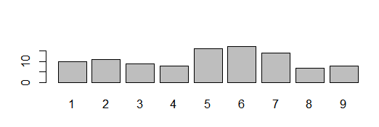

#2.Binomial

#To find the probability of biased coin given 6 tosses with a probability

#of 0.3 to be heads

b <- dbinom(x=3, size=6, prob=0.3) #Probability of 3 heads

plot(b)

binom <- dbinom(x=0:6, size=7, prob=0.3)

plot(binom)

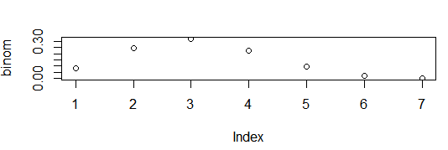

#3.Normal

#Weight with a mean of 166 pounds and standard deviation 20 pounds

xaxis <- seq(120,190,10)

normal <- rnorm(xaxis, 155, 20)

probdf <- dnorm(normal, 155, 20)

cumdf <- pnorm(normal, 155, 20)

plot(xaxis,normal)

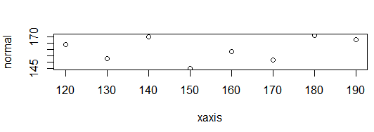

#4.Bernoulli

#Probability of flipping a coin 8 times

install.packages('Rlab')

library(Rlab)

rb <- rbern(8, 0.5)

prb <- pbern(rb, 0.5, lower.tail=TRUE, log.p=FALSE)

qrb <- qbern(rb, 0.5, lower.tail=TRUE, log.p=FALSE)

plot(rb)

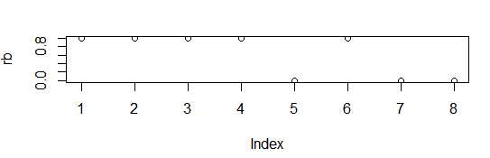

#5.HyperGeometric

#Probability of drawing 20 white balls from 45 White,50 Red, 45 Black

rh <- rhyper(45, 45, 50, 20)

prh <- phyper(20, 45, 50, 45)

plot(rh)

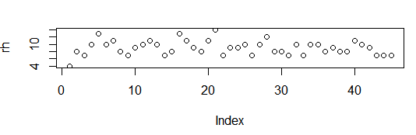

#6.Geometric

#100 continuous flips of a coin where probability is 0.5 success of

#getting a head before a tail

rg <- rgeom(100, 0.5)

dg <- dgeom(rg, 0.4, log = FALSE)

pg <- pgeom(rg, 0.4, lower.tail = TRUE, log.p = FALSE)

qg <- qgeom(rg, 0.4, lower.tail = TRUE, log.p = FALSE)

hist(rg)

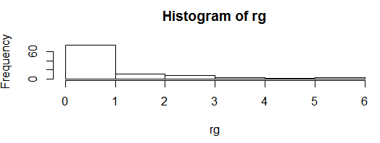

#7.Negative Binomial

#Getting a tail at the 10th toss before 3 heads with a probability of 0.3 as success

rnb <- rnbinom(10,3,0.3)

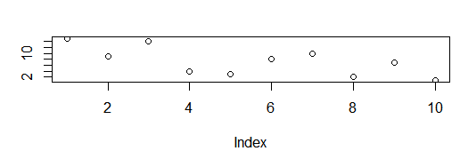

#8.Poisson

#5 flights take off in an hour. Probability of 10 or more flights to be taken off

ppois(10,5,lower.tail = FALSE, log.p = FALSE)

rps <- rpois(10,5)

plot(rps)

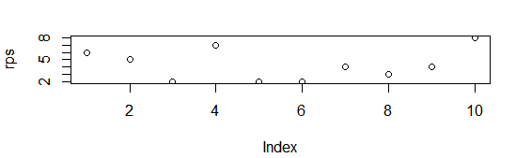

#9.Exponential

#Average Time taken by a marketing person for a call is 5 mins

#Probability of the person to complete the call in less than 3mins

rex <- rexp(3,rate = 0.2)

prex <- pexp(3,rate = 0.2)

plot(rex)

lines(rex)

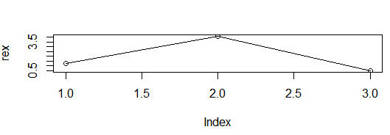

#10.LogNormal

rln <- rlnorm(100, meanlog = 1.5, sdlog = 0.3)

plot(rln)

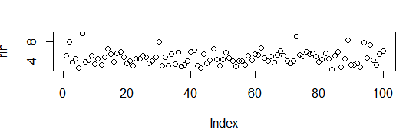

#11.Weibull

#In radar systems to model the dispersion of the received signals level

#produced by some types of clutters

ran <- rweibull(100, shape = 0.5, scale = 1)

hist(ran)

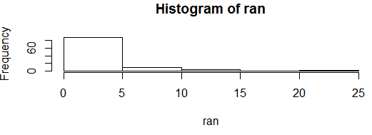

#12.Chi-squared

#Application in Magnetic Resonance Imaging

#80th percentile with 5 as degree of freedom

rch <- rchisq(80, 5, ncp = 0)

plot(rch)

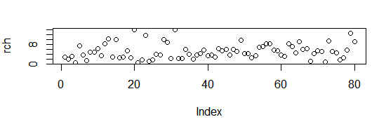

#13.Student-t

#Used In Bayesian Statistics

rst <- rt(10,5)

plot(rst)

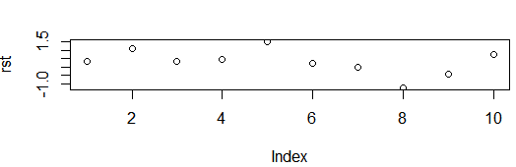

#14.Beta

rbet <- rbeta(100,9,9,ncp=0)

dgma <- dbeta(rbet,9,9)

hist(rbet)

curve(dbeta(rbet, 9, 9, log = FALSE))

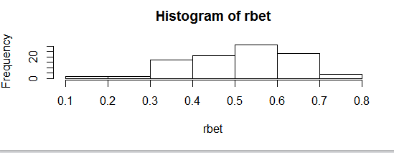

#15.Gamma

#In wireless communication, the gamma distribution is used to model the multi-path fading of signal power

rgma <- rgamma(100, 9, scale = 1)

dgma <- dgamma(rgma)

hist(rgma)

curve(dgamma(rgma, shape = 9, rate = 1, log = FALSE))

