**Data Exploration and Preprocessing**

The following stages of data exploration and preprocessing is carried out:

1. Variable identification
2. Titanic Dataset (Categorical Model)

Target: Survived

Predictors: Pclass

Sex

Age

SibSp

Parch

Fare

Embarked

Data Types –

Numeric: Survived, Pclass, Age, SibSp, Parch, Fare

Character: Sex, Embarked

1. Energy Efficiency (Continuous Model)

Target: Y1 or Y2

Predictors: X1 to X8

DataTypes –

All the variables are of type numeric and continuous.

1. Missing Value Treatment

The missing values are treated using the prediction model or by ignoring them through deletion.

**Model**

1. Titanic

* Plot

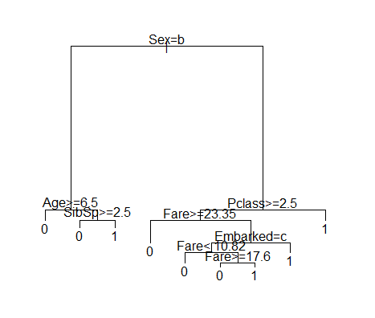  
- Fancy Plot

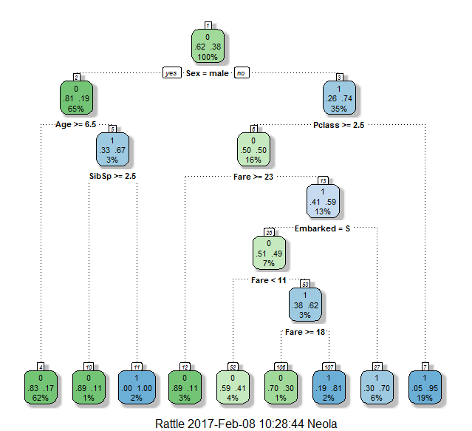

1. Energy Efficiency

Y1

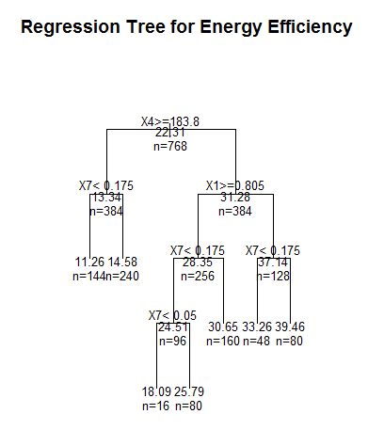

Y2

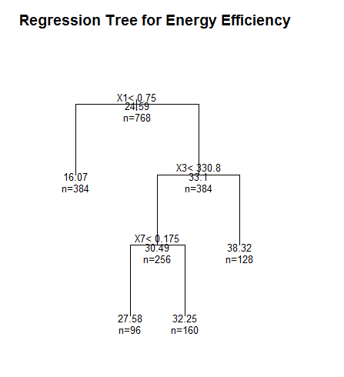

**Model Evaluation**

Model is evaluated using Cross Validation function ‘printcp’.

1. Titanic Dataset:

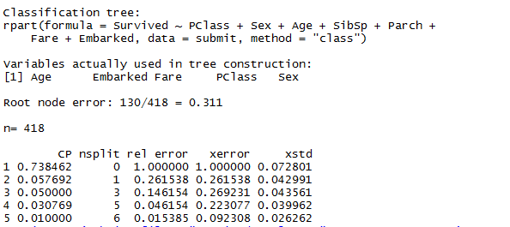

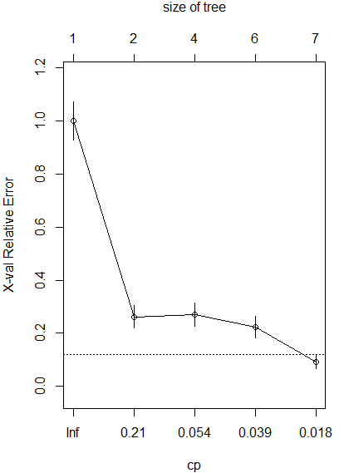

1. Energy Efficiency

Y1

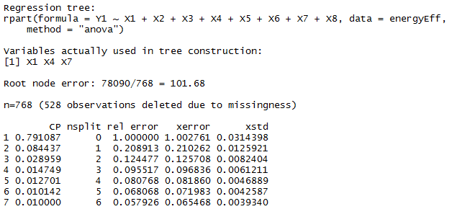

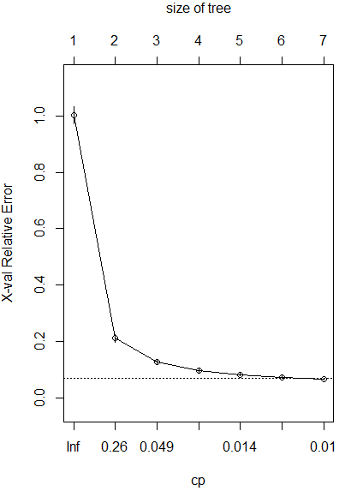

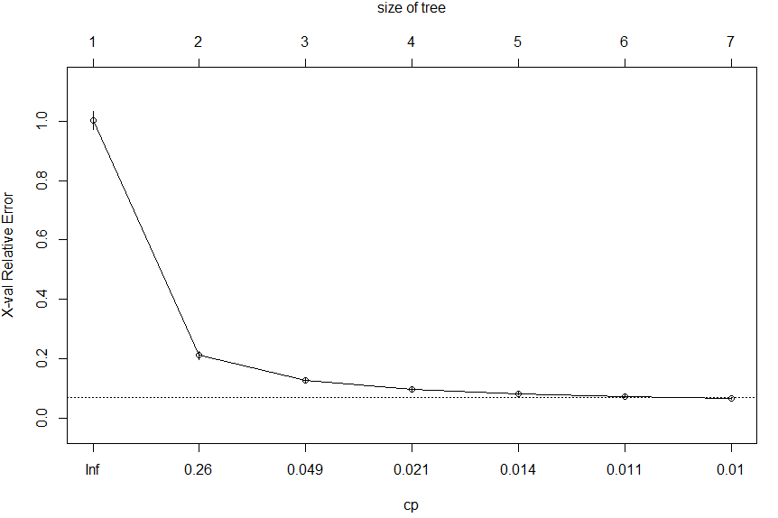

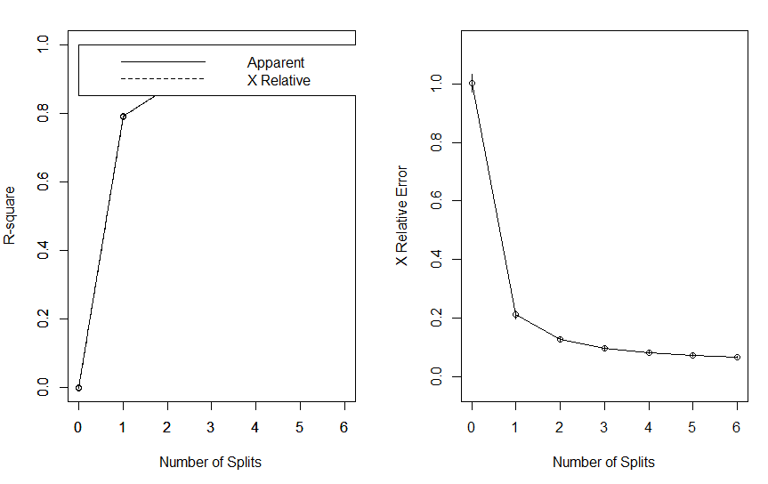

Y2

