**Report**

**In R**

###########################################################

######### Please fill the ??? with proper description (atleast 130 charaters for each)

######### for SVM function try different values to achieve better results

# loading neccessary packages and dataset

#install.packages("caret")

#install.packages("e1071")

library(caret)

library(e1071)

data(GermanCredit)

dataset = GermanCredit

#Display the dataset GermanCredit with the help of str() function. This function displays the

#structure of the dataset with 1000 observations of 62 variables in a compact manner.

#The first seven variables/fields of the dataset are scaled and the first 7 fields of the dataframe

#are rewritten with the scaled values. Once again the str() function is applied to display the scaled

#values alongwith the values of other fields.

str(dataset)

dataset[,1:7] = as.data.frame(lapply(dataset[,1:7], scale))

str(dataset)

#The sample function will pick up 200 random number/observations between 1 and 1000 inclusive

#and store it in sample_index. The 200 numbers picked up is selected as the test dataset

#and the remaining 800 observations form the training dataset.

sample_index = sample(1000, 200)

test_dateset = dataset[sample_index,]

train_dateset = dataset[-sample_index,]

#substituting cost as 8 and gamma as 1 to determine SVM for linear kernel.

#The number of support vectors generated is 406.Higher the value of gamma closer the range

model = svm(Class ~ ., kernel = "linear", cost = 150, gamma = 1, data = train_dateset, scale = F)

summary(model)

#substituting cost as 4 and gamma as 1 to determine SVM for radial kernel.

#The number of support vectors generated is 800.

model = svm(Class ~ ., kernel = "radial", cost = 0.5, gamma = 0.25, data = train_dateset, scale = F)

summary(model)

#The predict function is used to get the predictions for the test_dataset

#display the summary of the prediction

predictions <- predict(model, test_dateset[-10])

summary(predictions)

#display the predictions in the form of a table/matrix called confusion matrix

table(test_dateset[,10], predictions)

For kernel - linear

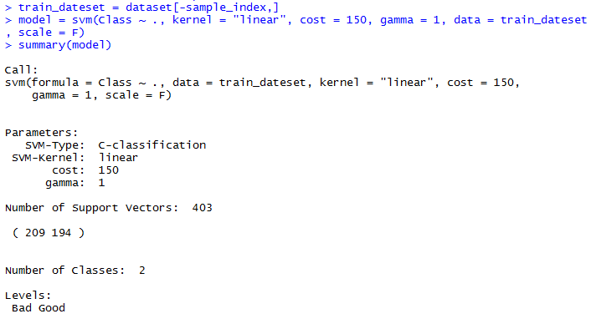

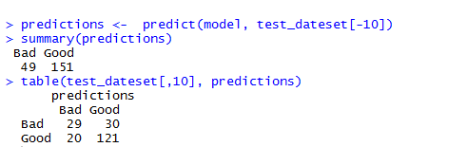

Kernel - Radial

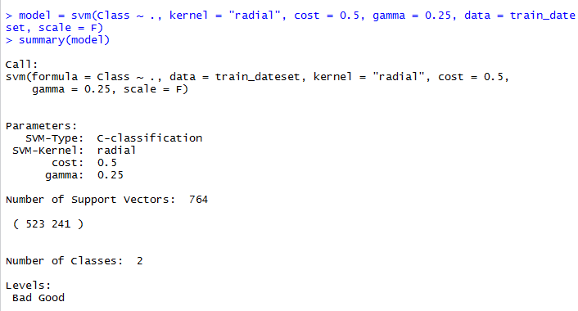

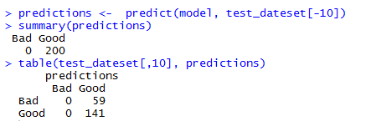

**In Orange**

**Data Flow Diagram:**

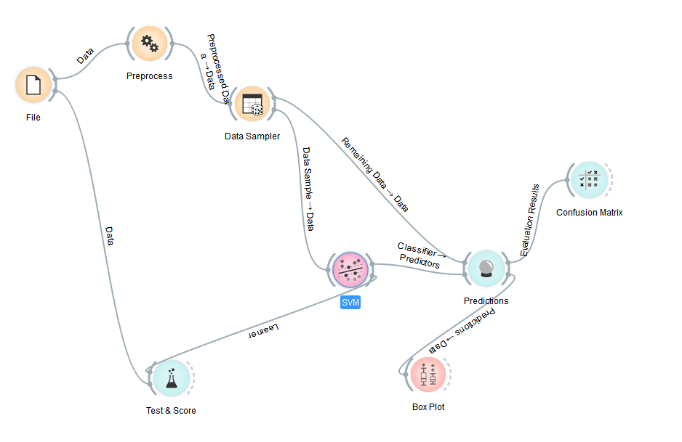

**SVM parameters:**

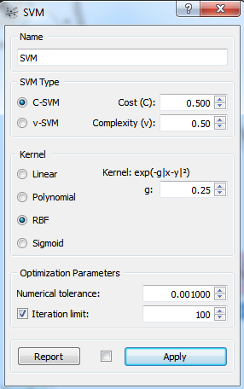

**Test & Score**

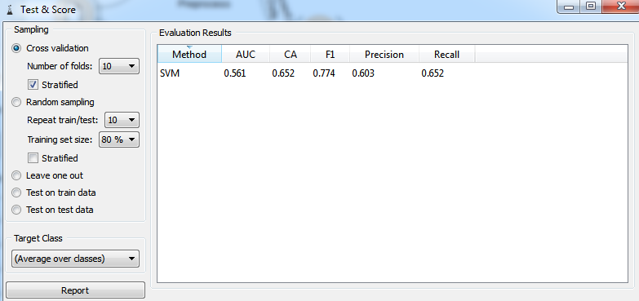

**Confusion matrix:**

