**Report**

**Part 1:**

Dataset: Loan

Model: Neural Network

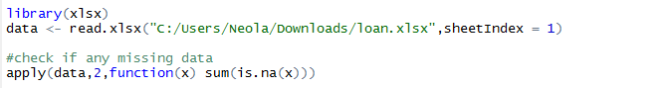

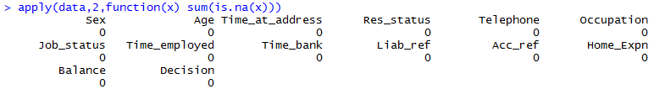

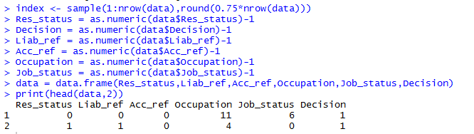

**Applying Neural Network to build the model:**

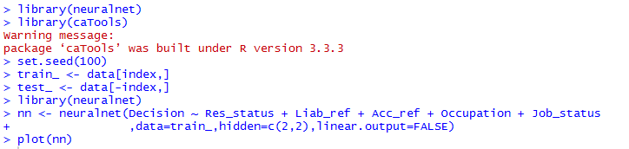

**Output of the model:**

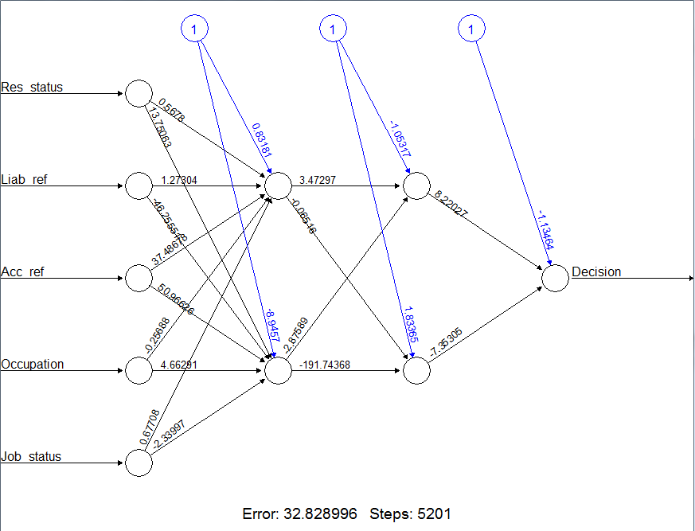

**Predicted output for the test data :**

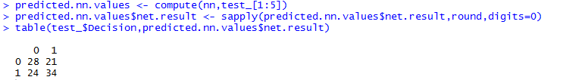

**Part 2:**

**Dataset:** Prudential Data

Preprocessing the data:

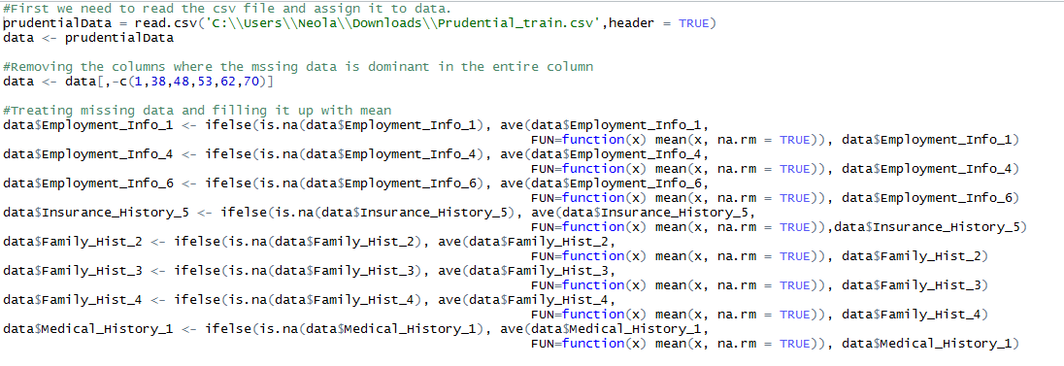

1-C Conversion function

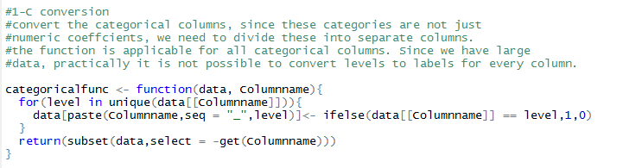

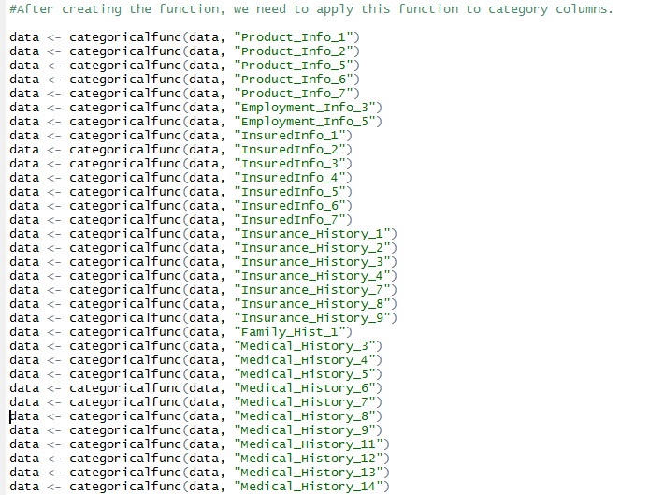

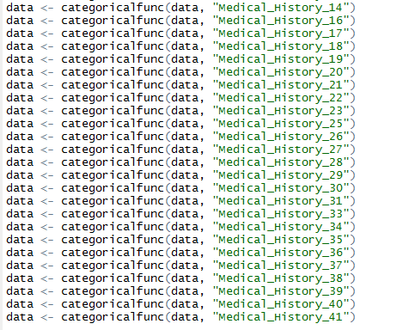

Summary of the dataset

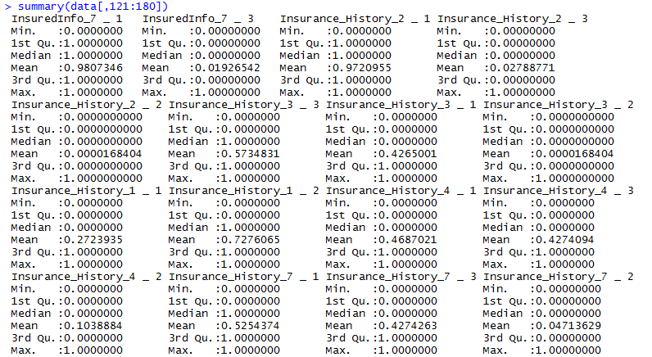

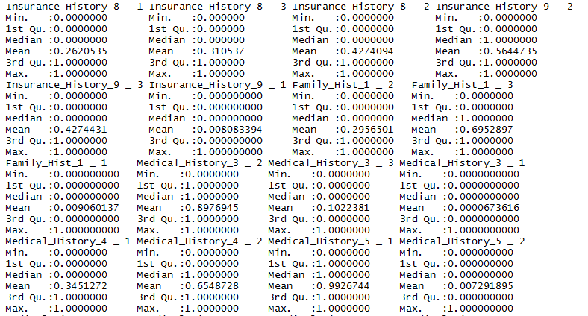

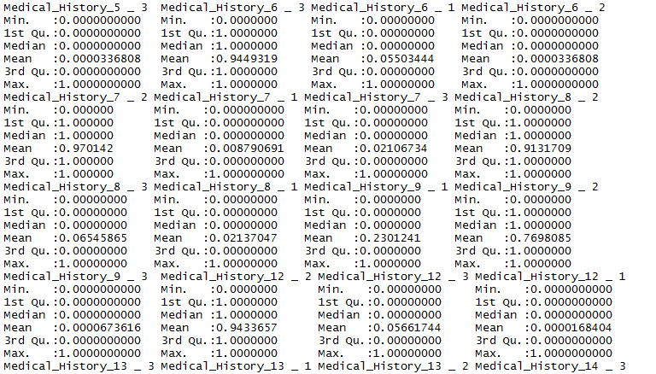

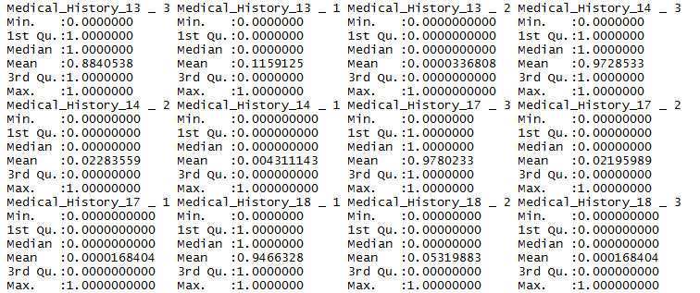

Saving the preprocessed data and then reading it:

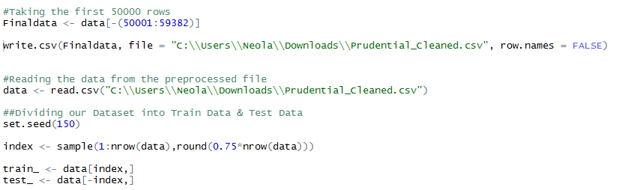

1 to C conversion of Response for Training Data:

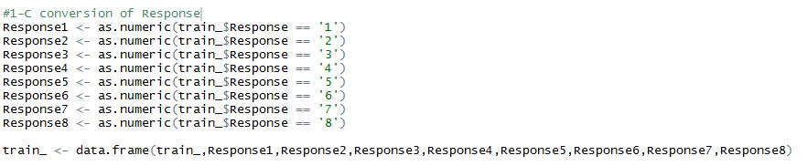

Training the model with trained dataset:

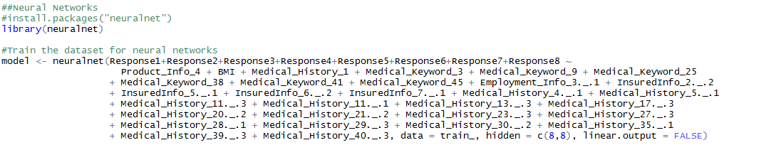

Plot the model:



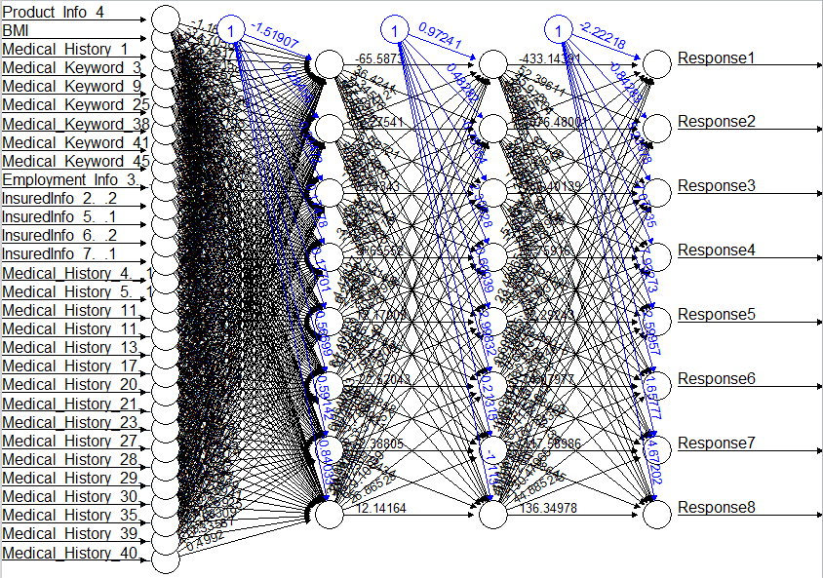

Test the model with test data and predict the output:

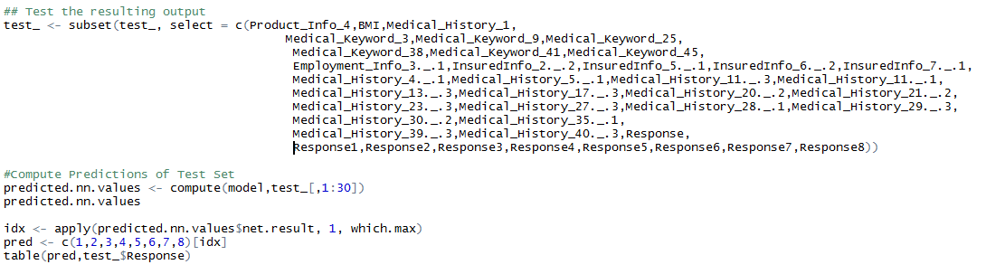

Predicted output Response:

