Module Name: Introduction to Computer Games and Graphical Systems

Module Number: CE00369-1

Title of Assignment: Animated Applet

Module Leader: Trevor

Tutor: Bob Hobbs

Students Name: Alex J Davison

Student ID: DV003874

Contents
Contents 2
Introduction 3
Animation 3
Key frame one 3
Key frame two 4
Key frame three 5
Key frame four 5
Key frame five 6
Key frame six 6
Key frame seven 7
Game 8
Predefine start positions 8
Random positions of munchies 8
White box defined 9
Display name 10
Display players score 10
Display remaining time 10
Shows information in status bar 11
Blue and orange monster move in four directions with mouth direction 11
Orange monster tries to get to blue monster 12
Blue and orange hit walls 12
Blue and orange hit each other 13
Blue monster collision with munchies 13
Blue 13
Orange 14
Number of munchies equals zero 15

Introduction

In this report I will describe a movie animation that I have created along with a game that I have also created. In this report I will use screenshots, to illustrate how the game works, and show what happens in the game and movie. In this report I will include brief detail about the game concepts and graphical concepts that I used to make them both.

Animation

In the animation that I have created, I have based it upon the game that I have also created. Below are the key frames, which are points/frames that define where certain objects should be and look like. I used the key frames to create the animation for the movie, below are the key frames that I used along with a brief description of how I have achieved the frame.

Key frame one

Below is key frame one, this shows the start positions of the two characters in the animation.

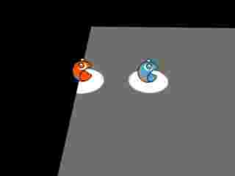

To start with I created one sphere and cut the mouth shape out using a cylinder. I then added another smaller sphere as an eye, and copied the sphere to create a pair of eyes. I then positioned the smaller spheres at the top of the larger sphere and equally spaced them apart from the centre of the larger sphere to look as if they were eyes. I grouped all the spheres together so that I could make another character identical to the first, also all the objects would move simultaneously when I got the character to move.

I copied the first character so that I had two identical characters, this is similar to in the game. I placed the two characters on a grey flat plane. The plane represents the playing surface in the game. I placed one of the characters in the centre of the z axis of the plane and one quarter of the plane on x axis on to the plane.

I placed the second character on the edge of the plane directly behind the first, so that it gives the impression of one chasing the other. I textured the two characters so that they looked different, however, only by the colour. I textured the two characters so that they have a cartoon like look. I used the same colours as the characters used in the game.

I used spot lights effect to highlight the two characters. I also used a camera to follow the two characters as they move. Same camera (view point) is used through out the movie
.

Key frame two

Below is the second key frame that I defined, this frame is fifteenth frame into the movie.

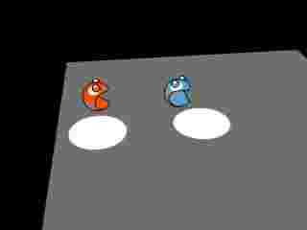

I made the two characters move in both y axis and the x axis, I moved both characters up and forward, the same amount. The blue character, however, rotates towards the camera at the same time as moving up and to the left in comparison to the camera. At the same time both spot lights follow the characters to ensure that they are well light. These movements are to show that the two characters are jumping, the red one chasing the blue one. I used two spot lights to make the characters seem theatrical, comical like Tom and Jerry cartoon characters.

Key frame three

Below is the third key frame that I defined, this frame is thirtieth frame into the movie.

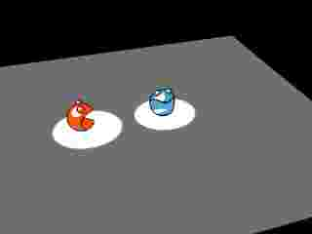

The frame shows that the blue character has landed back down on the plane at the same time as the red character, however the blue character has rotated ninety degrees towards the camera. The red character is now in the old position of the blue character.

Key frame four

Below is the fourth key frame that I defined, this frame is the forty fifth frame into the movie.

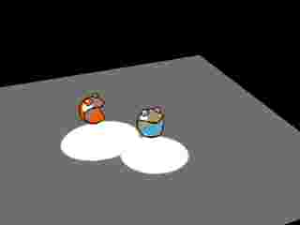

As you can probably tell by now, the red character chases the blue character. However, the red character mimics all the movements of that of the blue character. You can see the red one copying the blue one if you compare the second key frame with the fourth.
In the fourth frame the blue character moves towards the camera by using a forward jump style movement of curved linear line.

Key frame five

Below is the fifth key frame that I defined, this frame is the sixteenth frame into the movie.

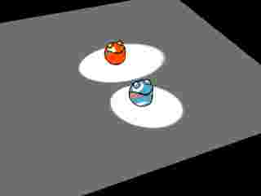

As you can see both characters return to the plane with both spot lights still fixed on the characters. The characters returning to the panel shows that the characters have ended the jump forward and the beginning of a new jump forward.

Key frame six

Below is the sixth key frame that I defined, this frame is the seventy fifth frame into the movie.

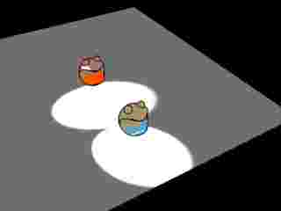

The frame shows the two characters in mid flight of their jump towards the camera. As you can see throughout all the frames, the shadows have moved around the characters increasing the look of the cartoon feel.

Key frame seven

Below is the seventh key frame that I defined, this frame is the ninetieth frame into the movie.

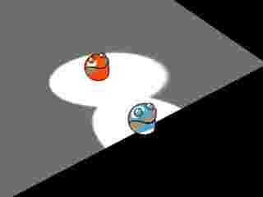

In this last frame we see that the blue character has reached the edge of the plane and that the red character isn’t that far behind. This defines the positions of the movie so that all the film doesn’t show the user what fully happens, as it is up to the user to define the ending of the game.
Game

The game that I created is mainly based upon pac-man. This is mainly because of the attributes. Below is a list of all the game attributes:

Predefine start positions

When the game starts or rests the two main characters which move have predefined start positions. This was done by setting the x and y position to one and minus one of the border. I used those values so that the monsters do not hit the border of the playing area. When the method which is used to rest the game is called, the x and y position of the vector animations are set to one and minus one of the border.

Below is a screen shot of the start positions of the characters circled in red.

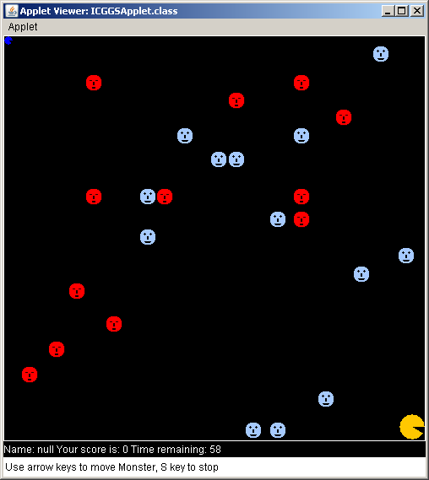

Random positions of munchies

The munchies are given random x and y number so that they appear in random places. The random numbers that are created are checked to ensure that the position of x and y don’t overlap any of the another munchies positions. The munchies then don’t become overlapped meaning that they are more spread out over the playing area and harder for the player to hit.

Below is a screen shot, within the red circle is the munchies randomly placed within the play area of the white box.

White box defined

A white box is defined which is the same size of the applet, apart from a small area at the bottom. The small area is used to display information to the user, such as player’s score, name and remaining time. The white box is used else where in the game to ensure that the gamer stays on in the game area and gives the game rules and restrictions. The white border is slightly smaller than the applet window so that it gives the impression of a second status bar.

Below is a screen shot, within the red circle is the edge of the white box.

Display name

The user’s name is displayed at the bottom of the game to make the player feel even more part of the game. This was achieved using a global variable and drawing the name at the end of the game loop.

Below is a screen shot, within the red circle is where the player’s name appears (Note: No name was entered for the game, this is why null appears).

Display players score

Displaying the score shows the user how well he/she is doing; this is updated every time the game loop is cycled through. This is done at the end of the loop so that if the player has achieved more points the score updates, seemly instantaneously rather than having lag. The player’s score is affected by the player colliding with one of the munchies with in the game area. This will explained later on in this report.

Below is a screen shot, within the red circle is where the player’s score appears (Note: score is zero because game has just started).

Display remaining time

The time of the game is displayed for the user, to add pressure and limitation of how long the player can play the game before the player’s score is reset to zero and the player has to start over all over again. The time is updated at the end of each game loop. The computer clock is used, the difference between the time the game started and the time the game should end defines when the game should stop. However the end time is edited throughout the game, this will be explained in the blue monster collision with munchies section.

The computer clock used in java is in millionths of a second, to change this I timed the number given by one thousand to give me the time in seconds then I added sixty seconds to the start time to give me the default end time. To give me the timer I minimised the current time from the end time to give me the count down displayed.

Below is a screen shot, within the red circle is where remaining time is displayed.

Shows information in status bar

In the status bar the player is informed of how to stop the game and what controls they should use. When the game is entering the status bar gives the player information so that they can play and interact with the game/applet. When the applet enters different modes the status information changes as well.

Below is a screen shot, within the red circle is the status information.

Blue and orange monster move in four directions with mouth direction

The two characters that move can move in all four directions. This is achieved by reading the input of the four arrow keys found on a keyboard. The inputted keystroke is read and a status is populated into a variable, so that the player only has to input the direction once. With each game loop the direction is dictated by the variable.

The variable then is used in a case statement for example, case left input, the red character x position minus one. However this is not the case for the orange character if the orange position is done with an if statement, for example if orange character x position is greater than blue character positions then minus one from orange x position. This will be explained further in Orange monster tries to get to blue monster section.

Not only does the movement of the character change but also the direction of the mouth of the character also changes to that of the direction of the character. To achieve the movement of the mouth I change the angle of draw for the circle much like the movement, using a case statement.

Below is a screen shot showing the orange character following the blue character.

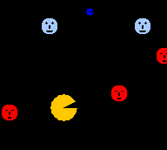

Orange monster tries to get to blue monster

When the blue character moves so does the orange character, however, the orange monster has predetermined rule of movement. The orange character may only move on the same axis as that of the blue character, for example if the blue one moves left, then the orange character may only move left or right. To determine whether the orange monster moves left or right is dependent on that or blue positions and movement, for example blue character is moving left and the orange character is on the left of the blue character, then the orange character will move to the right to intercept the blue character.

Below is a screen shot showing the orange character facing the blue monster, trying to intercept.

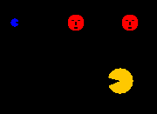

Blue and orange hit walls

The blue and orange characters are restricted to the white box play area, this is done using collision detection. When the two characters move, they move a pixel at a time making it easier to check whether the characters have moved onto or over the white box. When the game loop runs the character moves forward. However, if the position of character x is greater than that of the white board then the character is moved back so that the character ends up not passing the border.

The calculation for the left and top borders only takes into account the x and y position of characters. However for the right and bottom borders, the x and t position plus the size of the character is used to ensure that the character does not go over the lines.

When the if statement has redrawn the character back behind the line a sound file also plays, to inform the users that they cannot go passed the white box area. The sound that is played is “doheth”.

Below is a screen shot showing the orange and blue character hitting the bottom of the white box.

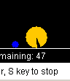

Blue and orange hit each other

When the two characters hit or collide with one another then the rest method is called so that everything is rest to its default setting. This includes timer, score positions of characters, size of characters etc. To achieve the rest method so that it rests everything, rather than just the position of the characters and munchies, I used a Boolean value in the rest method so that when the characters hit it it is set to true, that way the score and size is rest along with everything else.

If the Boolean value is not true meaning that the characters have not hit one another then, only positions of the characters and the munchies is rest. However, the munchies are randomly placed every time the rest method is called. I didn’t think that it was necessary to retain positions for the munchies as it makes the game more fun if the munchies are randomly placed.

Blue monster collision with munchies

There are two possible effects when a munchie is hit, below are descriptions of the out comes possible.

Blue

If the blue character hits a blue munchie, then the following happens:

- The player’s time increases
- The player’s character size increases
- The player’s score increases
- The orange character decreases
- A sound is played
The player’s time increases

When the player hits a munchie when it is blue the player is given more time to play to gain a higher score; this is achieved by adding five to the game end time. When the game loop runs through the new end time increases the timer aspect of the game.

The player’s character size increases

The variable that stores the size of the character increases by one each time the player hits a munchie when it is blue, however, there is a maximum size. The maximum size is set to thirty so when the player reaches that size the characters size stays at thirty. Every time the game loop through the character is redrawn so, it is easy to increase the size with the new position of the character.

The players score increases

The player’s score is kept in a variable which is to set to zero at the beginning. During the game the player’s score increases by fifty every time they hit a munchie when it is blue. The score is updated every game loop.

The orange character decreases

The variable that stores the size of the orange character decreases by one each time the player hits a munchie when it is blue, however, there is a minimum size. The minimum size is set to ten so when the player reaches the maximum size the orange characters is set to the minimum of ten.

A sound is played

When the player hits a blue munchie a sound effect plays, one that says “yes”. This is to positively reinforce how the player is doing within the game.

Orange

If the blue character hits a red munchie, then the following happens:

- The player’s time decreases
- The player’s size decreases
- The player’s score decreases
- The orange character increases
- A sound is played

The player’s time decreases

When the player hits a munchie when it is red the player is given less time to play, this makes it harder for the player to gain a high score. I achieved this by subtracting a second from the game end time. When the game loop runs through the new end time decreases the timer aspect of the game.

The player’s character size decreases

The variable that stores the size of the character decreases by one each time the player hits a munchie when it is red, however, there is a minimum size. The minimum size is set to ten so when the player reaches that size the characters size stays at ten. Every time the game loop is through the character is redrawn so, it is easy to decrease the size with the new position of the character.

The players score increases

The player’s score is kept in a variable which is to set to zero at the beginning. During the game the player’s score decreases by ten every time they hit a munchie when it is red. The score is updated every game loop.

The orange character increases

The variable that stores the size of the orange character increases by one each time the player hits a munchie when it is red, however, there is a maximum size. The maximum size is set to thirty so when the orange character reaches the minimum size the orange characters is set to the maximum of thirty.

A sound is played

When the player hits a red munchie a sound effect plays, one that says “doh”. This is to negatively inform the player how the player is doing within the game.

Number of munchies equals zero

When the player has hit a munchie, then the munchie is drawn on the outside of the white box in the bottom right hand corner. They stack on top of one another, when all of the munchies have been stacked at that position then the rest method is called. However, Boolean value for resting the score and time is kept at false so that the player can continue playing. This rest can make the game last a long time and allow for the player to home their skills in playing the game.

