Introduction to Software Development Portfolio
By Alex J Davison

Student Number: DV003874

Content
Content 2
Tutorial 1 Introduction 3
Part 1 – Hello World 3
Part 2 – Understanding Java error messages 4
Part 3 – Personal details 12
Part 4 – Review Questions 13
Tutorial 2 Variables 14
Part 1 – An application using variables 14
Part 2 – Finding the area of and perimeter of a rectangle 15
Part 3 – Experimenting with Division 16
Part 4 – Review Questions 18
Tutorial 3 19
Part 1 – Problem Solving – the gas bill 01 19
Part 2 – Input – the gas bill 02 20
Part 3 – Problem Solving – the water bill 24
Tutorial 4 27
Part 1 – Find the area and circumference of a circle 27
Part 2 – Secs, to mins, hours 30
Part 3 – Convert temp 33
Part 4 – Phrase editing 35
Tutorial 5 39
Part 1 – Design, implement and test programs to each of the following 39
Part 2 – Data validation 43
Part 3 – Problem solving 62
Tutorial 6 66
Part 1 – Design, implement and test programs to do each of the following: 66
Part 2 – Problem Solving – Student grades 73
Part 3 – Problem Solving – Leap Year 78
Part 4 – Problem Solving – 24hr Time 82

Tutorial 1 Introduction

Part 1 – Hello World

Created a program that displayed “Hello World” with other text below it.

Code

// A simple Hello World Application
public class Hello
{
public static void main (String[] args)
{
System.out.println ("Hello World");
System.out.println ("Welcome");
System.out.println ("Created By Alex J Davison");
System.out.println ("23/09/08");
}
}

Testing

Expected results:

Hello World
Welcome
Created By Alex J Davison
23/09/08

Code in action

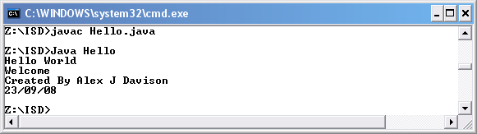

Part 2 – Understanding Java error messages

I changed the keyword class to Class

Code

// A simple Hello World Application
public Class Hello
{
public static void main (String[] args)
{
System.out.println ("Hello World");
System.out.println ("Welcome");
System.out.println ("Created By Alex J Davison");
System.out.println ("23/09/08");
}
}

Testing

Expected results: Error showing the fault

Code in action

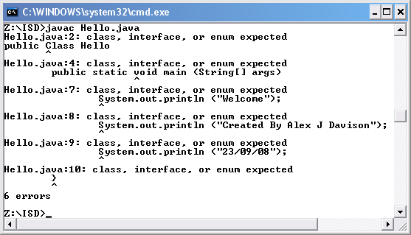

I changed the class name Hello to hello

Code

// A simple Hello World Application
public class hello
{
public static void main (String[] args)
{
System.out.println ("Hello World");
System.out.println ("Welcome");
System.out.println ("Created By Alex J Davison");
System.out.println ("23/09/08");
}
}

Testing

Expected results: Error showing the fault

Code in action

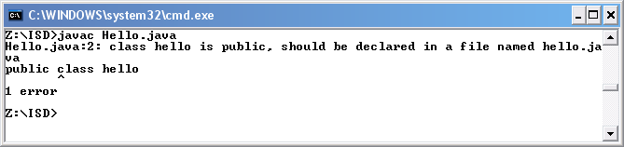
I removed the first {

Code

// A simple Hello World Application
public class Hello

public static void main (String[] args)
{
System.out.println ("Hello World");
System.out.println ("Welcome");
System.out.println ("Created By Alex J Davison");
System.out.println ("23/09/08");
}
}

Testing

Expected results: Error showing the fault

Code in action

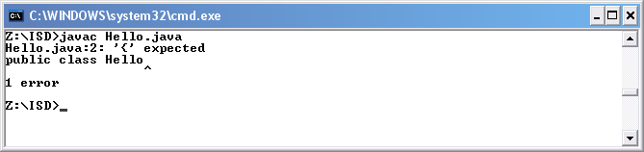

I removed the last }

Code

// A simple Hello World Application
public class Hello
{
public static void main (String[] args)
{
System.out.println ("Hello World");
System.out.println ("Welcome");
System.out.println ("Created By Alex J Davison");
System.out.println ("23/09/08");
}

Testing

Expected results: Error showing the fault

Code in action

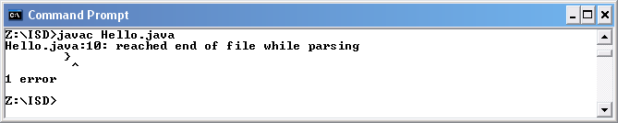
I changed String to string

Code

// A simple Hello World Application
public class Hello
{
public static void main (string[] args)
{
System.out.println ("Hello World");
System.out.println ("Welcome");
System.out.println ("Created By Alex J Davison");
System.out.println ("23/09/08");
}
}

Testing

Expected results: Error showing the fault

Code in action

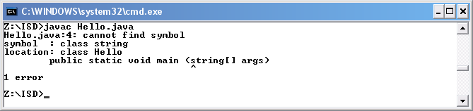
I changed the method cal System.out.println to system.out.println

Code

// A simple Hello World Application
public class Hello
{
public static void main (string[] args)
{
system.out.println ("Hello World");
System.out.println ("Welcome");
System.out.println ("Created By Alex J Davison");
System.out.println ("23/09/08");
}
}

Testing

Expected results: Error showing the fault

Code in action

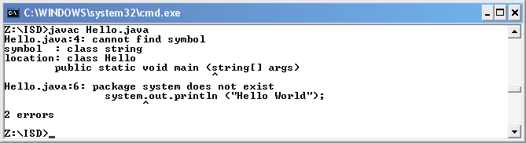
I removed the opening quotes in the println call

Code

// A simple Hello World Application
public class Hello
{
public static void main (string[] args)
{
System.out.println (Hello World);
System.out.println ("Welcome");
System.out.println ("Created By Alex J Davison");
System.out.println ("23/09/08");
}
}

Testing

Expected results: Error showing the fault

Code in action

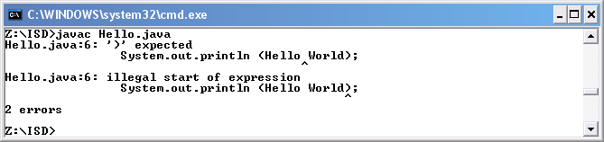
I removed the semicolon at the end of the first println call

Code

// A simple Hello World Application
public class Hello
{
public static void main (string[] args)
{
System.out.println (“Hello World”)
System.out.println ("Welcome");
System.out.println ("Created By Alex J Davison");
System.out.println ("23/09/08");
}
}

Testing

Expected results: Error showing the fault

Code in action

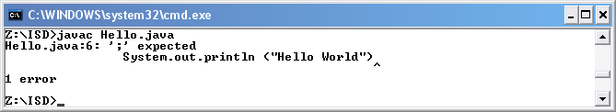

Part 3 – Personal details

I created a program that displayed my details

Code

// A simple Personal Details Application
public class PersonalDetails
{
public static void main (String[] args)
{
System.out.print ("First name ");
System.out.println ("Alex");
System.out.print ("Surename ");
System.out.println ("Davison");
System.out.print ("Date of birth ");
System.out.println ("29/01/1987");
System.out.print ("Home town ");
System.out.println ("Oxford");
}
}

Testing

Expected results:

First name Alex
Surname Davison
Date of birth 29/01/1987
Home town Oxford

Code in action

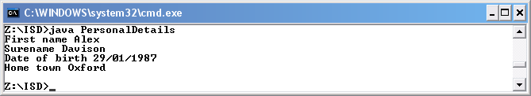

Part 4 – Review Questions

Q: What is the relationship between the name of a class and the name of the file that contains the class?

A: The class name and the file name must be the same for the application to work.

Q: How is the java complier invoked?

A: Complier is invoked using javac (Name of file)Hello.java

Q: What is the output from the java compiler if the compilation is successful?

A: A blank line with a command line waiting for the next instruction

Q: How is the java interpreter invoked?

A: java (Name of file)Hello

Q: What is the difference between the following statements:
System.out.print(“hello”); A: (Doesn’t make a new line after displaying “hello”)
System.out.println(“hello”); A: (Inserts a new line after displaying “hello”)

Tutorial 2 Variables

Part 1 – An application using variables

I created an application to add two integer variables together.

Code

// Simple Java Application to add two intergers

public class AddInts
{
public static void main(String[]args)
{
int num1;
num1 = 10;
int num2;
num2 = 20;
int sum;
sum = num1 + num2;
System.out.println ("The sum is: "+sum);
}
}

Testing

Expected results:

The sum is: 30

Code in action

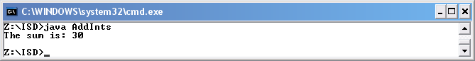

Part 2 – Finding the area of and perimeter of a rectangle

I created an application to find the area and perimeter of a rectangle.

Code

// Simple Java Application to find the area and perimeter of a rectangle

public class RectangleArea
{
public static void main(String[]args)
{
int num1;
num1 = 10;
int num2;
num2 = 20;
int sum1;
sum1 = (num1 + num2) * 2;
System.out.println ("The perimeter of the rectangle is: "+sum1);
int sum2;
sum2 = (num1 * num2);
System.out.println ("The area of the rectangle is: "+sum2);
}
}

Testing

Expected results:

The perimeter of the rectangle is 60
The area of the rectangle is 200

Code in action

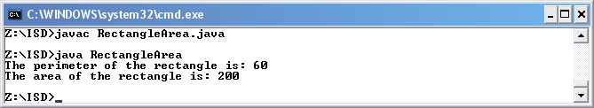

Part 3 – Experimenting with Division

I created an application to experiment with division

Code

// Simple Java Application to Exeriment with divison

public class Divison01
{
public static void main(String[]args)
{
int num1;
num1 = 10;
int num2;
num2 = 20;
int res;
res = num1 / num2;
System.out.print("The result of dividing " + num1 + " by num2 " + num2);
System.out.println (" is " + res);
res = num2 / num1;
System.out.print("The result of dividing " + num2 + " by num1 " + num1);
System.out.println (" is " + res);

// additional code to be addes here in the next part of this exercise

}
}

Code in action

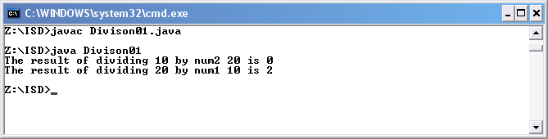
Code

// Simple Java Application to Exeriment with divison

public class Divison
{
public static void main(String[]args)
{
int num1;
num1 = 10;
int num2;
num2 = 20;
int res;
res = num1 / num2;
System.out.print("The result of dividing " + num1 + " by num2 " + num2);
System.out.println (" is " + res);
res = num2 / num1;
System.out.print("The result of dividing " + num2 + " by num1 " + num1);
System.out.println (" is " + res);

// additional code to be addes here in the next part of this exercise

// will work but won't gave an accurate answer, the answer will be 0 and be rounded down.

res = 7/ 10;
System.out.println ("The result of 7/10 is " + res);

// won't work because there is no decimal place in ints

// res = 7.0/ 10.0;
// System.out.println ("The result of 7.0/10.0 is " + res);

// won't work because there is no decimal place in ints

// res = 7.0/ 10;
// System.out.println ("The result of 7.0/10 is " + res);

double dRes = 7 / 10;
System.out.println ("(Double) The result of 7/10 is " + dRes);
double dnum1 = 7, dnum2 = 10;
dRes = dnum1 / dnum2;
System.out.println ("(Double) The result of dnum1/dnum2 is " + dRes);
dRes = dnum1 / dnum2;
System.out.println ("(Double) The result of dnum1/dnum2 is " + dRes);

}
}

Code in action

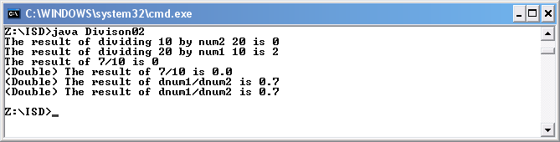

Part 4 – Review Questions

Q: How do you declare a variable of type integer?

A: int variableName

Q: If you divide an integer by an integer what type of result do you get?

A: An integer

Q: What type of data does a double hold?

A: Numbers with decimal places

Q: What type of division is carried out when a variable of type double is divided by a variable of type integer?

A:

Q: What type of division is carried out when a variable of type integer is divided by a variable of type double?

A:

Q: What does the symbol + mean in the following Java statement?
System.out.println("The value is " + num1);

A: Print “The value is” along with the value in the variable.
Tutorial 3

Part 1 – Problem Solving – the gas bill 01

I created an application to produce a gas bill.

Code

// this applcation is a gas bill

// the package containing Scanner

import java.util.*;

public class GasBill01
{
public static void main(String[] args)
{
// Input the data
int accountNumber;
System.out.println("Enter the account number: ");
accountNumber = 123; // simulate data entry
// Input the number of gas units used - integer assumed
int unitsUsed ;
System.out.println("Enter the number of units used: ");
unitsUsed = 100; // simulate data entry

// set the cost per unit to be 5 pence per unit
double costPerUnit = 0.05; // assuming bill should be £

// Process the data - calculate the bill
double totalCost;
totalCost = unitsUsed * costPerUnit;

// Output the gas bill
System.out.println("Customer account number: " +
accountNumber);
System.out.println("Units of gas used: " + unitsUsed);
System.out.println("Total cost: £" + totalCost + "\n" );
}
}

Code in action

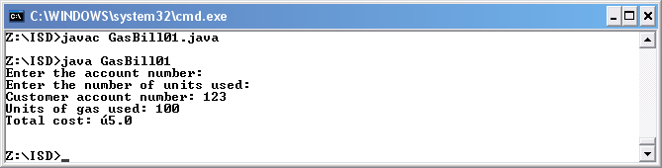

Part 2 – Input – the gas bill 02

Application Brief

I created an application that displays characteristics of a gas bill, I also test the application to ensure that it worked as a gas bill application would.

Application Requirements

The requirements of the application are as follows, to produce am extremely simple gas bill which has the relevant outputs. These outputs should be details such as the customer account number, the units of gas used and the total cost.

Input

Customer account number
Number of units used
Cost per unit
VAT

Process

Total cost is calculated by multiplying the number of units used by a cost per unit.

Output

The customer account number
The units of gas used
The total cost.

Initial Design

Data that will need to be inputted for this application will be , the customer’s account number, the number of units of gas used.

The data that is inputted will then be processed by calculating the bill. This involves, the total cost = number of units used * cost per unit

The output for the gas bill will show the customer’s account number, the number of units used and the total cost

Testing the Design

A look through the plan brought about area of interest and concern:
- An example of an account number would be good as I assumed that the account number was only made up of digits thus making the data type int.
- What currency is used to bill the user was another area for concern as the brief didn’t indicate what country, which also has an effect on the unit of measurement. I assume England and used the data type int.
- The typical cost per unit was I store within the code of the application however what if the unit were to change in the future?
- What would I get if I multiply number of units used by the cost per unit?
- A cost in pounds for the units used however java in dos can’t display the pound sign.
Pseudo Code Design

read (accountNumber)
read (unitsUsed)
costPerUnit = 0.05

totalCost = unitsUsed * costPerUnit

write (“Customer account number “, accountNumber )
write (“Units of gas used “, unitsUsed )
write (“Total cost is “, totalCost )

Structure Diagram Design
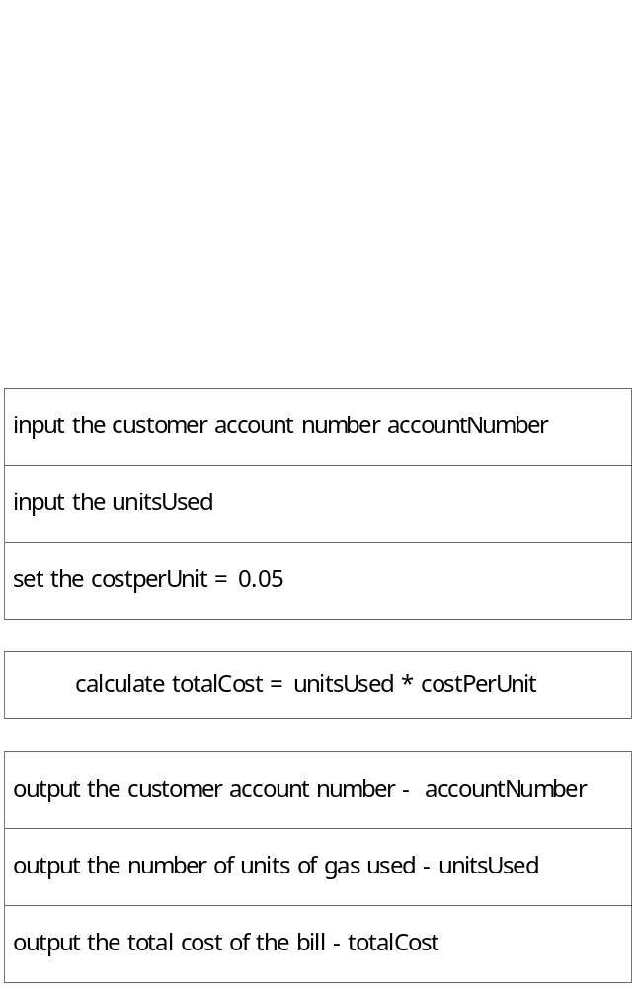

Code

// this applcation is a gas bill

// the package containing Scanner

import java.util.*;

public class GasBill02
{
public static void main(String[] args)
{

// build an instance of Scanner, that is an object
Scanner kybd = new Scanner(System.in);
// Input the data
int accountNumber;
System.out.println("Enter the account number: ");
accountNumber = kybd.nextInt();
// Input the number of gas units used - integer assumed
int unitsUsed ;
System.out.println("Enter the number of units used: ");
unitsUsed = kybd.nextInt();

// set the cost per unit to be 5 pence per unit
double costPerUnit = 0.05; // assuming bill should be £

// Process the data - calculate the bill
double totalCost;
totalCost = unitsUsed * costPerUnit;

// Output the gas bill
System.out.println("Customer account number: " +
accountNumber);
System.out.println("Units of gas used: " + unitsUsed);
System.out.println("Total cost: £" + totalCost + "\n" );
}
}
Testing

I compiled the applcaiton using javac and then run using the java interpreter.

Enter customer number: 0123
Enter number of units used: 5

Expected results:

Customer account number: 123
Units of gas used: 5
Total cost: £0.25

Actual output

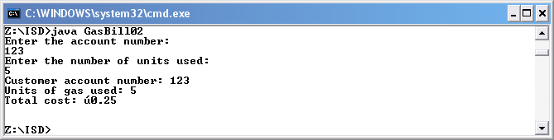

The actual results were as expected.

Part 3 – Problem Solving – the water bill

Input

read (refNum)
read (perRead)
read (curRead)
price = 0.25

Process

totalCost = ((perRead + curRead) * price) + 10
vatCost = totalCost * 1.05

Output

write("The customer refernce number is: " + refNum);
write("The total cost of the bill not inc vat is: " + totalCost + " GBP");
write("The total cost of the bill including vat is: " + vatCost + " GBP");

Code

// Octagon Water Ltd Billing

// the package containing Scanner

import java.util.*;

public class WaterBill01
{
public static void main(String[] args)
{
// build an instance of Scanner, that is an object

Scanner kybd = new Scanner(System.in);

// customer refernce number

int refNum;
System.out.println("Please enter the customer refernce number: ");
refNum = kybd.nextInt();

// input current meter reading and perious meter reading

//pervious meter reading
int perRead;
System.out.println("Please enter the pervious reading: ");
perRead = kybd.nextInt();

//current meter reading
int curRead;
System.out.println("Please enter the current reading: ");
curRead = kybd.nextInt();

//setting the unit price at £0.25
double price = 0.25;

//cal the cost
double totalCost;
double vatCost;
totalCost = ((perRead + curRead) * price) + 10;
vatCost = totalCost * 1.05;

// Bill output
//Customer Refernce number
System.out.println("The customer refernce number is: " + refNum);
//Total Cost
System.out.println("The total cost of the bill not inc vat is: " + totalCost + " GBP");
//Total Cost inc Vat
System.out.println("The total cost of the bill including vat is: " + vatCost + " GBP");

}
}
Testing

Enter customer number: 0123
Enter number of units used previously : 5
Enter number of units used currently : 10

Expected Output

Customer account number: 123
Total not inc vat: 13.75
Total inc vat: 14.4375

Actual output

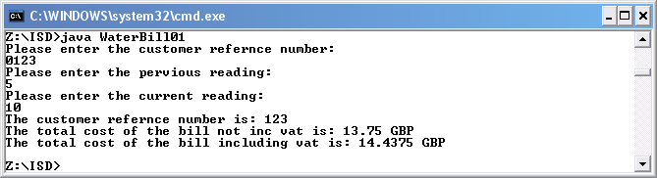

Tutorial 4

Part 1 – Find the area and circumference of a circle

Develop a Java program that calculates the circumference and area of a circle, given a radius input by the user. The relevant formulae are:

circumference = 2πr area = πr²

The application should allow the user to enter the radius of the circle and for the circumference and area to be calculated. The answer from the calculations should be displayed in a readable format for the users.

Input

read (radius)
pi = 3.1416

Process

area = pi * radius * radius;
circum = 2 * pi * radius;

Output

Write ("The circumference of the circle is: " + circum);
Write ("The area of the circle is: " + area);

Code

//Application to the find the circumference and area of a circle

import java.util.*;

public class Circle
{
public static void main(String[]args)
{

// Define pi

final double pi = 3.1416;

// Build an instance of Scanner, that is an object

Scanner kybd = new Scanner(System.in);

// Inputting the radius

int radius;
System.out.println("Please enter the radius of the circle: ");
radius = kybd.nextInt();

//Calcucation to work out the Circumference of a circle of a radius

double circum;
circum = 2 * pi * radius;

//Calcucation to work out the Area of a circle of a radius

double area;
area = pi * radius * radius;

// Output of circumference of the circle

System.out.println("The circumference of the circle is: " + circum);

// Output of the area the circle

System.out.println("The area of the circle is: " + area);

}
}
Testing

Please enter the radius of the circle: 25

Expected Output

The circumference of the circle is: 157.079999
The area of the circle is: 1963.499999

Actual output

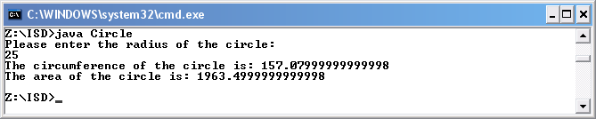

The actual results were as expected.

Part 2 – Secs, to mins, hours
Develop a Java program that asks the user to input a number of seconds, and outputs the number of hours, minutes and seconds this represents.

The application should take the number of seconds that the users inputs and should calculate if there is another method of showing the time i.e. 3666secs is equal to 1 hour 1 min and 6 secs. This should be achieved by using the below:

Input

read (secsIn)

Process

hours = secsIn / 3600;
hours = secsIn % 3600;
mins = hours / 60;
mins = hours % 60;

Output

Write ("In " + secsIn + " secs, there is " + hours + "hour(S)");
Write (" with " + mins + " min(s) ");
Write ("and " + mins + " sec(s) left over.");

Code

// Convert seconds into other time values

import java.util.*;

public class Seconds
{
public static void main(String[]args)
{

// build an instance of Scanner, that is an object

Scanner kybd = new Scanner(System.in);

// Input the number os seconds

int secsIn;
System.out.println("Please enter the number of seconds: ");
secsIn = kybd.nextInt();

//Delcare variables

int hours, mins, secs;

//Cals the number of hours in secs inputted

hours = secsIn / 3600;

//Outputs the number of hours

System.out.print("In " + secsIn + " secs, there is " + hours + " hour(S)");

//Cals the remainder

hours = secsIn % 3600;

//Cal number of mins in remainder

mins = hours / 60;

//Outputs the number of mins

System.out.print(" with " + mins + " min(s) ");

//Cals the remainder

mins = hours % 60;

//Outputs remaining number of secs

System.out.print("and " + mins + " sec(s) left over.");

}
}
Testing

Please enter number of secs: 3666

Expected Output

In 3666 secs, there is 1 hour(s) with 1 min(s) and 6 sec(s) left over.

Actual output

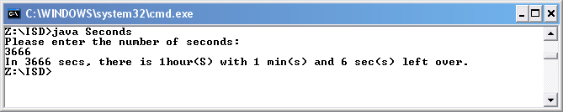

The actual results were as expected.

Part 3 – Convert temp

To convert a temperature in Fahrenheit to Celsius, you subtract 32 from the temperature in Fahrenheit and multiply the result by 5/9. Write a temperature conversion program that asks the user for a temperature in Fahrenheit and outputs the equivalent temperature in degrees Celsius. Be sure to test your program.

The user should input the temperature in Fahrenheit and then the application should calculate the temperature into Celsius which it will then display.

Input

read (fahrenheit)

Process

celsius = (fahrenheit - 32) * (5/9)

Output

Write ("The temp in celsius is: " + celsius);

Code

//Application to convert Celsius into Fahrenheit

import java.util.*;

public class Temp
{
public static void main(String[]args)
{

// Build an instance of Scanner, that is an object

Scanner kybd = new Scanner(System.in);

// Inputting the temp in Celsius

int fahrenheit;
System.out.println("Please enter the temp in fahrenheit: ");
fahrenheit = kybd.nextInt();

double celsius;

celsius = (5.0 / 9.0) * (fahrenheit - 32);

System.out.println("The temp in celsius is: " + celsius);

}
}
Testing

Please enter the temp in fahrenheit: 32

Expected Output

The temp in celsius is: 0.0

Actual output

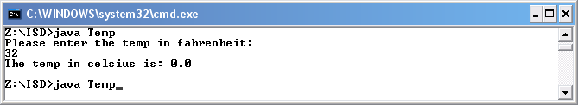

The actual results were as expected.

Testing

Please enter the temp in fahrenheit: 100

Expected Output

The temp in celsius is: 37.7777

Actual output

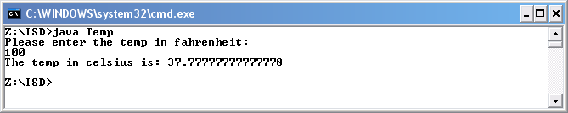

The actual results were as expected.

Part 4 – Phrase editing

Develop a Java program that asks the user to enter a phrase, and then outputs:
- the first character of the phrase
- the entered phrase with all the letters in UPPER CASE
- the position of the last occurrence of the character 'a' in the phrase
- the substring that begins at position 2 of the phrase
- a new phrase created by replacing all the occurrences of the character 'e' in the original phrase with the character '@'

Example output:

You entered the phrase "Java is great!"
The first character of the phrase is 'J'
In upper case the phrase is "JAVA IS GREAT!"
The character 'a' last occurs at position 11
The substring beginning at position 2 is "va is great!"
Replacing 'e' with '@' gives "Java is gr@at!"

The user should enter a phrase and the application should change the phrase in many different ways as shown above.

Input

read (phrase)

Process

int phraseLength = phrase.length();
char firstLetter = phrase.charAt(0);
char lastLetter = phrase.charAt(phraseLength - 1);
String newString = phrase.replace('a', '@');
int lastLetterA = phrase.lastIndexOf('a');
String phrase2 = phrase.substring(2);
String phrase 3 = phrase.toUpperCase()

Output

Write ("You entered the following phrase: " + phrase);
Write ("The first character of the phrase is: '" + firstLetter +"'");
Write ("In upper case the phrase is: " + phrase3);
Write ("The character 'a' last occurs at: " + lastLetterA);
Write ("The substring beginning at postion 2 is: " + phrase2);
Write ("Replacing 'a' with '@' gives: " + newString);
Write ("The phrase is " + phraseLength + " letters long");
Code

//Application for phrase

import java.util.*;

public class Phrase
{
public static void main(String[]args)
{

// Build an instance of Scanner, that is an object

Scanner kybd = new Scanner(System.in);

// Inputting the phrase (Line of text not just a word)

String phrase;
System.out.println("Please enter a phrase: ");
phrase = kybd.nextLine();

//Finds out the phrase lenght

int phraseLength = phrase.length();

//Find the first letter of the phrase

char firstLetter = phrase.charAt(0);

//Finds the last letter in the phrase

char lastLetter = phrase.charAt(phraseLength - 1);

//Replace "a" with @

String newString = phrase.replace('a', '@');

//Finds where "a" last occurs

int lastLetterA = phrase.lastIndexOf('a');

//Remove first two letter and starts a new string

String phrase2 = phrase.substring(2);

//Makes the prhase uppercase

String phrase3 = phrase.toUpperCase();

//Prints out the phrase that was inputted by the user

System.out.println("You entered the following phrase: " + phrase);

//Prints out the first letter of the phrase

System.out.println("The first character of the phrase is: '" + firstLetter +"'");

//Prints out the phrase in uppercase

System.out.println("In upper case the phrase is: " + phrase3);

//Prints out the location of where a last occurs

System.out.println("The character 'a' last occurs at: " + lastLetterA);

//Prints out the sub string created after removing the first 2 letters

System.out.println("The substring beginning at postion 2 is: " + phrase2);

//Print of the phrase after replacing a with @

System.out.println("Replacing 'a' with '@' gives: " + newString);

//Prints out how long the pharse is

System.out.println("The phrase is " + phraseLength + " letters long");

//Prints out the last letter of the phrase

System.out.println("The last letter of the phrase is " + lastLetter);
}
}
Testing

Please enter a phrase: Hello my name is Alex

Expected Output

You entered the following phrase: Hello my name is Alex
The first character of the phrase is: '’H’
In upper case the phrase is: HELLO MY NAME IS ALEX
The character 'a' last occurs at: 10
The substring beginning at postion 2 is: llo my name is Alex
Replacing 'a' with '@' gives: Hello my n@me is Alex
The phrase is 21 letters long
The last letter of the phrase is x

Actual output

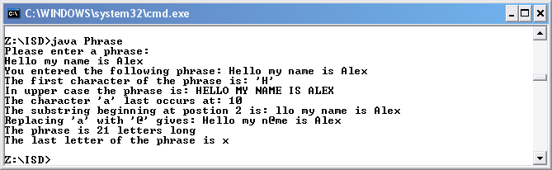

Tutorial 5

Part 1 – Design, implement and test programs to each of the following

Input an integer and output whether or not it is positive (assume 0 is not positive)

Application Brief

To create an application that displays whether an entered number is negative or positive. I will also test the application to ensure that it works correctly.

Application Requirements

The requirements of the application are as follows, to produce display read out that tells the user whether the number that they entered is positive or negative.

Input

Number

Process

If number is less than or equal to zero then it is a negative, else it is a positive number.

Output

Result of number entered

Initial Design

Data that will need to be inputted for this application will be the number.

The data that is inputted will then be processed by using an if statement to determine whether the number is negative or positive.

The output will be a displayed read out.

Testing the Design

Testing will include ensuring that the number that is entered i.e. 123, comes out to a positive number.

Pseudo Code Design

read (num)

if (num >0)
write ("The number, " + num + " is positive.")
else
write("The number, " + num + " is negative.")

Code

// Input an integer and output whether or not it is positive (assume 0 is not positive).

import java.util.*;

public class PositiveNum
{
public static void main(String[]args)
{

// build an instance of Scanner, that is an object

Scanner kybd = new Scanner(System.in);

// Input the number os seconds

int num;
System.out.println("Please enter a number: ");
num = kybd.nextInt();

//If statement to determine whether inputted number is postive or negative

if(num >0)
{
System.out.println("The number, " + num + " is positive.");
}
else
{
System.out.println("The number, " + num + " is negative.");
}
}
}
Testing

I compiled the applcaiton using javac and then run using the java interpreter.

Enter a number: 123

Expected results:

The number, 123 is positive.

Actual output

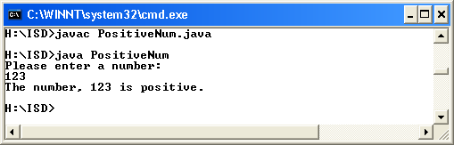

The actual results were as expected.

Testing

I compiled the application using javac and then run using the java interpreter.

Enter a number: -123

Expected results:

The number, -123 is negative.

Actual output

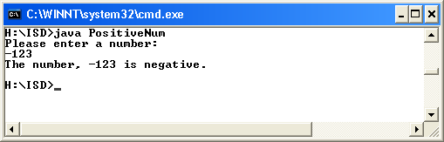

The actual results were as expected.
Input an integer and output whether it is even or odd.

//Input an integer and output whether it is even or odd.

import java.util.*;

public class OddEven
{
public static void main(String[]args)
{

// build an instance of Scanner, that is an object

Scanner kybd = new Scanner(System.in);

// Input the number os seconds

int num;
System.out.println("Please enter a number: ");
num = kybd.nextInt();

//If statement to determine whether inputted number is odd or even
if(num % 2 == 0)
{
System.out.println("The number, " + num + " even.");
}
else
{
System.out.println("The number, " + num + " is odd.");
}
}
}

Part 2 – Data validation

An integer in the range -10 to 25 inclusive

//An integer in the range -10 to 25 inclusive

import java.util.*;

public class Range01
{
public static void main(String[]args)
{
// build an instance of Scanner, that is an object

Scanner kybd = new Scanner(System.in);

// Input the number is seconds

int num;
System.out.println("Please enter a number: ");
num = kybd.nextInt();

//If statement to determine whether inputted number is in range

if(num >=-10 && num <=25)
{
System.out.println("The number, " + num + " is in range.");
}
else
{
System.out.println("The number, " + num + " is not in range.");
}
}
}

Testing

I compiled the application using javac and then run using the java interpreter.

Please enter a number: -11

Expected results:

The number, -11 is not in range.

Actual output

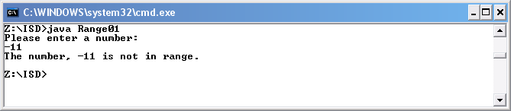

The actual results were as expected.

Testing

I compiled the application using javac and then run using the java interpreter.

Please enter a number: -10

Expected results:

The number, -10 is in range.

Actual output

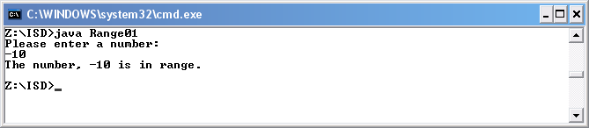

The actual results were as expected.
Testing

I compiled the application using javac and then run using the java interpreter.

Please enter a number: 25

Expected results:

The number, 25 is in range.

Actual output

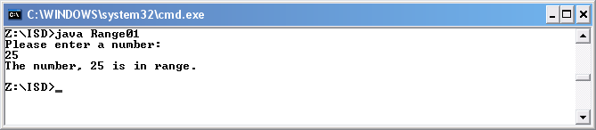

The actual results were as expected.

Testing

I compiled the application using javac and then run using the java interpreter.

Please enter a number: 26

Expected results:

The number, 26 is not in range.

Actual output

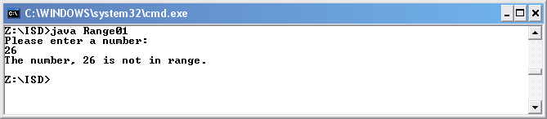

The actual results were as expected.
Either a negative number that is less than -10 or a positive number in the range 3 to 45 exclusive

//Either a negative number that is less than -10 or a positive number in the range 3 to 45 exclusive.

import java.util.*;

public class Range02
{
public static void main(String[]args)
{
// build an instance of Scanner, that is an object

Scanner kybd = new Scanner(System.in);

// Input the number os seconds

int num;
System.out.println("Please enter a number: ");
num = kybd.nextInt();

//If statement to determine whether inputted number is postive or negative

if((num <-10) || (num >3 && num <45))
{
System.out.println("The number, " + num + " is in range.");
}
else
{
System.out.println("The number, " + num + " is not in range.");
}
}
}

Testing

I compiled the application using javac and then run using the java interpreter.

Please enter a number: 44

Expected results:

The number, 44 is in range.

Actual output

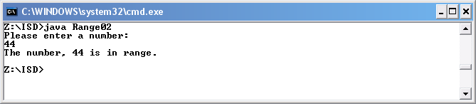

The actual results were as expected.

Testing

I compiled the application using javac and then run using the java interpreter.

Please enter a number: 45

Expected results:

The number, 45 is not in range.

Actual output

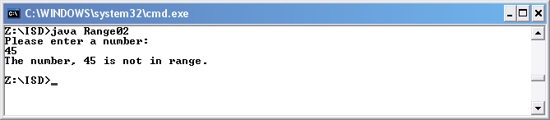

The actual results were as expected.
Testing

I compiled the application using javac and then run using the java interpreter.

Please enter a number: 3

Expected results:

The number, 3 is not in range.

Actual output

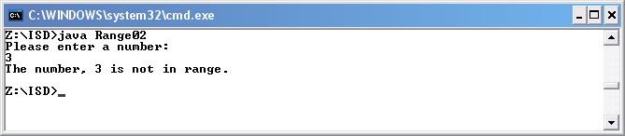

The actual results were as expected.

Testing

I compiled the application using javac and then run using the java interpreter.

Please enter a number: 4

Expected results:

The number, 4 is in range.

Actual output

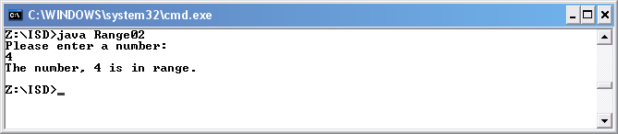

The actual results were as expected.
Testing

I compiled the application using javac and then run using the java interpreter.

Please enter a number: -11

Expected results:

The number, -11 is in range.

Actual output

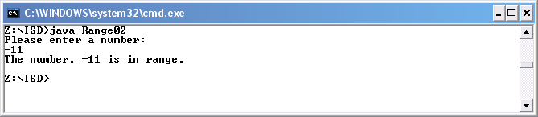

The actual results were as expected.

Testing

I compiled the application using javac and then run using the java interpreter.

Please enter a number: -10

Expected results:

The number, -10 is not in range.

Actual output

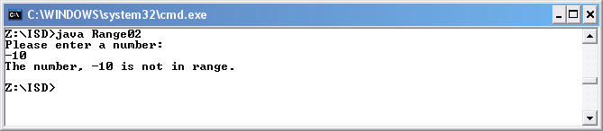

The actual results were as expected.
A string that has a value of Cathy or Kelvin

//A string that has a value of Cathy or Kelvin

import java.util.*;

public class Range03
{
public static void main(String[]args)
{
// build an instance of Scanner, that is an object

Scanner kybd = new Scanner(System.in);

// Input the number os seconds

String name;
System.out.println("Please enter a name: ");
name = kybd.next();

//If statement to determine whether name is vaild

if(name.equals("Cathy") || name.equals("Kelvin"))
{
System.out.println("Welcome " + name);
}
else
{
System.out.println("Access Denied");
}
}
}
Testing

I compiled the application using javac and then run using the java interpreter.

Please enter a name: Cathy

Expected results:

Welcome Cathy.

Actual output

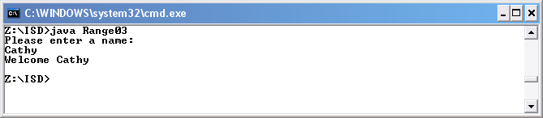

The actual results were as expected.

Testing

I compiled the application using javac and then run using the java interpreter.

Please enter a name: cathy

Expected results:

Access Denied

Actual output

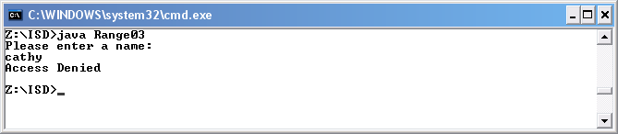

The actual results were as expected.
Testing

I compiled the application using javac and then run using the java interpreter.

Please enter a name: CATHY

Expected results:

Access Denied

Actual output

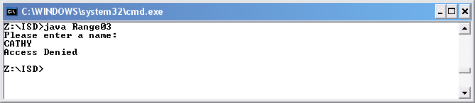

The actual results were as expected.

Testing

I compiled the application using javac and then run using the java interpreter.

Please enter a name: Kelvin

Expected results:

Welcome Kelvin.

Actual output

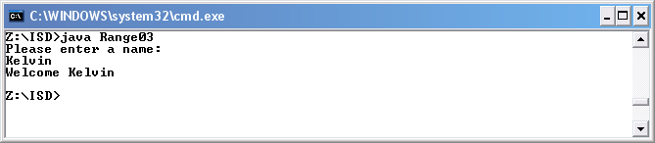

The actual results were as expected.

Testing

I compiled the application using javac and then run using the java interpreter.

Please enter a name: kelvin

Expected results:

Access Denied

Actual output

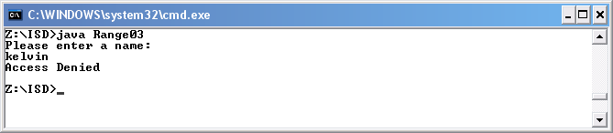

The actual results were as expected.

Testing

I compiled the application using javac and then run using the java interpreter.

Please enter a name: KELVIN

Expected results:

Access Denied

Actual output

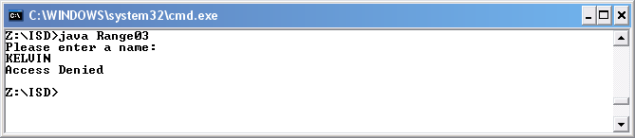

The actual results were as expected.
A string that has a value of Cathy, CATHY, Kelvin or KELVIN

//A string that has a value of Cathy or Kelvin

import java.util.*;

public class Range04
{
public static void main(String[]args)
{
// build an instance of Scanner, that is an object

Scanner kybd = new Scanner(System.in);

// Input the number os seconds

String name;
System.out.println("Please enter a name: ");
name = kybd.next();

//If statement to determine whether name is vaild

if(name.equals("Cathy") || name.equals("Kelvin") || name.equals("CATHY") || name.equals("KELVIN"))
{
System.out.println("Welcome " + name);
}
else
{
System.out.println("Access Denied");
}
}
}

Testing

I compiled the application using javac and then run using the java interpreter.

Please enter a name: Cathy

Expected results:

Welcome Cathy.

Actual output

The actual results were as expected.

Testing

I compiled the application using javac and then run using the java interpreter.

Please enter a name: cathy

Expected results:

Access Denied

Actual output

The actual results were as expected.
Testing

I compiled the application using javac and then run using the java interpreter.

Please enter a name: CATHY

Expected results:

Welcome CATHY

Actual output

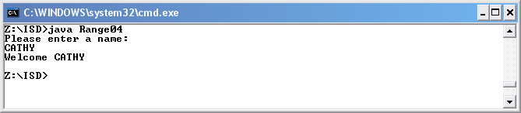

The actual results were as expected.

Testing

I compiled the application using javac and then run using the java interpreter.

Please enter a name: Kelvin

Expected results:

Welcome Kelvin.

Actual output

The actual results were as expected.

Testing

I compiled the application using javac and then run using the java interpreter.

Please enter a name: kelvin

Expected results:

Access Denied

Actual output

The actual results were as expected.

Testing

I compiled the application using javac and then run using the java interpreter.

Please enter a name: KELVIN

Expected results:

Welcome KELVIN

Actual output

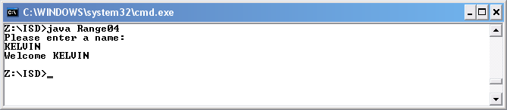

The actual results were as expected.
A string that has a value of Cathy or Kelvin where the case used is unimportant.

//A string that has a value of Cathy or Kelvin

import java.util.*;

public class Range05
{
public static void main(String[]args)
{
// build an instance of Scanner, that is an object

Scanner kybd = new Scanner(System.in);

// Input the number os seconds

String name;
System.out.println("Please enter a name: ");
name = kybd.next();

//If statement to determine whether name is vaild

if(name.equalsIgnoreCase("Cathy") || name.equalsIgnoreCase("Kelvin"))
{
System.out.println("Welcome " + name);
}
else
{
System.out.println("Access Denied");
}
}
}
Testing

I compiled the application using javac and then run using the java interpreter.

Please enter a name: Cathy

Expected results:

Welcome Cathy.

Actual output

The actual results were as expected.

Testing

I compiled the application using javac and then run using the java interpreter.

Please enter a name: cathy

Expected results:

Welcome cathy

Actual output

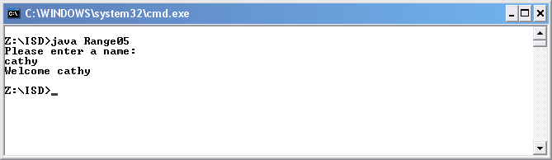

The actual results were as expected.
Testing

I compiled the application using javac and then run using the java interpreter.

Please enter a name: CATHY

Expected results:

Welcome CATHY

Actual output

The actual results were as expected.

Testing

I compiled the application using javac and then run using the java interpreter.

Please enter a name: Kelvin

Expected results:

Welcome Kelvin.

Actual output

The actual results were as expected.

Testing

I compiled the application using javac and then run using the java interpreter.

Please enter a name: kelvin

Expected results:

Welcome kelvin

Actual output

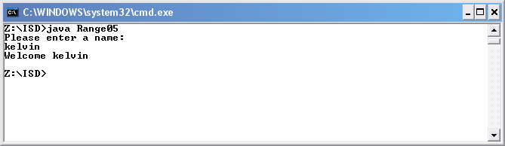

The actual results were as expected.

Testing

I compiled the application using javac and then run using the java interpreter.

Please enter a name: KELVIN

Expected results:

Welcome KELVIN

Actual output

The actual results were as expected.

Part 3 – Problem solving

Application Brief

To extend the water bill program such that a discount of 10% is given on the entire bill for customers who pay by direct debit. It must be possible to determine whether or not a customer pays by direct debit by inspecting the customer reference number; as the reference number will be a sequence of digits and letters containing an upper case D as the last character.

I must produce a pseudo code design before attempting to code your solution and to test both the design and the finished code. Ensure that you comment the solution and choose suitable names for all variables used. In this tutorial, pay particular attention to the way in which you comment any conditional statements. Remember that comments should be meaningful and at the level of intent so that someone inspecting the code understands what it is supposed to do.

Pseudo Code Design

Inputs

Read(refNum);
Read(perRead):
Read(curRead);
price = 0.25;
refNumLength = refNum.length();
lastLetter = refNum.charAt(refNumLength - 1);

Process

if (lastLetter == 'D')

preTotalCost = (((perRead + curRead) * price) + 10);
discountCost = preTotalCost / 10;
totalCost = preTotalCost - discountCost;
vatCost = totalCost * 1.05;

else

totalCost = ((perRead + curRead) * price) + 10;
vatCost = totalCost * 1.05;

Output

Write("The customer refernce number is: " + refNum);
Write("The total cost of the bill not inc vat is: " + totalCost + " GBP");
Write("The total cost of the bill including vat is: " + vatCost + " GBP");
Code

// Octagon Water Ltd Billing

// the package containing Scanner

import java.util.*;

public class WaterBill02
{
public static void main(String[] args)
{
// build an instance of Scanner, that is an object

Scanner kybd = new Scanner(System.in);

// customer refernce number

String refNum;
System.out.println("Please enter the customer refernce number: ");
refNum = kybd.next();

// input current meter reading and perious meter reading

//pervious meter reading
int perRead;
System.out.println("Please enter the pervious reading: ");
perRead = kybd.nextInt();

//current meter reading
int curRead;
System.out.println("Please enter the current reading: ");
curRead = kybd.nextInt();

//setting the unit price at £0.25
double price = 0.25;

//declare variables

double totalCost;
double vatCost;
double preTotalCost;
double discountCost;
int refNumLength = refNum.length();
char lastLetter = refNum.charAt(refNumLength - 1);

if (lastLetter == 'D')
{

//cal the cost with discont

preTotalCost = (((perRead + curRead) * price) + 10);
discountCost = preTotalCost / 10;
totalCost = preTotalCost - discountCost;
vatCost = totalCost * 1.05;

}

else

{

//cal the cost

totalCost = ((perRead + curRead) * price) + 10;
vatCost = totalCost * 1.05;

}

// Bill output
//Customer Refernce number
System.out.println("The customer refernce number is: " + refNum);
//Total Cost
System.out.println("The total cost of the bill not inc vat is: " + totalCost + " GBP");
//Total Cost inc Vat
System.out.println("The total cost of the bill including vat is: " + vatCost + " GBP");

}
}

Testing

I compiled the application using javac and then run using the java interpreter.

Please enter the customer reference number: 123D

Please enter the pervious reading: 123

Please enter the current reading: 123

Expected results:

The customer reference number is: 123D

The total cost of the bill not inc vat is: 64.35 GBP

The total cost of the bill including vat is: 67.5675 GBP

Actual output

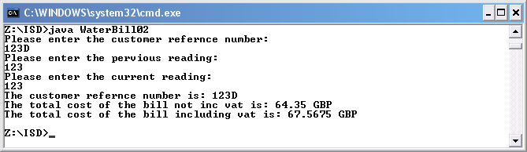

The actual results were as expected.

Testing

I compiled the application using javac and then run using the java interpreter.

Please enter the customer reference number: 123

Please enter the pervious reading: 123

Please enter the current reading: 123

Expected results:

The customer reference number is: 123

The total cost of the bill not inc vat is: 71.5 GBP

The total cost of the bill including vat is: 75.075 GBP

Actual output

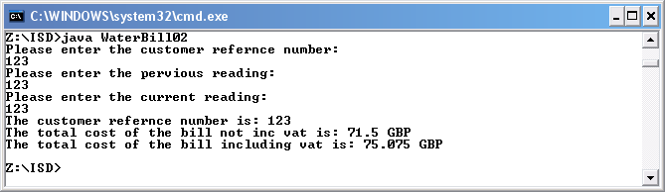

The actual results were as expected.

Tutorial 6

Part 1 – Design, implement and test programs to do each of the following:

Input an integer and output whether it is positive, negative or zero.

Code

//Input an integer and output whether or not it is positive (assume 0 is netiher).

import java.util.*;

public class PositiveNum02
{
public static void main(String[]args)
{

// build an instance of Scanner, that is an object

Scanner kybd = new Scanner(System.in);

// Input a number

int num;
System.out.println("Please enter a number: ");
num = kybd.nextInt();

//If statement to determine whether inputted number is postive or negative

if(num >0)
{
System.out.println("The number, " + num + " is positive.");
}
else
if (num < 0)
{
System.out.println("The number, " + num + " is negative.");
}
else
{
System.out.println("The number, " + num + " is zero.");
}
}
}
Testing

I compiled the application using javac and then run using the java interpreter.

Please enter a number: 1

Expected results:

The number, 1 is positive

Actual output

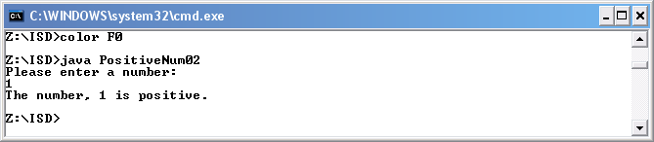

The actual results were as expected.

Testing

I compiled the application using javac and then run using the java interpreter.

Please enter a number: -1

Expected results:

The number, -1 is negative.

Actual output

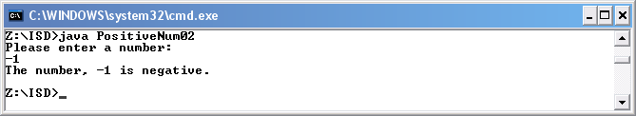

The actual results were as expected.
Testing

I compiled the application using javac and then run using the java interpreter.

Please enter a number: 0

Expected results:

The number, 0 is zero.

Actual output

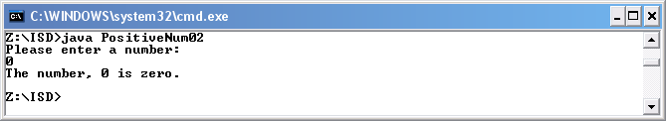

The actual results were as expected.
Input an integer and output information about it of the form “the number 3 is positive and odd”, “the number -4 is negative and even”, “the number is zero”

Code

//Input an integer and output whether or not it is positive (assume 0 is not positive)

import java.util.*;

public class NumType01
{
public static void main(String[]args)
{

// build an instance of Scanner, that is an object

Scanner kybd = new Scanner(System.in);

// Input a number

int num;
System.out.println("Please enter a number: ");
num = kybd.nextInt();

//If statement to determine whether inputted number is odd or even and positive or negative and zero is zero

if(num % 2 == 0 && num >0)
{
System.out.println("The number, " + num + " is positive and even.");
}
else
if (num % 2 == 0 && num <0)
{
System.out.println("The number, " + num + " is negative and even.");
}
else
if(num % 2 != 0 && num >0)
{
System.out.println("The number, " + num + " is positive and odd.");
}
else
if (num % 2 != 0 && num <0)
{
System.out.println("The number, " + num + " is negative and odd.");
}
else
{
System.out.println("The number, " + num + " is zero.");
}
}
}
Testing

I compiled the application using javac and then run using the java interpreter.

Please enter a number: 2

Expected results:

The number, 2 is positive and even.

Actual output

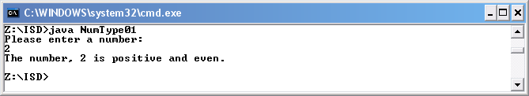

The actual results were as expected.

Testing

I compiled the application using javac and then run using the java interpreter.

Please enter a number: 1

Expected results:

The number, 1 is positive and odd.

Actual output

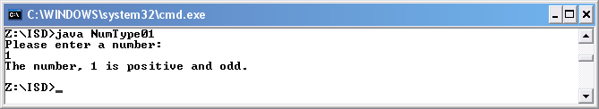

The actual results were as expected.
Testing

I compiled the application using javac and then run using the java interpreter.

Please enter a number: 0

Expected results:

The number, 0 is zero

Actual output

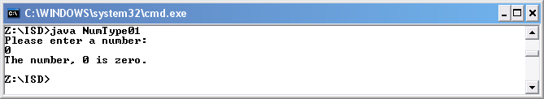

The actual results were as expected.

Testing

I compiled the application using javac and then run using the java interpreter.

Please enter a number: -2

Expected results:

The number, -2 is negative and is even

Actual output

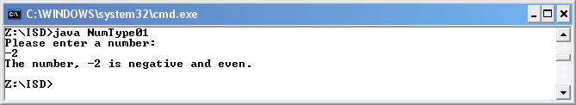

The actual results were as expected.
Testing

I compiled the application using javac and then run using the java interpreter.

Please enter a number: -1

Expected results:

The number, -1 is negative and is odd

Actual output

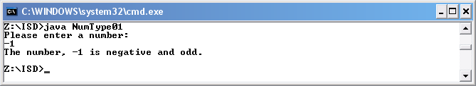

The actual results were as expected.

Part 2 – Problem Solving – Student grades

Application Brief

A student is awarded an integer test mark in the range 0 to 25 inclusive. Your task is to convert the mark into a grade such as A or B. The criteria for awarding the various grades are as follows:
A for a mark greater than 17
B for a mark in the range 15 and 17 inclusive
C for a mark greater than 12 and less than 15
D for a mark of 10, 11 or 12
U for any mark less than 10.

Code

//Input an integer and output a grade

import java.util.*;

public class Grade01
{
public static void main(String[]args)
{

// build an instance of Scanner, that is an object

Scanner kybd = new Scanner(System.in);

// Input the a grade

int num;
System.out.println("Please enter a number: ");
num = kybd.nextInt();

//If statement to determine grade

if(num <= 25 && num > 17)
{
System.out.println("Grade A");
}
else
if (num >=15 && num <=17)
{
System.out.println("Grade B");
}
else
if(num >12 && num <15)
{
System.out.println("Grade C");
}
else
if (num >= 10 & num <= 12)
{
System.out.println("Grade D");
}
else
if (num <10)
{
System.out.println("Grade U");
}
else
{
System.out.println("Error");
}

}
}
Testing

I compiled the application using javac and then run using the java interpreter.

Please enter a number: 18

Expected results:

Grade A

Actual output

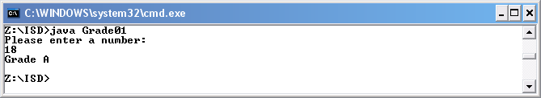

The actual results were as expected.

Testing

I compiled the application using javac and then run using the java interpreter.

Please enter a number: 15

Expected results:

Grade B

Actual output

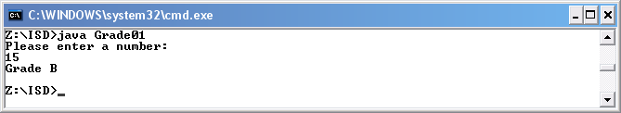

The actual results were as expected.

Testing

I compiled the application using javac and then run using the java interpreter.

Please enter a number: 13

Expected results:

Grade C

Actual output

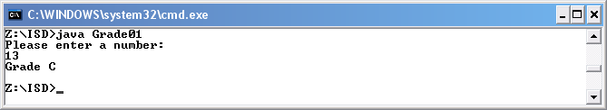

The actual results were as expected.

Testing

I compiled the application using javac and then run using the java interpreter.

Please enter a number: 11

Expected results:

Grade D

Actual output

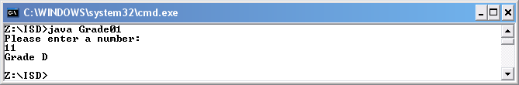

The actual results were as expected.
Testing

I compiled the application using javac and then run using the java interpreter.

Please enter a number: 9

Expected results:

Grade U

Actual output

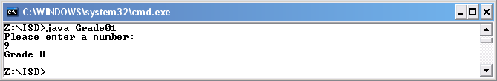

The actual results were as expected.

Testing

I compiled the application using javac and then run using the java interpreter.

Please enter a number: 26

Expected results:

Error

Actual output

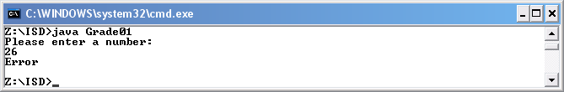

The actual results were as expected.
Part 3 – Problem Solving – Leap Year

A year is a leap if it is exactly divisible by 4, unless it is exactly divisible by 100 in which case it is only a leap year if it is exactly divisible by 400.

Design, implement and test a program to input a year and output whether or not it is a leap year.

Input
read(num)

System.out.println ( num + " is a leap year." ) ;
else
System.out.println ( num + " is not a leap year." ) ;

Process

if ( ( num % 4 == 0 && num % 100 != 0 ) || ( num % 4 == 0 && num % 400 == 0 ) )
Statement 1
else
Statement 2

Output

Statement 1 write ( num + " is a leap year." ) ;
Statement 2 write ( num + " is not a leap year." ) ;

Code

//find out if a year is a leap year or not

import java.util.*;

public class LeapYear01
{
public static void main(String[]args)
{

// build an instance of Scanner, that is an object

Scanner kybd = new Scanner(System.in);

// Input the number years

int num;
System.out.println("Please enter a year: ");
num = kybd.nextInt();

//If statement to determine whether year is leap year or not

if ( ( num % 4 == 0 && num % 100 != 0 ) || ( num % 4 == 0 && num % 400 == 0 ) )
{
System.out.println ( num + " is a leap year." ) ;
}
else
{
System.out.println ( num + " is not a leap year." ) ;
}

}
}
Testing

I compiled the application using javac and then run using the java interpreter.

Please enter a year: 2008

Expected results:

2008 is a leap year.

Actual output

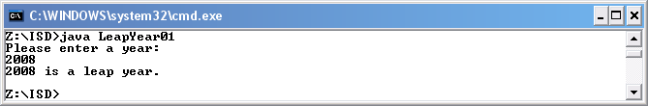

The actual results were as expected.

Testing

I compiled the application using javac and then run using the java interpreter.

Please enter a year: 2007

Expected results:

2007 is not a leap year

Actual output

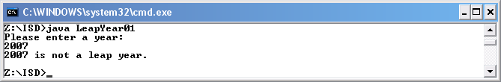

The actual results were as expected.
Testing

I compiled the application using javac and then run using the java interpreter.

Please enter a year: 1900

Expected results:

1900 is not a leap year.

Actual output

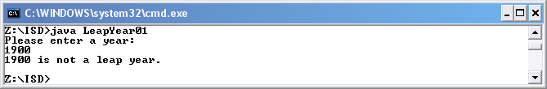

The actual results were as expected.

Testing

I compiled the application using javac and then run using the java interpreter.

Please enter a year: 1200

Expected results:

1200 is a leap year.

Actual output

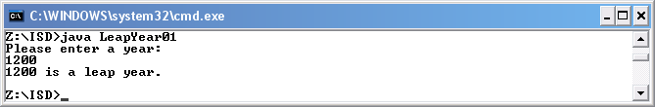

The actual results were as expected.

Part 4 – Problem Solving – 24hr Time

Assuming 24hour time is input as a 4 digit integer, such as 1530, design, implement and test a program to input a 24hour time and output the time in 12hour notation followed by a.m. or p.m. as appropriate. Extend your program to output midnight or midday instead of a numeric equivalent.

Code

//Convert 24 to 12hour clock

import java.util.*;

public class Time01
{
public static void main(String[]args)
{

// build an instance of Scanner, that is an object

Scanner kybd = new Scanner(System.in);

// Input the number os seconds

int num;
System.out.println("Please enter a number: ");
num = kybd.nextInt();

//If statement to determine whether the clock is 24hour or not

if (num >2400)
{
System.out.println("Not a time value");
}
else
if (num == 0)
{
System.out.println("Midnight");
}
else
if (num == 1200)
{
System.out.println("Midday");
}
else
if(num <=1200 && num >0)
//converts time if time is 24 hours
{
num = num - 1200;
System.out.println(num + "pm");
}
else
{
System.out.println(num + "am");
}
}
}
Testing

I compiled the application using javac and then run using the java interpreter.

Please enter a number: 700

Expected results:

700am

Actual output

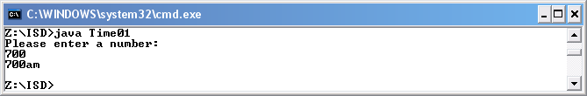

The actual results were as expected.

Testing

I compiled the application using javac and then run using the java interpreter.

Please enter a number: 1700

Expected results:

500pm

Actual output

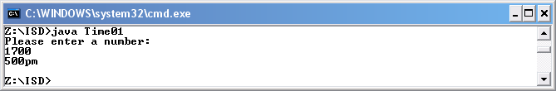

The actual results were as expected.
Testing

I compiled the application using javac and then run using the java interpreter.

Please enter a number: 2401

Expected results: Not a time value

Actual output

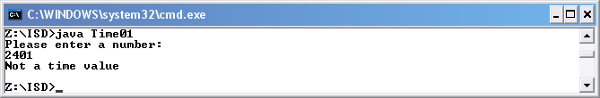

The actual results were as expected.

Testing

I compiled the application using javac and then run using the java interpreter.

Please enter a number: 0000

Expected results: Midnight

Actual output

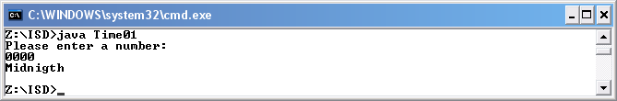

The actual results were as expected.

Testing

I compiled the application using javac and then run using the java interpreter.

Please enter a number: 1200

Expected results: Midday

Actual output

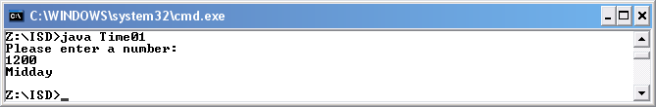

The actual results were as expected.

