Introduction to Software Development Portfolio 2
By Alex J Davison

Student Number: DV003874

Content
Content 2
Tutorial 8 3
Part 1 – Using the ternary form of if 3
Part 2 – Using Switch Statements 10
Part 3 – Problem Solving – Using Switch Statements 25
Part 4 – Formatting Output 30
Tutorial 9 33
Part 1 – Problems involving repetition 33
Part 2 – Problems involving selection and repetition 41
Tutorial 10 - Problems involving repetition – while and do-while loops 50
Part 1 – Exercises 50
Part 2 – Problem Solving 59
Tutorial 11 76
Part 1 – Using Java Library methods 76
Part 2 – Simple Methods 78
Tutorial 12 82
Part 1 82
Tutorial 13 - Simple Arrays 87
Part 1 87
Tutorial 14 92
Part 1 – Arrays and Methods 92
Part 2 – More Array Methods 92

Tutorial 8

Part 1 – Using the ternary form of if

Write a program to test the following code sample:
smallest = (num1 < num2) ? num1: num2 ;
Write an equivalent program to this using an if else statement.

Code

//A program to test the ternary if

import java.util.*;

public class If
{
public static void main(String[]args)
{

// build an instance of Scanner, that is an object

Scanner kybd = new Scanner(System.in);

// Input the num01

int num01;
System.out.println("Please enter a num01: ");
num01 = kybd.nextInt();

// Input the num02

int num02;
System.out.println("Please enter a num02: ");
num02 = kybd.nextInt();

int smallest01;

//Case which changes the smallest variable to the value of the smallest values out num01 and num02

smallest01 = (num01 < num02) ? num01: num02;

System.out.println("(Part A If) The smallest number of two inputted is: " + smallest01);

// If statement that finds the smallest number out of the two inputted.

if(num01 < num02)
{
System.out.println("(Part B If) The smallest number is num01, which is: " + num01);
}
else
{
System.out.println("(Part B If) The smallest number is num02, which is: " + num02);
}

}
}
Testing

I compiled the application using javac and then run using the java interpreter.

Please enter a num01: 1

Please enter a num02: 2

Expected results:

<Part A If> The smallest number of two inputted is: 1
<Part B If> The smallest number is num01, which is: 1

Actual output

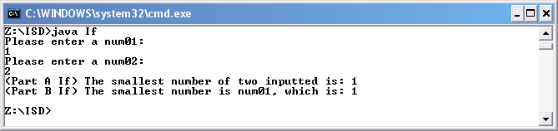

The actual results were as expected.

Testing

I compiled the application using javac and then run using the java interpreter.

Please enter a num01: 2

Please enter a num02: 1

Expected results:

<Part A If> The smallest number of two inputted is: 1
<Part B If> The smallest number is num02, which is: 2

Actual output

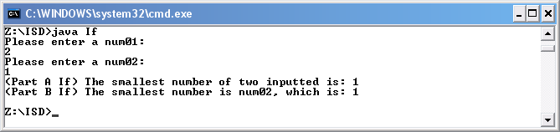

The actual results were as expected.

What does the following expression test?
if ( (( num % 2) == 0) ? (num >50): (num < 50) )
Test that you are correct by using it in a program.
Add a suitable comment to the test.
Re-write the condition without using a ternary if.
Test that it works with a suitable set of test data.
Think carefully about how to choose the test data.

Code

//A program to teat the ternary if

import java.util.*;

public class If02
{
public static void main(String[]args)
{

// build an instance of Scanner, that is an object

Scanner kybd = new Scanner(System.in);

// Input the num01

int num01;
System.out.println("Please enter a num01: ");
num01 = kybd.nextInt();

//Statement that shows if a number is even or odd and if the number is greater or less then 50 by displaying true or fails. The output is pointless

if ((( num01 % 2) == 0) ? (num01 >50): (num01 < 50))
{
System.out.println("True");
}
else
{
System.out.println("False");
}

//This statement is the same as the above and is more useful as it has more outcomes.

if (num01 % 2 == 0 && num01 >50)
{
System.out.println("The number is even and is greater than 50");
}
else if (num01 % 2 == 0 && num01 <50)
{
System.out.println("The number is even and is less than 50");
}
else if (num01 % 2 != 0 && num01 < 50)
{
System.out.println("The number is odd and is less than 50");
}
else if (num01 % 2 != 0 && num01 >50)
{
System.out.println("The number is odd and is greater than 50");
}
else
{
System.out.println("Error");
}

}
}
Testing

I compiled the application using javac and then run using the java interpreter.

Please enter a num01: 1

Expected results:

True
The number is odd and is less than 50

Actual output

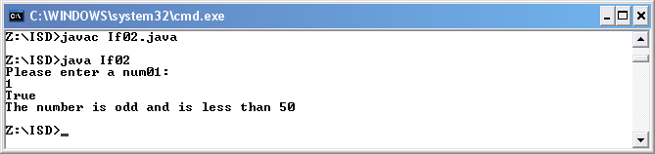

The actual results were as expected.

Testing

I compiled the application using javac and then run using the java interpreter.

Please enter a num01: 2

Expected results:

False
The number is even and is less than 50

Actual output

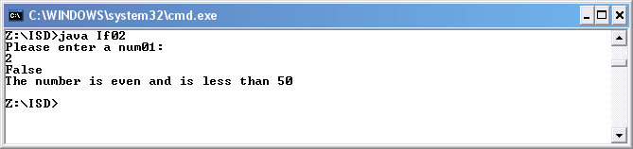

The actual results were as expected.
Testing

I compiled the application using javac and then run using the java interpreter.

Please enter a num01: 51

Expected results:

False
The number is odd and is greater than 50

Actual output

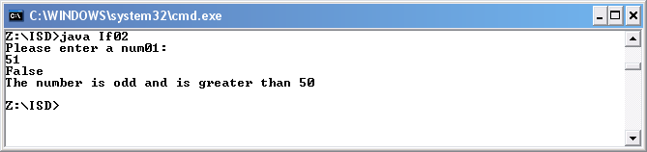

The actual results were as expected.

Testing

I compiled the application using javac and then run using the java interpreter.

Please enter a num01: 52

Expected results:

True
The number is even and is greater than 50

Actual output

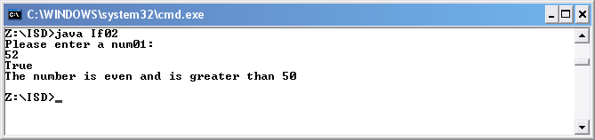

The actual results were as expected.

Part 2 – Using Switch Statements

a) Design, implement and test a program to input an integer in the range 1-7, representing a day of the week, and output the corresponding day as a String as follows:

Input | Output
1 | Monday
2 | Tuesday
3 | Wednesday
4 | Thursday
5 | Friday
6 | Saturday
7 | Sunday

Code

//An application that uses a switch to determine the day based on a number

import java.util.*;

public class Days
{
public static void main(String[]args)
{

// build an instance of Scanner, that is an object

Scanner kybd = new Scanner(System.in);

// Input a number

int num;
System.out.println("Please enter a number: ");
num = kybd.nextInt();

//The number that is inputted is used to determine the day of the week in this switch statement.

switch (num)
{
case 1: System.out.println("Monday");
break;
case 2: System.out.println("Tuesday");
break;
case 3: System.out.println("Wednesday");
break;
case 4: System.out.println("Thursday");
break;
case 5: System.out.println("Friday");
break;
case 6: System.out.println("Saturday");
break;
case 7: System.out.println("Sunday");
break;
default:
System.out.println("Error");
}
}
}
Testing

I compiled the application using javac and then run using the java interpreter.

Please enter a number: 1

Expected results:

Monday

Actual output

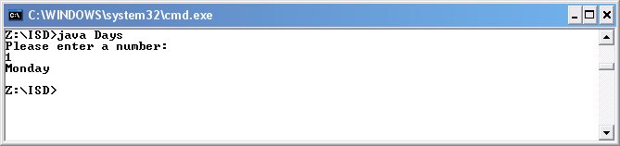

The actual results were as expected.

Testing

I compiled the application using javac and then run using the java interpreter.

Please enter a number: 2

Expected results:

Tuesday

Actual output

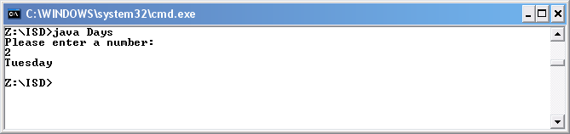

The actual results were as expected.
Testing

I compiled the application using javac and then run using the java interpreter.

Please enter a number: 3

Expected results:

Wednesday

Actual output

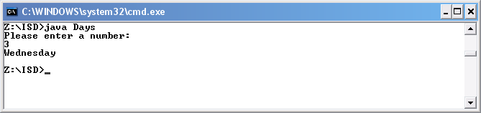

The actual results were as expected.

Testing

I compiled the application using javac and then run using the java interpreter.

Please enter a number: 4

Expected results:

Thursday

Actual output

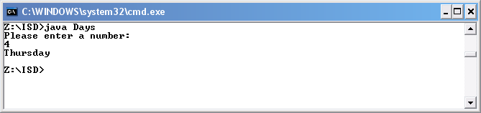

The actual results were as expected.

Testing

I compiled the application using javac and then run using the java interpreter.

Please enter a number: 5

Expected results:

Friday

Actual output

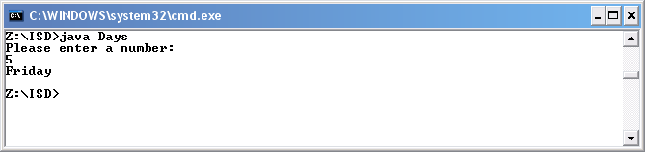

The actual results were as expected.

Testing

I compiled the application using javac and then run using the java interpreter.

Please enter a number: 6

Expected results:

Monday

Actual output

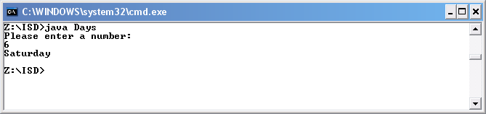

The actual results were as expected.
Testing

I compiled the application using javac and then run using the java interpreter.

Please enter a number: 7

Expected results:

Sunday

Actual output

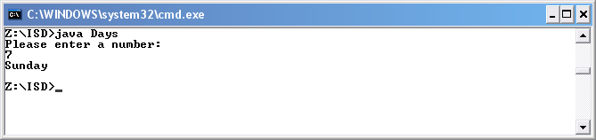

The actual results were as expected.

Testing

I compiled the application using javac and then run using the java interpreter.

Please enter a number: 8

Expected results:

Error

Actual output

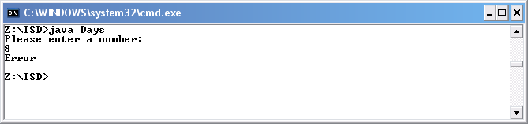

The actual results were as expected.

b) Design, implement and test a program to input an integer in the range 1-12, representing a month in the year, and output the corresponding season as a String as follows:
Input | Output
3, 4 or 5 | Spring
6, 7 or 8 | Summer
9, 10 or 11 | Autumn
12, 1 or 2 | Winter

Code

//Application that output the time of the year of the number of the month it is

import java.util.*;

public class TimeOfYear
{
public static void main(String[]args)
{

// build an instance of Scanner, that is an object

Scanner kybd = new Scanner(System.in);

// Input a number

int num;
System.out.println("Please enter a number: ");
num = kybd.nextInt();

//Switch stateament that determines the time of year

switch (num)
{
case 3: case 4: case 5: System.out.println("Spring");
break;
case 6: case 7: case 8: System.out.println("Summer");
break;
case 9: case 10: case 11:System.out.println("Autumn");
break;
case 12: case 1: case 2: System.out.println("Winter");
break;

default:
System.out.println("Error");
}
}
}
Testing

I compiled the application using javac and then run using the java interpreter.

Please enter a number: 1

Expected results:

Winter

Actual output

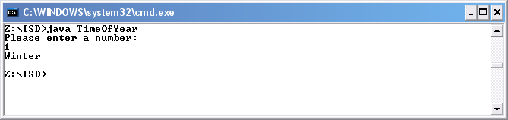

The actual results were as expected.

Testing

I compiled the application using javac and then run using the java interpreter.

Please enter a number: 2

Expected results:

Winter

Actual output

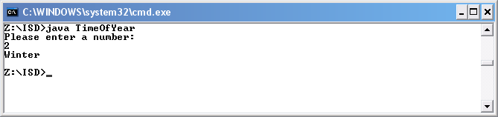

The actual results were as expected.
Testing

I compiled the application using javac and then run using the java interpreter.

Please enter a number: 3

Expected results:

Spring

Actual output

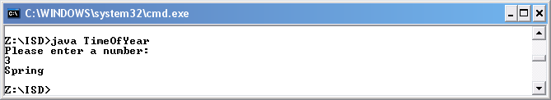

The actual results were as expected.

Testing

I compiled the application using javac and then run using the java interpreter.

Please enter a number: 4

Expected results:

Spring

Actual output

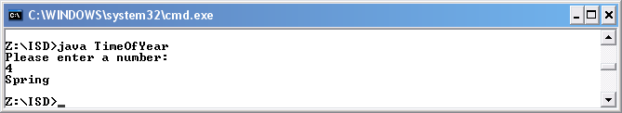

The actual results were as expected.
Testing

I compiled the application using javac and then run using the java interpreter.

Please enter a number: 5

Expected results:

Spring

Actual output

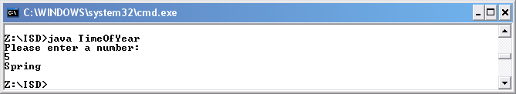

The actual results were as expected.

Testing

I compiled the application using javac and then run using the java interpreter.

Please enter a number: 6

Expected results:

Summer

Actual output

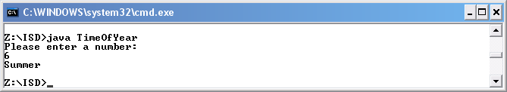

The actual results were as expected.
Testing

I compiled the application using javac and then run using the java interpreter.

Please enter a number: 7

Expected results:

Summer

Actual output

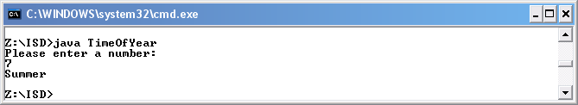

The actual results were as expected.

Testing

I compiled the application using javac and then run using the java interpreter.

Please enter a number: 8

Expected results:

Summer

Actual output

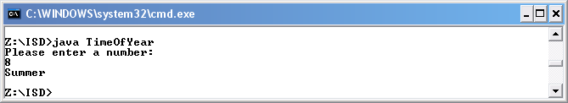

The actual results were as expected.
Testing

I compiled the application using javac and then run using the java interpreter.

Please enter a number: 9

Expected results:

Autumn

Actual output

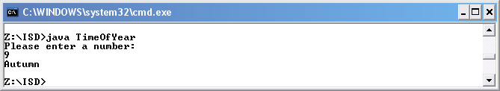

The actual results were as expected.

Testing

I compiled the application using javac and then run using the java interpreter.

Please enter a number: 10

Expected results:

Autumn

Actual output

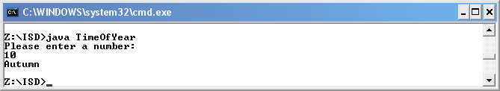

The actual results were as expected.
Testing

I compiled the application using javac and then run using the java interpreter.

Please enter a number: 11

Expected results:

Autumn

Actual output

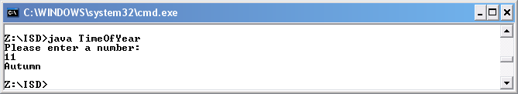

The actual results were as expected.

Testing

I compiled the application using javac and then run using the java interpreter.

Please enter a number: 12

Expected results:

Winter

Actual output

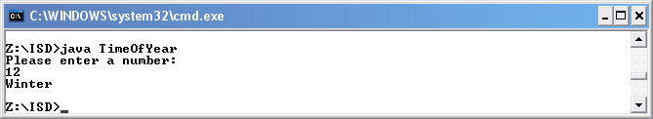

The actual results were as expected.
Testing

I compiled the application using javac and then run using the java interpreter.

Please enter a number: 13

Expected results:

Error

Actual output

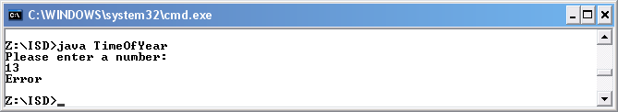

The actual results were as expected.

Part 3 – Problem Solving – Using Switch Statements

Design, implement and test a program to act as a simple calculator. Your program should accept data of the form and output the appropriate result:
12 + 30
2 – 5
That is the data consists of a number followed by an operator followed by another number.
The operators supported must include at least +, -, * and /.

Hint: prompt the user to enter the data, then read it in using a Scanner nextInt(), followed by next() followed by nextInt(). (You don't need to prompt the user between the three reads). This is MUCH easier than attempting to read the entire line and split it into its components. The operator will be read in as a string, so you need to use an appropriate String method to extract the first character. You can then test the character in a switch statement.

Note – the original version of this contained incorrect scanner methods, corrections in red.

Code

// An application that acts as a calculator using an if

import java.util.*;

public class Sum
{
public static void main(String[]args)
{

// build an instance of Scanner, that is an object

Scanner kybd = new Scanner(System.in);

// Input a number

int num01;
int num02;
String sign;
double res;

// populate variables with vaules input via phrase

System.out.println("Please enter sum: ");
num01 = kybd.nextInt();
sign = kybd.next();
num02 = kybd.nextInt();

//if statement to determine that calc to be carried out

if (sign.equals("+"))
{
res = num01 + num02;
System.out.println("Result: " + res);
}
else if (sign.equals("-"))
{
res = num01 - num02;
System.out.println("Result: " + res);
}
else if (sign.equals("*"))
{
res = num01 * num02;
System.out.println("Result: " + res);
}
else if (sign.equals("/"))
{
res = num01 / num02;
System.out.println("Result: " + res);
}
else
{
System.out.println("Error");
}
}
}
Code

//An application that acts as a calculator using an switch

import java.util.*;

public class Sum02
{
public static void main(String[]args)
{

// build an instance of Scanner, that is an object

Scanner kybd = new Scanner(System.in);

// Input a number

int num01;
int num02;
String sign;
double res = 0;

// populate variables with vaules input via phrase

System.out.println("Please enter sum: ");
num01 = kybd.nextInt();
sign = kybd.next();
num02 = kybd.nextInt();

//switch statement to determine that calc to be carried out

switch (sign.charAt(0))
{
case '+' : res = num01 + num02;
break;

case '-' : res = num01 - num02;
break;

case '*' : res = num01 * num02;

break;

case '/' : res = num01 / num02;
break;

default:
System.out.println("Error");
}
System.out.println("The result is " + res);
}
}
Testing

I compiled the application using javac and then run using the java interpreter.

Please enter sum: 123 + 123

Expected results:

246

Actual output

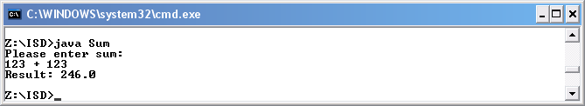

The actual results were as expected.

Testing

I compiled the application using javac and then run using the java interpreter.

Please enter sum: 123 - 123

Expected results:

0

Actual output

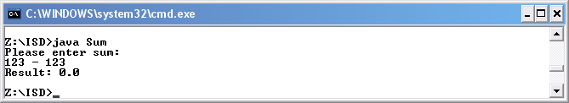

The actual results were as expected.
Testing

I compiled the application using javac and then run using the java interpreter.

Please enter sum: 123 * 123

Expected results:

15129

Actual output

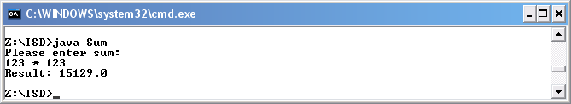

The actual results were as expected.

Testing

I compiled the application using javac and then run using the java interpreter.

Please enter sum: 123 / 123

Expected results:

1

Actual output

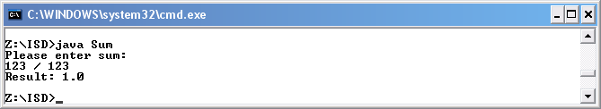

The actual results were as expected.

Part 4 – Formatting Output

Design, implement and test a program to input a first name, surname, age, nationality and weekly salary.
The data should be output on a single line with suitable headings displayed on the previous line.
The salary should be displayed to two significant places.

Code

//Application for phrase

import java.util.*;

public class Details
{
public static void main(String[]args)
{

// Build an instance of Scanner, that is an object

Scanner kybd = new Scanner(System.in);

// Inputting the details

String firstName;
System.out.println("Please enter your first name: ");
firstName = kybd.nextLine();

String surname;
System.out.println("Please enter your surname: ");
surname = kybd.nextLine();

String nationality;
System.out.println("Please enter your nationality: ");
nationality = kybd.nextLine();

int age;
System.out.println("Please enter your age: ");
age = kybd.nextInt();

double salary;
System.out.println("Please enter your salary: ");
salary = kybd.nextDouble();

//format the output

System.out.println("First Name Surname Nationality Age Salary");
System.out.printf("%-11s",firstName);
System.out.printf("%-8s",surname);
System.out.printf("%-12s",nationality);
System.out.printf("%-4d",age);
System.out.printf("%-4.2f",salary);

}
}
Testing

I compiled the application using javac and then run using the java interpreter.

Please enter your first name: Alex
Please enter your surname: Davison
Please enter your nationality: Brit
Please enter your age: 21
Please enter your salary: 300.00

Expected results:

First Name | Surname | Nationality | Age | Salary
Alex | Davison | Brit | 21 | 300.00

Actual output

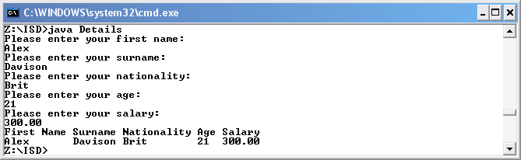

The actual results were as expected.

Tutorial 9

Part 1 – Problems involving repetition

Implement and test programs to do each of the following:
a) Write a list of the squares of the numbers from 1 to 10

Code

// Simple Java Application square all the numbers for 1 to 10 using a loop

public class SquareNums
{
public static void main(String[]args)

//A loop which square every number up to ten, when ten is reached then loop ends
{
for ( int i = 1; i <= 10; ++i )
{
System.out.print ( i );
System.out.println(" squared is " + i*i ) ;
}
}
}
Testing

I compiled the application using javac and then run using the java interpreter.

Expected results:

1 squared is 1
2 squared is 4
3 squared is 9
4 squared is 16
5 squared is 25
6 squared is 36
7 squared is 49
8 squared is 64
9 squared is 81
10 squared is 100

Actual output

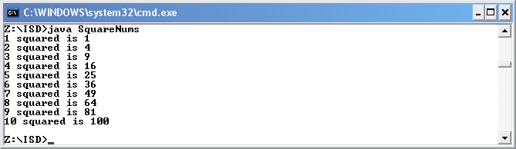

The actual results were as expected.

b) Find the sum and average of a list of 10 integers input by the user.

Code

// Simple Java Application to find the average of ten numbers entered

import java.util.*;

public class Average
{
public static void main(String[]args)
{

// Build an instance of Scanner, that is an object
Scanner kybd = new Scanner(System.in);

//declare variables.

int sum = 0;
int n;
double ave;

//loop that adds ten numbers that are entered

for (int i = 0; i < 10; ++i)
{

//requests a number

System.out.println("Please enter a number: ");
n = kybd.nextInt();

//add the intergers together

sum += n;

}

//calcs average

ave = sum / 10;

//prints out results

System.out.println("The sum of the 10 integers is " + sum);
System.out.println("The average of all 10 integers is " + ave);

}
}
Testing

I compiled the application using javac and then run using the java interpreter.

Please enter a number:
15
Please enter a number:
15
Please enter a number:
15
Please enter a number:
15
Please enter a number:
15
Please enter a number:
15
Please enter a number:
15
Please enter a number:
15
Please enter a number:
15
Please enter a number:
15

Expected results:

The sum of the 10 integers is 150
The average of all 10 integers is 15.0

Actual output

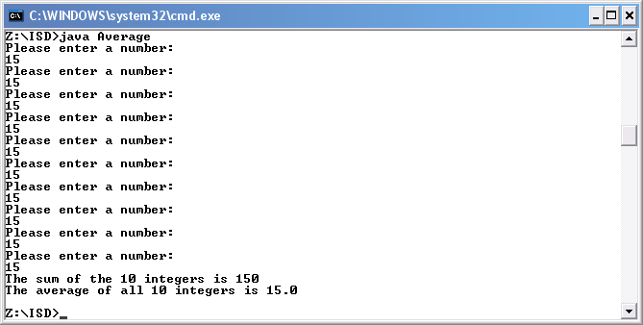

The actual results were as expected.

c) Input a number and output the corresponding times table. For example if 4 is input your program should output:
1 times 4 = 4
2 times 4 = 8
…. And so on to
10 time 4 = 40

Code

// Simple Java Application time an interger that is entered to you the time table up to 10

import java.util.*;

public class Times
{
public static void main(String[]args)
{

// Build an instance of Scanner, that is an object
Scanner kybd = new Scanner(System.in);

//declare variables

int sum = 0;
int n;
double ave;

//requests input for number to be times

System.out.println("Please enter a number: ");
n = kybd.nextInt();

for (int i = 0; i < 11; ++i)
{

//carries out times

sum = i * n;

//prints out results

System.out.print ( i );
System.out.println(" times " + n + " = " + sum );
}

}
}
Testing

I compiled the application using javac and then run using the java interpreter.

Please enter a number:
9

Expected results:

0 times 9 = 0
1 times 9 = 9
2 times 9 = 18
3 times 9 = 27
4 times 9 = 36
5 times 9 = 45
6 times 9 = 54
7 times 9 = 63
8 times 9 = 72
9 times 9 = 81
10 times 9 = 90

Actual output

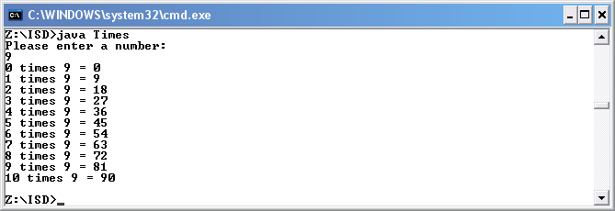

The actual results were as expected.

d) Output a multiplication table in the form:
1 2 3 4 5 6 7 8 9 10
2 4 6 8 10 12 14 16 18 20
3 6 9 …
……..
20 30 …..

Code

// Simple Java Application that gives the timetable up to 10

public class TimeTable
{
public static void main(String[]args)
{

//loop that counts to 1 to 10and then stops

for ( int i = 1; i <= 10; ++i )
{

//a loop within a loop that count 1 to 10 but also times the first counter by the second loop.

for ( int j = 1; j <= 10; ++j )
{

//Prints the timestable

System.out.print(i + "*" + j + "=" + i * j +" ");
}

//Prints a new line after the 2nd loop has finished

System.out.println();
}

}
}
Testing

I compiled the application using javac and then run using the java interpreter.

Expected results:

1*1=1 1*2=2 1*3=3 1*4=4 1*5=5 1*6=6 1*7=7 1*8=8 1*9=9 1*10=10
2*1=2 2*2=4 2*3=6 2*4=8 2*5=10 2*6=12 2*7=14 2*8=16 2*9=18 2*10=20
3*1=3 3*2=6 3*3=9 3*4=12 3*5=15 3*6=18 3*7=21 3*8=24 3*9=27 3*10=30
4*1=4 4*2=8 4*3=12 4*4=16 4*5=20 4*6=24 4*7=28 4*8=32 4*9=36 4*10=40
5*1=5 5*2=10 5*3=15 5*4=20 5*5=25 5*6=30 5*7=35 5*8=40 5*9=45 5*10=50
6*1=6 6*2=12 6*3=18 6*4=24 6*5=30 6*6=36 6*7=42 6*8=48 6*9=54 6*10=60
7*1=7 7*2=14 7*3=21 7*4=28 7*5=35 7*6=42 7*7=49 7*8=56 7*9=63 7*10=70
8*1=8 8*2=16 8*3=24 8*4=32 8*5=40 8*6=48 8*7=56 8*8=64 8*9=72 8*10=80
9*1=9 9*2=18 9*3=27 9*4=36 9*5=45 9*6=54 9*7=63 9*8=72 9*9=81 9*10=90
10*1=10 10*2=20 10*3=30 10*4=40 10*5=50 10*6=60 10*7=70 10*8=80 10*9=90 10*10=100

Actual output

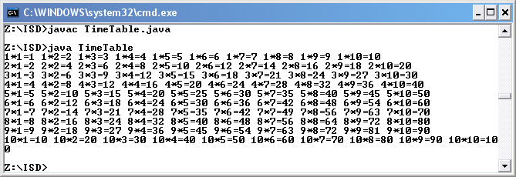

The actual results were as expected.

Part 2 – Problems involving selection and repetition

Implement and test programs to do each of the following:

a) Find number of positive integers, and the sum of these positive integers (ie ignore the negative integers), in a list of 10 integers input by the user.

Code

// Simple Java Application which add only positive numbers

import java.util.*;

public class PositiveLoop
{
public static void main(String[]args)
{

// Build an instance of Scanner, that is an object
Scanner kybd = new Scanner(System.in);

//Declare variables

int sum = 0;
int n;
int count = 0;

//loop to request numbers and adds numbers

for ( int i = 1; i <= 10; ++i)

{

//requests number

System.out.println("Please enter a number: ");
n = kybd.nextInt();

//if statement to find out whether the number is positive number or not. If positive adds number if not it doesn't ass the number.

if (n >0)
{
sum += n;
++count;
}

}

//Print out result

System.out.println("The sum of the 10 integers is " + sum + " out of " + count + " positve numbers.");

}
}
Testing

I compiled the application using javac and then run using the java interpreter.

Please enter a number:
9
Please enter a number:
-9
Please enter a number:
9
Please enter a number:
-9
Please enter a number:
9
Please enter a number:
-9
Please enter a number:
9
Please enter a number:
-9
Please enter a number:
9
Please enter a number:
-9

Expected results:

The sum of the 10 integers is 45 out of 5 positive numbers.

Actual output

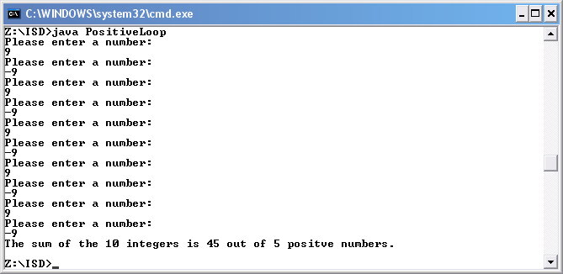

The actual results were as expected.
b) Find the smallest number in a list of 10 integers input by the user.

Code

// Simple Java Application finds the biggest integer in a list of 10 positive integers

import java.util.*;

public class Smallest
{
public static void main(String[]args)
{

// Build an instance of Scanner, that is an object
Scanner kybd = new Scanner(System.in);

//Declare variables

System.out.println("Please enter a number: ");
int n = kybd.nextInt();

int smallest = n;

//loop to enter ten numbers

for (int i = 1; i <=9; ++i)
{

//Request numbers

System.out.println("Please enter a number: ");
n = kybd.nextInt();

//If statmentto find the smallest number

if ( n < smallest )
{
smallest = n ;
}
}

//print result

System.out.println("The smallest number out of the ten entered is: " + smallest) ;

}
}
Testing

I compiled the application using javac and then run using the java interpreter.

Please enter a number:
10
Please enter a number:
9
Please enter a number:
8
Please enter a number:
7
Please enter a number:
6
Please enter a number:
5
Please enter a number:
4
Please enter a number:
3
Please enter a number:
2
Please enter a number:
1

Expected results:

The sum of the 10 integers is 45 out of 5 positive numbers.

Actual output

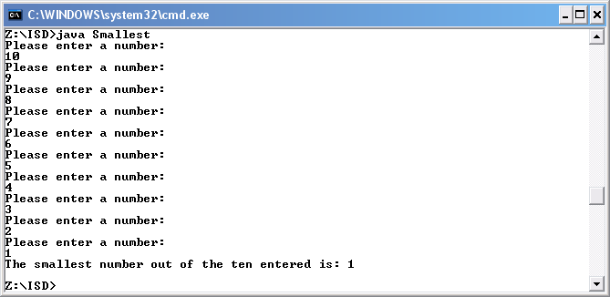

The actual results were as expected.
Testing

I compiled the application using javac and then run using the java interpreter.

Please enter a number:
1
Please enter a number:
2
Please enter a number:
3
Please enter a number:
4
Please enter a number:
5
Please enter a number:
6
Please enter a number:
7
Please enter a number:
8
Please enter a number:
9
Please enter a number:
10

Expected results:

The sum of the 10 integers is 45 out of 5 positive numbers.

Actual output

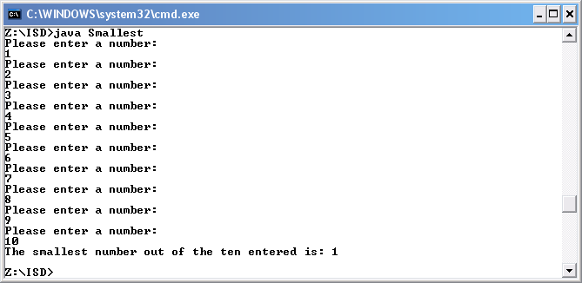

The actual results were as expected.
Design, implement and test a program to:

c) Determine and output the biggest and smallest numbers, and their positions, in a list of 10 integers input by the user. The output should be of the form :
“The biggest number 304 was at position 3 in the list”
“The smallest number 4 was at position 8 in the list”

Design

int n = 0
int biggest
int small
int biggestCount = 0
int smallCount = 0

Write("Please enter a number: ")
Read (n)

int biggest = n
int small = n

for (int i = 1; i <=10; ++i)

Write("Please enter a number: ")
Read (n)

if ( n > biggest )

biggest = n
biggestCount = i

end if

if ( n < small )

small = n
smallCount = i

end if

Write ("The biggest number out of the ten entered is " + biggest + " and was the " + biggestCount + " interger entered.");
Write ("The smallest number out of the ten entered is: " + small + " and was the " + smallCount + " interger entered.");

Code

// Simple Java Application finds the biggest integer in a list of 10 positive integers

import java.util.*;
public class BigSmall
{
public static void main(String[]args)
{

// Build an instance of Scanner, that is an object
Scanner kybd = new Scanner(System.in);

//Decalare variables

int n;
int biggest;
int small;
int biggestCount = 0;
int smallCount = 0;

System.out.println("Please enter a number: ");
n = kybd.nextInt();

//for loop, that request ten numbers

small = n;
biggest = n;

for (int i = 1; i <=9; ++i)
{
System.out.println("Please enter a number: ");
n = kybd.nextInt();

// If statement to determine if the number entered is the biggest

if ( n > biggest )
{
biggest = n ;
biggestCount = i;
}

// If statement to determine if the number entered is the smallest

if ( n < small )
{
small = n ;
smallCount = i;
}
}

// prints the final result

System.out.println("The biggest number out of the ten entered is " + biggest + " and was the " + biggestCount + " interger entered.");
System.out.println("The smallest number out of the ten entered is: " + small + " and was the " + smallCount + " interger entered.");

}
}
Testing

I compiled the application using javac and then run using the java interpreter.

Please enter a number:
1
Please enter a number:
2
Please enter a number:
3
Please enter a number:
4
Please enter a number:
5
Please enter a number:
6
Please enter a number:
7
Please enter a number:
8
Please enter a number:
9
Please enter a number:
10

Expected results:

The biggest number out of the ten entered is 10 and was the 10 interger entered.

The smallest number out of the ten entered is: 1 and was the 1 interger entered.

Actual output

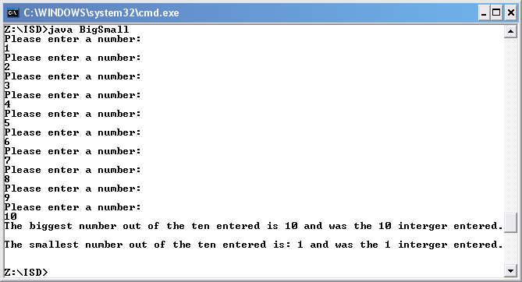

The actual results were as expected.
Testing

I compiled the application using javac and then run using the java interpreter.

Please enter a number:
1
Please enter a number:
2
Please enter a number:
3
Please enter a number:
4
Please enter a number:
5
Please enter a number:
6
Please enter a number:
7
Please enter a number:
8
Please enter a number:
9
Please enter a number:
10

Expected results:

The biggest number out of the ten entered is 10 and was the 1 interger entered.

The smallest number out of the ten entered is: 1 and was the 10 interger entered.

Actual output

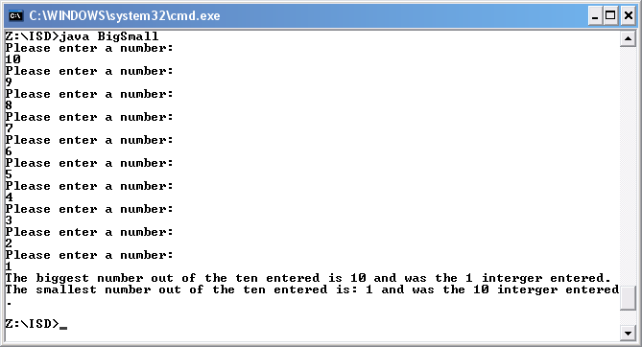

The actual results were as expected.

Tutorial 10 - Problems involving repetition – while and do-while loops

Part 1 – Exercises

a) Rewrite the following for- loop as a while- loop:

for (int i=0; i < 5; i++)
System.out.println(i * i);

Code

//An exchange a of a for loop for a while loop

public class While
{
public static void main(String[]args)
{

//Declare variable

int count = 0;

//while loop that counts to 5 while times the number by its self

while (count < 5)
{

// prints results

System.out.println(count * count);

//increase count

count++;

}
}
}
Testing

I compiled the application using javac and then run using the java interpreter.

Expected results:

0
1
4
9
16

Actual output

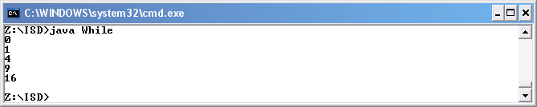

The actual results were as expected.
b) Implement a program to find the sum and average of a list of integers terminated by the data marker -999. (hint – start with the sum example in the lecture notes!) Test your program carefully. What happens if -999 is the first integer input?

Code

// Simple Java Application that adds the number entered (apart from -999)

import java.util.*;

public class WhileSum
{
public static void main(String[]args)
{

// build an instance of Scanner, that is an object

Scanner kybd = new Scanner(System.in);

//Declare variable

int sum = 0;

//Requesting number (kybd is an instance of Scanner)

System.out.println("Please enter number: ");
int num = kybd.nextInt();

// while will not end untl num equal -999

while ( num != -999 )
{
//add the numbers entered appart from -999

sum += num ;

//request number

System.out.println("Please enter number: ");
num = kybd.nextInt(); // input the next number
}

// prints out results

System.out.println("The sum of all the numbers enter (appart from -999) is: " + sum );

}
}
Testing

I compiled the application using javac and then run using the java interpreter.

Please enter number:
9
Please enter number:
6
Please enter number:
3
Please enter number:
-8
Please enter number:
-5
Please enter number:
-2
Please enter number:
-999

Expected results:

The sum of all the numbers enter (apart from -999) is: 3
The average of all the numbers is 0

Actual output

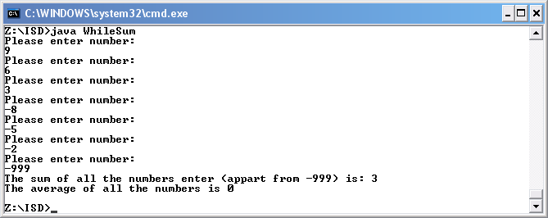

The actual results were as expected.
Testing

I compiled the application using javac and then run using the java interpreter.

Please enter number:
1
Please enter number:
2
Please enter number:
3
Please enter number:
4
Please enter number:
5
Please enter number:
6
Please enter number:
7
Please enter number:
8
Please enter number:
9
Please enter number:
-999

Expected results:

The sum of all the numbers enter (apart from -999) is: 45
The average of all the numbers is 5

Actual output

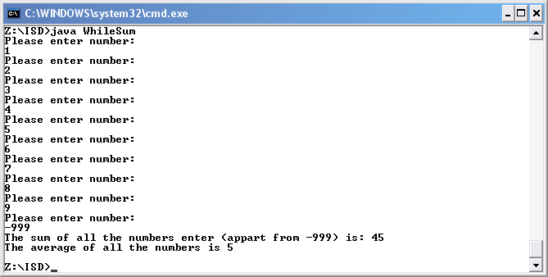

The actual results were as expected.
c) Implement a program that uses a do-while loop to validate input. The program should ask the user to input a number between 0 and 25 inclusive. If the number is not within this range, it should continue to prompt the user to enter a number, until a valid number is input. It should then output the number input.

Structure diagram

output enter – range 0 to 25 inclusive
input num
while num is not in range 0 to 25 inclusive

Code

//Application that will not end until the correct number is entered using a do-while loop

import java.util.*;

public class DoWhile
{
public static void main(String[]args)
{

// build an instance of Scanner, that is an object

Scanner kybd = new Scanner(System.in);

//declare varable

int num ;

do
{

//requests a number

System.out.print("Enter number (Please etner a number in the range between 10 and 50 inclusive): ");
num =kybd.nextInt(); // kybd is an instance of Scanner

//if number is not between 10 and 50 then loop continues

} while ( ( num < 10 ) || ( num > 50 ) );

//print if everything is correct

System.out.println("Thanks for entering the correct number.")

}
}
Testing

I compiled the application using javac and then run using the java interpreter.

Expected results:

Enter number (Please etner a number in the range between 0 and 25 inclusive): -9

Enter number (Please etner a number in the range between 0 and 25 inclusive): -1

Enter number (Please etner a number in the range between 0 and 25 inclusive): 26

Enter number (Please etner a number in the range between 0 and 25 inclusive): 25

Thanks for entering the correct number.

Actual output

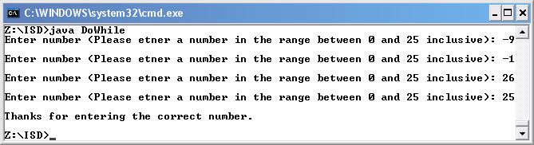

The actual results were as expected.

Part 2 – Problem Solving

a) Implementing a menu

Write a program that presents the following menu of options and asks the user to enter their choice:

1. Good morning message
2. Good afternoon message
3. Good evening message
4. Exit

After the user enters their choice, the program should output an appropriate message (for options 1-3), then show the menu again and ask the user to enter another choice. When the user enters option 4, the program should output a Goodbye message and end. Your solution should use a read-ahead while loop and a switch statement.

Example – whenever the user chooses menu option 2, the program could output "Good afternoon, sir!"

Design

int select = 0;

Write ("1. Good morning message");
Write ("2. Good afternoon message");
Write ("3. Good evening message");
Write ("4. Exit");
Write ("Please enter your selection: ");

Read (select)

while (select != 4)

switch (select)

case 1: Write("Good morning message, Alex J Davison.");
case 2: Write("Good afternoon message, Alex J Davison");
case 3: Write("Good evening message, Alex J Davison");
default: Write("Error");

Write ("Please enter your selection: ");

Read(select);

Write("Good Bye, Alex J Davison");
Code

// Application that allows you to choice a welcome message

import java.util.*;

public class WhileWelcome
{
public static void main(String[]args)
{

// build an instance of Scanner, that is an object

Scanner kybd = new Scanner(System.in);

//Declare variables

int select = 0;

//prints out the options to choice

System.out.println("1. Good morning message");
System.out.println("2. Good afternoon message");
System.out.println("3. Good evening message");
System.out.println("4. Exit");

//Requests a selectiong for welcome message

System.out.println("Please enter your selection: ");
select = kybd.nextInt();

//Loop that won't end unit option to end is chossen

while (select != 4)
{

//Switch statments to allow selection of message

switch (select)
{
case 1: System.out.println("Good morning message, Alex J Davison.");
break;
case 2: System.out.println("Good afternoon message, Alex J Davison");
break;
case 3: System.out.println("Good evening message, Alex J Davison");
break;
default:
System.out.println("Error");
}

//requests selection

System.out.println("Please enter your selection: ");
select = kybd.nextInt();

}

//prints out at the end of the application

System.out.println("Good Bye, Alex J Davison");

}
}
Testing

I compiled the application using javac and then run using the java interpreter.

Expected results:

1. Good morning message
2. Good afternoon message
3. Good evening message
4. Exit
Please enter your selection:
1
Good morning message, Alex J Davison.
Please enter your selection:
2
Good afternoon message, Alex J Davison
Please enter your selection:
3
Good evening message, Alex J Davison
Please enter your selection:
4
Good Bye, Alex J Davison

Actual output

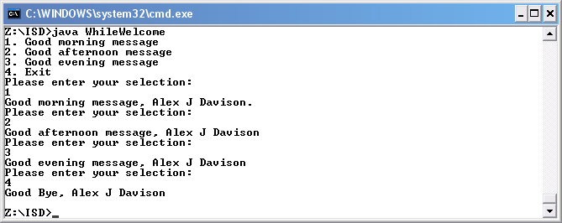

The actual results were as expected.
b) Student grades

Implement a program which:

Asks the user to input a student number, name, and mark in the range 0-25.
Verifies the mark is within the specified range (0-25); if not, the user is repeatedly asked to re-enter the mark until a valid mark is entered.
Outputs a grade based on the mark, using the following criteria:

A for a mark greater than 17
B for a mark in the range 15 and 17 inclusive
C for a mark greater than 12 and less than 15
D for a mark of 10, 11 or 12
U for any mark less than 10.

Your program should allow the user to input data for any number of students. Use a student number of -999 as the end-of-data marker. After the end-of-data marker is input, the program should output the number of As, Bs, Cs, Ds and Us achieved.

You may want to incorporate code you developed in previous exercises in your solution.

Design

int num = -1;
int studid = 0;

while (studid != -1)

Write ("Enter student number:");
Read (studid)

if(studid != -1)

Write ("Enter student name:");
Read(name)

do

Write ("Enter number (Please enter a number in the range between 0 and 25 inclusive): ");

Read(num)
End do while ( ( num < 0 ) || ( num > 25 ) );

if(num <= 25 && num > 17)

Write ("The students ID is: " + studid);
Write ("The students name is: " + name);
Write ("The students grade is: A");

else

if (num >=15 && num <=17)

Write ("The students ID is: " + studid);
Write ("The students name is: " + name);
Write ("The students grade is: B");

else

if(num >12 && num <15)

Write ("The students ID is: " + studid);
Write ("The students name is: " + name);
Write ("The students grade is: C");

else

if (num >= 10 & num <= 12)

Write ("The students ID is: " + studid);
Write ("The students name is: " + name);
Write ("The students grade is: D");

else

if (num <10)
{
Write ("The students ID is: " + studid);
Write ("The students name is: " + name);
Write ("The students grade is: U");

else

Write ("Error");

End if
End do while
End if
End while

Write ("Good Bye.");

Code

//Input an integer and output a grade

import java.util.*;

public class Grade02
{
public static void main(String[]args)
{

// build an instance of Scanner, that is an object

Scanner kybd = new Scanner(System.in);

//Declare Variables

int num = -1;
int studid = 0;
int a = 0, b = 0, c = 0, d= 0, u = 0;

// kybd is an instance of Scanner
// requess a student id

System.out.println("Enter student number:");
studid =kybd.nextInt();

//while loop that won't stop until -1 is entered

while (studid != -999)
{

// kybd is an instance of Scanner

System.out.println("Enter student name:");
String name =kybd.next();

//do while statement to ensure that the correct value is entered

do
{

// kybd is an instance of Scanner
// Input the a grade

System.out.print("Enter number (Please enter a number in the range between 0 and 25 inclusive): ");
num =kybd.nextInt();

} while ( ( num < 0 ) || ( num > 25 ) );

//If statement to determine grade and print the correct result

if(num <= 25 && num > 17)
{
System.out.println("The students ID is: " + studid);
System.out.println("The students name is: " + name);
System.out.println("The students grade is: A");
a++;
}
else if (num >=15 && num <=17)
{
System.out.println("The students ID is: " + studid);
System.out.println("The students name is: " + name);
System.out.println("The students grade is: B");
b++;
}
else if(num >12 && num <15)
{
System.out.println("The students ID is: " + studid);
System.out.println("The students name is: " + name);
System.out.println("The students grade is: C");
c++;
}
else if (num >= 10 & num <= 12)
{
System.out.println("The students ID is: " + studid);
System.out.println("The students name is: " + name);
System.out.println("The students grade is: D");
d++;
}
else if (num <10)
{
System.out.println("The students ID is: " + studid);
System.out.println("The students name is: " + name);
System.out.println("The students grade is: U");
u++;
}
else
{
System.out.println("Error");
}

// kybd is an instance of Scanner
// requess a student id

System.out.println("Enter student number:");
studid =kybd.nextInt();

}

//prints out at the end of the application
System.out.println("The number of students that acheived an A are: " + a);
System.out.println("The number of students that acheived an B are: " + b);
System.out.println("The number of students that acheived an C are: " + c);
System.out.println("The number of students that acheived an D are: " + d);
System.out.println("The number of students that acheived an U are: " + u);
System.out.println("Good Bye.");

}
}
Testing

I compiled the application using javac and then run using the java interpreter.

Enter student number:
123
Enter student name:
Alex
Enter number (Please enter a number in the range between 0 and 25 inclusive): 0

Expected results:

The students ID is: 123
The students name is: Alex
The students grade is: U
Enter student number:

Actual output

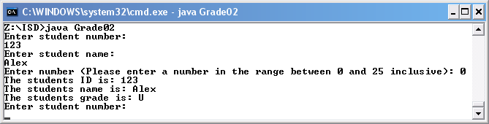

The actual results were as expected.
Testing

I compiled the application using javac and then run using the java interpreter.

Enter student number:
123
Enter student name:
Alex
Enter number (Please enter a number in the range between 0 and 25 inclusive): 11

Expected results:

The students ID is: 123
The students name is: Alex
The students grade is: D
Enter student number:

Actual output

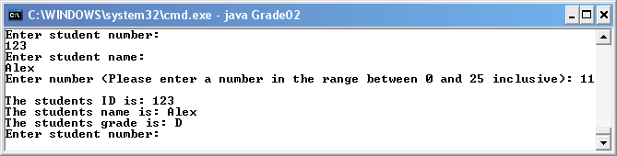

The actual results were as expected.
Testing

I compiled the application using javac and then run using the java interpreter.

Enter student number:
123
Enter student name:
Alex
Enter number (Please enter a number in the range between 0 and 25 inclusive): 13

Expected results:

The students ID is: 123
The students name is: Alex
The students grade is: C
Enter student number:

Actual output

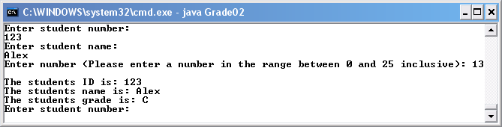

The actual results were as expected.
Testing

I compiled the application using javac and then run using the java interpreter.

Enter student number:
123
Enter student name:
Alex
Enter number (Please enter a number in the range between 0 and 25 inclusive): 16

Expected results:

The students ID is: 123
The students name is: Alex
The students grade is: B
Enter student number:

Actual output

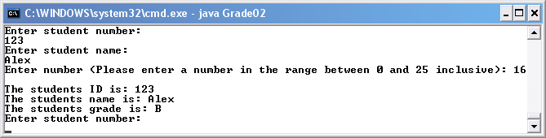

The actual results were as expected.

Testing

I compiled the application using javac and then run using the java interpreter.

Enter student number:
123
Enter student name:
Alex
Enter number (Please enter a number in the range between 0 and 25 inclusive): 25

Expected results:

The students ID is: 123
The students name is: Alex
The students grade is: A
Enter student number:

Actual output

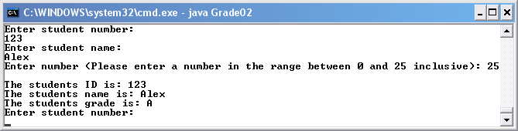

The actual results were as expected.

Testing

I compiled the application using javac and then run using the java interpreter.

Enter student number:
123
Enter student name:
Alex
Enter number (Please enter a number in the range between 0 and 25 inclusive): 26

Expected results:

Enter number (Please enter a number in the range between 0 and 25 inclusive):

Actual output

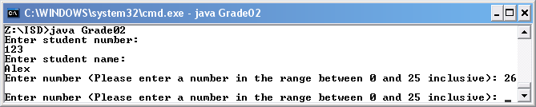

The actual results were as expected.

Testing

I compiled the application using javac and then run using the java interpreter.

Enter student number:
123
Enter student name:
Alex
Enter number (Please enter a number in the range between 0 and 25 inclusive): -1

Expected results:

Enter number (Please enter a number in the range between 0 and 25 inclusive):

Actual output

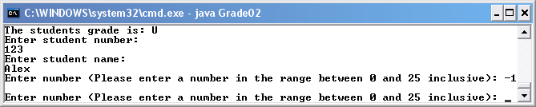

The actual results were as expected.

Testing

I compiled the application using javac and then run using the java interpreter.

Enter student number:
-999

Expected results:

The number of students that achieved an A are: 1
The number of students that achieved an B are: 0
The number of students that achieved an C are: 0
The number of students that achieved an D are: 0
The number of students that achieved an U are: 2
Good Bye.

Actual output

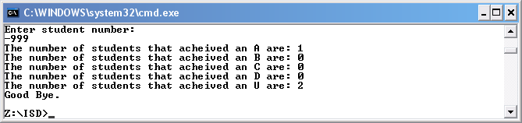

The actual results were as expected.

Tutorial 11

Part 1 – Using Java Library methods

Using the Java API documentation on http://java.sun.com/javase/6/docs/api/ , find the documentation of the Math class. Use suitable static Math methods to write a short application which asks the user to enter a double number and prints out
The number rounded to the nearest integer
The square root of the number
The number to the power 6

Code

//My first method

import java.util.*;

public class Maths
{
public static void main(String[]args)
{

// Build an instance of Scanner, that is an object

Scanner kybd = new Scanner(System.in);

// Declare variables

double num;

//Initialize variables

System.out.println("Please enter a number: ");
num = kybd.nextDouble();

// prints out the rounded, square root and power of six of the numbers entered

System.out.println(num + " rounded is " + Math.round(num));
System.out.println(num + " square root " + Math.sqrt(num));
System.out.println(num + " to the power of six is " + Math.pow(num,6));

}
}
Testing

I compiled the application using javac and then run using the java interpreter.

Please enter a number:
8.9

Expected results:

8.9 rounded is 9
8.9 square root 2.9832867780352594
8.9 to the power of six is 496981.29096100014

Actual output

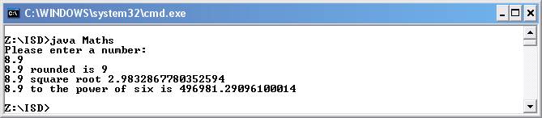

The actual results were as expected.

Part 2 – Simple Methods

In this section you will write and test your own static methods. All these methods can be included and tested in a single class. Your main method should invoke each method using appropriate arguments, and print out any returned value. There is no need to use user input in the main method, as the method arguments can be hard-coded. To test each method thoroughly, call it multiple times using different arguments (test data).

Implement and test a simple method called HelloName, which has no parameters, does not return a value, but which outputs a cheery greeting including your name.

Example output: Hi, Cathy!

Write a second version (overload) of the HelloName method which outputs a cheery greeting including any name supplied to it as an argument. This version of the method should take a String parameter.

Implement a method to draw a line of characters. The method parameters should specify the character and the number of times it is output to form the line. Test this method by using it in your HelloName methods (hint – look at the notes!).

Implement and test a method to return the biggest of three integers. The main method of the program should call this method with suitable test arguments, and output the returned value.

Implement and test a method to input an integer in a specified range. The range should be specified by two parameters to the method. The method should prompt the user for input until a valid number is entered. The method should return the validated input.

The main method of the program should call this method with suitable test arguments, and output the returned value.

Implement two overloaded methods to calculate the average of three numbers. One should deal with integer numbers while the other should deal with doubles. Test both.

Code

// Many methods used in one class

import java.util.*;

public class Method
{
public static void main(String[]args)
{

// Call all the methods that have been created
//Default hello name method
HelloName();

//Hello name method with Dainie parameters
HelloName("Daine");

//Drawline * 60 times
Drawline('*',60);

//Print statement with methods in them
System.out.println("The big number is: " + Big(9,6,3));
System.out.println("The number that is in range is: " + Validate(10,20));
System.out.println("The average of the total numbers is: " + Average(2,4,6));
System.out.println("The average of the total numbers is: " + Average(1,4,6));
}

//Method to print hello Alex J Davison with another method in it to draw – 25 times

public static void HelloName()
{
//Print Alex J Davison
System.out.println("Hello Alex J Davison");
// Method to print symbol x number of times
Drawline('-',25);
//Print line
System.out.println();

}

//Overlap the other HelloName method

public static void HelloName(String name)
{
System.out.println("Hello " + name);
}

//Method to draw a line of symbols x times

public static void Drawline(char s, int num)
{
for (int i = 0; i <= num;i++)
{
System.out.print(s);
}
}

//Method to determine the biggest number of three

public static int Big(int num1, int num2, int num3)
{
System.out.println();
if(num1 > num2 && num1 > num3)
{
return(num1);
}
else if (num2 > num1 && num2 > num3)
{
return(num2);
}
else
{
return(num3);
}
}

//A method to ensure that a number is the range so that it is valid

public static int Validate(int low, int high)
{

int n;

do
{
// Build an instance of Scanner, that is an object
Scanner kybd = new Scanner(System.in);
System.out.println("Please enter a number: ");
n = kybd.nextInt();

} while ( ( n < low ) || ( n > high ) );

return(n);

}

//Method to find the average of three numbers using integers only

public static int Average(int num1, int num2, int num3)
{

return((num1 + num2 + num3)/3);

}

//Method to find the average of three numbers using doubles

public static double Average(double num1, double num2, double num3)
{

return((num1 + num2 + num3)/3);
}

}
Testing

I compiled the application using javac and then run using the java interpreter.

Input and expected results:

Hello Alex J Davison
--------------------------
Hello Dainie
*************************************************************
The big number is: 9
Please enter a number:
1
Please enter a number:
50
Please enter a number:
15
The number that is in range is: 15
The average of the total numbers is: 4
The average of the total numbers is: 3

Actual output

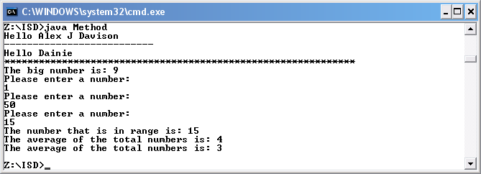

The actual results were as expected.

Tutorial 12

Part 1

Implement the Pontoon game discussed in the lecture.

Code

//A program to play Pontoon

import java.util.*;

public class Pontoon
{
public static void main(String[]args)
{

// build a scanner for keyboard input

Scanner kybd = new Scanner(System.in);

//variable declared for answer to Do you want to keep playing?
String ans;

//do statement to check that the wants to keep playing
do
{
playHand();

System.out.println("Have you finished playing?");
ans = kybd.next();

} while (ans.equals("no") );

}

//method to play a hand of pontoon
public static void playHand()
{

//statement to inform player that hand has been dealt
System.out.println("Starting a new hand of the game");
int playerScore = 0; // set players score to 0
int computerScore = 0; // set computers score to 0

// deal a first card to the player and generate players score
playerScore+=dealCard();
// deal a second card to the player and generate players score
playerScore+=dealCard();
// deal a first card to the computer and generate computers score
computerScore+=dealCard();
// deal a second card to the computer and generate computers score
computerScore+=dealCard();

Scanner kybd = new Scanner(System.in);

// check if the score for computer and player is not greater than 21, if less than 21 then allow another card
if ( computerScore > 21 )
{
//tell the users that the computer is bust
System.out.println("Sorry i'm bust!");
// check and display the winner
checkWinner( computerScore, playerScore) ;

}
else if ( playerScore > 21 )
{
//tell the users that the user is bust
System.out.println("Sorry your bust!");
// check and display the winner
checkWinner( computerScore, playerScore) ;

}
else
{

// ask the player if they want another card
System.out.println("Would you like another card?");
String reply = kybd.next();

//a while statement that deals another card until user doesn’t want another card
while ( reply.equals("yes"))
{
System.out.print("Your next card is ");
playerScore += dealCard();
System.out.println("Your score is " + playerScore);

// check if the score is greater than 21, if not allow another card
if ( playerScore > 21 )
{
System.out.println("Sorry you have bust!");
// player cannot have more cards
reply = "no";
}
else
{
System.out.println("Would you like another card?");
reply = kybd.next();
}
}

//if the computer score is less than 14 then deal another card to the computer
if (playerScore <= 21 )
{
System.out.println("My score is " + computerScore);

// deal more cards for the computer while the score is less than 14
while ( computerScore < 14 )
{
// deal a card to the computer and generate players score
System.out.print("My next card is ");
computerScore += dealCard();
System.out.println("My score is " + computerScore);
}
}
else if (computerScore > 21)
{
System.out.println("Sorry i'm bust!");
}

// check and display the winner
checkWinner( computerScore, playerScore) ;

}

}

//method to deal another card at random
public static int dealCard()
{
//declare variable
int cardValue = 0;

// choose card at random by generating a random number in the range 1-13
int card = (int)(Math.random() * 13) + 1;

// display the card name instead of value
switch (card)
{
case 1: System.out.println("Ace"); cardValue = 11;
break;
case 11: System.out.println("Jack"); cardValue = 10; break;
case 12: System.out.println("Queen"); cardValue = 10; break;
case 13: System.out.println("King"); cardValue = 10; break;
default: System.out.printf("%4d\n", card); cardValue = card;
}
return cardValue;
}

//method to check the winner of the game
public static void checkWinner(int computerScore, int playerScore)
{

if (computerScore > 21 && playerScore > 21)
{
System.out.println("We both lose.");
}
else if (computerScore > 21)
{
System.out.println("Congratulations you win");
}
else if (playerScore > 21)
{
System.out.println("Sorry you lose, I win");
}
else if(playerScore == computerScore)
{
System.out.println("We both win!!!");
}
else if (playerScore > computerScore)
{
System.out.println("Congratulations you win");
}
else
{
System.out.println("Sorry you lose, I win");
}
}

}

Tutorial 13 - Simple Arrays

Part 1

1. Implement and test a program to:
- Input 10 integers and store them in an array
- Output the integers in the order that they were entered
- Output the integers in reverse order
- Output the value of the largest number stored in the array
- Output the value of the smallest number stored in the array.

2. Implement and test a program to input a list of ten integers and output the numbers that are greater than the average number in the list.

Note: Code for both is in one program, as suggested by tutor.
Code

//Program for trying arrays

import java.util.*;

public class Arrays
{
public static void main(String[]args)
{

//declare array
int [] myArray = new int [10];

//for statement to input ten integers into an array
for(int i = 0; i < myArray.length; ++i)
{
// build an instance of Scanner, that is an object

Scanner kybd = new Scanner(System.in);

// Input the a grade

System.out.println("Please enter a number: ");
myArray [i] = kybd.nextInt();

}

//print out the values in the array in the order they were entered
for(int i = 0; i < myArray.length; ++i)
{
System.out.println("The number in array " + i + " is " + myArray[i]);

}

//prints a line for formatting
System.out.println();

//print out the values in the array in the order they were entered
for(int i = myArray.length - 1; i >= 0; --i)
{
System.out.println("The number in array " + i + " is " + myArray[i]);
}

int biggest = myArray [0];

//checks all the array to check for the biggest number
for(int i = 1; i < myArray.length; ++i)
{
if ( myArray [i] > biggest )
{
biggest = myArray [i] ;
}
}

System.out.println();
System.out.println("The biggest number is " + biggest);

int small = myArray [0];

// checks all the array to check for the smallest number
for(int i = 1; i < myArray.length; ++i)
{
if ( myArray [i] < small )
{
small = myArray [i] ;
}
}

System.out.println();
System.out.println("The smallest number is " + small);

int sum = 0;
double average;

//calculates the average of the sum of the array
for(int i = 0; i < myArray.length; ++i)
{
sum += myArray[i];
}

average = (double)sum / myArray.length;

//prints out the sum and average of the array
System.out.println();
System.out.println("The total of the numbers entered is " + sum);
System.out.println();
System.out.println("The average of the numbers entered is " + average);
System.out.println();

//prints out the number that are bigger than the average
System.out.println("These numbers are bigger than the average: ");
for(int i = 0; i < myArray.length; ++i)
{
if(myArray[i]> average)
{
System.out.println(myArray[i]);
}
}

}
}
Testing

I compiled the application using javac and then run using the java interpreter.

Please enter a number:
10
Please enter a number:
9
Please enter a number:
8
Please enter a number:
7
Please enter a number:
6
Please enter a number:
5
Please enter a number:
4
Please enter a number:
3
Please enter a number:
2
Please enter a number:
1

Expected results:

The number in array 0 is 10
The number in array 1 is 9
The number in array 2 is 8
The number in array 3 is 7
The number in array 4 is 6
The number in array 5 is 5
The number in array 6 is 4
The number in array 7 is 3
The number in array 8 is 2
The number in array 9 is 1

The number in array 9 is 1
The number in array 8 is 2
The number in array 7 is 3
The number in array 6 is 4
The number in array 5 is 5
The number in array 4 is 6
The number in array 3 is 7
The number in array 2 is 8
The number in array 1 is 9
The number in array 0 is 10

The biggest number is 10

The smallest number is 1

The total of the numbers entered is 55

The average of the numbers entered is 5.5

These numbers are bigger than the average:
10
9
8
7
6
5

Actual output

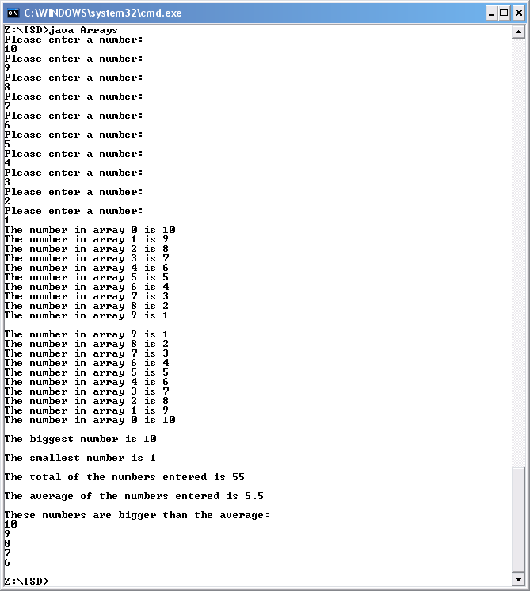

The actual results were as expected.

Tutorial 14

Part 1 – Arrays and Methods

1. Design, implement and test a set of array methods to
- Input an array
- Output an array
- Find the index of the largest value in an array
- Find the index of the smallest value in an array

Assume that the data to be stored in the arrays is of type integer.

Part 2 – More Array Methods

Design, implement and test a set of array methods to
- Exchange two elements of an array. The method should take three arguments; the array and two indices, one to each of the elements to be swapped. Be sure the method checks whether the array indices are valid.
- Find the index of the largest value in a section of an array. The section of the array should be specified by an inclusive lower and upper bound. For example an array may contain n elements and hence be indexed from 0 to n-1. This method could be used to find the largest value in the section of the array from index position 2 to 5. What should the method do if the positions specified are not valid?
- Concatenate two arrays. The function should take two arrays as arguments, and return a new longer array containing all the elements of both original arrays (which should be unchanged).

Assume that the data to be stored in the arrays is of type integer.
Code

//Methods and array

import java.util.*;

public class ArrayMethod
{
public static void main(String[]args)
{

int num = 0;

// build an instance of Scanner, that is an object

Scanner kybd = new Scanner(System.in);

// Input the a grade

System.out.println("How big would you like the array? ");
num = kybd.nextInt();

//declare variables
int [] myArray = new int [num];
int [] oneToTenArray = {0,1,2,3,4,5,6,7,8,9};

//call methods
inputArray(myArray);
printArray(myArray);

//prints out results
System.out.println("The biggest number in the array is: " + findBiggestInArray(myArray) + ", the index of the number is " + findBiggestIndexInArray(myArray));
System.out.println("The smallest number in the array is: " + findSmallestInArray(myArray) + ", the index of the number is " + findSmallestIndexInArray(myArray));
exchangeElementsArray (myArray, 2, 5);
System.out.println("The biggest number from index 2 to 5 is " + findBiggestInArray (myArray, 2, 5));
System.out.println("The new array is: ");
printArray(newArray (myArray,oneToTenArray)));
int [] myArray2 = newArray (myArray,oneToTenArray);

//Index out of range test
exchangeElementsArray (myArray, 0, 100);
findBiggestInArray (myArray, 0, 100);

}

//method to input to array
public static void inputArray(int [] theArray)
{
//allows you to input all the values into the array
for(int i = 0; i < theArray.length; ++i)
{
// build an instance of Scanner, that is an object

Scanner kybd = new Scanner(System.in);

// Input the a grade

System.out.println("Please enter a number: ");
theArray [i] = kybd.nextInt();
}
}

//method to print all the values in a array
public static void printArray (int [] theArray)
{
System.out.println("The array has the following data:") ;
// output the array

//prints all the values
for(int i=0; i < theArray.length; i++)
{
System.out.print(theArray[i] + " ");
}

System.out.println();
}

//find the biggest value in an array
public static int findBiggestInArray (int [] theArray)
{
int biggest = theArray[0];

// check if biggest by considering other elements

for(int i=1; i < theArray.length; i++)
{
if (theArray[i] > biggest)
{
biggest = theArray[i];
}
}

return biggest;

}

//finds the index of the biggest number in an array
public static int findBiggestIndexInArray (int [] theArray)
{
int biggest = theArray[0];
int index = 0;
// check if biggest by considering other elements

for(int i=1; i < theArray.length; i++)
{
if (theArray[i] > biggest)
{
biggest = theArray[i];
index = i;
}
}

return index;

}

//find the smallest value in an array
public static int findSmallestInArray (int [] theArray)
{
int biggest = theArray[0];

// check if biggest by considering other elements

for(int i=1; i < theArray.length; i++)
{
if (theArray[i] < biggest)
{
biggest = theArray[i];
}
}

return biggest;

}

//finds the index of the smallest number in an array
public static int findSmallestIndexInArray (int [] theArray)
{
int biggest = theArray[0];
int index = 0;
// check if biggest by considering other elements

for(int i=1; i < theArray.length; i++)
{
if (theArray[i] < biggest)
{
biggest = theArray[i];
index = i;
}
}

return index;

}

//swap two numbers in the array
public static void exchangeElementsArray (int [] theArray, int num1, int num2)
{
if((num1 < theArray.length) && (num2 < theArray.length) && (num1 >=0) && (num2>=0))
{
int temp1,temp2;
temp1 = theArray[num1];
temp2 = theArray[num2];
theArray[num2] = temp1;
theArray[num1] = temp2;
}
else
{
System.out.println("Index out of range");
}

}

//find the biggest value in an array within a range
public static int findBiggestInArray (int [] theArray, int start, int end)
{
int biggest = theArray[start];

if ((start >= -0) && (end <theArray.length))
{
// check if biggest by considering other elements
for(int i=start; i <= end; i++)
{
if (theArray[i] > biggest)
{
biggest = theArray[i];
}
}
}
else
{
System.out.println("Index out of range");
}
return biggest;

}

//Method that creates a new array out of two
public static int [] newArray (int [] firstArray, int [] secondArray)
{
int [] newArray = new int [firstArray.length + secondArray.length];
System.arraycopy (firstArray, 0, newArray, 0,firstArray.length);
System.arraycopy (secondArray, 0, newArray, firstArray.length, secondArray.length);

return newArray;
}

}
Testing

I compiled the application using javac and then run using the java interpreter.

How big would you like the array?
10
Please enter a number:
1
Please enter a number:
2
Please enter a number:
3
Please enter a number:
4
Please enter a number:
5
Please enter a number:
6
Please enter a number:
7
Please enter a number:
8
Please enter a number:
9
Please enter a number:
10

Expected results:

The array has the following data:
1 2 3 4 5 6 7 8 9 10
The biggest number in the array is: 10, the index of the number is 9
The smallest number in the array is: 1, the index of the number is 0
The biggest number from index 2 to 5 is 6
The new array is:
The array has the following data:
1 2 6 4 5 3 7 8 9 10 0 1 2 3 4 5 6 7 8 9
Index out of range
Index out of range

Actual output

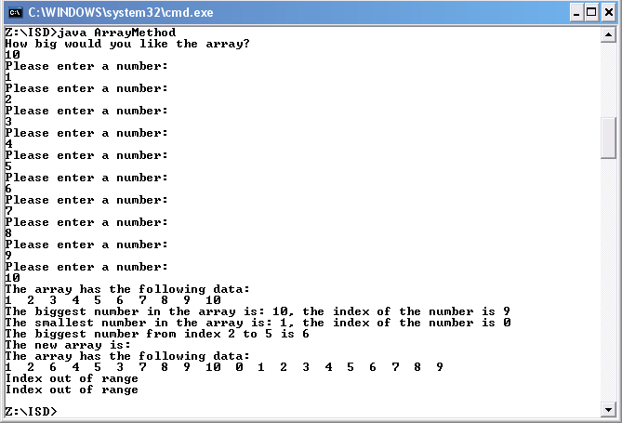

The actual results were as expected.

