Introduction to Software Development Portfolio 3
By Alex J Davison

Student Number: DV003874

Content
Content 2
Week 8 Tutorial 2 3
Part 1 – Problem Solving 3
Design 4
Code 5
Testing 7
Week 9 Tutorial 1 13
Part 1 - Two-dimensional arrays in Java 13
Code 14
Testing 16
Part 2 - Modelling a table using 1- and 2-D arrays 17
Code 18
Testing 20
Week 9 Tutorial 2 21
Part 1 – Sorting Algorithms 21
Part 2 – Some Statistics 21
Code 22
Testing 25
Code 26
Testing 29
Week 10 Tutorial 1 30
Part 1 – List Algorithms 30
Part 2 – Search Algorithms 30
Code 31
Testing 36
Week 10 Tutorial 2 37
Part 1 – Developing a Simple Addition Tester 37
Part 2 – High Scores 38
Design 39
Week 11 Tutorial 1 - File Handling 43
Part 1 – File input and output 43
Code 44
Testing 45
Part 2 46
Code 47
Testing 48
Part 3 – Persisting the "Addition Tester" high scores 49
Code 50
Week 11 Tutorial 2 60
Example of Javadoc 61

Week 8 Tutorial 2

Part 1 – Problem Solving

Complete the following problem that was introduced and partially solved in the lecture.

Write a program to determine the favourite colour among the students in your tutorial group

Assume that you will present the students you survey with a limited list of colours to chose from

You should design, implement and test this example.

Design

Initialize String [] colours = {"Red", "Blue", "Green", "Yellow", "Papaya Whip"}
Initialize int [] coloursCount = new int [5]
Initialize int input = 0, count = 0, favouriteColour = 0, big = 0

selection(colours)

do
Write("Please enter your choice [1-5]:")
Read input = kybd.nextInt()
End while((input <0) || (input >5))

while(input != 0)

selection(colours)
coloursCount [input - 1]++
count++
do
Write("Please enter your choice [1-5]:")
input = kybd.nextInt()
end while((input <0) || (input >5))

for (int i = 0; i < coloursCount.length; i++)

if(coloursCount[i] > big)
big = coloursCount[i]
favouriteColour = i

Write("The favourite colour was " + colours[favouriteColour] + " out of " + (count-1) + " people.")

method selection(String colours [] )

Write("Which is your favourite colour?")
Write ("1. " + colours[0])
Write ("2. " + colours[1])
Write ("3. " + colours[2])
Write ("4. " + colours[3])
Write ("5. " + colours[4])
Write ("0. To Exit")

Code

// Finding fav colour

import java.util.*;

public class Colour
{
public static void main(String[]args)
{

//Initialize variables
String [] colours = {"Red", "Blue", "Green", "Yellow", "Papaya Whip"};
int [] coloursCount = new int [5];
int input = 0, count = 0, favouriteColour = 0, big = 0;

//Build an instance of Scanner, that is an object

Scanner kybd = new Scanner(System.in);

//called method to show list of colours
selection(colours);

//Request a valid selection from the list
do
{
System.out.println("Please enter your choice [1-5]:");
input = kybd.nextInt();
}while((input <0) || (input >5));

// loop to keep asking unit the input is zero
while(input != 0)
{

//increase counters for selected colour and overall counter
selection(colours);
coloursCount [input - 1]++;
count++;

//Request a valid selection from the list
do
{
System.out.println("Please enter your choice [1-5]:");
input = kybd.nextInt();
}while((input <0) || (input >5));
}

// loop to find the colour that has been selected the most
for (int i = 0; i < coloursCount.length; i++)
{

//check the value of the biggest against others
if(coloursCount[i] > big)
{
big = coloursCount[i];
favouriteColour = i;
}
}

//Print outs the result.
System.out.println("The favourite colour was " + colours[favouriteColour] + " out of " + (count) + " people.");

}

// method to print the list for the selection.
public static void selection(String colours [] )
{
System.out.println("Which is your favourite colour?");
System.out.println("1. " + colours[0]);
System.out.println("2. " + colours[1]);
System.out.println("3. " + colours[2]);
System.out.println("4. " + colours[3]);
System.out.println("5. " + colours[4]);
System.out.println("0. To Exit");

}
}
Testing

I compiled the application using javac and then run using the java interpreter.

Please enter your choice [1-5]:
1
Please enter your choice [1-5]:
1
Please enter your choice [1-5]:
2
Please enter your choice [1-5]:
3
Please enter your choice [1-5]:
4
Please enter your choice [1-5]:
5
Please enter your choice [1-5]:
0

Expected results:

The favourite colour was Red out of 6 people.

Actual output

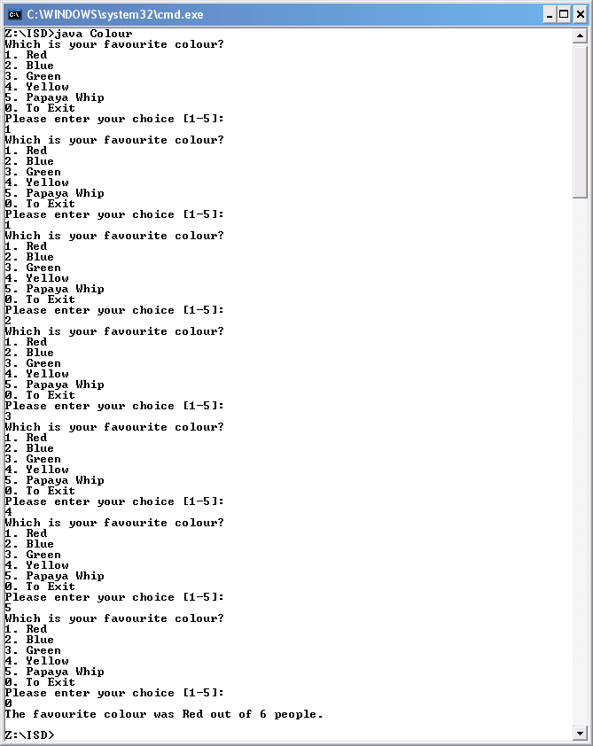

The actual results were as expected.

I compiled the application using javac and then run using the java interpreter.

Please enter your choice [1-5]:
1
Please enter your choice [1-5]:
2
Please enter your choice [1-5]:
2
Please enter your choice [1-5]:
3
Please enter your choice [1-5]:
4
Please enter your choice [1-5]:
5
Please enter your choice [1-5]:
0

Expected results:

The favourite colour was Blue out of 6 people.

Actual output

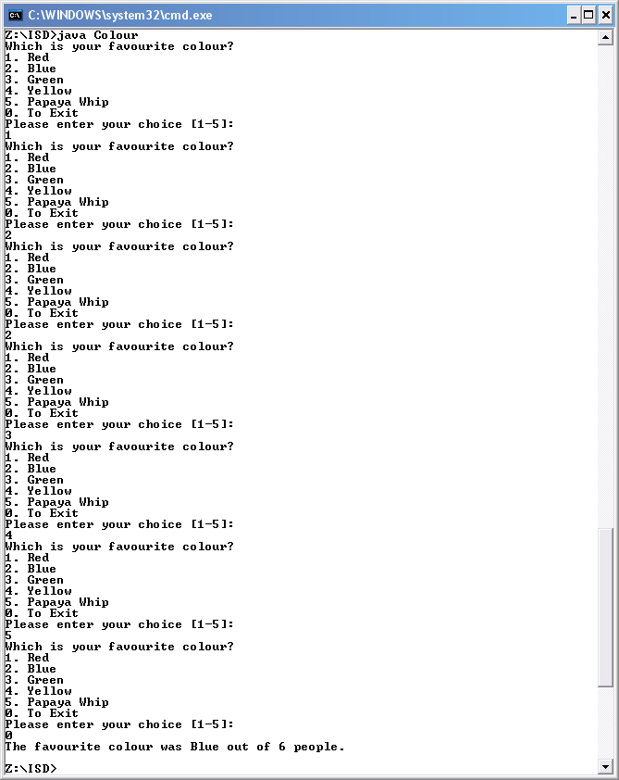

The actual results were as expected.
I compiled the application using javac and then run using the java interpreter.

Please enter your choice [1-5]:
1
Please enter your choice [1-5]:
2
Please enter your choice [1-5]:
3
Please enter your choice [1-5]:
3
Please enter your choice [1-5]:
4
Please enter your choice [1-5]:
5
Please enter your choice [1-5]:
0

Expected results:

The favourite colour was Green out of 6 people.

Actual output

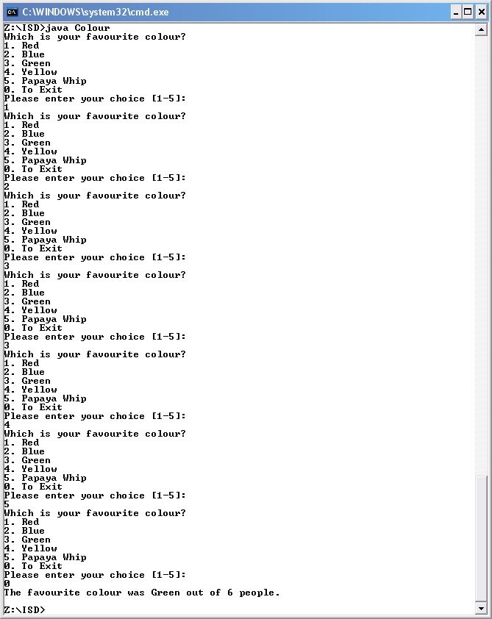

The actual results were as expected.
I compiled the application using javac and then run using the java interpreter.

Please enter your choice [1-5]:
1
Please enter your choice [1-5]:
2
Please enter your choice [1-5]:
3
Please enter your choice [1-5]:
4
Please enter your choice [1-5]:
4
Please enter your choice [1-5]:
5
Please enter your choice [1-5]:
0

Expected results:

The favourite colour was Yellow out of 6 people.

Actual output

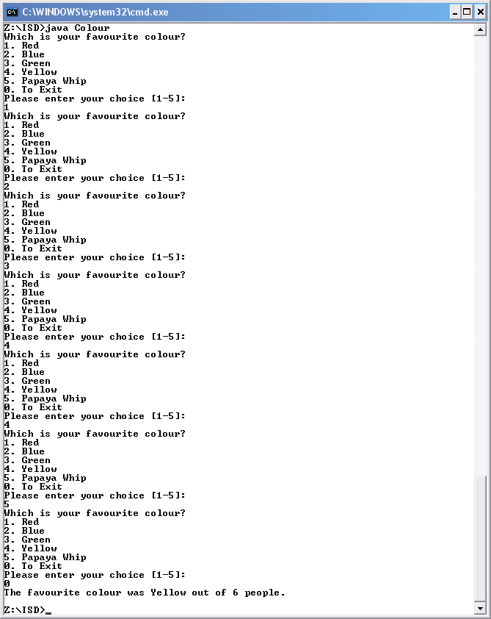

The actual results were as expected.
I compiled the application using javac and then run using the java interpreter.

Please enter your choice [1-5]:
1
Please enter your choice [1-5]:
2
Please enter your choice [1-5]:
3
Please enter your choice [1-5]:
4
Please enter your choice [1-5]:
5
Please enter your choice [1-5]:
5
Please enter your choice [1-5]:
0

Expected results:

The favourite colour was Papaya Whip out of 6 people.

Actual output

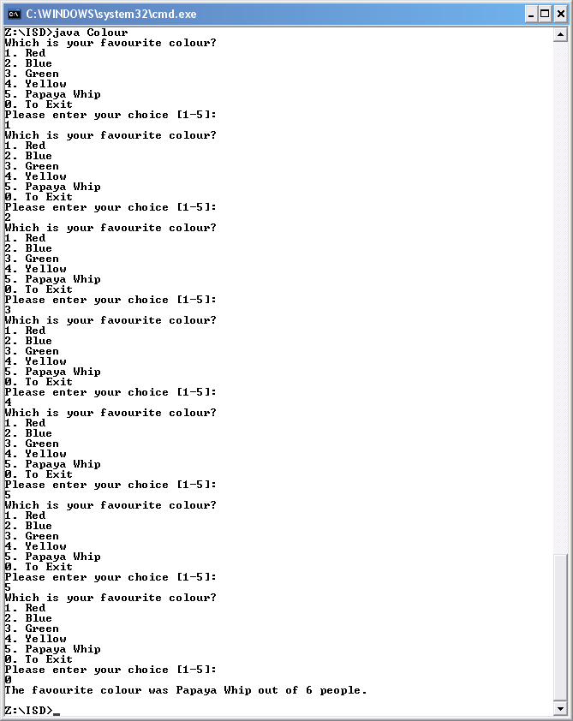

The actual results were as expected.
I compiled the application using javac and then run using the java interpreter.

Please enter your choice [1-5]:
-1
Please enter your choice [1-5]:
6
Please enter your choice [1-5]:
1
Please enter your choice [1-5]:
0

Expected results:

The favourite colour was Red out of 1 people.

Actual output

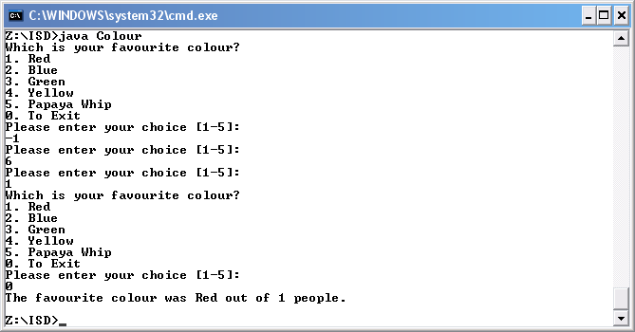

The actual results were as expected.

Week 9 Tutorial 1

Part 1 - Two-dimensional arrays in Java

1. Write a Java program that
- Declares and initialises the 2D array of food (foodArray) discussed in the lecture
- Prints out the entire array, suitably formatted
- Prints out only the list of vegetables vegetables

2. Write a Java program that
- declares and initialises a 5x3 2D array of integers such as the one below
- prints out the entire array
- prints out all the elements in the 4th row (position 3)
- prints out all the elements in the 3rd column

 | 0 | 1 | 2
0 | 437 | 6 | 25000
1 | 525 | 4 | 60000
2 | 214 | 3 | 40000
3 | 639 | 4 | 35000
4 | 309 | 5 | 15000

Code

//Progam for trying 2d arrays

import java.util.*;

public class TwoDArrays
{
public static void main(String[]args)
{

//initialization of string array
String[][] foodArray = {
{"pears", "apples", "plums"},
{ "fish", "beef", "chicken", "lamb"},
{ "milk", "cheese"},
{ "peas", "celery", "onions", "swede", "carrots"},
{ "bread", "cereal"}
};

//initialization of int array
int[][] numArray = {
{437, 6, 25000},
{525, 4, 60000},
{214, 3, 40000},
{639, 4, 35000},
{309, 5, 15000}
};

// prints all the string values in the array
printArray(foodArray);

//prints line
System.out.println(" ");

// prints all the elements in row five
printRowInfo(foodArray[4]);

//prints two line
System.out.println(" ");
System.out.println(" ");

// prints all the int values in the array
printArray(numArray);

//prints line
System.out.println("");

// prints all the elements in row four
printRowInfo(numArray [3]);

//prints two line
System.out.println("");
System.out.println("");

//prints all the values in the column 3
printColInfo(numArray,2);

}

//method to print all the values in a array
public static void printArray(String [] [] my2DArray)
{
for (int row = 0; row < my2DArray.length; ++row)
{
for (int col = 0; col<my2DArray[row].length; ++col)
{
System.out.printf("%8s",my2DArray[row][col]);
}
System.out.println();
}
}

//print all the string information in a row
public static void printRowInfo(String[] theArray)
{
for (int i = 0; i < theArray.length; ++i)
{
System.out.printf("%8s", theArray[i]);
}

}

//method to print all the int values in an array
public static void printArray (int [] [] my2DArray)
{
for (int row = 0; row < my2DArray.length; ++row)
{
for (int col = 0; col<my2DArray[row].length; ++col)
{
System.out.printf("%8s",my2DArray[row][col]);
}
System.out.println();
}
}

//print all the int information in a row
public static void printRowInfo(int[] theArray)
{
for (int i = 0; i < theArray.length; ++i)
{
System.out.printf("%8s", theArray[i]);
}

}

// print all the int information in a column
public static void printColInfo(int[][] the2DArray, int col)
{
for (int row = 0;row < the2DArray.length;++row)
{
System.out.printf("%8d", the2DArray[row][col]);
System.out.println("");
}
}
}

Testing

I compiled the application using javac and then run using the java interpreter.

Actual output

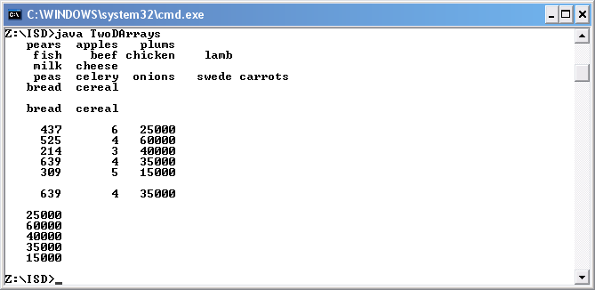

The actual results were as expected.

Part 2 - Modelling a table using 1- and 2-D arrays

3. Develop a simple payroll application which stores the name (as a String), employee number, department, and salary (all integers) of 5 employees, as shown in the table below. Your application should
- initialise the data
- print it all out as a table
- find the employee with the largest employee number, and print out all this employee's information
- Your application can be very simple, with no menu choices or user input.

Name | Employee number | Department | Salary
Pete | 437 | 6 | 25000
Cathy | 525 | 4 | 60000
Graham | 214 | 3 | 40000
Claude | 639 | 4 | 35000
Dave | 309 | 5 | 15000

Code

//Progam for trying 2d arrays

import java.util.*;

public class Payroll
{
public static void main(String[]args)
{

//declare and initialization two single arrays to store strings
String [] headingArray = {"Name", "Employee number", "Department", "Salary"};
String [] namesArray = {"Pete","Cathy","Graham","Claude","Dave"};

//declare and initialization one two dimensions array to store numbers
int[][] numArray = {
{437, 6, 25000},
{525, 4, 60000},
{214, 3, 40000},
{639, 4, 35000},
{309, 5, 15000}
};

//call method to write the headings
printRowInfo(headingArray);

//new line
System.out.println();

//write the name and number in a table format
printArray (numArray,namesArray);

//new line
System.out.println();

// find employee with biggest ID and print there infomation
bigArray (numArray,namesArray,0);

}

//print the row information in an array
public static void printRowInfo(String[] theArray)
{
for (int i = 0; i < theArray.length; ++i)
{
System.out.printf("%-16s", theArray[i]);
}

}

//method to print all the values in a array
public static void printArray (int [] [] my2DArray, String [] myarray)
{

for (int row = 0; row < my2DArray.length; ++row)
{
System.out.printf("%-15s %-15d %-15d %-15d", myarray[row], my2DArray[row][0], my2DArray[row][1], my2DArray[row][2]);
System.out.println();
}

}

//finds the employee with a biggest employee id and print there information.
public static void bigArray (int [] [] my2DArray, String [] myarray,int col)
{

int big = my2DArray[0][col];
int index = 0;

for (int row = 0;row < my2DArray.length;++row)
{

//check the value of the biggest against others
if(my2DArray[row][col] > big)
{
big = my2DArray[row] [col];
index = row;
}
}
System.out.printf("%-15s %-15d %-15d %-15d",myarray[index], my2DArray[index][0], my2DArray[index][1], my2DArray[index][2]);
}

}

Testing

I compiled the application using javac and then run using the java interpreter.

Actual output

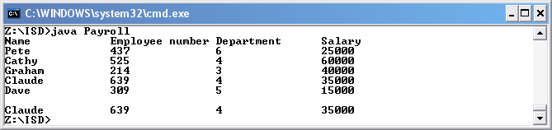

The actual results were as expected.

Week 9 Tutorial 2

Part 1 – Sorting Algorithms

- Implement and test a class containing a method to perform the selection sort on an array of integers. Make full use of the lecture materials that give details of how to do this.

- Implement and test a class containing a method to perform the bubble sort on an array of integers. Make full use of the lecture materials that give details of how to do this.

Part 2 – Some Statistics

2. Extend your sorting methods so that they keep track of the number of comparisons. Test your methods and output the number of comparisons. Think carefully about how many comparisons take place and where it easiest to gather the information.

3. Extend your sorting methods so that they keep track of the number of swaps. Test your methods and output the number of swaps as well as the number of comparisons.

4. Use your application to find out the number of comparisons and swaps for both the selection sort and the bubble sort for each of the following data sets:

1 2 3 4 5 6 7 8
8 7 6 5 4 3 2 1
6 2 7 3 1 8 5 4

Code

// Selection sorting integers

import java.util.*;

public class SelectSortFour
{
//declare global variables for counting in methods
static int comparisonsCount = 0;
static int swapCount = 0;

public static void main(String[]args)
{

//declare variables arrays
int [] myList = { 10, 8, 6, 11, 7 };
int [] myList2 = { 1, 2, 3, 4, 5, 6, 7, 8 };
int [] myList3 = { 8, 7, 6, 5, 4, 3, 2, 1 };
int [] myList4 = { 6, 2, 7, 3, 1, 8, 5, 4 };

//Print array before being sorted
System.out.println("Before sort.");
printArray (myList);

// Use a selection sort to sort array
selectSort(myList);

//Print array after being sorted to show prove of sort
System.out.println("After sort.");
printArray (myList);

//Print the number of comparisons made to sort array
System.out.println("Number of times comparison was made was: " + comparisonsCount);

//Print the number of swaps made to sort array
System.out.println("The number of time a swap occured was: " + swapCount);

//Print array before being sorted
System.out.println("Before sort.");
printArray (myList2);

// Use a selection sort to sort array
selectSort(myList2);

//Print array after being sorted to show prove of sort
System.out.println("After sort.");
printArray (myList2);

//Print the number of comparisons made to sort array
System.out.println("Number of times comparison was made was: " + comparisonsCount);

//Print the number of swaps made to sort array
System.out.println("The number of time a swap occured was: " + swapCount);

//Print array before being sorted
System.out.println("Before sort.");
printArray (myList3);

// Use a selection sort to sort array
selectSort(myList3);

//Print array after being sorted to show prove of sort
System.out.println("After sort.");
printArray (myList3);

//Print the number of comparisons made to sort array
System.out.println("Number of times comparison was made was: " + comparisonsCount);

//Print the number of swaps made to sort array
System.out.println("The number of time a swap occurred was: " + swapCount);

//Print array before being sorted
System.out.println("Before sort.");
printArray (myList4);

// Use a selection sort to sort array
selectSort(myList4);

//Print the number of swaps made to sort array
System.out.println("After sort.");
printArray (myList4);

//Print the number of comparisons made to sort array
System.out.println("Number of times comparison was made was: " + comparisonsCount);

//Print the number of swaps made to sort array
System.out.println("The number of time a swap occured was: " + swapCount);

}

//method to sort an array
public static void selectSort(int [] myList)
{
//Rest comparison and swap count to zero
swapCount = 0;
comparisonsCount = 0;

// For i = n downto 2
for (int i = myList.length; i >= 2; --i)
{
// Find the position of the largest item in the sublist
// of the first i items from the list
int posBig = findPosBig( myList, i );

// Swap the largest item with the ith item; i.e. item at position i -1
swapArrayItems( myList, i-1, posBig );

}
}

//method to find the position of biggest
public static int findPosBig ( int [] sublist, int numItems )
{

// check if biggest by considering other elements
Int posBiggest = 0;

for (int i=1; i < numItems; i++)
{
comparisonsCount ++;

if ( sublist[i] > sublist[posBiggest] )
{
posBiggest = i;
}
}
return posBiggest;
}

//method to swap two integers in an array
public static void swapArrayItems ( int [] list, int pos1, int pos2 )
{
int temp = list[pos1];
list[pos1] = list[pos2];
list[pos2] = temp;
swapCount++;
}

//method to print all the values in an array
public static void printArray (int [] theArray)
{
System.out.println("The array has the following data:") ;
// output the array

//prints all the values
for(int i=0; i < theArray.length; i++)
{
System.out.print(theArray[i] + " ");
}

System.out.println();
}

}
Testing

I compiled the application using javac and then run using the java interpreter.

Actual output

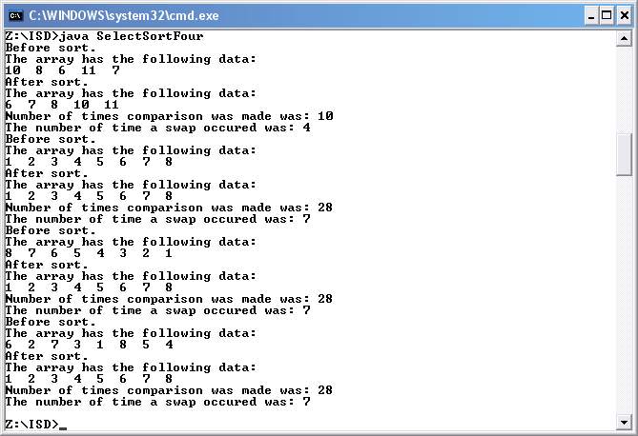

The actual results were as expected.

Code

// Bubble sorting intergers

import java.util.*;

public class BubbleSortFour
{
//declare global variables for counts
static int comparisonsCount = 0;
static int swapCount = 0;

public static void main(String[]args)
{

//declare variables arrays
int [] list = { 10, 8, 6, 11, 7 };
int [] list2 = { 1, 2, 3, 4, 5, 6, 7, 8 };
int [] list3 = { 8, 7, 6, 5, 4, 3, 2, 1 };
int [] list4 = { 6, 2, 7, 3, 1, 8, 5, 4 };

//Print array before being sorted
System.out.println("Before sort.");
printArray (list);

// Use a bubble sort to sort array
bubbleSort (list);

//Print array after being sorted to show prove of sort
System.out.println("After sort.");
printArray (list);

//Print the number of comparisons made to sort array
System.out.println("Number of times comparison was made was: " + comparisonsCount);

//Print the number of swaps made to sort array
System.out.println("The number of time a swap occured was: " + swapCount);

//Print array before being sorted
System.out.println("Before sort.");
printArray (list2);

// Use a bubble sort to sort array
bubbleSort (list2);

//Print array after being sorted to show prove of sort
System.out.println("After sort.");
printArray (list2);

//Print the number of comparisons made to sort array
System.out.println("Number of times comparison was made was: " + comparisonsCount);

//Print the number of swaps made to sort array
System.out.println("The number of time a swap occured was: " + swapCount);

//Print array before being sorted
System.out.println("Before sort.");
printArray (list3);

// Use a bubble sort to sort array
bubbleSort (list3);

//Print array after being sorted to show prove of sort
System.out.println("After sort.");
printArray (list3);

//Print the number of comparisons made to sort array
System.out.println("Number of times comparison was made was: " + comparisonsCount);

//Print the number of swaps made to sort array
System.out.println("The number of time a swap occured was: " + swapCount);

//Print array before being sorted
System.out.println("Before sort.");
printArray (list4);

// Use a bubble sort to sort array
bubbleSort (list4);

//Print array after being sorted to show prove of sort
System.out.println("After sort.");
printArray (list4);

//Print the number of swaps made to sort array
System.out.println("Number of times comparison was made was: " + comparisonsCount);

//Print the number of swaps made to sort array
System.out.println("The number of time a swap occured was: " + swapCount);

}

//method to bubble sort
public static void bubbleSort (int [] list)
{
//rest counter
swapCount = 0;
comparisonsCount = 0;

//declare variables and initialize then
int numItems = list.length;
boolean notSorted = true;

while ( notSorted && (numItems >= 2) )
{
notSorted = false;
for (int i = 0; i < numItems - 1; ++i)
{
comparisonsCount++;
if ( list[i] > list[i+1] )
{
swapArrayItems( list, i, i+1 );
// a swap occurred so possibly not sorted
notSorted = true;
}
}
--numItems;
}
}

//method to swap two array integers
public static void swapArrayItems ( int [] list, int pos1, int pos2 )
{
int temp = list[pos1];
list[pos1] = list[pos2];
list[pos2] = temp;
swapCount++;
}

//method to print all the values in a array
public static void printArray (int [] theArray)
{
System.out.println("The array has the following data:") ;
// output the array

//prints all the values
for(int i=0; i < theArray.length; i++)
{
System.out.print(theArray[i] + " ");
}

System.out.println();
}
}

Testing

I compiled the application using javac and then run using the java interpreter.

Actual output

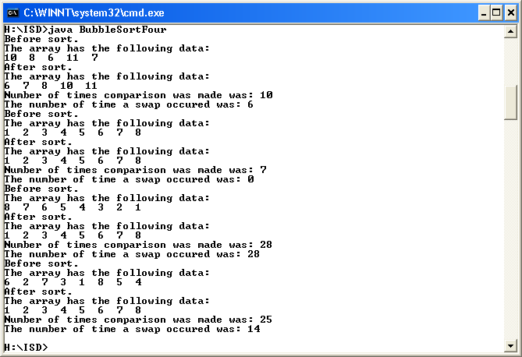

The actual results were as expected.

Week 10 Tutorial 1

Part 1 – List Algorithms

1. Implement and test a class containing methods to implement the following list algorithms (which can be found in the lecture notes):
- print a list
- add an element to the end of the list
- delete an element from the list
Add the methods one at a time to your class.
In the main method, declare a 5-integer array to model a list. Test the methods to add and delete integers from the list. Print the list after each modification. Make sure you test the cases where the list is full and empty, and deleting at an invalid position.

Part 2 – Search Algorithms

2. Extend your class from Part 1 to include methods for
- linear search of an unsorted list
- linear search of a sorted list
- binary search of a sorted list
Test your methods.

3. Extend your search methods so that they keep track of and output the number of list elements that are compared to the search value. Determine the number of comparisons necessary to find values in (and not in) the following data sets. What is the maximum number of comparisons made by each type of search?

unsorted list: 6 2 8 5 1 3
sorted list: 1 2 3 5 6 8

Code

// List Algorithms and Search Algorithms

import java.util.*;

public class Algorithms
{
//declare global variables
static int comparisonsCount = 0;

public static void main(String[]args)
{

//declare integer arrays
int [] myList = new int [5];
int [] unsorted = {6, 2, 8, 5, 1, 3};
int [] sorted = {1, 2, 3, 5, 6, 8};

//declare integer
int next = 0;

// print the array list
printList(myList,next);

//add 1,2,3,4 and 5 to the array
next = add(myList,next,1);
next = add(myList,next,2);
next = add(myList,next,3);
next = add(myList,next,4);
next = add(myList,next,5);

// print the array list
printList(myList,next);

//add one to many to array
next = add(myList,next,6);

//delete contents of index zero
next = remove(myList,next,0);
next = remove(myList,next,0);
next = remove(myList,next,0);
next = remove(myList,next,0);
next = remove(myList,next,0);

// print the array list
printList(myList,next);

//delete one to many from the array
next = remove(myList,next,0);

//add 46,49,10,19 and 21 to the array
next = add(myList,next,46);
next = add(myList,next,49);
next = add(myList,next,10);
next = add(myList,next,19);
next = add(myList,next,21);

// print the array list
printList(myList,next);

//Prints out the result for linear search of 10
System.out.println ("The linear search for number 10 is at index " + linearSearch(myList,next,10));

//Bubble sorts the array
bubbleSort(myList);

//Prints the sorted array
printList(myList,next);

// Prints out the result for linear sort search of 10
System.out.println ("The linear sort search of sorted numbers for 10 is at index " + linearSearchSorted(myList,next,10));

// Prints out the result for binary sort search of 10
System.out.println ("The binary sort search for number 3 is at index " + binarySearch(unsorted,next,10));

//changes the next to six because the next arrays are six index long
next = 6;

//prints the unsorted array
printList(unsorted,next);

//prints how many times the elements were compared

// Prints out the result for linear search of 3
System.out.println ("The linear search for number 3 is at index " + linearSearch(unsorted,next,3)+ ". There was " + comparisonsCount + " comparisons done." );

// Prints out the result for binary sort search of 3 which won’t work
System.out.println ("The binary sort search for number 3 is at index " + binarySearch(unsorted,next,3) + ". There was " + comparisonsCount + " comparisons done." );

// Prints out the result for linear sort search of 3 which won’t work
System.out.println ("The linear sort search of sorted numbers for 3 is at index " + linearSearchSorted(unsorted,next,3) + ". There was " + comparisonsCount + " comparisons done." );

//prints the sorted array
printList(sorted,next);

// Prints out the result for linear search of 3
System.out.println ("The linear search for number 3 is at index " + linearSearch(sorted,next,3)+ ". There was " + comparisonsCount + " comparisons done." );

// Prints out the result for binary search of 3
System.out.println ("The binary sort search for number 3 is at index " + binarySearch(sorted,next,3) + ". There was " + comparisonsCount + " comparisons done." );

// Prints out the result for linear search of 3
System.out.println ("The linear sort search of sorted numbers for 3 is at index " + linearSearchSorted(sorted,next,3) + ". There was " + comparisonsCount + " comparisons done." );

}

//prints the array according to the number of elements in an array
public static void printList(int[] myArray, int next)
{
System.out.println("List follows: ");
for (int i=0; i < next; i++)
{
System.out.println(i+": "+ myArray[i]);
}
}

//allows another element to be added to the array returns the next value
public static int add(int[] myArray, int next, int newData)
{
// make sure array not full
if (next < myArray.length)
{
myArray[next] = newData;
next++;
System.out.println(newData + " added");
}
else
System.out.println("array full");
return next;
}

//allows for an element to be deleted returns the next value
public static int remove(int[] myArray, int next, int pos)
{
// position valid?
if (pos >= 0 && pos < next)
{
System.out.println(myArray[pos]+ " deleted");
next--; // decrease number in list by 1

for (int i=pos; i<(next); i++) //fill gap
myArray[i] = myArray[i+1];
}
else
System.out.println(pos + " not a valid position");
return next; // new size of list
}

//linear search for value X returns the next value
public static int linearSearch(int[] myArray, int next, int searchV)
{
comparisonsCount = 0;
for (int i=0; i < next; i++)
{
comparisonsCount++;
if (myArray[i] == searchV)
return i; // return the position
}
return -1; // this indicates not found
}

//linear sort search for value X returns the next value
public static int linearSearchSorted(int[] myArray, int next, int searchV)
{
comparisonsCount = 0;
for (int i=0; i<next; ++i)
{
comparisonsCount++;
if (myArray[i] == searchV)
return i; // search value found
else if (myArray[i] > searchV)
return -1; // search value not in list
}
return -1; // search value not in list
}

//binary search for value X returns the next value
public static int binarySearch(int[] myArray, int next, int searchV)
{
int low = 0;
int high = next - 1;
comparisonsCount = 0;

while (high >= low)
{
comparisonsCount++;
int mid = (low + high)/2;

if (searchV < myArray[mid])
high = mid - 1;
else if (searchV > myArray[mid])
low = mid + 1;
else // found it!
return mid;
}
return -1; // search value not in list
}

//bubble sort to sort an array
public static void bubbleSort (int [] list)
{

int numItems = list.length;
boolean notSorted = true;

while ( notSorted && (numItems >= 2) )
{
notSorted = false;
for (int i = 0; i < numItems - 1; ++i)
{
if ( list[i] > list[i+1] )
{
swapArrayItems( list, i, i+1 );
// a swap occurred so possibly not sorted
notSorted = true;
}
}
--numItems;
}
}

//method to swap to array elements
public static void swapArrayItems ( int [] list, int pos1, int pos2 )
{
int temp = list[pos1];
list[pos1] = list[pos2];
list[pos2] = temp;
}

}

Testing

I compiled the application using javac and then run using the java interpreter.

Actual output

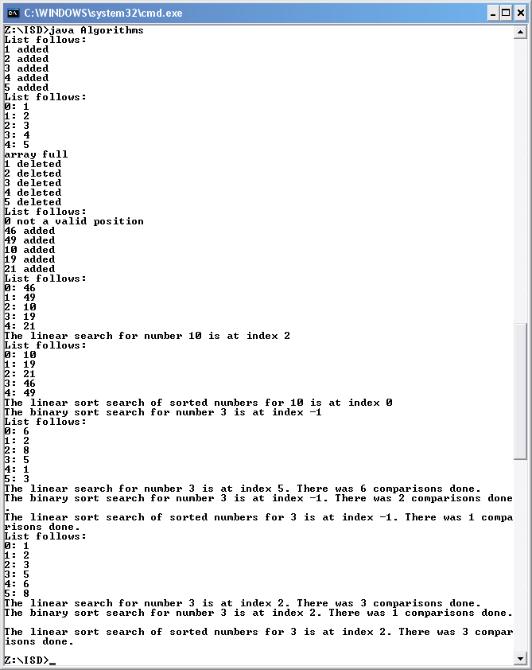

The actual results were as expected.

Week 10 Tutorial 2

Over the next few tutorials you will develop a menu driven application that can be used by children to test their ability to add two numbers between 0 and 20. This exercise brings together many of the topics that have been introduced throughout the module. Make full use of the lecture material and previous exercises.

Part 1 – Developing a Simple Addition Tester

- Design, implement and test a class containing a single method with the following signature:
public static boolean testAddition ( )
This method should select two numbers at random in the range 1 - 20 inclusive and ask
the user what the result of adding the first number by the second is. If the user
enters the correct answer the method should return true. The method should return
false if the answer is incorrect.

- Modify your program to be a menu driven application. Initially the menu options should be:
- try an addition test
- display the number of attempts so far, the number of correct answers and the percentage of correct answers
  - quit

Part 2 – High Scores

- Extend your program from part 1 to keep track of the name of the current user. Add an extra menu item, option 3, to change the user. When a user changes, the name of the new user should be read in and the number of attempts and the number of correct answers should both be reset to 0. Modify your code associated with menu item 2 to output the name of the user as well as the other information.

- Extend your program to keep track of the top five percentages and the names of the users who achieved them. In order to do this you should use arrays; one to store the percentages and the other to store the names. The two arrays can be initialised with five users each with the name “nobody” and a percentage of 0. Each time that the user changes, the old user should be added to the high score arrays if they have made more than 10 attempts and their percentage of correct answers is greater than one of the entries in the current top five. Add an extra menu item, option 4, to display the top five high scores and names of the corresponding users.

Hints and tips
Random numbers cab be generated using the Random class. The following sample code illustrates how to use the class:

int num;
num = (int)(Math.random( ) * 20) + 1
// num is now a number in the range 1 – 20 inclusive

- Math.random() returns a double between 0.0 and 0.9999999999 (ie greater than or equal to 0, and less than 1.0).
- Multiplying this number by 20 generates a number between 0.0 and 19.999999.
- Casting the result to an int truncates the answer to an integer in the range 0 to 19.
- Adding one means the final answer is an integer between 1 and 20 inclusive

A variation of one pass of the bubble sort is one way to add a high score in its correct position in the array. If the high score array is in descending order then one way to add a new high score would be as follows. Compare the current score with the last entry in the array. If it is bigger then it should be in the high score table, bubble it to its correct position. Consider a current score of 52% for Joe being added to the following arrays.\:
Names Liz Adam Henry Sarah Dan
Scores 84 75 51 49 47
After first comparison:
Names Liz Adam Henry Sarah Sarah
Scores 84 75 51 49 49
After second comparison:
Names Liz Adam Henry Henry Sarah
Scores 84 75 51 51 49
Now Joe is added
Names Liz Adam Joe Henry Sarah
Scores 84 75 52 51 49

Design

int attempts = 0;
double numCorrect = 0;
double ans = 0;
String [] topTen = new String [5];
int [] scores = new int [5];
int stringNext = 0;
int intNext = 0;
String name;
int option = 0;

load(topTen, scores);

Write("Please enter your name: ")
Read name
optionMenu( )
Write("Please pick an option: ")
Read option

while (option != 5)
switch (option)
case 1: attempts++;
if (testAddition ( )== true)
Write("Correct")
numCorrect++
else
Write("Incorrect")
break

case 2: Write("The number of attempts was: " + attempts + ".")
Write("The number of current answers was: " + numCorrect + ".")
ans = numCorrect/attempts*100
Write("That as a percentage is: " + ans)
break;

case 3: if (attempts > 10)
ans = numCorrect/attempts*100
intNext = add(scores, intNext, (int)Math.round(ans),topTen,name)
ans = 0
bubbleSort (scores,topTen)
Write ("Please enter new players name: ")
name = kybd.next()
else
Write("Sorry you didn't make the top ten.")
Write ("Please enter new players name: ");
name = kybd.next()
attempts = 0
numCorrect = 0
ans = 0
break;

case 4: printArray(scores, topTen)
break;

default:
Write("Error")
optionMenu( )
Write ("Please pick an option: ")
Read option
if(option == 5)
save(topTen,scores)

Return Method boolean testAddition ( )
int num1 = (int)(Math.random() * 20) + 1
int num2 = (int)(Math.random() * 20) + 1
int num3 = num1 + num2
boolean correct = false

Write (num1 + "+" + num2 + "=")
Write("What is the sum of the two numbers? ")
Read int guess

if ( guess == num3)
correct = true

return correct;
Method optionMenu( )

Write("1. Try an addition test")
Write ("2. Results")
Write ("3. New player")
Write ("4. Top five players")
Write ("5. Quit")

Method printArray (int [] myIntArray, String [] myStringArray)
for (int row = 0; row < myIntArray.length; ++row)
Write Formatted("%-15s %-15d", myStringArray[row], myIntArray[row])
Write()

Return Method int add(String [] myArray, int next, String newData)

if (next < myArray.length)
myArray[next] = newData
next++
Write (newData + " added")
else
Write ("array full")
return next

Return Method int add(int[] myArray, int next, int newData)

if (next < myArray.length)
myArray[next] = newData
next++
Write (newData + " added")
else
Write ("array full")
return next

Return Method int add(int[] myArray1, int next, int newData, String [] myArray2, String name)

if (next < myArray1.length)
add(myArray2, next, name)
myArray1[next] = newData
next++
Write (newData + " added")
else if (newData > myArray1[myArray1.length-1])
next = remove(myArray1,next,next-1)
myArray1[next] = newData
next++
Write (newData + " added")
next = remove(myArray2,next,next-1)
add(myArray2, next, name)
else
Write ("Your not in the top five")
return next;

Method bubbleSort (int [] list, String [] list2)

int numItems = list.length
boolean notSorted = true

while (notSorted && (numItems >= 2))
notSorted = false
for (int i = 0; i < numItems - 1; ++i)
if ( list[i] < list[i+1] )
swapArrayItems( list, i, i+1 )
swapArrayItems( list2, i, i+1 )
notSorted = true
--numItems
Method swapArrayItems ( int [] list, int pos1, int pos2 )

int temp = list[pos1]
list[pos1] = list[pos2]
list[pos2] = temp

Method swapArrayItems ( String [] list, int pos1, int pos2 )

String temp = list[pos1]
list[pos1] = list[pos2]
list[pos2] = temp

Return Method int remove(int[] myArray, int next, int pos)
if (pos >= 0 && pos < next)
Write(myArray[pos]+ " deleted")
next--
for (int i=pos; i<(next); i++)
myArray[i] = myArray[i+1]
else
Write (pos + " not a valid position")

return next

Return Method int remove(String[] myArray, int next, int pos)

if (pos >= 0 && pos < next)
Write(myArray[pos]+ " deleted")
next--
for (int i=pos; i<(next); i++)
myArray[i] = myArray[i+1]
else
Write (pos + " not a valid position")

return next

Method save(String [] myArray, int [] myArray2)

try
PrintWriter ts = new PrintWriter("Score.txt")

for (int i = 0; i < myArray.length; i++)
ts.println(myArray[i] + " " + myArray2[i])
ts.close()
catch(IOException e)

Write("Error handling file")

Method load(String [] myArray, int [] myArray2)

try {
Scanner inFile = new Scanner(new File("Score.txt"))

for (int i = 0; i < 5; i++)
myArray[i] = inFile.next()
myArray2[i] = inFile.nextInt()
inFile.close()

catch(IOException e)
Write ("Error reading from file")

Week 11 Tutorial 1 - File Handling

Part 1 – File input and output

1. The following is a complete program for reading a list of employee names and hourly pay rates input by a user and writing this information to a file. Copy it into a .java file, compile, run and test it. Be sure to inspect the output file produced (open it with Notepad).

import java.util.Scanner;
import java.io.*;

public class PayrollFile
{
public static void main(String[] args)
{
// declare variables
String name;
double hourlyPay;
int hoursWorked;

Scanner kybd = new Scanner(System.in);
try
{
PrintWriter pw = new PrintWriter("Payroll.txt");
System.out.println("Name? (type 'exit' to finish)");
name = kybd.next();
while (!name.equals("exit"))
{
System.out.println("Hourly pay? ");
hourlyPay = kybd.nextDouble();
pw.print(name);
pw.printf("%6.2f", hourlyPay);
pw.println();
System.out.println("Name? (type 'exit' to finish)");
name = kybd.next();
}
pw.close();
}
catch(IOException e)
{
System.out.println("Error handling file");
}
}
}

Code

//Code to write to a text file

//import java methods
import java.util.Scanner;
import java.io.*;

public class PayrollFile
{
public static void main(String[] args)
{

// declare variables
String name;
double hourlyPay;
int hoursWorked;

//Build a scanner for keyboard input
Scanner kybd = new Scanner(System.in);

//Exception catching
try
{
//Print to file method
PrintWriter pw = new PrintWriter("Payroll.txt");
System.out.println("Name? (type 'exit' to finish)");
name = kybd.next();

//loop to keep requesting data
while (!name.equals("exit"))
{
//request data to be written to file
System.out.println("Hourly pay? ");
hourlyPay = kybd.nextDouble();

//write text to file
pw.print(name + " ");
pw.printf("%6.2f", hourlyPay);
pw.println();

//request data to be written to file
System.out.println("Name? (type 'exit' to finish)");
name = kybd.next();
}

//close file
pw.close();

}
//Exception handeling
catch(IOException e)
{
//Print out if there is an error
System.out.println("Error handling file");
}
}
}

Testing

I compiled the application using javac and then run using the java interpreter.

Name? (type 'exit' to finish)
Alex
Hourly pay?
11
Name? (type 'exit' to finish)
Simon
Hourly pay?
22
Name? (type 'exit' to finish)
Dainie
Hourly pay?
33
Name? (type 'exit' to finish)
exit

Expected Output

Alex 11.00
Simon 22.00
Dainie 33.00

Note output in a notepad file.

Actual output

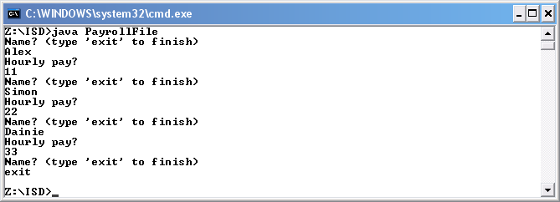

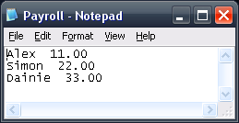

Part 2

2. Implement the Payroll program discussed in the lecture. This program should
- create a Scanner object to read from a file containing a list of employee names and hourly pay rates
- create a Scanner object to read from System.in
- while the file has more data
  - read an employee’s name from the file
  - read the employee’s hourly pay rate from the file
  - ask the user for the number of hours this employee worked
  - calculate the employee’s pay, and display the result in the console window
Don’t forget to wrap all the file-handling code in a try-catch block as discussed in the lecture. The input file (containing the employee data in the correct format) must be in the same folder as your .java file. You should use the data file created in question 1.

Code

//code to import data from a file

import java.util.Scanner;
import java.io.*;

public class PayrollFile2
{
public static void main(String[] args)
{

//declare variable
String name;
double hourlyPay;
int hoursWorked;

// build an instance of Scanner, that is an object

Scanner kybd = new Scanner(System.in);

//Exception are displayed in a better manner
try {
Scanner inFile = new Scanner(new File("Payroll.txt"));

//loop to read through the file
while (inFile.hasNext())
{
//text is put into string variable
name = inFile.next();
//hourly rate is put into a variable
hourlyPay = inFile.nextDouble();
//request the number of hours that the people have worked
System.out.println("Hours worked by "+name+"?");
hoursWorked = kybd.nextInt();
//calculate the pay
double pay = hourlyPay * hoursWorked;
//prints the employees wage
System.out.println("Pay is " + pay);
}
//close the file
inFile.close();
}
catch(IOException e) {
//printed out if an error occurs
System.out.println("Error reading from file");
}

}
}

Testing

I compiled the application using javac and then run using the java interpreter.

File input

Hours worked by Alex?
10
Hours worked by Simon?
12
Hours worked by Dainie?
13

Expected Output

Pay is 110.0
Pay is 264.0
Pay is 429.0

Actual output

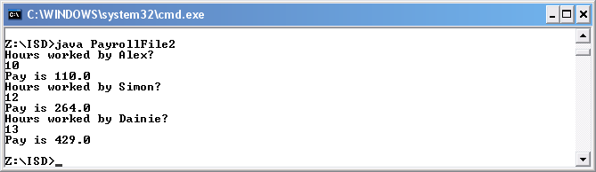

Part 3 – Persisting the "Addition Tester" high scores

In last week's tutorial you developed an "Addition Tester" application that included a high score table. Modify this application so that it persists the high score table to a file from one run of the program to another.

Code

/**
* <p>Math Game</p>
* <p>Description: This program has lots of methods to
* show that Alex J Davison has learnt and understood ISD.
* The program uses, case statements, if statements,
* while loop, for loop and other java tools.</p>
* <p>Copyright: Copyright (c) 2008</p>
* <p>Alex J Davison</p>
* @version 1.0
* @see java.util.Scanner
* @import java.util.*;
* @import java.io.*;
*/

// Maths game

import java.util.*;
import java.io.*;

public class MathGame2
{
/**
* Main method of program.<br>
* Execution starts here.
* @param args String[] - any run-time arguments
*/

public static void main(String[]args)
{

//delcare and intialize variables
int attempts = 0;
double numCorrect = 0;
double ans = 0;
String [] topTen = new String [5];
int [] scores = new int [5];
int stringNext = 0;
int intNext = 0;
String name;
int option = 0;

//load the past score values from a text file
load(topTen, scores);

// build an instance of Scanner, that is an object
Scanner kybd = new Scanner(System.in);

//request the players name
System.out.println("Please enter your name: ");
name = kybd.nextLine();

//display the options for the player
optionMenu( );

//request the users options
System.out.println("Please pick an option: ");
option = kybd.nextInt();

while (option != 5)
{

//Switch statments to allow the program to continue
switch (option)
{
case 1: //in case one increas number off attempts
attempts++;

//if statement to tell user whether they were correct or not and call test method
if (testAddition ( )== true)
{
//Correct answer was given and number or correct answer was increased
System.out.println("Correct");
numCorrect++;
}
else
{
//inform user they were incorrect
System.out.println("Incorrect");
}

break;
case 2: //print all the users current result
System.out.println("The number of attempts was: " + attempts + ".");
System.out.println("The number of current answers was: " + numCorrect + ".");

//calaculate the perecentage
ans = numCorrect/attempts*100;
System.out.println("That as a percentage is: " + ans);
break;
case 3: // if the users has made moremore than 10 attempts then the user may be consider for the top 5
if (attempts > 10)
{
//calacate the perecentage of the user socre
ans = numCorrect/attempts*100;
//call the add method to add the user to the top 5
intNext = add(scores, intNext, (int)Math.round(ans),topTen,name);
//rest the ans to 0
ans = 0;
//sort the top 5 after adding the new player
bubbleSort (scores,topTen);
//request new player's name
System.out.println("Please enter new players name: ");
name = kybd.next();
}
else
{
//Player didn't make the top 5
System.out.println("Sorry you didn't make the top ten.");
//request new player's name
System.out.println("Please enter new players name: ");
name = kybd.next();
}
//rest all values to 0
attempts = 0;
numCorrect = 0;
ans = 0;
break;

case 4: //print the top 5
printArray(scores, topTen);
break;
default:
//if anything eneter error appears
System.out.println("Error, please pick an option between 1 and 5.");
}

//print all the menu options
optionMenu( );

//requests selection
System.out.println("Please pick an option: ");
option = kybd.nextInt();

//if the option is 5 then save the data of the top 5 to a file
if(option == 5)
{
save(topTen,scores);
}

}

}

/**
* Test addition method that randomly creates two numbers between 1 and 20.
* Works out the answer.
* Asks the user if they know the answer and compares the users answer and computers.
* If the user gets thae answer correct then turn is returned, else false.
* @return bollean - True or false of as to whether the user was correct.
*/

//this is the test method
public static boolean testAddition ( )
{
// build an instance of Scanner, that is an object
Scanner kybd = new Scanner(System.in);

//makes a random from 0 and 20
int num1 = (int)(Math.random() * 20) + 1;
int num2 = (int)(Math.random() * 20) + 1;

// stores the answer in a variable
int num3 = num1 + num2;

//set correct to false
boolean correct = false;

// print out the sum and asks the question to allow a input for users answer
System.out.println(num1 + "+" + num2 + "=");
System.out.println("What is the sum of the two numbers? ");
int guess = kybd.nextInt();

//if the users guess the answer correct then set correct to true
if ( guess == num3)
{
correct = true;

}
//returns correct variable from the method
return correct;

}

/**
* Prints out a menu that says. 1. Try an addition test, 2. Results, 3. New player, 4. Top five players and 5. Quit.
*/

//method to print the menu options
public static void optionMenu( )
{
System.out.println("1. Try an addition test");
System.out.println("2. Results");
System.out.println("3. New player");
System.out.println("4. Top five players");
System.out.println("5. Quit");

}

/**
* Print array method, Prints all the values in two arrays.
* Loops through the arrays and prints all the values for the length of the array.
* @param myIntArray int - Array of int that is printed.
* @param myStringArray String - Array of String that is printed.
*/

//method to print all the values in a array
public static void printArray (int [] myIntArray, String [] myStringArray)
{

//loop to print all values in an array that is past through it
for (int row = 0; row < myIntArray.length; ++row)
{
System.out.printf("%-15s %-15d", myStringArray[row], myIntArray[row]);
System.out.println();
}

}

/**
* Add method to add an String value to and int array.
* Checks to see if the array is full or not.
* If array not full, add item to array.
* Else print message.
* Return Next postion to be written to.
* @param myArray String[] - Array of int to be checked.
* @param next int[] - The next position to be written to in the array.
* @param newData int - The new number to be consider to be added.
* @return int - The next Position to be written to in the array.
*/

//method to add strings to an array
public static int add(String [] myArray, int next, String newData)
{
// make sure array not full
if (next < myArray.length)
{
//adds new data and add one to counter past ing and cofrims addition
myArray[next] = newData;
next++;
System.out.println(newData + " added");
}
else
//confirms that array is full
System.out.println("array full");

//returns counter
return next;
}

/**
* Add method to add an int value to and int array.
* Checks to see if the array is full or not.
* If array not full, add item to array.
* Else print message.
* Return Next postion to be written to.
* @param myArray int [] - Array of int to be checked.
* @param next int - The next position to be written to in the array.
* @param newData int - The new number to be consider to be added.
* @return int - The next Position to be written to in the array.
*/

//method to add ints to an array
public static int add(int[] myArray, int next, int newData)
{
// make sure array not full
if (next < myArray.length)
{
//adds new data and add one to counter past ing and cofrims addition
myArray[next] = newData;
next++;
System.out.println(newData + " added");
}
else
//confirms that array is full
System.out.println("array full");

//returns counter
return next;
}

/**
* Add method to add a bigger number to an array and a string.
* Checks to see if the array is full or not.
* If array not full, add item to array.
* If array full, is number being added bigger than that of the last number in the array.
* Then detele last int and string of the two arrays and add the new values to them.
* Else print message.
* Return Next postion to be written to.
* @param myArray1 int [] - Array of int to be checked.
* @param next int - The next position to be written to in the array.
* @param newData int - The new number to be consider to be added.
* @param myArray2 String[] - The string array to be updated as well.
* @param name String - The new string value to be added.
* @return int - The next Position to be written to in the array.
*/

//method to add ints to an array for topfive
public static int add(int[] myArray1, int next, int newData, String [] myArray2, String name)
{
// make sure array not full
if (next < myArray1.length)
{
//call add method for names, adds new data and add one to counter past ing and cofrims addition
add(myArray2, next, name);
myArray1[next] = newData;
next++;
System.out.println(newData + " added");
}
else if (newData > myArray1[myArray1.length-1])
{
//deletes data if the value being added is high than the last in the top5,call add method for names, adds new data and add one to counter past ing and cofrims addition
next = remove(myArray1,next,next-1);
myArray1[next] = newData;
next++;
System.out.println(newData + " added");
next = remove(myArray2,next,next-1);
add(myArray2, next, name);

}
else
{
//confirm not making the top five
System.out.println("your not in the top five");
}

//returns counter
return next;
}

/**
* Bubble sort method, order an int array.
* The bubble sort also sorts a string arry to the same order as the int array.
* @param list int[] - The array of ints to be sorted.
* @param list2 String[] - The array of strings to be sorted along side the ints.
*/

//method to do a bubble sort
public static void bubbleSort (int [] list, String [] list2)
{

//declare variable and intialize
int numItems = list.length;
boolean notSorted = true;

//loop to go thourgh all the elements
while ( notSorted && (numItems >= 2) )
{
notSorted = false;
for (int i = 0; i < numItems - 1; ++i)
{
if ( list[i] < list[i+1] )
{
swapArrayItems( list, i, i+1 );
swapArrayItems( list2, i, i+1 );
// a swap occurred so possibly not sorted
notSorted = true;
}
}
--numItems;
}
}

/**
* Swap method, to swap two int items around in an array.
* @param list int - The array of ints for items to be swaped.
* @param pos1 int - The first position of the first item.
* @param pos2 int - The second position of the second item.
*/

//Method to swap to int elements
public static void swapArrayItems ( int [] list, int pos1, int pos2 )
{
int temp = list[pos1];
list[pos1] = list[pos2];
list[pos2] = temp;
}

/**
* Swap method, to swap two string items around in an array.
* @param list String - The array of strings for items to be swaped.
* @param pos1 int - The first position of the first item.
* @param pos2 int - The second position of the second item.
*/

//Method to swap to string elements
public static void swapArrayItems ( String [] list, int pos1, int pos2 )
{
String temp = list[pos1];
list[pos1] = list[pos2];
list[pos2] = temp;
}

/**
* Remove method to remove a int value from a array.
* Checks for Vaild postion, then loops to fill gap.
* If not a vaild postion then prints postion number inputted with "not valid position".
* Return next postion to be written to.
* @param myArray int[] - The array of ints for an item to be deleted.
* @param next int - The next position to be written to.
* @param pos int - The position to be deleted.
* @return int - The next Position to be written to in the array.
*/

//remove and int element from and array
public static int remove(int[] myArray, int next, int pos)
{
// position valid?
if (pos >= 0 && pos < next)
{
System.out.println(myArray[pos]+ " deleted");
// decrease number in list by 1
next--;

//fill gap
for (int i=pos; i<(next); i++)
myArray[i] = myArray[i+1];
}
else
{
//Print if not a valid postion
System.out.println(pos + " not a valid position");
}
// new size of list
return next;
}

/**
* Remove method to remove a string from an array.
* Checks for Vaild postion, then loops to fill gap.
* If not a vaild postion then prints postion number inputted with "not valid position".
* Return next postion to be written to.
* @param myArray String[] - The array of strings for an item to be deleted.
* @param next int - The next position to be written to.
* @param pos int - The position to be deleted.
* @return int - The next Position to be written to in the array.
*/

//method to remove name from top five
public static int remove(String[] myArray, int next, int pos)
{
// position valid?
if (pos >= 0 && pos < next)
{
System.out.println(myArray[pos]+ " deleted");
// decrease number in list by 1
next--;

//fill gap
for (int i=pos; i<(next); i++)
{
myArray[i] = myArray[i+1];
}
}
else
{
//Print if not a valid postion
System.out.println(pos + " not a valid position");
}
// new size of list
return next;
}

/**
* Saves the string and int values to a file called Score.txt.
* Has exception built in for error handeling.
* Loop through, writes all the the string and int numbers.
* @param myArray String[] - The array to store the names.
* @param myArray2 int[] - The array to store the scores.
*/

//save the top five into a text file
public static void save(String [] myArray, int [] myArray2)
{
//execption cather, if the file can't be written due to format
try
{
//print values to file
PrintWriter ts = new PrintWriter("Score.txt");

//loop to write all the vaules
for (int i = 0; i < myArray.length; i++)
{
//write all the elements to file
ts.println(myArray[i] + " " + myArray2[i]);
}
//close file
ts.close();

}
catch(IOException e)
{
//print if error occurs
System.out.println("Error handling file");
}

}

/**
* Loads the saved string and int values from a file called Score.txt.
* Has exception built in for error handeling.
* Loop through, reading all the the sting and int numbers.
* @param myArray String[] - The array to store the names.
* @param myArray2 int[] - The array to store the scores.
*/

//Load the top 5 from a file
public static void load(String [] myArray, int [] myArray2)
{

try
{
//save to file
Scanner inFile = new Scanner(new File("Score.txt"));

//loop thorugh to write all elements
for (int i = 0; i < 5; i++)
{
//write to file
myArray[i] = inFile.next();
myArray2[i] = inFile.nextInt();

}
//close file
inFile.close();
}
catch(IOException e)
{
//print if error occurs
System.out.println("Error reading from file");
}
}

}

Week 11 Tutorial 2

Documentation for the Addition Tester

In previous tutorials you developed an "Addition Tester" application.

Use the techniques discussed in the lecture to add javadoc comments to this application. Examples of the documentation pages produced from your comments should be included in your Portfolio.

Note that you do not have to have completed all the "Addition Tester" functionality to do this – just add comments to the methods you have managed to implement.

Example of Javadoc

