4/16/2010

|  |
| --- |
| By Alex J Davison (DV003874) | Tutor Ms Janet Lawton |

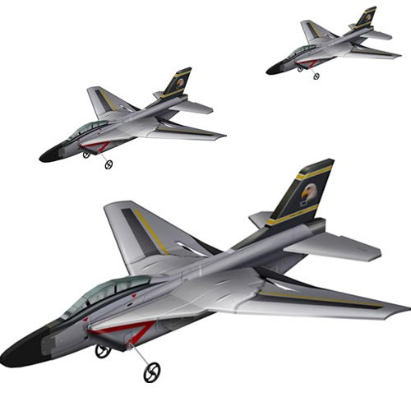

Title Image (2010)

|  |  |
| --- | --- |
| Staffordshire University | Concurrent Programming in C# Assignment |

Contents

Strategy for one plane per panel at any given time 2

Diagram/map of all threads and how they interact 4

UML object diagram 5

Bibliography 5

Appendix 5

Code 5

# Strategy for one plane per panel at any given time

The strategy for ensure that the panels only ever have one plane within them at any given time was to use semaphores and buffer to encapsulate the plane within the panel. For example plane A wishes to move from arrival panel to the runway panel, however, the runway panel is occupied by plane B and there is also another plane (plane C) waiting to go into the runway from a straight through section. Below is a diagram of the sections full.

Runway

Arrival

Plane B

Plane C

Plane A

Straight through

Once plane B has left the runway then plane A or C can enter the runway, (dependent on the programming of the runway will determine the next plane into the panel), the runway will signal the semaphore and read in the from the buffer for the next plane to run through the runway to the next section or buffers acting as the planes in the air. Below is an example of the plane A and C waiting before the semaphore gets signalled.

Plane A

Runway

Arrival

Plane C

Straight through

Once the semaphore has been signalled the pending plane will enter the runway, the semaphore will then be set to wait by the straight through section so not to let plane A enter the runway section as well as plane C. Below is an example of plane C moving on and plane A waiting.

Once plane C has left the runway the process begins again, the semaphore is signalled then the plane is written to the arrival section and the plane is read in by the runway section, the semaphore is set to wait if another plane wants to move into the panel.

Runway

Arrival

Plane C

Plane A

Straight through

Runway

Arrival

Plane A

Straight through

# Diagram/map of all threads and how they interact

# UML object diagram

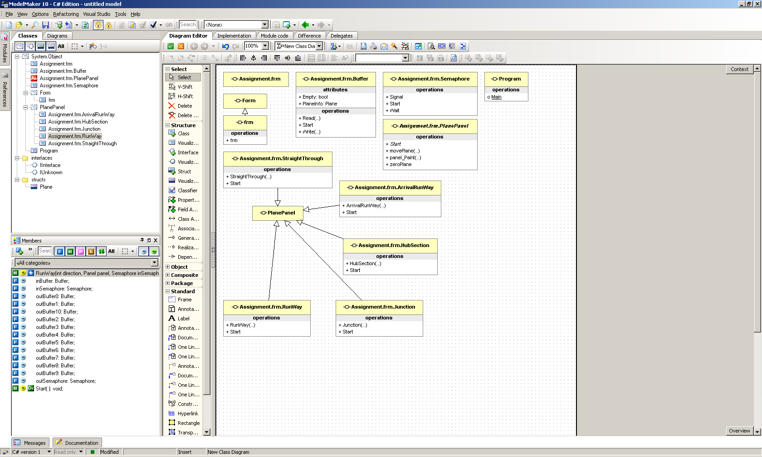

# Bibliography

|  |  |  |  |
| --- | --- | --- | --- |
| |  | | --- | |  | | Title Image. (2010). RC Airplanes Warehouse. [Online]. April 2010. Available from: <http://www.rcairplaneswarehouse.com/userfiles/image/rc_plane1.jpg>. [Accessed: 12th April 2010] | |  | |

# Appendix

## Code