**Pseudo Code:**

string resturauntName;

string businessName;

string city;

string state;

int zipCode;

print(resturauntName);

print(businessName);

print(city + state + zipCode);

end;

**Java Code: ResturantInfo.java**

* @author Alec Mcdaugale

* December 17,2023

**/

class ResturauntInfo {

public static void main(String[] args) {

final String resturauntName = "McDonalds";

final String businessName = "McDonalds Inc.";

final String city = "Denver";

final String state = "Colorado";

final int zipCode = 80236;

System.out.println(resturauntName);

System.out.println(businessName);

System.out.println(city + ", " + state + " " + zipCode);

System.exit(0);

}

}

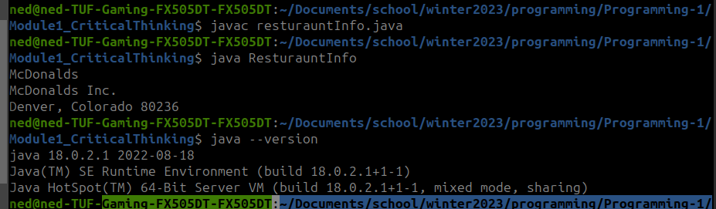**Execution:**

**Git Repo:**

<https://github.com/neoHax05555/Programming-1/tree/main/Module1_CriticalThinking>