**Pseudocode**:

doubble income = 0;

double taxWitheld = 0;

boolean inputValid = false;

print Welcome to The Average Tax Witholding Calculator.

print enter your weekly income:

while (inputValid)

income = input;

if (input is valid)

inputValid = true;

if (income < $500)

taxWitheld = 10% income

else if (incomes >= $500 && income < $1500)

taxWitheld = 15% income

else if (incomes >= $1500 && income < $2500)

taxWitheld = 20% income

else

taxWitheld = 30% income

print With and income of: $income

print \n

print Tax Witheld per week: $taxWitheld

print Tax Witheld per month: $($taxWitheld * 4)

**Source Code:**

import java.util.Scanner;

public class AverageWitholdingCalculator {

public static void main(String[] args) {

double income = 0;

double taxWitheld = 0;

double percentage = 0;

String incomeInput = "";

boolean incomeAccepted = false;

Scanner scanner = new Scanner(System.in);

System.out.println("Welcome to The Average Tax Witholding Calculator.");

System.out.println("enter your weekly income:");

// Take input and verify is numeric and is value greater than 0.

while (!incomeAccepted) {

incomeInput = scanner.next();

try {

// Attempt to cast input to double throws NumberFormatException if input is NAN.

income = Double.parseDouble(incomeInput);

if (income < 0) {

System.out.println("Invalid input: Please enter a value greater than 0");

} else {

incomeAccepted = true;

}

} catch (NumberFormatException e) {

System.out.println("Invalid input: Please enter a numeric value.");

}

}

if (income < 500) {

// Income less than $500: tax rate 10%

percentage = .10;

} else if (income >= 500 && income < 1500) {

// Incomes greater/equal to $500 and less than $1500: tax rate 15%

percentage = .15;

} else if (income >= 1500 && income < 2500) {

// Incomes greater/equal to $1500 and less than $2500: tax rate 20%

percentage = .20;

} else {

// Assumed Incomes greater than/equal to $2500: tax rate 30%

percentage = .30;

}

// Calculate witholdings.

taxWitheld = income * percentage;

System.out.println("\n");

System.out.println(" With and income per week of: $" + income);

System.out.println(" Your percentage of taxable income is: " + (percentage * 100) + "%");

System.out.println(" Tax Witheld per week: $" + taxWitheld);

System.out.println(" Tax Witheld per month: $" + (taxWitheld * 4));

}

}

**Screen Shot: (**Executed 4 times to verify all 4 cases.**)**

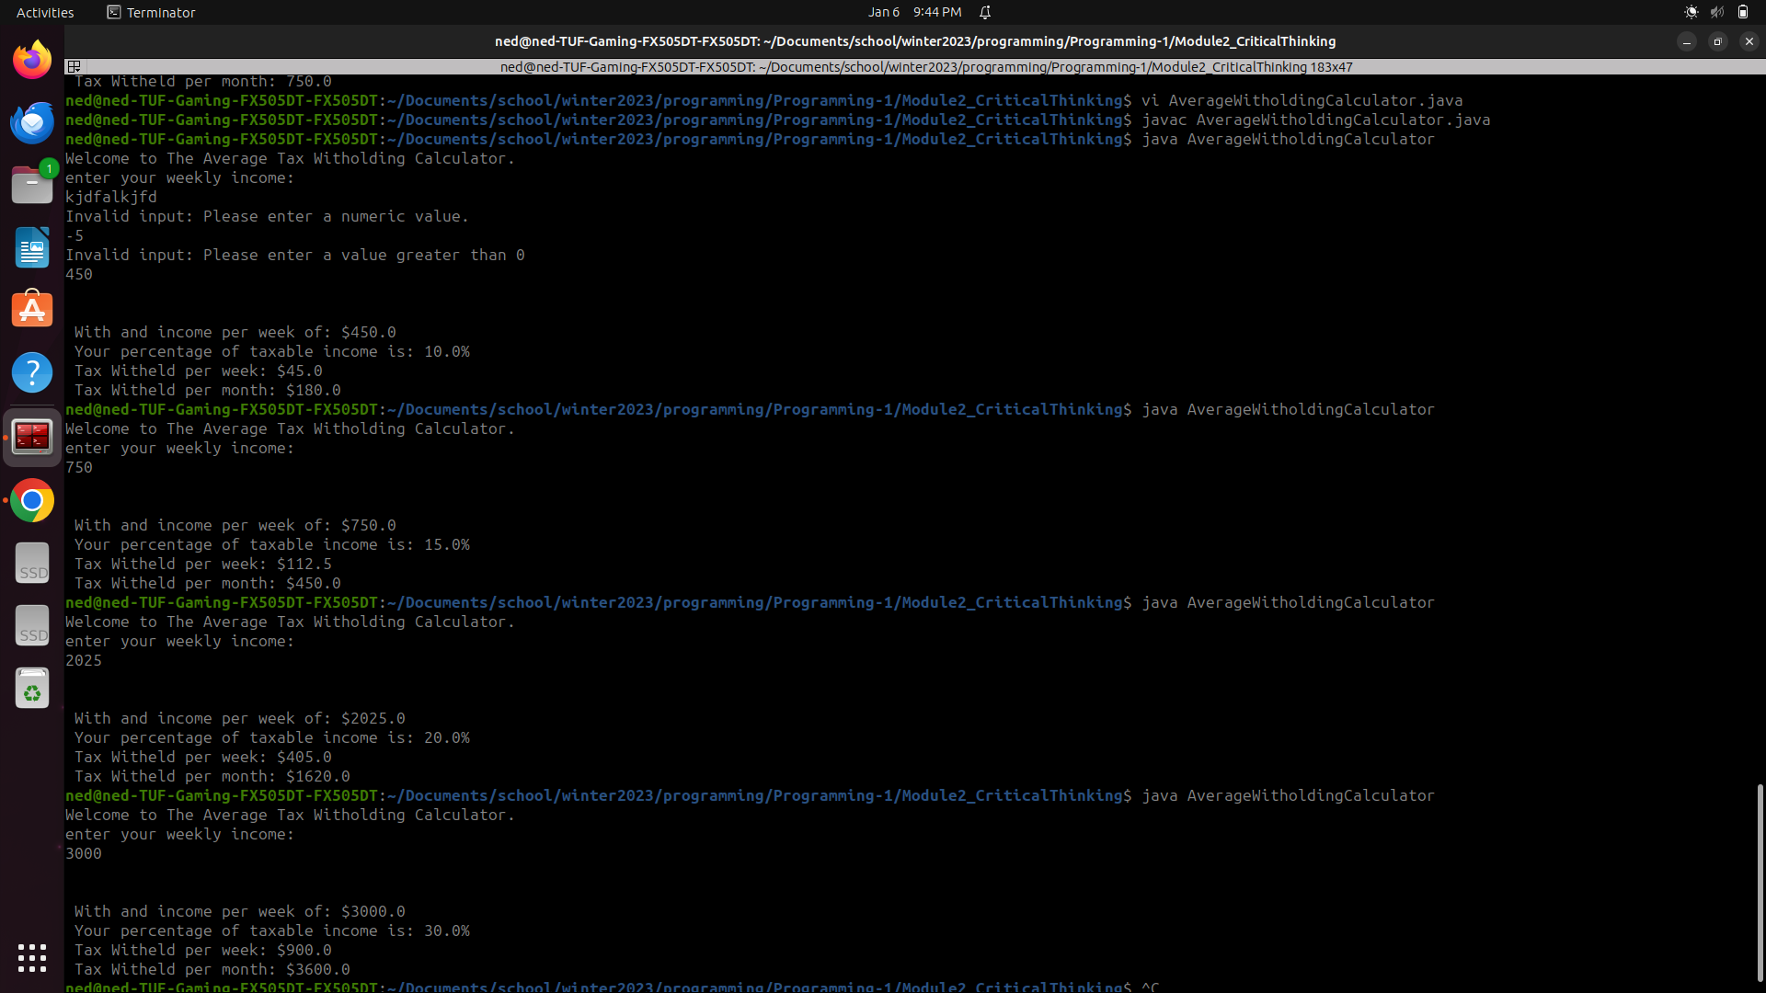

**Github:**

https://github.com/neoHax05555/Programming-1/tree/main/Module3_CriticalThinking