**Pseudocode**:

float[] inputValues;

String rawInput;

boolean done = false;

boolean invalid = false;

int acceptedCount = 0;

int invalidCount = 0;

print("Please input a total of 5 numbers one by one.");

do {

try {

print("Please input a floating point value.");

rawInput = userinput;

inputValues.add(cast(rawInput));

acceptedCount++;

invalidCount = 0;

if (5 == acceptedCount) {

done = true;

}

} catch (NumberFormatException e) {

invalidCount++;

if (5 == invalidCount) {

done = true;

invalid = true;

print("5 Invalid attempts, aborting to avoid infinite looping.");

} else {

print("Please input a valid floating point number. ex: 1.23");

}

}

} while (!done);

if (!invalid) {

float total = 0;

float average = 0;

float max = inputValues[0];

float min = inputValues[0];

float interest = 0;

int count = 0;

for (float value : inputValues) {

count++;

total += value;

max = (value > max) ? value : max;

min = (value < min) ? value : min;

}

//Average

average = total / count;

interest = total * INTEREST_RATE;

print();

print("Here are the results:");

print("Total:" + total);

print("Average: " + average);

print("Maximum: " + max);

print("Minimum: " + min);

print("Interest 20%: " + interest);

} else {

print("Please restart program and try again.");

}

**Java src:**

public class WhileLoopInput {  
 private static final float *INTEREST_RATE* = 0.20f;  
  
 public static void main(String[] args) {  
 ArrayList<Float> inputValues = new ArrayList<>();  
 String rawInput;  
 boolean done = false;  
 boolean invalid = false;  
 int acceptedCount = 0;  
 int invalidCount = 0;  
 Scanner scanner = new Scanner(System.*in*);  
  
 System.*out*.println("Please input a total of 5 numbers one by one.");  
 do {  
 try {  
 System.*out*.println("Please input a floating point value.");  
 rawInput = scanner.next();  
 inputValues.add(Float.*parseFloat*(rawInput));  
 acceptedCount++;  
 invalidCount = 0;  
 if (5 == acceptedCount) {  
 done = true;  
 }  
 } catch (NumberFormatException e) {  
 invalidCount++;  
 if (5 == invalidCount) {  
 done = true;  
 invalid = true;  
 System.*out*.println("5 Invalid attempts, aborting to avoid infinite looping.");  
 } else {  
 System.*out*.println("Please input a valid floating point number. ex: 1.23");  
 }  
 }  
 } while (!done);  
  
 if (!invalid) {  
 float total = 0;  
 float average = 0;  
 // init max and min to first value to ensure initialized for first comparison.  
 float max = inputValues.get(0);  
 float min = inputValues.get(0);  
 float interest = 0;  
 int count = 0;  
  
 for (float value : inputValues) {  
 count++;  
 //Total  
 total += value;  
 //Maximum/Minimum  
 max = (value > max) ? value : max;  
 min = (value < min) ? value : min;  
 }  
  
 //Average  
 average = total / count;  
 //Interest on total at 20%  
 interest = total * *INTEREST_RATE*;  
  
 System.*out*.println();  
 System.*out*.println("Here are the results:");  
 System.*out*.println("Total: " + total);  
 System.*out*.println("Average: " + average);  
 System.*out*.println("Maximum: " + max);  
 System.*out*.println("Minimum: " + min);  
 System.*out*.println("Interest 20%: " + interest);  
 } else {  
 System.*out*.println("Please restart program and try again.");  
 }  
 }

**Screenshot:**

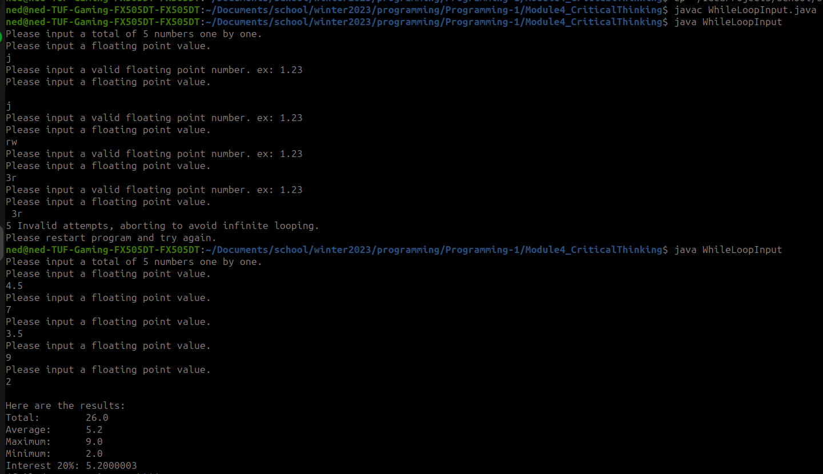

**Github:**

<https://github.com/neoHax05555/Programming-1/tree/main/Module4_CriticalThinking>