**Pseudocode**:

ArrayList<String> weekDay = {"Monday", "Tuesday", "Wednessday",

"Thursday", "Friday", "Saturday", "Sunday"};

ArrayList<Double> tempuature = {55.0, 77.2, 65.5, 33.4, 2.0, -4.1, 25.2};

boolean done = false;

int weekdayIndex = -1;

String rawInput;

print("Please input a day of the week to get the average tempuature for that day, " +"\nor enter 'week' for the average tempuature this week.");

do {

rawInput = input;

if ("week" == rawInput) {

weekdayIndex = 7;

} else {

for (String day : weekDay) {

if (day == rawInput) {

weekdayIndex = indexOfDay;

}

}

}

if (-1 == weekdayIndex) {

print("Input was invalid. Please enter a day of the week (Monday -> Sunday) or the word \"week\".");

}

} while (-1 == weekdayIndex);

if (7 == weekdayIndex) {

for (String day : weekDay) {

print( day + temp);

}

average = weeklySum/ALL_WEEKDAY;

print("Weekly Average: " + average);

} else {

print(day + temp));

}

**Java src:**

import java.util.ArrayList;  
import java.util.Arrays;  
import java.util.Scanner;  
  
*/**  
 * @author Alec McDaugale  
 * @Date: 01-13-24  
 * @Course: CSC320-1  
 * <br><br>  
 * Option #1: Get Weekly Tempuatures<br><br>  
 * Develop a Java program that will store data in the form of daily average temperatures for one week. Store the day and  
 * average temperature in two different arraylists. Your program should prompt the user for the day of the week (Monday  
 * through Sunday) and display both the day and temperature for each day. If "week" is entered, the output for your  
 * program should provide the temperature for each day and the weekly average. Use the looping and decision constructs  
 * in combination with the arrays to complete this assignment.  
 *  
 * ------------------------------------------------------------------------------------------  
 * Compile and submit your pseudocode, source code, and screenshots of the application executing the application, the  
 * results and GIT repository in a single document.  
 */*public class WeeklyTempuatures {  
 */**  
 * Initial state for weekdayIndex, represents an invalid value to use to determine if weekdayIndex was set.  
 */* private static final int INVALID_WEEKDAY = -1;  
 */**  
 * Max weekday, above range of valid indexes to represent all values for the week.  
 */* private static final int ALL_WEEKDAY = 7;  
  
 public static void main(String[] args) {  
 ArrayList<String> weekDay = new ArrayList<>(Arrays.asList("Monday", "Tuesday", "Wednessday",  
 "Thursday", "Friday", "Saturday", "Sunday"));  
 ArrayList<Double> tempuature = new ArrayList<>(Arrays.asList(55.0, 77.2, 65.5, 33.4, 2.0, -4.1, 25.2));  
 boolean done = false;  
 // Default to -1 until set.  
 int weekdayIndex = INVALID_WEEKDAY;  
 String rawInput;  
 Scanner scanner = new Scanner(System.in);  
  
 System.out.println("Please input a day of the week to get the average tempuature for that day, " +  
 "\nor enter 'week' for the average tempuature this week.");  
 // Accept user input.  
 do {  
 rawInput = scanner.next();  
 if ("week".equalsIgnoreCase(rawInput)) {  
 weekdayIndex = ALL_WEEKDAY;  
 } else {  
 for (String day : weekDay) {  
 if (day.equalsIgnoreCase(rawInput)) {  
 // If found get the index of the given day.  
 weekdayIndex = weekDay.indexOf(day);  
 }  
 }  
 }  
  
 if (INVALID_WEEKDAY == weekdayIndex) {  
 System.out.println("Input was invalid. Please enter a day of the week (Monday -> Sunday) or the word \"week\".");  
 }  
 } while (INVALID_WEEKDAY == weekdayIndex);  
  
 // Print results.  
 if (ALL_WEEKDAY == weekdayIndex) {  
 // If 'week' was entered, we need to pring averages.  
 double average = 0;  
 double weeklySum = 0;  
 double temp;  
  
 // Sum temps for each day.  
 for (String day : weekDay) {  
 temp = tempuature.get(weekDay.indexOf(day));  
 weeklySum += temp;  
 System.out.printf("%-11s %2.2f\n", day, temp);  
 }  
 // Calculate average.  
 average = weeklySum/ALL_WEEKDAY;  
 System.out.println("Weekly Average: " + average);  
 } else {  
 // Else a weekday was entered, so print that data out for that index.  
 System.out.printf("%-11s %2.2f\n", weekDay.get(weekdayIndex), tempuature.get(weekdayIndex));  
 }  
 }  
}

**Screenshot:**

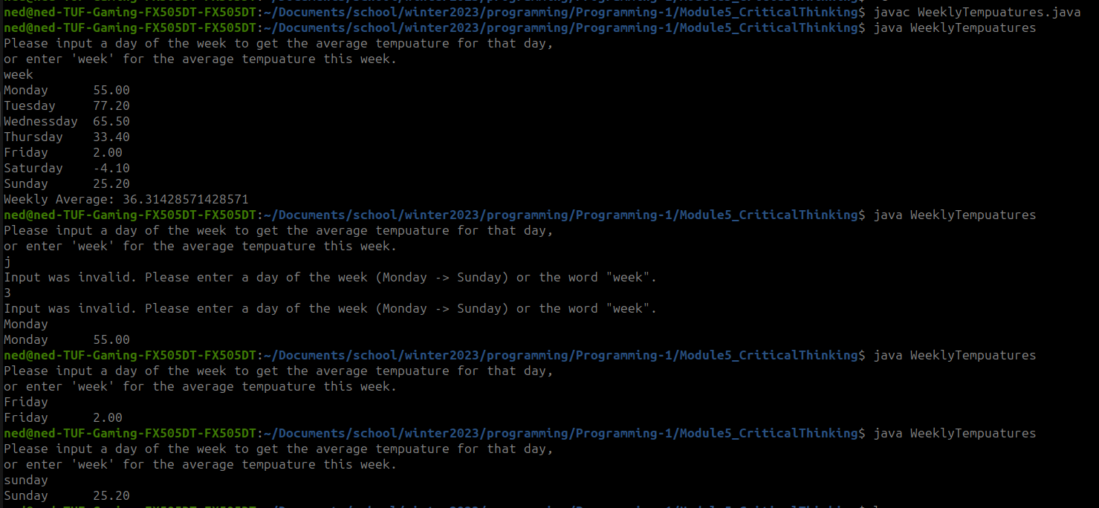

**Github:**

[https://github.com/neoHax05555/Programming-1/tree/main/Module5_CriticalThinking](https://github.com/neoHax05555/Programming-1/tree/main/Module4_CriticalThinking)