Pseudocode:
doubble income = 0;
double taxWitheld = 0;
boolean inputValid = false;

print Welcome to The Average Tax Witholding Calculator.
print enter your weekly income:

while (inputValid)
income = input;
if (input is valid)
inputValid = true;

if (income < $500)
taxWitheld = 10% income
else if (incomes >= $500 && income < $1500)
taxWitheld = 15% income
else if (incomes >= $1500 && income < $2500)
taxWitheld = 20% income
else
taxWitheld = 30% income

print With and income of: $income
print \n
print Tax Witheld per week: $taxWitheld
print Tax Witheld per month: $($taxWitheld * 4)

Source Code:
import java.util.Scanner;

public class AverageWitholdingCalculator {
public static void main(String[] args) {
double income = 0;
double taxWitheld = 0;
double percentage = 0;
String incomeInput = "";
boolean incomeAccepted = false;
Scanner scanner = new Scanner(System.in);

System.out.println("Welcome to The Average Tax Witholding Calculator.");
System.out.println("enter your weekly income:");

// Take input and verify is numeric and is value greater than 0.
while (!incomeAccepted) {
incomeInput = scanner.next();
try {
// Attempt to cast input to double throws NumberFormatException if input is NAN.
income = Double.parseDouble(incomeInput);
if (income < 0) {
System.out.println("Invalid input: Please enter a value greater than 0");
} else {
incomeAccepted = true;
}
} catch (NumberFormatException e) {
System.out.println("Invalid input: Please enter a numeric value.");
}
}

if (income < 500) {
// Income less than $500: tax rate 10%
percentage = .10;
} else if (income >= 500 && income < 1500) {
// Incomes greater/equal to $500 and less than $1500: tax rate 15%
percentage = .15;
} else if (income >= 1500 && income < 2500) {
// Incomes greater/equal to $1500 and less than $2500: tax rate 20%
percentage = .20;
} else {
// Assumed Incomes greater than/equal to $2500: tax rate 30%
percentage = .30;
}

// Calculate witholdings.
taxWitheld = income * percentage;

System.out.println("\n");
System.out.println(" With and income per week of: $" + income);
System.out.println(" Your percentage of taxable income is: " + (percentage * 100) + "%");
System.out.println(" Tax Witheld per week: $" + taxWitheld);
System.out.println(" Tax Witheld per month: $" + (taxWitheld * 4));
}
}

Screen Shot: (Executed 4 times to verify all 4 cases.)
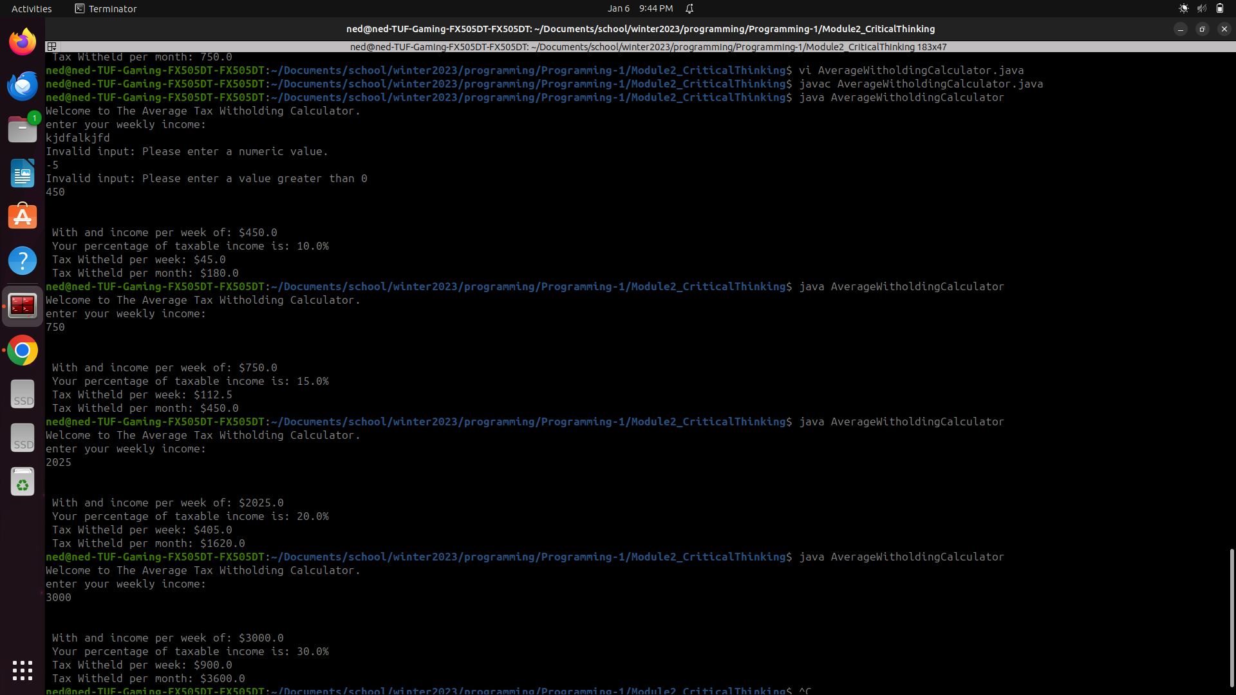

Github:
https://github.com/neoHax05555/Programming-1/tree/main/Module3_CriticalThinking

