Pseudocode:
float[] inputValues;
String rawInput;
boolean done = false;
boolean invalid = false;
int acceptedCount = 0;
int invalidCount = 0;

print("Please input a total of 5 numbers one by one.");
do {
try {
print("Please input a floating point value.");
rawInput = userinput;
inputValues.add(cast(rawInput));
acceptedCount++;
invalidCount = 0;
if (5 == acceptedCount) {
done = true;
}
} catch (NumberFormatException e) {
invalidCount++;
if (5 == invalidCount) {
done = true;
invalid = true;
print("5 Invalid attempts, aborting to avoid infinite looping.");
} else {
print("Please input a valid floating point number. ex: 1.23");
}
}
} while (!done);

if (!invalid) {
float total = 0;
float average = 0;
float max = inputValues[0];
float min = inputValues[0];
float interest = 0;
int count = 0;

for (float value : inputValues) {
count++;
total += value;
max = (value > max) ? value : max;
min = (value < min) ? value : min;
}

//Average
average = total / count;
interest = total * INTEREST_RATE;

print();
print("Here are the results:");
print("Total:" + total);
print("Average: " + average);
print("Maximum: " + max);
print("Minimum: " + min);
print("Interest 20%: " + interest);
} else {
print("Please restart program and try again.");
}

Java src:
public class WhileLoopInput {
private static final float INTEREST_RATE = 0.20f;
public static void main(String[] args) {
ArrayList<Float> inputValues = new ArrayList<>();
String rawInput;
boolean done = false;
boolean invalid = false;
int acceptedCount = 0;
int invalidCount = 0;
Scanner scanner = new Scanner(System.in);
System.out.println("Please input a total of 5 numbers one by one.");
do {
try {
System.out.println("Please input a floating point value.");
rawInput = scanner.next();
inputValues.add(Float.parseFloat(rawInput));
acceptedCount++;
invalidCount = 0;
if (5 == acceptedCount) {
done = true;
}
} catch (NumberFormatException e) {
invalidCount++;
if (5 == invalidCount) {
done = true;
invalid = true;
System.out.println("5 Invalid attempts, aborting to avoid infinite looping.");
} else {
System.out.println("Please input a valid floating point number. ex: 1.23");
}
}
} while (!done);
if (!invalid) {
float total = 0;
float average = 0;
// init max and min to first value to ensure initialized for first comparison.
float max = inputValues.get(0);
float min = inputValues.get(0);
float interest = 0;
int count = 0;
for (float value : inputValues) {
count++;
//Total
total += value;
//Maximum/Minimum
max = (value > max) ? value : max;
min = (value < min) ? value : min;
}
//Average
average = total / count;
//Interest on total at 20%
interest = total * INTEREST_RATE;
System.out.println();
System.out.println("Here are the results:");
System.out.println("Total: " + total);
System.out.println("Average: " + average);
System.out.println("Maximum: " + max);
System.out.println("Minimum: " + min);
System.out.println("Interest 20%: " + interest);
} else {
System.out.println("Please restart program and try again.");
}
}

Screenshot:
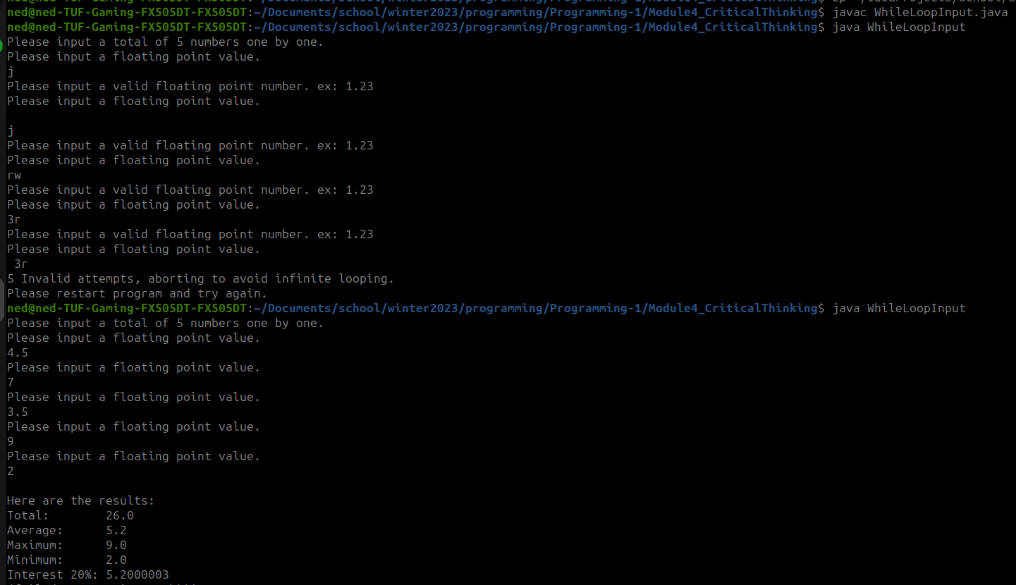
Github:

