Pseudocode:

ArrayList<String> weekDay = {"Monday", "Tuesday", "Wednessday",
"Thursday", "Friday", "Saturday", "Sunday"};
ArrayList<Double> tempuature = {55.0, 77.2, 65.5, 33.4, 2.0, -4.1, 25.2};
boolean done = false;
int weekdayIndex = -1;
String rawInput;

print("Please input a day of the week to get the average tempuature for that day, " +"\nor enter 'week' for the average tempuature this week.");

do {
rawInput = input;
if ("week" == rawInput) {
weekdayIndex = 7;
} else {
for (String day : weekDay) {
if (day == rawInput) {
weekdayIndex = indexOfDay;
}
}
}

if (-1 == weekdayIndex) {
print("Input was invalid. Please enter a day of the week (Monday -> Sunday) or the word \"week\".");
}
} while (-1 == weekdayIndex);

if (7 == weekdayIndex) {
for (String day : weekDay) {
print( day + temp);
}
average = weeklySum/ALL_WEEKDAY;
print("Weekly Average: " + average);
} else {
print(day + temp));
}

Java src:
import java.util.ArrayList;
import java.util.Arrays;
import java.util.Scanner;
/**
* @author Alec McDaugale
* @Date: 01-13-24
* @Course: CSC320-1
* <br><br>
* Option #1: Get Weekly Tempuatures<br><br>
* Develop a Java program that will store data in the form of daily average temperatures for one week. Store the day and
* average temperature in two different arraylists. Your program should prompt the user for the day of the week (Monday
* through Sunday) and display both the day and temperature for each day. If "week" is entered, the output for your
* program should provide the temperature for each day and the weekly average. Use the looping and decision constructs
* in combination with the arrays to complete this assignment.
*
* ------------------------------------------------------------------------------------------
* Compile and submit your pseudocode, source code, and screenshots of the application executing the application, the
* results and GIT repository in a single document.
*/
public class WeeklyTempuatures {
/**
* Initial state for weekdayIndex, represents an invalid value to use to determine if weekdayIndex was set.
*/
private static final int INVALID_WEEKDAY = -1;
/**
* Max weekday, above range of valid indexes to represent all values for the week.
*/
private static final int ALL_WEEKDAY = 7;
public static void main(String[] args) {
ArrayList<String> weekDay = new ArrayList<>(Arrays.asList("Monday", "Tuesday", "Wednessday",
"Thursday", "Friday", "Saturday", "Sunday"));
ArrayList<Double> tempuature = new ArrayList<>(Arrays.asList(55.0, 77.2, 65.5, 33.4, 2.0, -4.1, 25.2));
boolean done = false;
// Default to -1 until set.
int weekdayIndex = INVALID_WEEKDAY;
String rawInput;
Scanner scanner = new Scanner(System.in);
System.out.println("Please input a day of the week to get the average tempuature for that day, " +
"\nor enter 'week' for the average tempuature this week.");
// Accept user input.
do {
rawInput = scanner.next();
if ("week".equalsIgnoreCase(rawInput)) {
weekdayIndex = ALL_WEEKDAY;
} else {
for (String day : weekDay) {
if (day.equalsIgnoreCase(rawInput)) {
// If found get the index of the given day.
weekdayIndex = weekDay.indexOf(day);
}
}
}
if (INVALID_WEEKDAY == weekdayIndex) {
System.out.println("Input was invalid. Please enter a day of the week (Monday -> Sunday) or the word \"week\".");
}
} while (INVALID_WEEKDAY == weekdayIndex);
// Print results.
if (ALL_WEEKDAY == weekdayIndex) {
// If 'week' was entered, we need to pring averages.
double average = 0;
double weeklySum = 0;
double temp;
// Sum temps for each day.
for (String day : weekDay) {
temp = tempuature.get(weekDay.indexOf(day));
weeklySum += temp;
System.out.printf("%-11s %2.2f\n", day, temp);
}
// Calculate average.
average = weeklySum/ALL_WEEKDAY;
System.out.println("Weekly Average: " + average);
} else {
// Else a weekday was entered, so print that data out for that index.
System.out.printf("%-11s %2.2f\n", weekDay.get(weekdayIndex), tempuature.get(weekdayIndex));
}
}
}

Screenshot:
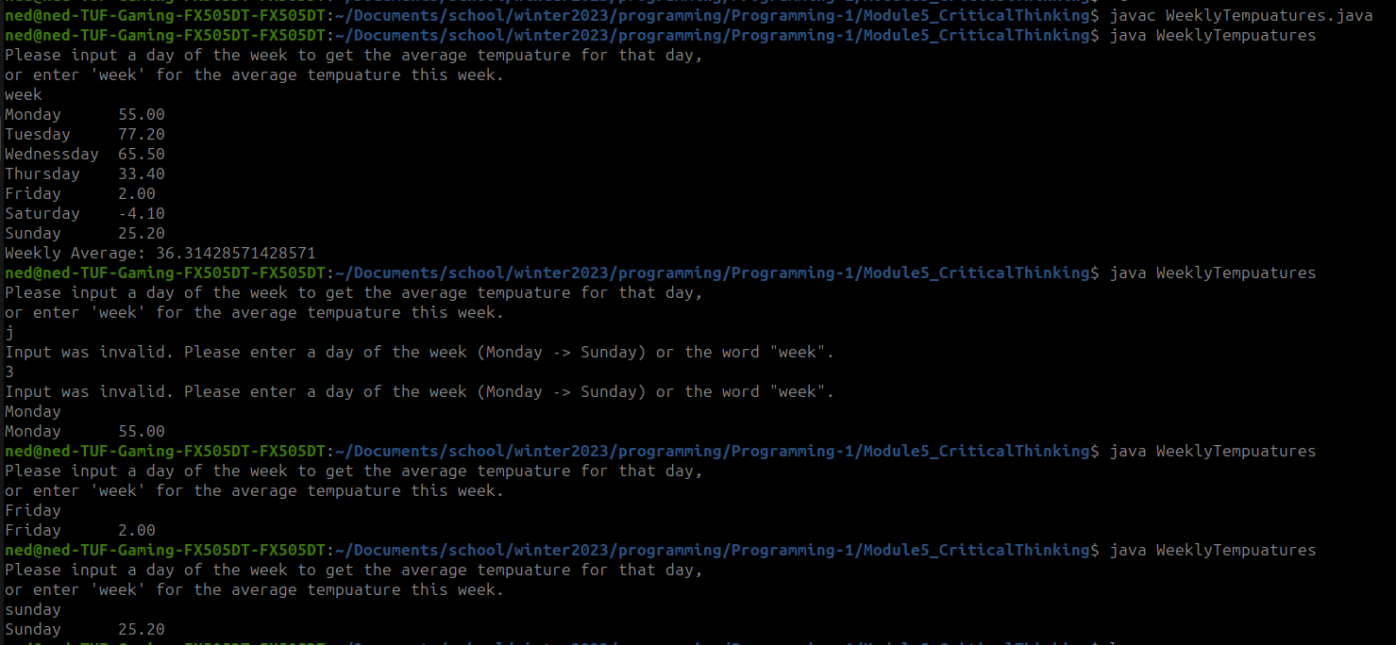
Github:
https://github.com/neoHax05555/Programming-1/tree/main/Module5_CriticalThinking

