Pseudo Code:
string resturauntName;
string businessName;
string city;
string state;
int zipCode;

print(resturauntName);
print(businessName);
print(city + state + zipCode);

end;

Java Code: ResturantInfo.java
* @author Alec Mcdaugale
* December 17,2023
**/

class ResturauntInfo {
public static void main(String[] args) {
final String resturauntName = "McDonalds";
final String businessName = "McDonalds Inc.";
final String city = "Denver";
final String state = "Colorado";
final int zipCode = 80236;
System.out.println(resturauntName);
System.out.println(businessName);
System.out.println(city + ", " + state + " " + zipCode);
System.exit(0);
}
}

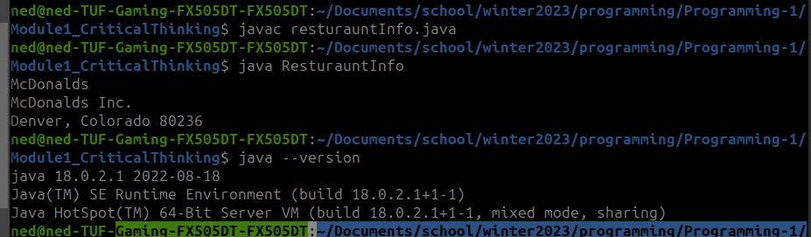
Execution:

Git Repo:
https://github.com/neoHax05555/Programming-1/tree/main/Module1_CriticalThinking

