Screenshot of program execution:

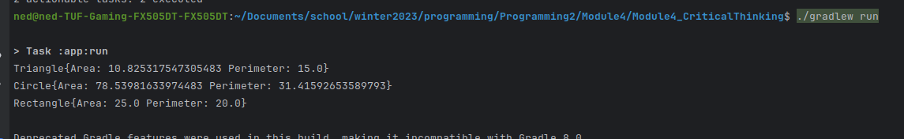

Screenshot of github: