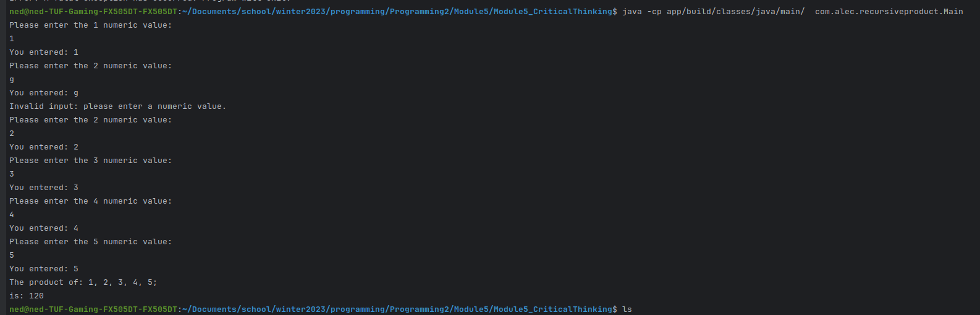Code execution:

Screenshot of git: <https://github.com/neoHax05555/Programming2/tree/main/Module5>

