Program execution:

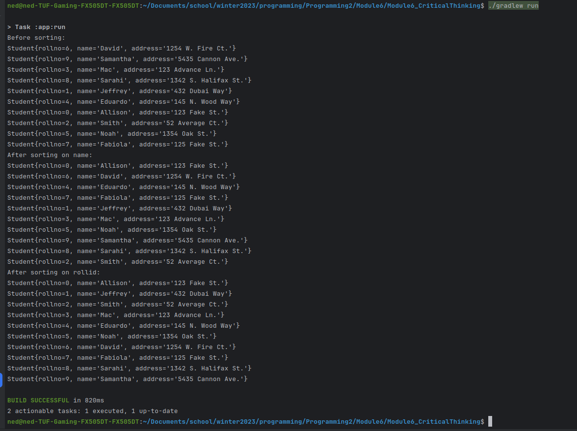

Github: <https://github.com/neoHax05555/Programming2/tree/main/Module6>

