Healthcare Data Analytics Assessment Report

1. INTRODUCTION –
The objective of this assessment was to analyze a healthcare dataset containing patient demographic information, diseases, departments, treatment costs, insurance status, and treatment outcomes. The analysis was performed using Python for data cleaning and exploratory analysis, followed by Power BI for creating an interactive dashboard to visualize the insights.

2. DATASET OVERVIEW –
The dataset consists of 515 patient records and 15 columns, including :
- Patient ID, Age, Gender, Blood Group, Height and Weight, BMI, Disease, Department, City, Admission Date, Discharge Date, Treatment Cost, Insurance Status, Outcome
The dataset was analyzed to answer business-related and patient demographic questions.

3. DATA CLEANING –
The following preprocessing steps were performed before analysis :
- Loaded the dataset using Pandas.
- Checked the structure and data types of all columns.
- Identified missing values.
- Converted Admission Date and Discharge Date into datetime format.
- Filled missing numerical values using the median.
- Filled missing categorical values using the mode.
- Removed duplicate records.
- Reset the index after removing duplicates.
- Saved the cleaned dataset for visualization in Power BI.
After cleaning, the final dataset contained 500 unique patient records with no missing values.

4. BUSINESS ANALYSIS –
The following business questions were analyzed :
1. Disease with the Highest Total Treatment Cost
Result : Asthma
2. Department Generating the Highest Revenue
Result : Neurology
3. Average Treatment Cost by Disease and Insurance Status
The average treatment cost was compared for insured and uninsured patients across different diseases.
4. Percentage of Total Treatment Cost Covered by Insured Patients
Result : 51.87%
5. City with the Highest Average Treatment Cost
Result : Delhi

5. PATIENT DEMOGRAPHICS ANALYSIS –
1. Healthcare Expenditure by Age Group
Highest Expenditure Age Group : 40-60
2. Most Common Diseases Among Different Age Groups
Disease distribution was analyzed across different age groups to understand age-specific healthcare trends.
3. Treatment Cost Comparison by Gender
The average treatment costs of male and female patients were compared to identify any noticeable differences.
4. Blood Group with the Highest Critical Outcomes
Result : AB+

6. DASHBOARD –
An interactive Power BI dashboard was developed to visualize the analysis.
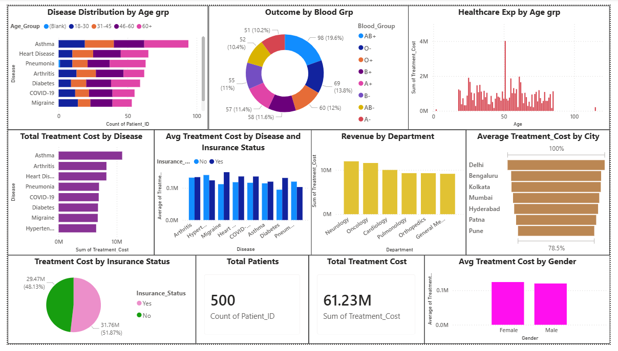

7. KEY INSIGHTS –
- The analysis identified the disease responsible for the highest treatment expenditure.
- Revenue contribution across hospital departments was compared.
- Insurance coverage and treatment costs were evaluated.
- Age-wise healthcare expenditure highlighted the most expensive patient group.
- Disease patterns across age groups were identified.
- Treatment costs were compared by gender.
- Blood group analysis identified the highest incidence of critical patient outcomes.

8. CONCLUSION –
This assessment demonstrates the complete data analytics workflow, including data cleaning, preprocessing, exploratory analysis, visualization, and reporting. Python was used to prepare and analyze the dataset, while Power BI was used to build an interactive dashboard. The findings provide meaningful insights into healthcare expenditure, disease distribution, departmental revenue, insurance coverage, and patient demographics, supporting informed healthcare decision-making.

